

**Sample Design App Design Review**

**Mobile Software Development**

**Design Document**

Completed By:

## Student Number: C16315253

## Author: William Carey

## Course Code: DT228

## Year: 3

## Date Due: 12 - 11 - 2018

## Date Completed: 0 – 11 – 2018

# Viber (Mobile Version) – A messaging application

## Mobile Layout

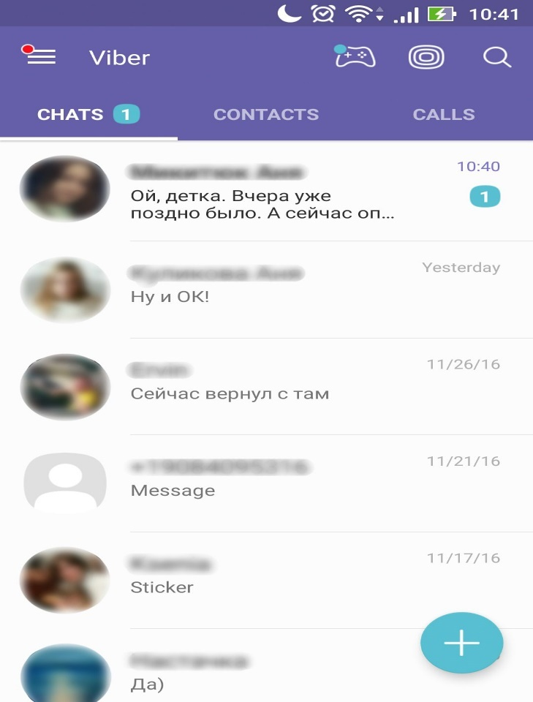

## What is the application designed for?

The application is designed, by my understanding from using it, s to contact others using the same application without having to resort to SMS, which the messages are transported over the internet instead. You can call people, text people, add new numbers update current ones delete undesired ones. In the part where we message people, we can send imagery, emoji, files and different file format that are supported by Viber themselves. You can also modify your own details, personalize your experience and use real money to assist others or further your experience. There is a sticker market which allows u to download some stickers to assist you in express yourself over text.

## What I like about this application

The effect of personalizing the experience is the most prominent feature to me but what initially attached me to the application was the visual aesthetic of the application as well as quality of what the application was designed for. Everything was easily understandable from the get go. The layout was clear to follow and what I had to do to make my experience of the application to work.

## What I don’t like about the application

If there is critics about the application, it would be that it has much further than the original design of the application. An example of this is facebook didn’t have the video or live video as part of the original design, they eventually added as part of ways to further expand the users experience.

## Colour scheme:

It is what I expect from the brand of the company – fits together as well as laid out nicely

## Navigation from screen to screen

This is easy to master all the functionality in a short period of time as it is easy to navigate from screen to screen

## Functionality

A application that allows you to contact people for free using the same application as a alternative to SMS

# LinkedIn – Mobile Version

## Layout

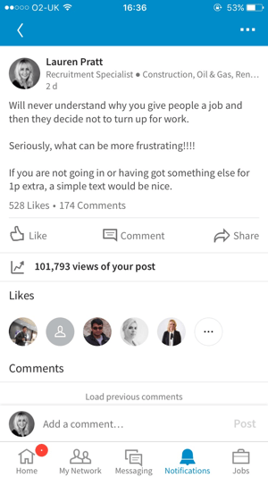

## What was the application designed for?

From my usage of the application, it is designed to allow you to display information about yourself in a business environment to allow you to get a job through this platform. It is a similar to social media platforms except it is a professional formal version. There is section to connect to other people, message people, home section, notifications and jobseeker section. There is also different ways to display the layout and you can edit your profile if you wish. You have to be careful with your content as a potential employer can come across them and not hire you through linkedin as a result. However, the content is in your control.

## What I like about the application

It is another way to link multiple resources to enhance your chance of getting employed by a suitable industry. It is useful as it content be done from anywhere in the world and does not need the requirement for each person to go out with CVs and hand them to shops. Like the previous app, there is layout that is visual appealing to me and the immediate sections makes sense to me.

## What I don’t like about the application

There is so much to with the site that it would take a while before you would master what needs to be done inside the platform of LinkedIn. And if you do not put the effort in enhancing the profile someone else may come up with a better one then you and gets picked over you. Also if you don’t go looking you cannot take advantage of some of the extensive features offered by the website.

## Colour sheme

It is visually appealing and matches the company brand in its dominant colour.

## Navigation form screen to screen

The immediately noticeable features are easy to navigate to. Once you want to uncover some of the more extensive features, the navigation becomes intermediate.

## Functionality

Every feature discovered are expected from the social media platform. The formal matter is the way people expect it to operate, so not every feature is taken advantaged off.

# What my application is going to be like.

## Screen Design

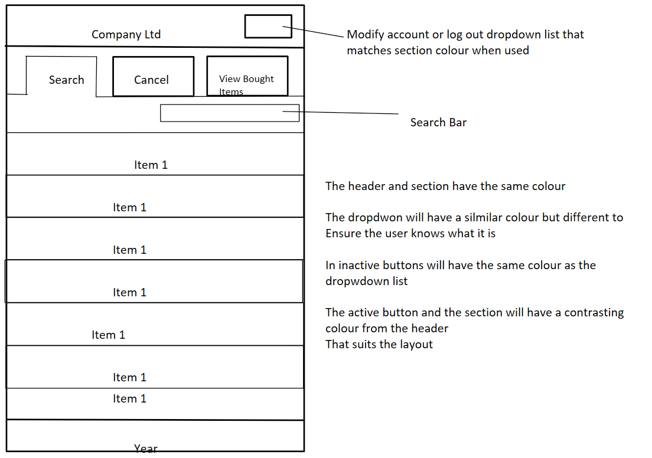

## Screen Flows

|  |  |  |  |
| --- | --- | --- | --- |
|  |  |  |  |
|  | |  |  |  |  | | --- | --- | --- | --- | |  |  |  |  | |  | C:\Users\William Carey\AppData\Local\Packages\Microsoft.Office.OneNote_8wekyb3d8bbwe\TempState\msohtmlclip\clip_image001.png button clicked  C:\Users\William Carey\AppData\Local\Packages\Microsoft.Office.OneNote_8wekyb3d8bbwe\TempState\msohtmlclip\clip_image001.png |  |  | |  |  | Clicked | |  |  |  | |
|  |
|  |