CA Part 1 of 2 of the Software Engineer Assignment

Note: the software methodogy will be agile

Deliverable 1 – Requirements & Design Document (due date: 4/11/18)

* You must submit a single document containing your **requirements, analysis and design models.**

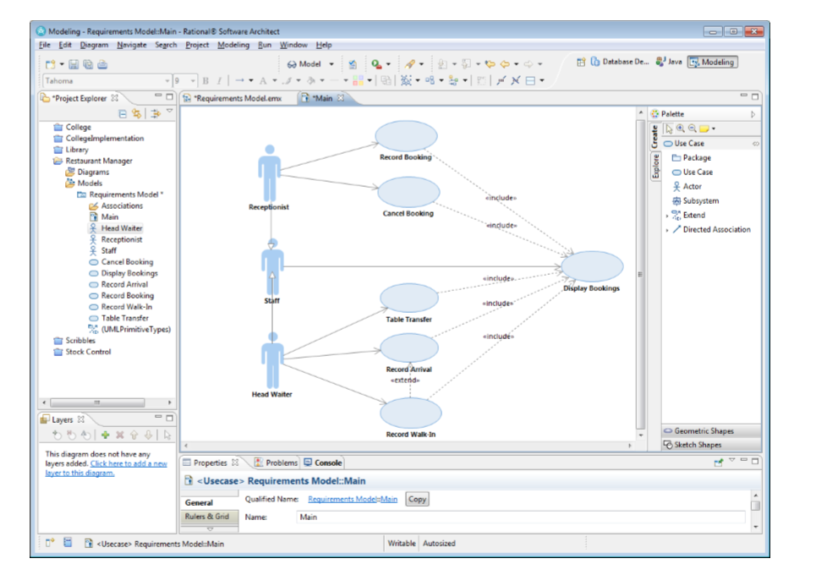

Requirement model above

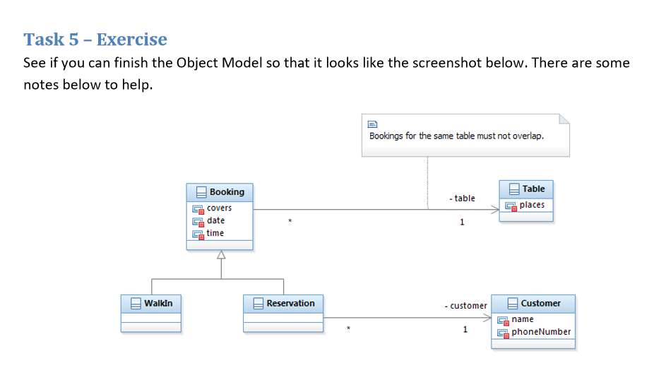

Analytical static diagram

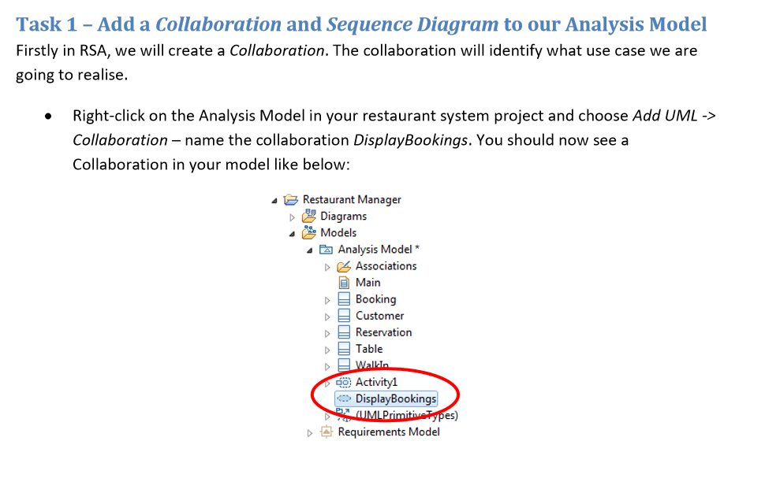

Analytical dynamic diagram

* The **system requirements model** in your document should be clearly stated using a **UML based approach** - a set of use cases (at least 3) with extended descriptions / narratives and one or more use case diagrams should be provided.
* The **structural model** in your document should consist of a detailed class diagram showing class attributes, class operations with arguments and return types and class associations.
* The **behavioural model** in your document should consist of **at least 1 sequence diagram** for each of the three use cases described in the requirements model.

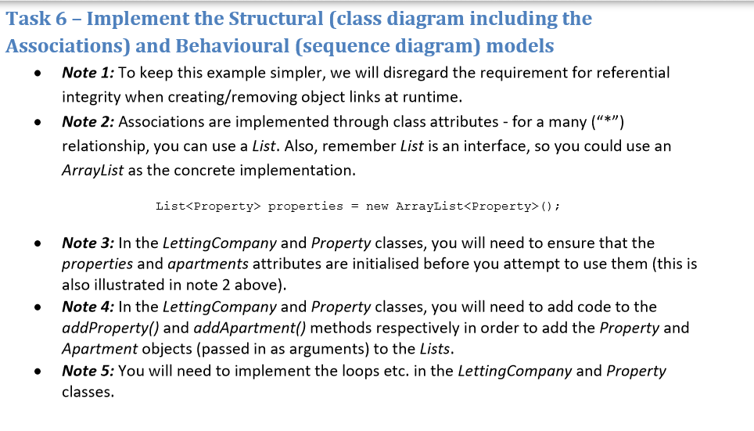

* Recorded Presentation
* You must use the following website (or similar) to record a 5 minute (max) presentation of your models. The purpose of this presentation is to show that you fully understand the models. To this end, you should present each diagram and talk through why it is modelled the way it is e.g. “these two classes have a unidirectional one to many association because…” http://www.screencast-o-matic.com/