

**Deliverable 1:**

**Requirement and Design Document**

**Software Engineering 3 Assignment Part 1**

Completed By:

## Student Number: C16315253

## Author: William Carey

## Course Code: DT228

## Year: 3

## Date Due: 4 - 11 - 2018

## Date Completed: 2 – 11 - 2018

Contents

The application to be designed 3

Potential Actors: 3

Requirements for the document 3

Registered User use case Diagram 4

Non-Registered Users Use Case Diagram 5

IT Administrator Use Case Diagram 6

Structural Model of the Application 7

The Behavioural model of the Application 8

ModifyAccount 8

Purchase 8

ViewProducts 9

Design Model 10

Link to the video 10

# The application to be designed

The web application that I am designing is an online music ordering / information website. The functionality of this website is to display the information about the products it has on offer to sell to various customers who have such interest in such items, as well as reviews of each of the product that has been bought by various customer.

At basic glance, that is all the website has to offer to a non-registered user. A non-registered user has the option to register within the system to obtain access to some of the extended features the website has to offer. Once registered, the user has the choice to retrieve their own version of the products in offer in numerous different shapes or forms, depending on their specific area of interest. If an error is made in purchasing the item, they have a time limit to cancel their item they had previously wished to purchase.

They also have the choice to modify their account details if they wish to do so, as long as the identifier does not clash with someone else details. Through all the changes and transaction, there will be confirmation of the details of the account, with an error being displayed if one does pop up with the system.

When getting access to the information, the products details are stored in the database associated with the website application which can be only accessed by the website methods and cannot be directly accessed by the user. In this way, we can apply an object-oriented design of an decoupled website application.

All the details of this application will be furthered explained in several different ways, such as a requirement model using a UML based approach, an analysis model using a detailed class diagram which will show the structural model and a sequence diagram which displays the behavioural model. At the end there will be a design model to display a diagram of all the systems the application use to talk to each other in the design of the online music application.

# Potential Actors:

Non-registered user

Registered user

IT admin

# Requirements for the document

Requirement, analysis and design models

The requirement model to have a UML based approach with three+ use cases with extended narratives / descriptions along within one+ use case diagrams to be provided.

The structural model to include a detailed class diagram containing all the fields, methods, parameters and associations.

The behavioural model to have one+ sequence diagram for every three+ use case in each use case diagram.

Have a section where there is a link to a YouTube video explaining all the features of the application.

# Registered User use case Diagram

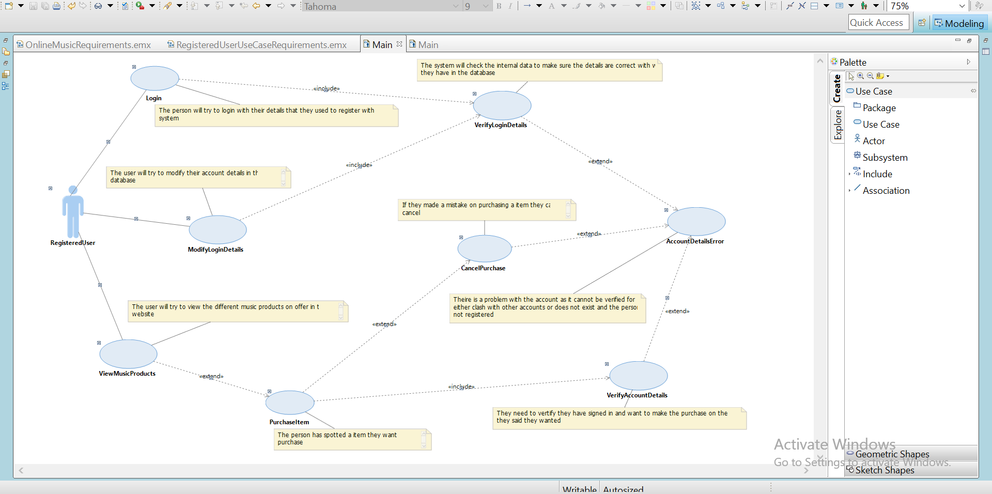

The above use case is a visually representation of the functionality which we believe the registered user will interact with the website. It accounts for those who use the website for looking at the items, those who want to buy an item, those who have changed details, and such want to update their online details. If there is an error in their input or a clash with the system interior information, the system will the problem to the user in the way they can understand so they can try to fix the problem. We assume the user may be new despite being registered and provide the easiest way to navigate to the products which they want to view or retrieve.

Everything that the user requests from the website will be retrieved from the database and displayed by the site. This way, we can protect the database information by forcing the user to get the website to retrieve the information. The only thing they cannot do within this website is registered with details they previously registered with as that will clash with the systems interior information as well as making redundant information in the server database. We will also make sure the user cannot get to specific pages unless they go through the proper process of getting to the pages, such as purchasing an item page. If there is a case where they try to breach that, they will be redirected to a page where they are allowed accessed to or a page where they have to confirm their details before being redirected to the original page they tried to access to.

# Non-Registered Users Use Case Diagram

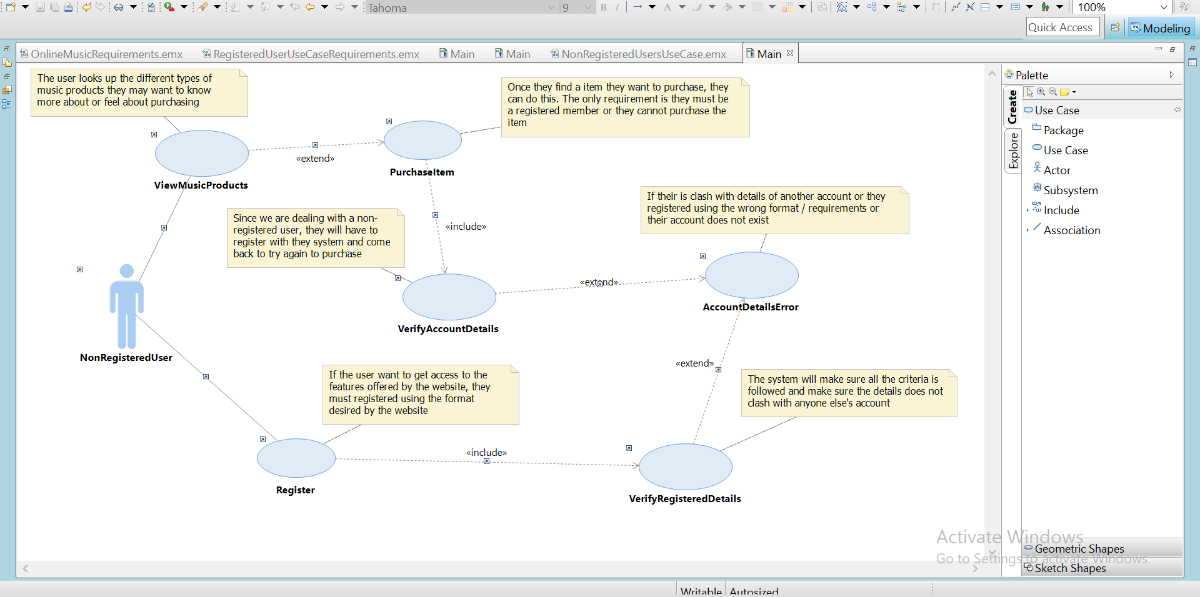

The non-registered user will behave in a similar manner as a registered user. They can browse information by requesting the website to retrieve the information from the database in the way desired. The functionality for a non-registered user is limited. They cannot purchase items, change their details or login as those options are only available to registered users. To avail of these additional features, they can become a registered user by signing up with the register page inside the site. Until they do this, they cannot get the additional benefits that are offered to the registered users. The only feature they have is to look at the products offered by the site itself.

They also cannot login with random details as the system only allows the users with the information it recognizes to access the additional features of the site. If there is a problem with their registration process, the site will notify them of the problem and it is up to them to decide what to do to fix the issue. The pages will make sure the non-registered user does not access the pages that not even a registered user can’t access to, unless the registered user goes through the correct procedure to get there.

# IT Administrator Use Case Diagram

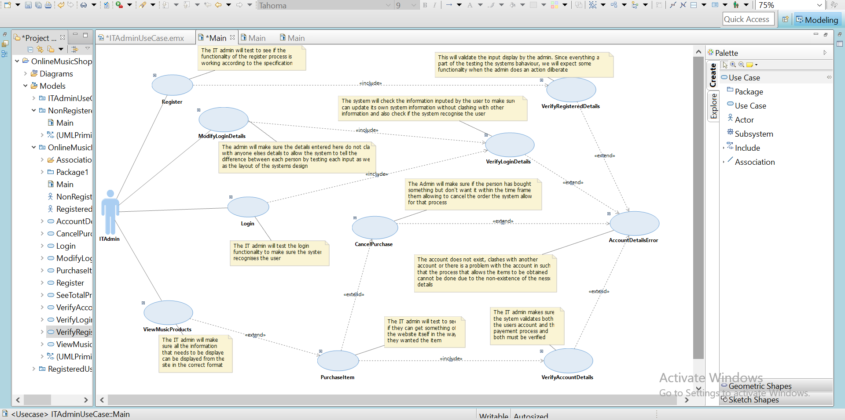

The IT admin is the most important actor for the website. These people are the only ones who can have access to the shortcuts to every page that even registered users cannot directly access. Their job is to make sure the site is running as expecting by pretending to be a non-registered user and registered user in some of the cases to test the functionality of the site and how the system behaves with the user and the database it interacts with. Through the testing, it makes sure the site goes as expected and to fix and update the system in the areas that is not behaving as expecting.

As the previous two use case diagrams displayed the expected behavior of the registered users and non-registered users with the system, the use case diagram for the IT admin will combine the previous two to allow full access to the IT admin to the site. This means the expected behavior will be a combination of the previous two plus an additional few features for the admin.

# Structural Model of the Application

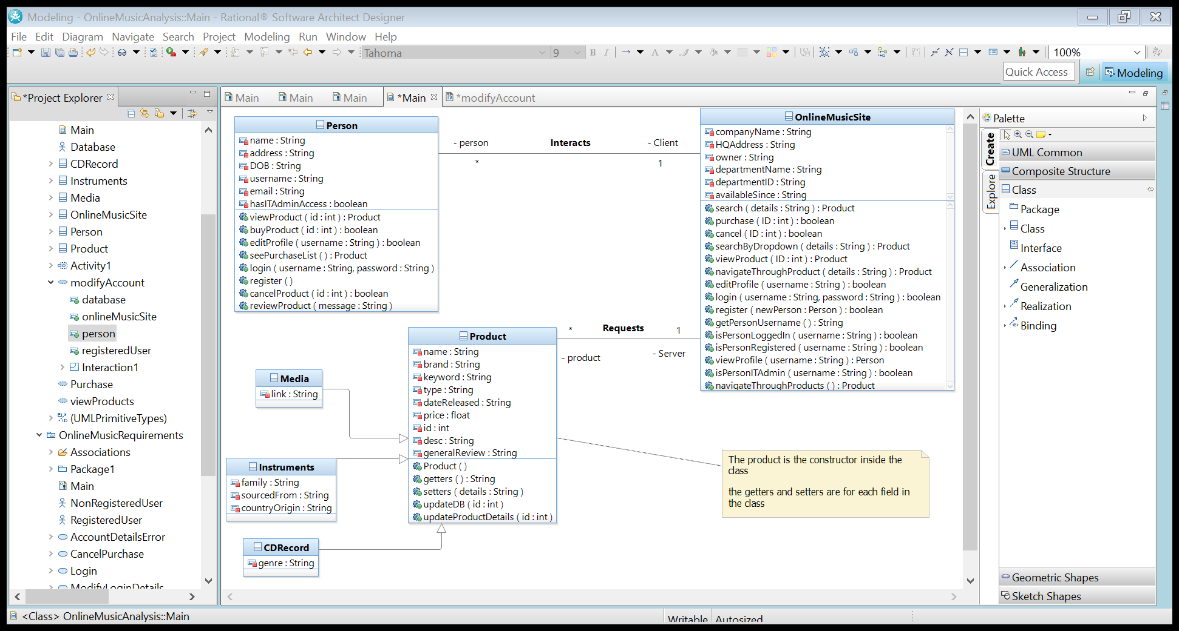

The structural model of the application is displayed as above. This model ensures all of the features of the application are within the control of the website as well as keeping the system decoupled. When it comes to getting the information from the database, the Product class and its subclasses will retrieve the information, while the Person class will deal with the persons information with the database. In terms of how the system work, the OnlineMusicSite class controls the feel and behavior of the elements of the system. It will deal with the interaction from the user to the classes that it associates with, which then interacts with the database themselves. This way, all the software can be optimized and maintained easily within the boundaries of the system.

# The Behavioural model of the Application

## ModifyAccount

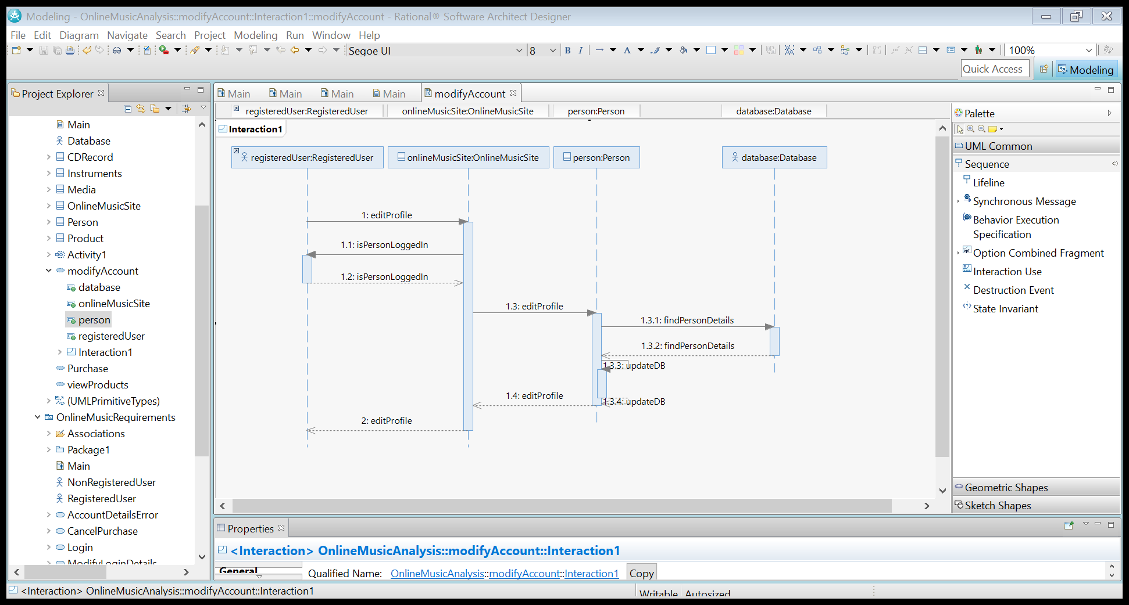

## Purchase

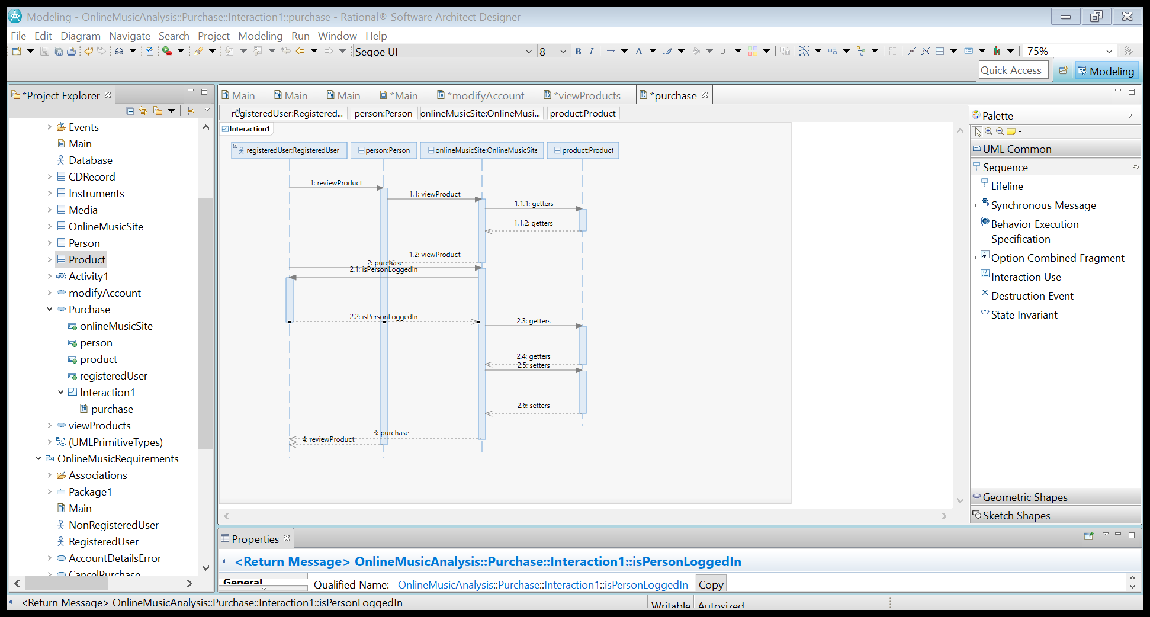

## ViewProducts

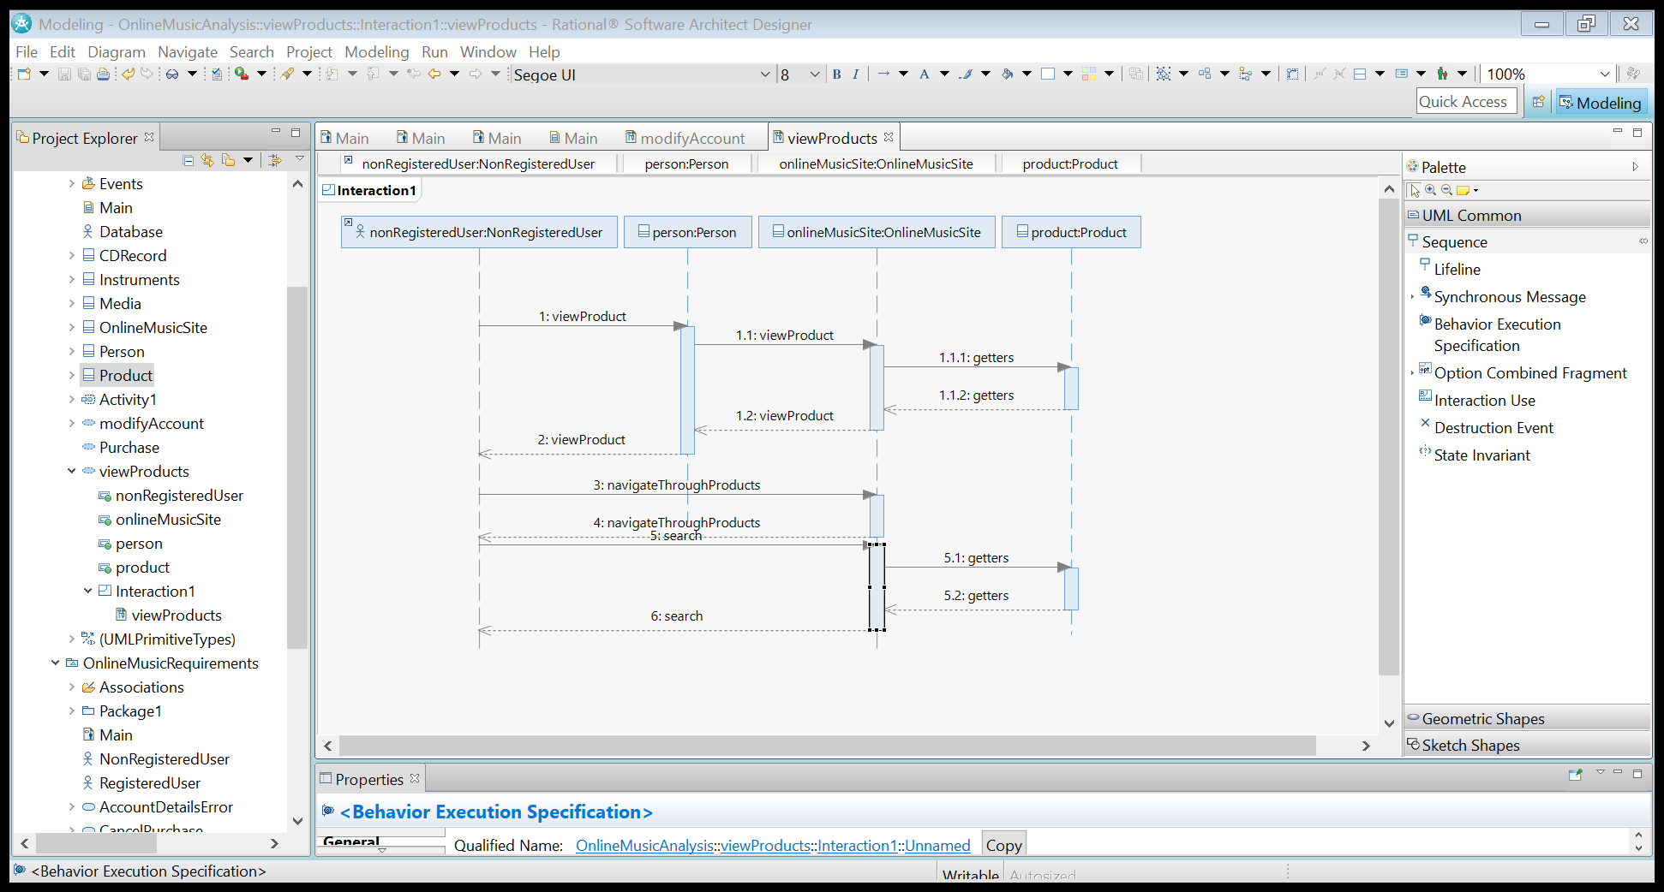

# Design Model

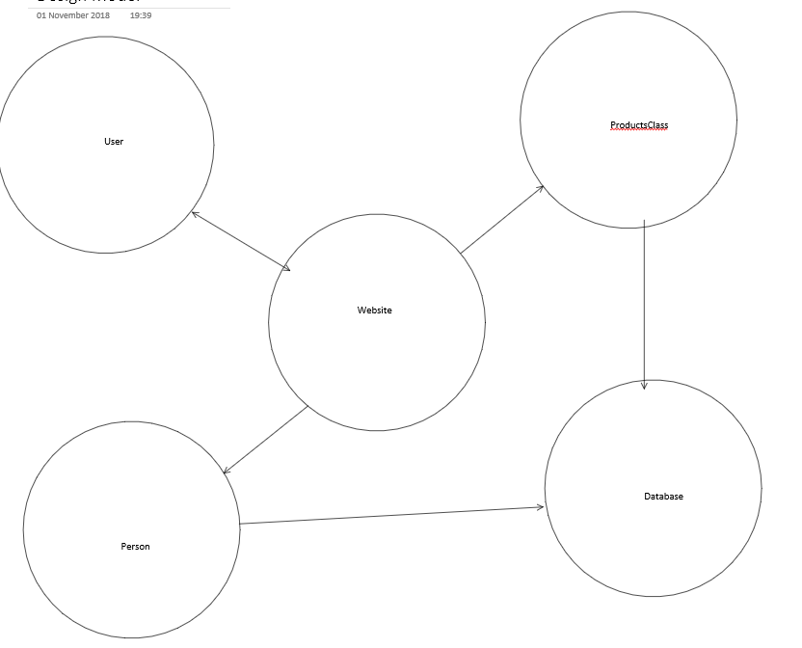

# Link to the video

The video that displays my knowledge of my work and my presentation can be found at the following site: <https://youtu.be/WQPf8iYm9KM>