OrderStatusDetails

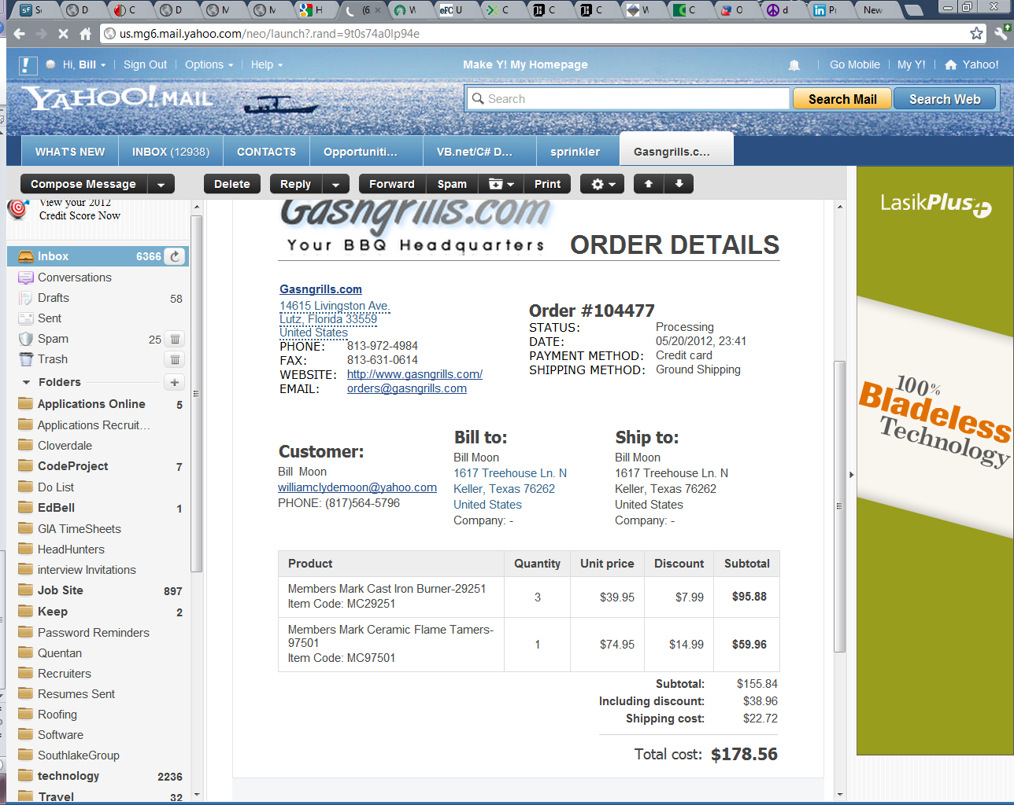

Manifest

Company

IP

Address

City

State

Zip

Phone

Fax

Website

Email

Order

Order.OrderNumber

Shipping.Status

Shipping.Date

Order.PaymentMethod

Shipping.ShippingMethod

Customer

Name

Email

Phone

Address

Billing

City

State

Zip

Company Name

Address

Shipping

Name

Address

City

State

Zip

Company name

Product

Item

Quantity

Unit price

Discount

subtotal

Customer

Contact

Contact Type

Street

City

State

Zip

Product

Accounting

Order

Inventory

Entity