Humanitarian Connection Need to get a good font

Home

Programs

About Us

Photo Gallery

Humanitarian Work

Contact Us

**Page Layout:**

**Logo**

**Logon**

**Header**

**Navigation**

**Content**

**Testimonials**

**Footer**

**Footer Navigation**

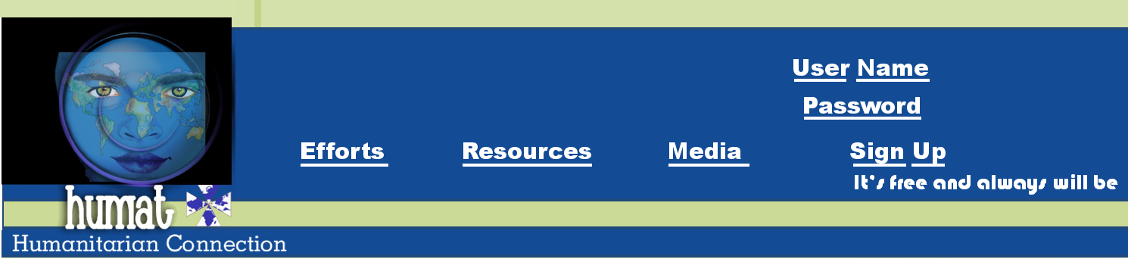

**Top of Form**

**   
 **

**Bottom of Form**

Who We Are:  **We are a community of altruists, facilitating a humanitarian network.**Mission: **Our mission is to connect**[**charitable**](http://humat.org/homepage.html)**individuals, organizations, and resources.**Objective: **Our objective is to contain a public driven index, media source, communication link, and**[**networking**](http://humat.org/homepage.html)**center for all humanitarian endeavors.**

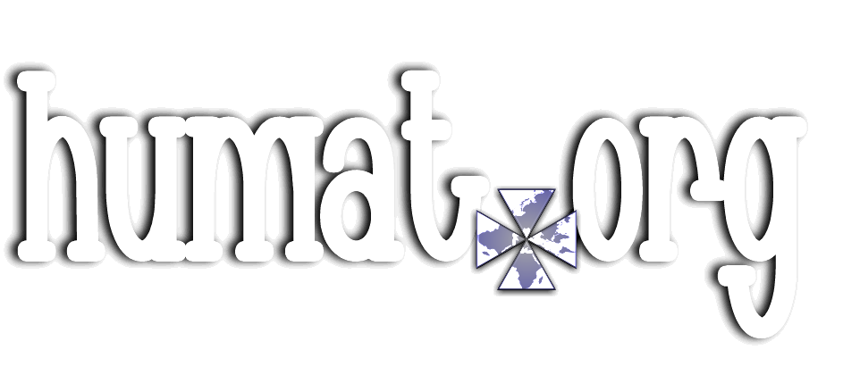

Humanitarian Connection Need to get a good font

Humanitarian Connection

Our mission is to connect charitable individuals, organizations, and resources.

Home

Programs

About Us

Photo Gallery

Humanitarian Work

Contact Us

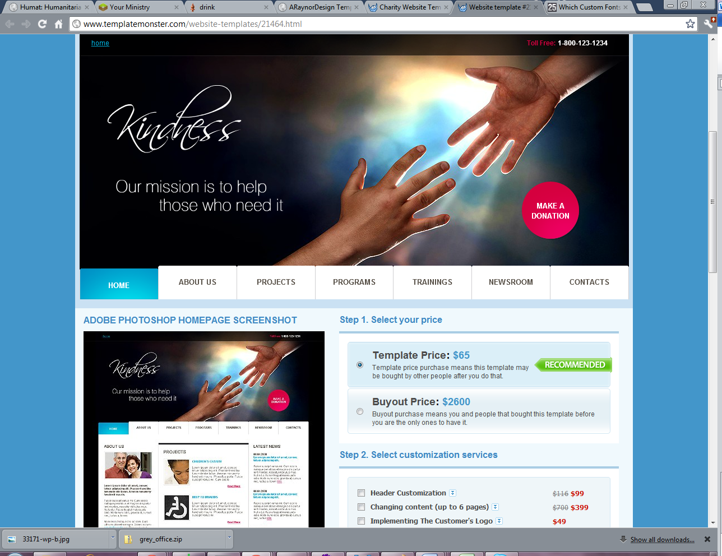

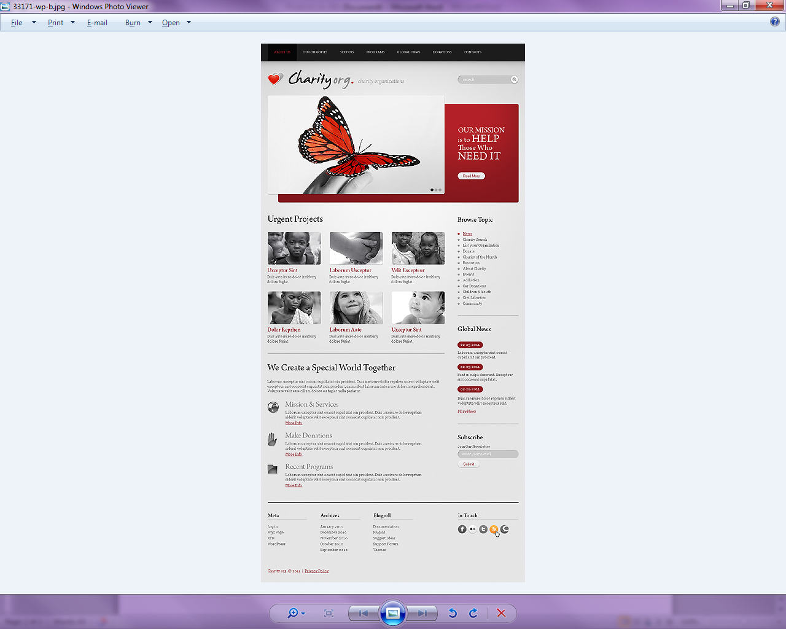

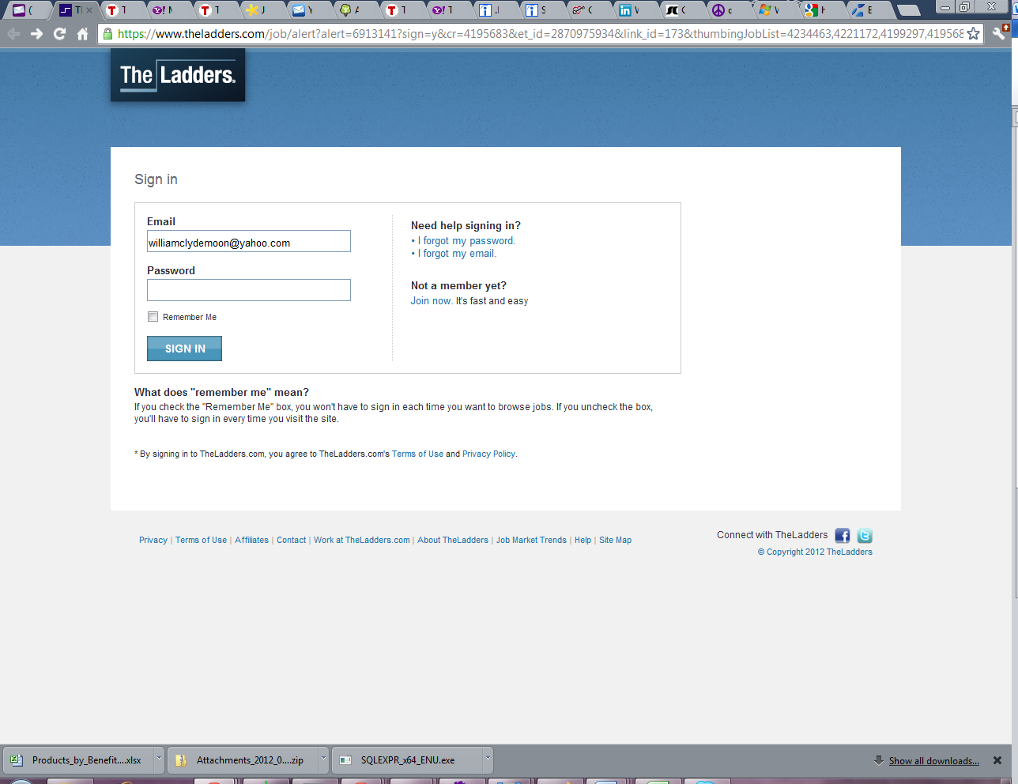

Templates:

<http://www.templatemonster.com/category/charity/?from=1&category=27>