Log time at ... [ssysinc.com/Timesheet.aspx](http://ssysinc.com/Timesheet.aspx)

BillM

to do highlights

Lost Password  
Email Confirmation  
html email for confirmation (embedded url for confirm)

emailConfirmPending.aspx  
new emailConfirm.aspx  
new lostPassword.aspx  
new changePassword.aspx

client site @ [humat.org/homepage.html](http://humat.org/homepage.html)

Sign ON

Properties

UserName

Password

Email

UserId

Locked

lastLogin

lastActivity

lastPasswordchange

lastLockedOut

CreatedOn

Active

Methods

authentication workflow

*User Sign in*.

Accept username/password. Run at server if found return userId, Redirect user to mainpage send userId to mainpage too. If not found give option for new sign up, and lost password.

*User Sign Up.*

*Capture email address, password. Verify valid email address first by content then by email test. Run at server the content and send email confirmation. Instruct user to return email as confirmation with a guid token. If received then confirm*

*account setup by populating the guid token into the userid*

*field.*

*Change Password. Provide username, oldpassword, oldpassword confirm, new password new password confirm. Run at server lookup on username password, if found replace oldpassword with new password. Send email confirmation*

*Log On*

*Create New Account*

*Change Password*

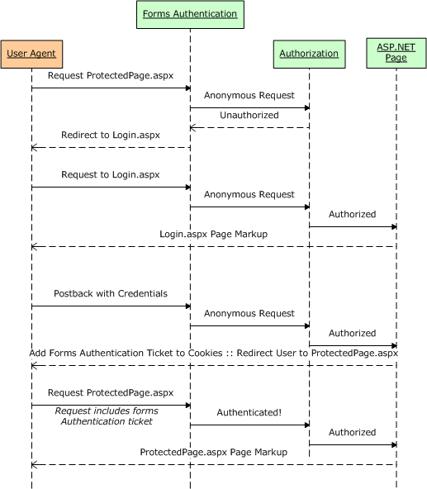

**Figure 2**: The Forms Authentication Workflow