# NAVRONGO HEALTH RESEARCH CENTRE

## Navrongo Health and Demographic Surveillance System (HDSS) Workshop Report

## Background

The Navrongo Health Research Centre (NHRC) is a leading health research institution in Ghana, committed to conducting high-quality research to inform policy and improve healthcare delivery. One of its key components is the Health and Demographic Surveillance System (HDSS), which systematically collects and maintains longitudinal data on demographic and health indicators within the study area. The HDSS provides a vital platform for tracking population dynamics and health trends, as well as evaluating public health interventions.

## Preamble and Rationale for the Workshop

Prior to 2022, data collection for the NHDSS was conducted using a paper-based tools and captured electronically using the HRS2 system. These paper-based tools with time became obsolete presenting numerous challenges, including inefficiencies in data entry, storage, and retrieval, as well as a risk of data loss. The system was also costly to maintain since the HDSS platform lacked core funding. To enhance data management and accessibility, the NHRC migrated the NHDSS to an electronic database system known as HDS Explorer in 2024.

Following the migration, various challenges emerged, including data inconsistencies, integration difficulties, and training gaps among staff members. To address these issues, a week-long workshop was organised from 3rd to 7th March 2025 at the Richmanda Hotel in Bolgatanga. The primary objective was to provide a comprehensive overview of the new database, assess migration-related challenges, develop strategies to resolve identified issues and explore potential data analyses opportunities.

## DAY ONE: 3rd March 2025

### Introduction and Presentations

The workshop started at 9 a.m. with a welcome address from Dr. Timothy Awine (TW) on behalf of the Director. This was followed by a brief statement about the purpose of the workshop. The objectives and expected deliverables of the workshop were spelt out to guide the workshop's activities throughout the week.

## Main Objective

The primary objective of the workshop was to conduct a trend analysis on key demographic and health indicators using the HDSS data and produce a report covering the period from 2018 to 2024. Another important aim was to assess the structure and functionality of the HDS Explorer application, currently used for collecting HDSS data, by comparing it with the paper-based FoxPro/HR2 system. This involved identifying inconsistencies and missing information and proposing solutions to address the challenges and enhance data quality for future use. It is essential to note that since the rollout of the HDS-Explorer application for NHDSS data updates during the NHDSS Round 95 update in July 2024, no assessment has been conducted to evaluate the data quality and completeness. Therefore, there was an urgent need for the HDSS team to meet to assess the HDS Explorer application and its data quality to inform future decisions regarding its adaptability and scalability to cover the BHDSS.

### Specific Objectives

1. Assess the HDS Explorer system data structure and format and how it is linked to the HR2 paper-based format.
2. Identify inconsistencies in the data by mapping the old data format (paper-based) with the new electronic (HDS Explorer) data format.
3. Identify challenges associated with the transition of the old data to HDSS Explorer
4. Determine how much old data is missing/not captured in the HDSS Explorer
5. Undertake trend analysis and report on key demographic indicators annually from 2018-2022.

## Expected Deliverables

1. Suggest measures to resolve identified problems with the HDS Explorer
2. Propose additional health indicators to be included in the HDS platform to attract funding for the HDSS.
3. Produce annual reports (2018-2022) for NHDSS and BHDSS on key demographic indicators (Population distribution, Fertility, Migration, and Mortality) to understand the state of the HDSS area.

Mr Samuel Oladokun (OL) presented an overview of the status of NHDSS and BHDSS from 2024 to the present, which captured a brief history of the HDSS, data collection methods, and key demographic indicators. This was followed by a presentation by John Frey, who introduced us to the new data system, HDS Explorer, which concluded the day's sessions at 5:26 p.m.

## Key Discussions and Concerns

1. **Verbal autopsy date differences:** Compare the dates (dob and dod) using verbal autopsy reports submitted by supervisors and deaths reported by fieldworkers captured on the deaths table.
2. **Disabling Enumeration Feature:** A suggestion was made to disable the enumeration feature to prevent field workers from selecting it as a start-type for certain individuals.
3. **Incorrect Start Dates:** Some household heads had start-dates recorded before the DSS even began, such as 1909-06-15, which is clearly incorrect.
4. **Recording Miscarriages and Stillbirths:** Some suggested that miscarriages, stillbirths, and abortions should only be recorded under pregnancy outcomes and should not be generated from the death table.
5. **Collecting Health Indicators:** It was strongly recommended that the HDSS enhance the data it collects by incorporating several relevant health indicators. This would aid in determining disease prevalence that can address current health challenges, inform public health programmes in the district, and serve as a catalyst for attracting additional funding to support the platform.
6. **Sampling for Health Checks:** A proposal was made to randomly sample individuals who self-report diseases, such as hypertension, to measure their actual blood pressure and verify the accuracy of their self-reports.
7. **Pregnancy Registration Form Issues:** There were concerns about how pregnancy status is recorded, with a need for more precise options, such as “delivered” and “still pregnant.”
8. **Household Pregnancy Display:** It was suggested that pregnancies recorded in the previous rounds should be displayed in each household listing to facilitate monitoring of their outcomes.
9. **Maternal Book Entries:** Fieldworkers do not always utilise the maternal health book during pregnancy registration, resulting in the omission of essential information, such as the last menstrual period (LMP), which is necessary for calculating the estimated date of delivery (EDD), gestational period, and pre-term births.
10. **Inconsistencies in Pregnancy Registration:** It was observed that there were significant disparities between the number of recorded pregnancies in the HDS Explorer core system (4473) compared to the extension system (3806) indicating that fieldworkers are not consistently updating/synchronising their records.
11. **Duplicate IDs:** The member table contained cases of duplicate IDs, and it was recommended that the old and new IDs be manually matched to resolve this issue.
12. **Events Reported on 15th June:** Many of the births, deaths and in and out migration events were dated on the 15th day of the month or in June 15th of the year of event if the month of the event is not known creating a heaping of the events on these days. This presents several challenges in analysing the data that require precise dates of these events. It is suggested that follow-up checks to confirm the dates reported by field workers could reduce unknown birth and death dates.

# DAY TWO: 4th March 2025

A welcome address and a recap of day one was made by TW. This then opened the floor for clarifying some unclear issues raised the previous day before continuing with the day’s activities.

## Presentations

* **Key Demographic Indicators:** Dr George Wak's (GP) presentation highlighted the importance of accurate, timely, and reliable data on births, deaths, and migration for improving population well-being. He also highlighted the key metric that should be used to evaluate the quality of the data, as well as capture and monitor events to avoid the possibility of underestimating rates.
* **Data Management and Consistency:** Dr. Paul led the team in assessing data consistency between the two systems.

**Key Discussions and Concerns**

1. **Resolving Duplicate IDs:** A need arose to address duplicate IDs in the new system.
2. **Urban and Rural Reclassification:** It was suggested that there was a need to reclassify urban and rural areas within the HDS, taking into consideration the Ghana Statistical Service's Enumeration Area classification, current population density and other socio-economic and geographic parameters.
3. **Writing of Reports:** A recommendation was made to consistently write the annual HDSS reports to provide basic health and demographic indicators on fertility, mortality and migrations. This was the only way data on births, deaths, pregnancies and migration could be used to inform both data management practice and fieldwork.
4. **Internal Migration Date Errors:** Some discrepancies were found in the start-date and entry-date for internal migrations. The data management team took notice of these quality issues to address them
5. **Missing IDs in Tables:** Some IDs appear only in the residency or member tables rather than both. These two tables were expected to contain the same number of records.
6. **Unknown Gender Entries:** There were eight individuals whose gender and names were unknown. Further checks suggested these were stillbirths.
7. **Overlapping Records:** 178 records showed inconsistencies in their start-type, start-date, end-type, and end-date, with some individuals appearing to have died twice.
8. **Massive Duplicate IDs:** Nearly 2000 duplicate IDs were identified. This was as a result of increasing the individual ID’s to 9 digits by adding 3 zeros and a household ID.
9. **Unusual End-Type Code:** One ID was found with an end-type coded as CHG.
10. **Missing Birth Data (2015-2023):** Some birth records were missing from the birth table, with as few as 15 recorded deaths for an entire year. This issue was resolved when residency and member tables were merged.
11. **Inconsistencies in Birth Data:** The residency table in the new system recorded 98,195 births (BIR), which did not match with the data from the old system.
12. **Incorrect Start-Type:** About 63,459 individuals had the same start-date as their date of birth but were not recorded as BIR instead, they were listed as ENT or ENU.
13. **Separate Data Analysis:** It was agreed that new (data after the migration to the new system) and old data (data before the migration to the new system) should be analyzed separately to better understand inconsistencies in trends.

# DAY THREE: 5th March 2025

A welcome address and a recap of day two was made by TW. This provided an opportunity to address unresolved issues from the previous day before proceeding with the day's activities. Mr. Daniel Azongo (DZ) led the development of an outline for the technical report.

### Key Discussions and Concerns

1. **Missing Place of Death Data**: The place of death was missing for some individuals in the new dataset. This issue was observed mainly in recent years after migrating to the new system. It was noted that the place of death is recorded as text instead of a coded (categorical) format.
2. **In-Migration Data Discrepancy**: The new data recorded 438,691 in-migrations, while the old data had 499,676. This is concerning as the number should increase rather than decrease.
3. **Out-Migration Data Shortfall**: The new dataset (HDS explorer) has 475,844 out-migrations, whereas the old data (HRS2) has 541,962. Over 12% of data or individuals are missing in the new dataset.
4. **Abnormally High In-Migration in 2023**: The 2023 data showed an unusually high in-migration of 29,677. This was due to field workers using the last visit date on CRBs as the migration date for individuals missing during the data migration process. It was suggested to retrieve individuals whose migration reason is “Return to DSS” and reconstruct them into the system without filling a migration form, as these individuals never actually migrated.
5. **Incorrect Number of Clusters**: The new dataset contains 250 clusters at Hierarchy4, which is incorrect. The old data from the HRS2 contains 247 clusters.

## REPORT ON THE BUILSA HDSS

### Background

The baseline for establishing the BHDSS was conducted in 2017 and 2018, covering both the Builsa North and South Districts. However, it was not until 2019 that the first round of data updates was carried out. This data update also extended the BHDSS coverage areas to include approximately four communities in the North-East District. It was also during this first round of data updates that electronic data capturing system (OpenHDSS) was deployed to collect data. Although seven rounds of data updates have been collected, there has been no systematic analysis of the data to assess its quality, nor has a report been written to highlight the socio-demographic profile of the area.

### BDHSS (Bulisa data issues)

1. **Residency Table Inconsistencies**: Some individuals have end-dates before their start-dates. Some end-dates appear only a few days after enumeration, which is incorrect.
2. **Inconsistencies in Start and End Data**: 29 individuals in the Builsa data have inconsistencies in start-type, end-type, start-date, and end-date.
3. **Migration Data Issues**: The migration records do not indicate whether migration is internal or external.
4. **Missing Place of Birth Data**: Total recorded births are 9,912, but only 9,903 have a recorded place of birth, leaving 9 missing.
5. **Questionnaire Differences:** Clarification was needed on whether the data collection questionnaires for Builsa differed from those used in Navrongo.
6. **Need for a Manual:** A suggestion was made to develop a manual describing the variables and field operations.
7. **Mismatch Between Births and Pregnancy Outcomes**
8. **Pregnancy Outcome Table Issues**: The table does not indicate outcome types such as stillbirths or abortions.
9. **Name Inconsistencies**: Some last names, particularly of wives, were interchanged with first names.
10. **Missing Cause of Death Data**: No cause of death is recorded in the death table.
11. **Low Under-Five Mortality Rates**: The calculated under-five mortality rates appear very low:

Table 1: Under-five mortality rates for BHDSS from 2019 - 2024

|  |  |  |  |
| --- | --- | --- | --- |
| **Year** | **Deaths** | **Births** | **Rates** |
| 2019 | 11 | 1,659 | 6.6 |
| 2020 | 32 | 2,059 | 15.5 |
| 2021 | 30 | 2,075 | 14.5 |
| 2022 | 30 | 1,776 | 16.9 |
| 2023 | 26 | 1,615 | 16.1 |
| 2024 | 29 | 1,070 | 27.1 |

1. **Commitment to Regular Meetings**: The team should commit to regular meetings, either virtual or in-person, as a one-time workshop will not yield effective long-term results.
2. **Gaps in Verbal Autopsy Data**: The verbal autopsy system lacks sufficient information to arrive at definitive conclusions, creating gaps, especially if Inter-VA is to be used.
3. **Builsa Verbal Autopsy Questionnaire**: The Builsa VA questionnaire follows the 2022 WHO standard, making it easier to integrate into Inter VA for determining the cause of death.
4. **Standardizing the Verbal Autopsy Questionnaire**: Discussions were held on whether to use the WHO 2016 questionnaire for verbal autopsy in Navrongo or adopt the 2022 version used in Builsa. Daniel indicated that the WHO has yet to develop an algorithm for analysis using the 2022 version of the VA tools and that it is advisable to use the 2016 version of the WHO VA tools, as has been done in both Kintampo and Dodowa HDSS and in other countries implementing mortality surveillance systems. However, Dr. Timothy suggested that the 2022 VA tools could be transformed for inter-VA analysis. It was concluded that the WHO 2022 questionnaire should be used for Navrongo to facilitate integration with InterVA for cause-of-death determination.
5. **Age Estimation Issues in Older Populations**: Many older individuals do not know their exact birthdates, leading field workers to assign rounded years (e.g., 1960, 1970, 1980). This contributes to the unusual concentration of data in those years, as noted in the individual table for Builsa.
6. **A suggestion was made to include a field that captures whether dates (dob,dod etc) were estimated or actual**. This includes the HDS explorer.

We ended the day at 5:41pm after going through the Builsa data.

### DAY FOUR and FIVE: 6th and 7th March 2025

A brief recap of day three was made by TW after which participants were put into three groups to conduct analysis and produce annual report (2018-2022) containing tables (rates) and graphs of key demographic indicators. Below is a list of members on each team;

|  |  |  |
| --- | --- | --- |
| Fertility | Migration | Mortality |
| Dr. Timothy Awine (TW) | Dr. George Wak (GP) | Mr. Samuel Oladonkun (OL) |
| Dr. Cornelius Debpuur (CD) | Mr. Daniel Azongo (DZ) | Dr. Paul Welaga (PW) |
| Dr. Paul Welaga (UW) | Mr. Peter Wontuo | Benedicta An-Mwaaba |
| Mr. Peter Wontuo (PW) | Mr. Frey John | Mr. Peter Wontuo |
| Mr. Frey John (JF) | Mr. Robert Johnson | Mr. Frey John |
| Mr. Robert Johnson (RJ) | Benedicta An-Mwaaba | Mr. Robert Johnson |
| Judith Adagenera | Judith Adagenera | Judith Adagenera |

### Assessing Data Quality

During the course of this exercise, it was discovered that the population of the NHDSS has been decreasing consistently since 2020, with a gap margin of approximately 1,330 people, which raised a significant concern. Efforts were made to identify the reasons for this difference. Some plausible reasons were that field workers were not capturing or updating information on some individuals during these years. A trend analysis of the data reveals that, after 2019, the total population has been declining, even before the data were cleaned for migration to HDSS Explorer (see Fig. 1).

The HDSS Head, Mr. Ola, in response to the decline in the total population, noted that two other significant factors contributed to this decline. These include a reduction in the number of rounds from two to one in 2020 due to the COVID-19 pandemic outbreak and the ethnic conflict between the Kandiga and Doba communities.

It was also observed that the cleaning of the data for migration to HDSS Explorer resulted in the loss of several data points. The Data Managers (John and Peter) explained that several logical inconsistencies were identified in the HDSS data during the cleaning process, and all illogical data were dropped, resulting in a significant reduction in the HDSS population and the loss of several data. For instance, some individuals have moved in and out of the HDSS multiple times; however, not all of these movements were consistent, resulting in individuals moving in without initially moving out of the study area. Other issues found were some individuals have end dates before their start dates, and not all of such events could be migrated into HDSS Explorer.

Figure 1 shows the population trends for both HRS2 data and HDSS Explorer data.

Figure 1. Overall population trends by year using HRS2 Data set.

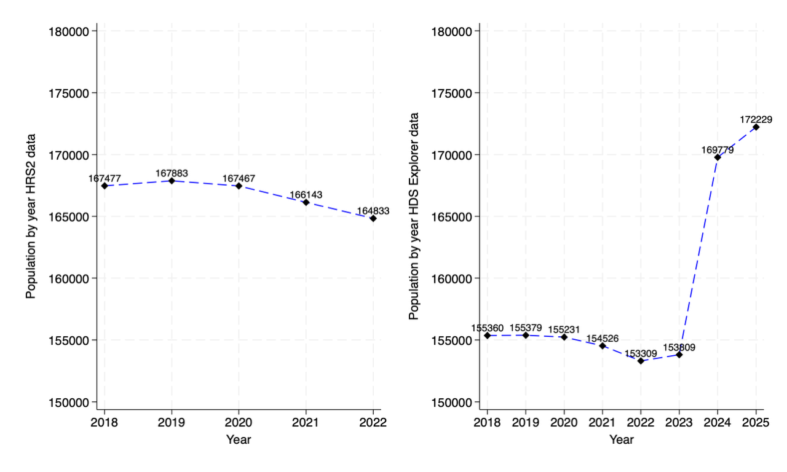

The discussion then focused on selecting the most appropriate dataset for this analysis to minimize bias resulting from the reduced data in some datasets. The team agreed to use Round 93 data after several explorations and considerations, and the cut period for the analysis should be from 2018 to 2022. These datasets had higher population sizes and recorded more events to estimate certain demographic indicators compared to the most recent dataset.

The team also assessed the BHDSS data for its quality and completeness for the analysis. Basic descriptive analyses were conducted to evaluate trends in key demographic indicators. However, it was observed that since 2023, there has been a consistent decline in the number of key events recorded in the data (Figure 2).

Figure 2: Overall population trends of BDHSS by year

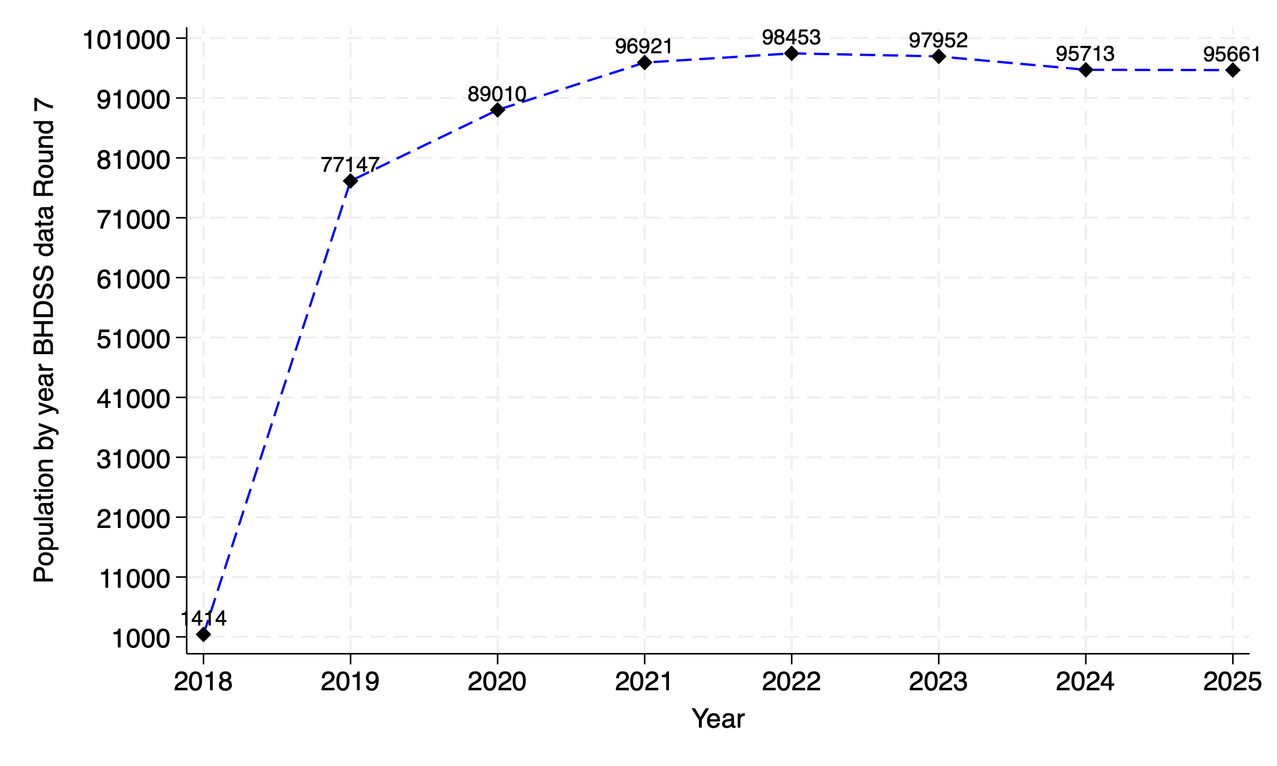

Additionally, some of the generated mortality indicators (see Table 1) were misleading and did not accurately reflect the mortality profiles of the areas as reported in other national surveys. The team, therefore, concluded that the BHDSS data could not be analysed for a report without further investigations and addressing the fieldwork issues.

The session on day five started at 9 am, chaired by GP. Using the 2022 dataset generated by TW, it was observed that the number of births estimated from 2018 to 2022 using the individual table was higher than the number observed using the residency table. As a result, the individual table was used to estimate the Total, General, and Age-specific fertility birth rates for the period 2018-2022. The session concluded with a debriefing at 1 pm.

**Way Forward**

* An urgent meeting needs to be convened to discuss the best way to tackle the problems identified
* Feedback on key data management corrections to be obtained from the data management team (John Frey and Peter Wontuo)
* Align terminologies in HDS Explorer to the HRS2 system

**Recommendations**

* There is a need for refresher orientation for field staff and supervisors to re-orient them on what each matrix (table) is about and what and how each table should be completed.
* Develop a manual that describes variables and field operations for both field workers and supervisors.
* Periodic workshops should be organised for the HDSS team to continuously monitor and evaluate the state of the data collected. This would aid the detection of data inconsistencies and errors, propose solutions for identified issues and produce reports on the demographic state of the HDSS.
* Strengthen field operation and improve supervision of fieldwork for both BHDSS and NHDSS
* Produce annual reports on key demographic indicators (Population distribution, Migration, Fertility, and Mortality).

**Terms in the HDSS Explorer /new data system**

1. **XEN** - External In-migration
2. **CHG** - Internal Out-migration
3. **Region** - Compound
4. **Pregnancy Child** - Livebirths
5. **ENT** - Internal Migration
6. **ENU** – Enumeration
7. **EXT**-External out-migration

# APPENDIX

Descriptive analysis of NDSS data 2018-2022-HRS2 data

Table A1: Age and sex distribution of the population by year

|  |  |  |  |  |  |  |
| --- | --- | --- | --- | --- | --- | --- |
|  | 2018 | 2019 | 2020 | 2021 | 2022 | Total |
|  | (N=167,477) | (N=167,883) | (N=167,467) | (N=166,143) | (N=164,833) | (N=833,803) |
| Mid-year age (years) |  |  |  |  |  |  |
| <5 | 20,584 (12.3%) | 20,345 (12.1%) | 19,972 (11.9%) | 19,887 (12.0%) | 19,086 (11.6%) | 99,874 (12.0%) |
| 5-9 | 19,941 (11.9%) | 20,251 (12.1%) | 20,160 (12.0%) | 19,731 (11.9%) | 19,689 (11.9%) | 99,772 (12.0%) |
| 10-14 | 19,505 (11.6%) | 19,273 (11.5%) | 19,106 (11.4%) | 19,013 (11.4%) | 18,825 (11.4%) | 95,722 (11.5%) |
| 15-19 | 17,916 (10.7%) | 18,145 (10.8%) | 17,805 (10.6%) | 17,546 (10.6%) | 17,402 (10.6%) | 88,814 (10.7%) |
| 20-24 | 13,674 (8.2%) | 13,474 (8.0%) | 13,740 (8.2%) | 13,569 (8.2%) | 13,388 (8.1%) | 67,845 (8.1%) |
| 25-29 | 12,178 (7.3%) | 11,784 (7.0%) | 11,515 (6.9%) | 11,186 (6.7%) | 10,950 (6.6%) | 57,613 (6.9%) |
| 30-34 | 9,926 (5.9%) | 10,696 (6.4%) | 10,732 (6.4%) | 10,476 (6.3%) | 10,420 (6.3%) | 52,250 (6.3%) |
| 35-39 | 9,408 (5.6%) | 8,908 (5.3%) | 8,620 (5.1%) | 9,068 (5.5%) | 9,137 (5.5%) | 45,141 (5.4%) |
| 40-44 | 7,512 (4.5%) | 7,672 (4.6%) | 8,313 (5.0%) | 8,113 (4.9%) | 8,358 (5.1%) | 39,968 (4.8%) |
| 45-49 | 6,454 (3.9%) | 6,349 (3.8%) | 5,999 (3.6%) | 6,552 (3.9%) | 6,616 (4.0%) | 31,970 (3.8%) |
| 50-54 | 6,437 (3.8%) | 6,542 (3.9%) | 6,779 (4.0%) | 6,324 (3.8%) | 6,337 (3.8%) | 32,419 (3.9%) |
| 55-59 | 6,668 (4.0%) | 6,590 (3.9%) | 5,799 (3.5%) | 6,060 (3.6%) | 5,934 (3.6%) | 31,051 (3.7%) |
| 60-64 | 5,286 (3.2%) | 5,426 (3.2%) | 6,448 (3.9%) | 6,114 (3.7%) | 6,057 (3.7%) | 29,331 (3.5%) |
| 65-69 | 4,317 (2.6%) | 4,422 (2.6%) | 3,779 (2.3%) | 4,145 (2.5%) | 4,218 (2.6%) | 20,881 (2.5%) |
| 70-74 | 3,251 (1.9%) | 3,333 (2.0%) | 3,599 (2.1%) | 3,388 (2.0%) | 3,548 (2.2%) | 17,119 (2.1%) |
| 75-79 | 2,484 (1.5%) | 2,553 (1.5%) | 2,456 (1.5%) | 2,483 (1.5%) | 2,254 (1.4%) | 12,230 (1.5%) |
| 80+ | 1,936 (1.2%) | 2,120 (1.3%) | 2,645 (1.6%) | 2,488 (1.5%) | 2,614 (1.6%) | 11,803 (1.4%) |
| GENDER |  |  |  |  |  |  |
| F | 87,649 (52.3%) | 87,906 (52.4%) | 87,605 (52.3%) | 87,072 (52.4%) | 86,571 (52.5%) | 436,803 (52.4%) |
| M | 79,828 (47.7%) | 79,977 (47.6%) | 79,862 (47.7%) | 79,071 (47.6%) | 78,262 (47.5%) | 397,000 (47.6%) |

Figure A1. Population pyramid for Navrongo DSS2018-HRS2 data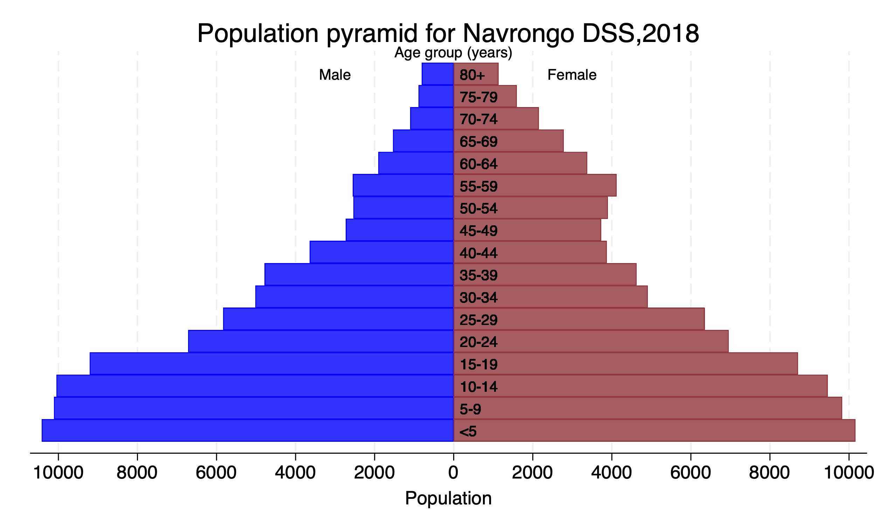

Figure A2. Population pyramid for Navrongo DSS2022-HRS2 data 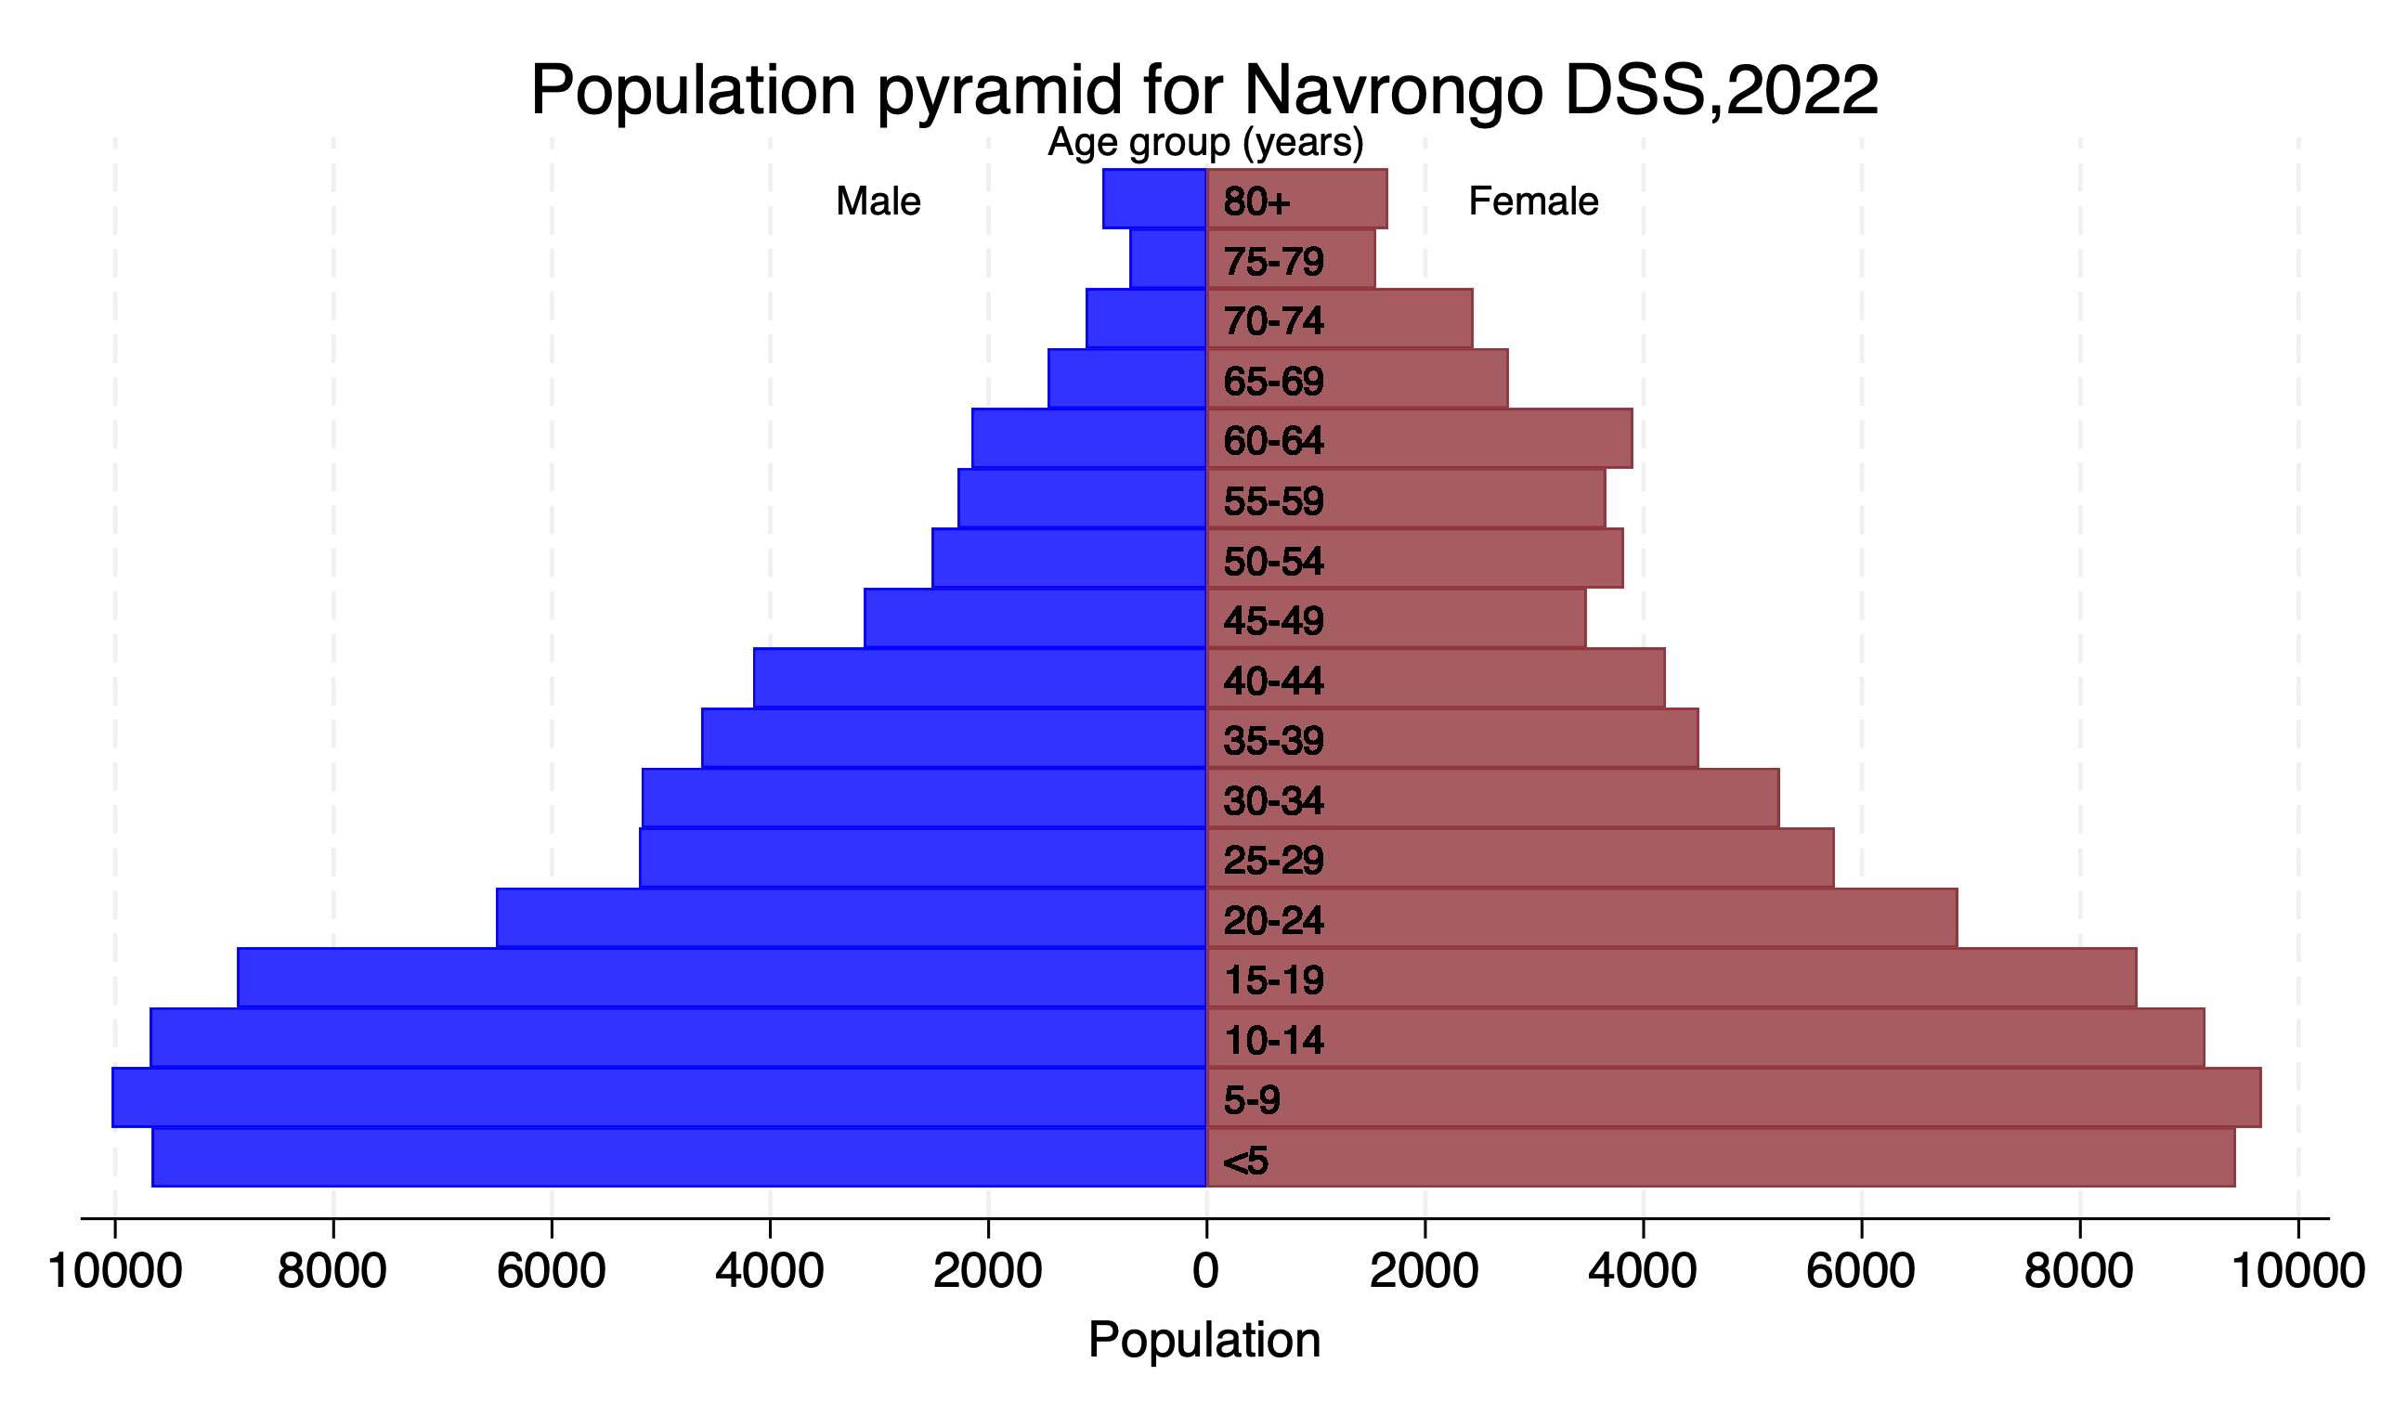

## Descriptive analysis of NDSS data 2018-2022_HDS_Explorer

Table A2: Age and sex distribution of the population by year-HDS-Explorer

|  |  |  |  |  |  |  |
| --- | --- | --- | --- | --- | --- | --- |
|  | 2018 | 2019 | 2020 | 2021 | 2022 | Total |
|  | (N=155,360) | (N=155,379) | (N=155,231) | (N=154,526) | (N=153,309) | (N=773,805) |
| Mid-year age (years) |  |  |  |  |  |  |
| <5 | 20,615 (13.3%) | 20,235 (13.0%) | 19,906 (12.8%) | 20,020 (13.0%) | 20,179 (13.2%) | 100,955 (13.0%) |
| 5-9 | 20,181 (13.0%) | 20,467 (13.2%) | 20,356 (13.1%) | 19,927 (12.9%) | 19,733 (12.9%) | 100,664 (13.0%) |
| 10-14 | 19,556 (12.6%) | 19,406 (12.5%) | 19,323 (12.4%) | 19,316 (12.5%) | 19,081 (12.4%) | 96,682 (12.5%) |
| 15-19 | 17,496 (11.3%) | 17,738 (11.4%) | 17,595 (11.3%) | 17,399 (11.3%) | 17,193 (11.2%) | 87,421 (11.3%) |
| 20-24 | 12,954 (8.3%) | 12,877 (8.3%) | 13,259 (8.5%) | 13,302 (8.6%) | 12,883 (8.4%) | 65,275 (8.4%) |
| 25-29 | 10,733 (6.9%) | 10,442 (6.7%) | 10,359 (6.7%) | 10,262 (6.6%) | 10,041 (6.5%) | 51,837 (6.7%) |
| 30-34 | 7,824 (5.0%) | 8,492 (5.5%) | 8,727 (5.6%) | 8,792 (5.7%) | 8,892 (5.8%) | 42,727 (5.5%) |
| 35-39 | 7,301 (4.7%) | 6,900 (4.4%) | 6,633 (4.3%) | 6,967 (4.5%) | 7,023 (4.6%) | 34,824 (4.5%) |
| 40-44 | 6,082 (3.9%) | 6,106 (3.9%) | 6,498 (4.2%) | 6,294 (4.1%) | 6,430 (4.2%) | 31,410 (4.1%) |
| 45-49 | 5,386 (3.5%) | 5,233 (3.4%) | 4,905 (3.2%) | 5,260 (3.4%) | 5,252 (3.4%) | 26,036 (3.4%) |
| 50-54 | 5,454 (3.5%) | 5,521 (3.6%) | 5,685 (3.7%) | 5,235 (3.4%) | 5,179 (3.4%) | 27,074 (3.5%) |
| 55-59 | 5,775 (3.7%) | 5,599 (3.6%) | 4,860 (3.1%) | 5,064 (3.3%) | 4,926 (3.2%) | 26,224 (3.4%) |
| 60-64 | 4,690 (3.0%) | 4,773 (3.1%) | 5,601 (3.6%) | 5,241 (3.4%) | 5,130 (3.3%) | 25,435 (3.3%) |
| 65-69 | 3,898 (2.5%) | 3,935 (2.5%) | 3,331 (2.1%) | 3,629 (2.3%) | 3,643 (2.4%) | 18,436 (2.4%) |
| 70-74 | 3,012 (1.9%) | 3,051 (2.0%) | 3,235 (2.1%) | 3,016 (2.0%) | 3,103 (2.0%) | 15,417 (2.0%) |
| 75-79 | 2,377 (1.5%) | 2,415 (1.6%) | 2,280 (1.5%) | 2,300 (1.5%) | 2,054 (1.3%) | 11,426 (1.5%) |
| 80+ | 2,026 (1.3%) | 2,189 (1.4%) | 2,678 (1.7%) | 2,502 (1.6%) | 2,567 (1.7%) | 11,962 (1.5%) |
| gender1 |  |  |  |  |  |  |
| F | 81,377 (52.4%) | 81,484 (52.4%) | 81,409 (52.4%) | 81,301 (52.6%) | 80,960 (52.8%) | 406,531 (52.5%) |
| M | 73,983 (47.6%) | 73,895 (47.6%) | 73,822 (47.6%) | 73,225 (47.4%) | 72,349 (47.2%) | 367,274 (47.5%) |

Figure A3. Population pyramid for Navrongo DSS2018-HDS-Explorer

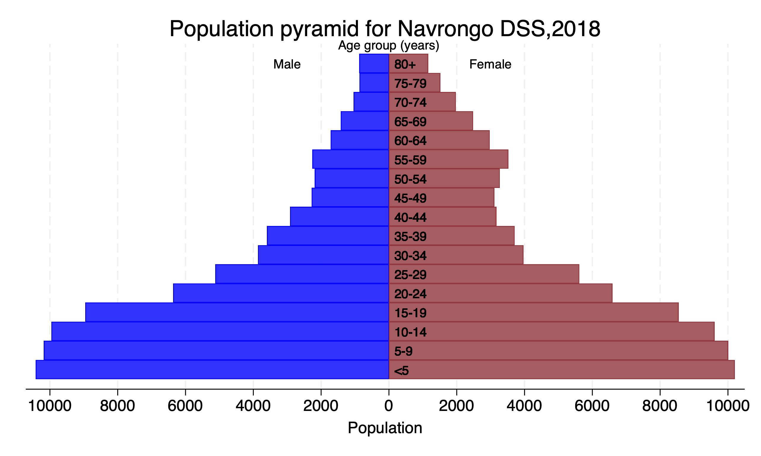

Figure A4. Population pyramid for Navrongo DSS2019-HDS-Explorer

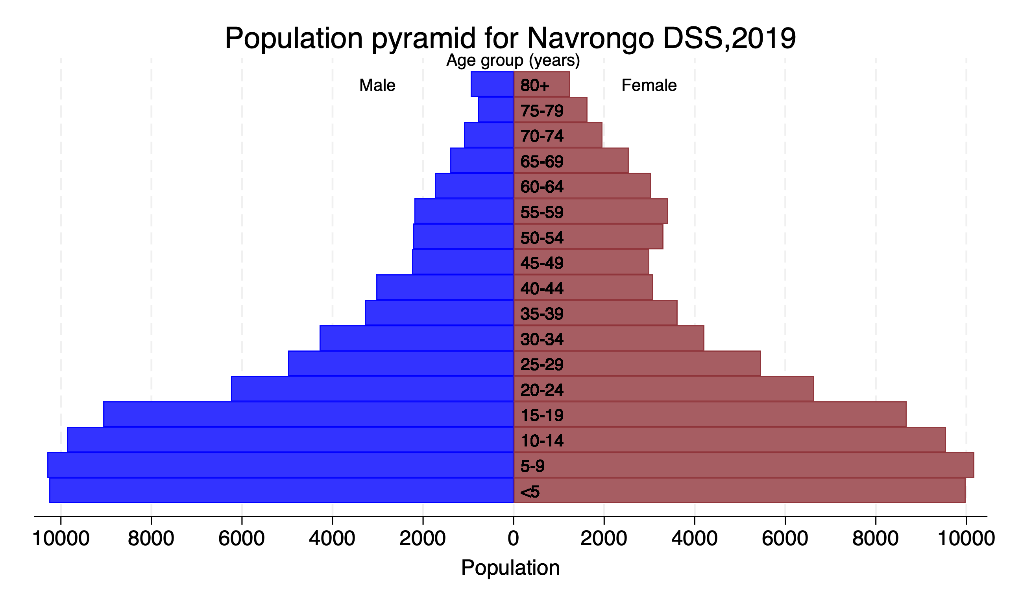

Figure A5. Population pyramid for Navrongo DSS2020-HDS-Explorer

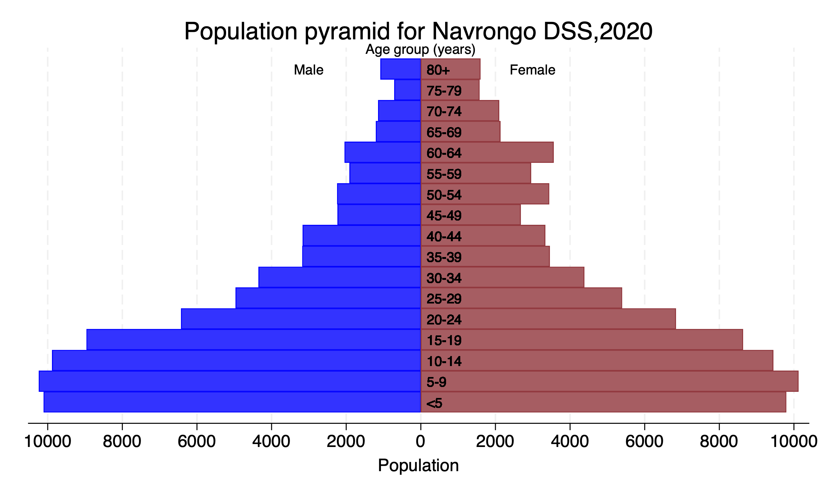

Figure A6. Population pyramid for Navrongo DSS2021-HDS-Explorer

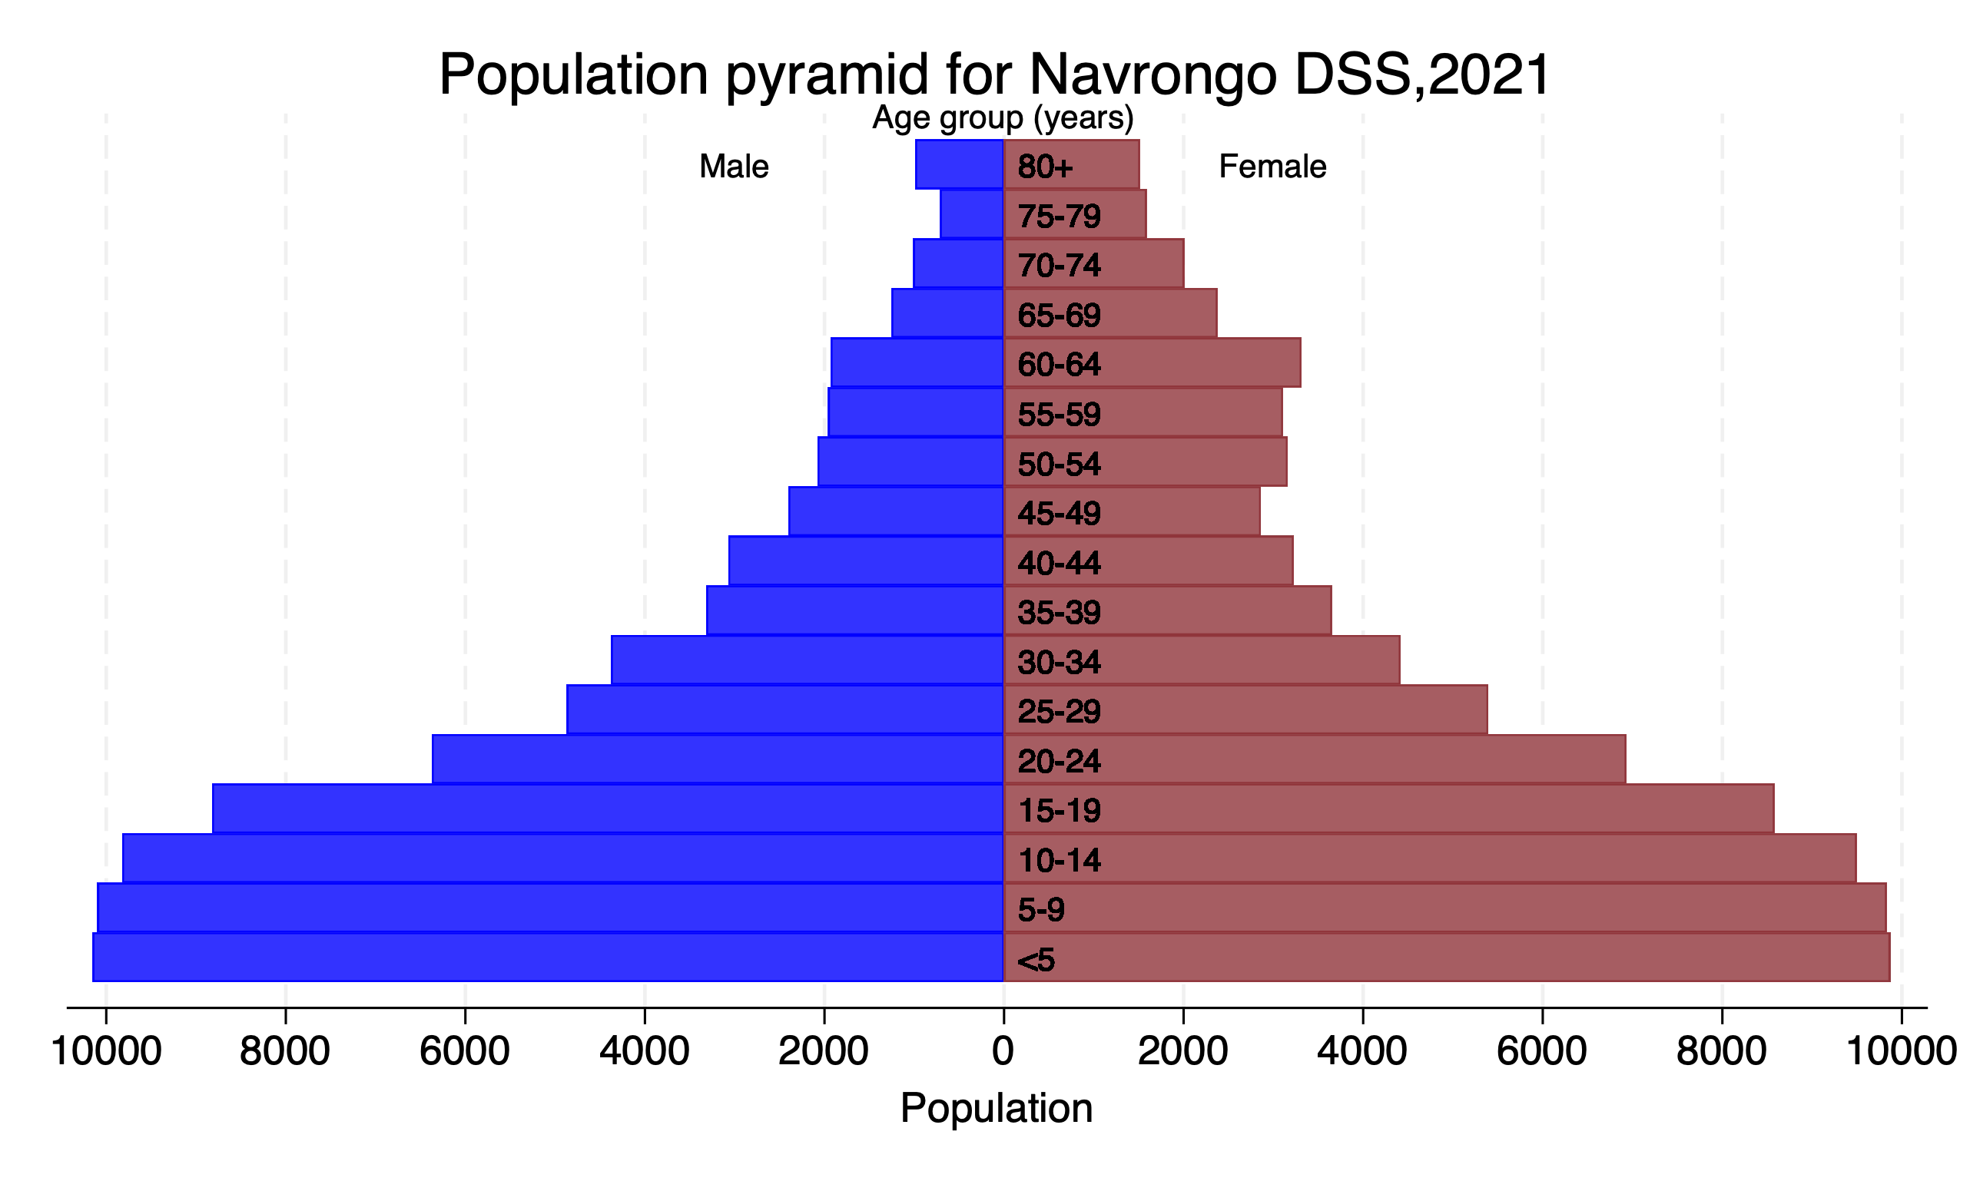

Figure A7. Population pyramid for Navrongo DSS2022-HDS-Explorer

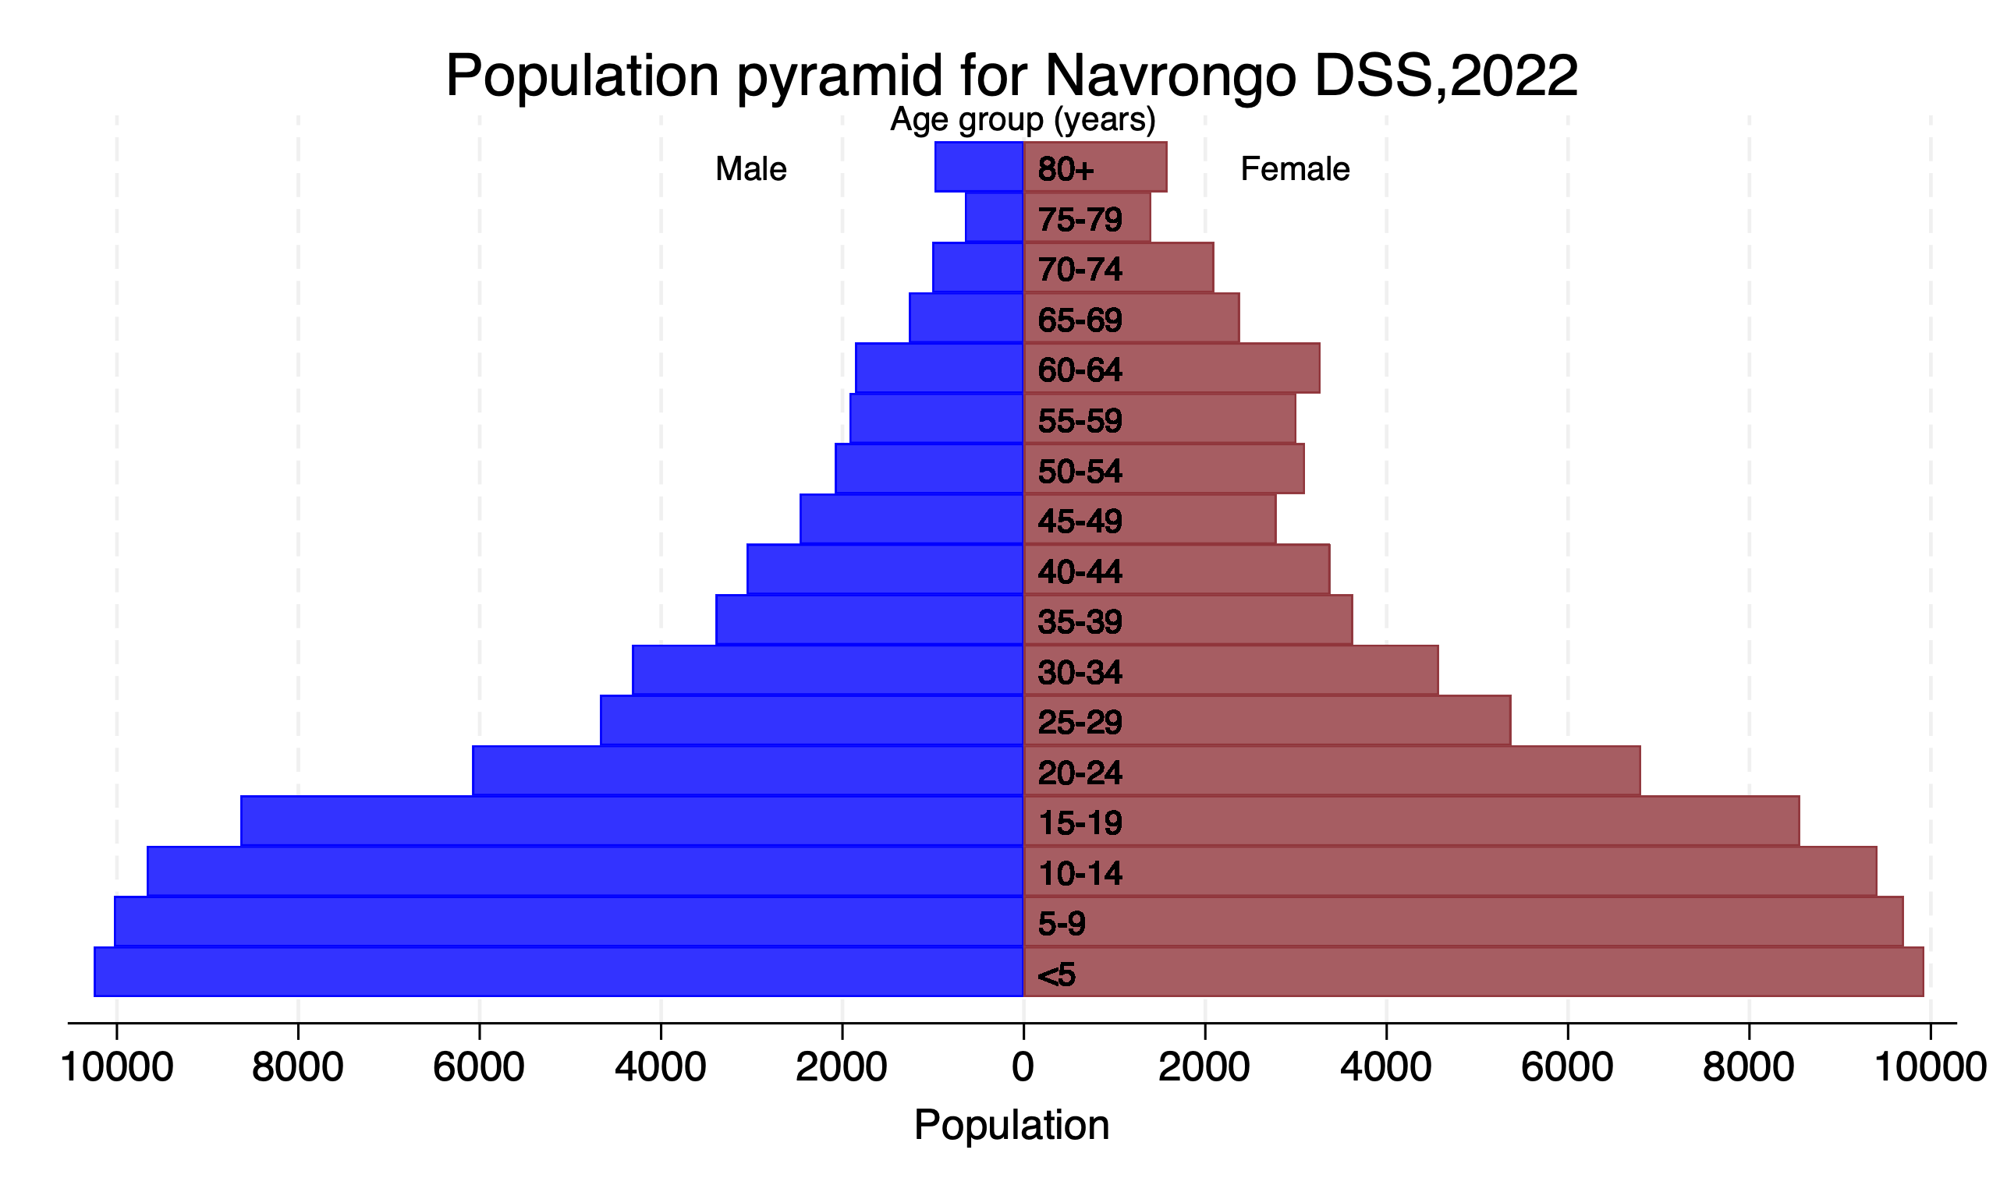

## Descriptive analysis of BHDSS data 2018-2024_Round 7

Figure A8: Overall population trends by year (line graph)



Table A3: Age and sex distribution of the population by year BHDSS

|  |  |  |  |  |  |  |  |  |  |
| --- | --- | --- | --- | --- | --- | --- | --- | --- | --- |
|  | 2018 | 2019 | 2020 | 2021 | 2022 | 2023 | 2024 | 2025 | Total |
|  | (N=1,414) | (N=77,147) | (N=89,010) | (N=96,921) | (N=98,453) | (N=97,952) | (N=95,713) | (N=95,661) | (N=652,271) |
| Mid-year age |  |  |  |  |  |  |  |  |  |
| <5 | 280 (19.8%) | 9,034 (11.7%) | 10,500 (11.8%) | 11,719 (12.1%) | 11,835 (12.0%) | 10,842 (11.1%) | 9,474 (9.9%) | 7,437 (7.8%) | 71,121 (10.9%) |
| 5-9 | 161 (11.4%) | 10,195 (13.2%) | 11,304 (12.7%) | 11,997 (12.4%) | 11,908 (12.1%) | 11,669 (11.9%) | 11,649 (12.2%) | 11,725 (12.3%) | 80,608 (12.4%) |
| 10-14 | 161 (11.4%) | 9,555 (12.4%) | 10,672 (12.0%) | 11,731 (12.1%) | 12,082 (12.3%) | 12,244 (12.5%) | 12,141 (12.7%) | 12,086 (12.6%) | 80,672 (12.4%) |
| 15-19 | 173 (12.2%) | 9,100 (11.8%) | 10,144 (11.4%) | 10,888 (11.2%) | 11,071 (11.2%) | 11,192 (11.4%) | 10,872 (11.4%) | 11,014 (11.5%) | 74,454 (11.4%) |
| 20-24 | 143 (10.1%) | 6,741 (8.7%) | 8,371 (9.4%) | 9,296 (9.6%) | 9,586 (9.7%) | 9,584 (9.8%) | 9,401 (9.8%) | 9,548 (10.0%) | 62,670 (9.6%) |
| 25-29 | 121 (8.6%) | 5,862 (7.6%) | 6,698 (7.5%) | 7,290 (7.5%) | 7,199 (7.3%) | 7,129 (7.3%) | 6,882 (7.2%) | 7,457 (7.8%) | 48,638 (7.5%) |
| 30-34 | 89 (6.3%) | 4,379 (5.7%) | 5,610 (6.3%) | 6,171 (6.4%) | 6,589 (6.7%) | 6,675 (6.8%) | 6,555 (6.8%) | 6,403 (6.7%) | 42,471 (6.5%) |
| 35-39 | 77 (5.4%) | 4,113 (5.3%) | 4,593 (5.2%) | 5,082 (5.2%) | 5,107 (5.2%) | 5,198 (5.3%) | 5,213 (5.4%) | 5,606 (5.9%) | 34,989 (5.4%) |
| 40-44 | 51 (3.6%) | 3,272 (4.2%) | 4,123 (4.6%) | 4,583 (4.7%) | 4,806 (4.9%) | 4,816 (4.9%) | 4,852 (5.1%) | 4,699 (4.9%) | 31,202 (4.8%) |
| 45-49 | 37 (2.6%) | 2,979 (3.9%) | 3,330 (3.7%) | 3,586 (3.7%) | 3,556 (3.6%) | 3,700 (3.8%) | 3,786 (4.0%) | 4,202 (4.4%) | 25,176 (3.9%) |
| 50-54 | 22 (1.6%) | 2,230 (2.9%) | 2,776 (3.1%) | 3,128 (3.2%) | 3,336 (3.4%) | 3,399 (3.5%) | 3,412 (3.6%) | 3,372 (3.5%) | 21,675 (3.3%) |
| 55-59 | 22 (1.6%) | 1,981 (2.6%) | 2,132 (2.4%) | 2,267 (2.3%) | 2,194 (2.2%) | 2,328 (2.4%) | 2,440 (2.5%) | 2,747 (2.9%) | 16,111 (2.5%) |
| 60-64 | 24 (1.7%) | 1,515 (2.0%) | 1,989 (2.2%) | 2,157 (2.2%) | 2,223 (2.3%) | 2,190 (2.2%) | 2,185 (2.3%) | 2,063 (2.2%) | 14,346 (2.2%) |
| 65-69 | 12 (0.8%) | 1,354 (1.8%) | 1,380 (1.6%) | 1,481 (1.5%) | 1,504 (1.5%) | 1,562 (1.6%) | 1,604 (1.7%) | 1,873 (2.0%) | 10,770 (1.7%) |
| 70-74 | 17 (1.2%) | 1,369 (1.8%) | 1,495 (1.7%) | 1,490 (1.5%) | 1,487 (1.5%) | 1,450 (1.5%) | 1,374 (1.4%) | 1,277 (1.3%) | 9,959 (1.5%) |
| 75-79 | 4 (0.3%) | 1,312 (1.7%) | 1,281 (1.4%) | 1,369 (1.4%) | 1,290 (1.3%) | 1,266 (1.3%) | 1,239 (1.3%) | 1,301 (1.4%) | 9,062 (1.4%) |
| 80+ | 20 (1.4%) | 2,156 (2.8%) | 2,612 (2.9%) | 2,686 (2.8%) | 2,680 (2.7%) | 2,708 (2.8%) | 2,634 (2.8%) | 2,851 (3.0%) | 18,347 (2.8%) |
| gender1 |  |  |  |  |  |  |  |  |  |
| F | 753 (53.3%) | 39,074 (50.6%) | 45,164 (50.7%) | 49,240 (50.8%) | 50,124 (50.9%) | 49,813 (50.9%) | 48,599 (50.8%) | 48,587 (50.8%) | 331,354 (50.8%) |
| M | 661 (46.7%) | 38,073 (49.4%) | 43,846 (49.3%) | 47,681 (49.2%) | 48,329 (49.1%) | 48,139 (49.1%) | 47,114 (49.2%) | 47,074 (49.2%) | 320,917 (49.2%) |

Figure A9. Population pyramid for Builsa_HDSS2019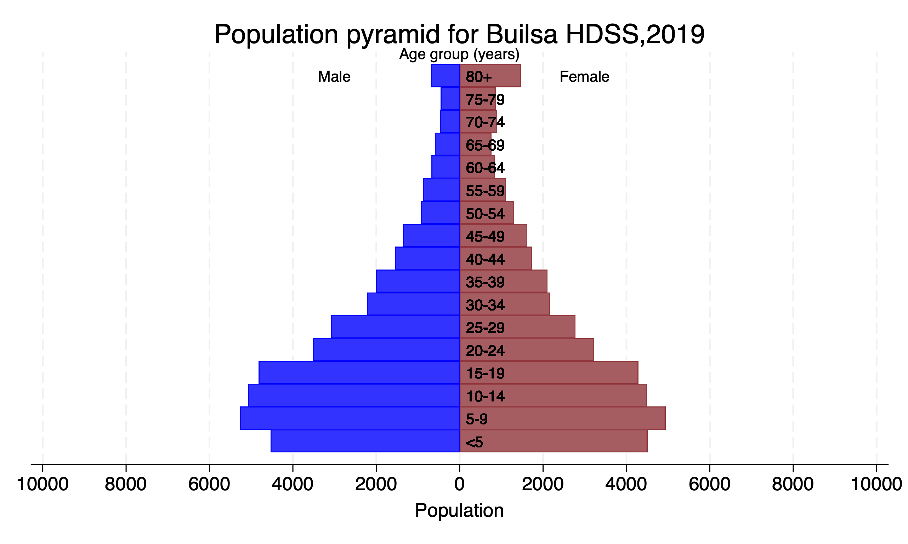

Figure A10. Population pyramid for Builsa_HDSS2020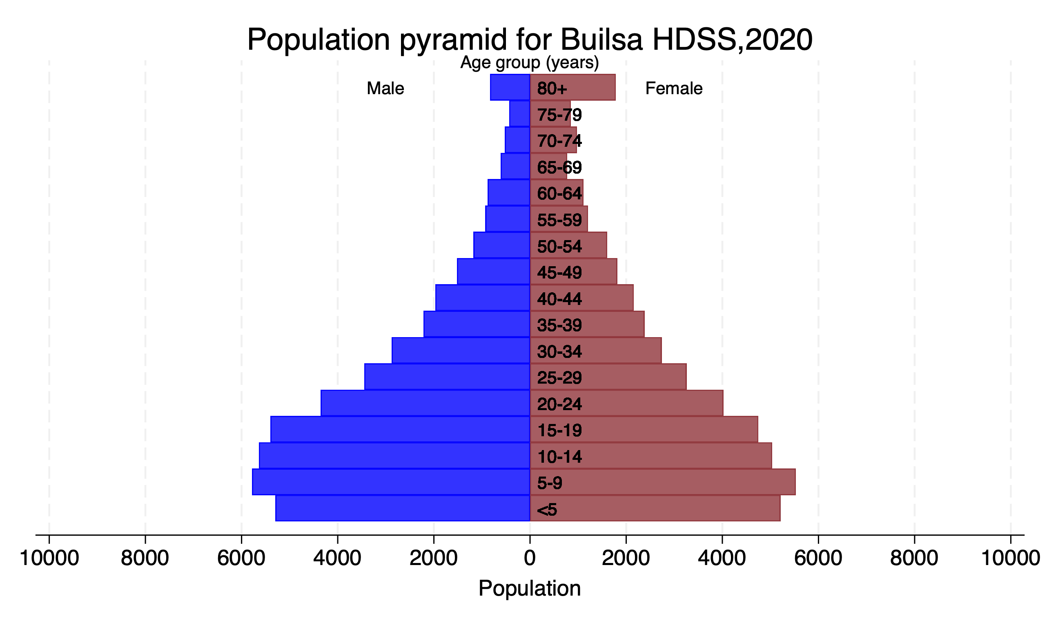

Figure A11. Population pyramid for Builsa_HDSS2021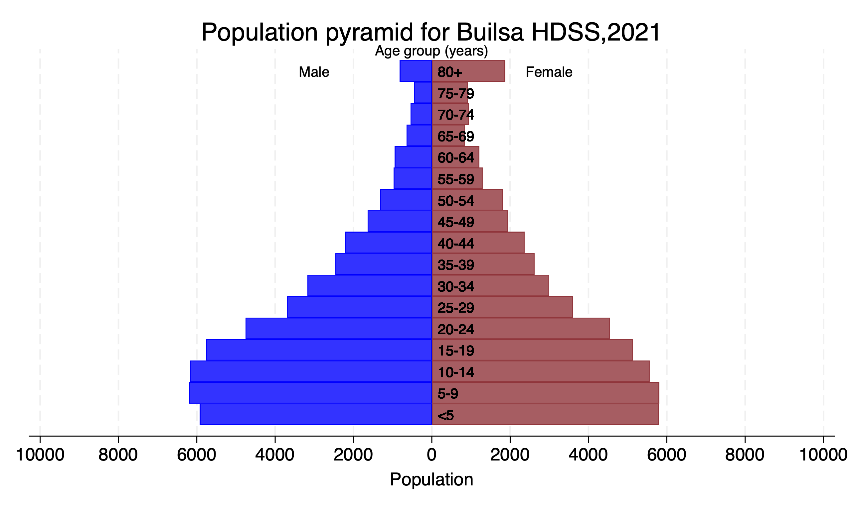

Figure A12. Population pyramid for Builsa_HDSS2022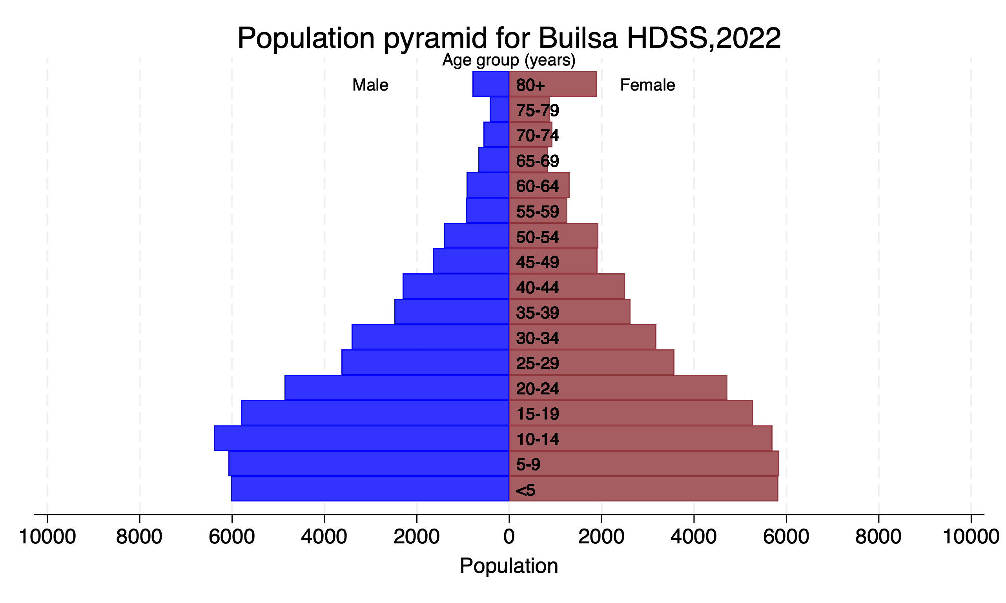

Figure A13. Population pyramid for Builsa_HDSS2023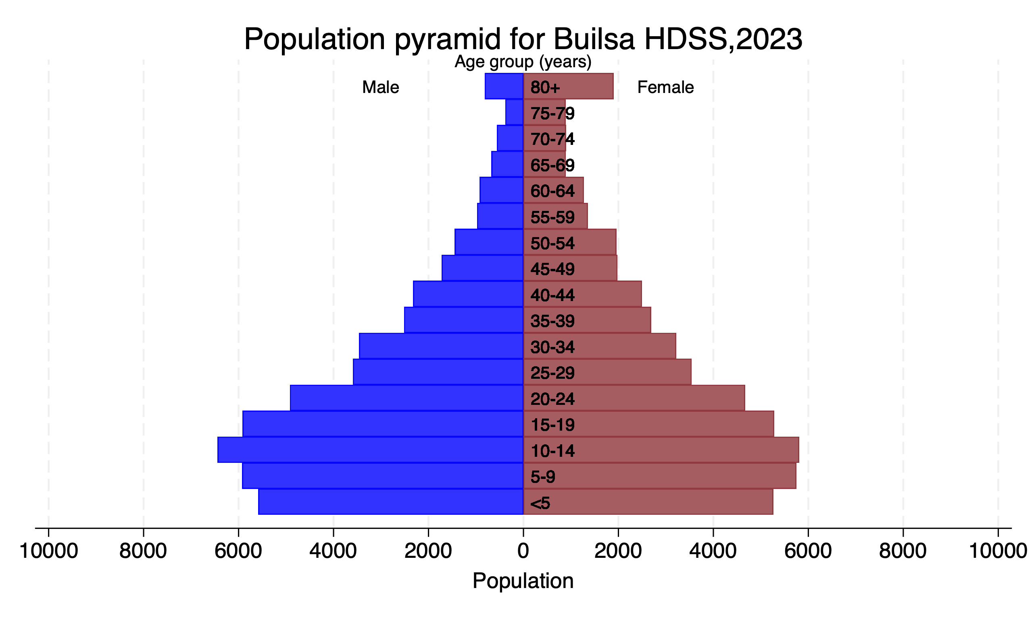

Figure A14. Population pyramid for Builsa_HDSS2024