**TRƯỜNG ĐẠI HỌC MỞ THÀNH PHỐ HỒ CHÍ MINH**

**KHOA CÔNG NGHỆ THÔNG TIN**

36. Using the AutoComplete Control

gvHD. Th.S Tô Oai Hùng

SV: Phạm Nhất Đức huy

MSSV : 1551010043

BÀI TẬP LỚN MÔN LẬP TRÌNH WEB

2017

Mục Lục

I. Giới thiệu 2

1. Tài liệu tham khảo 2

2. Công cụ sử dụng 2

3. Tổng quan chương trình 2

II. Nội dung chính 3

1. Using AutoCompleteExtender with a Page Method 3

a. Định nghĩa 3

b. Hiển thị 3

c. Code 5

2. Using AutoCompleteExtender with a Web Servicers Method 8

a. Định nghĩa 8

b. Hiển thị 8

c. Code 8

3. Using Text and Value Pairs with the AutoCompleteExtender 12

a. Định nghĩa 12

b. Hiển thị 12

c. Code 12

4. Using the DragPanel Control 15

a. Định nghĩa 15

b. Hiển thị 15

c. Code 16

5. Using the FilteredTextBox Control 17

a. Định nghĩa 17

b. Hiển thị 18

c. Code 18

6. Using the MaskedEdit Control 21

a. Định nghĩa 21

b. Hiển thị 21

c. Code 21

7. Using the Animation Control 23

a. Định nghĩa 23

b. Hiển thị 23

c. Code 24

# Giới thiệu

## Tài liệu tham khảo

* ASP.NET 4 Unleashed - Copyright ©2011 by Pearson Education, Inc

## Công cụ sử dụng

* Visual Studio 2015
* Ajax Toolkit 17.1
* Framework 4.6.1
* Source đính kèm

## Tổng quan chương trình

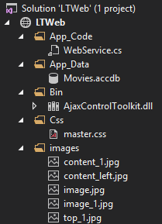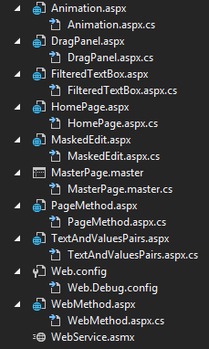

# Nội dung chính

## Using AutoCompleteExtender with a Page Method

### Định nghĩa

* Nếu không cần thiết phải sử dụng gợi ý trên nhiều trang, có thể tạo một danh sách các gợi ý từ phương thức web là phương tĩnh tĩnh trên một trang

### Hiển thị

* Khi chưa nhập dữ liệu

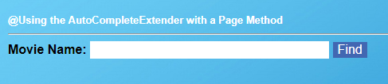

* Khi đã nhập dữ liệu

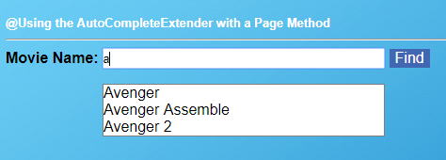

* Chọn gợi ý phù hợp và click Find

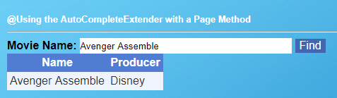

### Code

#### PageMethod.aspx

* using System;
* using System.Collections.Generic;
* using System.Linq;
* using System.Web;
* using System.Web.UI;
* using System.Web.UI.WebControls;
* using System.Data;
* using System.Data.OleDb;
* public partial class PageMethod : System.Web.UI.Page
* {
* protected void Page_Load(object sender, EventArgs e)
* {
* }
* [System.Web.Script.Services.ScriptMethod()]
* [System.Web.Services.WebMethod]
* public static List<string> GetMovie(string prefixText)
* {
* OleDbConnection con = new OleDbConnection("Provider=Microsoft.ACE.OLEDB.12.0;Data Source=|DataDirectory|\\Movies.accdb;Persist Security Info=True");
* OleDbCommand cmd = new OleDbCommand("SELECT Name FROM Movies Where Name LIKE'" + prefixText + "%'", con);
* OleDbDataReader reader;
* List<string> result = new List<string>();
* using (con)
* {
* con.Open();
* reader = cmd.ExecuteReader();
* while (reader.Read())
* {
* result.Add(reader["Name"].ToString());
* }
* return result;
* }
* }
* protected void Button1_Click(object sender, EventArgs e)
* {
* OleDbConnection con = new OleDbConnection("Provider=Microsoft.ACE.OLEDB.12.0;Data Source=|DataDirectory|\\Movies.accdb;Persist Security Info=True");
* OleDbCommand cmd = new OleDbCommand("SELECT * FROM Movies Where Name='" + TextBox1.Text + "'", con);
* DataTable dtb = new DataTable();
* dtb.Columns.Add("Name");
* dtb.Columns.Add("Producer");
* OleDbDataReader reader;
* using (con)
* {
* con.Open();
* reader = cmd.ExecuteReader();
* DataRow row;
* while (reader.Read())
* {
* row = dtb.NewRow();
* row["Name"] = (string)reader["Name"];
* row["Producer"] = (string)reader["Producer"];
* dtb.Rows.Add(row);
* }
* GridView1.DataSource = dtb;
* GridView1.DataBind();
* }
* }
* }

#### PageMethod.aspx.cs

<%@ Page Title="" Language="C#" MasterPageFile="~/MasterPage.master" AutoEventWireup="true" CodeFile="PageMethod.aspx.cs" Inherits="PageMethod" %>

<%@ Register Assembly="AjaxControlToolkit" Namespace="AjaxControlToolkit" TagPrefix="ajaxToolkit" %>

<asp:Content ID="Content1" ContentPlaceHolderID="head" runat="Server">

</asp:Content>

<asp:Content ID="Content2" ContentPlaceHolderID="ContentPlaceHolder1" runat="Server">

<br />

<asp:Label ID="Label2" runat="server" Font-Size="Small" ForeColor="#ffffff" Font-Bold="True" Text="@Using the AutoCompleteExtender with a Page Method" BorderStyle="None"></asp:Label>

<hr />

<asp:ScriptManager ID="ScriptManager1" runat="server"></asp:ScriptManager>

<asp:Label ID="Label3" runat="server" Text="Movie Name:" Font-Bold="True" Font-Size="Medium" Height="20px" BorderStyle="None"></asp:Label>

<asp:TextBox

ID="TextBox1"

runat="server"

Height="20px"

Width="300px" BorderStyle="None"></asp:TextBox>

<ajaxToolkit:AutoCompleteExtender

ID="TextBox1_AutoCompleteExtender"

runat="server"

BehaviorID="TextBox1_AutoCompleteExtender"

DelimiterCharacters=""

ServiceMethod="GetMovie"

TargetControlID="TextBox1"

CompletionInterval="100"

CompletionSetCount="10"

MinimumPrefixLength="1">

</ajaxToolkit:AutoCompleteExtender>

<asp:Button ID="Button1" runat="server" Text="Find" BackColor="#4267B2" BorderStyle="None" Font-Size="Medium" ForeColor="White" Height="20px" OnClick="Button1_Click" />

<asp:GridView ID="GridView1" runat="server" CellPadding="4" ForeColor="#333333" GridLines="None">

<AlternatingRowStyle BackColor="White" />

<EditRowStyle BackColor="#2461BF" />

<FooterStyle BackColor="#507CD1" Font-Bold="True" ForeColor="White" />

<HeaderStyle BackColor="#507CD1" Font-Bold="True" ForeColor="White" />

<PagerStyle BackColor="#2461BF" ForeColor="White" HorizontalAlign="Center" />

<RowStyle BackColor="#EFF3FB" />

<SelectedRowStyle BackColor="#D1DDF1" Font-Bold="True" ForeColor="#333333" />

<SortedAscendingCellStyle BackColor="#F5F7FB" />

<SortedAscendingHeaderStyle BackColor="#6D95E1" />

<SortedDescendingCellStyle BackColor="#E9EBEF" />

<SortedDescendingHeaderStyle BackColor="#4870BE" />

</asp:GridView>

</asp:Content>

## Using AutoCompleteExtender with a Web Servicers Method

### Định nghĩa

* Tạo gợi ý cho nhiều trang cùng sử dụng

### Hiển thị

* Hiển thị giống Page Method

### Code

#### WebServices.asmx

<%@ WebService Language="C#" CodeBehind="~/App_Code/WebService.cs" Class="WebService" %>

#### WebServices.cs

using System;

using System.Collections.Generic;

using System.Linq;

using System.Web;

using System.Web.Services;

using System.Data.OleDb;

using System.Data;

/// <summary>

/// Summary description for WebService

/// </summary>

[WebService(Namespace = "http://tempuri.org/")]

[WebServiceBinding(ConformsTo = WsiProfiles.BasicProfile1_1)]

[System.Web.Script.Services.ScriptService]

public class WebService : System.Web.Services.WebService

{

[WebMethod]

public List<string> SearchMovie (string prefixText)

{

OleDbConnection con = new OleDbConnection("Provider=Microsoft.ACE.OLEDB.12.0;Data Source=|DataDirectory|\\Movies.accdb;Persist Security Info=True");

OleDbCommand cmd = new OleDbCommand("SELECT Name FROM Movies Where Name LIKE'" + prefixText + "%'", con);

OleDbDataReader reader;

List<string> result = new List<string>(); ;

using (con)

{

con.Open();

reader = cmd.ExecuteReader();

while (reader.Read())

{

result.Add(reader["Name"].ToString());

}

return result;

}

}

}

#### WebMethod.aspx

<%@ Page Title="" Language="C#" MasterPageFile="~/MasterPage.master" AutoEventWireup="true" CodeFile="WebMethod.aspx.cs" Inherits="Css_WebMethod" %>

<%@ Register assembly="AjaxControlToolkit" namespace="AjaxControlToolkit" tagprefix="ajaxToolkit" %>

<asp:Content ID="Content1" ContentPlaceHolderID="head" Runat="Server">

</asp:Content>

<asp:Content ID="Content2" ContentPlaceHolderID="ContentPlaceHolder1" Runat="Server">

<asp:Label ID="Label1" runat="server" Font-Size="XX-Large" Text="AutoCompleteExtender with a Web Service Method"></asp:Label>

<br />

<asp:Label ID="Label2" runat="server" Font-Size="Small" ForeColor="White" Font-Bold="True" Text="@Using the AutoCompleteExtender with a Web Service Method"></asp:Label>

<hr />

<asp:ScriptManager ID="ScriptManager1" runat="server">

<Services>

<asp:ServiceReference Path="~/WebService.asmx" />

</Services>

</asp:ScriptManager>

<asp:Label ID="Label3" runat="server" Text="Movie Name:" Font-Bold="True" Font-Size="Medium" Height="20px" BorderStyle="None"></asp:Label>

<asp:TextBox

ID="TextBox1"

runat="server"

Height="20px"

Width="300px" BorderStyle="None"></asp:TextBox>

<ajaxToolkit:AutoCompleteExtender

ID="TextBox1_AutoCompleteExtender"

runat="server"

BehaviorID="TextBox1_AutoCompleteExtender"

DelimiterCharacters=""

ServicePath="~/WebService.asmx"

ServiceMethod="SearchMovie"

TargetControlID="TextBox1"

Enabled="true"

EnableCaching="true"

CompletionInterval="100"

CompletionSetCount="10"

MinimumPrefixLength="1">

</ajaxToolkit:AutoCompleteExtender>

<asp:Button ID="Button1" runat="server" Text="Find" BackColor="#4267B2" BorderStyle="None" Font-Size="Medium" ForeColor="White" Height="20px" OnClick="Button1_Click" Width="42px" />

<br />

<asp:GridView ID="GridView1" runat="server" CellPadding="4" ForeColor="#333333" GridLines="None">

<AlternatingRowStyle BackColor="White" />

<EditRowStyle BackColor="#2461BF" />

<FooterStyle BackColor="#507CD1" Font-Bold="True" ForeColor="White" />

<HeaderStyle BackColor="#507CD1" Font-Bold="True" ForeColor="White" />

<PagerStyle BackColor="#2461BF" ForeColor="White" HorizontalAlign="Center" />

<RowStyle BackColor="#EFF3FB" />

<SelectedRowStyle BackColor="#D1DDF1" Font-Bold="True" ForeColor="#333333" />

<SortedAscendingCellStyle BackColor="#F5F7FB" />

<SortedAscendingHeaderStyle BackColor="#6D95E1" />

<SortedDescendingCellStyle BackColor="#E9EBEF" />

<SortedDescendingHeaderStyle BackColor="#4870BE" />

</asp:GridView>

</asp:Content>

#### WebMethod.aspx.cs

using System;

using System.Collections.Generic;

using System.Linq;

using System.Web;

using System.Web.UI;

using System.Web.UI.WebControls;

using System.Data;

using System.Data.OleDb;

public partial class Css_WebMethod : System.Web.UI.Page

{

protected void Page_Load(object sender, EventArgs e)

{

}

protected void Button1_Click(object sender, EventArgs e)

{

OleDbConnection con = new OleDbConnection("Provider=Microsoft.ACE.OLEDB.12.0;Data Source=|DataDirectory|\\Movies.accdb;Persist Security Info=True");

OleDbCommand cmd = new OleDbCommand("SELECT * FROM Movies Where Name='" + TextBox1.Text + "'", con);

DataTable dtb = new DataTable();

dtb.Columns.Add("Name");

dtb.Columns.Add("Producer");

OleDbDataReader reader;

using (con)

{

con.Open();

reader = cmd.ExecuteReader();

DataRow row;

while (reader.Read())

{

row = dtb.NewRow();

row["Name"] = (string)reader["Name"];

row["Producer"] = (string)reader["Producer"];

dtb.Rows.Add(row);

}

GridView1.DataSource = dtb;

GridView1.DataBind();

}

}

}

## Using Text and Value Pairs with the AutoCompleteExtender

### Định nghĩa

* Hiển thị gợi ý nếu người dung chọn gợi ý đó thì hiển thị luôn ID của gợi ý

### Hiển thị

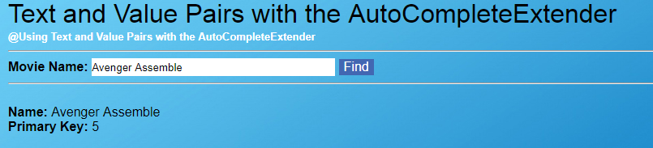

### Code

#### TextAndValuesPairs.aspx

<%@ Page Title="" Language="C#" MasterPageFile="~/MasterPage.master" AutoEventWireup="true" CodeFile="TextAndValuesPairs.aspx.cs" Inherits="Css_TextAndValuesPairs" %>

<%@ Register Assembly="AjaxControlToolkit" Namespace="AjaxControlToolkit" TagPrefix="ajaxToolkit" %>

<asp:Content ID="Content1" ContentPlaceHolderID="head" runat="Server">

</asp:Content>

<asp:Content ID="Content2" ContentPlaceHolderID="ContentPlaceHolder1" runat="Server">

<script type="text/javascript">

function ace1_itemSelected(sender, e) {

var ace1Value = $get('<%= ace1Value.ClientID %>');

ace1Value.value = e.get_value();

}

</script>

<asp:Label ID="Label1" runat="server" Font-Size="XX-Large" Text="Text and Value Pairs with the AutoCompleteExtender"></asp:Label>

<br />

<asp:Label ID="Label2" runat="server" Font-Size="Small" ForeColor="White" Font-Bold="True" Text="@Using Text and Value Pairs with the AutoCompleteExtender"></asp:Label>

<hr />

<asp:ScriptManager ID="ScriptManager1" runat="server"></asp:ScriptManager>

<asp:UpdatePanel runat="server" ID="up">

<ContentTemplate>

<asp:Label ID="Label3" runat="server" Text="Movie Name:" Font-Bold="True" Font-Size="Medium" Height="20px" BorderStyle="None"></asp:Label>

<asp:TextBox

ID="TextBox1"

runat="server"

Height="20px"

Width="300px" BorderStyle="None"></asp:TextBox>

<ajaxToolkit:AutoCompleteExtender

ID="TextBox1_AutoCompleteExtender"

runat="server"

ServiceMethod="GetMovie"

TargetControlID="TextBox1"

MinimumPrefixLength="1"

OnClientItemSelected="ace1_itemSelected"

FirstRowSelected="true">

</ajaxToolkit:AutoCompleteExtender>

<asp:Button ID="Button1" runat="server" Text="Find" BackColor="#4267B2" BorderStyle="None" Font-Size="Medium" ForeColor="White" Height="20px" OnClick="Button1_Click" />

<asp:HiddenField

ID="ace1Value"

runat="server" />

<hr />

<br />

<asp:Label ID="Label4" runat="server" Text="Name: " Font-Bold="true" />

<asp:Label ID="lblSelectedName" runat="server" />

<br />

<asp:Label ID="Label5" runat="server" Text="Primary Key: " Font-Bold="true" />

<asp:Label ID="lblSelectedNameId" runat="server" />

</ContentTemplate>

</asp:UpdatePanel>

</asp:Content>

#### TextAndValuesPairs.aspx.cs

using System;

using System.Collections;

using System.Collections.Generic;

using System.Linq;

using System.Web;

using System.Web.UI;

using System.Web.UI.WebControls;

using System.Data;

using System.Data.OleDb;

using System.Configuration;

public partial class Css_TextAndValuesPairs : System.Web.UI.Page

{

protected void Page_Load(object sender, EventArgs e)

{

}

[System.Web.Script.Services.ScriptMethod()]

[System.Web.Services.WebMethod]

public static List<string> GetMovie(string prefixText)

{

OleDbConnection con = new OleDbConnection("Provider=Microsoft.ACE.OLEDB.12.0;Data Source=|DataDirectory|\\Movies.accdb;Persist Security Info=True");

OleDbCommand cmd = new OleDbCommand("SELECT * FROM Movies Where Name LIKE'" + prefixText + "%'", con);

OleDbDataReader reader;

List<string> result = new List<string>();

using (con)

{

con.Open();

reader = cmd.ExecuteReader();

while (reader.Read())

{

string item = AjaxControlToolkit.AutoCompleteExtender.CreateAutoCompleteItem(reader["Name"].ToString(), Convert.ToUInt32(reader["ID"]).ToString());

result.Add(item);

}

return result;

}

}

protected void Button1_Click(object sender, EventArgs e)

{

lblSelectedName.Text = TextBox1.Text;

lblSelectedNameId.Text = ace1Value.Value;

}

}

## Using the DragPanel Control

### Định nghĩa

* Cho phép tạo một cửa sổ ảo trong trang web và có thể di chuyển bất kì nơi nào trong trang web

### Hiển thị

* Hiển thị ban đầu

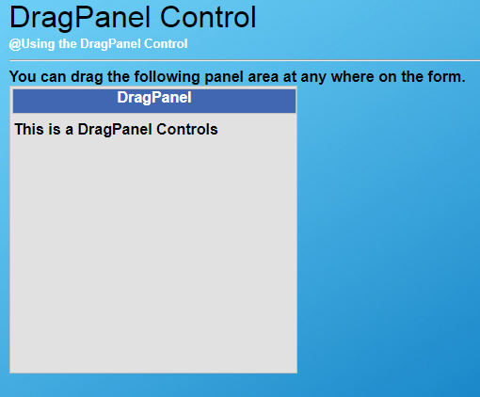

* Di chuyển

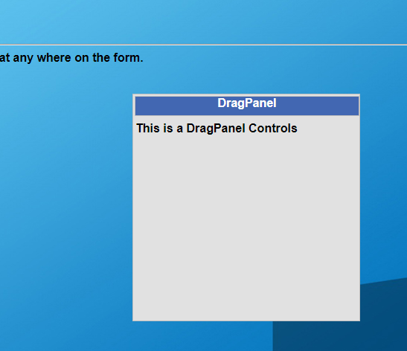

### Code

#### DragPanel.aspx

<%@ Page Title="" Language="C#" MasterPageFile="~/MasterPage.master" AutoEventWireup="true" CodeFile="DragPanel.aspx.cs" Inherits="DragPanel" %>

<%@ Register Assembly="AjaxControlToolkit" Namespace="AjaxControlToolkit" TagPrefix="ajaxToolkit" %>

<asp:Content ID="Content1" ContentPlaceHolderID="head" runat="Server">

</asp:Content>

<asp:Content ID="Content2" ContentPlaceHolderID="ContentPlaceHolder1" runat="Server">

<asp:Label ID="Label1" runat="server" Font-Size="XX-Large" Text="DragPanel Control"></asp:Label>

<br />

<asp:Label ID="Label2" runat="server" Font-Size="Small" ForeColor="White" Font-Bold="True" Text="@Using the DragPanel Control"></asp:Label>

<hr />

<style type="text/css">

.outerPanel {

border: solid 1px #C0C0C0;

background-color: #e1e1e1;

width: 300px;

height: 300px;

z-index: 20;

padding: 2px;

}

.dragPanel {

border: solid 1px #C0C0C0;

background-color: #4267B2;

width: 300px;

height: 25px;

color: #FFFFFF;

font-weight: bold;

cursor: move;

}

.auto-style1 {

text-align: center;

}

</style>

<asp:ScriptManager ID="ScriptManager1" runat="server"></asp:ScriptManager>

<b> You can drag the following panel area at any where on the form. </b>

<ajaxToolkit:DragPanelExtender ID="DragPanelExtender1" runat="server" TargetControlID="pnlCover"

DragHandleID="pnlAdd"></ajaxToolkit:DragPanelExtender>

<asp:Panel ID="pnlCover" runat="server" CssClass="outerPanel">

<asp:Panel ID="pnlAdd" runat="server" CssClass="dragPanel">

<div class="auto-style1">

<b>DragPanel</b>

</div>

<p style="color: #000000">This is a DragPanel Controls</p>

</asp:Panel>

</asp:Panel>

<script type="text/javascript">

function setBodyHeightToContentHeight() {

document.body.style.height = Math.max(document.documentElement.scrollHeight, document.body.scrollHeight) + "px";

}

setBodyHeightToContentHeight();

</script>

</asp:Content>

## Using the FilteredTextBox Control

### Định nghĩa

* Ngăn không cho người dung nhập sai kiểu dữ liệu

### Hiển thị

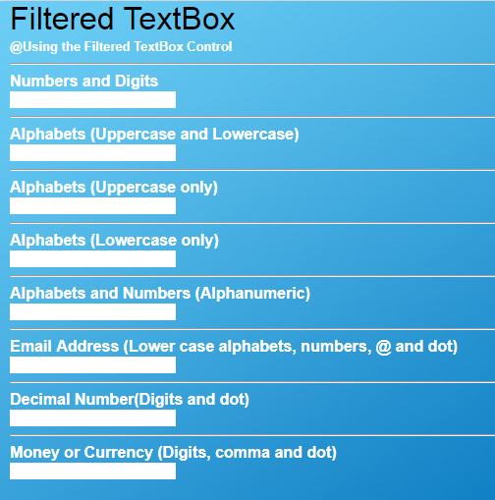

### Code

#### FilteredTextBox.aspx

<%@ Page Title="" Language="C#" MasterPageFile="~/MasterPage.master" AutoEventWireup="true" CodeFile="FilteredTextBox.aspx.cs" Inherits="FilteredTextBox" %>

<%@ Register Assembly="AjaxControlToolkit" Namespace="AjaxControlToolkit" TagPrefix="ajaxToolkit" %>

<asp:Content ID="Content1" ContentPlaceHolderID="head" runat="Server">

</asp:Content>

<asp:Content ID="Content2" ContentPlaceHolderID="ContentPlaceHolder1" runat="Server">

<asp:Label ID="Label1" runat="server" Font-Size="XX-Large" Text="Filtered TextBox"></asp:Label>

<br />

<asp:Label ID="Label2" runat="server" Font-Size="Small" ForeColor="White" Font-Bold="True" Text="@Using the Filtered TextBox Control"></asp:Label>

<hr />

<asp:ScriptManager ID="ScriptManager1" runat="server"></asp:ScriptManager>

<b style="color:white">Numbers and Digits</b><br />

<asp:TextBox ID="TextBox1" runat="server" BorderStyle="None"></asp:TextBox>

<ajaxToolkit:FilteredTextBoxExtender ID="FilteredTextBoxExtender1" runat="server" FilterType="Numbers"

TargetControlID="TextBox1" />

<hr />

<b style="color:white">Alphabets (Uppercase and Lowercase)</b><br />

<asp:TextBox ID="TextBox2" runat="server" BorderStyle="None"></asp:TextBox>

<ajaxToolkit:FilteredTextBoxExtender ID="FilteredTextBoxExtender2" runat="server" FilterType="LowercaseLetters, UppercaseLetters"

TargetControlID="TextBox2" />

<hr />

<b style="color:white">Alphabets (Uppercase only)</b><br />

<asp:TextBox ID="TextBox3" runat="server" BorderStyle="None"></asp:TextBox>

<ajaxToolkit:FilteredTextBoxExtender ID="FilteredTextBoxExtender3" runat="server" FilterType="UppercaseLetters"

TargetControlID="TextBox3" />

<hr />

<b style="color:white">Alphabets (Lowercase only)</b><br />

<asp:TextBox ID="TextBox4" runat="server" BorderStyle="None"></asp:TextBox>

<ajaxToolkit:FilteredTextBoxExtender ID="FilteredTextBoxExtender4" runat="server" FilterType="LowercaseLetters"

TargetControlID="TextBox4" />

<hr />

<b style="color:white">Alphabets and Numbers (Alphanumeric)</b><br />

<asp:TextBox ID="TextBox5" runat="server" BorderStyle="None"></asp:TextBox>

<ajaxToolkit:FilteredTextBoxExtender ID="FilteredTextBoxExtender6" runat="server" FilterType="Numbers, UppercaseLetters, LowercaseLetters"

TargetControlID="TextBox5" />

<hr />

<b style="color:white">Email Address (Lower case alphabets, numbers, @ and dot)</b><br />

<asp:TextBox ID="TextBox6" runat="server" BorderStyle="None"></asp:TextBox>

<ajaxToolkit:FilteredTextBoxExtender ID="FilteredTextBoxExtender5" runat="server" FilterType="Numbers, LowercaseLetters, Custom"

ValidChars=".@" TargetControlID="TextBox6" />

<hr />

<b style="color:white">Decimal Number(Digits and dot)</b><br />

<asp:TextBox ID="TextBox7" runat="server" BorderStyle="None"></asp:TextBox>

<ajaxToolkit:FilteredTextBoxExtender ID="FilteredTextBoxExtender7" runat="server" FilterType="Numbers, Custom"

ValidChars="." TargetControlID="TextBox7" />

<hr />

<b style="color:white">Money or Currency (Digits, comma and dot)</b><br />

<asp:TextBox ID="TextBox8" runat="server" BorderStyle="None"></asp:TextBox>

<ajaxToolkit:FilteredTextBoxExtender ID="FilteredTextBoxExtender8" runat="server" FilterType="Numbers, Custom"

ValidChars=".," TargetControlID="TextBox8" />

</asp:Content>

## Using the MaskedEdit Control

### Định nghĩa

* Tạo trước kiểu mà người dung được phép nhập

### Hiển thị

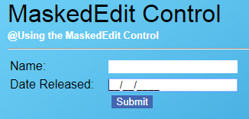

### Code

#### MaskedEdit.aspx

<%@ Page Title="" Language="C#" MasterPageFile="~/MasterPage.master" AutoEventWireup="true" CodeFile="MaskedEdit.aspx.cs" Inherits="MaskedEdit" %>

<%@ Register Assembly="AjaxControlToolkit" Namespace="AjaxControlToolkit" TagPrefix="ajaxToolkit" %>

<asp:Content ID="Content1" ContentPlaceHolderID="head" runat="Server">

<style type="text/css">

.auto-style1 {

height: 22px;

}

.auto-style2 {

width: 326px;

}

.auto-style3 {

text-align: center;

}

</style>

</asp:Content>

<asp:Content ID="Content2" ContentPlaceHolderID="ContentPlaceHolder1" runat="Server">

<asp:Label ID="Label1" runat="server" Font-Size="XX-Large" Text="MaskedEdit Control"></asp:Label>

<br />

<asp:Label ID="Label2" runat="server" Font-Size="Small" ForeColor="White" Font-Bold="True" Text="@Using the MaskedEdit Control"></asp:Label>

<hr />

<asp:ScriptManager ID="ScriptManager1" runat="server"></asp:ScriptManager>

<table class="auto-style2">

<tr>

<td class="auto-style1">

<asp:Label

ID="lblName"

Text="Name:"

AssociatedControlID="txtName"

runat="server" />

</td>

<td class="auto-style1">

<asp:TextBox

ID="txtName"

runat="server" BorderStyle="None" />

</td>

</tr>

<tr>

<td>

<asp:Label

ID="lblDateReleased"

Text="Date Released:"

AssociatedControlID="txtDateReleased"

runat="server" />

</td>

<td>

<asp:TextBox

ID="txtDateReleased"

runat="server" BorderStyle="None" />

<ajaxToolkit:MaskedEditExtender

ID="DateReleased_MaskedEditExtender"

TargetControlID="txtDateReleased"

Mask="99/99/9999"

MaskType="Date"

runat="Server" />

</td>

</tr>

<tr>

<td colspan="2" class="auto-style3">

<asp:Button

ID="btnSubmit"

Text="Submit"

runat="server" BorderStyle="None" BackColor="#4267B2" ForeColor="White" OnClick="btnSubmit_Click" />

</td>

</tr>

</table>

<asp:Label ID="lbShow" runat="server" Font-Size="Large" ForeColor="White" Font-Bold="True"></asp:Label>

</asp:Content>

#### MaskedEdit.aspx.cs

using System;

using System.Collections.Generic;

using System.Linq;

using System.Web;

using System.Web.UI;

using System.Web.UI.WebControls;

public partial class MaskedEdit : System.Web.UI.Page

{

protected void Page_Load(object sender, EventArgs e)

{

}

protected void btnSubmit_Click(object sender, EventArgs e)

{

lbShow.Text = "Movie Name: " + txtName.Text + " - Date Realsed: " + txtDateReleased.Text;

}

}

## Using the Animation Control

### Định nghĩa

* Tạo thêm hiệu ứng

### Hiển thị

* Khi trang được khởi động

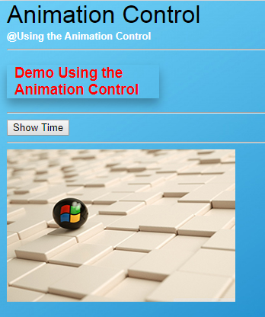

* Sau khi được kích hoạt

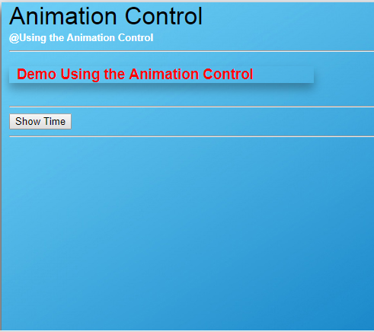

### Code

#### Animation.aspx

<%@ Page Title="" Language="C#" MasterPageFile="~/MasterPage.master" AutoEventWireup="true" CodeFile="Animation.aspx.cs" Inherits="Animation" %>

<%@ Register Assembly="AjaxControlToolkit" Namespace="AjaxControlToolkit" TagPrefix="ajaxToolkit" %>

<asp:Content ID="Content1" ContentPlaceHolderID="head" runat="Server">

</asp:Content>

<asp:Content ID="Content2" ContentPlaceHolderID="ContentPlaceHolder1" runat="Server">

<asp:Label ID="Label1" runat="server" Font-Size="XX-Large" Text="Animation Control"></asp:Label>

<br />

<asp:Label ID="Label2" runat="server" Font-Size="Small" ForeColor="White" Font-Bold="True" Text="@Using the Animation Control"></asp:Label>

<hr />

<asp:ScriptManager ID="ScriptManager1" runat="server"></asp:ScriptManager>

<asp:Panel ID="pnl" runat="server" Width="200">

<h3 style="color: Red; box-shadow: 0 8px 20px 0 rgba(0, 0, 0, 0.3); padding-left:10px">Demo Using the Animation Control</h3>

</asp:Panel>

<ajaxToolkit:AnimationExtender ID="pnl_AnimationExtender" runat="server" BehaviorID="pnl_AnimationExtender" TargetControlID="pnl">

<Animations>

<OnMouseOver>

<Resize Width="400" Unit="px"/>

</OnMouseOver>

</Animations>

</ajaxToolkit:AnimationExtender>

<hr />

<asp:Button runat="server" ID="btnPlay" Text="Show Time" OnClick="btnPlay_Click"></asp:Button>

<asp:Panel ID="pnl1" runat="server">

<asp:Label ID="Label3" runat="server" Font-Size="Large" Text=""></asp:Label>

<ajaxToolkit:AnimationExtender

ID="pnl1_AnimationExtender"

runat="server"

TargetControlID="btnPlay">

<Animations>

<OnClick>

<Sequence>

<Color

Property="style"

PropertyKey="backgroundColor"

StartValue="#FF0000"

EndValue="#666666"

Duration="1000">

</Color>

<EnableAction Enabled="true">

</EnableAction>

</Sequence>

</OnClick>

</Animations>

</ajaxToolkit:AnimationExtender>

</asp:Panel>

<hr />

<asp:Panel ID="pnl2" runat="server" Width="300px" Height="200px" BackImageUrl="~/images/image_1.jpg">

<ajaxToolkit:AnimationExtender ID="pnl2_Animationextender" runat="server" TargetControlID="pnl2">

<Animations>

<OnMouseOver>

<FadeOut

Duration="3"

Fps="20">

</FadeOut>

</OnMouseOver>

<OnMouseOut>

<FadeIn

Duration="3"

Fps="20">

</FadeIn>

</OnMouseOut>

</Animations>

</ajaxToolkit:AnimationExtender>

</asp:Panel>

</asp:Content>

#### Animation.aspx.cs

using System;

using System.Collections.Generic;

using System.Linq;

using System.Web;

using System.Web.UI;

using System.Web.UI.WebControls;

public partial class Animation : System.Web.UI.Page

{

protected void Page_Load(object sender, EventArgs e)

{

}

private void Time()

{

Label3.Text = DateTime.Now.ToString("dddd, MMMM dd yyyy"); ;

}

protected void btnPlay_Click(object sender, EventArgs e)

{

Time();

}

}