Project 1, Group G, M-W August 20, 2018

Project Name: Baseball “Infield Shift”

Team Members:

Elliot Graf

William Hibner

Larry VonDracek II

The baseball “infield shift” started to appear with more frequency in the year 2010. Team G’s data analytics efforts focused on determining if the “infield shift” has had an impact on Major League Baseball.

What is the “infield shift?” “The infield shift is used primarily against left-handed batters. It is designed to protect against base hits pulled hard into the gaps between the fielders on one side.” (Wikipedia)

Baseball has many metrics and statistics including batting averages for hitters and earned run averages for pitchers but there no readily available statistic for the ‘infield shift.”

Our initial research questions included:

1. Are teams scoring less since the “infield shift” become popular in year 2014?
2. Has the “infield shift” affected bunting %?
3. Has the “infield shift” impacted team batting metrics?
4. Has the “infield shift” impacted team pitching metrics?
5. Has the “infield shift” impacted team fielding metrics?

Our findings included:

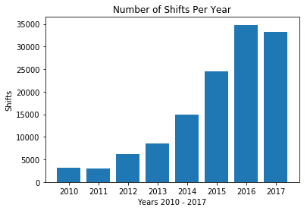We used Fangraphs.com for our research and were able see a general increase in the number of shifts employed in the years 2010 to 2017 but we could not make a correlation utilizing a t-test comparing the shift years 2010 to 2014 verses 2014 to 2017.

Our conclusion: our study didn’t focus on comparing common baseball statistics including: runs, ERA, hitting averages and we couldn’t make the case a positive correlation that the “infield shift” has made an impact on baseball. Therefore there is not sufficient evidence to reject the null hypothesis. So at this time we can make the case for changes in rules or encourage other teams to adopt this defensive tactic.