Software Requirements Specification

for

Web-based Application facilitating Evaluation of Health Information Systems in Real-Time

Prepared by Jeeyae Choi

School of Nursing, UNCW

9/5/2017

Table of Contents

Table of Contents ii

Revision History ii

1. Introduction 1

1.1 Purpose 1

1.2 Document Conventions 1

1.3 Intended Audience and Reading Suggestions 1

1.4 Product Scope 1

1.5 References 1

2. Overall Description 1

2.1 Product Perspective 1

2.2 Product Functions 1

2.3 User Classes and Characteristics 2

2.4 Operating Environment 2

2.5 Design and Implementation Constraints 2

2.6 User Documentation 2

2.7 Assumptions and Dependencies 2

3. External Interface Requirements 2

3.1 User Interfaces 2

3.2 Hardware Interfaces 2

3.3 Software Interfaces 2

3.4 Communications Interfaces 2

4. System Features 3

4.1 System Features 3

5. Other Nonfunctional Requirements 3

5.1 Performance Requirements 3

5.2 Safety Requirements 3

5.3 Security Requirements 3

Revision History

|  |  |  |  |
| --- | --- | --- | --- |
| **Name** | **Date** | **Reason For Changes** | **Version** |
|  |  |  |  |
|  |  |  |  |

# Introduction

## Purpose

To develop, a web-based application that can provide structured evaluation questions with voice recording capability, which can facilitate evaluation process of Health Information Systems (HISs) and enhance practical skills of improving HISs.

## Document Conventions

None

## Intended Audience and Reading Suggestions

Prof. Devon Simmonds

Developer: Timothy Tripp

## Product Scope

Evaluating existing Health Information Systems (HISs) is very important for students in the Nursing Informatics course. Learning about an evaluation process can facilitate students’ critical thinking about purpose of HISs and nurses’ role in using health information technologies and applications to support the delivery of quality nursing care. However, evaluation of HISs is done on a paper currently. Sharing these papers among students to enhance their learning has minimal impact. Proposed a web-based application, which can provide structured evaluation items with voice recording capability will facilitate evaluation process of a HIS in real time and increase students’ learning by sharing recorded evaluation of various HISs.

## References

# Overall Description

## Product Perspective

WebEval is a standalone web-based application and can be accessed through Android and iOS phones.

Figure 1 shows overall architecture of the WebEval.

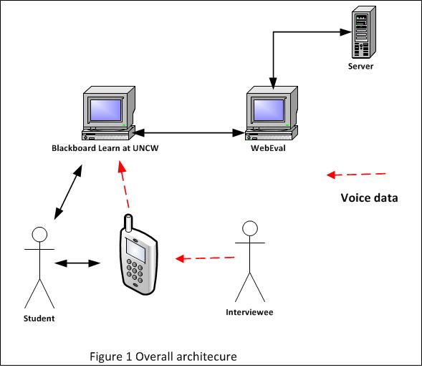

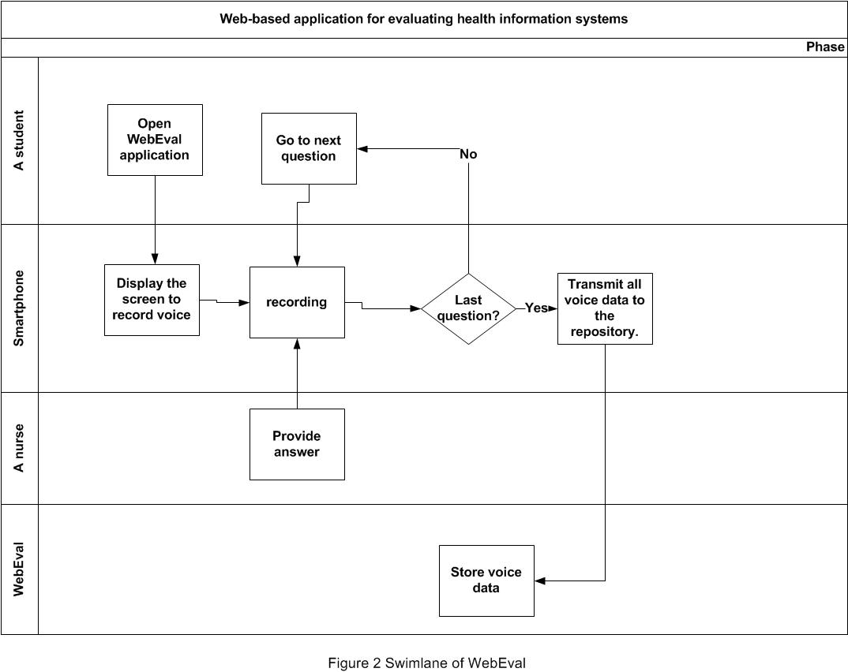Figure 2 shows swimlane of WebEval

## Product Functions

* Able to display its main interface to a user
* Able to get voice data from a user’s smart phone
* Able to write voice data into its server
* Able to retrieve voice data from its server

## User Classes and Characteristics

Graduate nursing students enrolled in Nursing Informatics course (NSG 501: Health Care Systems and Education Informatics and Technology), which is an online course and examines Health Information Systems (HISs), health care systems technology, education technology, and medical terminologies.

## Operating Environment

**Developer’s choice

## Design and Implementation Constraints

None

## User Documentation

User manual will be written

## Assumptions and Dependencies

None

# External Interface Requirements

## User Interfaces

Structured questions are:

1. Please describe a system briefly.
2. How can nurses use this system to meet the aims of “Support Safety and Quality of Nursing”?
3. How can nurses use this system to meet the aims of “Facilitate Continuity of Care and Care Coordination”?
4. How can nurses use this system to meet the aims of “Partner with Patients and Families to participate in Health care”?
5. Tell me about possible “Unexpected Outcomes” of this system
6. Any suggestions to improve “Unexpected Outcomes” this system?

The first screen and last scree examples will appear on smartphone.

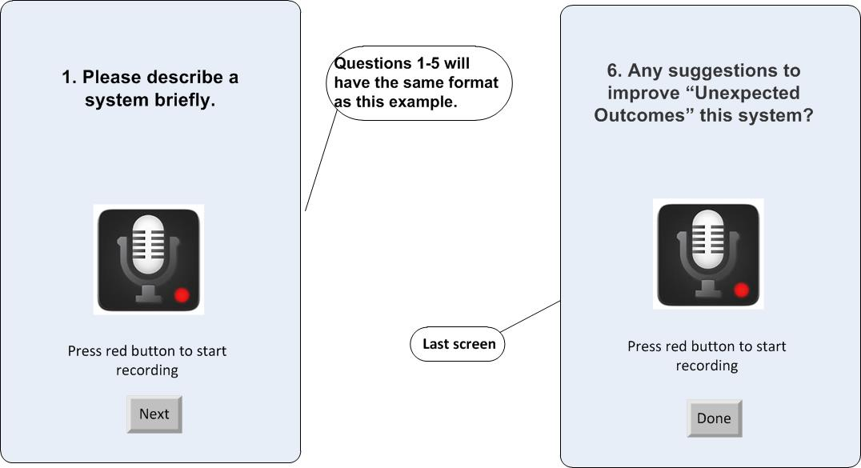

## Hardware Interfaces

None

## Software Interfaces

Developer’s choice

## Communications Interfaces

Developer’s choice

# System Features

## System Features

# Other Nonfunctional Requirements

## Performance Requirements

Users are clinicians and they can use WebEval without difficulties. Easy to launch this application on their phone is recommended.

* When a user has to stop WebEval due to emergency situation (e.g. cardiac arrest, urgent admissions etc) during an interview, WebEval can save whatever voice data recorded up to that time.
* When WebEval is disconnected due to unstable connection, WebEval can save whatever voice data recorded up to that time.

## Safety Requirements

None

## Security Requirements

None