Report Project 1 Computer Networks

William KACZMAREK 9002920227

## Introduction :

To begin this first report, I'll start by introducing myself. I’m a french student in the fourth year of engineering computing science in a french school. This spring semester I decided to study at hanyang university to follow an international education and learn more about computer science, english, korea and discover another teaching method.

## Computer Networks project number 1 :

Due to the april 23 2022, we train ourselves on socket programming and servers with this first project. Our goal was clear: develop a Web server in C or C++. I decided to choose to develop in C language because in France, we learnt to code during our first 2 years of school in C. So it’s a language that I know well.

To begin this project, and socket programming I followed the 1st tutorial that the teacher advised us to watch. I code it, and understood the basics of socket programming. I continue with the second tutorial of the same youtuber with http server & client.

## Description of my server’s design :

My http server works exactly like this slide from the course. I first begin by defining every variable and structure I’ll need. And I immediately created my server socket, I defined it family AF_INET, the way to connect to it INADDR and on which port. During all my work this port was defined on “8002”, it was only to gain time and not put the port every time I run it to test it. But the last changement i made on my server was to make it run on the port that the users choose. Like the teacher client server example and the .

Here is a screenshot of the beginning of my code where you can see the socket, bind, listen.

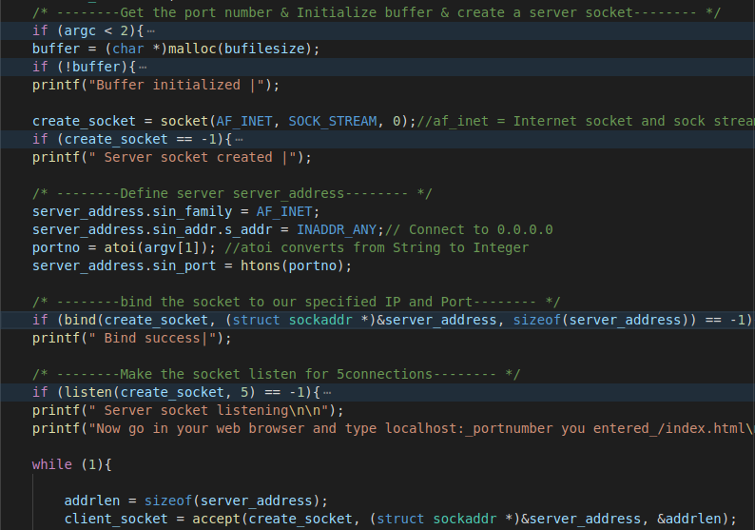

After we handle the client connection and request, we read it and make the appropriate response. 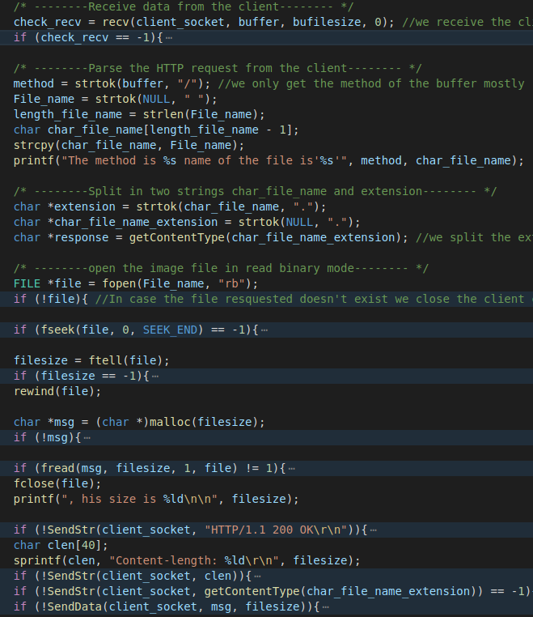

## Difficulties i faced :

The part I spent the most time on was on the content type. At the beginning, i did like on the tutorial with only those line : "HTTP/1.1 200 OK \r\n\n";

I thought that the function fopen was capable of opening every file html, png, pdf etc.

I got my first big bug when my html file won’t open.. And I saw that if I put all of my HTML code on one line, my server would be able to open it correctly. After trying to open images and other types of files, it was of course a failure. I searched for hours to understand how and why I wasn't able to send to the client a file other than an html file written on one line.

I finished by understanding that the problem was coming from my request and response that I gave to the client. When the client requests a file to the server I need to handle it correctly and completely. I completely missed to add what type of content it is. So i create the function GetContentType, who receive in parameter the extension the client ask to return the correct response for example with html :

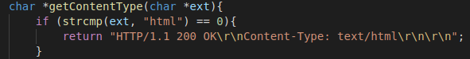

After this breakthrough I was able to respond to the client a normal html file not only on one line, and of course also able to return other types of file like css, png, jepg, gif, pdf, or even icon.

## My outputs :

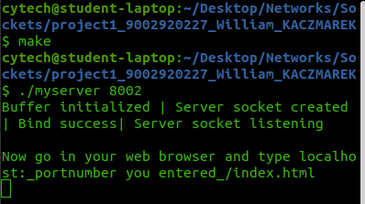

After execute the make file, we can launch my server using “./myserver <port>”, and we can instantly see if there were any errors to open the socket or not and if the server is listening or not. After making a request to the server by going into chrome and entering “localhost:8002/index.html”, the servers print me out everything just happen :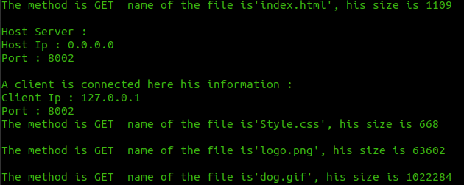

Imagine now that the port or the server can’t execute or open properly we saw it immediatly in the shell which step was correctly executed and which not.



Here the result, when you request index.html on my server :

