**Math 115: Set up your working environment**

1. **GitHub**. Establish a GitHub account, it is free. This is necessary because you will get write-up problems through GitHub. You will also submit write-ups for grading by completing your assignment and pushing it to your GitHub account and the submitting the write-up URL.
   1. Got to <https://github.com/> Select the ‘Sign Up’ button

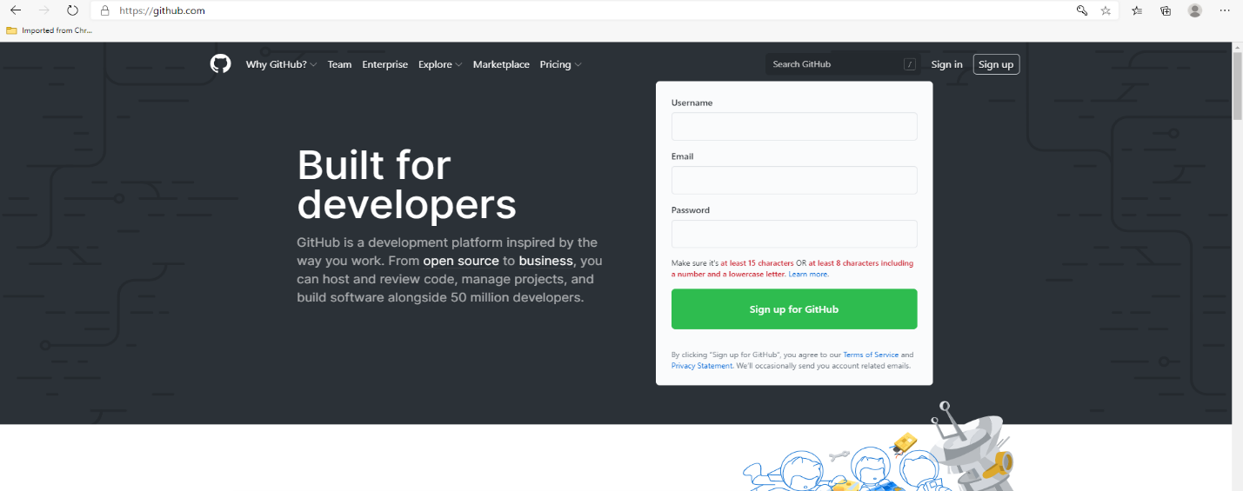

Select a username, I recommend you use your AVC email account and select your password. BE SURE TO REMEMBER YOUR USERNAME AND PASSWORD. These are username and password for you GitHub account. If you forget either, you will not be able to access your GitHub account.

1. 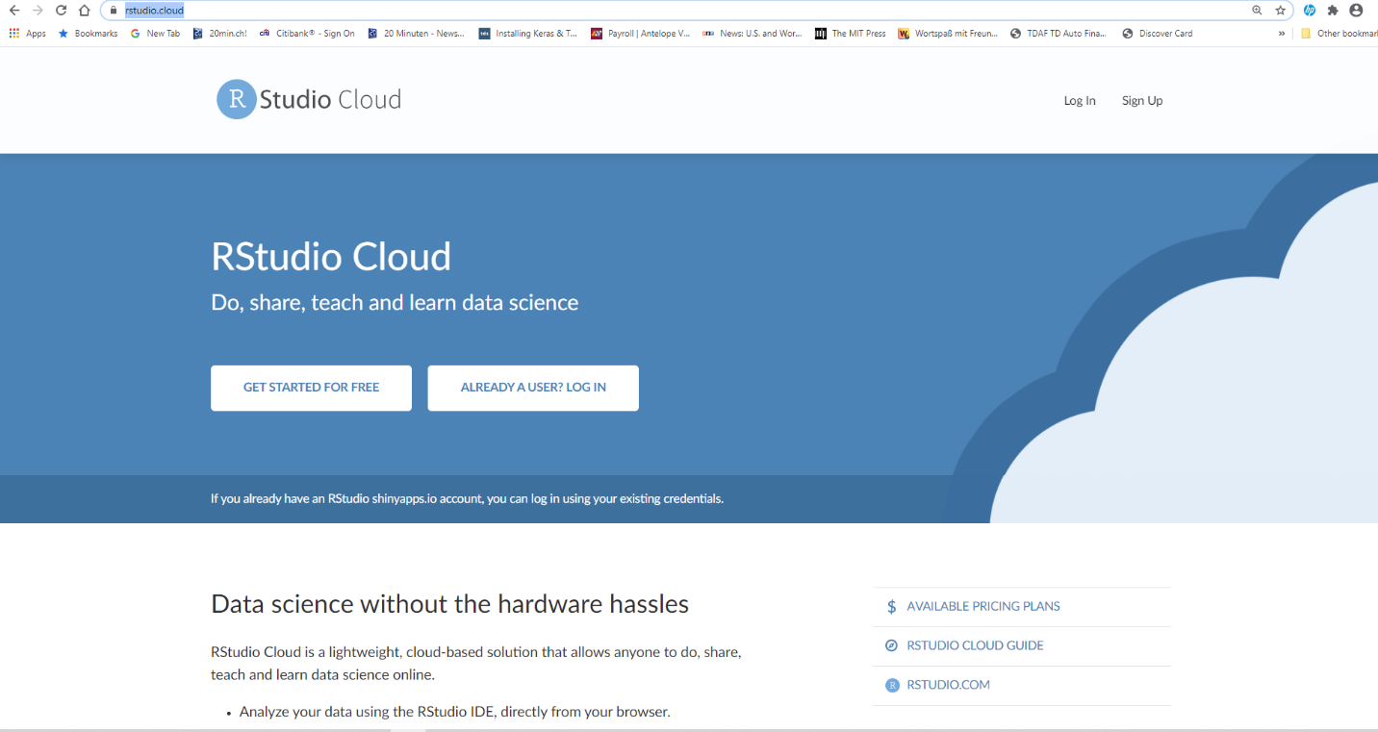**Rstudio.cloud.** Rstudio.cloud is the free software we use for statistical analysis and reporting. Establish two Rstudio.cloud accounts, one using your AVC.EDU email address and one using another email address: <https://rstudio.cloud/>

Select the Free student account for both. You need two Rstudio.cloud accounts because the free accounts limit you to 15 hours and 5 projects each. We will link the two accounts

* 1. Set up a shared account and a base project in each