Longitudinal Methods

William Lage

1/6/2021

library(readr)  
library(readxl)  
library(mice)

##   
## Attaching package: 'mice'

## The following objects are masked from 'package:base':  
##   
## cbind, rbind

library(VIM)

## Loading required package: colorspace

## Loading required package: grid

## Loading required package: data.table

## VIM is ready to use.   
## Since version 4.0.0 the GUI is in its own package VIMGUI.  
##   
## Please use the package to use the new (and old) GUI.

## Suggestions and bug-reports can be submitted at: https://github.com/alexkowa/VIM/issues

##   
## Attaching package: 'VIM'

## The following object is masked from 'package:datasets':  
##   
## sleep

library(jmv)  
library(ggplot2)  
library(lme4)

## Loading required package: Matrix

## Registered S3 methods overwritten by 'lme4':  
## method from  
## cooks.distance.influence.merMod car   
## influence.merMod car   
## dfbeta.influence.merMod car   
## dfbetas.influence.merMod car

library(nlme)

##   
## Attaching package: 'nlme'

## The following object is masked from 'package:lme4':  
##   
## lmList

WideF <- read_csv("Dataset.csv")

## Parsed with column specification:  
## cols(  
## AID = col_double(),  
## BIO_SEX = col_double(),  
## SES = col_double(),  
## Dep1 = col_double(),  
## Dep2 = col_double(),  
## Dep3 = col_double(),  
## Dep4 = col_double()  
## )

#Step 2: Cleaning Data ##Formatting

#This is a longer route in case you want to remove specific values  
WideF$Dep1[WideF$Dep1=="6"]<-"NA"  
WideF$Dep1[WideF$Dep1=="8"]<-"NA"  
WideF$Dep2[WideF$Dep2=="6"]<-"NA"  
WideF$Dep2[WideF$Dep2=="8"]<-"NA"  
WideF$Dep3[WideF$Dep3=="6"]<-"NA"  
WideF$Dep3[WideF$Dep3=="8"]<-"NA"  
WideF$Dep3[WideF$Dep3=="9"]<-"NA"  
WideF$Dep4[WideF$Dep4=="6"]<-"NA"  
WideF$Dep4[WideF$Dep4=="8"]<-"NA"  
WideF$SES[WideF$SES=="9996"]<-"NA"  
WideF$BIO_SEX[WideF$BIO_SEX=="6"]<-"NA"  
WideF$BIO_SEX[WideF$BIO_SEX=="8"]<-"NA"  
  
  
#str allows us to check the structure of the data. As we can see many of the variables got recoded when we made our NAs. By using an as.integer function, we can force the computer to treat them as non-numbers in an integer variable  
str(WideF)

## tibble [6,504 x 7] (S3: spec_tbl_df/tbl_df/tbl/data.frame)  
## $ AID : num [1:6504] 57100270 57101310 57103171 57103869 57104553 ...  
## $ BIO_SEX: chr [1:6504] "2" "2" "1" "1" ...  
## $ SES : chr [1:6504] "55" NA "45" "9" ...  
## $ Dep1 : chr [1:6504] "1" "0" "0" "1" ...  
## $ Dep2 : chr [1:6504] NA "0" NA "1" ...  
## $ Dep3 : chr [1:6504] "3" "1" NA "0" ...  
## $ Dep4 : chr [1:6504] NA "0" NA "0" ...  
## - attr(*, "spec")=  
## .. cols(  
## .. AID = col_double(),  
## .. BIO_SEX = col_double(),  
## .. SES = col_double(),  
## .. Dep1 = col_double(),  
## .. Dep2 = col_double(),  
## .. Dep3 = col_double(),  
## .. Dep4 = col_double()  
## .. )

WideF$Dep1 <- as.integer(WideF$Dep1)  
WideF$Dep2 <- as.integer(WideF$Dep2)  
WideF$Dep3 <- as.integer(WideF$Dep3)  
WideF$Dep4 <- as.integer(WideF$Dep4)  
WideF$SES <- as.integer(WideF$SES)  
WideF$BIO_SEX <- as.integer(WideF$BIO_SEX)

md.pattern(WideF)

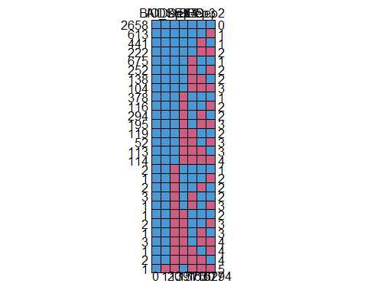

## AID BIO_SEX Dep1 Dep4 SES Dep3 Dep2   
## 2658 1 1 1 1 1 1 1 0  
## 613 1 1 1 1 1 1 0 1  
## 441 1 1 1 1 1 0 1 1  
## 222 1 1 1 1 1 0 0 2  
## 675 1 1 1 1 0 1 1 1  
## 252 1 1 1 1 0 1 0 2  
## 138 1 1 1 1 0 0 1 2  
## 104 1 1 1 1 0 0 0 3  
## 378 1 1 1 0 1 1 1 1  
## 116 1 1 1 0 1 1 0 2  
## 294 1 1 1 0 1 0 1 2  
## 195 1 1 1 0 1 0 0 3  
## 119 1 1 1 0 0 1 1 2  
## 52 1 1 1 0 0 1 0 3  
## 113 1 1 1 0 0 0 1 3  
## 114 1 1 1 0 0 0 0 4  
## 2 1 1 0 1 1 1 1 1  
## 1 1 1 0 1 1 1 0 2  
## 2 1 1 0 1 1 0 1 2  
## 3 1 1 0 1 0 1 1 2  
## 1 1 1 0 1 0 1 0 3  
## 1 1 1 0 0 1 1 1 2  
## 2 1 1 0 0 1 1 0 3  
## 1 1 1 0 0 1 0 1 3  
## 3 1 1 0 0 1 0 0 4  
## 1 1 1 0 0 0 1 0 4  
## 2 1 1 0 0 0 0 1 4  
## 1 1 0 0 1 0 0 0 5  
## 0 1 20 1391 1575 1630 1677 6294

mice_plot <-aggr(WideF,   
 col=c('navyblue', 'yellow'),   
 numbers = TRUE,   
 sortVars = TRUE,   
 labels = names(WideF),   
 cex.axis = .7,   
 gap = 3,   
 ylab = c("Missing data", "Pattern"))

## Warning in plot.aggr(res, ...): not enough vertical space to display frequencies  
## (too many combinations)

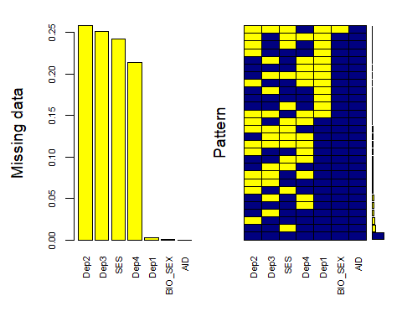

##   
## Variables sorted by number of missings:   
## Variable Count  
## Dep2 0.2578413284  
## Dep3 0.2506150062  
## SES 0.2421586716  
## Dep4 0.2138683887  
## Dep1 0.0030750308  
## BIO_SEX 0.0001537515  
## AID 0.0000000000

#What we see is there is no specific pattern, but there was high attrition in Wave 2

desc_full <- descriptives(data = WideF,   
 vars = c('Dep1','Dep2','Dep3','Dep4','SES', 'BIO_SEX'),   
 sd = TRUE,   
 skew = TRUE,   
 kurt = TRUE,  
 hist = TRUE)  
desc_full

##   
## DESCRIPTIVES  
##   
## Descriptives   
## ------------------------------------------------------------------------------------   
## Dep1 Dep2 Dep3 Dep4 SES BIO_SEX   
## ------------------------------------------------------------------------------------   
## N 6484 4827 4874 5113 4929 6503   
## Missing 20 1677 1630 1391 1575 1   
## Mean 0.512 0.498 0.335 0.376 47.7 1.52   
## Median 0.00 0 0.00 0 40 2   
## Standard deviation 0.752 0.735 0.644 0.666 56.4 0.500   
## Minimum 0 0 0 0 0 1   
## Maximum 3 3 3 3 999 2   
## Skewness 1.49 1.52 2.12 1.95 8.78 -0.0643   
## Std. error skewness 0.0304 0.0352 0.0351 0.0342 0.0349 0.0304   
## Kurtosis 1.80 2.01 4.48 3.79 120 -2.00   
## Std. error kurtosis 0.0608 0.0705 0.0701 0.0685 0.0697 0.0607   
## ------------------------------------------------------------------------------------

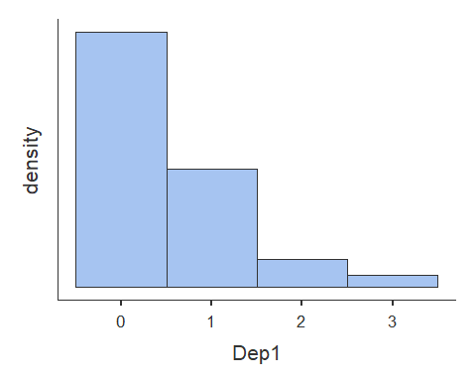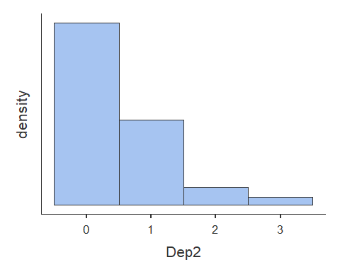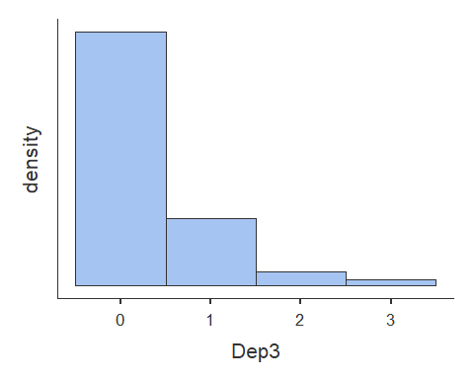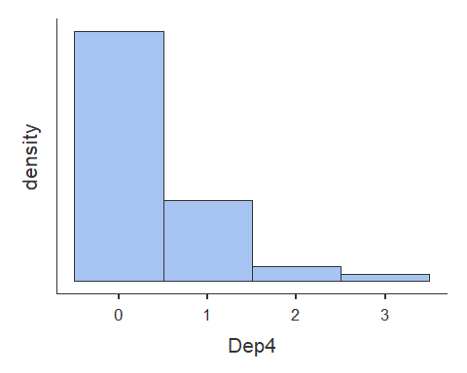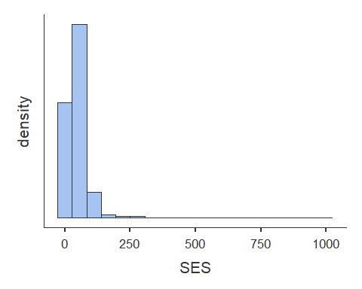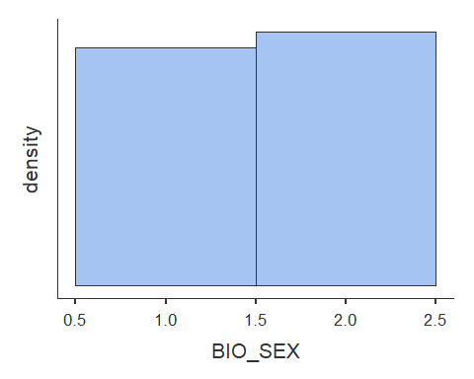 ##Transformation and Subsetting

#we made a few decisions about the data.  
  
#1st: SES is too heavily skewed. Rather than transforming this variable we're going to identify the interquartile range (IQR)  
boxplot(WideF$SES, horizontal = TRUE)

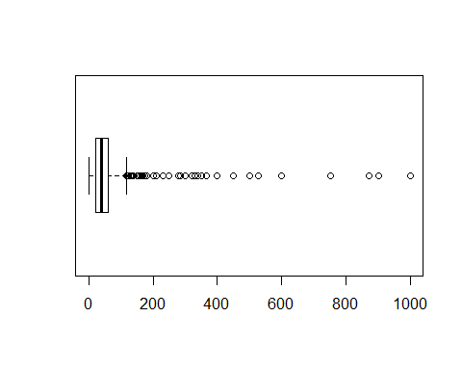

quantile(WideF$SES, na.rm = TRUE)

## 0% 25% 50% 75% 100%   
## 0 22 40 60 999

#with an IQR of 38, the practice of using 1.5*IQR from the mean (40) means we split the data at 97k  
#We are therefor removing anyone whose parents made over 97k per year as non-normal  
WideF2 <- WideF[WideF$SES<=97, ]  
  
#2nd: we will not be keeping the NAs, we have enough data to not have to worry about them  
dat.listW <- na.omit(WideF2)  
  
#3rd: we don't need to have Sex as 1 & 2  
dat.listW$BIO_SEX <- dat.listW$BIO_SEX - 1

#Check and remove multivariate outliers based on mahalanobis' distance  
  
#Create a variable of mahalanobis' distance  
x <- dat.listW[2:7]  
mean <- colMeans(x)  
Sx <- cov(x)  
dat.listW$mahal <- mahalanobis(x, mean, Sx)  
  
#Identify any multivariate outliers based on mahalanobis' distance variable --> +/- 3 SD's of mahalanobis distance mean  
dat.listW[abs(scale(dat.listW$mahal)) > 3, ]

## Warning: The `i` argument of ``[`()` can't be a matrix as of tibble 3.0.0.  
## Convert to a vector.  
## This warning is displayed once every 8 hours.  
## Call `lifecycle::last_warnings()` to see where this warning was generated.

## # A tibble: 72 x 8  
## AID BIO_SEX SES Dep1 Dep2 Dep3 Dep4 mahal  
## <dbl> <dbl> <int> <int> <int> <int> <int> <dbl>  
## 1 90570282 0 70 3 0 0 1 22.7  
## 2 90577929 1 76 3 3 1 0 23.1  
## 3 90578004 1 40 3 1 1 3 25.3  
## 4 90578404 1 10 3 0 0 2 25.5  
## 5 90578487 1 20 2 3 0 3 28.8  
## 6 90578805 0 27 2 1 3 3 28.9  
## 7 90714022 1 13 1 1 3 0 22.5  
## 8 91572346 1 21 3 3 3 0 31.7  
## 9 91573419 1 53 2 0 2 3 25.7  
## 10 91575151 0 14 0 1 0 3 22.8  
## # ... with 62 more rows

#There are 254 multivariate outliers in Long Format which translates to 72 people removed in Wide Format.  
  
#Remove multivariate outliers  
CleanD <- dat.listW[!abs(scale(dat.listW$mahal)) > 3,]

desc_full <- descriptives(data = CleanD,   
 vars = c('Dep1','Dep2','Dep3','Dep4','SES', 'BIO_SEX'),   
 sd = TRUE,   
 skew = TRUE,   
 kurt = TRUE,  
 hist = TRUE)  
desc_full

##   
## DESCRIPTIVES  
##   
## Descriptives   
## ------------------------------------------------------------------------------------   
## Dep1 Dep2 Dep3 Dep4 SES BIO_SEX   
## ------------------------------------------------------------------------------------   
## N 2392 2392 2392 2392 2392 2392   
## Missing 0 0 0 0 0 0   
## Mean 0.463 0.465 0.303 0.333 39.5 0.544   
## Median 0.00 0.00 0.00 0.00 38.0 1.00   
## Standard deviation 0.700 0.704 0.578 0.594 22.2 0.498   
## Minimum 0 0 0 0 0 0.00   
## Maximum 3 3 3 3 97 1.00   
## Skewness 1.56 1.55 1.93 1.85 0.365 -0.178   
## Std. error skewness 0.0501 0.0501 0.0501 0.0501 0.0501 0.0501   
## Kurtosis 2.23 2.15 3.42 3.43 -0.593 -1.97   
## Std. error kurtosis 0.100 0.100 0.100 0.100 0.100 0.100   
## ------------------------------------------------------------------------------------

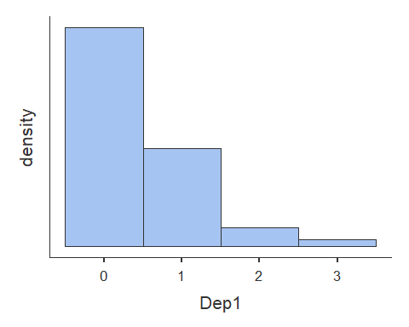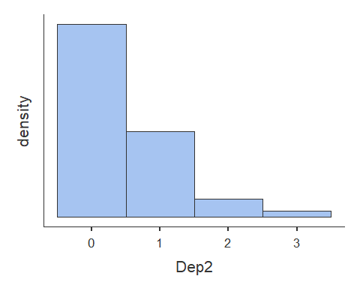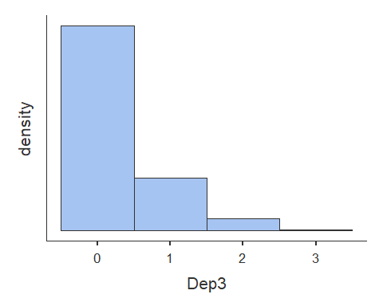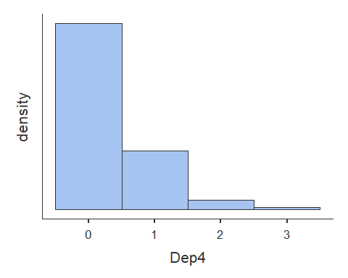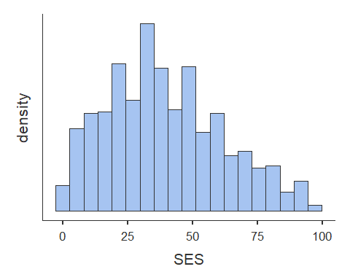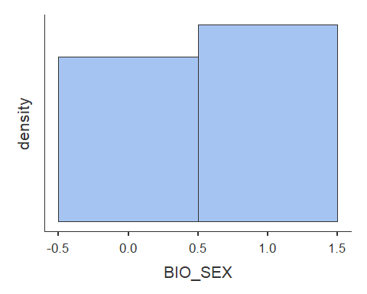

#because the time-series functions require the data in long format we need to create a time variable  
LongD <- reshape(data = as.data.frame(CleanD),  
 idvar='AID',  
 varying=c('Dep1','Dep2','Dep3','Dep4'),  
 times=c(1,2,3,4),  
 v.names='Dep',   
 direction='long')

#creating a plot and assigning it to an object   
plot_obs <- ggplot(data=LongD,  
 aes(x=time, y=Dep, group=AID)) + #calling variables  
 geom_line() + #adding lines to plot  
 theme_bw() + #changing style/background  
 scale_x_continuous(breaks = c(1,2,3,4), name = "Wave") + #creating breaks in the x-axis and labeling the x-axis  
 scale_y_continuous(breaks = c(0,1,2,3), name = "Depression") #creating breaks in the y-axis and labeling the y-axis  
  
#printing the object (plot)  
print(plot_obs)

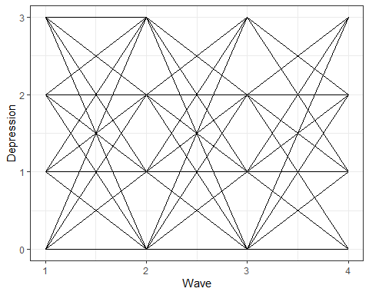 #comparing growth and no growth models to test if time is a factor

#fitting no growth model and assigning it to an object  
ng.lmer <- lmer(Dep ~ 1 + (1 | AID),   
 data = LongD,   
 REML = FALSE,  
 na.action = "na.exclude")  
  
#obtaining summary of the model using the object we just created   
summary(ng.lmer)

## Linear mixed model fit by maximum likelihood ['lmerMod']  
## Formula: Dep ~ 1 + (1 | AID)  
## Data: LongD  
##   
## AIC BIC logLik deviance df.resid   
## 18208.9 18230.4 -9101.4 18202.9 9565   
##   
## Scaled residuals:   
## Min 1Q Median 3Q Max   
## -2.0715 -0.5509 -0.2975 0.7168 4.2659   
##   
## Random effects:  
## Groups Name Variance Std.Dev.  
## AID (Intercept) 0.1058 0.3252   
## Residual 0.3176 0.5635   
## Number of obs: 9568, groups: AID, 2392  
##   
## Fixed effects:  
## Estimate Std. Error t value  
## (Intercept) 0.390991 0.008798 44.44

#fitting linear growth model and assigning it to an object  
lg.dep.nlme <- nlme(Dep~(beta_1+d_1i)+(beta_2+d_2i)*(time),   
 data=LongD,   
 fixed=beta_1+beta_2~1,   
 random=d_1i+d_2i~1,  
 group=~AID,   
 start=c(beta_1=0,beta_2=0),  
 na.action = "na.exclude")

## Warning in nlme.formula(Dep ~ (beta_1 + d_1i) + (beta_2 + d_2i) * (time), :  
## Iteration 2, LME step: nlminb() did not converge (code = 1). PORT message: false  
## convergence (8)

#obtaining summary of the model using the object we just created  
summary (lg.dep.nlme)

## Nonlinear mixed-effects model fit by maximum likelihood  
## Model: Dep ~ (beta_1 + d_1i) + (beta_2 + d_2i) * (time)   
## Data: LongD   
## AIC BIC logLik  
## 17935.78 17978.77 -8961.889  
##   
## Random effects:  
## Formula: list(d_1i ~ 1, d_2i ~ 1)  
## Level: AID  
## Structure: General positive-definite, Log-Cholesky parametrization  
## StdDev Corr   
## d_1i 0.5891950 d_1i   
## d_2i 0.1350504 -0.871  
## Residual 0.5311178   
##   
## Fixed effects: beta_1 + beta_2 ~ 1   
## Value Std.Error DF t-value p-value  
## beta_1 0.5288462 0.017946886 7175 29.467293 0  
## beta_2 -0.0551421 0.005587232 7175 -9.869313 0  
## Correlation:   
## beta_1  
## beta_2 -0.877  
##   
## Standardized Within-Group Residuals:  
## Min Q1 Med Q3 Max   
## -2.2157635 -0.5242495 -0.2829542 0.5460225 4.4167852   
##   
## Number of Observations: 9568  
## Number of Groups: 2392

#model did not converge in 50 iterations, so we're adjusting  
lmeCtlList <- lmeControl(maxIter = 500, msMaxIter = 200, tolerance = 1e-4, niter = 100,  
 msTol = 1e-5, nlmStepMax = 500,   
 msVerbose = FALSE,  
 returnObject = TRUE)  
  
quad.nlme <- nlme(Dep~b_1i+b_2i*(time)+b_3i*(time)^2,  
 data=LongD,  
 fixed=b_1i+b_2i+b_3i~1,  
 random=b_1i+b_2i+b_3i~1,  
 groups=~AID,  
 start=c(0, 0, 0),  
 na.action=na.exclude,  
 control=lmeCtlList)  
summary(quad.nlme)

## Nonlinear mixed-effects model fit by maximum likelihood  
## Model: Dep ~ b_1i + b_2i * (time) + b_3i * (time)^2   
## Data: LongD   
## AIC BIC logLik  
## 17940.67 18012.33 -8960.336  
##   
## Random effects:  
## Formula: list(b_1i ~ 1, b_2i ~ 1, b_3i ~ 1)  
## Level: AID  
## Structure: General positive-definite, Log-Cholesky parametrization  
## StdDev Corr   
## b_1i 0.58875384 b_1i b_2i   
## b_2i 0.17098373 -0.739   
## b_3i 0.01248745 0.037 -0.693  
## Residual 0.53071862   
##   
## Fixed effects: b_1i + b_2i + b_3i ~ 1   
## Value Std.Error DF t-value p-value  
## b_1i 0.5638587 0.03252416 7174 17.336612 0.0000  
## b_2i -0.0901547 0.02778423 7174 -3.244815 0.0012  
## b_3i 0.0070025 0.00543253 7174 1.288996 0.1974  
## Correlation:   
## b_1i b_2i   
## b_2i -0.914   
## b_3i 0.834 -0.980  
##   
## Standardized Within-Group Residuals:  
## Min Q1 Med Q3 Max   
## -2.2117860 -0.5138727 -0.2903517 0.5275482 4.4783603   
##   
## Number of Observations: 9568  
## Number of Groups: 2392

SES <- nlme(Dep ~ (beta_01 + beta_11*(SES/10) + d_1i) +  
 (beta_02 + beta_12*(SES/10) + d_2i)*(time),  
 data=LongD,  
 fixed=beta_01+beta_11+beta_02+beta_12~1,  
 random=d_1i+d_2i~1,  
 group=~AID,  
 start=c(beta_01=0, beta_11=0, beta_02=0, beta_12=0),  
 na.action=na.exclude)  
  
summary(SES)

## Nonlinear mixed-effects model fit by maximum likelihood  
## Model: Dep ~ (beta_01 + beta_11 * (SES/10) + d_1i) + (beta_02 + beta_12 * (SES/10) + d_2i) * (time)   
## Data: LongD   
## AIC BIC logLik  
## 17904.26 17961.59 -8944.13  
##   
## Random effects:  
## Formula: list(d_1i ~ 1, d_2i ~ 1)  
## Level: AID  
## Structure: General positive-definite, Log-Cholesky parametrization  
## StdDev Corr   
## d_1i 0.5834228 d_1i   
## d_2i 0.1344851 -0.87  
## Residual 0.5311178   
##   
## Fixed effects: beta_01 + beta_11 + beta_02 + beta_12 ~ 1   
## Value Std.Error DF t-value p-value  
## beta_01 0.6749776 0.03642471 7173 18.530762 0.000  
## beta_11 -0.0370278 0.00804253 7173 -4.604005 0.000  
## beta_02 -0.0770680 0.01137828 7173 -6.773252 0.000  
## beta_12 0.0055557 0.00251231 7173 2.211400 0.027  
## Correlation:   
## bet_01 bet_11 bet_02  
## beta_11 -0.871   
## beta_02 -0.878 0.765   
## beta_12 0.765 -0.878 -0.871  
##   
## Standardized Within-Group Residuals:  
## Min Q1 Med Q3 Max   
## -2.2332383 -0.5127487 -0.2852387 0.5184603 4.4125996   
##   
## Number of Observations: 9568  
## Number of Groups: 2392

#for some reason, if this one has gender coded as 0/1 it doesn't run. So we boosted it back to 1/2 to get it running again. In interpretting, remember to use 1/2 for gender accordingly.  
SEX <- nlme(Dep ~ (beta_01 + beta_11*(BIO_SEX) + d_1i) +  
 (beta_02 + beta_12*(BIO_SEX) + d_2i)*(time),  
 data=LongD,  
 fixed=beta_01+beta_11+beta_02+beta_12~1,  
 random=d_1i+d_2i~1,  
 group=~AID,  
 start=c(beta_01=0, beta_11=0, beta_02=0, beta_12=0),  
 na.action=na.exclude)

## Warning in nlme.formula(Dep ~ (beta_01 + beta_11 * (BIO_SEX) + d_1i) + (beta_02  
## + : Iteration 2, LME step: nlminb() did not converge (code = 1). PORT message:  
## false convergence (8)

summary(SEX)

## Nonlinear mixed-effects model fit by maximum likelihood  
## Model: Dep ~ (beta_01 + beta_11 * (BIO_SEX) + d_1i) + (beta_02 + beta_12 * (BIO_SEX) + d_2i) * (time)   
## Data: LongD   
## AIC BIC logLik  
## 17863.74 17921.07 -8923.872  
##   
## Random effects:  
## Formula: list(d_1i ~ 1, d_2i ~ 1)  
## Level: AID  
## Structure: General positive-definite, Log-Cholesky parametrization  
## StdDev Corr   
## d_1i 0.5762289 d_1i   
## d_2i 0.1336505 -0.869  
## Residual 0.5311178   
##   
## Fixed effects: beta_01 + beta_11 + beta_02 + beta_12 ~ 1   
## Value Std.Error DF t-value p-value  
## beta_01 0.3944954 0.02632689 7173 14.984503 0e+00  
## beta_11 0.2468256 0.03568410 7173 6.916965 0e+00  
## beta_02 -0.0339450 0.00825682 7173 -4.111144 0e+00  
## beta_12 -0.0389429 0.01119148 7173 -3.479692 5e-04  
## Correlation:   
## bet_01 bet_11 bet_02  
## beta_11 -0.738   
## beta_02 -0.878 0.648   
## beta_12 0.648 -0.878 -0.738  
##   
## Standardized Within-Group Residuals:  
## Min Q1 Med Q3 Max   
## -2.2439991 -0.4920901 -0.3001009 0.5012485 4.3894967   
##   
## Number of Observations: 9568  
## Number of Groups: 2392

lg.var <- nlme(Dep ~ (beta_01 + beta_11*(SES/10) + beta_21*BIO_SEX + d_1i) +  
 (beta_02 + beta_12*(SES/10)+ beta_22*BIO_SEX +d_2i)*(time),  
 data=LongD,  
 fixed=beta_01+beta_11+beta_12+beta_21+beta_02+beta_22~1,  
 random=d_1i+d_2i~1,  
 group=~AID,  
 start=c(beta_01=0, beta_11=0, beta_12=0, beta_21=0, beta_02=0, beta_22=0),  
 na.action=na.exclude)

## Warning in nlme.formula(Dep ~ (beta_01 + beta_11 * (SES/10) + beta_21 * :  
## Iteration 2, LME step: nlminb() did not converge (code = 1). PORT message: false  
## convergence (8)

summary(lg.var)

## Nonlinear mixed-effects model fit by maximum likelihood  
## Model: Dep ~ (beta_01 + beta_11 * (SES/10) + beta_21 * BIO_SEX + d_1i) + (beta_02 + beta_12 * (SES/10) + beta_22 * BIO_SEX + d_2i) * (time)   
## Data: LongD   
## AIC BIC logLik  
## 17832.55 17904.21 -8906.274  
##   
## Random effects:  
## Formula: list(d_1i ~ 1, d_2i ~ 1)  
## Level: AID  
## Structure: General positive-definite, Log-Cholesky parametrization  
## StdDev Corr   
## d_1i 0.5705686 d_1i   
## d_2i 0.1331039 -0.868  
## Residual 0.5311178   
##   
## Fixed effects: beta_01 + beta_11 + beta_12 + beta_21 + beta_02 + beta_22 ~ 1   
## Value Std.Error DF t-value p-value  
## beta_01 0.5388393 0.04114084 7171 13.097432 0.0000  
## beta_11 -0.0362640 0.00796562 7171 -4.552559 0.0000  
## beta_12 0.0054351 0.00250657 7171 2.168356 0.0302  
## beta_21 0.2445713 0.03553757 7171 6.882050 0.0000  
## beta_02 -0.0555788 0.01294595 7171 -4.293144 0.0000  
## beta_22 -0.0386050 0.01118275 7171 -3.452196 0.0006  
## Correlation:   
## bet_01 bet_11 bet_12 bet_21 bet_02  
## beta_11 -0.771   
## beta_12 0.677 -0.879   
## beta_21 -0.481 0.014 -0.012   
## beta_02 -0.879 0.677 -0.771 0.422   
## beta_22 0.422 -0.012 0.014 -0.879 -0.481  
##   
## Standardized Within-Group Residuals:  
## Min Q1 Med Q3 Max   
## -2.2618229 -0.5062577 -0.2832857 0.5113375 4.3851048   
##   
## Number of Observations: 9568  
## Number of Groups: 2392

#look to the equation to interpret the scores below. Remember outcome ~ intercept + slope * time

ng.lmer

## Linear mixed model fit by maximum likelihood ['lmerMod']  
## Formula: Dep ~ 1 + (1 | AID)  
## Data: LongD  
## AIC BIC logLik deviance df.resid   
## 18208.857 18230.355 -9101.428 18202.857 9565   
## Random effects:  
## Groups Name Std.Dev.  
## AID (Intercept) 0.3252   
## Residual 0.5635   
## Number of obs: 9568, groups: AID, 2392  
## Fixed Effects:  
## (Intercept)   
## 0.391