**Customer Analytics 2018-2019 - Guidelines**

*Prof. dr. Cédric Verbeeck – Prof. dr. Arne De Keyser*

The grading of the CA course entails 3 components:

* Class participation (i.e., continuous assessment - individual)
* 3 case assignments (group work)
* 1 oral presentation (group work)

**Class Participation [4/20]**

Grading criteria include:

* Active responding to questions during class sessions
* Active participation in class coding exercises
* Helping others in class
* Displaying appropriate and professional behavior
* Timely arrival in class

These criteria will be assessed on a continuous basis. Presence in class without any active involvement is not sufficient for a high participation grade.

**Case Assignments [10/20]**

In total 3 case assignments need to be completed and submitted in teams of 4 (and 2 teams of 3) – teams need to be made by **15/2** and added to this google sheet: <https://docs.google.com/spreadsheets/d/1YKzZGODggGF7vOCqs9JBYJn1xrliNwwhVPb6Hz5Hs5A/edit#gid=0>

All 3 assignments are linked and built around the Augmented Reality (AR) game Pokémon Go ([pokemongo.com/en-us/](https://www.pokemongo.com/en-us/)), developed by Niantic, Inc. ([nianticlabs.com/](https://www.nianticlabs.com/)). Specific information about this mobile game can be found in the Harvard case uploaded on Blackboard and the additional appendix covering some of the latest updates to the game.

Across the three assignments, you will work to understand the European player database[1] across 2 time periods – summer 2018 and fall 2018. Three aspects are of particular interest:

1. The development of an understanding of the playing patterns. More specifically, Niantic notes that game play peaks during summer time, driving by returning and new players, and then gradually declines during fall to reach a minimum in winter time. To counterbalance this churn behavior, the company has launched a ‘fall bonus’ at the end of summer (sent out on 31/08/2018 to a specified set of customers). This bonus involves free items that can immediately be used in the game.
2. One aspect of the game’s monetization model involves in-game purchases. These microtransactions allow gamers to buy in-game virtual goods (e.g., egg incubators, Pokéballs, and raid passes) to enhance gameplay. Despite the effectiveness of these virtual goods to advance in the game, only a small percentage of players actually makes in-game purchases. Developing insights into these purchase patterns is crucial to Niantic.
3. In an effort to enhance the game play for 2019, the company is particularly interested in understanding what player segment is most promising and warrants specific interest. Specifically, the Niantic’s marketing department has discerned four player segments: (1) Walkers, (2) Miscellaneous Players, (3) Social Raiders, and (4) Catchers (see appendix A for more details).

For these assignments, 5 databases will be at your disposal: **(1)** customerdata, **(2)** summerfintrx, **(3)** summersesstrx, **(4)** fallfintrx, **(5)** fallsesstrx.

1. **Customerdata: contains player-related information**

*CustomerID:* unique number to identify a player

*CustomerType:* player profile (1= walker, 2= miscellaneous, 3= social raider, 4=catcher)

*RegistrationDate:* date when the player first registered to play the game. (Note that the game was launched in July 2016.)

*Sex:* gender of the player (0 male, 1 female)

*Age:* age of the player

*Fallbonus:* did the player receive a promo code on 31/08/2018 or not? 0=no, 1=yes

*Income:* estimated income level (1=low,2=medium,3=high) of the player in maximum spendable € per month

1. **Summerfintrx: contains all microtransactions at the individual customer level (period 01-05-2018 to 31-08-2018)**

*TransID:* unique code per microtransaction

*Date:* date at which the micro transaction occurred

*CustomerID:* unique number to identify a player

*ProductID:* code corresponding to a financial value matching the transaction**[2]** (1= 2.99€, 2=4.99€, 3=9.99€, 4=25€, 5=99€)

1. **SummersessTRX: play sessions at the individual customer level (period 01-05-2018 to 31-08-2018)**

*PlayID:* unique code per play session

*Date*: date at which a play session started

*CustomerID*: unique number to identify a player

*Experience*: amount of experience points the player collected during the session

*Pokéstops*: amount of Pokéstops the player spinned during the session

*Gyms*: amount of gyms the player interacted with during the session

*Raids*: amount of raids the player performed during the session

*Social*: amount of social actions the player performed during the session

*Pokémon*: amount of (wild) Pokémon the player caught during the session

*Distance*: distance in kilometers the player walked during the session

*Duration*: The duration in minutes per play session

***Note:*** A session starts when a player logs into the game and ends when the connection with the server is lost or at the end of the day. It is possible for a player to have multiple sessions recorded per day.

1. **& (5) FallFinTRX and FallSesstrx use the same variables as their summer**

**equivalents, but during the period 01-09-2018 to 31-10-2018.**

**Assignment 1 (3 points) – Creation of a basetable**

Create a basetable containing the active customers (at least 1 play session during the summer period). Indicate whether they received the fall boost package discount or not.

Calculate the demographics and RFM metrics for the relevant play and financial transactions database. Based on these metrics, sketch a general profile (use the correct descriptive metric for each variable) of the customer base according to demographics, spending and usage transactions.

Calculate the customer life time value for these customers. You can make assumptions for unknown variables (e.g., discount rate, # periods in the future), but motivate your assumptions clearly in the report.

**Assignment 2 (3,5 points) – Lifecycle grids**

This assignment focuses on the creation of relevant lifecycle grids. Based on the data provided, distinct grids may be made that each hold managerial value. The goal is to select those grids most relevant to Niantic and to discuss their value in detail – hence, the creation of a series of grids is recommended as this will help you collect insights and select those most relevant to the case. Keep in mind that the goals of Niantic include to better understand their player segments, the financial value of the database, and to eventually increase profits in the future.

**Assignment 3 (3,5 points) – Churn analysis**

This assignment focuses on understanding churn after the summer period - i.e., defined as not performing any microtransactions in fall 2018. According to this definition calculate which customers have churned in the fall using the fall financial and usage transaction database.

Update the basetable from assignment 1 with this churn information and check the average churn rate.

Use logistic regression to find the significant factors that affect the churn rate of a customer. Did the fall bonus have any impact on the churn rate? You can add additional independent variables to the basetable as well but please motivate why you would think that they affect churn.

Come up with a marketing strategy based on your insights from 2018 to prevent churning in the future.

**Deadline for all three assignments:** April 12, 2019

**Deliverables:**

* R-code
* Summary report containing the most relevant insights gather from the datasets (descriptive statistics, lifecycle grids, churn analysis, etc.), a discussion on their managerial relevance and a set of recommendations to Niantic on how to enhance their player database for 2020.

**Feedback moment:** All teams will be able to ask questions in relation to the assignment during session 9 (March 14, 2019).

**Presentation [6/20]**

Presentations will be held on April 12, 2019 (a detailed schedule with a time slot for each team will be made)

Duration: 10 minutes max. + 5 min questions

Briefly present analysis from your results in the 3 assignments and propose of a set of CRM-related recommendations for Niantic.

You may assume that we are familiar with the Pokémon-go case, data and problems. Focus on your own added value instead of repeating the case setting.

**APPENDIX A**

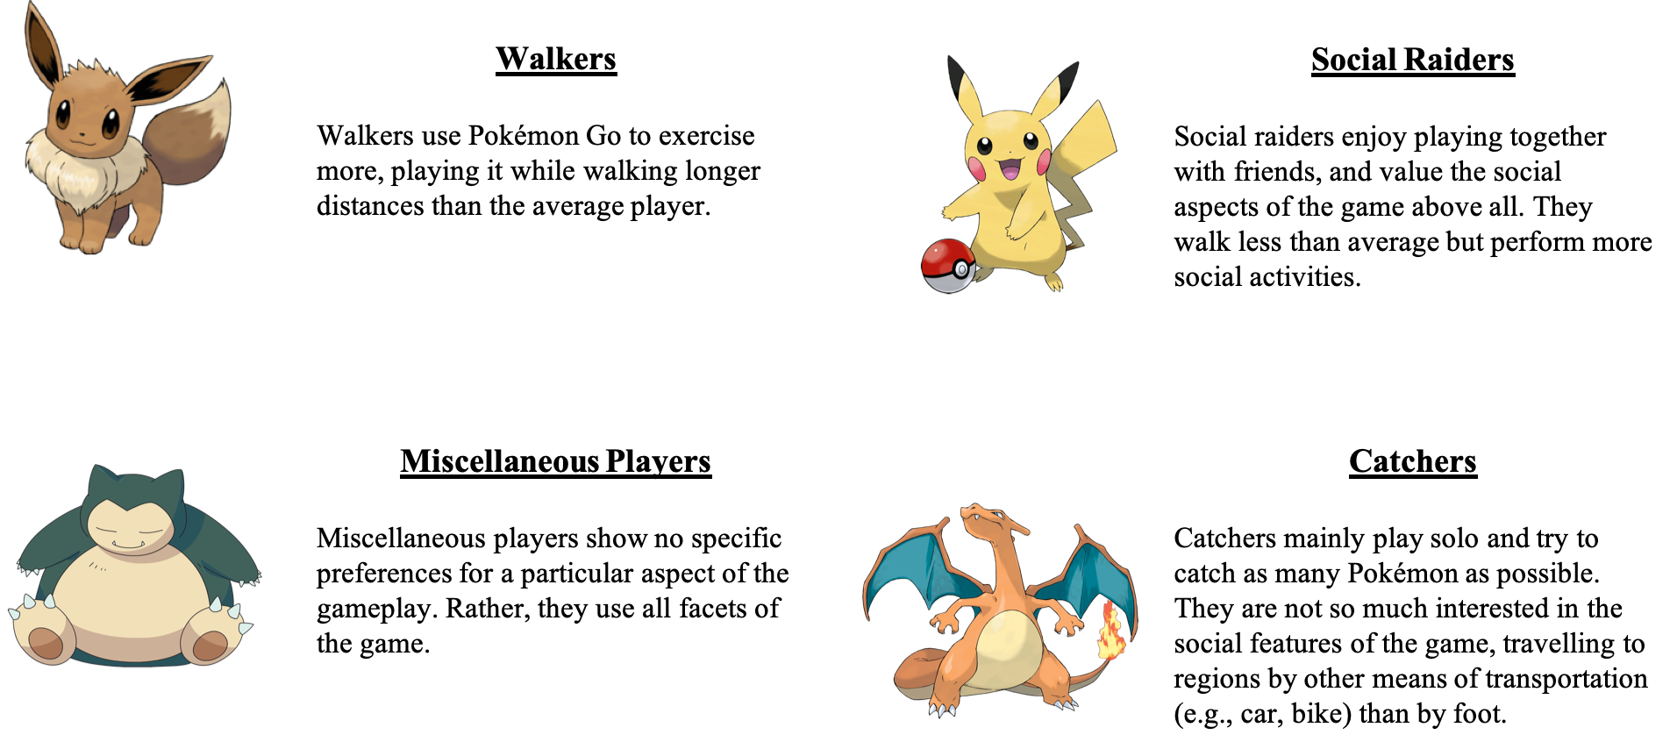

1. This database is fictitious and was simulated for the purposes of this case. Note that the size of the database is also limited to ensure student laptops can handle the analyses.
2. For simplicity, this case does not make a difference between various types of purchases. To this end, only their financial value is taken into account.