Lab report 2: Hall Sensor and Actuation

For part 2A voltage dependent on the angular position of the haptic paddle was recorded and the transfer function [volts 🡪 degrees] was derived. Further the noise characterization with mean and standard deviation in volts and degrees was recorded. In addition the raw position signal was used to calculate velocity and acceleration of the haptic paddle. All signals were filtered online (in LabView) and offline (in MATLAB) and were being recorded.

For part 2B motor current and motor torque both dependent on input voltage were recorded and the transfer functions [volts 🡪 amps] and [volts 🡪 milli-newtonmeters] were derived.

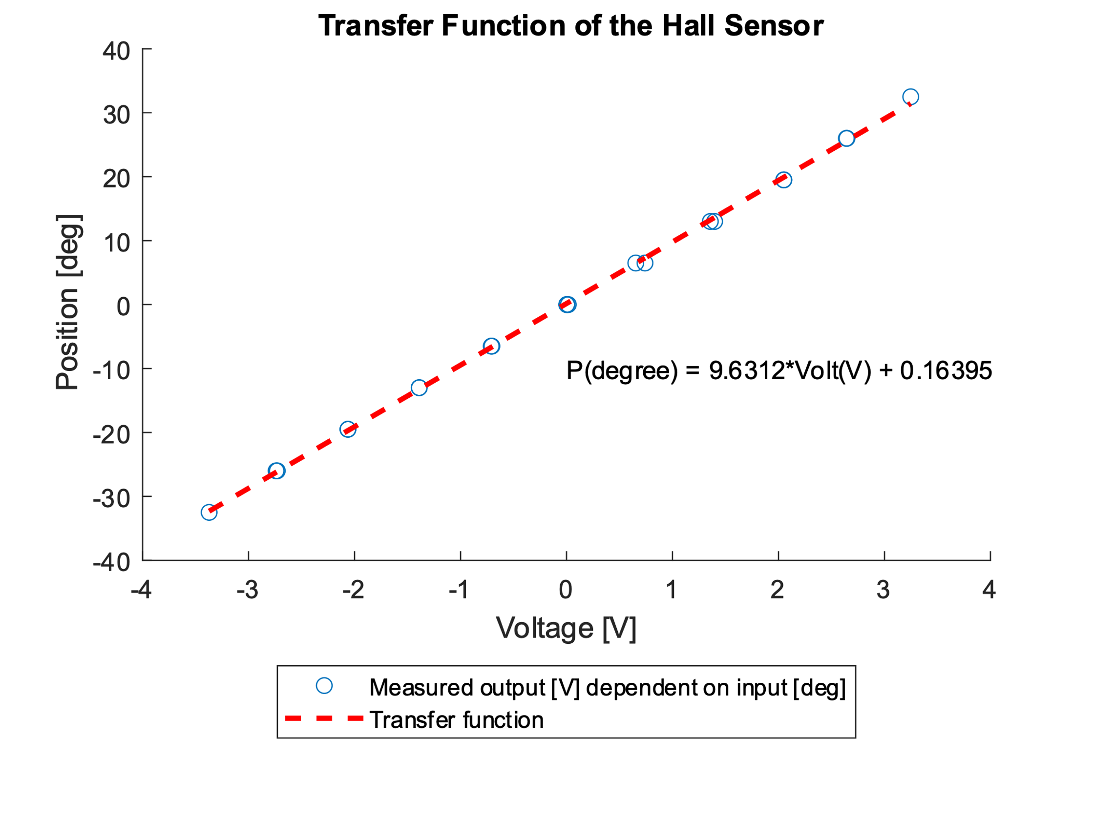

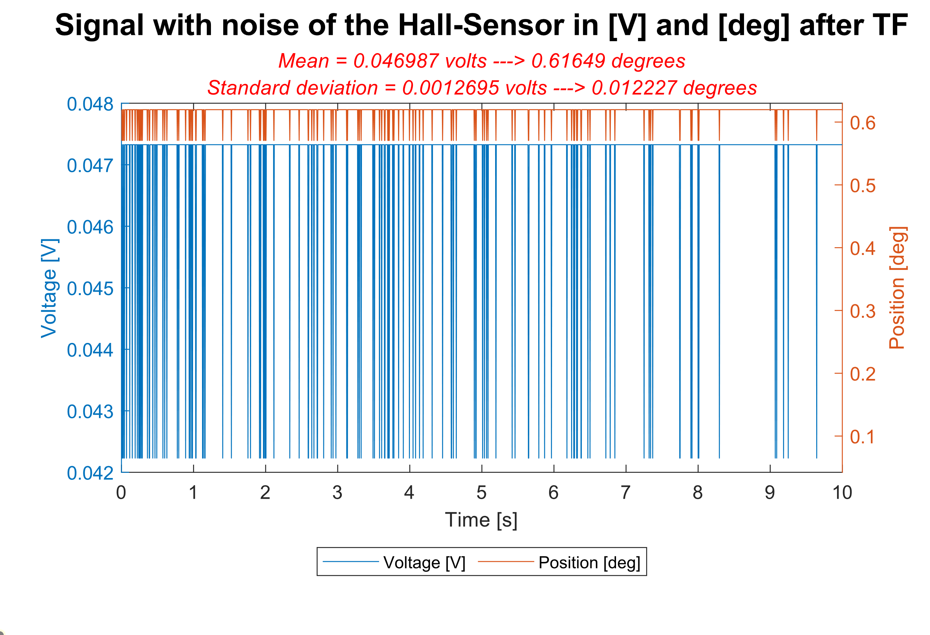

Mean amplitude of signal noise : 46.987 mV 🡪 0.616 °

Standard deviation: 1.270 mV 🡪 0.012 °

To define our low cutoff frequency for our position signal, we decided to go with twice the amount of a humans frequency, which is 10 Hz 🡪 20Hz. For the velocity and the acceleration we tried different frequencies and decided to go with 10Hz and 5Hz.

**Position Filter:**

Filter type: Butterworth Lowpass

Low cutoff frequency: 20Hz

Sampling frequency: 200Hz

**Velocity Filter:**

Filter type: Butterworth Lowpass

Low cutoff frequency: 10Hz

Sampling frequency: 200Hz

**Acceleration Filter:**

Filter type: Butterworth Lowpass

Low cutoff frequency: 5Hz

Sampling frequency: 200Hz

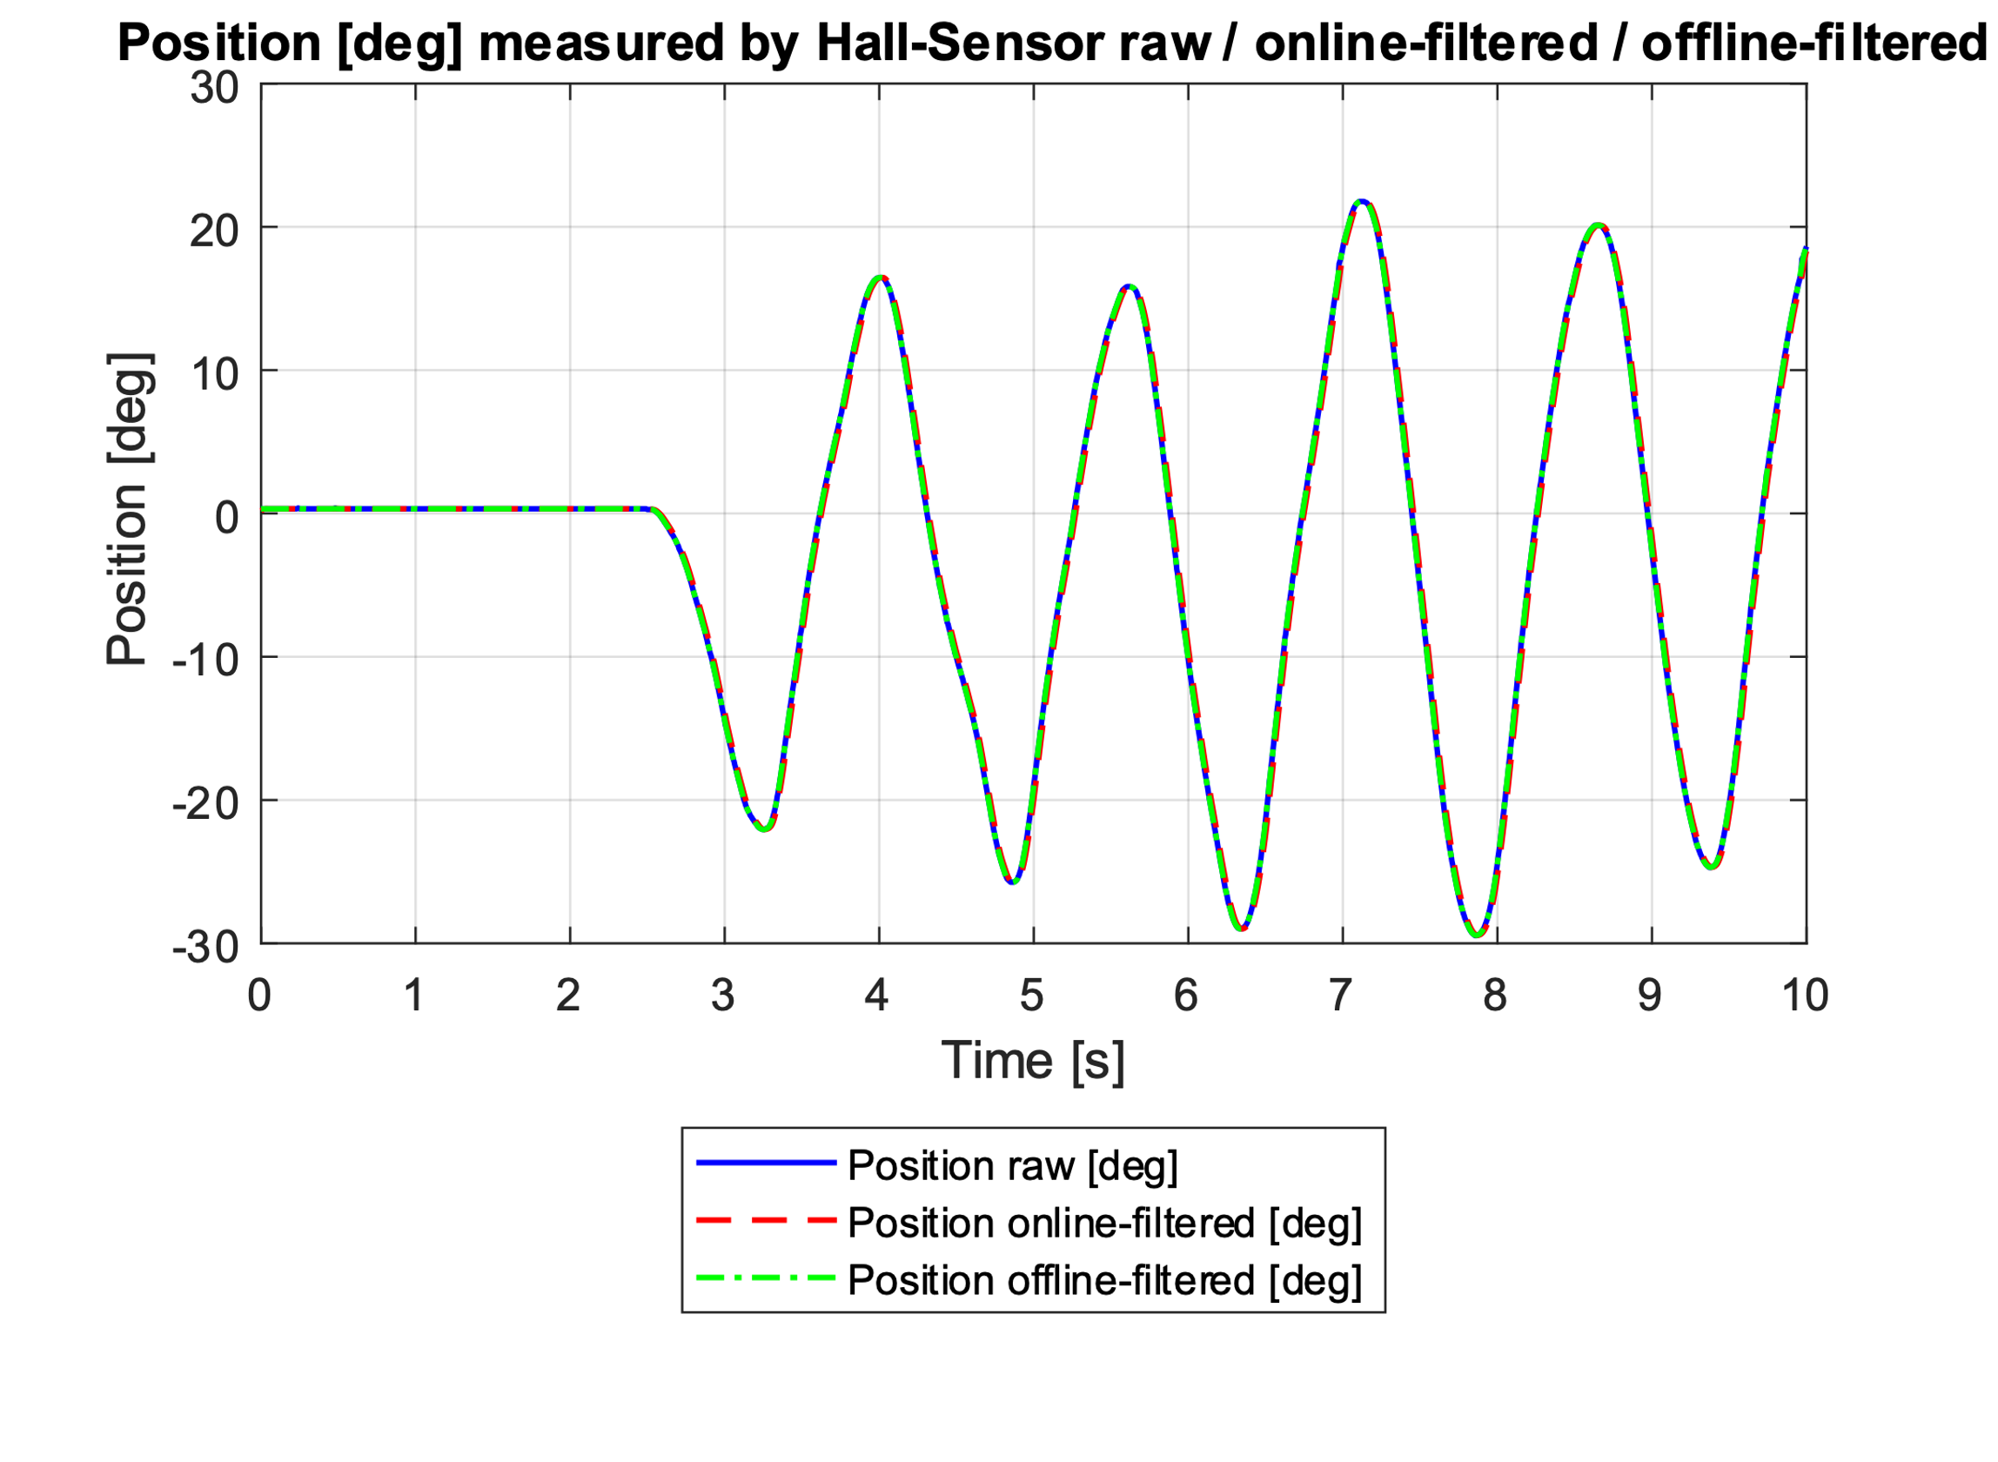

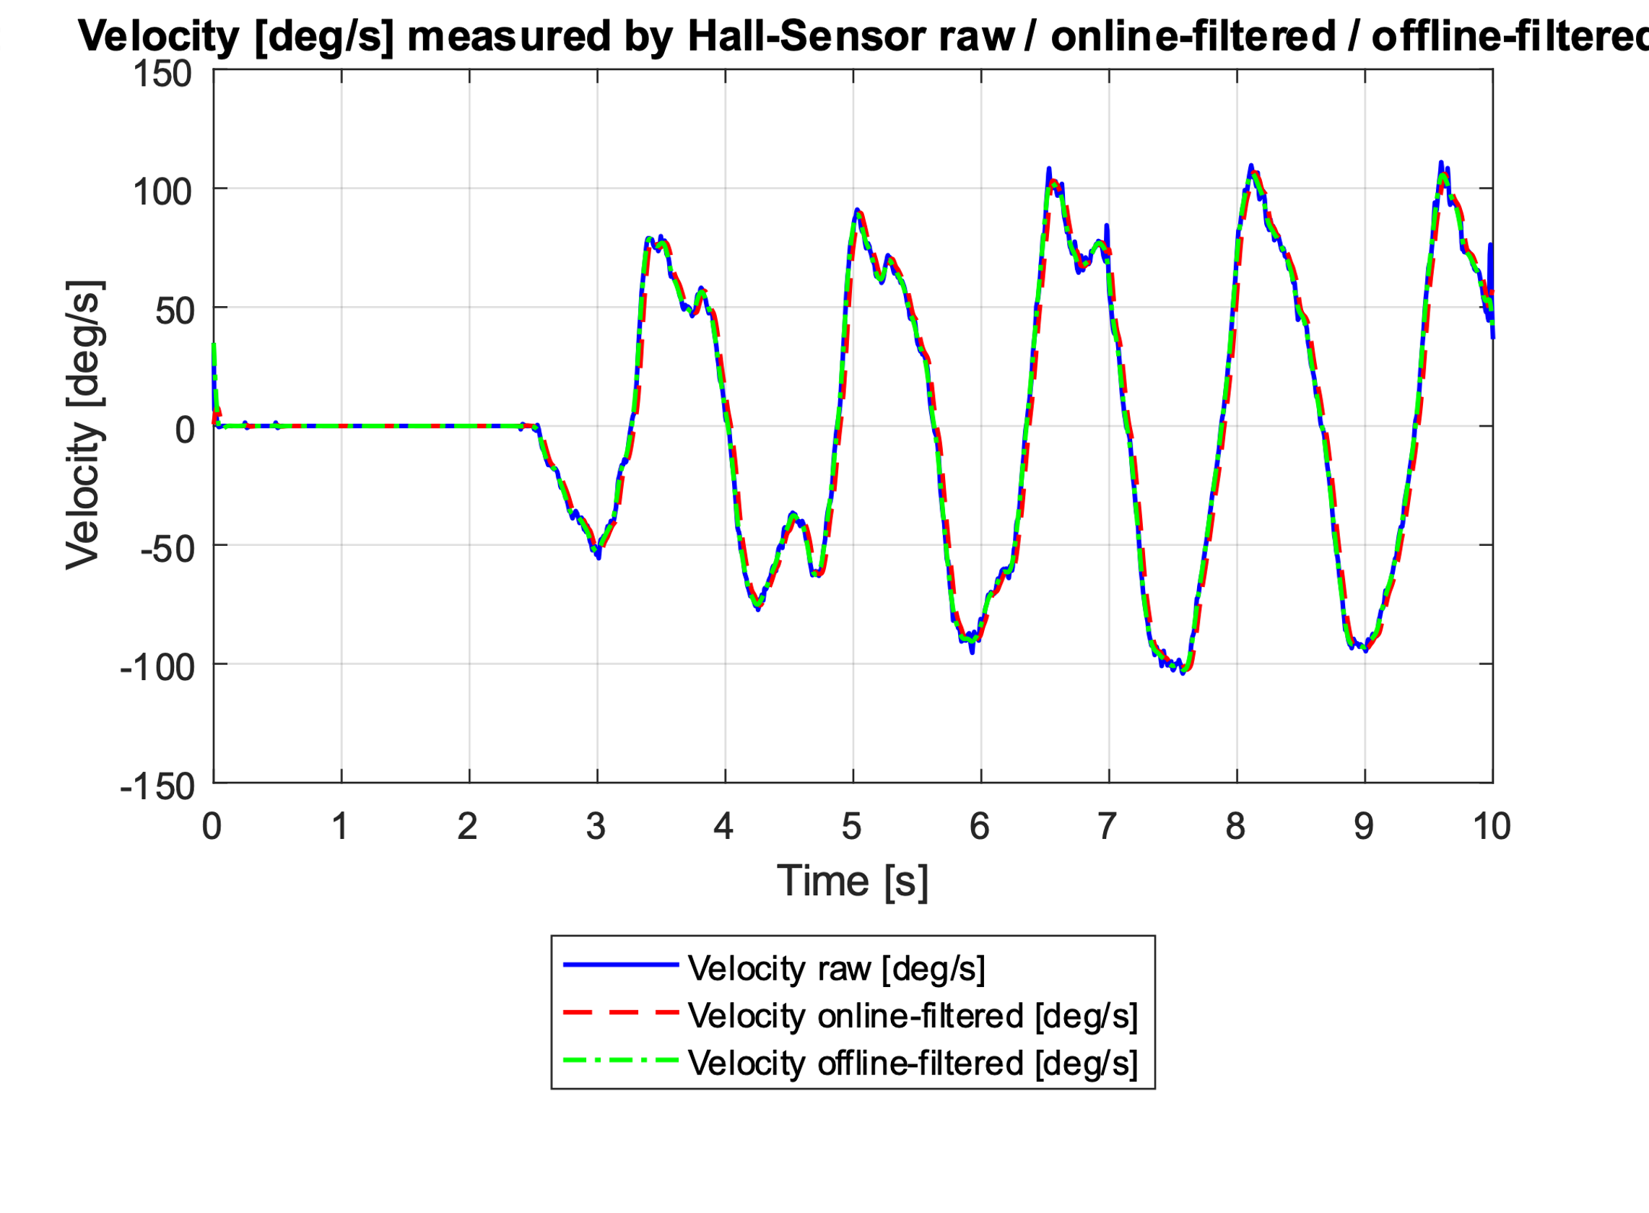

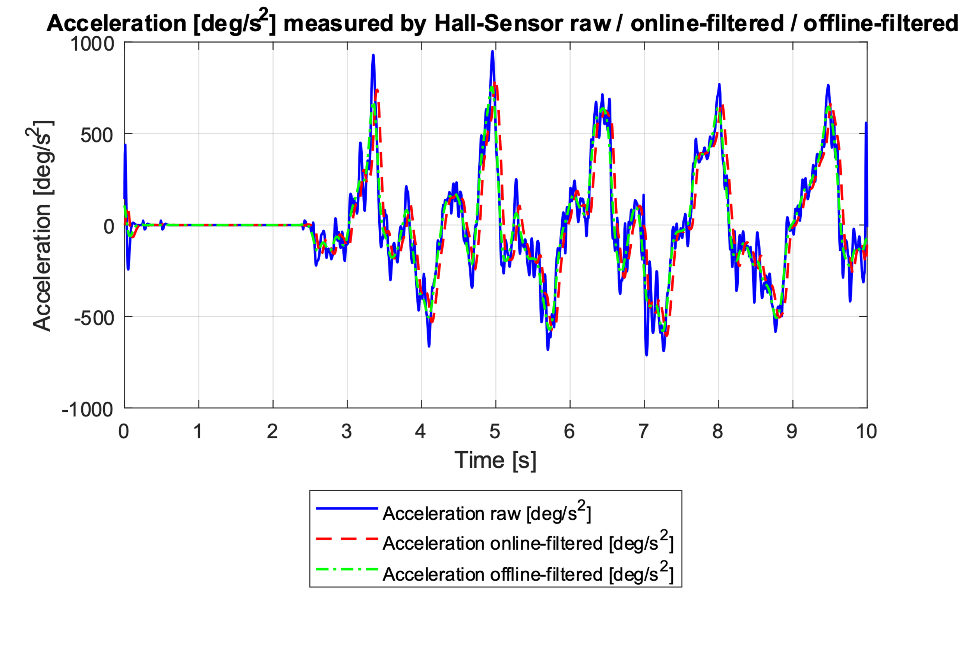

The online-filtered signal is slightly time shifted to the right in comparison to the raw signal and also the offline-filtered signal. This time delay is caused by the real-time filtering of the signal. The delay can be corrected if the shift is the same amount over the hole signal. The MATLAB function *filtfilt* does exactly this correction. That is why our offline-filtered signal is not delayed.

To define our low cutoff frequency for our motor current signal, we decided to go with 30Hz.

**Motor current Filter:**

Filter type: Butterworth Lowpass

Low cutoff frequency: 30Hz

Sampling frequency: 1Hz

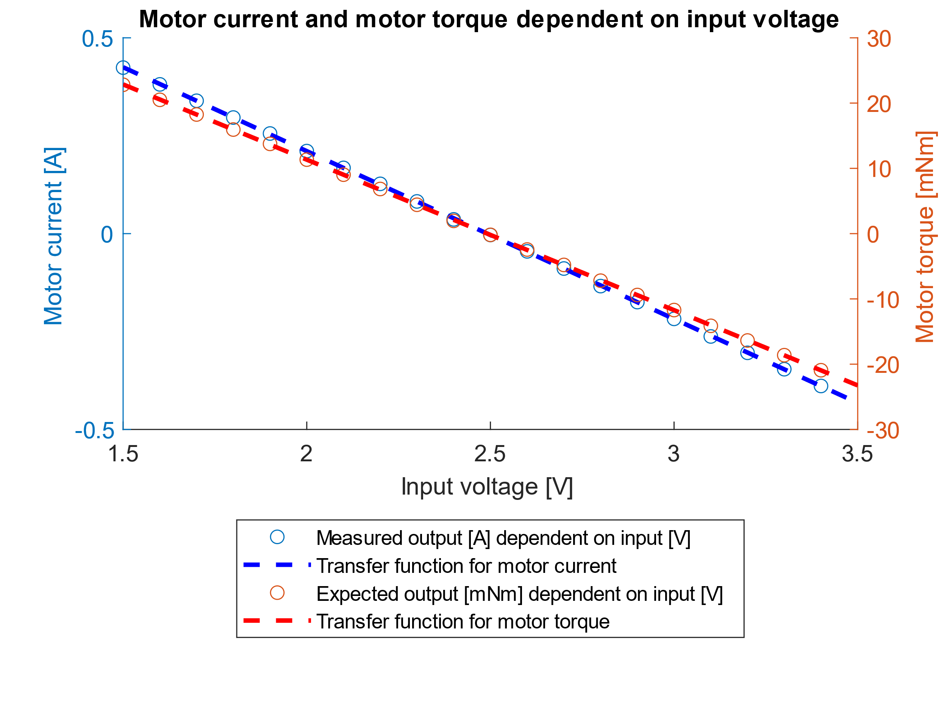

Without the lowpass filtering of the motor current signal, the linear fits of the two signals had been far off. The first rising and then suddenly changing direction signals (nonlinear region) were responsible for the too flat linear fits. By trying out different cutoff frequencies we managed to get this quite linear input-output relationship and were able to derive the transfer functions of motor current and motor torque.