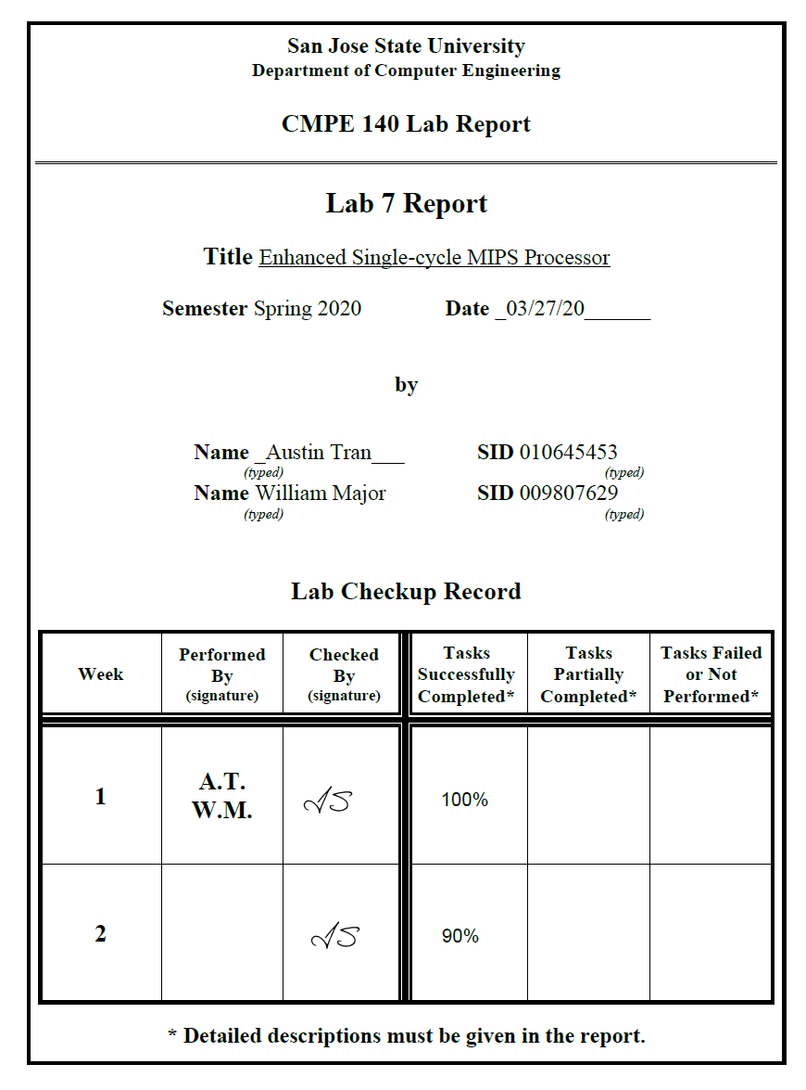

**Diagrams:**

Data Path

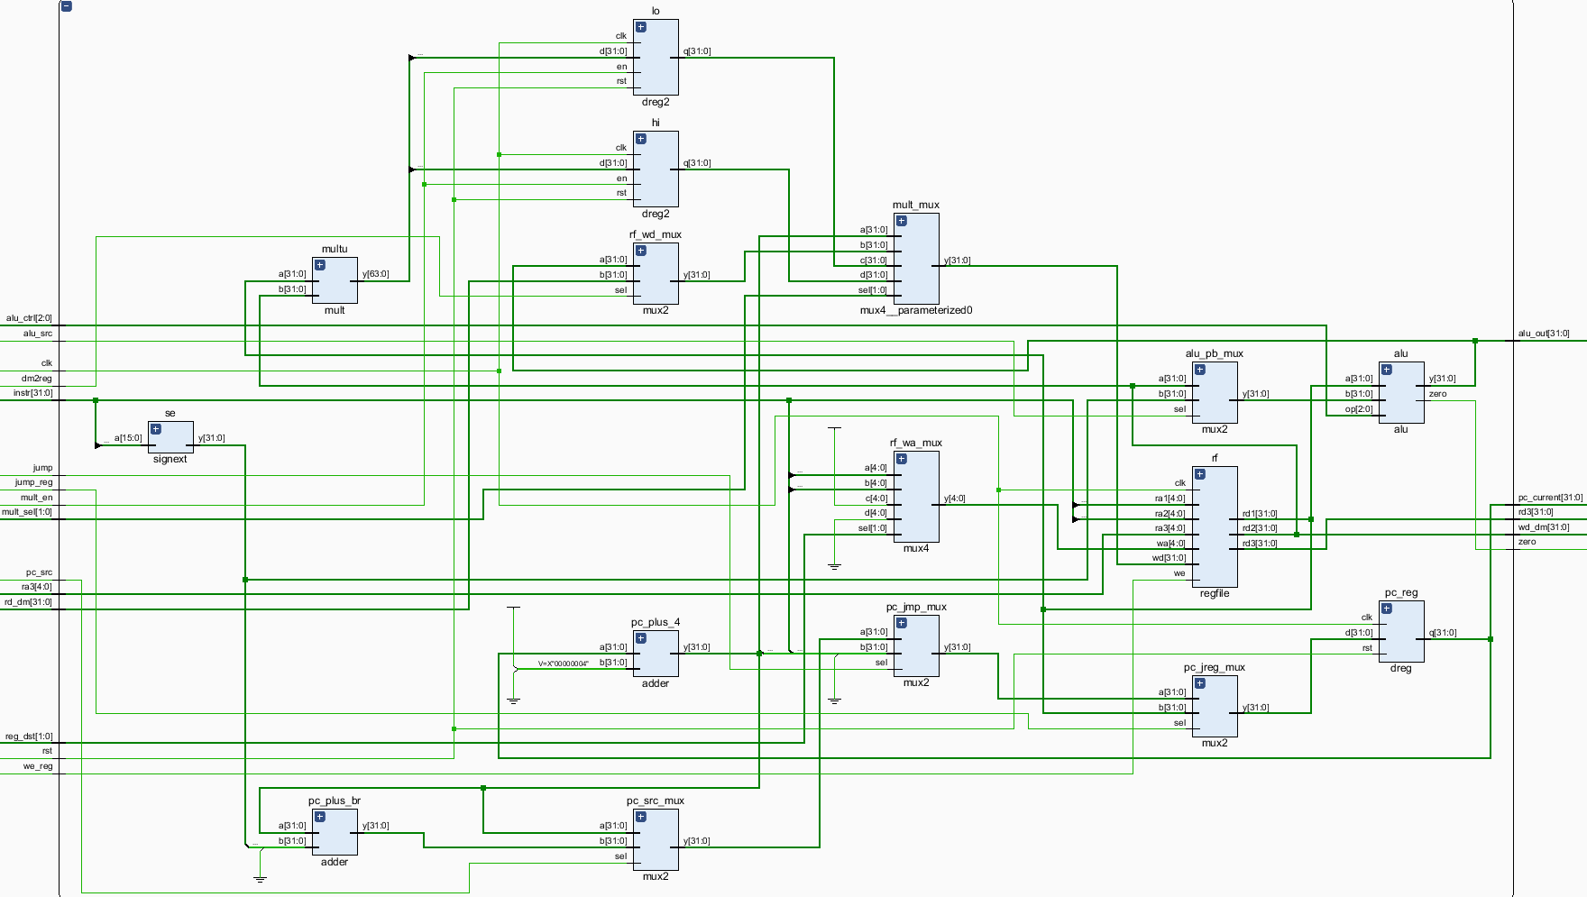

Control Unit – Data Path

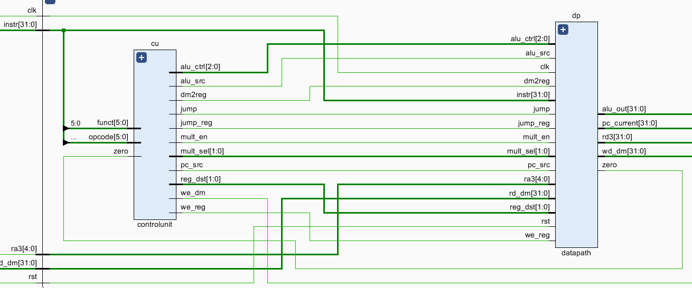

**Truth Table**

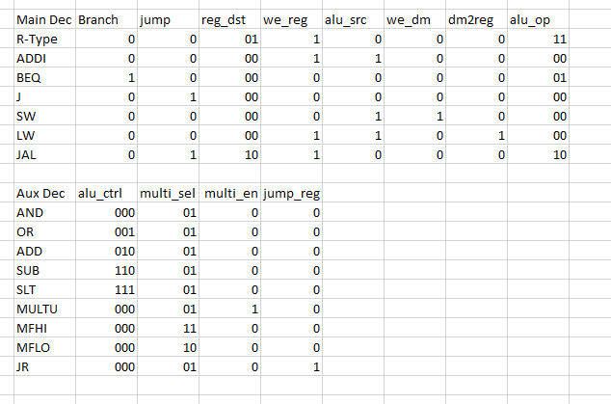

**Testbench waveform**



**Board Validation**

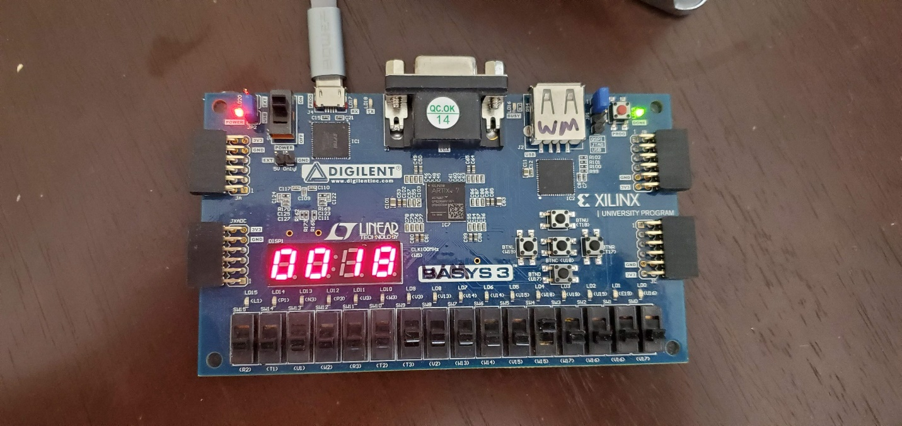

**Source Code**

module mips_fpga

(

input wire clk,

input wire rst,

input wire button,

input wire [8:0] switches,

output wire we_dm,

output wire [3:0] LEDSEL,

output wire [7:0] LEDOUT

);

reg [15:0] reg_hex;

wire clk_sec, clk_5KHz, clk_pb;

wire [7:0] digit0, digit1, digit2, digit3;

wire [31:0] pc_current, instr, alu_out, wd_dm, rd_dm, dispData;

clk_gen clk_gen (

.clk100MHz (clk),

.rst (rst),

.clk_4sec (clk_sec),

.clk_5KHz (clk_5KHz)

);

button_debouncer bd (

.clk (clk_5KHz),

.button (button),

.debounced_button (clk_pb)

);

mips_top mips_top (

.clk (clk),

.rst (rst),

.ra3 (switches[4:0]),

.instr (instr),

.we_dm (we_dm),

.pc_current (pc_current),

.alu_out (alu_out),

.wd_dm (wd_dm),

.rd3 (dispData)

);

hex_to_7seg hex3 (

.HEX (reg_hex[15:12]),

.s (digit3)

);

hex_to_7seg hex2 (

.HEX (reg_hex[11:8]),

.s (digit2)

);

hex_to_7seg hex1 (

.HEX (reg_hex[7:4]),

.s (digit1)

);

hex_to_7seg hex0 (

.HEX (reg_hex[3:0]),

.s (digit0)

);

led_mux led_mux (

.clk (clk_5KHz),

.rst (rst),

.LED3 (digit3),

.LED2 (digit2),

.LED1 (digit1),

.LED0 (digit0),

.LEDSEL (LEDSEL),

.LEDOUT (LEDOUT)

);

always @ (posedge clk) begin

case ({switches[8:5]})

4'b0000: reg_hex = dispData[15:0];

4'b0001: reg_hex = dispData[31:16];

4'b0010: reg_hex = instr[15:0];

4'b0011: reg_hex = instr[31:16];

4'b0100: reg_hex = alu_out[15:0];

4'b0101: reg_hex = alu_out[31:16];

4'b0110: reg_hex = wd_dm[15:0];

4'b1000: reg_hex = pc_current[15:0];

4'b1001: reg_hex = pc_current[31:16];

default: reg_hex = pc_current[15:0];

endcase

end

endmodule

module mips(

input wire clk,

input wire rst,

input wire [4:0] ra3,

input wire [31:0] instr,

input wire [31:0] rd_dm,

output wire we_dm,

output wire [31:0] pc_current,

output wire [31:0] alu_out,

output wire [31:0] wd_dm,

output wire [31:0] rd3

);

wire pc_src, jump, we_reg, alu_src, dm2reg, mult_en, jump_reg;

wire [1:0] mult_sel, reg_dst;

wire [2:0] alu_ctrl;

wire zero;

datapath dp (clk, mult_en, jump_reg, rst, pc_src, jump, we_reg, alu_src, dm2reg, alu_ctrl, reg_dst, mult_sel, ra3, instr, rd_dm, zero, pc_current, alu_out, wd_dm, rd3);

controlunit cu (zero, instr[31:26], instr[5:0], pc_src, jump, we_reg, alu_src, we_dm, dm2reg, mult_en, jump_reg, reg_dst, mult_sel, alu_ctrl);

endmodule

module maindec

(input [5:0] opcode, output branch, output jump, output [1:0] reg_dst, output we_reg, output alu_src,

output we_dm, output dm2reg, output [1:0] alu_op);

reg [9:0] ctrl;

assign {branch, jump, reg_dst, we_reg, alu_src, we_dm, dm2reg, alu_op} = ctrl;

always @ (opcode)

begin

case (opcode)

6'b00_0000: ctrl = 10'b0_0_01_1_0_0_0_11; // R-type

6'b00_1000: ctrl = 10'b0_0_00_1_1_0_0_00; // ADDI

6'b00_0100: ctrl = 10'b1_0_00_0_0_0_0_01; // BEQ

6'b00_0010: ctrl = 10'b0_1_00_0_0_0_0_00; // J

6'b10_1011: ctrl = 10'b0_0_00_0_1_1_0_00; // SW

6'b10_0011: ctrl = 10'b0_0_00_1_1_0_1_00; // LW

6'b00_0011: ctrl = 10'b0_1_10_1_0_0_0_10; // JAL

default: ctrl = 10'bx_x_xx_x_x_x_x_xx;

endcase

end

endmodule

module auxdec

(input [1:0] alu_op, input [5:0] funct, output [2:0] alu_ctrl, output [1:0] multi_sel, output multi_en, output jump_reg);

reg [6:0] ctrl;

assign {alu_ctrl, multi_sel, multi_en, jump_reg} = ctrl;

always @ (alu_op, funct)

begin

case (alu_op)

2'b00: ctrl = 7'b010_01_0_0; // add

2'b01: ctrl = 7'b110_01_0_0; // sub

2'b10: ctrl = 7'b000_00_0_0; // jal

default: case (funct)

6'b10_0100: ctrl = 7'b000_01_0_0; // AND

6'b10_0101: ctrl = 7'b001_01_0_0; // OR

6'b10_0000: ctrl = 7'b010_01_0_0; // ADD

6'b10_0010: ctrl = 7'b110_01_0_0; // SUB

6'b10_1010: ctrl = 7'b111_01_0_0; // SLT

6'b01_1001: ctrl = 7'b000_01_1_0; // MULTU

6'b01_0000: ctrl = 7'b000_11_0_0; // MFHI

6'b01_0010: ctrl = 7'b000_10_0_0; // MFLO

6'b00_1000: ctrl = 7'b000_01_0_1; // JR

default: ctrl = 7'bxxx_xx_x_x;

endcase

endcase

end

endmodule

module controlunit(

input zero,

input [5:0] opcode,

input [5:0] funct,

output pc_src,

output jump,

output we_reg,

output alu_src,

output we_dm,

output dm2reg,

output mult_en,

output jump_reg,

output [1:0] reg_dst,

output [1:0] mult_sel,

output [2:0] alu_ctrl

);

wire [1:0] alu_op;

wire branch;

maindec md (opcode, branch, jump, reg_dst, we_reg, alu_src, we_dm, dm2reg, alu_op);

auxdec ad (alu_op, funct, alu_ctrl, mult_sel, mult_en, jump_reg);

assign pc_src = branch & zero;

endmodule

module datapath(

input wire clk,

input wire mult_en,

input wire jump_reg,

input wire rst,

input wire pc_src,

input wire jump,

input wire we_reg,

input wire alu_src,

input wire dm2reg,

input wire [2:0] alu_ctrl,

input wire [1:0] reg_dst,

input wire [1:0] mult_sel,

input wire [4:0] ra3,

input wire [31:0] instr,

input wire [31:0] rd_dm,

output wire zero,

output wire [31:0] pc_current,

output wire [31:0] alu_out,

output wire [31:0] wd_dm,

output wire [31:0] rd3

);

wire [4:0] rf_wa;

wire [31:0] pc_plus4, pc_pre, pc_next, sext_imm, ba, bta, jta, alu_pa, alu_pb, wd_rf;

wire [63:0] mult_out;

wire [31:0] lo_out, hi_out, mult_mux_out, jr_mux_out;

assign ba = {sext_imm[29:0], 2'b00};

assign jta = {pc_plus4[31:28], instr[25:0], 2'b00};

// --- PC Logic --- //

dreg pc_reg (clk, rst, jr_mux_out, pc_current);

adder pc_plus_4 (pc_current, 4, pc_plus4);

adder pc_plus_br (pc_plus4, ba, bta);

mux2 #(32) pc_src_mux (pc_src, pc_plus4, bta, pc_pre);

mux2 #(32) pc_jmp_mux (jump, pc_pre, jta, pc_next);

mux2 #(32) pc_jreg_mux (jump_reg, pc_next, alu_pa, jr_mux_out);

// --- RF Logic --- //

//mux2 #(5) rf_wa_mux (reg_dst, instr[20:16], instr[15:11], rf_wa);

mux4 #(5) rf_wa_mux (reg_dst, instr[20:16], instr[15:11], 31, 0, rf_wa);

regfile rf (clk, we_reg, instr[25:21], instr[20:16], ra3, rf_wa, mult_mux_out, alu_pa, wd_dm, rd3);

signext se (instr[15:0], sext_imm);

// --- ALU Logic --- //

mux2 #(32) alu_pb_mux (alu_src, wd_dm, sext_imm, alu_pb);

alu (alu_ctrl, alu_pa, alu_pb, zero, alu_out);

// --- MEM Logic --- //

mux2 #(32) rf_wd_mux (dm2reg, alu_out, rd_dm, wd_rf);

// --- MULTU Logic --- //

mult multu (alu_pa, wd_dm, mult_out);

dreg2 lo (clk, rst, mult_en, mult_out[31:0], lo_out);

dreg2 hi (clk, rst, mult_en, mult_out[63:32], hi_out);

mux4 #(32) mult_mux(mult_sel, pc_plus4, wd_rf, lo_out, hi_out, mult_mux_out);

endmodule

module mips_top(

input wire clk,

input wire rst,

input wire [4:0] ra3,

input wire [31:0] instr,

output wire we_dm,

output wire [31:0] rd_dm,

output wire [31:0] pc_current,

output wire [31:0] alu_out,

output wire [31:0] wd_dm,

output wire [31:0] rd3

);

wire [31:0] DONT_USE;

mips mips (clk, rst, 0, instr, rd_dm, we_dm, pc_current, alu_out, wd_dm, DONT_USE);

imem imem (pc_current[7:2], instr);

dmem dmem (clk, we_dm, alu_out[7:2], wd_dm, rd_dm);

endmodule

**Discussion:**

The purpose of this lab was to further our understanding of single-cycle CPUs by implementing MULTU, MFHI, MFLO, JAL, JR into the previous labs. This was a two-week lab where in the first week we designed the connections of the system and the control logic, and in the second week we implemented the code in Verilog and validated our results onboard our BASYS 3 FPGA. The results of the labs are above. Overall as visible in the test bench the we were able to achieve the correct output from our design. Our group struggled with getting the overall layout correct and spent a lot of time chasing down loose connections, however, once all the connections were wired in correctly our control logic was able to correctly control the process.