**Introduction to Systems Programming (System I)**

**Lab #3**

Max Points: 50

|  |
| --- |
| **You should save/rename this document using the naming convention MUid.docx (example: ahmede.docx).**  **Objective**: The objective of this exercise is to:   1. Explore tools associated with the Mac layer and Network layers 2. Experiment with HTTP GET method to fetch Web Site   Fill in answers to all of the questions. For some of the questions you can simply copy-paste appropriate text from the terminal/output window into this document. You may discuss the questions with your instructor. |

|  |  |
| --- | --- |
| **Name:** | **William Mechler** |

# Part #1: Using ifconfig to find MAC and IP address

*Estimated time: 12 minutes*

**Background**: Linux & Mac provides a command called ifconfig that displays information on all networking devices on a given computer. This command is handy to find out information about hardware and IP addresses of various devices on the computer.

**Exercise**: Find the Mac and IP address of the Ethernet device on os1.csi.miamioh.edu using the following procedure:

1. From a Powershell/Terminal ssh into os1.csi.miamioh.edu.
2. At the shell prompt run ifconfig as shown below and record the necessary information from its output in the table further below:

|  |
| --- |
| $ ifconfig |

|  |  |
| --- | --- |
| **Number of devices:** | 2 |
|  |  |
| **Information on 1st device** |  |
| Mac (ether) address: | 00:50:56:87:ca:51 |
| IP (inet) address: | 172.17.0.58 |
|  |  |
| **Information on 2nd device** |  |
| Mac (ether) address: | N/A |
| IP address: | 127.0.0.1 |

1. In the space below briefly (1 or 2 sentences) describe what a loopback (lo) device is and what is the typical loopback IP address?

|  |
| --- |
| A loopback device is a why to interpret files as real devices. A loopback device typical has an IP address of 127.0.0.1. |

1. In the space below briefly answer the following questions:

|  |  |
| --- | --- |
| 4.a. What network-layer is the MAC (or Ethernet) address associated with? | 1 |
|  |  |
| 4.b. What network-layer is the IP address associated with? | 2 |

# Part #2: Tracing route to a host

*Estimated time: 12 minutes*

**Background**: Similar to ping, the Internet Control Message Protocol (ICMP) can be used to trace the route in which packets are currently taking (routes can and do change) to reach a destination. The route includes intermediate routers (that respond to ICMP requests) and other IP devices through which a packet is traversing.

**Exercise**: Trace the route from os1.csi to [www.google.com](http://www.google.com) using the following procedure:

1. From a Terminal ssh into os1.csi.miamioh.edu.
2. At the shell prompt run traceroute as shown below:

|  |
| --- |
| $ traceroute [www.google.com](http://www.google.com) |

1. Copy-paste the route into the space below:

|  |
| --- |
| 1 _gateway (172.17.0.254) 0.479 ms 0.424 ms 0.389 ms  2 134.53.148.254 (134.53.148.254) 1.058 ms 1.040 ms 1.020 ms  3 hythubrou004-2 (172.18.253.97) 1.395 ms 1.497 ms 1.470 ms  4 172.18.253.130 (172.18.253.130) 1.398 ms 1.373 ms 1.343 ms  5 134.53.202.254 (134.53.202.254) 2.251 ms 2.226 ms 2.204 ms  6 cncnc-r5-et-3-3-0s285.core.oar.net (199.18.164.17) 3.522 ms 3.556 ms 3.525 ms  7 cncno-r5-et-1-0-0s100.core.oar.net (199.218.20.114) 4.055 ms 3.496 ms 3.495 ms  8 et-8-0-0.1243.rtsw.cinc.net.internet2.edu (64.57.29.65) 3.946 ms 3.732 ms 3.700 ms  9 ae-2.4079.rtsw.indi.net.internet2.edu (162.252.70.87) 6.128 ms 6.118 ms 6.097 ms  10 ae-5.4079.rtsw.chic.net.internet2.edu (162.252.70.152) 11.102 ms 9.774 ms 9.761 ms  11 lo-0.8.rtsw3.eqch.net.internet2.edu (64.57.20.28) 10.304 ms 10.285 ms 10.256 ms  12 72.14.216.92 (72.14.216.92) 11.594 ms 11.548 ms 10.150 ms  13 108.170.243.225 (108.170.243.225) 25.982 ms 108.170.244.1 (108.170.244.1) 24.991 ms 108.170.243.225 (108.170.243.225) 25.675 ms  14 216.239.51.117 (216.239.51.117) 25.824 ms 25.352 ms 25.456 ms  15 lga15s47-in-f68.1e100.net (172.217.4.68) 25.148 ms 24.925 ms 24.764 ms |

# Part #3: Using ping to estimate communication latency

*Estimated time: 10 minutes*

## Background

The command ping is available on Linux, Mac, and Windows. ping uses the Internet Control Message Protocol (ICMP's) mandatory ECHO request datagram to elicit an ICMP ECHO response from a host or gateway. The ECHO request datagrams ("pings") have an IP and ICMP header, followed by a timestamp. On receiving the echo response the timestamp (that was sent before in request) is compared with local system time to estimate Round Trip Time (RTT) between your computer and the destination computer.

**Key aspects to note:**

* ICMP works at the network layer. So it does not have port numbers
* ICMP measures Round Trip Time (RTT) which can vary between packets
* Not all hosts may respond to ICMP ping requests as security measure

## Exercise

By suitably modifying the following ping command estimate and record the average Round Trip Time (RTT) [**reported in the last line of ping output**] to the hosts shown in the table further below:

|  |
| --- |
| $ ping -c 10 <HostName> |

|  |  |
| --- | --- |
| **Host** | **Estimated RTT** |
| www.miamioh.edu | rtt min/avg/max/mdev = 1.095/1.154/1.260/0.054 ms |
| www.yahoo.com | rtt min/avg/max/mdev = 21.456/21.749/21.971/0.178 ms |
| cds.cern.ch | rtt min/avg/max/mdev = 112.594/112.811/113.138/0.435 ms |
| www.shu.edu.cn | rtt min/avg/max/mdev = 232.587/233.352/234.375/0.797 ms |

Using the statistics from ping answer the following questions:

|  |  |
| --- | --- |
| Which server is the closest? Why? | [www.miamioh.edu](http://www.miamioh.edu) was the closest because it is has the lowest avg and is the closest physical to the server. |
|  |  |
| Which server is the furthest one? Why? | [www.shu.edu.cn](http://www.shu.edu.cn) because it’s avg was the highest and it’s located in Asia. |

Assume two servers have exactly the same information. They also have exactly same average ping times as shown in the table below:

|  |  |
| --- | --- |
| **Host** | **Estimated RTT** |
| Server1 | min/avg/max/mdev = 4/**5**/10/2 ms |
| Server2 | min/avg/max/mdev = 5/**5**/9/4 ms |

Which one of the above 2 servers would be a better one to use? Why?

|  |
| --- |
| Server1 is the better server to use due to it’s lower min and mdev values. |

Part # 4: Experimenting with HTTP

*Estimated time: 12 minutes*

Background: A web-server is an application layer program that processes HTTP requests and generates responses. Recollect that HTTP is a multi-line text protocol that is used by web-browsers to interact with web-servers. In this homework you will be developing a program to respond to HTTP requests. Overall this program is essentially just string processing from I/O streams.

Because HTTP is an ASCII protocol, it is easy for a person at a terminal (as opposed to a browser) to directly talk to Web server. All that is needed is a TCP connection to port 80 on the server. Experiment with the following command sequence. It will work in most UNIX/Linux shells and the command window on Windows (once the telnet program is enabled).

|  |  |
| --- | --- |
|  | **telnet gaia.cs.umass.edu 80**  **GET /kurose_ross/interactive/index.php HTTP/1.1**  **Host:gaia.cs.umass.edu** |

NB: You have to press Enter twice after 3rd line of the Host: command to get the result and make sure that you capture a screen that will show HTTP 200 OK

This sequence of commands starts up a telnet (i.e., TCP) connection to port 80 on umass’s Web server, gaia.cs.umass.edu. Then comes the GET command naming the path of the URL and the protocol. The next line is the mandatory *Host* header. A blank line following the last header is mandatory. It tells the server that there are no more request headers. The server will then send the response. Depending on the server and the URL, many different kinds of headers and pages can be observed.

The result should be some valid content, meaning it should NOT be any connection error, time out etc.

Attach in the report what you get from above site

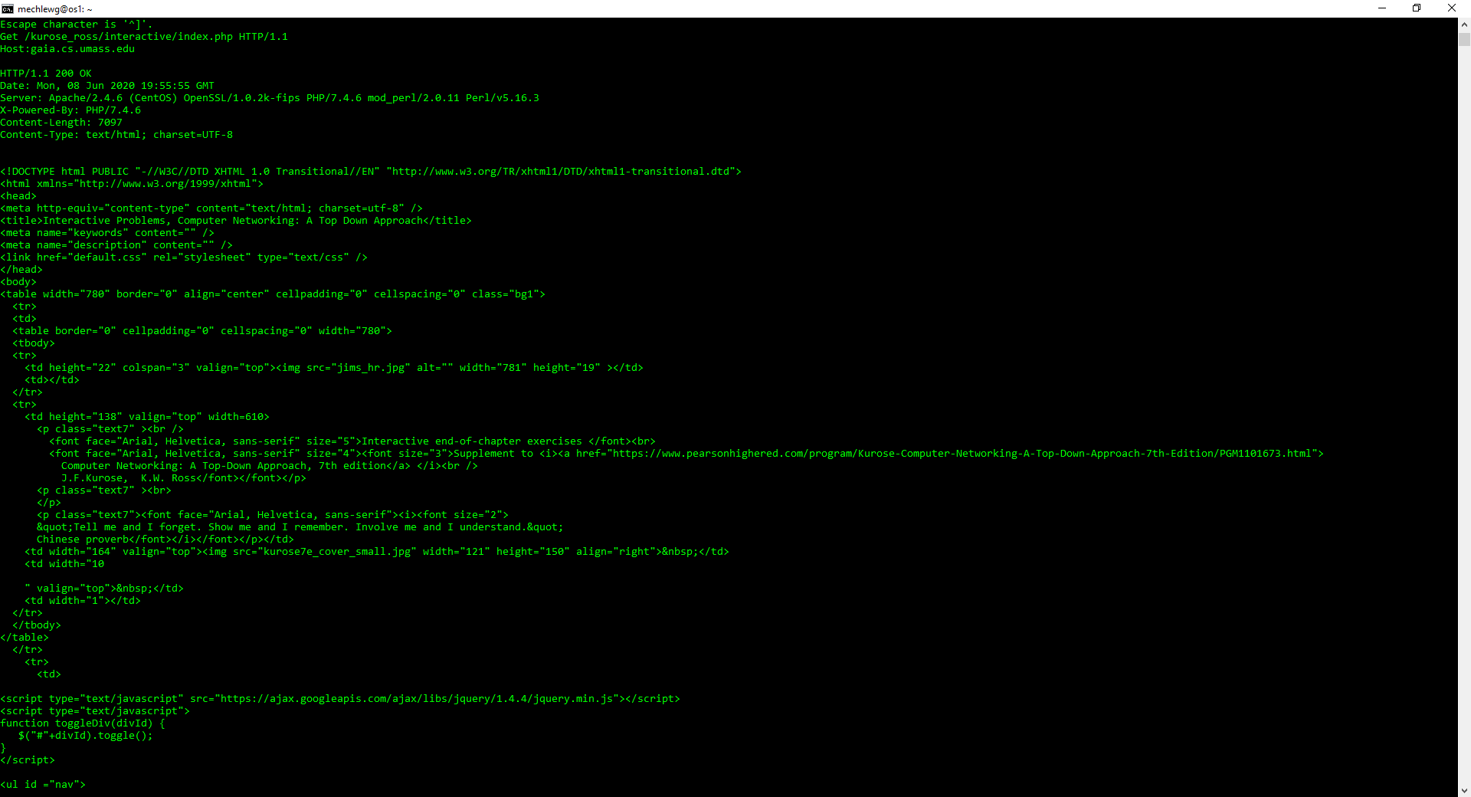

Try the following server and URL as well:

|  |  |
| --- | --- |
|  | **telnet cis.poly.edu 80**  **GET /~ross/ HTTP/1.1**  **Host:cis.poly.edu** |

NB: You have to press Enter twice after 3rd line of the Host: command to get the result and make sure that you capture a screen that will show HTTP 200 OK

The result should be some valid content, meaning it should NOT be any connection error, time out etc.

Attach in the report what you get from above site.

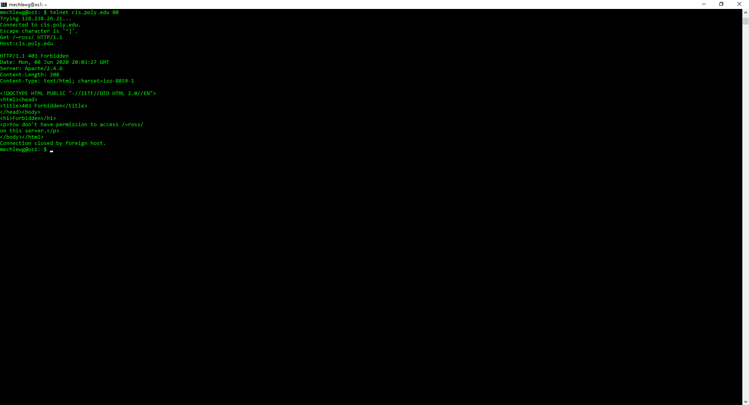

# Part 5: Submit to Canvas

* No late assignments will be accepted!
* This work is to be done individually
* This MS-Word document (duly filled-in) saved as a PDF document.
* The submission file will be saved with the name ***Lab3_yourMUID.pdf***
* Assignment is Monday, June 8 before Midnight
* On or before the due time, drop the *electronic copy* of your work in the *canvas*

Don’t forget to Turn in the file! Lab3_yourMUID.pdf