William Medley, II
Dr. Lamprecht
CIS 369 01
2/12/18
Lab 1: Tickets Issued
For this lab, we had to create a form that issued tickets to guest. The two forms were named ticketing system assignment, and ticketing system options. The ticketing system options form pops up first because you are inputting the data for first ticket number, guest per window, minutes per window, start time, and end time. The ticketing system assignment is for officially issuing the tickets to the guest with total tickets issued and next available entry. Once you have set up both forms, and name it correctly, you can finally start coding. Within the coding we had to add data verification to the options form to ensure that the user enters acceptable values for all textboxes. For the verification code we use the IsPresent method and a modified IsDouble method from the Review notes. Then add a message box to display a message when all possible tickets have been issued and disallow any further tickets to be issued.
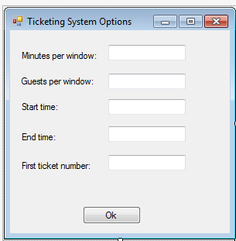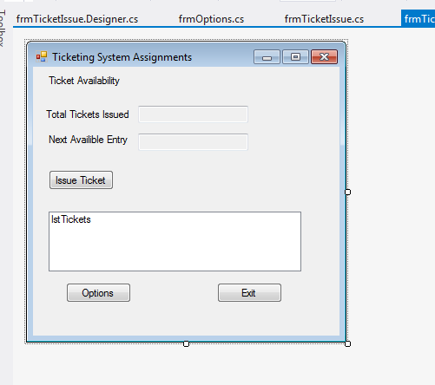
Figure 1 The setup of the ticketing system option form Figure 2 The setup of the ticketing system assignment form
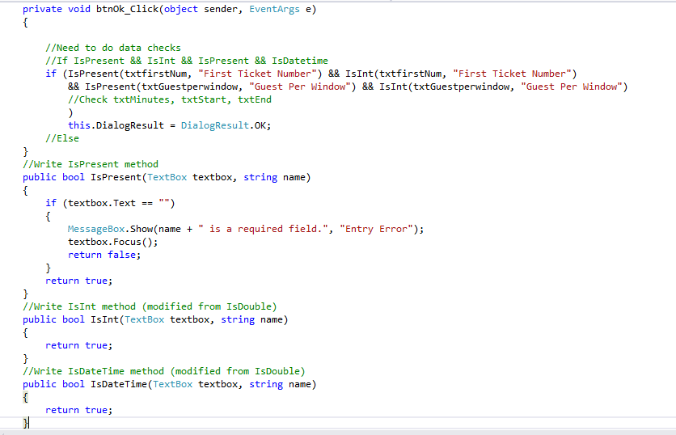
Figure 3 The ticketing system option form code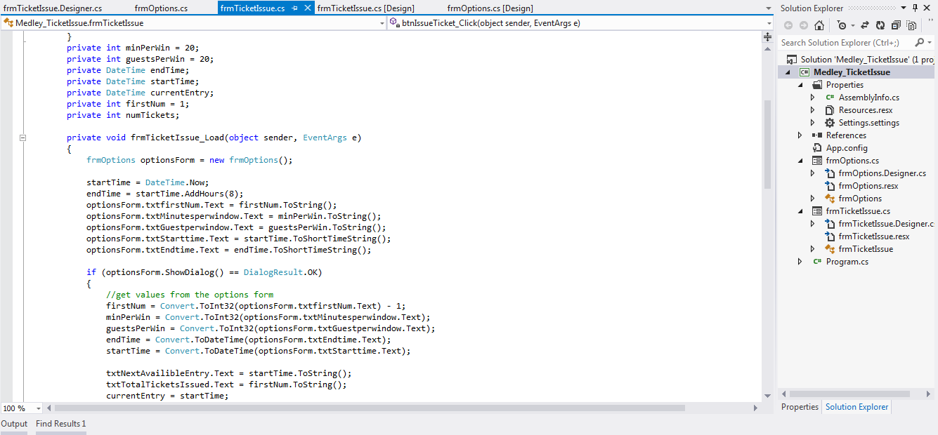
Figure 4 Part one of the ticketing system assignments form code
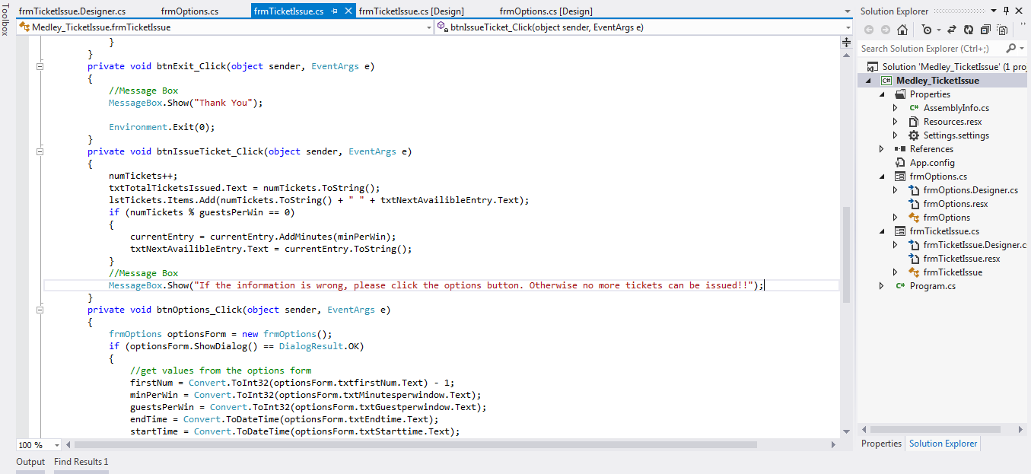
Figure 5 Part two of the ticketing system assignments form code
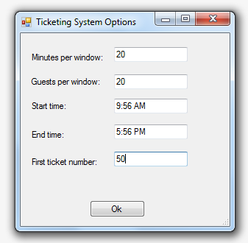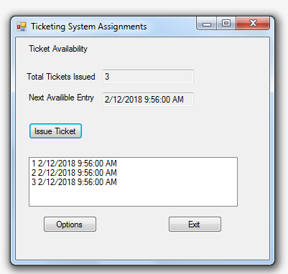
Figure 6 Part one of the forms in play Figure 7 Part two of the forms in play
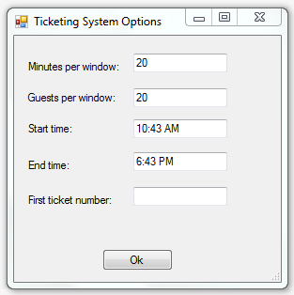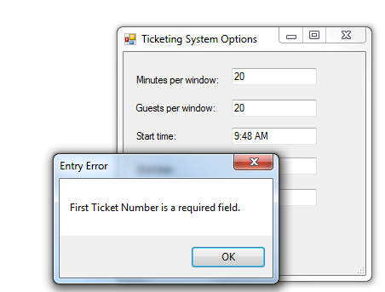
Figure 8 Part one of the empty field Figure 9 Part two of the empty field and the error message
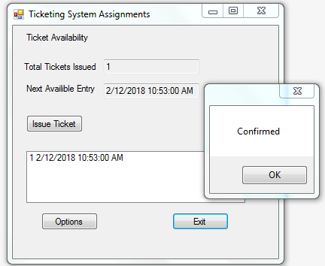
Figure 10 The pop up message confirming the tickets issued

