|  |  |  |
| --- | --- | --- |
|  | Available online at www.sciencedirect.com | AASRI |
|  |
|  | Procedia |
|  | AASRI Procedia 1 ( 2012 ) 480 – 485 | www.elsevier.com/locate/procedia |

2012 AASRI Conference on Computational Intelligence and Bioinformatics

A Vehicle Detection Algorithm Based on Compressive Sensing and Background Subtraction

Yiqin Caoa,Zhangming Leia,*,Xiaosheng Huangb,Zhen Zhanga,Tao Zhonga

*aSchool of software,East China Jiaotong University,Nanchang,330013,China*   
*bSchool of Information Engineering,East China Jiaotong University,Nanchang,330013,China*

**Abstract**

An efficient vehicle detection method is a necessity for the intelligent transportation system under the complicated traffic environment at present. To solve the problems of large computation and the poor real-time in traditional vehicle detecting methods, this article proposes a real-time vehicle detecting algorithm integrated compressive sensing (CS) theories and background subtraction method. In addition, this paper undertakes the reconstruction of foreground image of vehicle based on the orthogonal matching pursuit (OMP) algorithm. Proved by the experimental result, the proposed vehicle detection algorithm could produce higher precision detection, smaller calculation and higher-quality reconstructed image compared to the traditional ones.

2012 Published by Elsevier B.V. Selection and/or peer review under responsibility of American Applied Science Research Institute Open access under [CC BY-NC-ND license.](http://creativecommons.org/licenses/by-nc-nd/3.0/)

*Keywords*: CS (compressive sensing); background subtraction; image reconstruction; OMP (orthogonal matching pursuit)

**1. Introduction**

The urban traffic has been developing rapidly. However, traffic accidents and road congestions have emerged along with an increasing number [1] which result in enormous casualties and economic losses.

* Corresponding author. Tel.: +8615979053735.   
*E-mail address:* leizhangming168@126.com.

2212-6716 © 2012 Published by Elsevier Ltd. Open access under [CC BY-NC-ND license.](http://creativecommons.org/licenses/by-nc-nd/3.0/) doi: 10.1016/j.aasri.2012.06.075

*Yiqin Cao et al. / AASRI Procedia 1 ( 2012 ) 480 – 485*  481

Intelligent transportation system has attracted plenty of researchers. As one of the essential steps, vehicle detection [1] is extremely significant for video intelligent traffic monitoring system.

The common methods for moving vehicle detection contain: optical flow [2], frame subtraction [3], and background subtraction [4]. For optical flow algorithm, it is of greatly large calculation and without of the real-time monitoring function. In view of the frame subtraction, it is hardly to get the complete vehicle information and the vehicle at low speed can not be detected. The background subtraction used in this article is the more popular algorithm at present [5-6]. At the earliest, Wren proposed the running-Gaussian-average background subtraction algorithm [7]. He believed that each pixel of the background image was independent and satisfied the Gaussian probability function. The algorithm was very fast and required small storing space, but the result of the background image was not good. Later, Koller made improvement in background updating, which did litter work on the basic of the former algorithm and increased the calculation. To suit the complicated external environment, Stauffer and Grimson carried out the background subtraction method based on Gaussian mixture model [8]. The algorithm obtained good performance for target detection, but was restricted to the calculation. Though many researchers proposed modifications for the model [9], it was difficult to solve the problem. The algorithms above are assessed in terms of the computing speed, the storage volume and complexity under the premise of the favourable detection. Then the target detecting methods based on data compression was emerged. B.Ugur suggested the wavelet-domain target detection algorithm [10]. Considering that the vehicle target possesses a small part in the background image which agrees to the characteristic of compressive sense sparse, this article integrates compressive sensing [11-13] and background subtraction method. The algorithm operates compressive sample on background image and input image respectively, from which the compressive measurement will be received, then subtracts the measurements of background image and input image to get the measurement of the target vehicle, and precisely reconstructs the vehicle information by orthogonal matching pursuit algorithm at last. As the background update is just conducted on the measurements, the calculation is largely decreased.

**2. The compressive sensing theory**

|  |  |  |  |  |  |  |  |  |  |  |
| --- | --- | --- | --- | --- | --- | --- | --- | --- | --- | --- |
| Suppose that we have an image X of size *N* 1�*N* 2 and we vectorize it into a column vector **x** of size *N* �1  ( *N*�*N* 1�*N* 2 ) by concatenating the individual columns of X in order. The *n*th element of the image vector **x**  is referred to as *x*(n), where *n*�1,�, *N* . Let us assume that the basis � �[ 1�,�,�*N*] provides a K-sparse  representation of **x**: | | | | | | | | | | |
| *x* | | � | *N* ��( )�*n*  *n*�1 | � | *K* ��(  *l*�1 | *n l* | )�*n l* | | , | *(1)* |
| where ( )�*n* | is the coefficient of the *n*th basis vector � ( *n* � : *n* | | | | | | | *N* � ) and the coefficients indexed by | | *ln* are |

the K-nonzero entries of the basis decomposition. Equation (1) can be more compactly expressed as follows

|  |  |  |  |  |  |  |  |  |  |  |
| --- | --- | --- | --- | --- | --- | --- | --- | --- | --- | --- |
| *x* | | | � �� | *(2)* | | | | | | |
| where � is an | | *N* � column vector with K-nonzero elements. Using || ||*p* | | to denote the | | | � norm where | | | |
| the | � norm simply counts the nonzero elements of � , we call an image X as K-sparse if | | | | � | ��0 | | � | *K* | . |

|  |  |  |  |  |  |  |  |  |  |  |  |  |  |  |  |  |  |  |  |  |
| --- | --- | --- | --- | --- | --- | --- | --- | --- | --- | --- | --- | --- | --- | --- | --- | --- | --- | --- | --- | --- |
| 482 | *Yiqin Cao et al. / AASRI Procedia 1 ( 2012 ) 480 – 485* | | | | | | | | | | | | | | | | | | | |
| In the CS framework, it is assumed that the K-largest ( )�*n* | | | | | | | | are not measured directly. Rather, *M* | | | | | | | | | | | | �*N* |
| linear projections of the image vector **x** onto another set of vectors | | | | | | | | | � � | [ ,....,�1 �� � | are measured: | | | | | | | | | |
| *y* | | | | | � � � ���, | | | | | | | *(3)* | | | | | | | | |
| where the vector | *y M* �1) | constitutes the compressive samples and the matrix | | | | | | | | | | | � | ( | *M* | � | *N* | ) | is called the | |
| measurement matrix. Since *M* | | | �*N* | , recovery of the image X from the compressive samples y is | | | | | | | | | | | | | | | | |
| underdetermined; however , as we discuss below, the additional sparsity assumption makes recovery possible. | | | | | | | | | | | | | | | | | | | | |
| There exists a computationally efficient recovery method based on the following | | | | | | | | | | | | 1� -optimization problem | | | | | | | | |
| [11-12]: | | | | | | | | | | | | | | | | | | | | |
| min �1�. . | | | | | | *y* | � ��� | | | | | *(4)* | | | | | | | | |

This optimization problem, also known as Basis Pursuit [11], can be efficiently solved using polynomial time algorithms.

**3. Vehicle detection algorithm based on CS**

Applying the background subtraction method based on CS, in this paper, the measurements of the video is firstly obtained through the compressive sample operated on the input video images. And then, the measurements of the background image will be achieved from the estimation of the former measurements. Besides, the background image needs real-time update considered about the changes in external environment. When conducting the background subtraction, the differential threshold operation should be undertaken on the measurements of background model and measurements of the real-time video frame image to determine whether there existed moving vehicle in the frame image. If there is no existence, drop the image. Otherwise, reconstruct the target vehicle image through the OMP image reconstruction algorithm in Ref. [14].

*3.1. Background modeling and updating*

As background subtraction target detection algorithm has been widely applied to monitoring systems, the method of background subtraction is expanded to the image data compression domain [10]. In this paper, we use the data compression based on CS to realize background subtraction that estimating the measurement of

|  |  |  |  |  |  |  |  |  |  |  |  |  |  |  |  |  |  |  |  |  |
| --- | --- | --- | --- | --- | --- | --- | --- | --- | --- | --- | --- | --- | --- | --- | --- | --- | --- | --- | --- | --- |
| the background image from the video-image measurement. Suppose that | | | | | | | | | | | | | | | | | | *X* , *n* | *B* represents the input image at *n* | |
| present and the background image, respectively. And *y* is the measurement of *bn*  *B* , *n*  *y* is what to *tn*  *X* . Then, *n*  at the time of *n* � , the measurement *ybn*1� of background image *B* � could be stated as expression (5). | | | | | | | | | | | | | | | | | | | | |
| *y bn* | �1 | ( ) | ��*y bn* ( )� �  �*y bn* ( ), | | | � | (1 | | � | �)( | *y tn* | ( ) | | � | *y bn* | ( )), | *there is moving in i* | | | *(5)* |
| *there is non* | | | | | | | � | *moving in i* | | | | | |
| *i* | | | | | | | | | � | 1,2,..., | | | *M* | | | | | | | |
| where � is a constant satisfied 0 | | | | � �� | | 1 | | , M is the number of measurements, *i* represents the | | | | | | | | | | | | |
| corresponding position of the measurement, | | | | | *by*0 | | is the measurement of the first frame image | | | | | | | | | | | | | *X* . 0 |
| At position *i*, if the condition satisfies expression (6), it means the existed moving target at the position. | | | | | | | | | | | | | | | | | | | | |

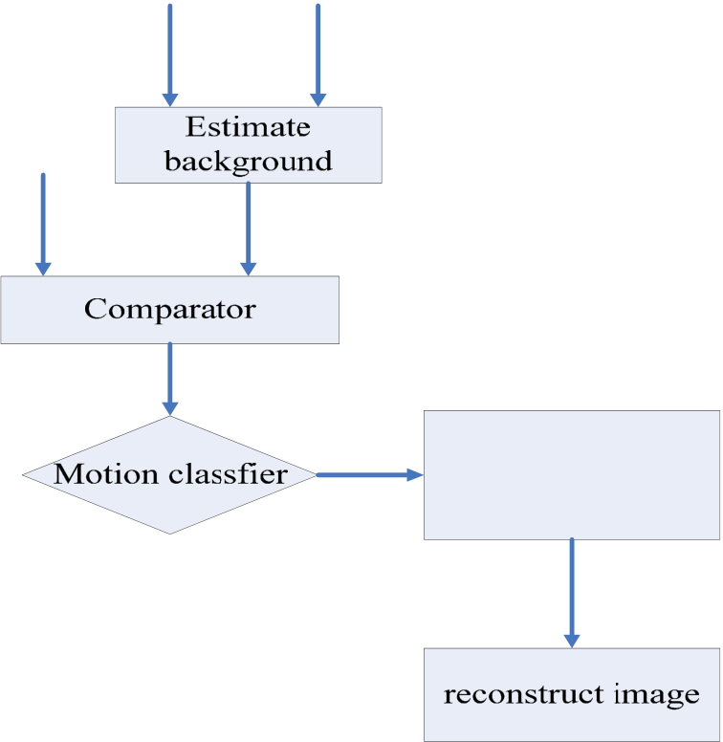

|  |  |  |  |  |  |  |  |  |  |  |  |  |  |  |  |  |  |  |  |  |  |  |  |
| --- | --- | --- | --- | --- | --- | --- | --- | --- | --- | --- | --- | --- | --- | --- | --- | --- | --- | --- | --- | --- | --- | --- | --- |
| where | *Yiqin Cao et al. / AASRI Procedia 1 ( 2012 ) 480 – 485* | | | | | | | | | | | | | | | | | | | | | *(6)* | 483 |
| | | | | | | | *y tn* | | | ( ) | � | *y tn* | | | �1 | ( ) |� | | | *T i n* ( ) | | |
| *nT i* is a threshold of the real-time update. The update strategy is depicted as below. | | | | | | | | | | | | | | | | | | | | |
| *T n* | �1 | ( ) | �*aT i n* ( )� �  �*T i n* ( ), | � | (1 | � | | *a b y tn* | | | | | | ( ) | | � | *y bn* | | ( ) |), | *there is moving in i* |
| *there is non* | | | | | | | | � | | *moving in i* | | | | | | *(7)* |
| *i* | | | | | | | � | | 1,2,..., | | | | *M* | | | | | | | |

where *a* is an integer close to 1, *b* is a number greater than 1. The threshold could be adjusted by changing the value of *a* and *b*.

*3.2. Sparse representation for background subtraction image*

In traditional background subtraction method, the first step is to build the background model, then to conduct the subtraction between the input image and background image, set the threshold for subtracted image, and finally get the target. Though a great many of researchers’ works on the background modeling method, it is difficult to achieve the perfect result. What’s more, the estimation conducted through background modeling and updating for every pixel will make the calculation very large. The compressive sensing method used in this text overcomes the problem in traditional method which does not need modeling and updating for each pixel and is of no necessity for background image reconstruction. Instead, the proposed method subtracts on the measurement of background image compression sensing and it of the input image, as shown in expression (8).

|  |  |  |  |  |  |  |  |  |  |  |  |  |  |  |  |  |  |
| --- | --- | --- | --- | --- | --- | --- | --- | --- | --- | --- | --- | --- | --- | --- | --- | --- | --- |
| | | | | *y tn* | ( ) | � | *y bn* | ( ) |� | *T i*�( ) | | | | | | | | | *(8)* |
| where | *T i*�( ) | is the subtracted threshold updated by expression (7). | | | | | | | | | | | | | | |
| The flow chart of the vehicle detecting algorithm is illustrated as following. | | | | | | | | | | | | | | | | |
| *ytn* | | | *y bn* | | | | | | | | | | | | | |
| *y tn* | | | *ybn*1 | | | | | | | | | | | | | |
| | | | | | | | | | *y* | *tn* | ( ) | � | *y* | *bn* | ( ) |� | *T n* | ( ) |

*measurement at i*

*belongs to a moving*

*object*

Fig.1 the flow chart

484  *Yiqin Cao et al. / AASRI Procedia 1 ( 2012 ) 480 – 485*

**4. Experiment and analysis**

The proposed algorithm was experimented under the environment of Matlab 2009. Fig.2 was the 50th frame of the traffic video self-recorded. Fig.3 was the result of the steps that compressively sampled from each frame of the image by random observation matrices, got the value of the 50th frame of the background image measured by background modeling and updating according to expression (5), and reconstructed the foreground image of vehicle for observation. The vehicle detecting result was shown in Fig.4, from which the complete and accurate vehicle contour was almost obtained.

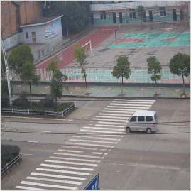

Fig.2 the 50th frame of the self-recorded video

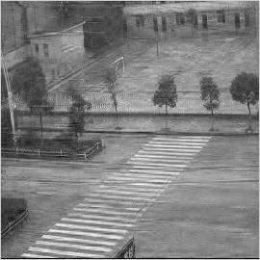

Fig.3 the background image of the 50th frame

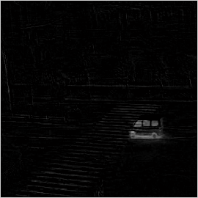

Fig.4 the detecting result

*Yiqin Cao et al. / AASRI Procedia 1 ( 2012 ) 480 – 485*  485

**5. Conclusions**

As an important part of modern intelligent transportation system, the high-efficient vehicle detecting algorithm has great significance for improving the reliability of intelligent transportation. For the characteristics of small amount of data for compressive sample and high precision for construction, the compressive sensing theory is suitable to apply to the vehicle detecting algorithm. As the few amount of the measurements on each frame of image through background model calculation, it is greatly decreased on computing operation. Proved by the experimental result, the proposed vehicle detection algorithm could produce higher precision detection, smaller calculation and higher-quality reconstructed image compared to the traditional ones.

**Acknowledgements**

This work is supported by the Foundation of postgraduate innovation of Jiangxi Province under Grant No.YC2011-S082.

**Reference**

[1] Zehang Sun, Bebis G, Miller, et al. On-road vehicle detection: A review. IEEE Transactions on Pattern Analysis and Machine Intelligence, 2006, 28(5): 694-711.

[2] BARRON J L, FLEET D J, Beauchem in S S. Performance of optical flow techniques. International Journal of Computer Vision, 1994,12(1): 43-47.

[3] ALI A T, DAGLESS E L. Alternative practical methods for moving object detection. International Conference on Image Processing and its Applications. Maastricht,1992: 77-80.

[4] HARITAOGLU I, HARWOOD D, DAVIS L S. Real-time surveillance of people and their activities. IEEE Transaction on Pattern Analysis and Machine Intelligence, 2000, 22(8): 809-830.

[5] Surenda Gupte, Osama Masoud, Robert F,K. Martin, et al. Detection and classification of vehicles. IEEE Transactions on Intelligent Transportation Systems,2002, 3(1): 413-417.

[6] Massimo Piccardi. Background subtraction techniques: a review. IEEE International Conference on Systems,Man and Cybernetics. 2005, 58(4): 3099-3104.

[7] C. Wren, A. Azarbayejani, T. Darrell, and A.P. Pentland. real-time tracking of the human body. IEEE Trans. on Pattern Anal. And Machine Intell.1997, 19: 780-785.

[8] C. Stauffer and W.E.L. Grimson, Adaptive background mixture models for real-time tracking, Proc.IEEE CVPR 1999.USA:Fort Collins;1999.

[9] A. Elgammal, D. Harwood, and L.S. Davis, Non-parametric model for background substraction. Proc. ECCV 2000, UK: London;2000.

[10] B. Ugur Toreyin, A. Enis Cetin, Anil Aksay et al.Moving object detection in wavelet compressed video. Signal Processing:Image Communication. 2005, 20(3): 255-264.

[11] DONOHO D L. Compressed sensing. IEEE Transaction on Information Theory, 2006, 52(4): 1289-1306. [12] CANDES E, ROM BERG J, TERENCE T. Robust uncertainty principles Exact signal reconstruction from highly incomplete frequency information. IEEE Transaction on Information Theory. 2006, 52(2): 489-509.

[13] BARANIUK R. A lecture Compressive sensing. IEEE Signal Processing Magazine, 2007, 24(4): 118-121.

[14] Tropp J, Gilbert A. Signal Recovery from Partial Information via Orthogonal Matching Pursuit. IEEE Transactions on Information Theory, 2007, 53(12): 4655-4666.