[Array 19 (2023) 100315](https://doi.org/10.1016/j.array.2023.100315)

|  |  |  |
| --- | --- | --- |
|  |  |  |
|  | Contents lists available at ScienceDirect |  |
| Array |
| journal homepage: [www.sciencedirect.com/journal/array](https://www.sciencedirect.com/journal/array) |

Affective state prediction of E-learner using SS-ROA based deep LSTM Snehal Rathia,*, Kamal Kant Hiranb, Sachin Sakharea   
a *Department of Computer Engineering, Vishwakarma Institute of Information Technology, Pune, India*   
b *School of Computer Science and IT, Symbiosis University of Applied Sciences, Indore, India*

|  |  |
| --- | --- |
| A R T I C L E I N F O | A B S T R A C T |
| *Keywords:*  E-learning  Higher education  Affective states  Deep LSTM  Squirrel search algorithm  Rider optimization algorithm and Interaction log | An affective state of a learner in E-learning has gained enormous interest. The prediction of the emotional state of a learner can enhance the outcome of learning by including designated mediation. Many techniques are developed for anticipating emotional states using video, audio, and bio-sensors. Still, examining video, and audio will not confirm secretiveness and is exposed to security issues. Here the creator devises a fusion technique, to be specific Squirrel Search and Rider optimization-grounded Deep LSTM for affect prediction.  The Deep LSTM is trained to exercise the new fusion SS-ROA. Then, the SS-ROA-grounded Deep LSTM clas-sifies the states like frustration, confusion, engagement, wrathfulness, and so on. It is based on the interaction log data of the E-learner. In conclusion, the course and student ID, predicted state, test marks, and course completion status are taken as result information to find out the correlations. The new algorithm gives the best performance in comparison to other present methods with the highest prediction accurateness of 0.962 and the most note-worthy connection of 0.379 respectively. After discovering affective states, students may get the advantage of getting real comments from a teacher for improving one’s performance during learning. However, such systems should also give feedback about the learner’s affective state or passion because it greatly affects the student’s encouragement toward better learning. |

**1. Introduction**

The emergence of E-courses helps to increase learning opportunities for individuals by allowing them to access premium courses at any time and from any location. As a result, the sharing of educational resources can greatly improve the spirit of learning [1]. Throughout many years, a vast range of online learning platforms have emerged. As a result, the quality of online education is regarded as a key component of an educational system [2].

In contrast to traditional learning methods like in-person instruction, research indicates that e-learners are less committed and transmit less knowledge. These poor results have ascribed to an asynchronous nature of interaction and hence lack of learning [3]. In a traditional classroom, it is possible to dynamically monitor student moods, lack of inspiration or focus, and interest in a particular subject. Yet, in digital learning platforms, this kind of sentiment analysis becomes a significant problem [4].

Even though e-learning platforms offer convenient learning ways and plentiful qualitative courses around the globe, they still face the problem of low completion rates [5]. Previous studies have expressed

that rates of completion using these platforms are as low as 7–11%. Less motivation among students and a lower perception of the value of courses are some causes of this [6]. So, it is crucial to understand and provide comments on the engagement of the learner in real-time [7].

By analyzing interaction logs or educational data, one can forecast a learner’s performance [8]. Due to the diverse motivations of learners for attending the course, the free online course has low commitment and knowledge transfer [9]. In corporate training, businesses in the USA invest roughly in billions. Employers, however, are not pleased with the knowledge transfer [10].

Research in specific fields such as data mining in education, cogni-tive science, multimodal learning, and psychology has made compelling progress in learning analysis. It is guaranteed to monitor learner engagement and improve learning effectiveness in online learning [7].

Data mining provided relationships between various variables developed based on activity records of students and student perfor-mance. Attributes that show a reasonably high correlation with the performance of students are used as improved predictors. These vari-ables are said to be relevant because they can be used to predict at-risk students [11]. Affordable online education has attracted the attention of

* Corresponding author.

*E-mail addresses:* [snehal.rathi@viit.ac.in](mailto:snehal.rathi@viit.ac.in) (S. Rathi), [kamalkant.hiran@suas.ac.in](mailto:kamalkant.hiran@suas.ac.in) (K. Kant Hiran), [sachin.sakhare@viit.ac.in](mailto:sachin.sakhare@viit.ac.in) (S. Sakhare).

<https://doi.org/10.1016/j.array.2023.100315>   
[Received 18 April 2023; Received in revised](https://doi.org/10.1016/j.array.2023.100315) form 25 July 2023; Accepted 30 July 2023   
Available online 2 August 2023   
[2590-0056](http://creativecommons.org/licenses/by-nc-nd/4.0/)/© 2023 The Authors. Published by Elsevier Inc. This is an open access article under the CC BY-NC-ND license (<http://creativecommons.org/licenses/by-nc-nd/4.0/>).

*S. Rathi et al.*  *Array 19 (2023) 100315*

the government, which provides educational guidelines [12].

Given the classical teaching method and the high student-teacher ratio, the teacher has additional problems in the auditorium. Tradi-tionally, trainers delivered content and learners learned it. This approach usually does not allow the teacher to respond to the individual requirements of the learners [13]. Also, due to the large number of learners in the auditorium, the instructor cannot focus on individual learners [14]. For evaluation, they conduct examination at the end of each course. Despite the large number of learners in the classroom, skilled teachers typically observe, address, and identify learners’ emotional states [15].

Research in areas such as multimodal learning, psychology, and other fields has made significant progress and has attracted a great deal of attention to improving learning efficiency in e-learning platforms [16]. Most of the applications focus on achieving learning engagement or identification. Efforts focus on the learner’s emotional state, including anxiety, learner attention, boredom, frustration [17], or evaluation by quizzes and coursework [7].

Additionally, Predictive Learning Analytics (PLA) [3] helps in-structors improve course quality. At-risk student predictions [3], exam grades, and quiz scores [3] show that is likely to have an absolute impact on the learning experience. The best-known predictive model for pre-dicting the performance of students is the Artificial Neural Network (ANN) [18].

Affect in learning play a very prominent role in education. Accu-rately predicting emotional states can improve learning outcomes using interference, which fine-tunes changes in a learner’s emotional state [19]. Various methods are available to classify emotions using acoustic, video, and biosensors. However, systems relying on these modalities cannot ensure confidentiality and are subject to privacy concerns.

It is very essential to apprehend the course complexity of engineering courses and their impacts on the state of E-Learners. Therefore, we want to devise an algorithm for E-Learner’s affective state prediction by considering engineering courses of different complexity. At first, three courses, Data Structure and Files (C1), Data Base Management and System (C2), and Human Computer Interface (C3) are viewed for the experimental study. The above noted three courses have High, Medium, and Low complexity. Different learners are made to learn these courses online. Based on the studying behavior of learners in LMS, a log file is recorded.

Each learning behavior log file carries the important points of course ID, topic ID, Lecture ID, lecture type, time spent, opening time, closing time, and the examination rating of the learners. Then, the feature in-dicators are extracted. Based on the features and using Deep LSTM, the affective states of the learners are predicted. The proposed SS-ROA is used to train Deep LSTM. The SS-ROA is devised through a combination of Squirrel Search and Rider Optimization Algorithm. Thus, SS-ROA- based Deep LSTM predicts the different affective states.

The key contributions of this paper are:

• Proposed SS-ROA: This algorithm is devised through a combination of Squirrel Search (SS) and Rider Optimization Algorithm (ROA) and it optimizes the training of neural network and hence enhances the performance.

• Proposed SS-ROA-based Deep LSTM for prediction of affective states: The affective states of E-learner are predicted using Deep LSTM which is trained using proposed SS-ROA

Other sections of the paper include: Section 2 displays an explanation of affective state prediction methods used in earlier works. The proposed method for affective state prediction using SS-ROA-based Deep LSTM is shown in the 3rd Section. The analysis of techniques is depicted in Section 4 and Section 5 provides the conclusion.

2

*S. Rathi et al.*  *Array 19 (2023) 100315*

researchers and designers looking for methods for the enhancement of human-computer interfaces by way of synchronizing emotion and knowledge [28]. Affective Computing makes the chance of developing computational frameworks for acknowledgment of human affective states. It minimizes the gap between intensely emotional individual and the emotionally challenged computer [28]. Subsequently, Affective Computing research is an interdisciplinary area. It investigates human affective involvement with technology by combining engineering and computer knowledge with different domains like brain science, intel-lectual science, humanism, education, and morals [29].

A modern couple of years have considered a flood in the utilization of multidisciplinary techniques to consider the hard position of feelings in learning. Affective computing is a growing subject uniting scientists and professionals from distinctive fields, extending from Artificial Intelli-gence (AI), and Natural Language Processing (NLP) to cognitive and sociology [30]. Emotion data is utilized to enhance studying [31]. Here, affirmative and distrustful feelings are perceived with the aid of the usage of two models, particularly behavioral logs and biosensors. Fusion of it is done using a Bayesian Network [32].

Neurological proof indicates that the online studying surroundings will no longer be luxurious if the affective states or psychological stip-ulations of learners are not considered. Here authors have featured a few consequences from the neurological literature which display that emo-tions play a critical job in individual thoughts and knowledge, but in addition in critical thinking and conclusion-making of humans. Personal Computers (PCs) that will collaborate logically and cleverly with humans have to apprehend and express affect [33].

Sandanayake and team [34] have constructed a gadget to compre-hend college students online learning to know overall performance whilst estimating the emotional state. They utilized a regression approach to categorize emotions. They have gathered the time used up on lessons, studying action, chat gathering, taking a look at marks, perusing, and course time on LMS. Surveys have been utilized for perceiving the learners’ affective states.

The assessment was carried out by using Khan F.A and group [35] set-up methodology to get more correct outcomes. Here learners are given a chance to finish lessons at their speed and preferences. The re-cords used to be gathered in the log report and a Bayesian network is used to classify affective states. Correlation between interaction log and questionnaire response used to predict the same. The effects had been practically the same, but larger realness was once obtained via the interaction log method. The model used in this research demonstrates a real-time method of getting learners’ affective states through the log of interaction and preferences. This effect constantly evaluates modifica-tions in the learner’s emotional states.

V. Chitraa [31] led a study on pre-processing techniques for behav-ioral logs utilized in web usage mining. The facts were once pre-processed to clean the records and afterward put in an information set. Session ID, Learner ID, and path completion records were used in the dataset. The Apriori algorithm was utilized for finding the patterns. According to investigations of Pekrun [36], the thoughts related to learning change on a massive scale. Anxiety is the most straight was inferred. Aside from this, the accompanying emotions related to study-ing had been boredom, anger, relief, satisfaction, and enjoyment. However, their assessment had a constraint of no longer enabling an actual conclusion structured on motives of feelings.

According to Manasi Chakurkar [37], user logs had been saved to analyze an area of interest of users. This gave customized advice struc-tured on the learner’s behavior. The result of this web usage content mining was utilized to personalize the e-learning framework itself.

Some experiments perceived feelings using biosensors [38,39], and some made use of a fusion of bio-sensors and facial expressions. The sensors would record changes in the nervous system of the body. They utilized SVM calculations for making ready data and perceiving feelings [40,41].

In a few experiments, information is collected from sensor-based

3

*S. Rathi et al.*  *Array 19 (2023) 100315*

the couple of years. Few of them are “I) Gradient Descent (GD), II) Stochastic Gradient Descent (SGD), III) Mini-Batch Stochastic Gradient Descent (MB-SGD), IV) SGD with Momentum, V) Nesterov Accelerated Gradient (NAG), VI) Adagrad, VII) AdaDelta and VIII) Adam”. Each one of it is enjoying its benefits and inconveniences. They have challenges like may get trap at local minima, Takes quite a while to converge and computationally costly. To overcome these challenges a novel optimizer is required.

By looking at literature survey, now, it is time to do an investigation of “How to beautify the accuracy of the technique used to predict af-fective state?” and “Will this prediction have any relationship with the complexity of the course taken by the students? What is the effect of optimization algorithm while training the Deep LSTM for prediction of affective states?

Here, it is proposed to construct an efficient and accurate prediction algorithm that will pick out the learners’ affective states during learning online engineering courses of different complexity. Affective states get recognized through the use of an interaction behavioral log. The novel optimization algorithm is designed to train neural networks used for the prediction of affective states.

*2.2. Challenges*

The issues suffered by the classical learning management system are

enlisted below.

• To alleviate the impact of lack of supervision.   
• Performance prediction due to per-student assessment response sparsity is challenging [10].

• Procrastination is one of the biggest challenge [11].   
• Identifying affective states for course is a big challenge.   
• The factors affecting student performance due to course complexity, learning styles, and affective states need to be addressed

• Need to identify a novel method for the detection of Affective States. • Need to have a novel optimization algorithm for training neural networks while predicting Affective States.

• No standard dataset based on interaction logs is available. • No benchmark for labeling the dataset is available.

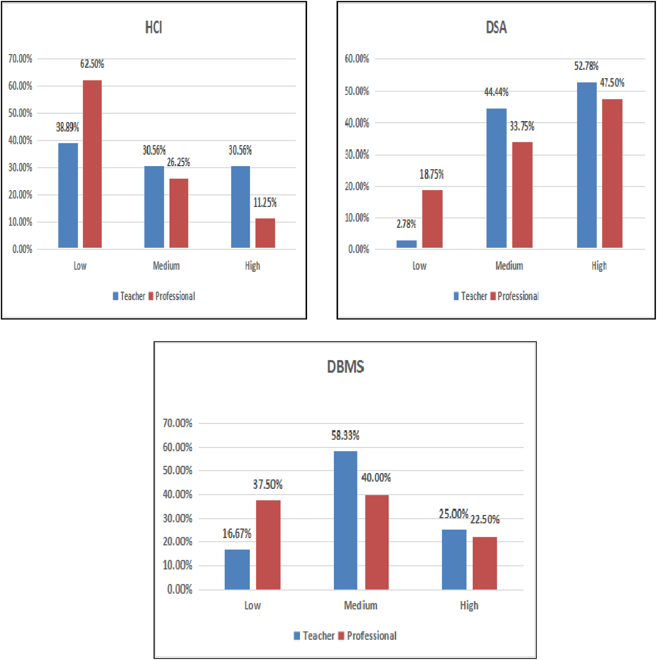

**Fig. 1.** Perceived course complexity: Survey outcome.

4

*S. Rathi et al.*  *Array 19 (2023) 100315*

**3. Proposed SS-ROA-based deep LSTM for affective state prediction**

An e-Learning system should focus on the acquisition of knowledge and cognition. The system can use affective state recognition for iden-tifying emotions while structuring the courses. This research aims to develop an efficient method of recognizing e-learners’ emotions for HCI study applied to courses of varied complexity. The three courses that were selected for the experimental study are Data Structures and Files (C1), Data Base Management and System (C2), and Human-Computer Interaction (C3) have High, Medium and Low complexity respectively. These courses were selected after analyzing data of perceived complexity collected from the survey of professionals and teachers.

To measure the perceived cognitive complexity of various engi-neering courses, a survey of teachers and computer and IT professionals is conducted. As shown in Fig. 1, Data Structures and Files (C1), Data Base Management and System (C2), and Human-Computer Interface (C3) are considered High, Medium, and Low complex subject respectively.

A log of interaction with the Learning Management System (LMS) was recorded to capture the learning behavior. The log file comprises the details of the course, topic, type of topic explored, time spent on different activities, and the exam score of learners. Then, the features were identified and Deep LSTM [48–50] was performed to identify the learner’s affective state. It was trained using the proposed SS-ROA which was developed through a combination of the Squirrel Search Algorithm (SSA) [51] and Rider Optimization Algorithm (ROA) [52]. Hence, the SS-ROA-based Deep LSTM was found more effective in predicting the different affective states including engagement, frustration, confusion, boredom, anger, and surprise. Finally, a correlation study was per-formed between affective state outcome with exam scores and course completion. Fig. 2 portrays the block diagram of the affective state prediction model using proposed SS-ROA-based Deep LSTM.

As shown in Fig. 2, the learner’s behavior data is recorded for identified 3 subjects namely data structures and files, database man-agement and system, and human-computer interface. These subjects have High, Medium, and Low complexity respectively. Each course has five units and each unit has topics with ten lectures which contain four

videos of 1 h, two documents, one PDF, one PPT, and two exams. The log is recorded for more than 100 students while studying these subjects. Student ID, Course ID, Topic ID, Lecture ID, Type of document (Video/ PPT/PDF/DOC), Opening and Closing time is recorded.

Extracted Features from the recorded data are.

**EF1:** Signifies the number of lectures covered.

**EF2:** Indicates the number of topics covered.

**EF3:** Represents the number of videos covered.

**EF4:** Symbolizes the number of documents covered (pdf/doc/ppt). **EF5:** Indicates the number of exams attended.

**EF6:** Signifies frequency ID (Morning/evening/afternoon/night). **EF7:** Denotes learning time.

**EF8:** Represents occurrence of sign_in.

The feature vector can be modeled by combining all the aforemen-tioned features.

*3.1. Affective state prediction of the student using proposed SS-ROA- based deep LSTM*

Affective states are events that are used for representing short and long-term emotions that are experienced by the user while doing some activity. Knowing the changes in the affective states of the learner is very helpful in the education field and it is associated with an increase in learning outcomes. Here, the proposed SS-ROA-based Deep LSTM is developed for the affective state prediction of students daily. The fea-tures are given as input to the Deep LSTM [18,22]. The Deep LSTM is trained using the proposed SS-ROA and is obtained by integrating SS and ROA. The proposed algorithm effectively predicts affective states, such as frustration, engagement, boredom, confusion, anger, and surprise. The architecture of Deep LSTM, training of Deep LSTM and the gener-ated output are illustrated below.

*3.1.1. Why deep LSTM*   
 Recurrent Neural Network (RNN) can also handle sequential data. They can memorize previous inputs. They suffer from short-term memory. For long sequences, it is difficult for RNNs to consider the in-formation from previous steps. The major concern associated with RNN

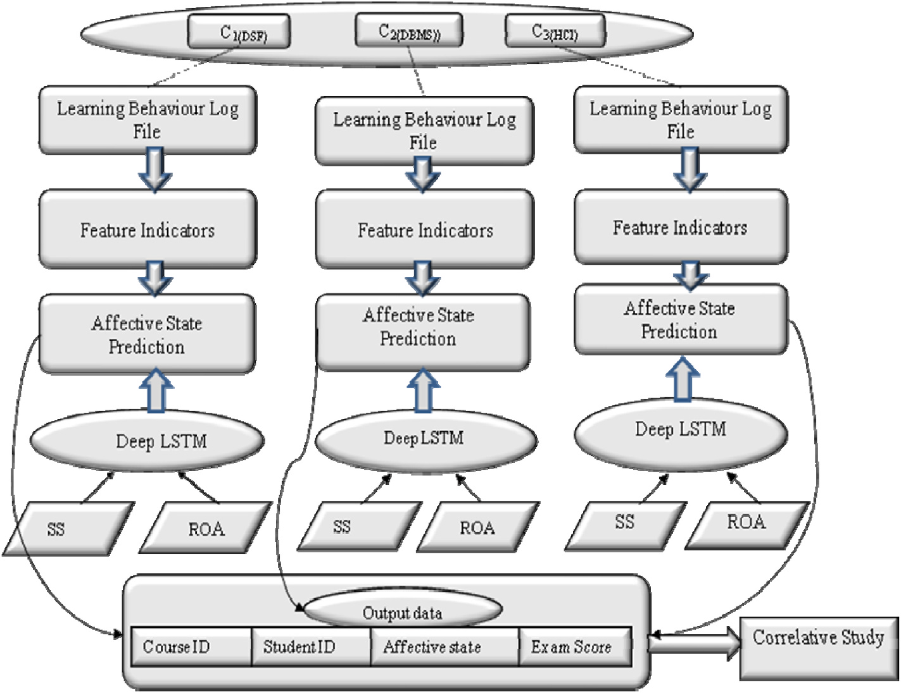

**Fig. 2.** Block diagram of an affective state prediction model using proposed SS-ROA-based Deep LSTM.

5

*S. Rathi et al.*  *Array 19 (2023) 100315*

is, it suffers from the vanishing and exploding gradient problem. Gra-dients are values that are used for updating the weights of neural net-works. It never finds optimal weight in both cases.

In LSTM architecture, the network “decides” whether to modify its “internal memory” at each step. By doing so, the layer can keep track of important events from earlier time steps to later ones, allowing for much richer inference. So Deep LSTM is used for the prediction of affective states.

*3.1.2. Architecture of deep LSTM*   
 The resultant extracted features (EF) acquired from interaction logs were fed to the deep LSTM for prediction. It is more beneficial rather than other classifiers. It is exceptionally effective to achieve the emotional state forecast, using the memory cell of the classifier. Deep LSTM uses the previous states and information related to their neigh-boring states for anticipating further states. It offers prediction by setting up the encoding layers. Gates can regulate the flow of information. It makes use of three gates Forget, Input, and Output. These gates have a very important role in LSTM.

Forget gate: This gate decides to remember or forget information. Input Gate: It decides what data to add from the current input.

Output Gate: The output gate decides the next hidden state.

When information is passed and the gate is activated, the informa-tion is fed to the memory cell. The significant benefit of adjusting the cell and the gates is to deal with the information flow. Here, the classifier utilizes the past condition of neighbors and the input cell to assess the further cell state.

*3.1.3. Deep LSTM training using proposed SS-ROA*   
 The affect is predicted through deep LSTM, trained by projected SS- ROA. The proposed SS-ROA is devised through a combination of SS and ROA. Here, the SS [51] is obtained by the dynamic foraging actions of squirrels. In warm weather, the squirrels find their foodstuff by gliding from one to another tree and expose to different locations of the forest. SSA acquires optimum global solutions with good convergence and poses the ability for solving complex problems. SSA assists to provide constant effectual accuracy. The update equation used in this algorithm is considered further in the SS-ROA algorithm.

Meanwhile, ROA [52] is propelled by deeds of rider gatherings, which travel to acquire the target to become a winner. Every single gathering plays out a few procedures for arriving at the target. Subse-quently, it is noticed that it performs affective state prediction with enhanced accuracy. Likewise, the ROA is exceptionally powerful. It undergoes fictional computing to settle the optimization issues. It has less convergence rate and it is more receptive to hyper-parameters. Besides, it follows the multi-directional search space and hence it has a fast convergence rate that depends on the over-taker position.

The ROA considers the four groups of riders. Every group follows its approach to arrive at the target position. As the name implies the bypass rider tries to win by bypassing the leading path. The follower goes after the rider who is in the lead position. The over-taker overtakes to arrive at the leading position. The attacker takes the position by taking the maximum speed to attain the goal.

According to the researchers [52], the update strategy used by over-takers elevates the rate of success so it is used further in SS-ROA.

Henceforth, by consolidating SSA with the ROA, the presentation of an emotional state forecast can be altogether improved. Thus, the newly, devised SS-ROA updates the weights of the Deep LSTM. The SS-ROA has the capability of fast convergence by avoiding local minima that mini-mizes the error while mapping the input feature vectors. Thus, a more accurate affective state classification is performed. Besides, the cost and training time is also being reduced through the optimization process.

The step of proposed the SS-ROA are given as follows,   
Step1) Random Initialization of Riders:   
The preliminary step is the random initialization of riders in groups.

Step 2) Error Determination:

6

*S. Rathi et al.*  *Array 19 (2023) 100315*

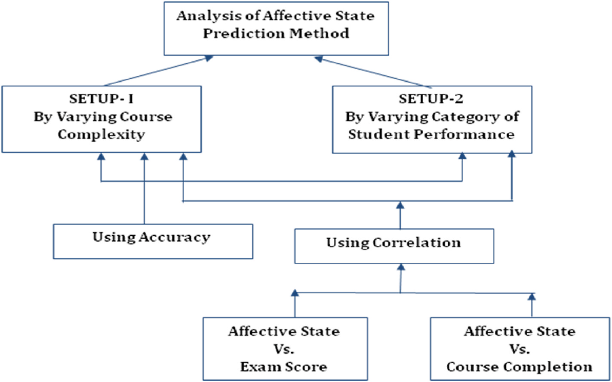

**Fig. 3.** Analysis of affective state prediction method.

affective states with varied student performance. In addition, the correlative study is analyzed by performing an analysis of affective state versus exam score, and affective state versus course completion.

*4.2. Methods used for comparison*

The methods, like Deep LSTM, SVM, and proposed SS-ROA-based Deep LSTM are used for the comparative study.

*4.3. Comparative analysis*

The analysis of techniques using accuracy and correlation is done by varying courses and students’ performance.

*4.3.1. Analysis using set-up* = *1* The analysis of affective state prediction techniques in terms of ac-curacy is described with varied courses. In addition, the correlative study is analyzed by performing an analysis of affective state versus exam score and affective state versus course completion.

Fig. 4 displays the analysis of methods with accuracy considering affective states with courses. Considering courses 1, 2, and 3, the ac-curacy measured by projected SS-ROA-based Deep LSTM are 0.898, 0.843, and 0.930 respectively. It is higher as compared to the other reputed algorithms Deep LSTM and SVM.

Fig. 5 displays the comparison of techniques with correlation for affective states vs. exam scores. Considering courses 1, 2, and 3, the accuracy measured by projected SS-ROA-based Deep LSTM are 0.379, 0.337, and 0.238 respectively. It is higher as compared to the other reputed algorithms Deep LSTM and SVM.

Fig. 6 displays the comparison of techniques with correlation for affective states vs. course completion. Considering courses 1, 2, and 3, the accuracy measured by projected SS-ROA-based Deep LSTM are 0.200, 0.241, and 0.127 respectively. It is higher as compared to the other reputed algorithms Deep LSTM and SVM.

*4.3.2. Analysis with set-up* = *2* The analysis of affective state prediction techniques in terms of ac-curacy is described with varied student performance. In addition, the

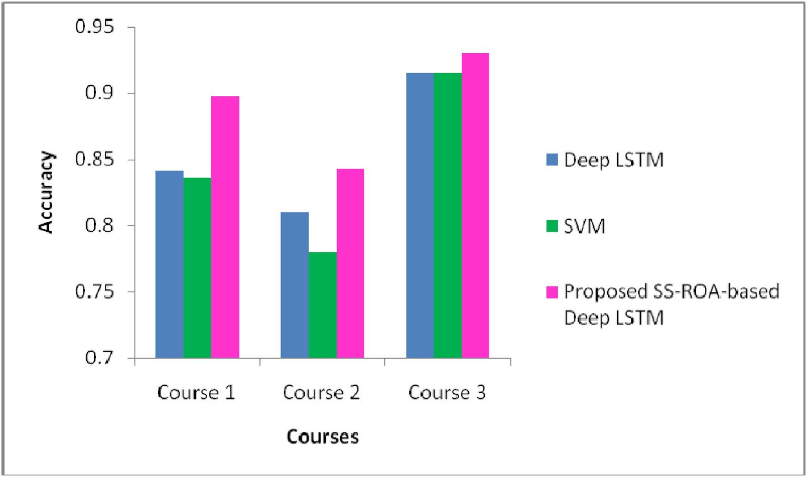

**Fig. 4.** Analysis of methods with accuracy considering affective states with courses a) Analysis in terms of accuracy considering affective states with courses.

7

*S. Rathi et al.*  *Array 19 (2023) 100315*

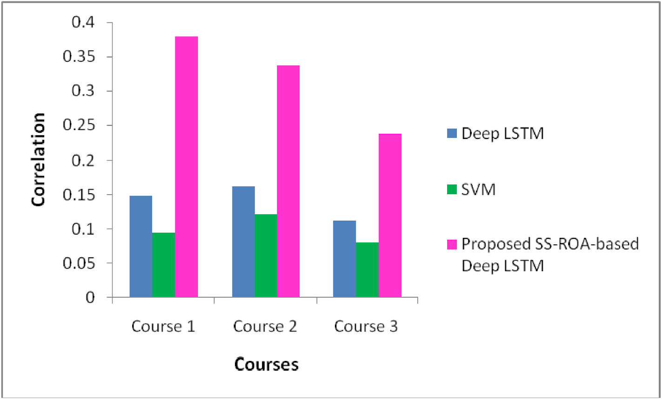

**Fig. 5.** Comparison of Techniques with correlation for affective states vs. exam score b) Correlation study (Affective state versus exam score).

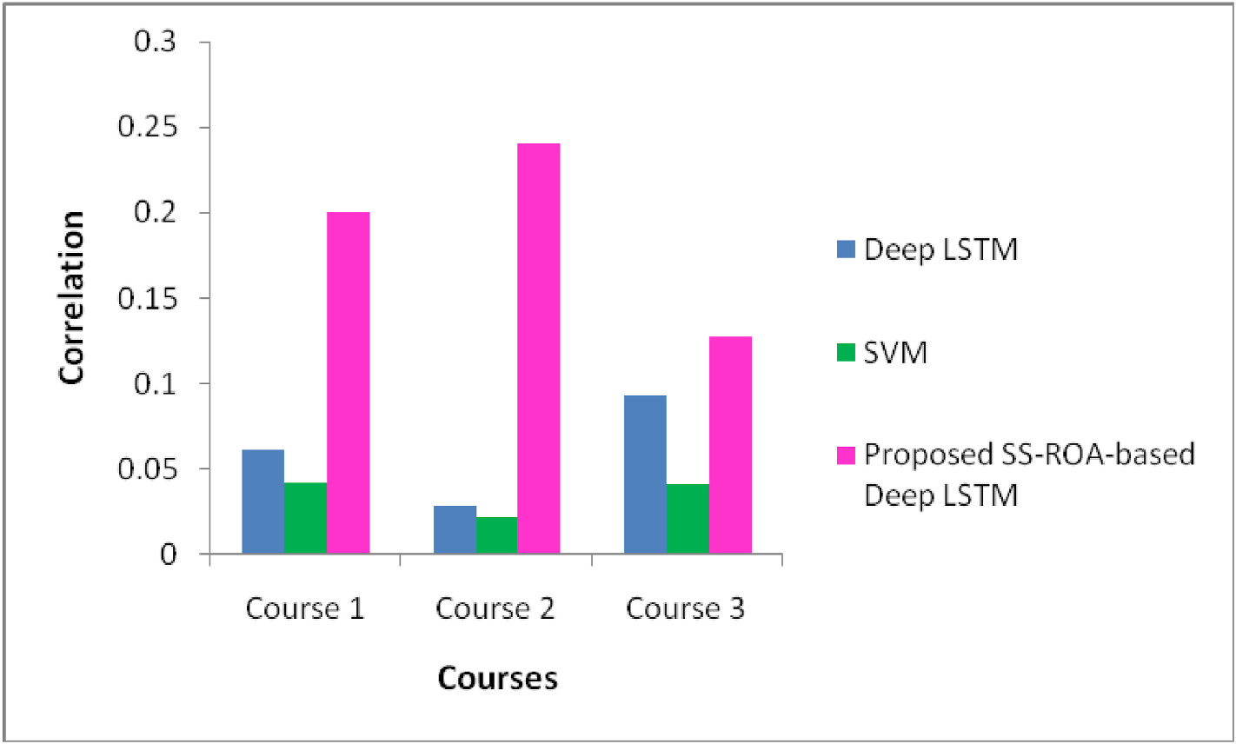

**Fig. 6.** Comparison of techniques with correlation for affective states vs. course completion d) Correlation study (Affective state versus course completion).

correlative study is analyzed by performing an analysis of affective state versus exam score and affective state versus course completion.

Fig. 7 displays the comparison of techniques with accuracy for af-fective states with student performance. Considering courses 1, 2, and 3, the accuracy measured by projected SS-ROA-based Deep LSTM are 0.949, 0.949, and 0.962 respectively. It is higher as compared to the other reputed algorithms Deep LSTM and SVM.

Fig. 8 displays the comparison of techniques with correlation for affective states vs. exam scores. Considering courses 1, 2, and 3, the accuracy measured by projected SS-ROA-based Deep LSTM are 0.236, 0.190, and 0.138 respectively. It is higher as compared to the other reputed algorithms Deep LSTM and SVM.

Fig. 9 exhibits the comparison of techniques with correlation for affective states vs. course completion. Considering courses 1, 2, and 3, the accuracy measured by projected SS-ROA-based Deep LSTM are 0.227, 0.164, and 0.161 respectively. It is higher as compared to the other reputed algorithms Deep LSTM and SVM.

8

*S. Rathi et al.*  *Array 19 (2023) 100315*

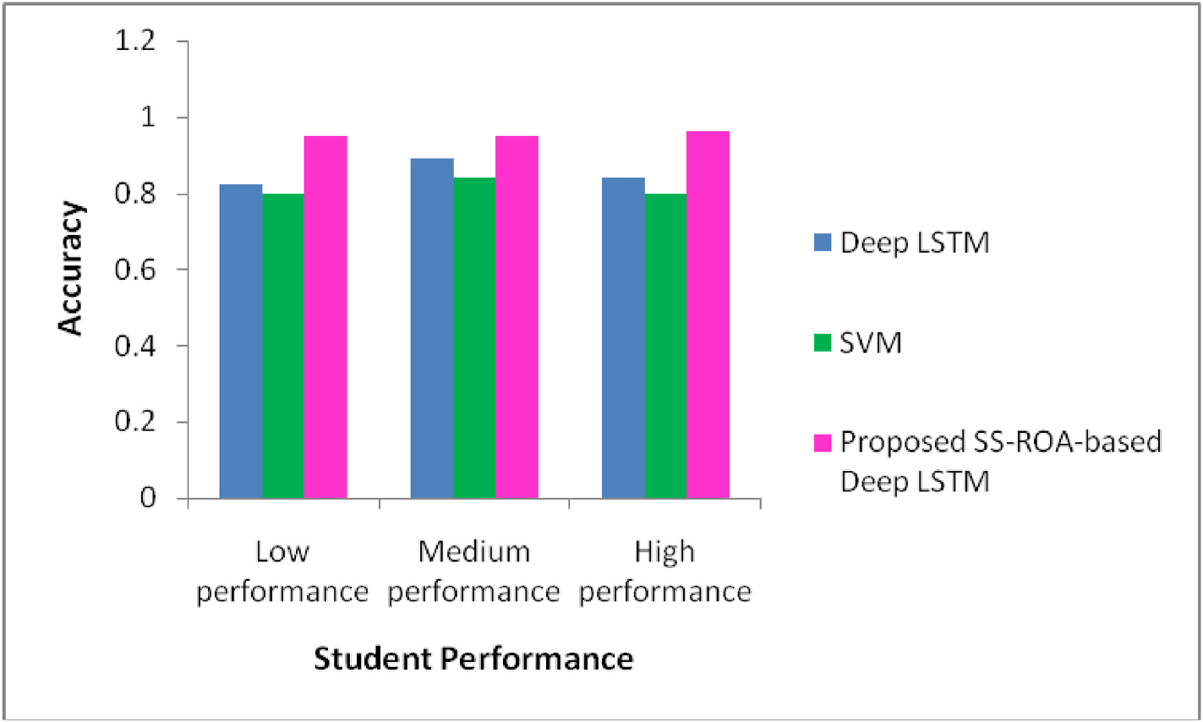

**Fig. 7.** Comparison of techniques with accuracy for affective states with student performance a) Analysis in terms of accuracy considering affective states.

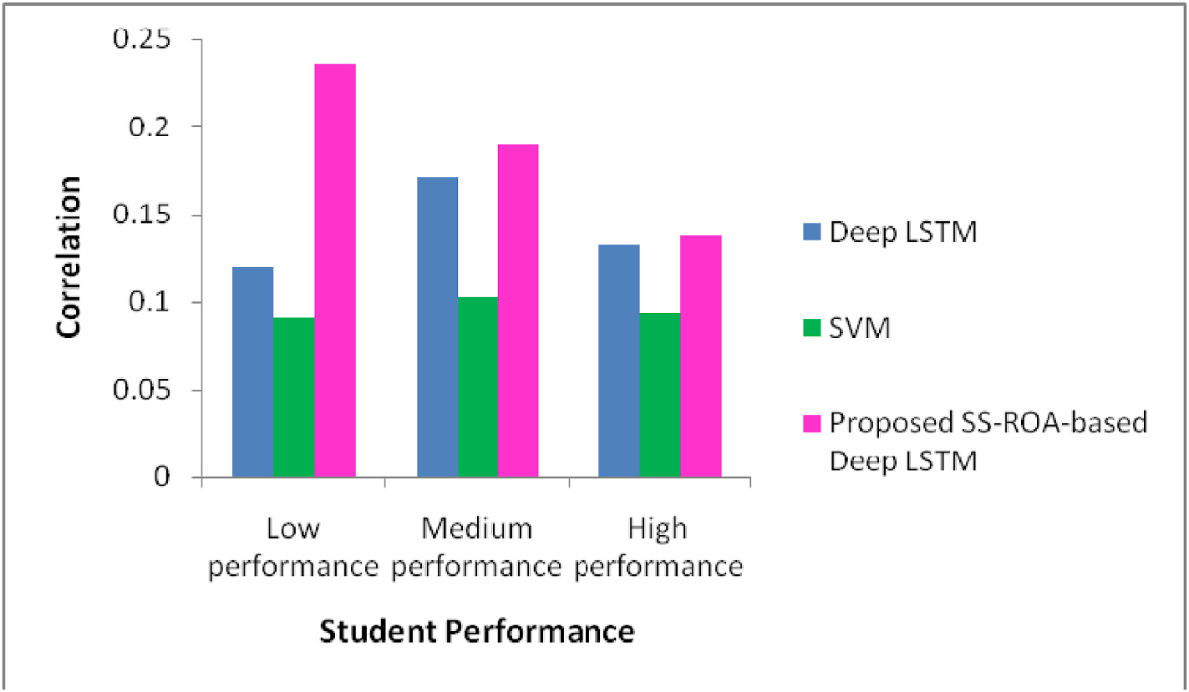

**Fig. 8.** Comparison of techniques with correlation for affective states vs. exam score b) Correlation study (Affective state versus exam score).

The developed affective state method (SS-ROA-based Deep LSTM) obtained the best performance in terms of accuracy and correlation. The newly devised SS-ROA algorithm has the capability of fast convergence rate with the avoidance of local minima. Besides, the most significant feature selection it also reduces the computational complexity of the network, and the Deep LSTM predicts the time series data more accu-rately. Thus the tuning of the Deep LSTM with the novel SS-ROA opti-mization enhances the prediction accuracy that leads to the better performance of the system.

The affective state prediction using the Deep LSTM obtained an ac-curacy of 0.825 for low performance category students as shown in Fig. 7, which is 13.07% lower than the newly devised SS-ROA-based Deep LSTM technique. Here, the best performance is achieved due to the novel optimization technique that tunes the weights of the classifier with the fast convergence rate by avoiding the premature convergence that makes the more accurate affective state prediction. The accurate affective state prediction makes the correlation study more useful. Similarly, the proposed method outperformed all the other state of art

9

*S. Rathi et al.*  *Array 19 (2023) 100315*

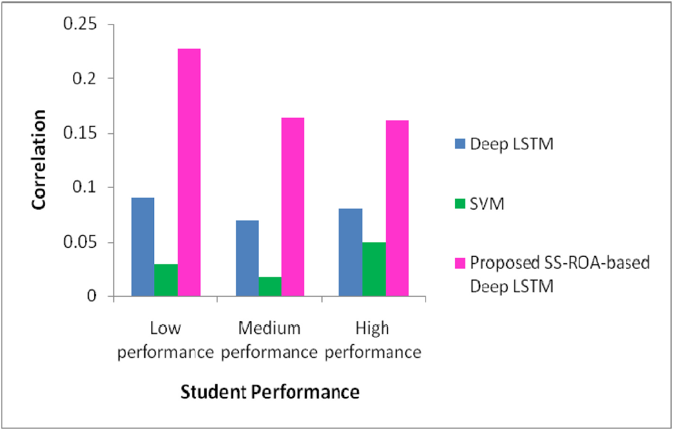

**Fig. 9.** Comparison of techniques with correlation for affective states vs. course completion

d) Correlation study (Affective state versus course completion).

**Table 1**   
Result of *t*-Test of SS-ROA based Deep LSTM and SVM.

Resources, Software, Validation, Sachin Sakhare: Writing - Review, Validation, Investigation.

*t*-Test: Two-Sample Assuming Equal Variances

|  |  |
| --- | --- |
| Mean  Observations  t Stat  P(T ≤ t) one-tail  t Critical one-tail  P(T ≤ t) two-tail  t Critical two-tail | 0.921833333  6  3.479428884  0.00296343  1.812461102  0.005926859  2.228138842 |

**Declaration of competing interest**   
 The authors declare that they have no known competing financial interests or personal relationships that could have appeared to influence the work reported in this paper.

**Data availability**

**5. Conclusion**  been used. The authors are unable or have chosen not to specify which data has

This paper devises a strategy for affective state prediction. Initially, three courses Data Structures and Files (C1), Data Base Management and System (C2), and Human-Computer Interface (C3) are employed for the experimental study. The three courses can be modeled as High complex subject, Medium complex subject, and Low complex subject. These courses are studied by different learners using LMS wherein the log file is created based on the learning patterns. Thereafter, the features are extracted which is further utilized for affective state prediction of the learners using Deep LSTM. The Deep LSTM is trained using the proposed SS-ROA and is formulated by combining Squirrel Search Algorithm (SSA) and Rider Optimization Algorithm (ROA). Here, the predictions of affective states like engagement, boredom, anger, happiness, etc. are performed. At last, the course and student ID, affective state, exam score, and course completion are considered for correlation study. The pro-posed algorithm outperformed than other methods with the utmost ac-curacy of 0.962 and the utmost correlation of 0.379 respectively. The developed model was stable for the varied levels of complexity of courses. It is useful for the applications like course recommendation systems, finding students at risk, improving the quality of online cour-ses, and tracking learners’ progress and performance. In the future other databases can be considered for providing briefer analysis. It may be possible to develop a multi modal approach that may take input in the form of facial expressions, sensor data, and gestures along with a log file.

**Credit author statement**

Snehal Rathi: Conceptualization, Methodology, Formal analysis

10

*S. Rathi et al.*  *Array 19 (2023) 100315*

[13] [Khan FA, Weippl ER, Tjoa AM. Integrated approach for the detection of learning](http://refhub.elsevier.com/S2590-0056(23)00040-1/sref13) [styles and affective states in EdMedia+ Innovate Learning. Association for the](http://refhub.elsevier.com/S2590-0056(23)00040-1/sref13) [Advancement ofComputing in Education (AACE); 2009. p. 753–61.](http://refhub.elsevier.com/S2590-0056(23)00040-1/sref13)

[14] [Cocea M, Weibelzahl S. Log file analysis for disengagement detecti](http://refhub.elsevier.com/S2590-0056(23)00040-1/sref13)[on in e-Learning](http://refhub.elsevier.com/S2590-0056(23)00040-1/sref14) [environments. User Model User-Adapted Interact 2009;19(4):341–85.](http://refhub.elsevier.com/S2590-0056(23)00040-1/sref14)

[15] [Wampfler R, Klingler S, Solenthaler B, Schinazi VR, Gross M. Affect](http://refhub.elsevier.com/S2590-0056(23)00040-1/sref14)[ive state](http://refhub.elsevier.com/S2590-0056(23)00040-1/sref15) [prediction based on semi-supervised learning from smartphone touch data. In:](http://refhub.elsevier.com/S2590-0056(23)00040-1/sref15) [Proceedings of the CHI conference on human factors in computing systems; 2020.](http://refhub.elsevier.com/S2590-0056(23)00040-1/sref15) [p. 1–13.](http://refhub.elsevier.com/S2590-0056(23)00040-1/sref15)

[16] [Francis BK, Babu SS. Predicting academic performance of students using a hybrid](http://refhub.elsevier.com/S2590-0056(23)00040-1/sref16) [data mining approach. J Med Syst 2019;43(6):162.](http://refhub.elsevier.com/S2590-0056(23)00040-1/sref16)

[17] [Kai S. Modeling student affective state patterns du](http://refhub.elsevier.com/S2590-0056(23)00040-1/sref16)[ring self-regulated learning in](http://refhub.elsevier.com/S2590-0056(23)00040-1/sref17) [physics playground”. Doctoral dissertation Columbia University); 2019.](http://refhub.elsevier.com/S2590-0056(23)00040-1/sref17)

[18] [Ibrahim Z, Rusli NM, Janor RM. Predicting students’ academic achieve](http://refhub.elsevier.com/S2590-0056(23)00040-1/sref17)[ment:](http://refhub.elsevier.com/S2590-0056(23)00040-1/sref18) [comparison between logistic regression, artificial neural network, and neuro-fuzzy.](http://refhub.elsevier.com/S2590-0056(23)00040-1/sref18)

[In: Proceedings of the international symposium on information technology; 2008.](http://refhub.elsevier.com/S2590-0056(23)00040-1/sref18) [19] [Shen L, Wang M, Shen R. Affective e-learning: using “emotional” data to improve](http://refhub.elsevier.com/S2590-0056(23)00040-1/sref28) [learning in pervasive learning environment. Educ Technol Soc 2009;12(2):176–89.](http://refhub.elsevier.com/S2590-0056(23)00040-1/sref28) [20] [Goleman D. Emotional intelligence. NewYork: Bantam Books; 1995.](http://refhub.elsevier.com/S2590-0056(23)00040-1/sref28)

[21] [Kort B, Reilly R. Analytical models of emotions, learning and relati](http://refhub.elsevier.com/S2590-0056(23)00040-1/sref19)[onships:](http://refhub.elsevier.com/S2590-0056(23)00040-1/sref20) [towardsan affect-sensitive cognitive machine, vol. 548. MIT Media Lab Tech](http://refhub.elsevier.com/S2590-0056(23)00040-1/sref20) [Report No; 2001.](http://refhub.elsevier.com/S2590-0056(23)00040-1/sref20)

[22] [Cocea M, Weibel](http://refhub.elsevier.com/S2590-0056(23)00040-1/sref20)zahl S. Eliciting motivation knowledge from log files towards motivation diagnosis for adaptive systems. In: Conati C, McCoy K, Paliouras G, editors. User Modeling 2007: 11th International Conference, UM 2007, Corfu, Greece, June 25-29, 2007, Proceedings (4511 ed., pp. 197-206). (Lecture notes in computer science; No. 4511). Springer; 2007. [https://doi.org/10.1007/978-3-540-](https://doi.org/10.1007/978-3-540-73078-1_23) [73078-1_23](https://doi.org/10.1007/978-3-540-73078-1_23).

[23] [D’Mello SK,](https://doi.org/10.1007/978-3-540-73078-1_23) [Craig SD, Witherspoon A, McDaniel B, Graesser A. Automatic](http://refhub.elsevier.com/S2590-0056(23)00040-1/sref22) [detection of learner’s affect from conversational cues. Journal of User Modeling](http://refhub.elsevier.com/S2590-0056(23)00040-1/sref22) [and User-Adapted Interaction 2008;18(1–2):45–80.](http://refhub.elsevier.com/S2590-0056(23)00040-1/sref22)

[24] [Weimin X, Wenhong X. E-learning assistant system](http://refhub.elsevier.com/S2590-0056(23)00040-1/sref22) based on virtual human interaction technology, ICCS2007, LNCS. Springer Berlin/Heidelberg; 2007.

<https://doi.org/10.1111/bjet.12324>.

[25] [Singh SV, Hiran KK. The impact of A](https://doi.org/10.1111/bjet.12324)[I on teaching and learning in higher education](http://refhub.elsevier.com/S2590-0056(23)00040-1/sref48) [technology. Journal of Higher Education Theory & Practice 2022;12(13).](http://refhub.elsevier.com/S2590-0056(23)00040-1/sref48)

[26] [Hiran KK. Investigating factors influencing the adoption of IT cloud co](http://refhub.elsevier.com/S2590-0056(23)00040-1/sref48)[mputing](http://refhub.elsevier.com/S2590-0056(23)00040-1/sref47) [platforms in higher education: case of Sub-Saharan Africa with IT professionals. Int](http://refhub.elsevier.com/S2590-0056(23)00040-1/sref47) [J Hum Cap Inf Technol Prof (IJHCITP) 2021;12(3):21–36.](http://refhub.elsevier.com/S2590-0056(23)00040-1/sref47)

[27] [Hiran KK. Impact of driving factors on cloud computing a](http://refhub.elsevier.com/S2590-0056(23)00040-1/sref47)[doption in the higher](http://refhub.elsevier.com/S2590-0056(23)00040-1/sref49) [education. In: IOP conference series: materials science and engineering (Vol.1131,](http://refhub.elsevier.com/S2590-0056(23)00040-1/sref49) [No. 1, p. 012016). IOP Publishing; 2021. April.](http://refhub.elsevier.com/S2590-0056(23)00040-1/sref49)

[28] [Calvo Rafael, D’Mello K, Sidney. Affect detecti](http://refhub.elsevier.com/S2590-0056(23)00040-1/sref49)on: an interdisciplinary Review of models, methods and their applications. T. Affective Computing; 2010. [https://doi.](https://doi.org/10.1109/T-AFFC.2010.1) [org/10.1109/T-AFFC.2010.1](https://doi.org/10.1109/T-AFFC.2010.1). 1. 18-37.

[29] [Picard, R.W. (1995) Affectiv](https://doi.org/10.1109/T-AFFC.2010.1)e Computing. M.I.T Media Laboratory Perceptual Computing Section Technical Report No. 321.

[30] [Poria Soujanya, Cambria Erik, Bajpai Rajiv, Hussain Amir. A review of affective](http://refhub.elsevier.com/S2590-0056(23)00040-1/sref26) [computing: from unimodal analysis to multimodal fusion. In: Information fusion.](http://refhub.elsevier.com/S2590-0056(23)00040-1/sref26) [Elsevier; 2017. p. 98–125. 37, September.](http://refhub.elsevier.com/S2590-0056(23)00040-1/sref26)

[31] [Chitraa V, Dr Davamani AS. A survey on](http://refhub.elsevier.com/S2590-0056(23)00040-1/sref26) [pre-processing methods for web usage](http://refhub.elsevier.com/S2590-0056(23)00040-1/sref32) [data. Int J Comput Sci Inf Secur 2010;7(3).](http://refhub.elsevier.com/S2590-0056(23)00040-1/sref32)

[32] [Ashwin TS, Guddeti RMR. Impact of inquir](http://refhub.elsevier.com/S2590-0056(23)00040-1/sref32)[y interventions on students in e-](http://refhub.elsevier.com/S2590-0056(23)00040-1/sref27) [learning and classroom environments using affective computing framework. User](http://refhub.elsevier.com/S2590-0056(23)00040-1/sref27) [Model User-Adapted Interact 2020:1–43.](http://refhub.elsevier.com/S2590-0056(23)00040-1/sref27)

[33] [Jason Matthew Harley. Chapter 5 - mea](http://refhub.elsevier.com/S2590-0056(23)00040-1/sref27)[suring emotions: a survey of cutting edge](http://refhub.elsevier.com/S2590-0056(23)00040-1/sref29) [methodologies used in computer-based learning environment research, editor(s. In:](http://refhub.elsevier.com/S2590-0056(23)00040-1/sref29)

11