|  |  |  |  |
| --- | --- | --- | --- |
|  |  | Available online at www.sciencedirect.com |  |
| **ScienceDirect** |
| AASRI Procedia 9 ( 2014 ) 78 – 83 |

2014 AASRI Conference on Circuit and Signal Processing (CSP 2014)

Application of RPM Logging for Reservoir Dynamic Monitoring at M Oilfield of Offshore

Zhonghao Wang1,a, Hao Wang1,a, Jingong Li2,b, Ji Tian3,c, Dahai Ju4,d

*aYangtze University, Wu Han, Hubei, 430100,China;*   
*bReservoir office, CNOOC, Beijing, 100010, China;*   
*cResearch Institute, CNOOC, Beijing, 100027, China,*   
*dExploration and Development Research Institute of Tarim Oilfield Company, Korla, Xinjiang ,841000, China*

**Abstract**

With the gradual depth exploit of residual oil in offshore oilfield, RPM logging are using widely in reservoirs dynamic monitoring , the process of logging RPM affected by lithology, porosity, borehole fluid and other factors, so we must do some correction for it. But M oilfield has a special well structure of gravel pack, therefore, some correction made in domestic are not suitable for application in the offshore reservoirs of gravel pack, Thus author design parallelogram method to obtain water holdup and water saturation , by comparing the calculated results with the PLT data, it is found that the error in a controllable range, and also design volumetric model to corrected formation capture cross section, by using the corrected capture cross section establish model with lithology; electrical property, then compares it with the model which corrected before, it improves the model accuracy a lot. By comparing the water saturation which calculated by corrected capture cross section with and the water saturation which obtained by the PLT data interpretation , It is found that the accuracy increased more than 6%,it provides a new method to instruct the RPM data interpretation.

© 2014. Published by Elsevier B.V. © 2014 Published by Elsevier B. V. This is an open access article under the CC BY-NC-ND license

Selection and/or peer review under responsibility of American Applied Science Research Institute (http://creativecommons.org/licenses/by-nc-nd/3.0/).

Peer-review under responsibility of Scientific Committee of American Applied Science Research Institute

*Keywords:* reservoirs dynamic monitoring,parallelogram method, water saturation, volumetric model, gravel pack

**1. Introduction**

RPM is a logging tool which through the tubing/casing for reservoir performance monitor, the current domestic and foreign dynamic reservoir monitoring instruments have RPM, RST,RMT, PNN, PND,

Fund: "Twelfth Five-year" national science and technology major projects (2011ZX05024-002-003)

2212-6716 © 2014 Published by Elsevier B. V. This is an open access article under the CC BY-NC-ND license (http://creativecommons.org/licenses/by-nc-nd/3.0/).

Peer-review under responsibility of Scientific Committee of American Applied Science Research Institute doi: 10.1016/j.aasri.2014.09.014

*Zhonghao Wang et al. / AASRI Procedia 9 ( 2014 ) 78 – 83*  79

etc[1] .Enhancements tool design; characterization and interpretation algorithms have contributed to increases in precision and accuracy of fluid saturation measurements. Different instruments have differences in the design and interpretation [2]. There is no single solution for the complex formation and borehole environment in C/O logging including cement, casing, fluid patterns etc. Some people had only did some simulation to research the influencing factors of carbon/oxygen (C/O) spectral logging, such as porosity; lithology; and so on[3][4].M oilfield has a characteristics with gravel pack, so the above personnel, for water saturation and the water holdup correction is not suitable for M oilfields. This paper consider the situation of gravel pack in offshore, by using PLT data measured distance C/O ratio and use of interpolation theory, it establishes parallelogram plate which obtaining water saturation and water holdup, by comparing the results with the PLT data, it is found that the error in a controllable range, author also make some corrected for capture cross sections, by using the corrected capture cross section to calculate water saturation, by comparing with the saturation which after corrected and before, Accuracy is improved by more than 6%, It provides a new guiding for RPM data interpretation.

**2. Method and principle of parallelogram**

First ,By using the flow parameters ,it converts the wellhead fluid flow into underground fluid flow and use the slippage model calculate water holdup, second, we establish the relationship between water holdup and moisture to calculate moisture, by using the relative permeability data establish the relationship between water holdup and moisture to calculate water saturation, finally we can determine water holdup and water saturation of each layer.

First, By classifying the data according to porosity, deviation angle, saturation, then callout the measured NCOR, FCOR which corresponding to layers in each class(carbon/oxygen ratio of the near detector and carbon/oxygen ratio of the far detector)in the coordinate plane which in the X-axis NCOR and In the Y-axis FCOR, and find some regular point value(Table 2). A, B, C, D, etc. point are regular data points which picked out according to inclination and porosity and the distribution of data points (Figure.1.(a)), And list the data in Table 2. Owing to water saturation of these two points A and B approximately 0.4, so make use of these two points can determine a linear water saturation of 0.4, by using linear interpolation methods Combined with D point, we can get the lines of water saturation of 0,0.2,0.4,0.6,0.8,1.0 ; analogously, water holdup of B and C are approximately 0.5, in the same way, we can obtain the lines of water holdup of 0,0.2,0.4,0.6,0.8,1.0;four intersections of the two lines of Water saturation of 0 and 1 with two lines water holdup of 0 and 1 are WW, WO, OO, OW[5] .After we certain four specific points, we make use of interpolation theory, we can combined with the actual measurements NCOR, FCOR and porosity data, then calculate the water holdup and water saturation quickly, accurately and directly(Figure.1.(b)).

**3. The theoretical basis for C/O interpolation method**

The study finds that the measured values of NCOR and FCOR have a relationship with the lithology and porosity of the formation; we can obtain four measured values of NCOR and FCOR which borehole and formation are pure oil and pure water respectively, By ploting the FCOR and NCOR for these conditions to define the quadrilateral in each case. Thus, the width of the quadrilateral is affected by lithology and porosity of the formation. In the general case: all measurement points basically fall on the quadrilateral area. Water holdup in the borehole and formation oil saturation affect the values of NCOR and FCOR ,so the quadrilateral is an indicator to resolve the formation oil saturation and water holdup in the borehole[6] .

In figure.1.(a). A, B, C, D four points represents the Carbon-oxygen ratio of actual measured near and far detectors. In figure.1.(b), Straight line on the left and right is water holdup envelope which the value is 1 and

80  *Zhonghao Wang et al. / AASRI Procedia 9 ( 2014 ) 78 – 83*

0 respectively , the straight line above and down is water saturation envelope which the value is 0 and 1 respectively.

|  |  |
| --- | --- |
|  |  |

Figure1.(a) Figure1.(b)

Figure 1.(a) Saturation parallelogram used to calculate water saturation in the formation and borehole with casing in borehole Figure 1.(b) Saturation parallelogram Envelope diagram used to calculate water saturation in the formation and borehole with casing in borehole

**4. Correction method research of the capture cross section**

Gravel packing is the special well structure in offshore M oilfield, the part of gravel packing mainly in the part of the screen and casing annulus and perforation tunnel. Such as the production string structure in M oilfield, the inner diameter and outer diameter of borehole annulus section are 15.24cm and 21.1cm. But the instrument detection depth is 21cm and the C/O mode logging speed is 0.6m/min, vertical resolution is 61cm [7], so the measured capture cross section of RPM is also affected by the gravel pack. Accordingly, in order to obtain the formation parameters accurately and improve interpretation accuracy, it is necessary to do some quantitative correction for related factors. So the author designed volumetric model corrected formation capture cross sections.

|  |  |  |  |  |  |  |  |  |  |  |  |  |  |  |  |  |  |  |  |  |  |  |
| --- | --- | --- | --- | --- | --- | --- | --- | --- | --- | --- | --- | --- | --- | --- | --- | --- | --- | --- | --- | --- | --- | --- |
| � | log | �� | *ma* | (1� �*V sh* | �*V* | *g* | ) | �� | *w* | *S* | *w*��� | *h* | (1� | *S* | *w* | )��� | *sh V sh* | �� | *g* | *V* | *g* | *(1)* |

Obtained from the equation(1):

|  |  |  |  |  |  |  |  |  |  |  |  |  |  |  |  |  |  |  |  |  |  |  |
| --- | --- | --- | --- | --- | --- | --- | --- | --- | --- | --- | --- | --- | --- | --- | --- | --- | --- | --- | --- | --- | --- | --- |
|  |  |  | � | log | �� | *ma* | (1� �*V sh* | �*V* | | *g* | ) | �� | | | *sh V sh* | �� | *g* | *V* | *g* | �� | *h*� |  |
| *S* | *w* | � |  |  |  |  | �( | � | *w* | �� | | | *h* | ) | |  |  |  |  |  |  | *(2)* |

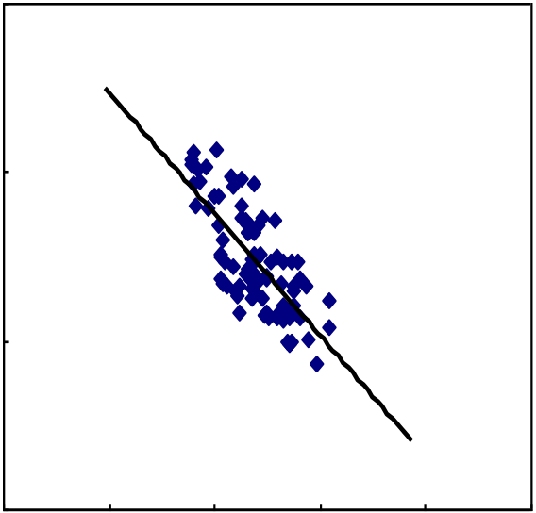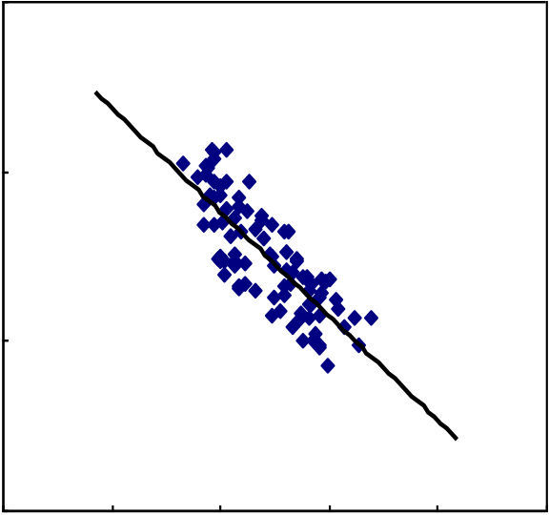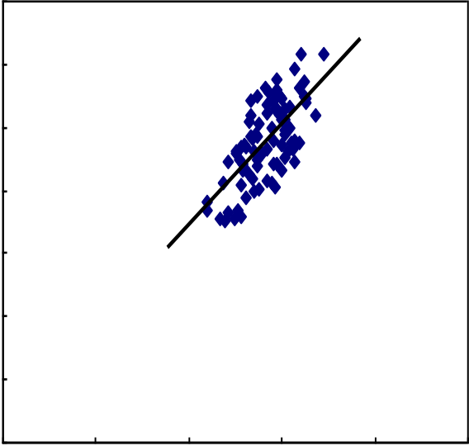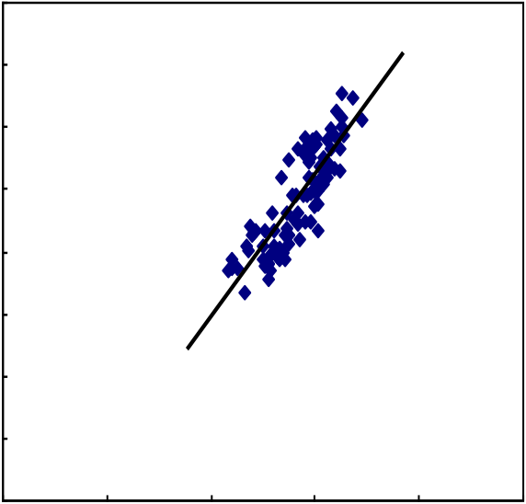

|  |  |  |  |  |  |  |  |  |  |  |  |  |  |  |
| --- | --- | --- | --- | --- | --- | --- | --- | --- | --- | --- | --- | --- | --- | --- |
| *Zhonghao Wang et al. / AASRI Procedia 9 ( 2014 ) 78 – 83* | | | | | | | | | | | | | | 81 |
| In equation(1), | *Sw* | is water saturation and | �log | is the intrinsic formation sigma estimated by the logging | | | | | | | | | |
| tool and associated environmental corrections, | | | �*ma* | | , | �*sh* | , | �*W* | , | � , | | � are sigma for rock matrix, shale, water | |
| and hydrocarbons and gravel[8]; � is the effective porosity, | | | | | | | | | *Vsh* | | is the shale or clay volumetric ratio, | | *V* is |

the gravel content.

The study found that there is some relevance between capture cross-section and natural gamma�resistivity. Compare with the Figure.2.(a) and Figure.2.(b), model accuracy of Figure.2.(b) increased 6%, Compare with the Figure.3.(a) and Figure.3.(b), model accuracy of Figure.3.(b) increased 13%.

|  |  |  |  |  |  |  |  |  |  |  |  |  |  |  |  |  |  |  |  |  |  |  |  |  |  |  |  |  |  |  |
| --- | --- | --- | --- | --- | --- | --- | --- | --- | --- | --- | --- | --- | --- | --- | --- | --- | --- | --- | --- | --- | --- | --- | --- | --- | --- | --- | --- | --- | --- | --- |
| |  |  |  |  |  |  |  |  |  | | --- | --- | --- | --- | --- | --- | --- | --- | --- | | |  |  | | --- | --- | | ����  �������������Ω ���  ���  �� | ������������������������������������������ |   �   |  |  |  |  |  |  | | --- | --- | --- | --- | --- | --- | | � | �� | �� | �� | �� | �� |   ��������������������������� | | |  |  |  |  |  |  |  |  |  |  |  |  |  |  |  |  |  |  |  |  | | --- | --- | --- | --- | --- | --- | --- | --- | --- | --- | --- | --- | --- | --- | --- | --- | --- | --- | --- | --- | | |  |  |  |  |  |  |  |  |  | | --- | --- | --- | --- | --- | --- | --- | --- | --- | | ���� | | |  | | --- | | �������������������������������������������  ��������������������������������� | | | | | | | | �������������Ω ��� | ���  �� | | � | | | � | �� | �� | �� | �� | �� |   ��������������������������� | |

Figure.2.(a) before correction the relationship between formation capture cross-section and the resistivity Figure.2.(b) After correction the relationship between formation capture cross-section and the resistivity

|  |  |  |  |  |  |  |  |  |  |  |  |  |  |  |  |  |  |  |  |  |  |  |  |  |  |  |  |  |  |  |  |  |  |  |  |  |  |  |  |  |  |  |  |
| --- | --- | --- | --- | --- | --- | --- | --- | --- | --- | --- | --- | --- | --- | --- | --- | --- | --- | --- | --- | --- | --- | --- | --- | --- | --- | --- | --- | --- | --- | --- | --- | --- | --- | --- | --- | --- | --- | --- | --- | --- | --- | --- | --- |
| |  |  |  |  |  |  |  |  |  |  |  |  |  |  |  |  |  |  |  |  |  |  |  | | --- | --- | --- | --- | --- | --- | --- | --- | --- | --- | --- | --- | --- | --- | --- | --- | --- | --- | --- | --- | --- | --- | --- | | |  |  |  |  |  |  |  |  |  | | --- | --- | --- | --- | --- | --- | --- | --- | --- | | �������������������������� | �� | |  | | --- | | �������������������������������������� | | | | | | | | �� | | �� | | �� | | �� | | �� | | � | | � | | � | �� | �� | �� | �� | ��� |   ������������������ | | |  |  |  |  |  |  |  |  |  |  |  |  |  |  |  |  |  |  |  | | --- | --- | --- | --- | --- | --- | --- | --- | --- | --- | --- | --- | --- | --- | --- | --- | --- | --- | --- | | ��   |  |  |  | | --- | --- | --- | | �������������������������� | �� | ������������������������ | | �������������� | | �� | ������������������ | | �� | | �� | | �� | | �� | | � | ��������������� |   �   |  |  |  |  |  |  | | --- | --- | --- | --- | --- | --- | | � | �� | �� | �� | �� | ��� |   ������������������ | |

Figure.3.(a) before correction the relationship between formation capture cross-section and the Natural gamma; Figure.3.(b) After correction the relationship between formation capture cross section and the Natural gamma;

82  *Zhonghao Wang et al. / AASRI Procedia 9 ( 2014 ) 78 – 83*

**5. Applications and analysis of the methods**

Author selecting the data of seven layers in two wells of offshore oilfield M[Table 1], the water saturation before and after corrected are shown in the following table, and compare the water saturation with actual water saturation data which measured by PLT production profile ,found that the accuracy of the after corrected increase 6% compare with the corrected before.

Table 1. error analysis of water saturation calculated by capture cross sections before and after correction

|  |  |  |  |  |  |  |
| --- | --- | --- | --- | --- | --- | --- |
| Perforating horizons | before   correction | after  correction | production explain | before  correction | after  correction | improve  accuracy(% ) |
| 1418.4-1423.6 | 0.467 | 0.72 | 0.58 | 0.261 | 0.182 | 7.93% |
| 1441.5-1449.8 | 0.439 | 0.625 | 0.53 | 0.207 | 0.152 | 5.53% |
| 1467.8-1480.6 | 0.513 | 0.482 | 0.471 | 0.082 | 0.022 | 6.0% |
| 1485.8-1496.0 | 0.547 | 0.449 | 0.467 | 0.146 | 0.04 | 10.62% |
| 1560.6-1566.1 | 0.483 | 0.352 | 0.385 | 0.203 | 0.09 | 10.91% |
| 1578.0-1578.5 | 0.674 | 0.489 | 0.51 | 0.206 | 0.09 | 11.22% |
| 1602.8-1609.5 | 0.385 | 0.493 | 0.452 | 0.174 | 0.083 | 9.09% |

|  |  |  |  |  |  |  |  |  |
| --- | --- | --- | --- | --- | --- | --- | --- | --- |
| Statistics the NCOR,FCOR, | *SW* | , | *YW* | of ten layers of two wells on Offshore oilfield, which NCOR nearly | | | | |
| carbon-oxygen ratio measured at the detector, FCOR far detector measured the carbon-oxygen ratio, | | | | | | | *YW* | is |
| water holdup calculated by slippage model, | | | | | *SW* | is water saturation calculated by built model. In accordance | | |

with degree is better when compared with water holdup calculated by Parallelogram and PLT data.(Table 3)

Table 2. Actual calibration data sheet

|  |  |  |  |  |  |
| --- | --- | --- | --- | --- | --- |
| Horizons  Number | inclination(°) | NCOR | FCOR | *YW* | *SW* |
| A | 28.3 | 1.976 | 2.011 | 0.413 | 0.407 |
| B | 30.4 | 1.92 | 1.942 | 0.481 | 0.389 |
| C | 31.7 | 1.907 | 1.892 | 0.492 | 0.517 |
| D | 33.5 | 1.878 | 1.866 | 0.715 | 0.602 |

Table 3. the table of water saturation error analysis

|  |  |  |  |  |  |  |  |  |
| --- | --- | --- | --- | --- | --- | --- | --- | --- |
| NO. | Perforating horizons | NCOR | FCOR | production explain YW | Calculate SW | Calculate YW | Error analysis | Conclusion |
| 1 | 1586.4-1592.2 | 1.976 | 1.981 | 0.420 | 0.563 | 0.380 | 0.095 | Yes |
| 2 | 1599.6-1614.2 | 1.959 | 1.9667 | 0.4418 | 0.483 | 0.460 | 0.041 | Yes |
| 3 | 1634.8-1654.1 | 1.891 | 1.898 | 0.539 | 0.413 | 0.570 | 0.057 | Yes |
| 4 | 1657.2-1659.1 | 1.885 | 1.858 | 0.605 | 0.669 | 0.583 | 0.036 | Yes |
| 5 | 1660.2-1662.0 | 1.882 | 1.897 | 0.653 | 0.680 | 0.600 | 0.082 | Yes |
| 6 | 1672.2-1674. 7 | 1.862 | 1.869 | 0.726 | 0.411 | 0.690 | 0.049 | Yes |
| 7 | 1680.7-1694.3 | 1.862 | 1.867 | 0.824 | 0.574 | 0.610 | 0.259 | NO |
| 8 | 1467.8-1480.6 | 2.033 | 2.043 | 0.142 | 0.280 | 0.135 | 0.029 | Yes |
| 9 | 1485.8-1496.0 | 2.035 | 2.021 | 0.205 | 0.310 | 0.100 | 0.510 | NO |
| 10 | 1500.8-1510.8 | 2.054 | 2.018 | 0.220 | 0.218 | 0.235 | 0.068 | Yes |

*Zhonghao Wang et al. / AASRI Procedia 9 ( 2014 ) 78 – 83*  83

**6. Conclusion**

**·**Writer considering the gravel packing characteristics of offshore oilfield M, make some correction to the capture cross section is necessary. After corrected ,the accuracy of model greatly improved.

**·**The accuracy of water saturation increased 6% after capture cross section has been corrected, improve the interpretation accuracy of water saturation.

**·**It is found that using the plates established by the parallelogram method to calculate Water holdup in borehole and formation water saturation can be very fast, accurately and directly. It is a feasible method which has some application prospect.

**Acknowledgements**

The authors acknowledge the assistance of Chinese National Key Project Foundation (2011ZX05024-002-003) and China National Offshore Oil Corporation Research Institute for the research in this paper.

**References**

[1] Zhang Feng ,Wang Xinguang , Numerical simulation of pulsed neutron - neutron logging influence factors, China University of Petroleum (Natural Science) [J],2009,33[6]: 46-51   
[2] Ramsin Y. Eyvazzadeh, Oscar Kelder, A.A.Hajari, Shouxiang Ma, Abdallah M. Behair. Modern Carbon/Oxygen Logging Methodologies: Comparing Hydrocarbon Saturation Determination Techniques. SPE90339,(2005): 1-14.

[3] Wu wensheng,Fu Geng,Zhang Zhi. factors and processing of Slim diameter dual source detector CO logging [J] . Chinese Journal of Geophysics,2005,48(2) : 459~464.

[4] Zhang Feng. Monte Carlo simulation using pulsed neutron gamma spectroscopy to determine the lithology and influencing factors [J] . Nuclear Electronics & Detection Technology,2008,28(2): 241~246.

[5] R. Y. Eyvazzadeh , OKelder ,C.Phillips, and A. A. Hajari ,Saudi Aramco. An Innovative Application to Reduce Petrophysical Uncertainty in Reservoir Monitoring: Case Studies from Giant Saudi Arabian Fields. SPE97519,(2005) : 1-12.

[6] Guo H M, Dai Jia cai. Formation parameters of casing well logging [M].Beijing: Oil Industry Press,(2007).

[7] Wang Zhonghao , Wu Jinbo , Li Jinggong. Correction Method Of RPM C/O In Offshore Heavy Oil Reservoir[J].Applied Mechanics and Materials,2013,Vol.390~394   
[8]Thomas A. Zalan,Ahmed Badruzzaman,Dale Julander.Steamflood Surveillance in Sumatra, Indonesia and San Joaquin Valley, California Using Steam Identification, Carbon/Oxygen, and Temperature Logs.

SPE80435,(2003) : 1-13