|  |  |  |
| --- | --- | --- |
|  | Available online at www.sciencedirect.com | AASRI |
|  |
|  | Procedia |
|  | AASRI Procedia 1 ( 2012 ) 416 – 421 | www.elsevier.com/locate/procedia |

2012 AASRI Conference on Computational Intelligence and Bioinformatics

Based on the Lotus Domino in OA System Security Mechanism Research

Jun Zhenga,*, Ying Chenb, Cheng Lic

*a Finance Department, Hebei United University, Hebei Tangshan, P.R.China, 063009 bDepartment of Student Affairs, Hebei United University, Hebei Tangshan, P.R.China,063009 c Jitang College, Hebei United University, Hebei Tangshan, P.R.China,063009*

**Abstract**

With the rapid development of computer technology, communications technology and network technology, OA (Office Automation), Office Automation obtained a rapid development, gourmet OA provide good Office means and environment forunit management personnel, staff, making work accurate, efficient and pleasant From previous text based on personal services, typesetting system developed for today's entry based on the workflow concept, enables internal staff to quickly and easily share information and work together efficiently� achieving a rapid, comprehensive information collection, information processing, enterprise management and decision-making to provide a scientific basis. Lotus Domino / Notes as of today's domestic and foreign most popular collaborative office groupware products, has a unique advantage in its knowledge management, collaborative work and the security mechanism.

2012 Published by Elsevier B.V. Selection and/or peer review under responsibility of American Applied Science Research Institute Open access under [CC BY-NC-ND license.](http://creativecommons.org/licenses/by-nc-nd/3.0/)

*Keywords:*  Lotus Domino/Notes; OA; Security Mechanism;

**1. Introduction**

Office automation system is the use of advanced electronic information technology, computer technology, network technology and automation technology and modern office equipment, man-machine information

* Corresponding author.

*E-mail address:* mycw1015@163.com.

2212-6716 © 2012 Published by Elsevier Ltd. Open access under [CC BY-NC-ND license.](http://creativecommons.org/licenses/by-nc-nd/3.0/) doi: 10.1016/j.aasri.2012.06.065

*Jun Zheng et al. / AASRI Procedia 1 ( 2012 ) 416 – 421*  417

processing system, the collection and processing of business information between departments at all levels, flow and sharing, collaboration and collaborative, helping to lead and manage a variety of office activities, to maximize office efficiency and work quality, to improve the office environment and working conditions, improve the automation of office management and decision-making and scientific level.

This paper expounds the basic concepts and connotations of office automation and OA system design and implementation. Combination of a detailed analysis of the functional requirements of the office automation system, OA system architecture and development platform needs, and OA system construction of a comprehensive university (referred to as LH), as the background, the C/S and B/S architecture implementation of the program, the system uses Lotus Domino/Notes R5, groupware development platform that integrates Lotus distributed document management system (Domino.doc) real-time collaboration systems for distance learning system (earningSpa.ce4.0) (SameTime), gives the system framework based on LotusDomino/N0tes the OA. Workflow automation, document databases and relational databases, system security, in-depth discussion. The paper presents the Notes and relational database integration solutions to effectively protect existing investments. The development the unstructured Notes database access structure of the relational database, the database data access interface, information processing and other business systems are integrated into a collaborative platform, effective solution to the traditional information silos exist OA system, application island, the problem of resource island. The combination of Domino / Notes platform focus on strengthening the system of application-level security.

This research and development of office automation systems, has been successfully applied to the actual good results, the system e-mail, process management, information dissemination, project management, remote office and other functions, greatly improving the level of internal management and office efficiency, has a broad application prospect. The reason it occupies such an important position in the field of commercial office. In addition to the workflow itself has perfect control, a powerful database replication technology and other factors, another important reason is that it provides advanced and reliable security mechanism. Focused on several security technology used in Lotus Domino / Notes.

**2. OA system design**

The OA system is an experimental system developed for the LH basic computer teaching within the Department of the electronic office. The system requires to achieve accurate, safe, reliable, efficient daily office transaction processing. Based on actual usage in the initial development of the system, including user management, internal communications, information dissemination, daily office module, the system by function, as the "Home", "daily office", "query and statistical analysis," "secondary business processes "information services", "internal communication BBS" systems management "seven interrelated sections, each subdivided into more specific functional modules.

Home page: including users log in, registration information, etc.

Routine office: office automation network within the commercial colleges and universities to establish and achieve personal office, e-mail, electronic language management functions in order to establish a set of office automation and data sharing system.

Query and statistical analysis: Provides functionality to query all kinds of information to managers; of their business accounting, credit, and planning departments to provide data for statistical analysis functions.

Auxiliary business processes: integrate the various departments of business processing system, and the the INTRANET way, release the data of various departments office collected information, reports and policies and regulations, provide to the managers and the relevant departments to query uses.

Integrated information services: to provide access to the user, including a variety of integrated information service center, including: public information, bulletin boards, exchange information, access the Internet.

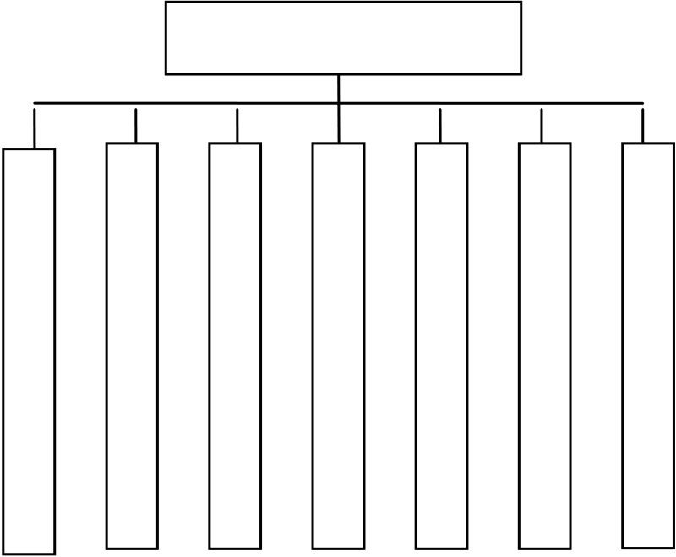

418  *Jun Zheng et al. / AASRI Procedia 1 ( 2012 ) 416 – 421*

Internal BBS module system includes: e-mail, maintenance of the internal forum, information dissemination and management, organizational structure maintenance, short message management, menu management page information maintenance.

System management: operation and maintenance of the entire office management information systems and management services.

The functional modules of the system shown in Figure l.

OAS

Fig. 1. OA system function module chart

**3. OA system architecture.**

Based on Lotus Domino / Notes office management information system "is an application in the College office management information systems, system architecture for the B / A / S three-tier architecture, the main technology: front-end using the browser Browser, (such as IE 6.0); application layer based on the Lotus Domino / Notes R5.0.8, integrated LotusScript, Java, SQL JavaScript technology; database service layer using SQL Server2000. The business logic of the system structure, including data management, application control layer and user interface layer of three parts.

Data management is responsible for the management and restructuring of business data; application control layer is responsible for processing and analysis system service control logic; human-computer interaction interface of the user interface layer to handle user to separate the user interface and business complex control logic, responsible for business information available to users with a user-friendly in a consistent manner. "based on Lotus Domino / Notes to the office of the Integrated Management information System" has been successfully LH University campus on line officially running.

Before after running the business under the jurisdiction of faculty, further improve the technical training and during operation, the system has achieved beyond the expected demand of the system to design a scientific and rational, performance, high reliability, stable operation, easy to operate, easy to maintain, the affirmation of the user and praise.

Office of integrated Management Information System developed to document data as the core of the exchange of information, thereby enhancing the systematic use of knowledge as the core of knowledge throughout the various ways the exchange of information, from simple e-mail, groupware and collaboration, up to build Web applications, its core purpose is to obtain knowledge and application of knowledge is the most valuable information to pass on the campus network effect of the use of knowledge related to the development strength of the colleges and universities based on Lotus Domino / Notes office management

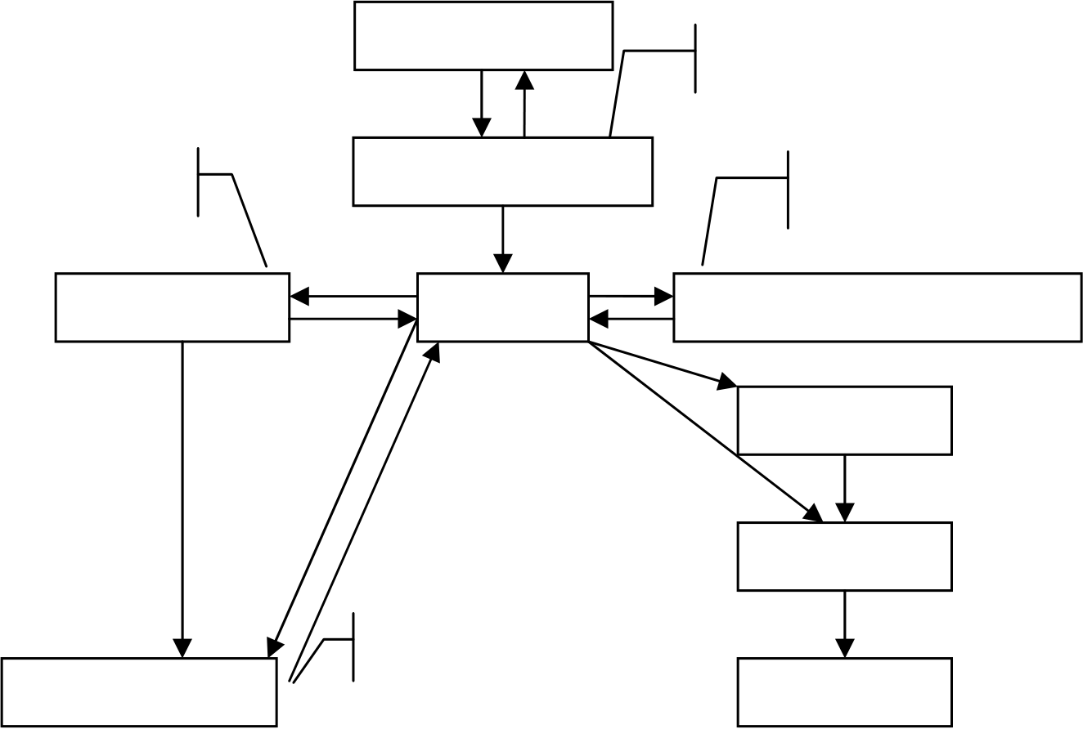

*Jun Zheng et al. / AASRI Procedia 1 ( 2012 ) 416 – 421*  419

information system will help colleges and universities from the process of transformation of the How To Know How, office automation, information management system is about to operate by hand to change and improve the transition of office operations efficiency.

**4. The design and realization of workflow**

*4.1. The demand analysis in the OAS workflow design*

The OAS of university is not only a processing system for word processing, excel making, personal resource management and filing, etc., but also a complex system using Internet technology and workflow concept, which provide university staff with easily shared information, so that they can cooperate in their work with high efficiency and carry out quick and full-scale information collection and processing.

The purposes of the development and using of the OAS are to standardize the management behavior to improve work efficiency to realize information sharing, however, a scientific design of the workflow is the basis for realizing the above mentioned objectives.

In fact, the business executed in OAS is mainly management operation, which is a kind of coordination of various work process. According to statistics, in the existing official business, only 31% can be finished by one person, the remaining works are finished by other person or department, such works maybe include documentation, business work, administration work and leader’s work, so the OAS should confirm these workflow and set workflow scientifically, specify authority of various kind of staff, which therefore can realize a smooth cooperation between different staffs and different works.

*4.2. An Analysis of Design Essentials of work procedure- Taking Document Issuing as an Example*

The procedures of document issuing in the OAS of Hebei united university is shown in figure 2.

|  |  |  |
| --- | --- | --- |
| modify document | department drafting | modify document |
| department review | modify document |
| review by director | sectary | countersign by different departments |

print

filing

modify document

sign by university leader document issuing

Fig. 2. The process of document issuing

420  *Jun Zheng et al. / AASRI Procedia 1 ( 2012 ) 416 – 421*

Note: secretary of general administration office is authorized to: modify document, edit document No., confidentiality, degree of urgency, Principal receivers, carbon copy, report, subject terms etc.; staff in print room is authorized to: typeset documents, edit document No., confidentiality, degree of urgency, principal receiver, carbon copy, report, subject terms etc.

(1) To make clear the work flow, and scientifically design the link of work steps. To scientifically design work flow, we must make clear the route of management work and the links of each work step. For example, the process of document issuing is as follows:   
 Department drafting � department review � edit document No. and make modification by sectary of general administration office � review by director of general administration office (countersign by different departments) � sign by university leader � print by general administration office � filing � document issuing.

Once the work flow is finalized, whatever happens, the procedures must be strictly followed, and no step should be omitted. The link between work steps are preset, which guarantees work stability and strictness.

(2) To give clear authorization to different people to prevent inaction or overstepping one’s authority, thus to standardize administrative behavior.

People in different work steps are given different authorization in this work flow. Only when relevant people performed his authority can the work proceed to the next step, and the administrative behaviors of people in different work steps are standardized, and inaction and overstepping one’s authority can be avoided as well.

(3) To set central link with two-way design so as to gain reversibility and flexibility.

Two-way design is employed at four steps. Two-way design means the relevant procedures are reversible and you can repeat your operation between one step and its previous step or next step, which offers a chance for improvement and coping unexpected changes. In the work flow, sectary of general administration office is the central link, because he/she is responsible for document issuing management. Because of this two-way design, sectary of general administration office is able to cope with all rising problems in document issuing flexibly in accordance with work demand.

**5. Domino security mechanism**

Lotus has been at the forefront of the security system architecture provides a high degree of security mechanisms on the protection of information. Mainly in:   
 (1) identification and verification: the Domino Notes public key infrastructure based on industry-standard RSA;   
 (2) access control: server access, database access permissions, forms, and view access rights, access to documents, document field access, regional and field access permissions control at multiple levels;   
 (3) digital signature: digital signature technology security data integrity and non-tampering;   
 (4) encryption mechanism: the RSA algorithm and RC2 or RC4 algorithm to provide a dense key encryption technology, data fields, the database file encryption;   
 (5) The execution control permissions table: through access control, to ensure the security of the system. In addition, the Domino more fully integrate the SSL3, X.509 and other security mechanisms to ensure the security of the entire system.

**6. Summary**

Lotus Domino / Notes security mechanisms is more complex, but very powerful. This paper analyzes the system from many safety problems existing in design, and gives the solutions. But the meaning of safety in

*Jun Zheng et al. / AASRI Procedia 1 ( 2012 ) 416 – 421*  421

extending, practice shows that the system is reliable and available, retractable cluster structure. Not just for institutions, government agencies, to in, small businesses and institutions also can adapt to expand. Support clustered database and distributed database structure, security unit interior office more clearly, more smoothly. Along with the development of network OA, Domino security mechanism will be further test and development.

**Funding sources**

The research was supported by 2012 Social Science Fund Projects of Hebei Province.

**References**

[1] Kawell, L., Beckhardt, S., Halvorsen, T., Ozzie, R., Greif, I. Replicated Document Management in a Group Communication System. In Groupware: Software for Computer-Supported Cooperative Work, IEEE Computer Press, 1992.

[2] Mohan, C., Dievendorff, R. Recent Work on Distributed Commit Protocols, and Recoverable Messaging and Queuing, Data Engineering, Vol. 17, No. 1, March 1994.