|  |  |  |
| --- | --- | --- |
|  | Available online at www.sciencedirect.com | AASRI |
|  |
|  | Procedia |
|  | AASRI Procedia 1 ( 2012 ) 124 – 135 | www.elsevier.com/locate/procedia |

2012 AASRI Conference on Computational Intelligence and Bioinformatics

Bioinformatics Analysis and Characteristics of UL21 Protein from Duck Virus Enteritis

Yong Shia,b Anchun Chenga,b,c,*, Mingshu Wanga,b,c

*aInstitute of Preventive Veterinary Medicine, Sichuan Agricultural University, Wenjiang, Chengdu city, Sichuan, 611130, P.R.China 2. bAvian Disease Research Center, College of Veterinary Medicine of Sichuan Agricultural University, 46 Xinkang Road, Ya’an, Sichuan 625014, P.R. China*   
*c.Key Laboratory of Animal Disease and Human Health of Sichuan Province, Sichuan Agricultural University,Wenjiang, Chengdu city, Sichuan, 611130, P.R.China)*

**Abstract**

The UL21 protein of duck virus enteritis is analyzed by means of some software and online tools. The physicochemical properties results showed that the DEV UL21 product is a stable protein which consists of 561 amino acids and contain 27 potential phosphorylation sites, 3 potential glycosylation sites at aa residues 2, 172, 522. Both the signal peptide and the transmembrance region are not found. The secondary structure results revealed that UL21 protein is composed of 44.56% Alpha helix (h), 13.55% extended strand (e) and 41.89% random coil (c), respectively. In addition, the protein subcellular localization mainly locates at cytoplasmic with 65.2%, nuclear with 17.4 %. The phylogenetic tree and amino acid sequence comparison analysis revealed DEV UL21 protein is conserved and most closely related to Varicellovirus and Mardivirus. These results provided rational data to elucidate biological function and physiological features of the UL21 gene.

© 2012 Published by Elsevier B.V. Open access under [CC BY-NC-ND license.](http://creativecommons.org/licenses/by-nc-nd/3.0/)

Selection and/or peer review under responsibility of American Applied Science Research Institute

*Keywords:* Duck virus enteritis(DVE); Duck plague(DP); UL21 Gene; UL21 protein.

* Anchun Cheng;Tel.: +86 835 2885774; fax: +86 835 2885774   
E-mail address: chenganchun@vip.163.com.

2212-6716 © 2012 Published by Elsevier Ltd. Open access under [CC BY-NC-ND license.](http://creativecommons.org/licenses/by-nc-nd/3.0/) doi: 10.1016/j.aasri.2012.06.021

*Yong Shi et al. / AASRI Procedia 1 ( 2012 ) 124 – 135*  125

**1.Introduction**

Duck Virus Enteritis(DVE), also called Duck Plague(DP), is a serious, contagious viral disease, and highly lethal in all ages of Anseriformes. The mortality and reduction in egg production in commercial caused significant economic losses[1-2]. Duck enteritis virus (DEV) is a member of the Alphaherpesvirinae subfamily, but it has not been divided into any genus according to the Eighth International Committee on Taxonomy of Viruses (ICTV) [3]. Previous researches focused on the epidemiology, diagnosis, prevention, the structure and morphogenesis of DEV[4-7]�but now, more about the DEV gene expression, protein purification, protein function, detective studies have reported with molecular biology technology[8-10].

Different herpesvirus have similar structure. The herpes simplex virion has four components: core, capsid, tegument and the envelope. The tegument which links the capsid and the envelope, composed of a multitude of about 20 proteins, including VP1/2 (UL36), VP11/12(UL46), VP13/14 (UL47), VP16 (UL48), VP22 (UL49), ICP0, ICP4, US2, US3, US10, US11, UL11, UL13, UL14, UL16, UL17, UL21, UL37, UL41, UL51 and UL56[11].

The HSV-1 UL21 gene product, a capsid-associated tegument protein, promotes the outgrowth of long cellular processes when it is over-expressed in non-neural cells. It is presumed that UL21 protein physically associates with microtubules[13]. The early reports showed that both HSV and PRV UL21 gene products are not essential for viral replication in cultured cells and its deletion resulted in only marginally reduced titers but clearly decreased plaque sizes[14-15]. The PrV UL21 gene is a major determinant of PrV virulence, and its point mutations affecting the UL21 gene of live vaccine strain Bartha contribute to its attenuated phenotype[16]. In addition, PRV UL21 mutants which lacks UL21 gene has apparently reduced virulence for mice[17-18]. In short, the PRV UL21 protein associates with virulence. But as far, studies about DEV UL21 gene product are limited.

The DEV CHv strain genome was identified and sequenced in our laboratory. In this paper, the product encoded by DEV-UL21 gene, which is presumed as a capsid-associated tegument protein, is analyzed by means of bioinformatics methods. These works may provide some information for further studies on DEV UL21gene.

**2.Materials and methods**

*2.1. DEV-UL21 gene and the deduced amino acid sequence*

The DEV CHv strain, which is a highly virulent field strain, was obtained from the Key Laboratory of Animal Disease and Human Health of Sichuan Province. The DEV UL21 gene (GenBank Accession No. EU 195090) corresponding amino acid is deduced on line http://mobyle.pasteur.fr/data/jobs/transeq.

*2.2.Analysis of the physico-chemical properties of DEV-UL21 gene product*

The component of the DEV-UL21 protein sequence was analyzed by DNAStar7.0 and on-line tool. All of the websites of online predicted tools are shown in Table1.

Table1 The Websites For Analysis And Prediction of DEV UL21 Protein Bioinformatics

|  |  |
| --- | --- |
| ***Functions*** | ***Websites*** |
| Protparam | http://www.expasy.org/tools/protparam.html |

|  |  |  |
| --- | --- | --- |
| 126 |  | *Yong Shi et al. / AASRI Procedia 1 ( 2012 ) 124 – 135* |
|  | Signal peptide | http://www.cbs.dtu.dk/services/SignalP |
| Phosphorylation sites | http://www.cbs.dtu.dk/services/NetPhos/ |
| Transmembrance region | http://genome.cbs.dtu.dk/services/TMHMM/ |
| Hydrophobicity | http://www.expasy.org/tools/protscale.html |
| Glycosylation sites | http://www.cbs.dtu.dk/services/NetNGlyc/ |
| Epitope analysis | http://www.cbs.dtu.dk/services/BepiPre |
| Subcellular locatization | http://psort.nibb.ac.jp/form2.html |
| Secondary structure | http://npsa-pbil.ibcp.fr/cgi- |

bin/npsa_automat.pl?page=/NPSA/npsa_mlrc.html

|  |  |
| --- | --- |
| Tertiary structure | http://www.cbs.dtu.dk/services/CPHmodels/ |

*2.3. Amino acid sequence comparison*

Amino acid sequence comparison between the putative proteins encoded by DEV UL21 and other DEV strains( DEV UL21-like strain and DEV VAC strain) were aligned with the DNAStar 7.1 software in order to investigate differences in different DEV strains. Meanwhile, multiple sequences alignment of UL21 protein sequence of DEV, GaHV-2, GaHV-3, MeHV-1, HSV-1, EHV-1 and SuHV-1 were performed to validate the conservatism of herpesvirion UL21 product.

*2.4. Phylogenetic analysis of the DEV-UL21 protein according to Compare with 25 Reference herpesviruses UL21 Protein Sequences*

A phylogenetic tree was performed according to the amino acid sequences of the UL21 product in DEV and 25 Reference herpesviruses by using the MegAlign of DNAStar 7.1. The 25 reference herpesviruses UL21 protein sequences were employed from the NCBI GenBank nucleotide database (shown in Table 2).

Table 2 The Information About UL21 Protein Sequence of 25 Reference Herpesviruses

|  |  |  |  |
| --- | --- | --- | --- |
| Genus | Virus name (Abbreviation) | GeneBank accession | L [aa] |
| NO. |
| Simplexvirus� | Cercopithecine herpesvirus 1(CeHV-1)� | AF 533768� | 526� |
| Simplexvirus� | Cercopithecine herpesvirus 2(CeHV-2)� | NC 006560� |
| 526� |
| Simplexvirus� | Bovine herpesvirus 2(BoHV-2)� | AF 387490� | 522� |
| Simplexvirus� | Human herpesvirus 1(HSV-1)� | NC 001806� | 535� |
| Simplexvirus� | Human herpesvirus 2(HSV-2)� | NC 001798� | 532� |
| Simplexvirus� | Papiine herpesvirus 2(PaHV-2)� | NC 007653� |
| 528� |
| Simplexvirus� | Saimiriine herpesvirus 1(SaHV-1)� | HM 625781� | 537� |
| Varicellovirus� | Bovine herpesvirus 1(BoHV-1)� | NC 001847� | 574� |
| Varicellovirus� | Bovine herpesvirus 5(BoHV-5)� | NC 005261� | 603� |
| Varicellovirus� | Equine herpesvirus 1( EHV-1)� | AY 464052� | 530� |
| Varicellovirus� | Equine herpesvirus 4( EHV-4)� | AF 030027� |
| 529� |
| Varicellovirus� | Equid herpesvirus 9( EHV-9)� | AP 010838� | 530� |
| Varicellovirus� | Felid herpesvirus 1�FeHV-1�� | FJ 478159� | 527� |

|  |  |  |  |  |
| --- | --- | --- | --- | --- |
|  | *Yong Shi et al. / AASRI Procedia 1 ( 2012 ) 124 – 135* |  |  | 127 |
| Varicellovirus� | Human herpesvirus 3(HSV-3)� | DQ 674250� | 541� |  |
| Varicellovirus� | Suid herpesvirus 1�SuHV-1�� | AY 363172� |
| 525� |
| Varicellovirus� | Canine Herpesvirus(CHV)� | AY 768815� |
| 522� |
| Iltovirus� | Psittacid herpesvirus 1 (PsHV-1)� | NC 005264� | 569� |
| Iltovirus | Gallid herpesvirus 1(GaHV-1)� | NC 006623� | 532� |
| Mardivirus� | Gallid herpesvirus 2(GaHV-2)� | AF 439271� | 546� |
| Mardivirus | Gallid herpesvirus 3(GaHV-3) | HQ 840738 |
| 532� |
| Mardivirus | Meleagrid herpesvirus 1 (MeHV-1) | AF 282130 | 581� |
| Roseolovirus | Human herpesvirus 7 (HSV-7) | AF 037218 | 430� |
| Lymphocryptovirus | Human herpesvirus 4(HSV-4) | NC 007605 | 404� |
| Rhadinovirus | Murid herpesvirus 4 (MHV-4) | AF 105037 | 644� |
| Macavirus | Ovine herpesvirus 2 (OvHV-2) | AY 839756 | 400� |

**3.Results**

*3.1. The character of DEV UL21 gene*

The complete open reading frame (ORF) of the DEV-UL21 gene was predicted to encode a polypeptide containing 561 amino acids, and the corresponding amino acid sequence was showed below:

MEFHYWETINHNGVTFYITRDGMRAYFACGGCILSVPRPPENDSDTQAELAKFGIALRGITSGDLVLS NYVRSELGRRGLKWIIGDGEVFIDSLDLLGHTSGSSERDLCGTNSGDGSTERDLCGALEVEVRDQCIA EYMVSLEISSGLILSTGHIFSNYQVIKLYDVPIITNASSGFIYEPNRNAFALMQARLTSLPQSLAAMVDG LFDRIAVRRRGVREETKQTDVIITGKRSFGTVLVKHGHGERHRGSGEGTLNTNDDCDITTTLHSRKHS RRGARKTTVSSFVQVKYIPAVLNIWEYGAGNFKPTRSLGALWTVFCRIGDVVSQDISTWFGLEPEFN DARARIGDAIEASFGNIGELFVGYSMGRSVSSAQKFALVQYILCKGGYPNCYPIIEHLCVSLSADSESF PEPPRDIHLLVDTTNRLFRESCIIWASSVAILSTRVKQLRVATDEDDSVMDDAETLFEMATDLLDTAQ EHQSIQLQRIARLASIIAEIYTTNDLMKTAIRTDRCFGNSYILNATIDAMCSSIFDEKCDIQKGVLTLGA LIDRRLKNAGLLG*

*3.2. The physic chemical properties of DEV UL21 gene product*

The open reading frame (ORF) of the DEV UL21 gene is expected to encode a protein with formula being C2723H4313N765O841S24 containing 561 amino acids with a molecular mass of 61993.2 and an isoelectric point (pI) of 5.49. The total number of negatively charged residues (Asp + Glu) is 70, and the positively charged residues (Arg + Lys) is 57. The instability index (II) is computed to be 36.98, indicating that this classifies the protein as stable.

Some information about the DEV UL21 protein were obtained by some online tools (shown in table I): neither signal peptide nor transmembrane region was found in DEV UL21 protein the through online analysis;

Phosphorylation sites analysis showed that there are 27 potential phosphorylation sites�showed in Fig. 1a�when the threshold is above 0.5, including serine 13, threonine 9, tyrosine 5; the DEV UL21 protein hydrophobic amine acid district centered in aa 50-80, 120-170, 180-210, 280-300, 350-410, 420-440 and 480-500 (shown in Fig.1b); NetNGlyc1.0 analysis shows DEV UL21 protein contains 3 potential N-linked glycosylation sites at aa residues 2, 172, 522 when the threshold of prediction score is above 0.5 (shown in Fig.1c); Epitope analysis by Bepipred 1.0 server shows that DEV UL21 protein epitope was centred in aa residue 36-49, 100-121, 178-183, 217-224, 244-263, 273-281, 303-310, 338-346, 405-416, 452-462 and 475-

128  *Yong Shi et al. / AASRI Procedia 1 ( 2012 ) 124 – 135*

480; the futhur analysis by using Protean program of DNAStar 7.1 (showed in Fig.1d); the analysis of the UL21 protein subcellular localization indicates that it locates in cytoplasmic with 65.2%, nuclear with 17.4 % , mitochondrial with 8.7%, vacuolar with 4.3% and vesicles of secretory system with 4.3%.

The prediction for DEV UL21 protein secondary structure is shown in Fig.2 and Fig3, the results suggest that of DEV UL21 protein consists of 44.56% Alpha helix (h), 13.55% extended strand (e) and 41.89% random coil (c) respectively. The Alpha helix of DEV UL21 protein is mainly located at aa 65-77, 119-143, 184-214, 341-353, 371-380, 422-451, 458-509, 521-534 and 544-556, Extended strand is mainly at aa 2-9, 14-19, 24-28, 295-300, 381-385, 393-403 and 417-421, the random coil are mainly situated in aa 36-44, 58-64, 97-107, 109-118, 215-254, 301-313, 404-415 and 534-543. However, there is no suitable template for modeling of tertiary structure of DEV UL21 protein could be found by CPHmodels-3.0 Server.

|  |
| --- |
| ��  � |

Fig. 1 A : The prediction result for potential phosphorylation sites of DEV UL21 protein. B : The prediction result for hydrophilicity domain of DEV UL21 protein, the hydrophilicity domain is in beneath with the score smaller than zero. C : Glycosylation sites of DEV UL21 protein by NetNGlyc1.0 D : the epitope analysis of DEV UL21 protein by Protean program of DNAStar 7.1

|  |  |  |
| --- | --- | --- |
| *Yong Shi et al. / AASRI Procedia 1 ( 2012 ) 124 – 135* | � | 129 |
|  |

Fig. 2 The prediction of secondary structure of DEV UL21 protein by online tool. “h”= alpha helix; “e” = extended strand; “c”= random coil.

|  |  |
| --- | --- |
|  | � |

Fig. 3 The prediction of distribution of secondary structure of DEV UL21 protein.

130  *Yong Shi et al. / AASRI Procedia 1 ( 2012 ) 124 – 135*

*3.3.Amino acid sequence comparison*

|  |  |
| --- | --- |
|  | � |

�

Fig. 4 Partly amino acid sequence comparison between the putative proteins encoded by DEV UL21 and other DEV strains( DEV UL21-

like strain and DEV VAC strain) . The amino acid distinction in same position is signed by pane.

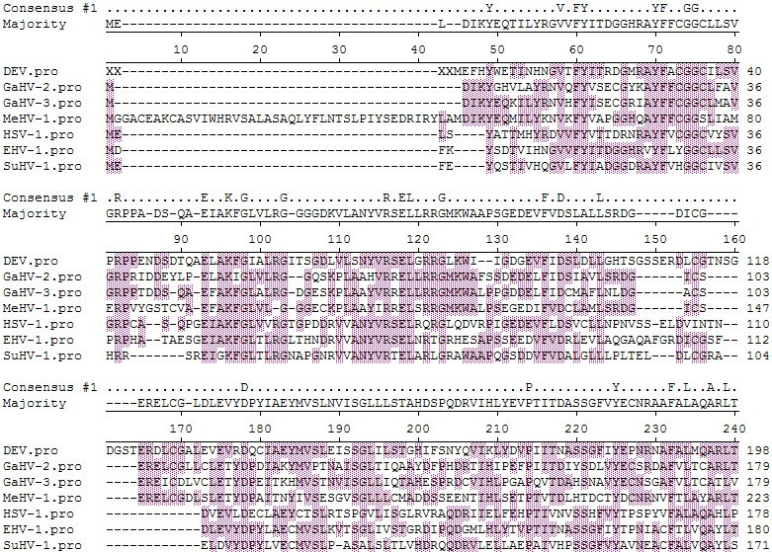

*Yong Shi et al. / AASRI Procedia 1 ( 2012 ) 124 – 135*  131

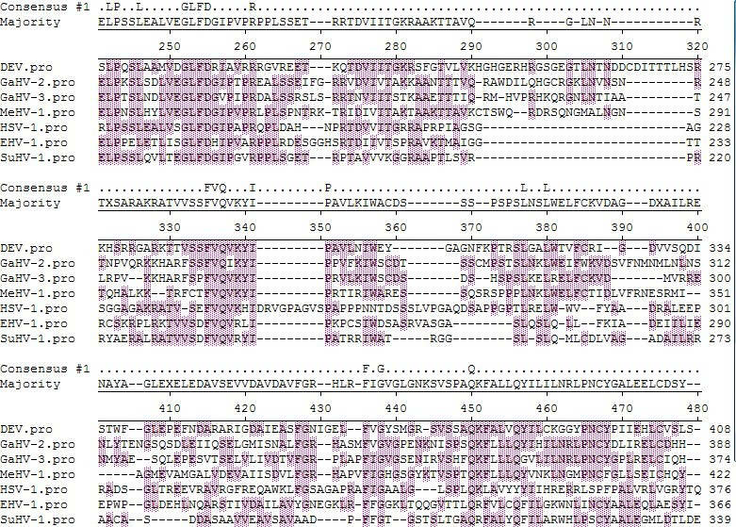

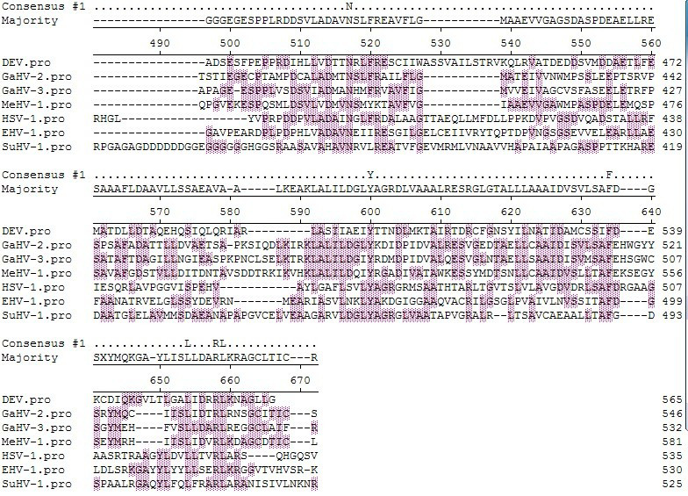

Fig. 5 Multiple sequences alignment of UL21 protein sequence of DEV, GaHV-2, GaHV-3, MeHV-1, HSV-1, EHV-1 and SuHV-1.The conserved structural motifs that are characteristic of the protein are shadowed.

Amino acid sequence comparison among different DEV strain shows that the sequences of DEV CHv and VAC strain are identical, the UL21-like strain are similar with them except aa position 268, 436, 447 respectively(shown in Figure 4). Multiple sequences alignment of UL21 protein sequences we selected showed the conserved region of UL21 protein centred in aa 69-84, 93-103, 112-124, 174-189, 230-260, 274-283 and 335-341.

*3.4.. Phylogenetic analysis about the UL21 protein sequence of DEV and 25 referenceherpesviruses*

A phylogenetic tree wsa established based on UL21 protein sequence of DEV and those of 25 reference herpesviruses (display in Fig.6). The result shows there are 4 mainly branches: Varicellovirus, Mardivirus and DEV in a large branches; Simplexvirus, and Iltovirus in a same branches; Betaherpesvirinae and Gammaherpesvirinae in other two branches respectively. The DEV are with MeHV-1, GaHV-2 and GaHV-3 in a monophyletic clade. Protein sequence comparison(showed in Fig.7) by Clustal multiple revealed that DEV UL21 protein shares 26.4%, 27.3%, 26.2% similarity with GaHV-2, GaHV-3 , MeHV-1 and 33.0%,

132  *Yong Shi et al. / AASRI Procedia 1 ( 2012 ) 124 – 135*

31.8%, 33.4%, 30.7% with EHV-1, EHV-4, EHV-9, FeHV-1, respectively. So we can conclude that the UL21

protein of DEV is most closely related to Varicellovirus and Mardivirus.

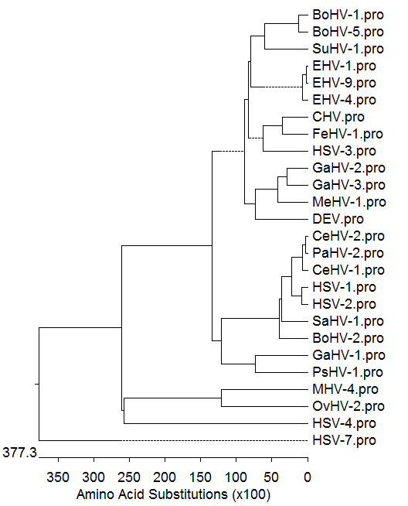

Fig. 6 Evolutionary relationships of the putative DEV CHv UL21 protein with its 25 reference herpesviruses( Table 2).

Phylogenetic tree of these proteins was generated by using the MegAlign program with Clustal V multiple alignment of

DNAStar 7.1.

|  |  |
| --- | --- |
|  | � |

*Yong Shi et al. / AASRI Procedia 1 ( 2012 ) 124 – 135*  133

�

Fig.7 Identify analysis of the UL21 protein sequences of DEV and other 25 alphaherpesviruses by using DNAStar 7.1 multiple alignments.

**4.Disccussion**

Previous reports about UL21 protein are mainly focused on the PRV and HSV-1.The UL21 protein is a tegument protein, and weakly associated with the capsid [13]. The deletion mutants which lacked the whole or partly UL21 gene sequences, were proved that UL21 protein is dispensable for growth both in cultured cells or in vivo[14-15,19]. There is a complex interaction between the UL16 and UL21 tegument proteins in PRV and HSV-1[15,20-23]. In addition, the PRV UL21 gene product associates with virulence, and package pUL46, pUL49, and pUS3 efficiently[24]; the HSV-1 UL21 gene product associates with microtubules, indicating that the UL21 protein may have function of transport. All above revealed UL21 product of HSV and PRV is a regulateing protein. The UL21gene is conserved among herpes virions[25], and we presumed the product of DEV UL21 gene may have similar function.

There are few reports about UL21 protein of DEV, so we study the DEV UL21 protein predicted information base on bioinformatics software and online tools. DEV UL21 protein doesn’t contain the signal peptide and the transembrance region, suggesting the protein is not secreted protein or membrane glycoprotein. Protein phosphorylation on serine, threonine, and tyrosine(Ser/Thr/Tyr) is generally considered the major regulatory posttranslational modification functional in prokaryotes[26]. There are 27 potential phosphorylation sites were found in DEV UL21 protein, which may associates wich regulateing function ,and the apparent molecular mass may be more than predicted value 61993.2. The analysis of the UL21 protein subcellular localization indicates that the UL21 gene product of DEV could both local in cytoplasmic and nuclear, which is similar with PRV and HSV-1 protein[13-14,17].

The secondary structure is related with protein function. The alpha helix of the protein have higher chemical bonding energy, can firmly maintain proteinic higher structure. The alpha helix of the protein plays a important role in DNA binding motifs, but it seldom become B cell epitopes because it is difficult to gomphosis antibody better, and usually locates at protein interior. Extended strand and random coil are more noncohesive flexibility structures and always include B cell dominant epitopes, because they are more loosen texture, which are easy to generate retortion and stretch out of the proteinic surface and gomphosis antibody[27-29]. DEV UL21 protein consists of 44.56% Alpha helix (h), 13.55% extended strand (e) and 41.89% random coil (c) respectively, indicating more extended strand and random coil structure may contain certain B cell epitopes. Previous results suggest that herpes simplex tegument proteins are processed for antigen presentation in vivo and are possible candidate compounds for herpes simplex vaccines[30], about 20 main antigenic determinants in epitope analysis further suggests that UL21 protein is possible candidate compounds for DEV vaccines to the prevention and diagnosis of the duck virus enteritis.

Amino acid sequence comparison among different DEV strain shows that there may be light difference of UL21 protein among different DEV strains. We presumed the difference of identical gene may cause virulence diversity. The result of multiple sequences alignment of UL21 protein sequence of DEV, GaHV-2, GaHV-3, MeHV-1, HSV-1, EHV-1 and SuHV-1 supports that UL21 gene is conserved among Alphaherpesvirinae at least.

From Fig.6, the established phylogenetic tree based on DEV CHv UL21 protein with its 25 reference herpesviruses and cluster analysis results show DEV has a close evolutionary relationship with GaHV-2, GaHV-3, MeHV-1, which belong to Mardivirus, but protein sequence comparison showed in Fig.7 revealed similarity between DEV UL21 protein and Varicellovirus (including EHV-1, EHV-4, EHV-9 and FeHV-1) is higher than those between Mardivirus. It has reported DEV dUTPase gene product, gI, UL15, UL27, UL35 and UL55 proteins also have a close relationship with Mardivirus[10,31-35], we presumed DEV may be one

134  *Yong Shi et al. / AASRI Procedia 1 ( 2012 ) 124 – 135*

member of Mardivirus or belong to an individual genus within the Alphaherpesvirinae subfamily based on these results. More researches are required to define which genus of herpesvirus the DEV belongs to.

In short, bioinformatics analysis of DEV UL21 protein by some software and online tools provides some important information about the molecular characteristics. Our work provided some basic information for the further DEV UL21 protein research.

**Acknowledgment**

The research was supported by China 973 program�2011CB111606, China Agricultural Research System(CARS-43-8), Changjiang Scholars and Innovative Research Team in University(PCSIRT0848) and National science and technology support program for agriculture�2011BAD34B03�An-chun Cheng and Ming-shu Wang are the corresponding authors. Institute of Preventive Veterinary Medicine, Sichuan Agricultural University, Wenjiang, Chengdu city, Sichuan, 611130, P.R.China. Avian Disease Research Center, College of Veterinary Medicine of Sichuan Agricultural University, 46# Xinkang Road, Ya’an, Sichuan 625014, P.R. China.Key Laboratory of Animal Disease and Human Health of Sichuan Province, Sichuan Agricultural University, Wenjiang, Chengdu city, Sichuan, 611130, P.R.China.. Tel.: +86 835 2885774; fax: +86 835 2885774; E-mail address: chenganchun@vip.163.com (A. Cheng); mshwang@ 163.com (M. Wang).

**References**

[1] Thomas N. Tully,Gerry M. Dorrestein, Saunders Ltd. .Waterfowl. Handbook of avian medicine (Second Edition), USA: Saunders Ltd,2009.

[2] Sandhu TS, Metwally SA. Diseases of poultry.Blackwell Publishing, 2008   
[3] Fauquet CM, Mayo MA, Maniloff J . Virus Taxonomy: Eighth report of the international committee on taxonomy of viruses, Elsevier Academic Press, California, 2005   
[4] Yang F, Jia WX, Yue H, et al. Development of quantitative real-time polymerase chain reaction for duck enteritis virus DNA. Avian Dis,AAAP.San Jose Blvd 2005:49:397-400,   
[5] Jia RY, Cheng AC, Wang MS, et al. Studies on ultrastructure of duck enteritis virus chv virulent strain”,Chinese J.Virol 2007:23:202-6,.

[6] Yuan GP, Cheng AC, Wang MS, et al. Electron microscopic studies of the morphogenesis of duck enteritis virus”,Avian Dis, AAAP, San Jose Blvd 2005:49:50-5   
[7] Pan H, Cao R, Liu L, et al. Prokaryotic expression of N-terminal antigenic domain of duck plague virus gB protein and the establishment of putative indirect ELISA assay. Wei Sheng Wu Xue Bao. 2008:48:98-102. [8] Xie W, Cheng AC, Wang MS. Expression and characterization of the UL31 protein from duck enteritis virus. Virology Journal 2009:6, doi:10.1186/1743-422X-6-19   
[9] Xiang J, Cheng AC, Wang MS.Molecular Cloning and sequence analysis of the Duck Enteritis Virus Nucleocapsid Gene UL38. Biomedical Engineering and Informatics, 2009. BMEI '09. 2nd International Conference on, 17-19 Oct. 2009   
 [10] Li LJ, Cheng AC, Wang MS.Molecular Cloning and sequence analysis of the Duck Plague Virus gI Gene, Bioinformatics and Biomedical Engineering (iCBBE), 2010 4th International Conference on, 18-20 June 2010   
[11] Valerio V, Eve D. Determination of Interactions between tegument proteins of herpes simplex virus type 1. Journal of virology 2005:79:9566–71   
[12] Li YF , Huang B.Molecular characterization of the genome of duck enteritis virus. Virology 2009:391:151–61   
[13] Hiroki Takakuwa, Fumi Goshima .Herpes simplex virus encodes a virion-associated protein which promotes long cellular processes in overexpressing cells.Genes to Cells 2001: 6 : 6955-66

*Yong Shi et al. / AASRI Procedia 1 ( 2012 ) 124 – 135*  135

[14] Baines JD, Koyama AH, Huang T, et al. The UL21 gene products of herpes simplex virus1 are dispensable for growth in cultured cells. Virol.,1994:68: 2929-36   
[15] Klupp BG, Bottcher S, Granzowet H ,et al. Complex formation between the UL16 and UL21 Tegument Proteins of Pseudorabies Virus. Journal of virology 2005:79 : 1510–22   
[16] Klupp BG, Lomniczi B, Visser N, et al. Mutations affecting the UL21 gene contribute to avirulence of pseudorabies virus vaccine strain Bartha. Virology 1995: 212:466-73   
[17] Wind DN., Wagenaar F, Pol J, et al. The pseudorabies virus homology of the herpes simplex virus UL21 gene product is acapsid protein which is involved in capsid maturation. Virol 1992:66 : 7096-103   
[18] Klop RF, Klupp BG, Fuchs W, et al. Influence of Pseudorabies Virus Proteins on Neuroinvasion and Neurovirulence in Mice. Journal of virology 2006:80 : 5571–6   
[19] Frans W, Jan MA. Deletion of the UL21 gene in Pseudorabies virus results in the formation of DNA-deprived capsids:an electron microscopy study.Vet. Res,2001: 32:47–54   
[20] Amy LH, David G. Meckes Jr, et al. Interaction domains of the UL16 and UL21 tegument proteins of herpes simplex virus. Journal of virology, 2010:84 :2963–71   
[21] Pei CY, David G. Meckes, Jr, et al. Analysis of the interaction between the UL11 and UL16 tegument proteins of herpes simplex virus. Journal of virology 2008:82: 10693–700   
 [22] David G, Meckes Jr., Jacob AM, et al .Complex mechanisms for the packaging of the UL16 tegument protein into herpes simplex virus. Virology 2010:398:208–13   
[23] David G, Meckes, Jr., John WW. Dynamic Interactions of the UL16 Tegument Protein with the Capsid of Herpes Simplex Virus. Journal of virology 2007:81: 13028-36

[24] Michael K�Klupp BG, Karger A, et al. Efficient Incorporation of Tegument Proteins pUL46, pUL49, and pUS3 into Pseudorabies Virus Particles Depends on the Presence of pUL21. Journal of virology 2007: 81 :1048-51   
[25] Barbara J. Kellya, Cornel Fraefelb, Anthony L. Functional roles of the tegument proteins of herpes simplex virus type 1. Virus Research 2009: 145: 173-86   
[26] Macek B, Gnad F, Soufi B. Phosphoproteome analysis of E. coli reveals evolutionary conservation of bacterial Ser/Thr/Tyr Phosphorylation. Biochemistry and Molecular Biology,2007:7:299-307   
[27] Xu C,.Li XR, Xin HY, et al. Cloning and molecular characterization of gC gene of duck plague virus. Chinese Veterinary Science 2008:38:1038-44.

[28] Sun T, Cheng AC, Wang MS, et al. Prediction of epitopes on B cell of UL6 gene of duck enteritis virus

|  |  |  |  |  |  |  |  |  |  |  |
| --- | --- | --- | --- | --- | --- | --- | --- | --- | --- | --- |
| and | prokaryotic | expression | of | major | antigen | determinant | sequence. | Veterinary | Science | in |

China .2008:.38:939-45   
[29]Barlow DJ, Edwards MS ,Thornton JM. Continuous and discontinuous protein antigenic determinants.

Nature 1986:322:747-48   
[30] David MK..Recognition of Herpes Simplex Virus Type 2 Tegument Proteins by CD4 T Cells Infiltrating Human Genital Herpes Lesions. Journal of virology1998:72:7476-83   
[31] Zhao LC, Cheng AC, Wang MS ,et al.Characterization of codon usage bias in the dUTPase gene of duck enteritis virus,” Progress in Natural Science 18 (2008) 1069–1076.

[32] Cai MS, Cheng AC, Wang MS, et al. Characterization of synonymous codon usage bias in the Duck Plague virus UL35 Gene,Intervirology 2009;52:266–278.

[33] Jiang L, Lin D, Cheng AC, et al. Bioinformatic analysis of UL27 gene of Duck Plague Virus CHv Strain.

Bioinformatics and Biomedical Engineering (iCBBE), 2010 4th International Conference on, 2010   
[34] Zhu HG, Li HX, Han ZX. Identification of a spliced gene from duck enteritis virus encoding a protein homologous to UL15 of herpes simplex virus 1. Virology Journal 2011, 8:156   
[35] Wu Y, Cheng AC, Wang MS. Molecular characterization analysis of newly identified Duck Enteritis Virus UL55 Gene. Bioinformatics and Biomedical Engineering (iCBBE), 2010 4th International Conference on, 18-20 June 2010