

[Applied Computing and Informatics (2017) 13, 169](http://dx.doi.org/10.1016/j.aci.2016.12.002)–[174](http://dx.doi.org/10.1016/j.aci.2016.12.002)

|  |  |
| --- | --- |
|  | Saudi Computer Society, King Saud University  Applied Computing and Informatics  (http://computer.org.sa)  www.ksu.edu.sa  [www.sciencedirect.com](http://www.sciencedirect.com/science/journal/22108327) |

ORIGINAL ARTICLE

Chattering-free sliding mode observer for speed

sensorless control of PMSM

Mahmoud M. Gaballah*, Mohammad El Bardini, Mohammad Sharaf

Dept. of Industrial Electronics & Control Engineering, Faculty of Electronic Engineering, Minufiya University, 32852, Egypt

Received 23 June 2016; revised 18 November 2016; accepted 21 December 2016 Available online 31 December 2016

|  |  |  |
| --- | --- | --- |
| KEYWORDS  PMSM;  Sensorless control;  Fuzzy logic | Abstract | This article presents a new speed observer based on fuzzy logic for speed sensorless |
| control applications of permanent magnet synchronous motor ‘‘PMSM”. The switch function in traditional Sliding Mode Observer ‘‘SMO” is replaced by a rule based fuzzy logic system. The pro-posed observer not only improves the system dynamic performance during disturbances or param- | |

eter variations, but also has a high accuracy tracking performance with sufficient chattering reduction. The validity of the new observer corroborated through experimental results using TMS320F28069M Digital Signal Processor ‘‘DSP”.

� 2016 The Authors. Production and hosting by Elsevier B.V. on behalf of King Saud University. This is an open access article under the CC BY-NC-ND license (<http://creativecommons.org/licenses/by-nc-nd/4.0/>).

|  |  |
| --- | --- |
| 1. Introduction | controlled using the estimated values of the angular speed of |

the rotor [1,2].

Permanent Magnet Synchronous Machine ‘‘PMSM” become a good choice in servo drives, and is on the way to step beside

|  |  |  |  |  |  |
| --- | --- | --- | --- | --- | --- |
| induction | machines | in | traction | applications. | Traditional |

PMSM drives employ position sensors to measure the speed, and rotor angular position. These sensors present several disadvantages, such as reduced reliability, susceptibility to noise, additional cost and weight and increased complexity of the drive system. Recently, there has been much interest in developing a sensorless algorithms in which the motor was

* Corresponding author at: Sigma Electronic Industries, Cairo, Egypt. E-mail addresses: [Mahmoud.Gaballah1@gmail.com](mailto:Mahmoud.Gaballah1@gmail.com) (M.M. Gabal-lah), [dralbardini@ieee.org](mailto:dralbardini@ieee.org) (M. El Bardini), [mohamed.sharaf@el-eng. menofia.edu.eg](mailto:mohamed.sharaf@el-eng.menofia.edu.eg) (M. Sharaf).

Peer review under responsibility of King Saud University.

**Production and hosting by Elsevier**

Several methods have been developed to estimate the rotor speed or position, and among them are Flux Linkage Observer‘‘FLO”, Extended Kalman Filter ‘‘EKF” based observer, and Sliding Mode Observer ‘‘SMO”. The latter has a fast response, good robustness for external disturbances, and machine parameter variations [3,4]. The SMO uses a sliding mode vari-able structure in the control loop to compensate the parametric

|  |  |  |  |  |  |  |
| --- | --- | --- | --- | --- | --- | --- |
| uncertainties | keeping | the | observer | independent | of | the |

unknown signals during the sliding motion with a stable dynamic error [5,6]. The estimated values in an ordinary SMO contain high frequency oscillation components because of the discrete switch control. The switch function is critical to the observer performance and it allows appearing the chat-tering phenomenon that can excite high frequencies which isn’t desirable in high performance speed drives [7,8]. Several solutions are proposed to make a trade-off between chattering phenomenon reduction, and observer robustness. In [9–11] a first order and second order SMO proposed, the chattering phenomenon reduced but low pass filter causes unavoidable

<http://dx.doi.org/10.1016/j.aci.2016.12.002>  
2210-8327 [�](http://dx.doi.org/10.1016/j.aci.2016.12.002) 2016 The Authors. Production and hosting by Elsevier B.V. on behalf of King Saud University.

This is an open access article under the CC BY-NC-ND license (<http://creativecommons.org/licenses/by-nc-nd/4.0/>).

|  |  |
| --- | --- |
| 170 | M.M. Gaballah et al. |

|  |  |  |  |  |  |  |  |  |  |  |  |  |  |  |  |  |  |  |  |  |  |  |
| --- | --- | --- | --- | --- | --- | --- | --- | --- | --- | --- | --- | --- | --- | --- | --- | --- | --- | --- | --- | --- | --- | --- |
| Nomenclature   |  |  |  |  | | --- | --- | --- | --- | | p; PI | derivative operator, proportional integral | Rs; Ls | phase resistance and Phase inductance | | Va; Vb | voltages in stationary reference frame | wf | flux linkage | | ia; ib | measured currents in stationary reference frame | xr | angle speed of the rotor | | ^ia; ^ib | estimated currents in stationary reference frame | h | position of the rotor | | �i | estimation error in current signal | k | observer gain | | ea; eb | EMFs in stationary reference frame | |

and unpredictable time delays in the estimated values which need a compensation technique. In [12], the ordinary switch

To guarantee the observer convergence based on lyapunov’direct theory, the observer gain ‘‘k” should be [11]:

|  |  |  |
| --- | --- | --- |
| function replaced with the sigmoid function, low-pass filter | k > maxðjeajjebjÞ | ð6Þ |
| avoided but there is a tracking error. In [13] a higher-order |

sliding mode ‘‘HOSM” observer presented, the estimation accuracy improved, but selecting sliding mode gains and boundary layer are difficult as they are dependent on the rotor speed. Other algorithms such as artificial neural network [14] and artificial intelligence (AI) methods [15], can achieve high performance, but they are relatively complicated and require large computational time.

This paper introduces a new Fuzzy Sliding Mode Observer (FSMO) in which the switch function in traditional Sliding Mode Observer ‘‘SMO” was replaced by a rule based Fuzzy Logic System ‘‘FLS”. The proposed observer not only ensures the robustness for various disturbances, but also improves the dynamic performance. The observer was experimentally tested out on a TMS320F28069M DSP Controller, and experimental results were introduced to validate the proposed observer covering digital implementation cost, position estimation accu-racy, and speed response.

Once the system reaches the sliding surface, then:

|  |  |  |  |  |
| --- | --- | --- | --- | --- |
| ( | �i ¼ ~ia | ~ib | �T¼ 0  p~ib�T¼ 0 | ð7Þ |
| p�i ¼ p~ia | |

Substituting Eq. (7) in Eq. (5), the back EMF can be obtained as follows:  
�0 ¼ 0 þ ea � ksgnð�iaÞ 0 ¼ 0 þ eb � ksgnð�ibÞ ; �ea ¼ ksgnð�iaÞ eb ¼ ksgnð�ibÞ ð8Þ

The back EMF in Eq. (8) usually contain high frequency com-

ponents [19]. To relieve this noise a low pass filter applied:�pð^eaÞ ¼ �x0^ea þ x0ea pð^ebÞ ¼ �x0^eb þ x0eb ð9Þ

where x0 ¼ 2pf0, and f0 is the cut-off frequency of the filter. Finally the rotor position, and rotor speed can be calcu-lated as follows:

|  |  |  |  |  |
| --- | --- | --- | --- | --- |
| 2. Motor model and sliding mode observer | 8 < : | ^h ¼ arctan �^ea�  ^xr ¼ p^h | � | ð10Þ |
| Based on these assumptions the motor appears to be or |
| becomes unsaturated; all the stator resistance, self- and mutual |
| inductances for each phase are the same, neglecting the iron | 3. Design of fuzzy sliding mode observer (FSMO) | | |

losses. The PMSM model in the stationary reference frame is

|  |  |  |  |
| --- | --- | --- | --- |
| described by the following equations [16]: | | ð1Þ | The idea behind SMO is to select the switching gain so the slid- |
| ( | LsðpiaÞ ¼ �Rsia � ea þ Va LsðpibÞ ¼ �Rsib � eb þ Vb |
| ing function ’’ksgnð�iÞ’’ compensate the parametric uncertain-ties keeping the observer independent of the unknown |
| signals during the sliding motion insuring a stable dynamic |

|  |  |  |  |  |
| --- | --- | --- | --- | --- |
| where | ( | ea ¼ �wfxr eb ¼ �wfxr | sin h | ð2Þ |
| cos h |

To observe the EMF components, the sliding mode observer is designed as follows [17,18]:

|  |  |  |  |  |  |
| --- | --- | --- | --- | --- | --- |
| � | Lsðp^iaÞ ¼ �Rs^ia þ Va � ksgnð^ia � iaÞ Lsðp^ibÞ ¼ �Rs^ib þ Vb � ksgnð^ib � ibÞ | | | | ð3Þ  ð4Þ |
| where sgn ðxÞ ¼ | | � | 1 | if x > 0 |
| �1 | if x < 0 |

Subtracting Eq. (1) from Eq. (3), Va cancel Vb, and the

error [5,6]. The discontinuous sign function in Eq. (4) is critical to the observer performance and needs fast switching of motion states, which will cause chattering [20,21]. To eliminate the chattering phenomenon in classical SMO, the fixed numer-ical values of the switching function are replaced by linguistic variables, and the switching function is calculated through fuzzy logic system. The new Fuzzy SMO ‘‘FSMO” will have the robustness property of SMO with sufficient chattering reduction via Fuzzy Logic System ‘‘FLS”. The FSMO block diagram is depicted in Fig. 1, and built as follows:

|  |  |  |
| --- | --- | --- |
| � | Lsðp^iaÞ ¼ �Rs^ia þ Va � kFs Lsðp^ibÞ ¼ �Rs^ib þ Vb � kFs | ð11Þ |

|  |  |  |  |  |
| --- | --- | --- | --- | --- |
| error equations will be the following: | | ð5Þ | where Fs ¼ FSMOð�i; p�iÞ | ð12Þ |
| � | Lsðp~iaÞ ¼ �Rs~ia þ ea � ksgnð�iaÞ Lsðp~ibÞ ¼ �Rs~ib þ eb � ksgnð�ibÞ |
| The proposed FSMO will have 49 if-then rule base, two input | |
| variables ½�i; and p�i� which define the current error and its rate | |

|  |  |
| --- | --- |
| Speed sensorless control of PMSM | 171 |

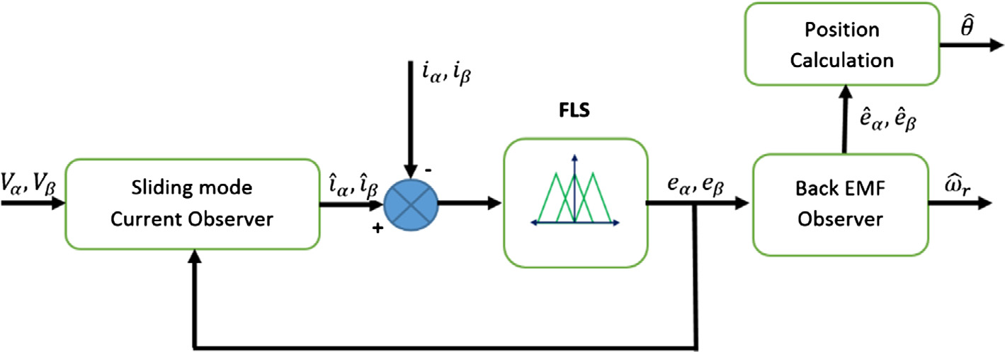

|  |  |
| --- | --- |
| Fig. 1 | Block diagram of FSMO. |

of change, respectively, and one crisp output ðFsÞ. All fuzzy variables have the same universe of discourse [�1 to 1], and been divided into seven fuzzy sets (A0, A1, A2, A3, A4, A5,

and A6) and (B0, B1, B2, B3, B4, B5, and B6) for the input

variables, and (NB = negative big, NM = negative medium,

obtained using expert engineering knowledge in the navigation field and satisfying the above-mentioned stability and reaching conditions. The FLS output is calculated based on singleton fuzzification strategy, center-average defuzzification and pro-duct inference. At each input values the FLC gives an output

|  |  |  |  |  |  |
| --- | --- | --- | --- | --- | --- |
| NS = negative | small, | ZE = zero, | PS = positive | small, | signal corresponds to the increase or decrease in sliding func- |

PM = positive medium, and PB = positive big) for the output variable. Membership functions are chosen in the form of sym-metrical triangular as in Fig. 2.

The output fuzzy ‘Fs’ set is normalized in the interval [�1,1] therefore, Fs ¼ jFSMOð�i; p�iÞj 6 1. A simple fuzzy rule table is constructed considering the following reaching and stability requirements;

1. When ð�i � p�iÞ becomes a positive value, the membership function of Fs is set in such a way that its sign becomes sim-ilar to that of ð�iÞ and therefore, �i � Fs 6 0.

2. When ð�i � p�iÞ is a negative value, the reaching condition would be satisfied automatically. In this case, the member-ship function of Fs could be changed with negative or even positive sign to enhance the tracking performance.

Regarding seven membership functions for each input vari-able of the fuzzy rule base, 49 if-then rules of Fig. 2 are

tion (Fs) to satisfy the dynamic stability of the observer.

4. Experimental setup

To assess the performance and the robustness of the proposed observer, field oriented control strategy was applied to an experimental DSP-based PMSM drive apparatus. The block diagram of the experimental setup is shown in Fig. 3. It consists of power inverter, PMSM with parameters shown in Table 1 and loading arrangement, voltage and current sensing circuits, and floating point TMS320F28069M digital controller.

The controller running clock and Pulse Width Modulation‘‘PWM” switching frequency are 50 MHz and 10 kHz, respec-tively. To avoid the switching harmonics in the samples phase currents, the sampling frequency is selected as 10 kHz for the current control loops and 1 kHz for the speed control loop. Two PI controllers are used for current, and speed control

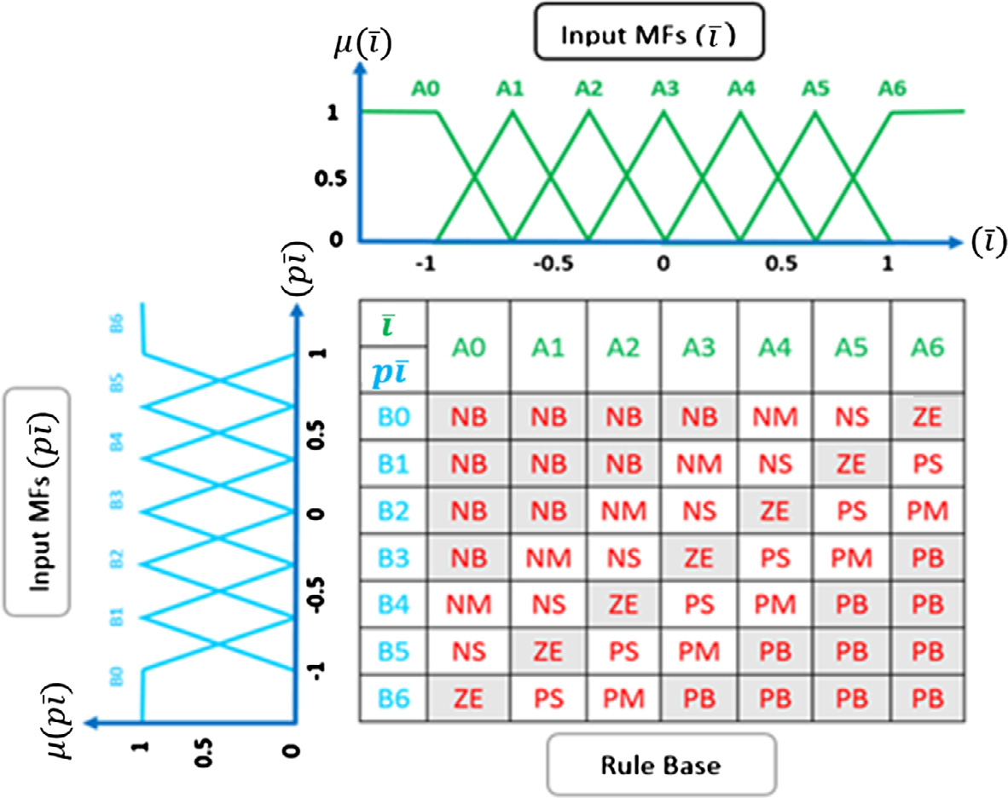

Fig. 2 Input MFs, and Rule base of FSMO Algorithm.

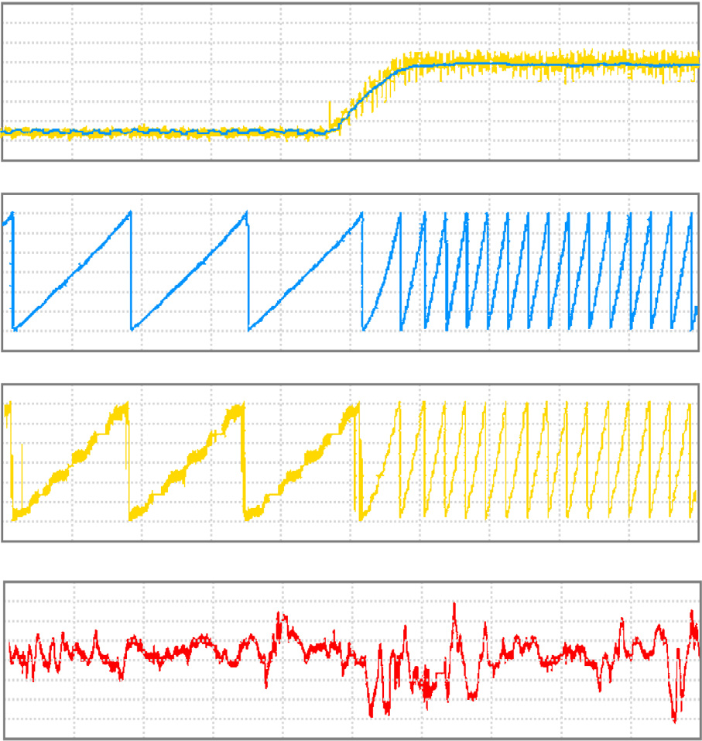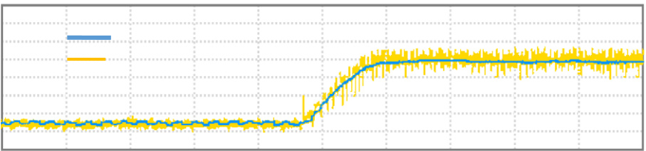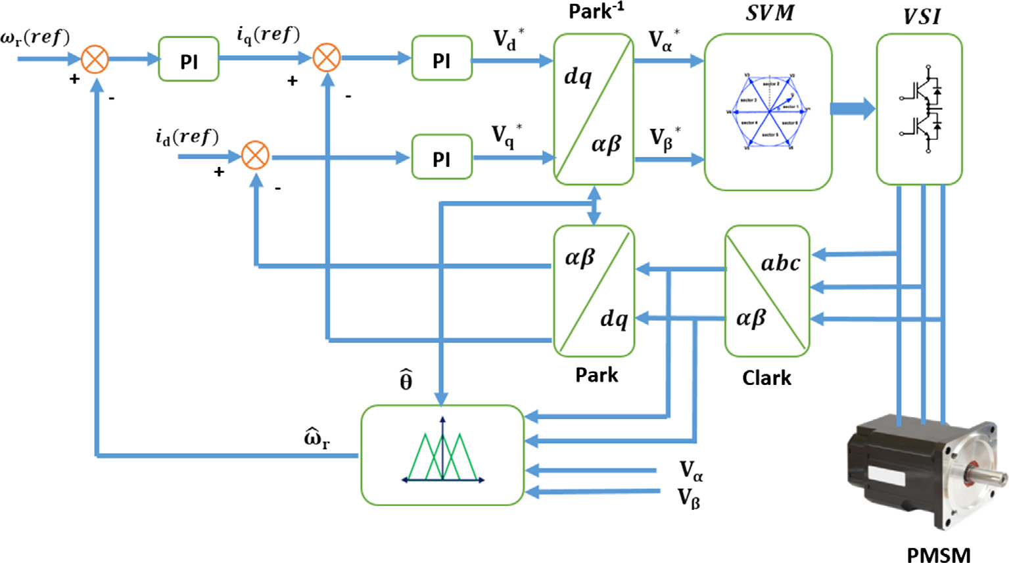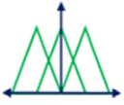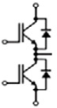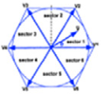

|  |  |  |  |
| --- | --- | --- | --- |
| 172 | Fig. 3 | Sensorless PMSM field-oriented control algorithm block diagram. | M.M. Gaballah et al. |

|  |  |  |  |  |  |
| --- | --- | --- | --- | --- | --- |
| Table 1 | Parameters of the applied | | 6 | **(a) Actual and es�mated rotor speed (KRPM)** | |
| PMSM motor. | | | Actual speed  Es�mated speed | **[200 ms / div]** |
| 4 |
| Rated speed | | 4000 rpm |  |
| 2 |
| Rated torque | | 0.125 N m | **(b) Actual rotor posi�on (degree)** | Time (sec) |
| 0 |
| Maximum voltage | | 24 V DC |
| Maximum current | | 5 A |
| 180 | **(c) Es�mated rotor posi�on (degree)** | Time (sec) |
| Stator resistance | | 0.39 X |
| 90 |
| Stator inductance | | 0.69 mH |
| Inertia | | 48 g cm2 | -90 |
| Torque constant | | 0.0355 N m/A | -180 |
| Pole pairs | | 4 |
| 180 |  |

90

|  |  |  |  |
| --- | --- | --- | --- |
| loop, and the tuning process of controller constants is designed | -90 | **(d) Rotor posi�on error (degree)** | Time (sec) |
| to get a bandwidth of 400 HZ, and 40 HZ respectively. The | -180 |
| resultant PI controller constants are KP = 10�4, Ki = 0.97 | 20 |
| for current controllers, and KP = 167.32, Ki = 28.58 for the |
| speed controller. |

0

|  |  |  |  |  |  |  |  |  |  |  |
| --- | --- | --- | --- | --- | --- | --- | --- | --- | --- | --- |
| 5. Experimental results | -20 | 0.2 | 0.4 | 0.6 | 0.8 | 1.0 | 1.2 | 1.4 | 1.6 | Time (sec) |
| Several tests have been carried out to verify the correctness and |
| robustness of the proposed observer. | Fig. 4 | Traditional SMO speed response and rotor position | | | | | | | | |

Test 1: Speed step increasesreference from 10% to 100% of

rated speed with constant load; this test examine the steady-state performance of the proposed observer at low and high-speed, comparing its performance with the traditional SMO. Figs. 4, and 5 shows the experimental results for traditional SMO, and the proposed observer respectively.

The actual and estimated rotor speed for traditional SMO is shown in Fig. 4a, while Fig. 4b, and c shows the waveforms of the actual and estimated rotor positions obtained for tradi-tional SMO respectively. The rotor position error is shown in Fig. 4d. The average steady-state speed error is (300/4000 = 7.5%) at 4000 rpm, and (55/400 = 13.7%) at 400 rpm.

The actual and estimated rotor speed for FSMO is shown in Fig. 5a, while Fig. 5b and c shows the waveforms of the actual and estimated rotor positions obtained for FSMO respectively.

waveforms at speed step reference from 400 to 4000 rpm.

The rotor position error is shown in Fig. 5d. The average steady-state speed error is (50/4000 = �1.25%) at 4000 rpm, and (10/400 = 2.5%) at 400 rpm. It can be observed that the FSMO is accurate with sufficient chattering reduction com-pared with traditional SMO.

Test 2: The speed response to bipolar command from 400 rpm

to ~~�~~400 rpm with constant load; this test examines the performance of the proposed observer at low speed bipolar command. The bipolar speed command is a square waveform with a half cycle of 2.5 s and bipolar references ±400 rpm. Fig. 5 shows the waveforms of the actual and estimated rotor

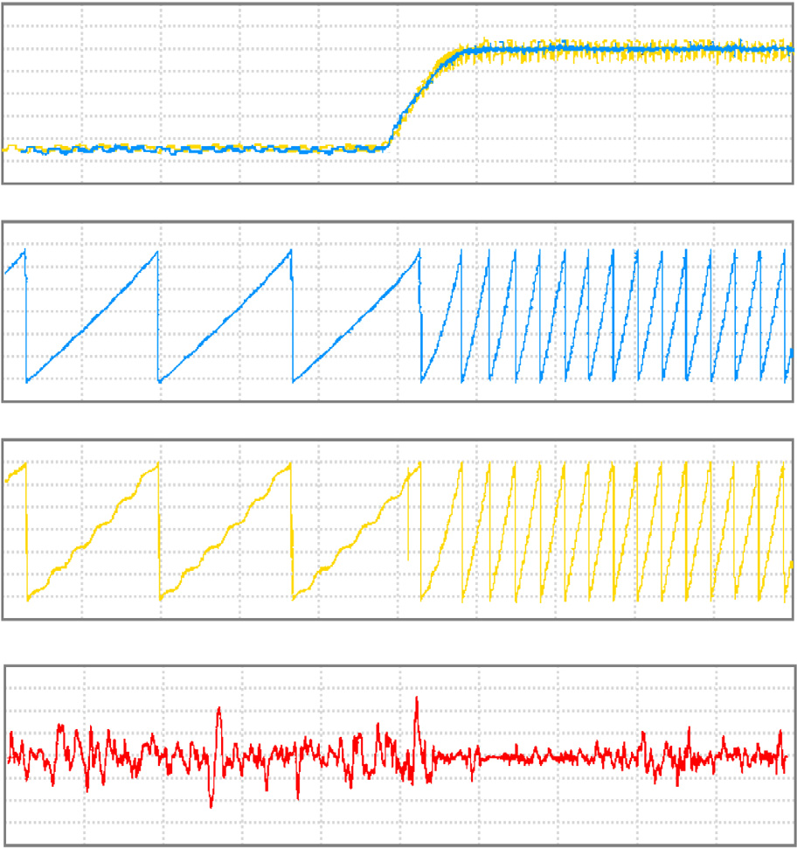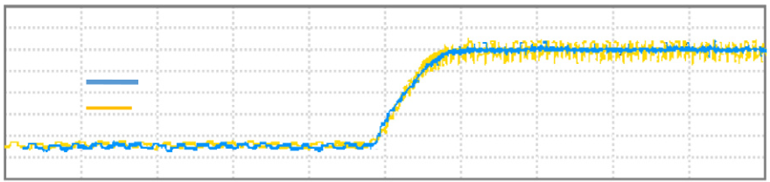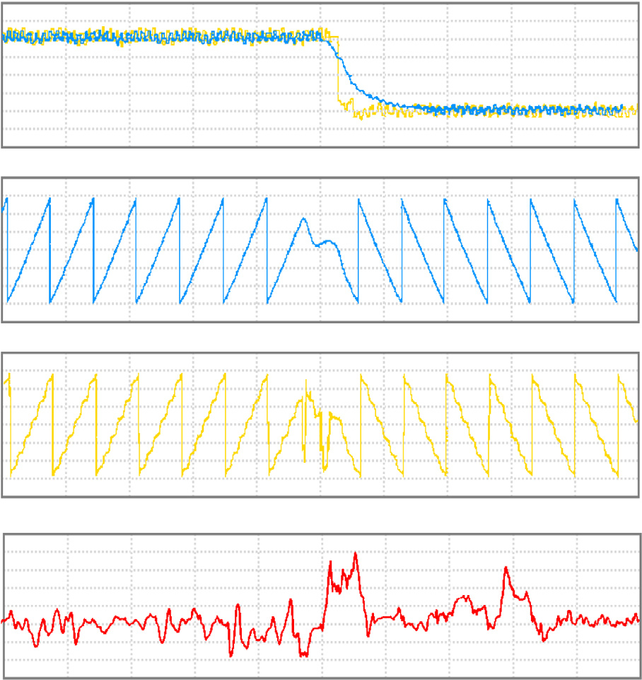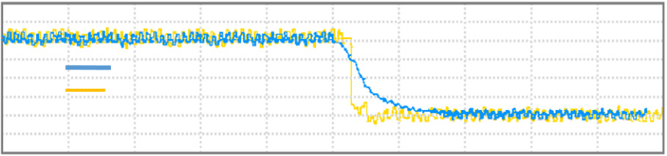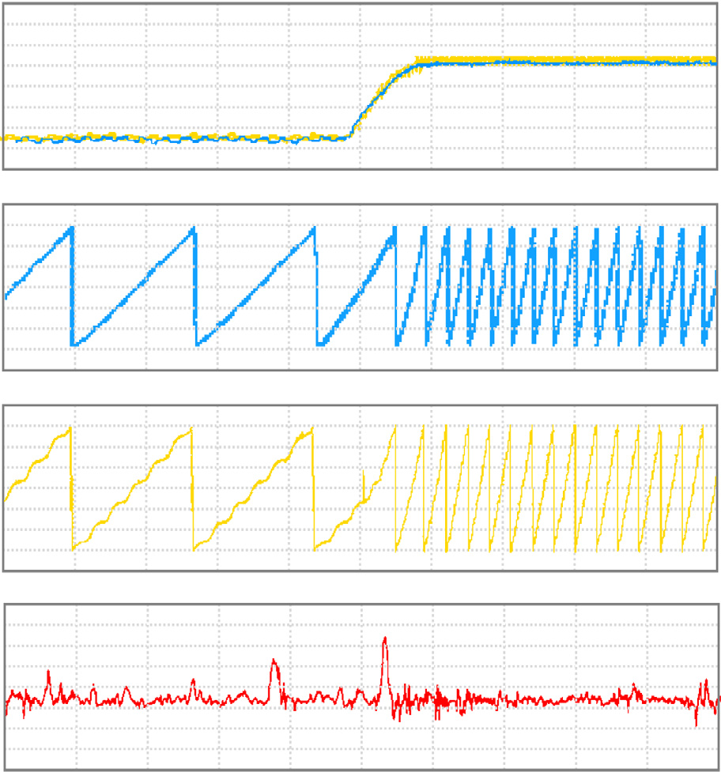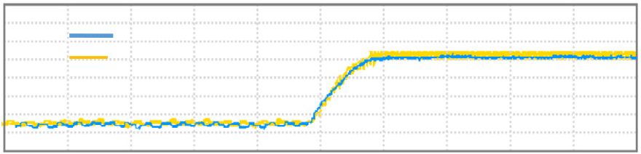

|  |  |  |  |  |  |  |  |  |  |  |  |  |  |  |  |  |  |  |
| --- | --- | --- | --- | --- | --- | --- | --- | --- | --- | --- | --- | --- | --- | --- | --- | --- | --- | --- |
| Speed sensorless control of PMSM | | | | | | | | |  |  | 173 | | | | | | | |
| **(a) Actual and es�mated rotor speed (KRPM)** | | | | | | | | | 6 | 0.2 | **(a) Actual and es�mated rotor speed (KRPM)** | | | | | | | |
| 6 | Actual speed  Es�mated speed | | | | **[200 ms / div]** | | | |
| 4 | Actual speed  Es�mated speed | | **[200 ms / div]** | | | | | |
| 4 |
| 2 |
| 2 | | | | | | | | |
| 0 | | | | | | | | | 0 | **(b) Actual rotor posi�on (degree)** | | | | | | | |
| **(b) Actual rotor posi�on (degree)** | | | | | | | | |
| 180 | | | | | | | | | 180 | **(c) Es�mated rotor posi�on (degree)** | | | | | | | |
| 90 |
| 90 | | | | | | | | |
| -90 |
| -90 | | | | | | | | |
| -180 |
| -180 | | | | | | | | |
| **(c) Es�mated rotor posi�on (degree)** | | | | | | | | |
| 180 | **(d) Rotor posi�on error (degree)** | | | | | | | |
| 180 | | | | | | | | |
| 90 |
| 90 | | | | | | | | |
| -90 |
| -90 | | | | | | | | |
| -180 |
| -180 | | | | | | | | |
| **(d) Rotor posi�on error (degree)** | | | | | | | | |
| 20 | 0.4 | 0.6 | 0.8 | 1.0 | 1.2 | 1.4 | 1.6 | Time (sec) |
| 20 | | | | | | | | |
| 0 |
| 0 | | | | | | | | |
| -20 |
| -20 | | | | | | | | |
| 0.2 | 0.4 | 0.6 | 0.8 | 1.0 | 1.2 | 1.4 | 1.6 | Time (sec) |

Fig. 5 FSMO speed response and rotor position waveforms at

speed step reference from 400 to 4000 rpm.

**(a) Actual and es�mated rotor speed (RPM)**

Fig. 7 FSMO speed response and rotor position waveforms

when doubling the stator resistance.

the core loss, copper loss and mechanical frictions. As a result,

|  |  |  |  |
| --- | --- | --- | --- |
| 400  200  0 -200 -400 -600 | Actual speed  Es�mated speed | **[500 ms / div]** | the stator winding resistances increase. The main purpose of |
| this test was to examine the robustness of the proposed obser- |
| ver in case of doubling the motor resistance. This test was done |
| by connecting 1 X resistor in series with the stator winding, |
| 180 | **(b) Actual rotor posi�on (degree)** | and a speed step reference from 400 rpm to 4000 rpm. |
| Fig. 6 shows the waveforms of the actual and estimated |
| 90 | **(c) Es�mated rotor posi�on (degree)** |
| rotor speed, actual and estimated rotor positions, and the |
| -90 | rotor position error respectively. Although position estimation |
| -180 | error exists, it is very small because of high rotating speed. In |
| this case, about 55 rpm speed estimation errors appear at tran- |
| 180 | sient time. But they converge to zero very quickly. Test results |
| prove the good performance of the proposed observer, despite |
| 90 |
| of the variations of stator resistance, in the speed range from |
| -90 |
| 10% of rated speed to full one (see Fig. 7). |
| -180 |

**(d) Rotor posi�on error (degree)**

|  |  |  |  |  |  |  |  |  |  |  |  |  |  |  |  |  |  |  |
| --- | --- | --- | --- | --- | --- | --- | --- | --- | --- | --- | --- | --- | --- | --- | --- | --- | --- | --- |
| 50 | 0.5 | 1.0 | 1.5 | 2.0 | 2.5 | 3.0 | 3.5 | 4.0 | Time (sec) | 6. Conclusion | | | | | | | | |
| 0 | A new efficient fuzzy based SMO algorithm for sensorless vec- | | | | | | | | |
| -50 | tor control of PMSM was introduced. The chattering reduc- | | | | | | | | |
| tion | is | achieved | by | using | linguistic | variables, | and | the |
| switching function is calculated through fuzzy logic system. | | | | | | | | |
| Fig. 6 | FSMO speed response and rotor position waveforms at | | | | | | | | | The proposed algorithm is successfully implemented on a | | | | | | | | |

bipolar command from 400 rpm to �400 rpm.

DSP controller, and the performance is compared to the tradi-tional SMO. Experimental results prove that the proposed FSMO has sufficient chattering reduction along with a good

speed, actual and estimated rotor positions, and the rotor posi- estimation accuracy, and high immunity to the motor

tion error respectively. It can be observed that the estimated parameter’s variations. In future work, a research is suggested

speed approaches the real value and responds correctly to the to develop a Genetic based sliding mode controller

bipolar command. The dynamic response seems satisfactory. Test 3: Observer robustness to motor parametervariation; the

‘‘GAs-SMC”, which will be used to choose the appropriate SMC discontinuous part’s gain to reduce the problem of chat-

body temperature of a running motor increases because of tering in SMC.

|  |  |  |  |  |  |  |
| --- | --- | --- | --- | --- | --- | --- |
| 174 |  |  |  | M.M. Gaballah et al. | | |
| References | Model | Imprecision, | International | Workshop | on | Recent |

Advances in Sliding Modes (RASM), 2015.

[1] [K.T. Ajmal, M.T. Rajappan Pillai, Back EMF based sensorless](http://refhub.elsevier.com/S2210-8327(16)30138-7/h0005)

|  |  |  |  |  |  |  |  |
| --- | --- | --- | --- | --- | --- | --- | --- |
| [BLDC](http://refhub.elsevier.com/S2210-8327(16)30138-7/h0005) | [drive](http://refhub.elsevier.com/S2210-8327(16)30138-7/h0005) | [using](http://refhub.elsevier.com/S2210-8327(16)30138-7/h0005) | [filtered](http://refhub.elsevier.com/S2210-8327(16)30138-7/h0005) | [line](http://refhub.elsevier.com/S2210-8327(16)30138-7/h0005) | [voltage](http://refhub.elsevier.com/S2210-8327(16)30138-7/h0005) | [difference,](http://refhub.elsevier.com/S2210-8327(16)30138-7/h0005) | [in:](http://refhub.elsevier.com/S2210-8327(16)30138-7/h0005) |

[International Conference on Magnetics, Machines & Drives, AICERA- iCMMD, 2014](http://refhub.elsevier.com/S2210-8327(16)30138-7/h0005).

[2] [A.E. Fitzgerald, C. Kingsley, S.D. Umans, Electric Machinery,](http://refhub.elsevier.com/S2210-8327(16)30138-7/h0010)  [McGraw-Hill, 2003](http://refhub.elsevier.com/S2210-8327(16)30138-7/h0010).

[3] Tingting Gao, A sliding-mode observer design for the unknown disturbance estimation of a PMSM, in: The 27th Chinese Control and Decision Conference, 2015.

[4] [J.M. Liu, Z.Q. Zhu, Improved sensorless control of permanent magnet synchronous machine based on third-harmonic back-EMF, in: Proc. IEEE International Electric Machines & Drives Conference, 2013, pp. 1180–1187](http://refhub.elsevier.com/S2210-8327(16)30138-7/h0020).

[5] [F.J. Lin, P.H. Shen, Robust fuzzy neural network sliding-mode control for two-axis motion control system, IEEE Trans. Ind. Electr. 53 (4) (2006) 1209–1225](http://refhub.elsevier.com/S2210-8327(16)30138-7/h0025).

[6] [F. Lin, C. Lin, P. Huang, Recurrent fuzzy neural network](http://refhub.elsevier.com/S2210-8327(16)30138-7/h0030)

|  |  |  |  |  |  |  |
| --- | --- | --- | --- | --- | --- | --- |
| [controller](http://refhub.elsevier.com/S2210-8327(16)30138-7/h0030) | [design](http://refhub.elsevier.com/S2210-8327(16)30138-7/h0030) | [using](http://refhub.elsevier.com/S2210-8327(16)30138-7/h0030) | [sliding-mode](http://refhub.elsevier.com/S2210-8327(16)30138-7/h0030) | [control](http://refhub.elsevier.com/S2210-8327(16)30138-7/h0030) | [for](http://refhub.elsevier.com/S2210-8327(16)30138-7/h0030) | [linear](http://refhub.elsevier.com/S2210-8327(16)30138-7/h0030) |

[synchronous motor drive, IEE Proc. – Control Theory Appl. 151 (4) (July 2004) 407–416](http://refhub.elsevier.com/S2210-8327(16)30138-7/h0030).

[7] [G. Tarchala, Influence of the sign function approximation form](http://refhub.elsevier.com/S2210-8327(16)30138-7/h0035)

|  |  |  |  |  |  |  |  |  |  |  |  |
| --- | --- | --- | --- | --- | --- | --- | --- | --- | --- | --- | --- |
| [on](http://refhub.elsevier.com/S2210-8327(16)30138-7/h0035) | [performance](http://refhub.elsevier.com/S2210-8327(16)30138-7/h0035) | | [of](http://refhub.elsevier.com/S2210-8327(16)30138-7/h0035) | [the](http://refhub.elsevier.com/S2210-8327(16)30138-7/h0035) | [sliding-mode](http://refhub.elsevier.com/S2210-8327(16)30138-7/h0035) | | | [speed](http://refhub.elsevier.com/S2210-8327(16)30138-7/h0035) | | [observer](http://refhub.elsevier.com/S2210-8327(16)30138-7/h0035) | [for](http://refhub.elsevier.com/S2210-8327(16)30138-7/h0035) |
| [induction](http://refhub.elsevier.com/S2210-8327(16)30138-7/h0035) | | [motor](http://refhub.elsevier.com/S2210-8327(16)30138-7/h0035) | [drive,](http://refhub.elsevier.com/S2210-8327(16)30138-7/h0035) | | [in:](http://refhub.elsevier.com/S2210-8327(16)30138-7/h0035) | [Proc.](http://refhub.elsevier.com/S2210-8327(16)30138-7/h0035) | [IEEE](http://refhub.elsevier.com/S2210-8327(16)30138-7/h0035) | | [Int.](http://refhub.elsevier.com/S2210-8327(16)30138-7/h0035) | [Symp.](http://refhub.elsevier.com/S2210-8327(16)30138-7/h0035) | [Ind.](http://refhub.elsevier.com/S2210-8327(16)30138-7/h0035) |

[Electronics, 2011, pp. 1397–1402](http://refhub.elsevier.com/S2210-8327(16)30138-7/h0035).

[8] [M.L. Corradini, G. Ippoliti, S. Longhi, G. Orlando, A quasi-sliding mode approach for robust control and speed estimation of PM synchronous motors, IEEE Trans. Ind. Electron. 59 (2) (Feb. 2012) 1096–1104](http://refhub.elsevier.com/S2210-8327(16)30138-7/h0040).

[9] [M. Comanescu, Cascaded emf and speed sliding mode observer for the non-salient PMSM, in: IECON 201O-36th Annual Conference on IEEE Industrial Electronics Society, Sep 2010, pp. 792–797](http://refhub.elsevier.com/S2210-8327(16)30138-7/h0045).

[10] [M. Comanescu, L. Xu, T.D. Batzel, Decoupled current control of sensorless induction motor drives by integral sliding mode, IEEE Trans. Industr. Electron. 55 (11) (2008) 3836–3845](http://refhub.elsevier.com/S2210-8327(16)30138-7/h0050).

[11] Vasilios C. Ilioudis, PMSM Sensorless Control based on Sliding Mode Observers Methodology for Nonlinear Systems with

[12] [K. Hongryel, S. Jubum, L. Jangmyung, Highspeed sliding-mode observer for the sensorless speed control of a PMSM, IEEE Trans. Ind. Electr. 58 (9) (2011) 4069–4077](http://refhub.elsevier.com/S2210-8327(16)30138-7/h0060).

[13] S.K. Kommuri; Sch. of Electron. Eng., Kyungpook Nat. Univ., Performance comparison of sliding mode observers for back EMFs based speed estimation in PMSM, in: 15th International Conference on Control, Automation and Systems (ICCAS), 2015.

[14] J. Resendiz, W. Yu, L. Fridman, Discrete-time sliding mode neural observer for continuous time mechanical systems, in: 47th IEEE Conference on Decision and Control, 2008, pp. 2838–2843. [15] [L. Da, X. Wang, Observer-based decentralized fuzzy neural sliding mode control for interconnected unknown chaotic systems via network structure adaptation, Fuzzy Sets Syst. 16 (2010) 2066–2080](http://refhub.elsevier.com/S2210-8327(16)30138-7/h0075).

[16] [H. Kim, J. Son, J. Lee, A high-speed sliding-mode observer for the sensorless speed control of a PMSM, IEEE Trans. Ind. Electr. 58 (9) (Sept 2011) 4069–4077](http://refhub.elsevier.com/S2210-8327(16)30138-7/h0080).

[17] [Z. Qiao, T. Shi, Y. Wang, Y. Yan, C. Xia, X. He, New sliding-mode observer for position sensorless control of permanent-magnet synchronous motor, IEEE Trans. Ind. Electr. 60 (2) (Feb 2013) 710–719](http://refhub.elsevier.com/S2210-8327(16)30138-7/h0085).

[18] N.K. Quang, D.Q. Vinh, N. That, Q.P. Ha, Observer-based integral sliding mode control for sensorless PMSM drives using FPGA, in: International Conference on Control, Automation and information Sciences (ICCAIS), 2013, pp. 218–223.

[19] P. Tao, J. Lin, Z. Chen, Ultra-low and zero speed sensorless control of permanent magnet synchronous motor based on

|  |  |  |  |  |  |  |
| --- | --- | --- | --- | --- | --- | --- |
| sliding | mode | observer, | in: | IEEE | Advanced | Information |

Technology, Electronic and Automation Control Conference (IAEAC), 2015.

[20] [H.T. Yau, C.L. Chen, Chattering-free fuzzy sliding-mode control strategy for uncertain chaotic systems, Chaos Solitons Fract. 30 (3) (2006) 709–718](http://refhub.elsevier.com/S2210-8327(16)30138-7/h0100).

[21] [Jafar](http://refhub.elsevier.com/S2210-8327(16)30138-7/h0105)  [Keighobadi,](http://refhub.elsevier.com/S2210-8327(16)30138-7/h0105)  [Parisa](http://refhub.elsevier.com/S2210-8327(16)30138-7/h0105)  [Doostdar,](http://refhub.elsevier.com/S2210-8327(16)30138-7/h0105)  [Fuzzy](http://refhub.elsevier.com/S2210-8327(16)30138-7/h0105)  [sliding](http://refhub.elsevier.com/S2210-8327(16)30138-7/h0105)  [mode](http://refhub.elsevier.com/S2210-8327(16)30138-7/h0105)  [observer](http://refhub.elsevier.com/S2210-8327(16)30138-7/h0105)  [for](http://refhub.elsevier.com/S2210-8327(16)30138-7/h0105)  [vehicular](http://refhub.elsevier.com/S2210-8327(16)30138-7/h0105)  [attitude](http://refhub.elsevier.com/S2210-8327(16)30138-7/h0105)  [heading](http://refhub.elsevier.com/S2210-8327(16)30138-7/h0105)  [reference](http://refhub.elsevier.com/S2210-8327(16)30138-7/h0105)  [system,](http://refhub.elsevier.com/S2210-8327(16)30138-7/h0105)  [Positioning 4 (3) (2013) 215–226](http://refhub.elsevier.com/S2210-8327(16)30138-7/h0105).