

[Applied Computing and Informatics 15 (2019) 94–101](https://doi.org/10.1016/j.aci.2018.05.004)

Contents lists available at [ScienceDirect](http://www.sciencedirect.com/science/journal/22108327)

Applied Computing and Informatics

journal homepage: [www.sciencedirect.com](http://www.sciencedirect.com)

|  |  |
| --- | --- |
| Customer relationship management and big data enabled: Personalization & customization of services |  |

Muhammad Ansharia,⇑, Mohammad Nabil Almunawara, Syamimi Ariff Lima, Abdullah Al-Mudimighb

a Universiti Brunei Darussalam, Brunei Darussalam

b Dar Al Uloom University, Saudi Arabia

|  |  |  |
| --- | --- | --- |
| a r t i c l e | i n f o | a b s t r a c t |
| Article history:  Received 8 March 2018  Revised 6 May 2018  Accepted 8 May 2018  Available online 9 May 2018 | | The emergence of big data brings a new wave of Customer Relationship Management (CRM)’s strategies in supporting personalization and customization of sales, services and customer services. CRM needs big data for better customers experiences especially personalization and customization of services. Big data is a popular term used to describe data that is volume, velocity, variety, veracity, and value of data both structured and unstructured. Big data requires new tools and techniques to capture, store and analyse it |
| Keywords:  Big data  Data analytics  CRM  Web 2.0  Social networks | | and is used to improve decision making for enhancing customer management. The aim of the research is to examine big data for CRM’s scenario. The method of collection of data for this study was literature review and thematic analysis from recent studies. The study reveals that CRM with big data has enabled business to become more aggressive in term of marketing strategy like push notification through smart-phone to their potential target audiences.  � 2018 The Authors. Production and hosting by Elsevier B.V. on behalf of King Saud University. This is an |

open access article under the CC BY-NC-ND license (<http://creativecommons.org/licenses/by-nc-nd/4.0/>).

Contents

1. Introduction . . . . . . . . . . . . . . . . . . . . . . . . . . . . . . . . . . . . . . . . . . . . . . . . . . . . . . . . . . . . . . . . . . . . . . . . . . . . . . . . . . . . . . . . . . . . . . . . . . . . . . . . . . 94

2. Literature review . . . . . . . . . . . . . . . . . . . . . . . . . . . . . . . . . . . . . . . . . . . . . . . . . . . . . . . . . . . . . . . . . . . . . . . . . . . . . . . . . . . . . . . . . . . . . . . . . . . . . . 95

2.1. Big data . . . . . . . . . . . . . . . . . . . . . . . . . . . . . . . . . . . . . . . . . . . . . . . . . . . . . . . . . . . . . . . . . . . . . . . . . . . . . . . . . . . . . . . . . . . . . . . . . . . . . . . . 95

2.2. Customer relationship management and social CRM . . . . . . . . . . . . . . . . . . . . . . . . . . . . . . . . . . . . . . . . . . . . . . . . . . . . . . . . . . . . . . . . . . . . 96

3. Method . . . . . . . . . . . . . . . . . . . . . . . . . . . . . . . . . . . . . . . . . . . . . . . . . . . . . . . . . . . . . . . . . . . . . . . . . . . . . . . . . . . . . . . . . . . . . . . . . . . . . . . . . . . . . . 97

4. Discussion. . . . . . . . . . . . . . . . . . . . . . . . . . . . . . . . . . . . . . . . . . . . . . . . . . . . . . . . . . . . . . . . . . . . . . . . . . . . . . . . . . . . . . . . . . . . . . . . . . . . . . . . . . . . 97

4.1. Customer profiling . . . . . . . . . . . . . . . . . . . . . . . . . . . . . . . . . . . . . . . . . . . . . . . . . . . . . . . . . . . . . . . . . . . . . . . . . . . . . . . . . . . . . . . . . . . . . . . 98

4.2. Value creation . . . . . . . . . . . . . . . . . . . . . . . . . . . . . . . . . . . . . . . . . . . . . . . . . . . . . . . . . . . . . . . . . . . . . . . . . . . . . . . . . . . . . . . . . . . . . . . . . . . 99

5. Challenges. . . . . . . . . . . . . . . . . . . . . . . . . . . . . . . . . . . . . . . . . . . . . . . . . . . . . . . . . . . . . . . . . . . . . . . . . . . . . . . . . . . . . . . . . . . . . . . . . . . . . . . . . . . 100

6. Conclusion . . . . . . . . . . . . . . . . . . . . . . . . . . . . . . . . . . . . . . . . . . . . . . . . . . . . . . . . . . . . . . . . . . . . . . . . . . . . . . . . . . . . . . . . . . . . . . . . . . . . . . . . . . 100

References . . . . . . . . . . . . . . . . . . . . . . . . . . . . . . . . . . . . . . . . . . . . . . . . . . . . . . . . . . . . . . . . . . . . . . . . . . . . . . . . . . . . . . . . . . . . . . . . . . . . . . . . . . 101

1. Introduction

⇑ Corresponding author.

E-mail addresses: [anshari.ali@ubd.edu.bn](mailto:anshari.ali@ubd.edu.bn) (M. Anshari), [nabil.almunawar@ubd.](mailto:nabil.almunawar@ubd.edu.bn)

[edu.bn](mailto:nabil.almunawar@ubd.edu.bn) (M.N. Almunawar), [syamimi.ariff@ubd.edu.bn](mailto:syamimi.ariff@ubd.edu.bn) (S.A. Lim), [almudimigh@](mailto:almudimigh@gmail.com)

[gmail.com](mailto:almudimigh@gmail.com) (A. Al-Mudimigh).

Peer review under responsibility of King Saud University.

**Production and hosting by Elsevier**

<https://doi.org/10.1016/j.aci.2018.05.004>

Managing good customer relationship in an organization refers to the concepts, tools, and strategies of customer relationship man-agement (CRM). CRM as a tools with Web/Apps technology pro-vides organizations ability to understand customers or potential customers its usual practices and thus deliver a particular activities that might convince them to make transactions and decisions [1]. CRM has been discussed in many fields such as business, health care, science, and other service industries. The massive adoption

2210-8327/� 2018 The Authors. Production and hosting by Elsevier B.V. on behalf of King Saud University. This is an open access article under the CC BY-NC-ND license (<http://creativecommons.org/licenses/by-nc-nd/4.0/>).

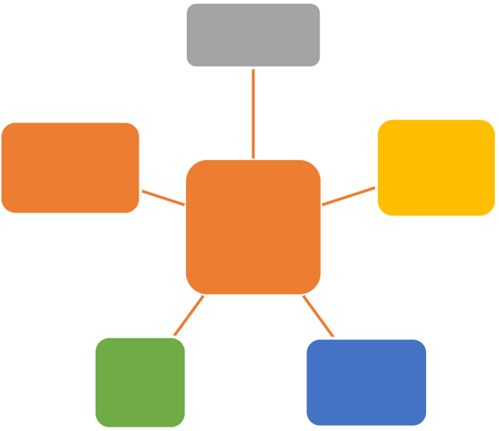

M. Anshari et al. / Applied Computing and Informatics 15 (2019) 94–101 95

of big data in any sectors has triggered assessment of frontend per-spective especially managing customer relationship [2]. It is piv-otal to examine the role of big data within CRM strategies.

Big data have quantum leap to a digital era where public gener-ates a huge data in any sectors and industries. The amount of data are captured, collected, and processed by organization through dig-ital sensors, communications, computation, and storage had cap-tured information which was valuable to businesses, sciences, government, and society at large [3]. A large amount of data streaming from smartphones, computers, parking meters, buses, trains, and supermarkets [4]. Search engine companies collect enormous amount of data per day and share these data to useful information for others as well as their own used.

Big data sources can come from structured or unstructured data formats [5]. These data sources are gathered from multi channels like social networks, voice recording, image processing, video

and so on. Since many organizations either privates or publics have realized the value of data gathered as an asset, data no longer trea-ted as its initial purpose. With the capabilities of processing huge amount of data, it has created a new industry of data analytic ser-vices. For example IBM and Twitter involved partnership on data analytics for the purpose of selling analytical information to corpo-rate clients in order to provide businesses a real-time conversa-tions to make smarter decision. With IBM analytical skills and Twitter massive data source, the partnership had created an inter-esting strategic partnership as both partners leverage on their respective strength and expertise [13]. Big data is considered as the recent development of decision support data management [14]. Big data have big impact towards businesses ranging from CRM, ERP, and SCM. In the next section is discussed recent litera-tures on CRM and big data [15].

|  |  |
| --- | --- |
| recording, open government data (OGD), and online customers’activities. Those activities are extracted for the business to under- | 2.1. Big data |

stand the patterns or behavior of their customers [6]. Big data can help business to portray their behavior to gain its value especially in sales, customer service, marketing and promotion [7].

Public or private organization see the potential of big data and mining them into big value [8]. Many organizations have made huge investments to collect, integrate, analyse data, and use it to run business activities. For instance in marketing activities as part of CRM’s module; customers are exposed with a lot of marketing messages every day and many people is just ignore those messages unless they find a value from the messages received [9]. Email campaigning program are distributed to public or random cus-tomers about their new product so that customers might be inter-ested to have one. Email campaigning may turn into disappointing situation because customers feel bombarded with the spam and lead to increase number of unsubscribes. Marketing strategy is about understanding customers’ habit and behavior about product or service so that the messages are perceived valuable for them [10]. Unfortunately, many organizations may simplify marketing strategies by focusing a short term relationship with their cus-tomers with no path in attracting, retaining, and extending for long term relationship. Therefore, there is a need for personalization and customization of marketing that fits for each and every poten-tial customer.

CRM as a frontline in organization requires extensive support-ing accurate data analytics to ensure potential customers to engage in transaction [11]. Since customers make buying decisions every day and every decision depends on consideration of cost, benefits, and value. At this point, big data aims to support CRM strategies so that organization can quantify sales transactions, promotion, pro-duct awareness, building long term relationship and loyalty [12]. Furthermore, the paper address the following question: How can big data in CRM will enhance CRM strategies in delivering per-

Big data is a huge amount of data that is hardly processed with a traditional processing tools for extracting its value [16]. It has an impact in various fields like business, healthcare, financial, secu-rity, communication, agriculture, and even traffic control [17]. Big data creates opportunities for business that can use it for gen-erating business value [6]. The purpose is intended to gain value from volumes and a variety of data by allowing velocity of analysis [18]. It is known as 5 Vs model; volume, velocity, and variety, value, and veracity [19] (Fig. 1). Volume means processing massive data scale from any data type gathered. The explosive of data vol-umes improve a knowledge sharing and people awareness [20]. Big data is a particularly massive volume with a large data sets, and those data cannot be analysed its content using traditional data-base tools, management, and processing. Velocity means real time data processing, specifically data collection and analysis. Velocity processes very large data in real-time processing. In addition, big data escalates its speed velocity surpassing that of old methods of computing. Variety is any types of data from various channels including structured and unstructured data like audio, video, image, location data for example Google Map, webpage, and text,

|  |  |  |  |  |  |  |  |  |  |
| --- | --- | --- | --- | --- | --- | --- | --- | --- | --- |
| as | well | as | traditional | structured | data. | Some | of | the | semi- |

structured data based can use Hadoop. It focuses on analysing vol-umes of data involved and mining the data and calculations involved in large amount of computing. Finally, veracity refers to data authenticity with the interest in the data source of Web log files, social media, enterprise content, transaction, data application. Date need a valid power of information to ensure its authenticity and safety.

Many organizations have been deploying big data application in running their business activities to gain value from big data

|  |  |
| --- | --- |
| sonalization and customization of services for customer? The structure of this study is organized as follows. In the next section, | **Volume** |

a literature review of related work. Section 3 explains the method-  
ology and results of our study. Section 4 presents a discussion of   
our findings. Recommendations for suggested future research

|  |  |  |  |
| --- | --- | --- | --- |
| directions are presented in Section 5, and Section 6 concludes the | Veracity | **Big**  **Data** | Variety |
| paper. |
| 2. Literature review |

In conventional business practice, data was collected as a

|  |  |  |
| --- | --- | --- |
| recording activities to the business with no formal intention as | **Value** | **Velocity** |
| an important asset, only collected for specific purposes such as |

retailers recorded sales for accounting, the number of visits in

the advertising banners for calculating advertisement revenue

Fig. 1. Big data’s components.

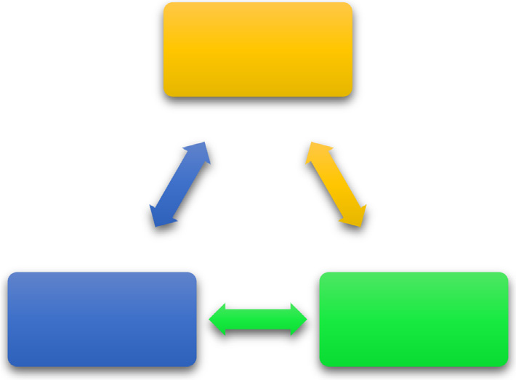

96 M. Anshari et al. / Applied Computing and Informatics 15 (2019) 94–101

analytics. Value is generated from big data processing that sup-ports the right decision. Organizations need to refine and process it to gain value from big data analytic [21]. For instance, value gen-erated from big data analytic can help to reveal the conditions and save life of a new born baby by recording, examining or analysing every heart rate of an infant, data analytics help to finalize the indi-cators of the new born [22]. One of the applications on the use of big data is to optimize machine or device performance. For instance, Toyota Prius is installed with cameras, GPS and sophisti-cated computers and sensors to ensure safety precaution on the

2.2. Customer relationship management and social CRM

Any business requires Customer Relationship Management (CRM) to sustain and survive in the long term [27]. CRM is a tool and strategy for managing customers’ interaction using technology to automate business processes. CRM consists of sales, marketing, and customer service activities (Fig. 3). The aims are to find, attract new customers, nurture and retain them for future business. Busi-ness uses CRM in meeting customers’ expectations and aligning with the organization’s mission and objectives in order to bring

|  |  |  |  |  |  |  |  |
| --- | --- | --- | --- | --- | --- | --- | --- |
| road automatically [23]. | about | a | sustainable | performance | and | effective | customer |
| Big data also reduces the maintenance costs for instance, orga- | relationships. | | |

nizations deploy cloud computing approach where data are stored in the cloud [24]. The emergence of cloud computing has enabled big data analytics to be cost efficient, easily accessed, and reliable. Cloud computing is robust, reliable and responsive when there are issues because it is responsible of cloud service provider. Since, ser-vice outrages are unacceptable at the business. Whenever data

The emergence of Web 2.0 has been based on collaboration platform like wikis, blogs, and social media aiming to facilitate cre-ativity, collaboration, and sharing among users for tasks other than just emailing and retrieving information [28]. The concept of a

|  |  |
| --- | --- |
| analytic goes down impacting marketing activities are disrupted and customers have to question whether to trust such a system. Therefore reliability is competitive advantage of cloud computing | Sales |

in big data application [25].

In addition, businesses have aggressively built their organiza-  
tion on big data capabilities. Unfortunately the fact is only 8% of   
the marketers have comprehensive and effective solutions in col-  
lecting and analysing those data [26]. Evans Data Corporation con-

|  |  |  |
| --- | --- | --- |
| ducted survey of big data and advanced analytics in organization | Marke�ng | Customer  Service |
| (Fig. 2). Customer-cantered departments like as marketing, sales, |
| and customer service are dominant users for 38.2% of all big data |
| and advanced analytical apps. While, marketing department has |

the most common users (14.4%) of the data analytics, followed by IT (13.3%), and research for 13% (Columbus, 2015).

Fig. 3. CRM scope & module.

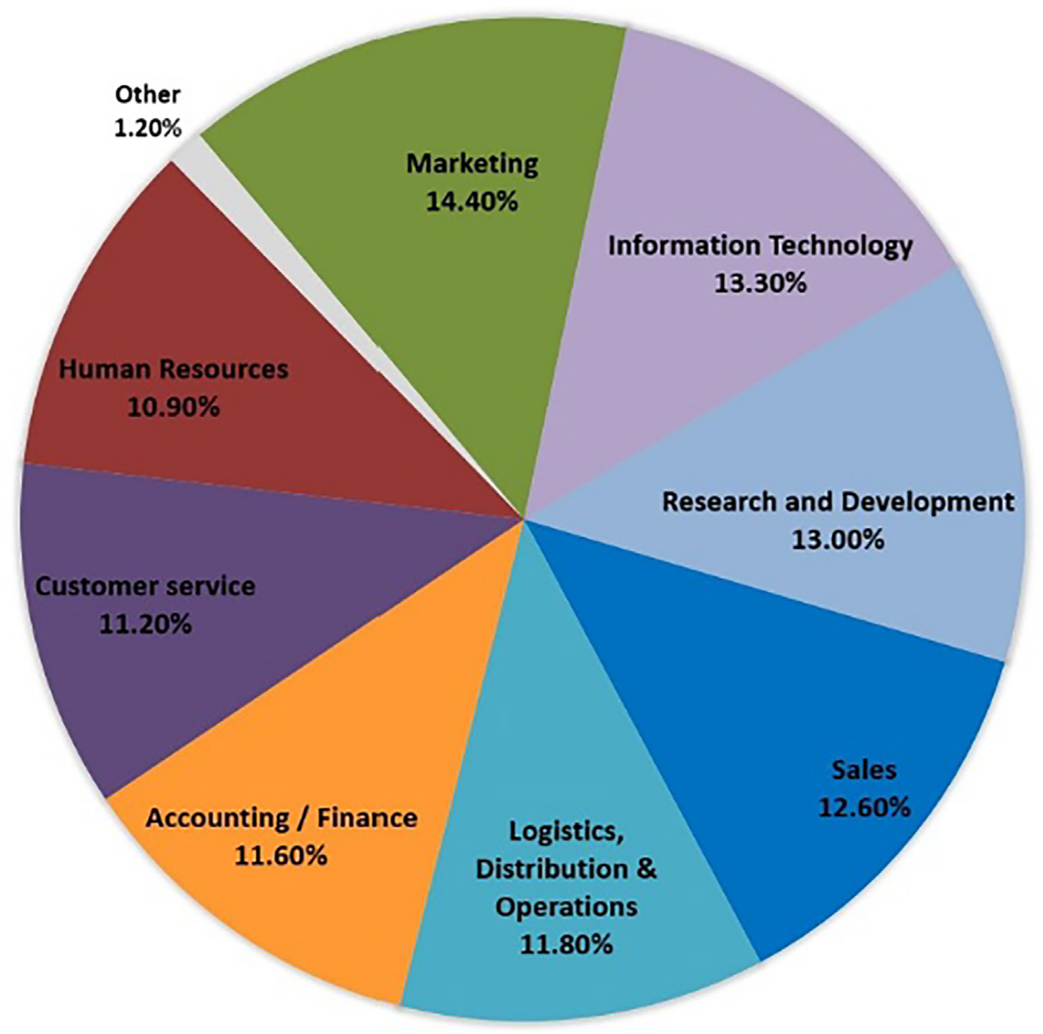

Fig. 2. Big data analytics usage in organization. Sources: Evans Data Corporation.

M. Anshari et al. / Applied Computing and Informatics 15 (2019) 94–101 97

social network defines an organization as a system that contains objects such as people, groups, and other organizations linked together by a range of relationships [29]. Web 2.0 is a tool that can be used to communicate a political agenda to the public via social networks. Users can gain access to the data on Web 2.0 enabled sites and exercise control over such data [30]. Web 2.0 represents a revolution in how people communicate facilitating peer-to-peer collaboration and easy access to real-time communi-cation. The rapid growth in Web 2.0 has impacted organization

of CRM (CRM 2.0) that empowers customers to express their opin-ions and expectations about product or services. Social CRM has become ‘a must’ strategies for any organization nowadays to understand their customers better. By playing a significant role in the management of relationships, Social CRM stimulates funda-mental changes in customer’s behavior [35]. Social CRM has an impact towards multi channels relationships in all areas either public or private sectors is no exception.

|  |  |
| --- | --- |
| that cannot their customer relationship by using traditional CRM techniques. Social CRM is a recent approach and strategies to | 3. Method |

reveal patterns in customer management, behavior, or anything related to the multi channels customers’ interactions as expressed at Fig. 4. Social CRM makes more precise analysis possible based on people conversation in social media, and thus helps them to pro-vide more accurate programs or activities leading to customers’interests and preferences.

Marketing is one of CRM’s activities or process of promoting and selling products or services, which also include research and adver-tisement. Social networks enables social marketing that is neces-sary efforts for marketing teams to expect going viral and receiving customers’ attention [31]. ‘‘Marketing, is defined an the activity, set of institutions, and processes for creating, communi-cating, delivering, and exchanging offerings that have value for customers, clients, partners, and society at large.” [32]. Marketing should focus on building relationships and meanings [33]. It also applies to sales and customer services where organizations use social networks as a tool to make sales as much as possible of han-dling customers’ complaint at social media. Since social networks

The study investigates the factors that an organization consid-ers to adopt big data. The objective of the study is to investigate recent big data adoption in an organization. The methods consisted of in-depth analysis of the latest research on big data in business organization. The data for this report was through literature review of articles ranging from 2010 to 2015. The reason for choosing this time period because of the velocity of big data, any older articles might have irrelevant information. Contents analysis is applied for reviewing literature reviews of big data published in peer-reviewed journals [36]. The review process then is clustered into a thematic. We enhance and integrate various possible solutions into proposed model. We chose only English-language articles published in peer-reviewed journals. After removing duplicates and articles beyond the scope of this study, these articles were reviewed to extract feature of CRM and big data capabilities at Fig. 5.

|  |  |
| --- | --- |
| is part of big data source, the next question, how big data will impact CRM strategies. | 4. Discussion |

Social media has empowered customers to make conversation and business organization may utilize an increasing amount of data through people conversations that is available to them for company’s benefits such as understanding customer preference, complaining items, people expectations. Web 2.0 platform allows customers to express their opinions [34]. In the context of CRM, social networks provide a means of strengthening relationships between customers and service providers. It might be utilized to create long-term relationships between business organizations and their customers and public in general. Adopting social net-works into CRM is known as Social CRM or a second generation

Business realizes that their most valuable assets are relation-ships with customers and all stakeholders. In fact, building per-

|  |  |  |  |  |  |  |  |
| --- | --- | --- | --- | --- | --- | --- | --- |
| sonal | and | social | relationships | become | important | area | in |

marketing [37]. The importance of relationships as market based assets that contribute to customers’ value [38]. With the amount of data increase, some business organizations use advanced power-ful computers with a huge storage to process big data analytics and to increase their performance resulting in tremendous cost saving [6]. Businesses manage structured and unstructured data sources such as social marketing, retail databases, recorded customer activity, logistics, and enterprise data to establish a quality level

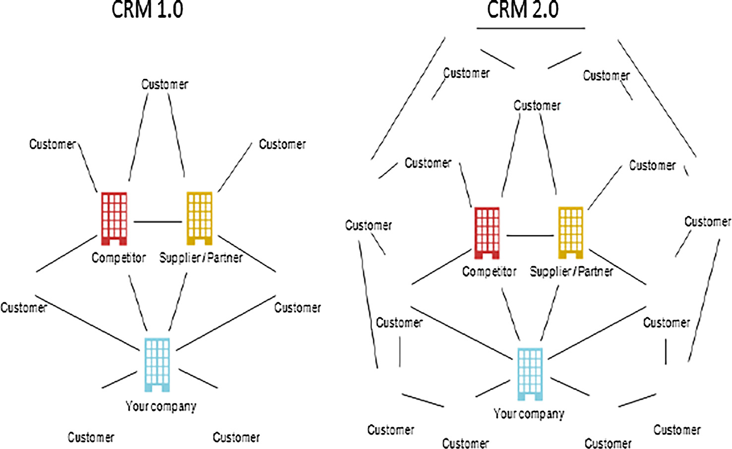

Fig. 4. CRM 1.0 vs CRM 2.0.

98 M. Anshari et al. / Applied Computing and Informatics 15 (2019) 94–101

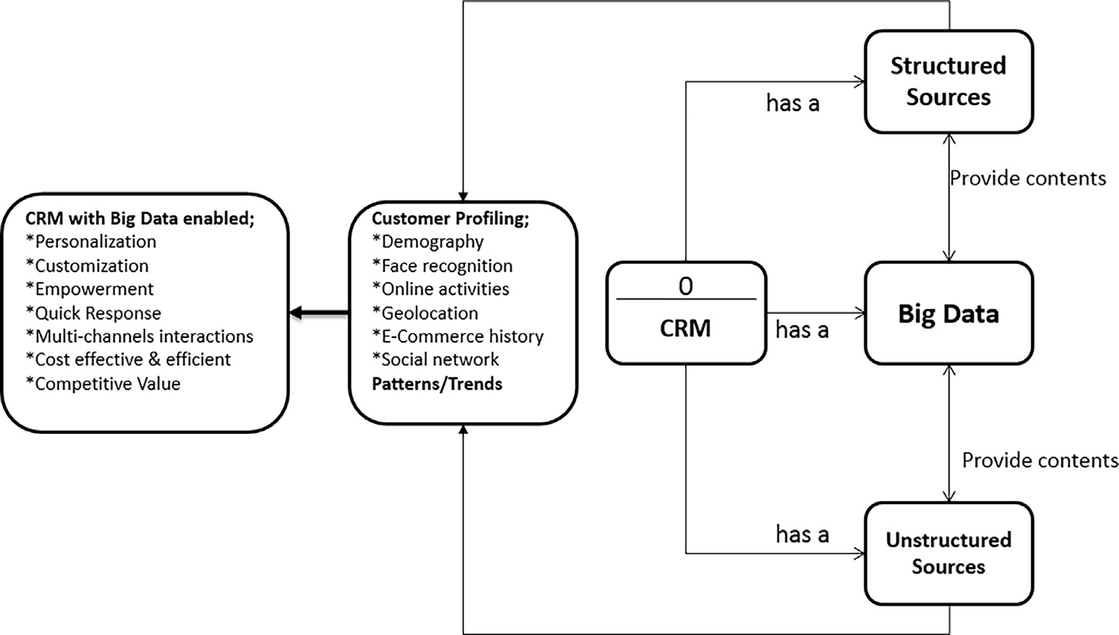

Fig. 5. Big data and marketing.

of CRM strategies by having the abilities or knowledge on how to recognize big data and its advantage. While, big data analytics is a process to reveal the variety of data types in big data itself. There are some CRM strategies that can happen through big data and big

big data in CRM can certainly enhance long term relationship with customers [40] and manifest into an impressive set of CRM activi-ties [41]. There is an example of the successful usage of big data in CRM when Netflix used big data to run their streaming video ser-

data analytics. vice [42]. Instead of using traditional methods of data gathering,

Since big data can provide a pattern of customers’ information, businesses can predict and assume what are the needs of their cus-tomers nowadays. Fig. 5 indicates basic framework on how big data can contribute to generating CRM strategy. Big data had helped shaped many industries and changed the way businesses operated nowadays. Big companies definitely benefited from this shift especially companies such as technology giants such as Ama-zon and googles and would continue to serve these giants from the sheer volume of data they generated. Data Velocity showed how marketers could have access to real-time data, for example real time analytics of interactions on internet sites and also social

they were able to find out what their customers want and made measurable marketing decisions. Big data can perform better CRM strategies than any processes with double the speed.

CRM with big data features becomes more aggressive in term of marketing strategy like push notification through smartphone to the potential target audiences. Web / Apps users who make com-ment, liking page, or comes back visiting Web or Apps are potential customers are targeted for pushed notification. Technically, there are many third parties for Apps or Web that can help business to set up push notification right to the users. For instance, there are also many plugin supports web push facilities in CMS based web-

media interactions. site. Notification can be set up auto generated or manual whenever

CRM with the big data influence, a new paradigm had been cre-ated to allow accessibility and availability of information which result in greater take up by big or small business alike. Big data offers pervasive knowledge acquisition in CRM activities. Big data will support long-term relationship through understanding cus-tomers’ life cycle and behavior in more comprehensive perspective. Customers voluntarily generate a huge amount of data daily by detailing their interest and preference about products or services to the public through various channels. Therefore, big data analytic can come up with a comprehensive views of customers so that organization can enhance service fitting with customer attention, engagement, participation, and personalization. The study intro-duces several fundamental concept of marketing with big data that are closely related to customer based CRM strategies in an organi-zation by engaging customer life cycle.

CRM with big data brings a promise of big transformation that can affect organization in delivering CRM strategies. There were many benefits for using big data in CRM and the following were just some of the benefits such as accurate and update in profiling

new contents are available directed at customer convenience in the form of text message, link sharing, or smartphone notification offering promotion at nearby shop. CRM aims to quantify sales transactions, promotion, product awareness, while its strategies for building long term relationship and loyalty. Businesses cannot simplify marketing strategies only focusing a short term relation-ship with customers without any path in attracting, retaining, and extending for long term relationship.

In addition, the organization can also create better customer personas by using the profile data as the backbone of creating accurately personifications for the customers. Also the organiza-tion will have data on what the customers’ needs and preferences and used this data to provide better content for the audience where the content is relevant and valuable to them. All these data can also provide valuable information for the management team to improve marketing budget management by ensuring business operational process stayed on budget with the help of data and to be more focused and targeted.

of target costumers, predicting trend on customer reaction toward 4.1. Customer profiling

marketing messages and product offerings, create personalise mes-

sage that create emotional attachment and product offering, max-imizing value chain strategies, producing accurate assessment measures, effective digital marketing and campaign-based strate-gies, customers retention which was a cheaper option, and create tactics and getting product insights [39]. The combination of using

Whenever business acquires a new customer through market-ing activities, the customer will determine what the value of each activity received from the business. When the customer perceives the value is positive they will be happy and satisfied. Otherwise they can consider finding another business even from other

M. Anshari et al. / Applied Computing and Informatics 15 (2019) 94–101 99

competitors that may fulfil their requirements. Therefore, cus-tomer profiling for each and every customer becomes important for business to make sure that the whole CRM’ life cycle (sales, marketing, and customer service) are offering personalized and customized services so that each customer will experience differ-ently according to their needs and interest.

Big data can help in delivering customer profiling since it includes business activities monitoring. Big data analytics have the abilities for tracking purchase histories and their online con-versations about their product or services. Business will gain more comprehensive view of customer’s expectation and can understand better for potential customers’ interest. The impact of the big data analytics are significant, especially on the distribution of marketing channels between service providers and customers whereas sup-pliers or service providers are engaging with customers directly,

opportunity. The aim of big data in CRM should target right market segment for the right product or services so that business improve market sharing, avoid access production, control budget, efficiency and effective in business process. Furthermore, long term strategy focuses on producing marketing materials for target customers than trying to reach random customers. Customization is impor-tant in marketing because marketing should be flexible in offering their product or service. Flexibility in offering product shows empowerment for customer. Businesses can improve their sense of understanding for their customers’ behaviors. Marketing team can customize campaigning agenda that is expected to be fit with the patterns of potential customers.

Customers’ profiling are also possible because big data with geolocation analytic promotes quick and appropriate marketing strategies. It can quicker than competitor in marketing product,

|  |  |  |  |  |  |  |
| --- | --- | --- | --- | --- | --- | --- |
| threatening | the | sustainability | of | intermediaries | marketing | appropriate in determine price by understanding purchasing |
| agencies. | power of potential buyers from data of financial abilities. Appropri- |

Customer profiling can gain invaluable insight from the big data analytic and create a competitive advantage. All of these organiza-tions derive business value from leveraging personalization. Some of the example for customers’ profiling of services; Amazon.com developed a system of product recommendation based on their analysis on customers’ previous purchases data [43]. Target, the supermarket, is able to develop a predict model in tracking the

ate in displaying product means supplier has the best possible place to display the product which is easily reach by customers, the data come from geolocation. The Netflix detects traffic details of customers’ view to spot problems in the area and add systems that can help the future demand. They are also able to get more vision of their customer’s desire [48].

purchase made by the pregnant women [44]. UPS, the package 4.2. Value creation

delivery company created an application to redesign their drivers’

daily routes to achieve fleet optimization.

Customers’ profiling are possible through big data analytics because the organizations have access to more accurate data as big data can discover value of the hidden data connections and pat-tern. In addition, it can improve business decisions because it pro-vides as much knowledge as possible [45]. CRM team generates customers’ knowledge profiling to enhance businesses and under-stand precisely target audience, personalize message for each potential customer, and tailoring message fits with customers’interest and preferences. CRM with big data analytic can develop comprehensive knowledge of customers for decision making. Roll Royce applies big data analytics in aircraft engine-manufacturing sector and use the result to predict when and where breakdown of aircraft engine might occur by installing censors to collect data [46]. Hence, they does not only sell engines but also packages of both engines and monitoring services that generates profit by charging customers based on usage, repairs and replacements. This service currently accounted for more than 70% of their annual rev-enue in their aircraft engine division by leveraging big data to cre-ate a competitive advantage [47].

Personalization is important for the organizations to focus on the user experience to boost digital marketing efforts by making sure the targeted audience seeing advertisements, social media post, contest or creating events that have emotional relation to the audience. These efforts will help to map the customer journey easier to tract since it is on digital marketing. These trending will be able to provide accurate and real-time mapping of customers’choices and also locations. Hence the organization can use this data to create a more personalized leading nurturing process by making the loyal customers feel important and their relationship with the company is meaningful.

While, customization enables business to sort out specific CRM activities to the targeted audiences more precisely. Business strate-gies should transform customer strategies and systems to cus-tomer engagement and ability for customization. The one is more

Big data brings new opportunities for discovering values, since it shows the behavior of customers’ trend or anything related to the society, and leading to more precise analysis. Big data’s source can come from geolocation of customers. Geolocation helps busi-ness to deliver right message to the right customers whereas busi-ness understands what can and cannot be delivered to the people at the localities. While, geolocation facility helps customers to find the nearest place to reach the product or service. There are situa-tions that marketing strategies are inapplicable due to different set of customs and conditions. Understanding local wisdom is important factor in delivering effective message to the target cus-tomers. Business organizations spend a huge amount of budget for advertising without considering geolocation of potential customers turn into disappointment and rejection. Conventional marketing strategy prompts any marketing contents to random audiences which is potentially costing inefficient budget. These businesses do the strategies to find some marketing activities that work. By effectively marketing on the basis of geolocation to deliver value to the target customers, business provide cost-effective marketing activities of their desired objective to increase local based engage-ment. Promotions are based on users’ records and histories either from web visit, customer’s buying history, current GPS data, and conversation in social networks. Push notification has to provide option for users either allow or don’t allow notification through their smartphone or web visit [49].

CRM strategy ventures potential customers, meeting expecta-tion, understanding their needs, and delivering value. While, gen-erating value can come from big data analytic. As described, big data grow an extraordinary rate huge amount of data sets contain-ing a variety of data types and come up with patterns, correlations variables, latest market trends, customers’ choices and preferences and other valuable business information [50,51]. These big data analytics provides effective marketing, new revenue streams, cus-tomer relation services, improved value chain efficiency, sustain-able competitive advantages over rival organizations and many

focused on the conversation that is going on between organization other benefits [52,53].

and customer and the collaborative models that cutting edge com-panies are carrying out for customer engagement. Customization strategies will improve customer services and great customer sup-port will increase loyalty, revenue, brand recognition, and business

CRM initiative needs to extract value from a variety of data sources gathered from customers to manage or analyses cus-tomers’ preferences. Big data generates value to understand peo-ple’s needs and preferences by having access to more accurate

100 M. Anshari et al. / Applied Computing and Informatics 15 (2019) 94–101

information as big data can discover hidden connections and pat-terns in customers’ behavior through multi sources and multi channels. Customers produce data voluntarily through various means including click stream activities while visiting web site for e-commerce transaction [54]. More customers generate and share data in the public sphere means more value for can be extracted by an organization. Customers produce data and business organiza-tions capture those data for their marketing plan. In addition, cus-tomers make conversation in social media about products are basically helping any audiences either customers or producers. Customers benefits from the conversations and reviews because they understand product knowledge better. While producer under-stands better about products’ expectation.

Big data has involved customers in delivering affective CRM activities where marketing teams at the organizations fine tune the ideas into executable marketing program. For instance, Star-bucks uses social networks to understand the costumers’ on the new product being introduced. This gives feedback faster as com-pared using a periodical method, waiting for the sale’s reports to

convincingly the value of product or service that fit with his or her need. Fitting customer’s need can come from personalization of marketing or treat each and every customer personally based on their interest and need. Engaging customer in providing feed-back will make a product or service superior than competitor. Velocity is the feature of big data analytics. Therefore, quick and appropriate in response will make improve customer satisfaction which in turn to customer loyalty.

Big data offers simplicity for CRM staffs since they are equipped with customer’s pattern in advance so that they know how to han-dle each and every customer. CRM department can offer extra facil-ities to the potential customer based on their interest and behavior. Big data facilitates multi channels interaction. For instance, an automotive manufacture releases a new sedan’s car and the man-ufacture concerns with the customers as well as competitors’responds. The manufacture can monitor all social networks and media to evaluate customers’ reactions to improve the product. At the end, big data provides cost efficient for overall CRM activi-ties because they can pin point of effective CRM strategy for

come in and evaluate its performances [6]. Social media analytics customer.

are the analysis of structured and unstructured data from social

|  |  |
| --- | --- |
| media channels. Furthermore, Amazon.com utilizes big data ana-lytics in producing the marketing strategies. Amazon.com can rec- | 5. Challenges |

ognize the patterns in the customers’ shopping behavior thus offering good bargain, advertisements, advertisements and dis-count to customers [55]. Big data helps e-commerce in gaining competitive advantage and business values, increasing the influx of customers, retaining the customers’ loyalty, improving the sales and revenues of the companies, ensuring customers’ satisfaction, creating a brand awareness, and building a reputation [56]. Offer-ing customized discount which is based on customers’ behavior can maximize sales and profit.

Value is added when customer is believe the information and is then able to make the appropriate decisions in their marketing strategy. Decision-making is important in marketing strategies. Decision making can improve because big data analytic provides comprehensive information from multi channels interactions. For instance, a marketing manager needs to understand customers’behaviors, expectations, and trends to deliver a favorable and impression marketing campaign to potential customers. Decisions on the appropriate marketing contents in specific area can be derived from big data reports and then analysing these data to dis-cover trends and key issues. Marketers who can identify problems and propose solutions are able to gain a greater understanding of customers’ desires. Therefore, marketing campaign needs to extract the value from various data source of Web log files, social media, enterprise content, transaction, and the team must ensure its authenticity and reliable a valid information derived from big data analytic. In short, CRM should support big data analytics. In order to mitigate the gap between expectation and delivery. How-ever, in order for big data to add value in marketing, marketers need to access and understand the comprehensive customer’s path from awareness to conversion so they can close the gap between online and offline customer behavior and experience.

Big data in CRM has very much potential to offer, with its ability to collect and produce a big amounts of data, big data could really be the downfall as well without the proper expertise and tools to obtain and analysed them. Many challenges must be managed before these potential can be fully optimized. Firstly, it may occur when organizations are shortage in technical supports and exper-tise. Secondly, it is difficult to track customer behavior especially trailing customers moving from brand awareness to conversion. It challenges to connect the dot from online to offline channels such as when and where customer see or read about a product to finally purchasing the product. Thirdly, CRM with big data may need more user friendly data analytics tools in producing report especially when it comes to utilizing the data appropriately across the channels, especially when they do not understand the effectiveness of their efforts in the process. There is no one size fit all solution, staffs need to integrate big data into their strategies, especially products lines, and content offering and customer jour-ney is unique. Until such tools is available many CRM staffs would continue to search for solutions to overcome this challenge. The last challenge refers to data authenticity with the interest in the data source of Web log files, social media, enterprise content, transaction, data application may need a valid power of informa-tion to ensure its authenticity and safety. For examples, all the post or tweets we post on social networks are observed by the one who manages the big data. Finally, there is a possibility that the research may lack of generalizability because it requires case study and primary data collection from the business organizations, this research will plan to reach a large number of participants in the future.

All data sources either structured sources and unstructured 6. Conclusion

sources form customers profiling that portray comprehensive view

of potential customers. Customer profiling can come from geoloca-tion data analytic of customers through smartphone or any smart mobile devices, face recognitions, browsing behavior and online activities, e-commerce histories, social networks, and so on [57]. Then, they are analysed to come up with the pattern, trend or behavior of customer. For instance, marketing staffs who deal with customer directly are supplied a comprehensive and user friendly reports of potential customers in the speed of data analytics (veloc-ity). The report shows pattern, behavior, and likelihood of cus-

CRM is about understanding of human behavior and interests. Big data can be expected to improve customer relationship as it allows interactivity, multi-way communications, personalization, and customization. The recent developments of big data analytics have optimized process, growth, and generate aggressive market-ing strategy and delivering value for each customer and potential customer. CRM with big data enabled engage customers in deliver-ing affective CRM activities where marketing teams at the organi-zations tune the ideas into executable marketing program. Big data

|  |  |  |  |  |  |  |  |  |  |
| --- | --- | --- | --- | --- | --- | --- | --- | --- | --- |
| tomer | so | that | the | marketing | staff | can | aggressively | and | enhance CRM strategies by understanding better customers’ habits |

M. Anshari et al. / Applied Computing and Informatics 15 (2019) 94–101 101

and behaviors so that business can deliver CRM be more personal-ized and customized for each and every customers. Finally, CRM with big data will make better tools and strategies more personal-ized and customized to the customers because they understand well target audiences and intended message to send.

[28] M. Anshari, Y. Alas, N. Yunus, N.I. Sabtu, M.H. Hamid, Social customer relationship management and student empowerment in online learning systems, Int. J. Electronic Customer Relat. Manage. 9(2/3) (2015) 104–121. [29] S.S. Askool, K. Nakata, Scoping study to identify factors influencing the acceptance of social CRM, in: IEEE International Conference on Management of Innovation and Technology (ICMIT), IEEE, 2010, pp. 1055–1060.

[30] H. Hinchcliffe, The state of Web 2.0, 2006. Retrieved 12 May 2012 from <<http://web2.socialcomputingmagazine.com/the_state_of_web_20.htm>>.

[31] [I. Novo-Corti, M. Barreiro-Gen, Public policies based on social networks for the](http://refhub.elsevier.com/S2210-8327(18)30073-5/h0155)

|  |  |
| --- | --- |
| References | [introduction of technology at home: demographic and socioeconomic profile](http://refhub.elsevier.com/S2210-8327(18)30073-5/h0155)s [of households, Comput. Hum. Behav. 51 (2015) 1216–1228](http://refhub.elsevier.com/S2210-8327(18)30073-5/h0155).  [32] AMA Definition of Marketing, American Marketing Association. Retrieved 1 |

[1] [T. Nisar, G. Prabhakar, Trains and Twitter: firm-generated content, custome](http://refhub.elsevier.com/S2210-8327(18)30073-5/h0005)r [relationship management and message framing, Transport. Res. Part A: Policy Pract. (2018) 1–43](http://refhub.elsevier.com/S2210-8327(18)30073-5/h0005).

[2] [P. Zerbino, D. Aloini, R. Dulmin, V. Mininno, Big data-enabled customer](http://refhub.elsevier.com/S2210-8327(18)30073-5/h0010)  [relationship management: a holistic approach, Inf. Process. Manage. (2018)](http://refhub.elsevier.com/S2210-8327(18)30073-5/h0010). [3] P.O. de Pablos, M. Lytras, W. Karwowski, R.W. Lee, Electronic Globalized Business and Sustainable Development through IT Management: Strategies and Perspectives, Business science reference, Hershey New York, 2011.

[4] [M. Anshari et al., Smartphone habit and behaviour in Brunei: personalization,](http://refhub.elsevier.com/S2210-8327(18)30073-5/h0020)  [gender, and generation gap, Comput. Hum. Behav. 64 (2016) 719–727](http://refhub.elsevier.com/S2210-8327(18)30073-5/h0020).

[5] [W. Yuan, P. Deng, T. Taleb, J. Wan, C. Bi, An unlicensed taxi identification mode](http://refhub.elsevier.com/S2210-8327(18)30073-5/h0025)l [based on big data analysis, IEEE Trans. Intell. Transp. Syst. 17 (6) (2016) 1703–1713](http://refhub.elsevier.com/S2210-8327(18)30073-5/h0025).

|  |  |  |  |  |  |  |  |  |
| --- | --- | --- | --- | --- | --- | --- | --- | --- |
| [6] [H.J.](http://refhub.elsevier.com/S2210-8327(18)30073-5/h0030) | [Watson,](http://refhub.elsevier.com/S2210-8327(18)30073-5/h0030) | [Tutorial:](http://refhub.elsevier.com/S2210-8327(18)30073-5/h0030) | [big](http://refhub.elsevier.com/S2210-8327(18)30073-5/h0030) | [data](http://refhub.elsevier.com/S2210-8327(18)30073-5/h0030) | [analytics:](http://refhub.elsevier.com/S2210-8327(18)30073-5/h0030) | [concepts,](http://refhub.elsevier.com/S2210-8327(18)30073-5/h0030) | [technologies,](http://refhub.elsevier.com/S2210-8327(18)30073-5/h0030) | [and](http://refhub.elsevier.com/S2210-8327(18)30073-5/h0030) |

[applications, Commun. Assoc. Inf. Syst. 34 (65) (2014) 1247–1268](http://refhub.elsevier.com/S2210-8327(18)30073-5/h0030).

[7] [P.C. Verhoef, E. Kooge, N. Walk, Creating Value with Big Data Analytics: Making](http://refhub.elsevier.com/S2210-8327(18)30073-5/h0035)  [Smarter Marketing Decisions, Routledge, 2016](http://refhub.elsevier.com/S2210-8327(18)30073-5/h0035).

[8] [S. Akter, S.F. Wamba, Big data analytics in E-commerce: a systematic review and agenda for future research, Electron. Markets 26 (2) (2016) 173–194](http://refhub.elsevier.com/S2210-8327(18)30073-5/h0040).

[9] S. Orenga-Roglá, R. Chalmeta, Social customer relationship management: taking advantage of Web 2.0 and Big Data technologies, SpringerPlus 5(1) (2016) 1462.

[10] [J. Strauss, R.D. Frost, E-marketing: Instructor’s Review Copy, Routledge, 2016](http://refhub.elsevier.com/S2210-8327(18)30073-5/h0050). [11] [Z. Sun, K. Strang, S. Firmin, Business analytics-based enterprise information systems, J. Comput. Inf. Syst. 57 (2) (2017) 169–178](http://refhub.elsevier.com/S2210-8327(18)30073-5/h0055).

[12] R.L. Angell, J.R. Kraemer, U.S. Patent No. 9,846,883, U.S. Patent and Trademark Office, Washington, DC, 2017.

[13] D. Clark, IBM and Twitter forge partnership in data analytics, Wall Street J.

Retrieved April 15, 2016 from <<http://www.marketwatch.com/story/ibm-and-twitter-forge-partnership-on-data-analytics-2014-10-29>>.

[14] H.J. Watson, O. Marjanovic, Big data: the fourth data management generation, Bus. Intelligence J. 18(3) (2013) 4–8 (Chicago).

[15] R.C. Härting, M. Moehring, R. Schmidt, C. Reichstein, B. Keller, What drives users to use CRM in a public cloud environment?-Insights from European experts, in: 49th Hawaii International Conference on System Sciences (HICSS), IEEE, 2016, pp. 3999–4008.

[16] F. Ohlhorst, Big data analytics: turning big data into money, 2013.

[17] Y. Gahi, M. Guennoun, H.T. Mouftah, Big data analytics: Security and privacy challenges, in: IEEE Symposium on Computers and Communication (ISCC), 2016, IEEE, pp. 952–957.

[18] R.L. Villars, C.W. Olofson, M. Eastwood, Big data: what it is and why you should care, White Paper, IDC, 2011.

[19] Y. Demchenko, C. De Laat, P. Membrey, Defining architecture components of the Big Data Ecosystem, in: International Conference on Collaboration Technologies and Systems (CTS), IEEE, 2014, pp. 104–112.

|  |  |  |  |  |  |  |  |
| --- | --- | --- | --- | --- | --- | --- | --- |
| [20] [P.O.](http://refhub.elsevier.com/S2210-8327(18)30073-5/h0100) | [de](http://refhub.elsevier.com/S2210-8327(18)30073-5/h0100) | [Pablos,](http://refhub.elsevier.com/S2210-8327(18)30073-5/h0100) | [Knowledge](http://refhub.elsevier.com/S2210-8327(18)30073-5/h0100) | [management](http://refhub.elsevier.com/S2210-8327(18)30073-5/h0100) | [and](http://refhub.elsevier.com/S2210-8327(18)30073-5/h0100) | [organizational](http://refhub.elsevier.com/S2210-8327(18)30073-5/h0100) | [learning:](http://refhub.elsevier.com/S2210-8327(18)30073-5/h0100) |

[typologies of knowledge strategies in the Spanish manufacturing industry from 1995 to 1999, J. Knowl. Manage. 6 (1) (2002) 52–62](http://refhub.elsevier.com/S2210-8327(18)30073-5/h0100).

[21] [E. Dumbill, Making sense of big data, Big Data 1 (1) (2013) 1–2](http://refhub.elsevier.com/S2210-8327(18)30073-5/h0105).

[22] S. Reddy, Big Data Saves Small Babies by Detecting Nosocomial Infections Earlier Than Clinicians, 2014. Retrieved March 31, 2016 from <[http:// nuviun.com/content/big-data-saves-small-babies-by-detecting-nosocomial-infections-earlier-than-clinicians#sthash.s33ABAP8.dpuf](http://nuviun.com/content/big-data-saves-small-babies-by-detecting-nosocomial-infections-earlier-than-clinicians#sthash.s33ABAP8.dpuf)>.

[23] B. Marr, The awesome ways big data is used today to change our world, 2013.

|  |  |  |
| --- | --- | --- |
| Retrieved | from: | <[https://www.linkedin.com/pulse/20131113065157-](https://www.linkedin.com/pulse/20131113065157-64875646-the-awesome-ways-big-data-is-used-today-to-change-our-world) |

[64875646-the-awesome-ways-big-data-is-used-today-to-change-our-world](https://www.linkedin.com/pulse/20131113065157-64875646-the-awesome-ways-big-data-is-used-today-to-change-our-world)>.

[24] [B.M. Purcell, Big data using cloud computing, J. Technol. Res. 5 (2014) 1](http://refhub.elsevier.com/S2210-8327(18)30073-5/h0120). [25] D. Agrawal, S. Das, A. El Abbadi, Big data and cloud computing: current state and future opportunities, in: Proceedings of the 14th International Conference on Extending Database Technology, ACM, 2011, pp. 530–533.

[26] [Sunil Erevelles, Nobuyuki Fukawa, Linda Swayne, Big Data consumer analytics and the transformation of marketing, J. Bus. Res. 69 (2) (2016) 897–904](http://refhub.elsevier.com/S2210-8327(18)30073-5/h0130).

[27] I. Hargreaves, D. Roth, M.R. Karim, M. Nayebi, G. Ruhe, Effective customer relationship management at ATB financial: a case study on industry-academia collaboration in data analytics, in: Highlighting the Importance of Big Data Management and Analysis for Various Applications, Springer, Cham, 2018, pp. 45–59.

|  |  |  |  |
| --- | --- | --- | --- |
| May | 2018 | from | <[https://www.ama.org/AboutAMA/Pages/Definition-of](https://www.ama.org/AboutAMA/Pages/Definition-of-Marketing.aspx)- |

[Marketing.aspx](https://www.ama.org/AboutAMA/Pages/Definition-of-Marketing.aspx)>.

[33] T. Duncan, S.E. Moriarty, A communication-based marketing model for managing relationships, J. Marketing (1998) 1–13.

[34] M.N. Almunawar, M. Anshari, Empowering customers in electronic health (e–health) through social customer relationship management, Int. J. Electronic Customer Relat. Manage. 8 (1/2/3) (2014).

[35] P. Greenberg, CRM at the Speed of Light: Social CRM 2.0 Strategies, Tools, and Techniques for Engaging yOur Customers, fourth ed., McGraw-Hill Osborne Media, 2009.

[36] [B. Kitchenham, O.P. Brereton, D. Budgen, M. Turner, J. Bailey, S. Linkman, Systematic literature reviews in software engineering–a systematic literature review, Inf. Softw. Technol. 51 (1) (2009) 7–15](http://refhub.elsevier.com/S2210-8327(18)30073-5/h0180).

[37] [S. Planalp, Relational communication and cognition, Rethinking Commun. 2](http://refhub.elsevier.com/S2210-8327(18)30073-5/h0185)  [(1989) 269–277](http://refhub.elsevier.com/S2210-8327(18)30073-5/h0185).

[38] [R.K. Srivastava, T.A. Shervani, L. Fahey, Market-based assets and shareholder](http://refhub.elsevier.com/S2210-8327(18)30073-5/h0190)  [value: a framework for analysis, J. Marketing (1998) 2–18](http://refhub.elsevier.com/S2210-8327(18)30073-5/h0190).

[39] Martin, Best use of big data in marketing, 2014. Retrieved 3 April 2016 from <<http://www.cleverism.com/best-uses-big-data-marketing/>>.

[40] [B. Brown, M. Chui, J. Manyika, Are you ready for the era of ‘big data’, McKinsey](http://refhub.elsevier.com/S2210-8327(18)30073-5/h0200)  [Q. 4 (2011) 24–35](http://refhub.elsevier.com/S2210-8327(18)30073-5/h0200).

[41] [M. Minelli, M. Chambers, A. Dhiraj, Big Data, Big Analytics: Emerging Business Intelligence and Analytic Trends for Today’s Businesses, John Wiley & Sons, 2012](http://refhub.elsevier.com/S2210-8327(18)30073-5/h0205).

[42] J. Schectman, Netflix uses big data to improve streaming video, Wall Street J.

|  |  |  |  |
| --- | --- | --- | --- |
| (2012). | Retrieved | from | <[http://blogs.wsj.com/cio/2012/10/26/netflix-uses](http://blogs.wsj.com/cio/2012/10/26/netflix-uses-big-data-to-improve-streaming-video)- |

[big-data-to-improve-streaming-video](http://blogs.wsj.com/cio/2012/10/26/netflix-uses-big-data-to-improve-streaming-video)>.

[43] C. Dalén, F. Dahlblom, Big Data in the telecom industry: a study of how big data affects innovativeness and market dynamics, Master Thesis, Stockholm School of Economics, Sweden, 2014. Retrieved April 15, 2016 from <[http://arc. hhs.se/download.aspx?MediumId=2120](http://arc.hhs.se/download.aspx?MediumId=2120)>.

|  |  |  |  |  |  |  |  |  |  |
| --- | --- | --- | --- | --- | --- | --- | --- | --- | --- |
| [44] [Yun](http://refhub.elsevier.com/S2210-8327(18)30073-5/h0220) | [Bae](http://refhub.elsevier.com/S2210-8327(18)30073-5/h0220) | [Kim,](http://refhub.elsevier.com/S2210-8327(18)30073-5/h0220) | [Big](http://refhub.elsevier.com/S2210-8327(18)30073-5/h0220) | [Data:](http://refhub.elsevier.com/S2210-8327(18)30073-5/h0220) | [A](http://refhub.elsevier.com/S2210-8327(18)30073-5/h0220) | [Temporary](http://refhub.elsevier.com/S2210-8327(18)30073-5/h0220) | [Thing?](http://refhub.elsevier.com/S2210-8327(18)30073-5/h0220) | [[PowerPoint](http://refhub.elsevier.com/S2210-8327(18)30073-5/h0220) | [Slide],](http://refhub.elsevier.com/S2210-8327(18)30073-5/h0220) |

[Sungkyunkwan University, Republic of Korea, 2015](http://refhub.elsevier.com/S2210-8327(18)30073-5/h0220).

[45] S. Fan, R.Y. Lau, J.L Zhao, Demystifying big data analytics for business intelligence through the lens of marketing mix. Big Data Res. 2(1) (2015) 28–32.

[46] H. Wang, O.L. Osen, G. Li, W. Li, H.N. Dai, W. Zeng, Big data and industrial internet of things for the maritime industry in northwestern Norway, in: TENCON 2015-2015 IEEE Region 10 Conference, IEEE, 2015, pp. 1–5.

[47] M. Van Rijmenam, Rolls Royce shift in higher gear with big data. Data floo:

|  |  |  |  |  |  |  |  |  |  |
| --- | --- | --- | --- | --- | --- | --- | --- | --- | --- |
| connecting | data | and | people, | 2015. | Retrieved | April | 15, | 2016 | from |

<[https://datafloq.com/read/rolls-royce-shifts-higher-gear-big-data/51](https://datafloq.com/read/rolls-royce-shifts-higher-gear-big-data/514)4>.

[48] S. Matteson, Big Data basic concepts and benefits explained, Wall Street J.

(2013). Retrieved March 23, 2015 from <[http://www.techrepublic.com/blog/ big-data-analytics/big-data-basic-concepts-and-benefits-explained](http://www.techrepublic.com/blog/big-data-analytics/big-data-basic-concepts-and-benefits-explained/)/>.

[49] [I. Novo-Corti, M. Barreiro-Gen, Competition, oligopoly, barriers and searching up new markets: do smartphones win the battle to digital cameras?, Int J. Knowl. Soc. Res. (IJKSR) 5 (4) (2014) 45–54](http://refhub.elsevier.com/S2210-8327(18)30073-5/h0245).

[50] D. Bollier, C.M. Firestone, The promise and peril of big data, Aspen Institute, Communications and Society Program, Washington, DC:, 2010, p. 1.

[51] M. Anshari, Y. Alas, Smartphones habits, necessities, and big data challenges, J. High Technol. Manage. Res. 26(2) (2015) 177–185 (Elsevier).

[52] H. Chen, R.H. Chiang, V.C. Storey, Business intelligence and analytics: from big data to big impact, MIS Q. 36(4) (2012) 1165–1188.

[53] [M. Anshari, Y. Alas, N.M. Yunus, N.I. Sabtu, M.S. Hamid, Online learning: trends, issues, and challenges in big data era, J. E-Learning Knowl. Soc. 12 (1) (2016) 121–134](http://refhub.elsevier.com/S2210-8327(18)30073-5/h0265).

[54] [J.H. Wu, S.C. Wang, What drives mobile commerce?: An empirical evaluation of the revised technology acceptance model, Inf. Manage. 42 (5) (2005) 719–729](http://refhub.elsevier.com/S2210-8327(18)30073-5/h0270).

[55] [Hsinchun Chen, Roger H.L. Chiang, Veda C. Storey, Business intelligence and](http://refhub.elsevier.com/S2210-8327(18)30073-5/h0275)  [analytics: from big data to big impact, MIS Q. (2012) 1165–1188](http://refhub.elsevier.com/S2210-8327(18)30073-5/h0275).

[56] [Ya-Ling Wu, Eldon Y. Li, Marketing mix, customer value, and customer loyalty in social commerce: a stimulus-organism-response perspective, Internet Res. 28 (1) (2018) 74–104](http://refhub.elsevier.com/S2210-8327(18)30073-5/h0280).

[57] J.H. Wu, Y.M. Wang, W.C. Tai, Mobile shopping site selection: the consumers’

|  |  |  |  |  |  |  |  |  |
| --- | --- | --- | --- | --- | --- | --- | --- | --- |
| viewpoint, | in: | Proceedings | of | the | 37th | Annual | Hawaii | International |

Conference on System Sciences, 2004, IEEE, 2004, pp. 8.