|  |  |  |
| --- | --- | --- |
|  | Available online at www.sciencedirect.com | AASRI |
|  |
|  | Procedia |
|  | AASRI Procedia 1 ( 2012 ) 261 – 266 | www.elsevier.com/locate/procedia |

2012 AASRI Conference on Computational Intelligence and Bioinformatics

Design of Digital Area Mapping Instrument Based on GPS

Wenjie Tonga, Jianhua Jiangb, Ke Zhaoa,b

*Information Engineering, Nanchang Hangkong University, Jiang xi, Nan Chang, China*

**Abstract**

In order to measure irregular land area, researches the method based on GPS digital mapping, by transformating the received GPS data (latitude longitude and altitude) into three-dimensional coordinates with which fast measuring land area. The experimental results show that the GPS digital mapping, used in land area measurement, is a kind of high precision, high efficiency, simple and convenient operation method.

© 2012 Published by Elsevier B.V. Open access under [CC BY-NC-ND license.](http://creativecommons.org/licenses/by-nc-nd/3.0/)

Selection and/or peer review under responsibility of American Applied Science Research Institute

*Keywords*: GPS; irregular land area; measure

**1.Introduction**

The traditional land area measurement technology, in the past, has been on simple of arrows or tapes as measurement tools, and the area is general rules, but if meeting irregular shape or large plot, these tools are not so precise as other advanced ones. On the other hand, in modern society, many aspects are closely related to area measurement, for instance, farm machinery homework charges, farmland contracting measurement, enterprise land tax, etc. So it is difficult to meet the requirements if still using the traditional measuring methods, and the digital measurement method is effective to resolve that problem.

**2. General Scheme**

The scheme is manipulative to make use of satellite: firstly, the device receives the data sent by the satellite, which to interpret the needed information to extract (namely longitude, latitude and altitude). And then

2212-6716 © 2012 Published by Elsevier Ltd. Open access under [CC BY-NC-ND license.](http://creativecommons.org/licenses/by-nc-nd/3.0/) doi: 10.1016/j.aasri.2012.06.040

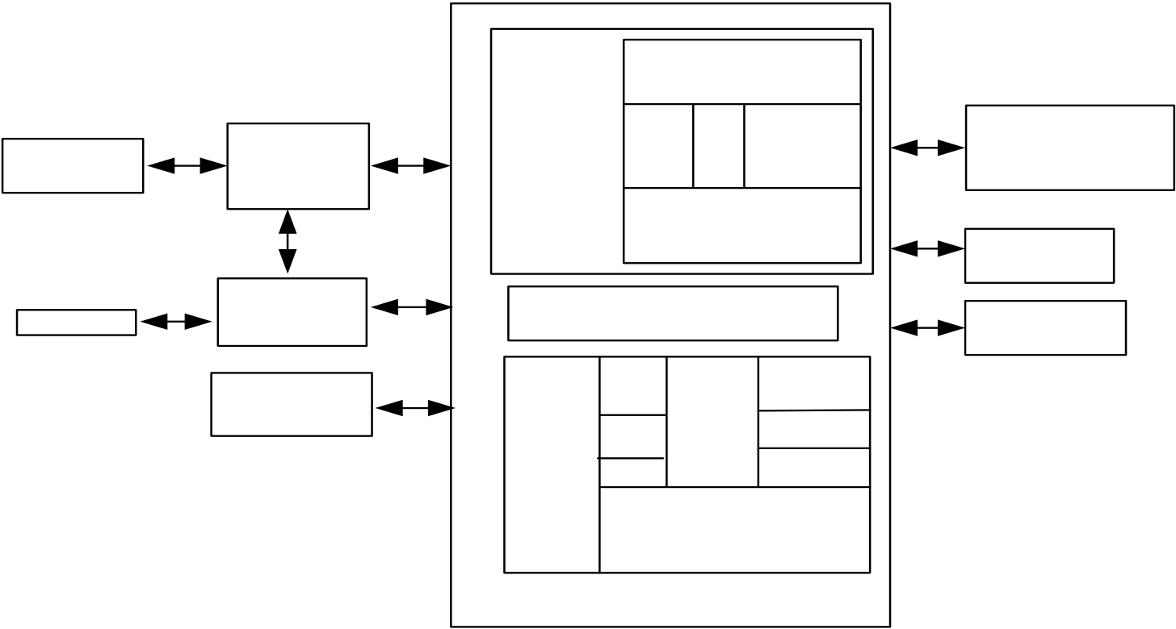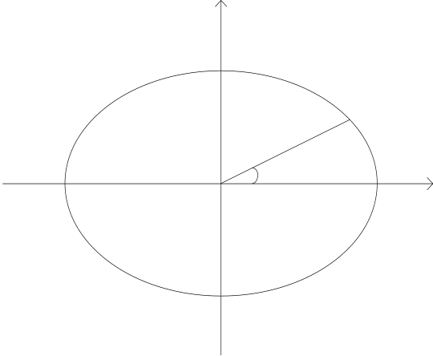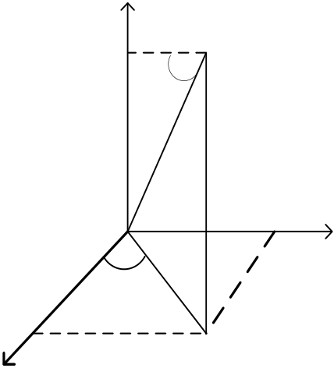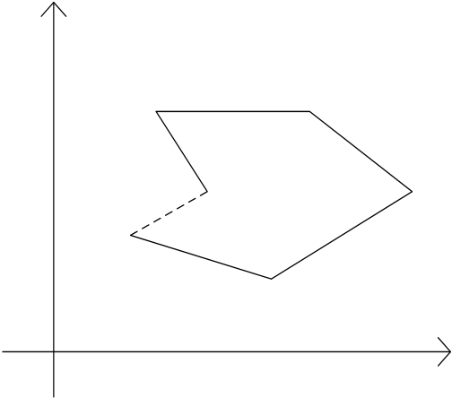

262  *Wenjie Tong et al. / AASRI Procedia 1 ( 2012 ) 261 – 266*

convert them to three-dimensional space coordinates data to calculate the area, which will be displayed by TFT subsequently.

The whole frame of the scheme is showed as figure 1

|  |  |  |  |  |  |  |  |  |  |
| --- | --- | --- | --- | --- | --- | --- | --- | --- | --- |
| ���������� | ��������� | �������� | | ������������ | | | | | �������� |
| ����� | | ������� | | | | |
| �������� | ����� | | ��� | | ����� | |
| ���������� | | ��������������� |
| ������ | |
| ���������� | ����� | ������������ |
| ������ |
| ������� | ���������� | | | | | | |
| �� | ����� | ��������� | | | | | | | ��� |
| ������ | | | | | | |
| ��������� |
| ���������� | | �������� | | | | |
| ��������� | ����� | ����������������� | | | | | | ����� |
| ��� | �������� | | | | | | |
| �� | | ��������� | | | | |
| ������� | �� | | ����� | | | | ��� |
| ������������ | | | | ����� | | |
| ����� | ������������������� | | | | | |

���������������  
������������

�������������  
����������������

Fig.1. the whole frame of the scheme

**3. Formulas and Algorithms used in scheme**

*3.1 Coordinate Transformation Formulas*

Take the earth as an ellipse, of which the equator radius is a, polar radius is b, The mathematical model

of the earth cross section is established as the following figure 2. Then the elliptic equation is

|  |  |  |  |  |  |  |  |  |  |  |  |
| --- | --- | --- | --- | --- | --- | --- | --- | --- | --- | --- | --- |
| *x* | 2 | |  |  | | --- | --- | | � | *y* | | 2 | � | 1 | � |  |  |  |
| *a* | 2 | *b* | 2 |  |  |  | � | latitude | M |
| � | | � |

�

|  |  |  |  |  |  |  |  |  |  |  |
| --- | --- | --- | --- | --- | --- | --- | --- | --- | --- | --- |
| latitude | � | � | X | O | P | Y | � | �� | �� | �� |
| longitude | � |

Fig.2. Cross section of earth Fig.3. 3-dimensional Fig.4. Irregular figure with n dots

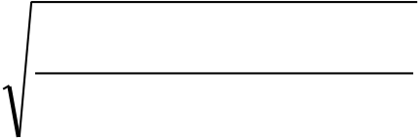

*Wenjie Tong et al. / AASRI Procedia 1 ( 2012 ) 261 – 266*  263

For any latitude point M, whose distance to the coordinates of the origin is N(N>0)�can be set to

|  |  |  |  |  |  |  |  |  |  |  |  |  |  |  |  |  |
| --- | --- | --- | --- | --- | --- | --- | --- | --- | --- | --- | --- | --- | --- | --- | --- | --- |
| ( N*cos(latitude), N*sin(latitude)). Take it into elliptic epuation, at the same time, have | | | | | | | | *eq* | � | *a* | 2 | � | | *b* | 2 |  |
|  |  |  |  | *b* | 2 |  |  | �*1*� |
| then� | *N* | � | 1 | � | *eq* | *a* | 2 |
| sin (latitude) 2 | |

So for the point(latitude, longitude, height are known), the distance from the origin of ellipsoid is

R=N+height�At its center to coordinate the origin, establish coordinate as shown in figure 3 below. For any

point M, in XOY plane projection for P, can draw | OM | = N + height, so M in the Z axis on coordinate is : z=(N+height)*sin(latitude) �*2*� then� |OP|=(N+height)*cos(latitude) �*3*�In XOY plane, the point P on the X axis in the coordinate x and Y axis in the coordinate y, can express as: x=|OP| cos(longitude) �*4*� y=|OP| sin(longitude) �*5*�By�����available: for any point M, the conversion equation that convert height, longitude and latitude into three-dimensional Cartesian coordinate are as followed   
 X=(N+height)*cos(latitude)*cos(longitude) �*6*� Y=(N+height)*cos(latitude)*sin(longitude) �*7*� Z=( N+height)*sin(latitude) �*8*�

And N=a/sqrt(1+(eq) *sin(latitude)*sin(latitude)) ; eq=(a*a-b*b)/(b*b) ;

*3.2 Area Calculation Formula*

Any point’s three-dimensional coordinates caculated in the front can be regarded as x, y, z, take the x, y as the projection in the XOY plane. Due to little latitude variation, all latitudes can be regarded varying around the average latitude. then the only working needed to do is to calculate the area of projection, according to a series of two-dimensional coordinates for *S reality*�S *projection* / sin(longitude) , during which we must utilize the Green’s Calculus Formula. As shown in figure 4, regional D is a close area surrounded by polygons A1,A2…… , and set its area as A.

|  |  |  |  |  |  |  |  |  |  |  |  |
| --- | --- | --- | --- | --- | --- | --- | --- | --- | --- | --- | --- |
| So that the area of the regional D for A=�*AA* 12 | | | | | � | *A A* 2 3 ...� | *AnA* 1 | *xdy* | � | *ydx* | , focus on the first segment is |
| �*A*1*A*2 | *xdy* | � | *ydx* | . The equation of line A1A2 is as following: | | | |

|  |  |  |  |  |  |  |  |  |  |  |  |  |  |  |  |  |  |  |  |  |  |  |  |  |  |  |  |  |  |  |  |  |  |  |  |  |  |  |  |  |  |  |  |  |  |  |  |
| --- | --- | --- | --- | --- | --- | --- | --- | --- | --- | --- | --- | --- | --- | --- | --- | --- | --- | --- | --- | --- | --- | --- | --- | --- | --- | --- | --- | --- | --- | --- | --- | --- | --- | --- | --- | --- | --- | --- | --- | --- | --- | --- | --- | --- | --- | --- | --- |
| 264 | | | | | | | | | | | | *Wenjie Tong et al. / AASRI Procedia 1 ( 2012 ) 261 – 266* | | | | | | | | | | | | | | | | | | | | | | | | | | | | | | | | | | *x* 1 | )�*dt* |
| � � � | | | *x* | � | *x* 1 | | | � | *t x* | | | | 2 | | � | | *x* 1 )  *y* 1 () 0 | | | | � � | | | )1 | | | | | | | | | |
| As so� | �*AA* 12 | | *xdy* | | � | *ydx* | | � | 1�0 | �[ | *x* 1 | *y* | � | � | � | |
| *y* 1 | | | *t y* | | | | 2 | |
| � | | *t x* 2 | | � | *x* 1 | | )]( | | | *y* | | 2 | � | | | *y* 1 | | | ) [ | | *y* 1 | � | *t y* | | | 2 | | � | *y* 1 | )]( | *x* | 2 | � |
| � | | | | | | | | | | *x* 1  *y* 1 | | *x* 2 | | � | *x* 1 | | | | | | | | | | | | | | | | | | | | | | | | | | | | | | |
| *y* | 2 | � | *y* 1 | | | | | | | | | | | | | | | | | | | | | | | | | | | | | | |
| Similarly: | | � | *AiAi* | �1 | *xdy* | | � | *ydx* | | | � | *x i* | | *x* | | *i*�1 | | � | | *x i* | | | 1( | | | � � | | | | | | *n A n* | | | �1 | | � | | *A* 1 | | ) | | | | |
| � | |
| *y i* | | *y* | | *y i* | | |
| *i*�1 | |
| Finally� | | | | | | | | | | | | *n*  A=0.5�  *i*�1 | | | | | | | *x i* | | | | *x i* | | | | | �1 | | � | | *x i* | | | | | | | | | | | | | |
| � | |
| *y i* | | | | *y i* | | | | | *y i* | | | | | | | | | | | | | |
| �1 | |

**4. Software Design**

Systematic software basically has the following three parts: GPS data receiving and reading, GPS data conversion and storage, the area calculation and display.

The GPS data is mainly received by the hardware Gstar-89m-J satellite receiving engine, which gets current GPS data around the location every short interval. Then it can read the information of latitude, longtitude and height by the data. GPS data conversion formulas as the ���have shown. As to data storage, dynamic data storage is used in the scheme combined with area calculation formula .To display, call the program after the finish of calculation of area, assume the attachment between the last survey point and starting point which composes a simulative polygons to display before a not complete measurement, which can provide access to view the area during the measurement.

The software design flow chart is shown as the figure 5.

**5. Results and Analysis**

After mapping ten pieces of areas of different size by two measurement instruments every time with mark�(the author developed) and mark�the difference, and finally conclude the data as the Table 1 shows : From the above table of data, it is known that the measurement area differs from the actual area in some errors, but this error is not very big, the minimum error is 0.2635%, the maximum error is 3.086%. At the same time we can calculate the average error is 1.172496%.

To improve the accuracy, the author thinks that the following aspects can be lucubrated: 1.Take the average number of latitude as the projection latitude to reduce the errors in the conversion formulas. 2. Take the average height as the set height, do not fix on a certain height value.3.Use more sophisticated GPS reciever.4.Use the optimal algorithm, so as to improve the accuracy of conversion value and area value, which, however, is difficult to achieve for it is not so easy to come up with.

*Wenjie Tong et al. / AASRI Procedia 1 ( 2012 ) 261 – 266*  265

**6 Conclusion**

Methods based on the GPS land area measurement have developed for irregular measurement instruments. The experimental results show that the instrument is able to quickly and efficiently achieve the function of the land area of irregular measurement. And for some projects related to area, the instrument, whose prospect is inestimable, has special application value.

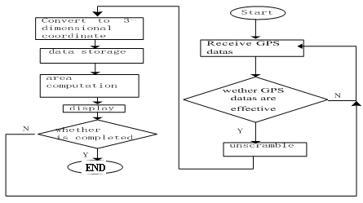

Fig. 5. Software Flowchart

Table 1 measured data

|  |  |  |  |  |  |  |  |  |  |  |  |  |  |  |  |
| --- | --- | --- | --- | --- | --- | --- | --- | --- | --- | --- | --- | --- | --- | --- | --- |
| ������ ����   |  |  | | --- | --- | | � ��� | ������� ��������  ��������� | | �� | ��������� |   � � | | ��������� | ��������� | �� | |  |  | | --- | --- | | � ��� | ������� ���������  ��������� | | �� | ��������� | | ��������� | ��������� |
| ����� | ������ | ������ | ������ |
| ������ | ��������� | ������ | ������� | ��������� |
| ���� |
| ���������  ����� ������  ���������� | |  |  | | --- | --- | | �� | ��������� | | �� | ��������� | | ������� | ��������� | ����� | |  |  | | --- | --- | | �� | ��������� | | �� | �������� | | ������� | ��������� |
| ����� |
| ������� | ��������� | ������ | ������� | ��������� |
| ������ |
| ������� | ��������� | ������ | ������� | �������� |
| ����� |

|  |  |  |  |  |  |  |  |  |  |  |  |  |  |  |
| --- | --- | --- | --- | --- | --- | --- | --- | --- | --- | --- | --- | --- | --- | --- |
| ���������� | �� | ��������� | ������   |  |  |  | | --- | --- | --- | | ������ | ��������� | ���� | | | | �� | ��������� | |  |  | | --- | --- | | ������� | ��������� | | |
| �� | ��������� | �� | �������� |

266  *Wenjie Tong et al. / AASRI Procedia 1 ( 2012 ) 261 – 266*

**References**

[1] XuWei. Compact practical 51 SCM GPS development board [J]. "radio" magazine, 2010(7)   
[2] TanYu Cheng ect. Land area of measuring apparatus mathematical principle [J]. Agricultural extension service, 2010.(1)   
[3] LiZheng Hang, HuangJin Song. GPS measurement and data processing [M]. Wuhan: Wuhan University Press, 2005   
[4] CengQing Xi. Software signal processing key technology [J]. Journal of instruments, 2009, (12) [5] ARM company. ARM Architecture Reference Manual. 2000.

[6] GPS interface . http : //www . garmin . com / GPS / GPS25LVS.

[7] LiHong Tao. GPS application design[J]. Beijing: science press, 2009:10-18