

[Applied Computing and Informatics 15 (2019) 120–128](https://doi.org/10.1016/j.aci.2017.12.003)

Contents lists available at [ScienceDirect](http://www.sciencedirect.com/science/journal/22108327)

Applied Computing and Informatics

journal homepage: [www.sciencedirect.com](http://www.sciencedirect.com)

Original Article

|  |  |
| --- | --- |
| EELAM: Energy efficient lifetime aware multicast route selection for mobile ad hoc networks |  |

N. Papannaa,⇑, A. Rama Mohan Reddyb, M. Seethac

a Dept. of CSE, Sree Vidyanikethan Engineering College, Tirupati, India   
b Dept. of CSE, S.V University College of Engineering, Tirupati, India   
c Dept. of CSE, GNITS, Hyderabad, India

|  |  |  |
| --- | --- | --- |
| a r t i c l e | i n f o | a b s t r a c t |
| Article history:  Received 2 August 2017  Revised 15 December 2017  Accepted 24 December 2017  Available online 26 December 2017 | | MANET (Mobile Ad hoc Network) consists the nodes that are self-energized and shall be able to accom-modate limited energy levels, and usually the nodes transmit the data using the intermediate nodes to the ones that are not in hop levels. In such conditions, the lifetime of the intermediary nodes turn out to be a critical factor, and hence only when the routes are having maximum residual energy and the ones that have high, spend minimal energy for transmitting the data is very important. In terms of route selec- |
| Keywords:  Ad hoc networks  Multicast routing  Adaptive genetic evaluation | | tion, the emphasis is much on multicast routing and the route discovery, and the effcient nodes selection has to take place with emphasis on QoS. Hence, the energy efficient multicast route discovery process has gained significant importance, and there are many potential solutions depicted in the process. Energy Efficient Lifetime Aware Multicast (EELAM) Route Selection strategy for MANETs is the proposed multi-cast route discovery approach that is developed using the adaptive genetic algorithm. EELAM works |

based on tree topology that differentiates to other tree based on multicast routing topologies by adapting evolutionary computation strategy defined as genetic algorithm, which shall play a critical role in terms of selecting optimal intermediate nodes with maximal residual energy and minimal energy usage. The fitness function that devised for the adaptive genetic algorithm targeted for improving the energy con-sumption ratio, improving the residual batter life and towards improving the multicasting scope. The process and the methods that are adapted are contemporary and is different to the traditional genetic algorithms, and still the outcome as depicted in the experimental results reflect the fact that the EELAM is the best of in its class that can support in addressing the limitations in the current solutions and towards managing improved route discovery.

� 2017 The Authors. Production and hosting by Elsevier B.V. on behalf of King Saud University. This is an open access article under the CC BY-NC-ND license (<http://creativecommons.org/licenses/by-nc-nd/4.0/>).

|  |  |
| --- | --- |
| 1. Introduction | communication, even in the routine communication too, the role |

of mobile communication has become an integral part. Network MANETs the mobile ad hoc networks constitutes usage from partition results as a part of network topology being classified in varied range of computing devices like the laptops, mobiles and the MANET [1].

other computing solutions. The network connects of the mobiles take place in the form of node connects and predominantly used in the current scenario. Alongside the classified range of

⇑ Corresponding author.

E-mail addresses: [n.papanname@gmail.com](mailto:n.papanname@gmail.com) (N. Papanna), [ramamohansvu@ yahoo.com](mailto:ramamohansvu@yahoo.com) (A. Rama Mohan Reddy), [smaddala2000@yahoo.com](mailto:smaddala2000@yahoo.com) (M. Seetha).

Peer review under responsibility of King Saud University.

**Production and hosting by Elsevier**

<https://doi.org/10.1016/j.aci.2017.12.003>

Among the key factors that depict the outcome for a system, energy-efficient-multicast plays a very vital role for MANETs. One of the critical issues that envisaged in the process is that as the mobile nodes usually operated on limited batteries, often switch-ing is leading to more battery consumption, and it could lead to affecting the nodes in a significant manner, as the data transmis-sion between the nodes might get impacted and it could lead to more challenges.

There are numerous studies that have been carried out earlier in terms of solutions for nodes that are aware of energy consumption, in the routing protocol for MANETs [2]. In MANET, there are varied was of power-aware algorithm solutions that are proposed to ensure that node energy is saved [3].

2210-8327/� 2017 The Authors. Production and hosting by Elsevier B.V. on behalf of King Saud University. This is an open access article under the CC BY-NC-ND license (<http://creativecommons.org/licenses/by-nc-nd/4.0/>).

N. Papanna et al. / Applied Computing and Informatics 15 (2019) 120–128 121

Power aware metrics are critical objective of majority of the studies, which focused on increasing the node and lifetime of the network [4]. The power aware routing metrics, those depicted in [5] are resourceful for transmitting data to the destination from

The key purpose of this model is towards evaluating the signal strength for stable levels in the hop links and shall be used further towards concluding the fitness in terms of stability and energy usage in the multicast tree. One of the significant constraints in

the source. this process is that though it aims at reducing the cost of battery

In another model that has been depicted in a study on conserv-ing energy in the transmission, MTPR has been projected which works on minimizing the utilization of power for transmission from the nodes to the participating nodes in a path. From the inputs depicted in the study, it is imperative that the required power for transmission is relative to the distance between corre-sponding two nodes. This model reflects on multicast routs with large number of nodes, and the crux is that it is not considering the leftover energy of the battery of the nodes involved in the route, hence it lasts the focus on lifetime of each node.

In the other model of MBC [6], the solution is about minimizing the path cost and hence worked on the reverse modeling of the residual energy of the nodes depicted in corresponding path.

Compared to the wired networks, the complexity of multicast-ing in the wireless networks are much higher because of the inter-ferences and mobility related issues. Multicast is an active

|  |  |  |  |  |  |
| --- | --- | --- | --- | --- | --- |
| communication | and | the | concerted | correspondence | process |

between various nodes. Flooding based multicasting is one pre-dominant strategy that evinces control packet overhead as high, and emphasized to generate minimal levels of data traffic in the network. However, the challenge is that the issue of scalability is a major constraint in the case of both the solutions. In the case of multicast protocols, there are varied factors that influence the solutions for MANETs, and categorically the issue of node mobility, is a key issue. The crux in the process is about the need for more bandwidth in terms of updates, by taking more of control message packets and high consumption of power.

In the proposed paper, the focus is on developing an energy effi-cient multicast algorithm for MANETs. In the proposed solution, the factor is that the data packets transmitted from source to the group destinations using a node, and such nodes relies on the path with higher efficiency of residual battery powers and relay-capacities. The other objective of the proposal is to minimize the process overhead to select possible multicast routes between source and destination. In regard to this, the depicted model is con-cluding the routes from destination to source, which is novel that compared to other contemporary models.

The proposed model explained in detail in the further sections constituting Section 2 as the related work, followed by Section 3 as discussion of outline of the proposed algorithm. In terms of experimental setup and the related performance analysis, Section 4 depicts the process outcome, followed by Section 5 depicting the conclusion and the scope of further research work.

life, still in terms of complexity observed in the process could be attributed to Genetic Algorithm. The other GA based multicast tree routing protocol [10] for HAP-satellite architecture [11] is depicted in contemporary literature. The QoS metrics called cost, band-width, and delay are consider to assess the fitness of the newly formed multicast trees (chromosomes). The cost metric denotes the energy consumption. The other contemporary model [12] that builds over Genetic algorithm is aimed to detect dynamic shortest path, and dynamic multicast route. The Link-stability, and energy efficiency is two critical objectives of the model depicted in [13], which is also based on genetic algorithm.

The probabilistic evolutions and evolutions complexity are the constraints of these GA based models, which are carried from tra-ditional GA evolution process. Henceforth probabilistic route accu-racy in regard to routing quality factors is often evinced, which is due to the probabilistic evolutions of the traditional Genetic Algorithm.

The evolutions carried in GA are probabilistic, since the initial chromosomes (multicast routes) are formed randomly. In addition, the parent chromosomes those were used as input to crossovers also being retained along with newly formed chromosomes due to crossover process.

In regard to overcome this, and to achieve route discovery deterministic process, this manuscript is preparing initial chromo-somes using the route discovery process called EACNS [14]. Later the process of the genetic algorithm is using these chromosomes in crossover process. Moreover, among the parent chromosomes and newly formed chromosomes, the best fit will be survive and rest will be pruned from the chromosome list, which is progressive evolution strategy. Due to this the number of evolutions are deter-ministic and limits the evolutions process complexity.

Profoundly the algorithms that are designed with intension of power efficiency was based on cluster-based or by adapting the tree-based models. In the later model, emphasis is on developing tree-based solutions that are highly efficient in power manage-

|  |  |  |  |  |  |  |  |  |
| --- | --- | --- | --- | --- | --- | --- | --- | --- |
| ment, | and | depending | on | source, | they | further | classified | as |

multicast-source or single-source algorithms. Some of the power efficient single-source multicast models defined are MIP, S-REMIT and RBIP [15].

In [16] G-REMIT was proposed as an alternative tree-based mul-ticast to enable routing between multiple sources and sinks. The critical objective of the model is to achieve multicasting with min-imal energy consumption. REMiT is another model with emphasis towards reducing the consumption levels of energies and improv-

|  |  |
| --- | --- |
| 2. Related work | ing network lifetime. L-REMit model proposed with objective of refining the lifetime of the network for the source-based trees. G- |

In the process of increasing the network lifetime, the power-aware routing plays a vital role, and there are certain solutions that developed earlier for the same. In the case of Broadcast Incremen-tal Power (BIP) algorithm [7], the process is that the system exploits the nature of wireless communication environments and the addresses that are essential in the process of handling the energy efficient operations in the system. Emphasis in the model is depicting multicast tree that broadcasts with minimal energy consumption. This model is fundamentally designed on the basis of Prim’s algorithm [7].

Genetic Algorithm based multicast routing [8,9] are focused towards achieving the stability and energy efficient outcome in terms of mobile ad hoc network routing is an effective system that can make significant difference in terms of energy consumption.

REMiT model is more about reducing the energy consumption amidst the group-shared trees.

In [17,18], the study has discussed contemporary solutions those enables multicasting. The emphasis of these models is to enhance the network life time. The MLMH [18] depicted a metric called EEM (Energy Efficiency Metric), which is the result of aggre-gate hop-count values and relative levels of increment of lifetime.

Lifetime-Aware-Multicast-Tree (LAM) works on maximizing the lifetime by identifying a route with minimal levels of energy con-sumption and exploits the multicast lifetime [19]. The other method of Prioritized-overlay-multicast algorithm shall work towards improving the effectiveness and efficacy of the superim-pose multicast in MANET, by ensuring that there is effective role–based-prioritized trees [20].

122 N. Papanna et al. / Applied Computing and Informatics 15 (2019) 120–128

The other method MAODV proposed in [21] is an extended ver-sion of AODV that targets improvisation of the process, where all multicast group constituted as a tree that leads by the root node that broadcasts the data packets to the nodes involved in corre-sponding tree. Any corrections, rectifications and repairing of the tree carried out using the MAODV protocol core. MP-MAODV dis-cussed in [22] is an extended model of MAODV and works on mul-tipath selection and establishment, and handling the process of multipath route maintenance along with other functions like load distribution. The MP-MAODV is capable to build multicast tree with multiple sources and multiple sinks that enables bidirectional sharing. In addition, the MAODV is one of the shortest routing with least levels of hops routing, however, the MP-MAODV is much rig-orous in terms of establishing the maximum possible number of multicast routes between so node and multiple sinks that is

The fuzzy oriented demand on multicast routing protocol (FBODMRP) [29] has been proposed as a highly efficient means of delivering information from the node at the source to different nodes, which are the receivers. The main objective of FBODMRP mainly entails establishing small, high quality as well as highly efficient forwarding group. When FBODMRP is compared to ODMRP, it is worth pointing out that fuzzy based approach results into higher packet delivery ratio, very low control information uti-lization as well as delays in the environment, which is highly dense. In addition, power saving option is greater if there is need for low control overhead. As future work, the fuzzy rules may use over the cognitive networks. This depicted model plays a role in increasing the rates of packet delivery by 40 percent, and the ratio of delay and energy dissipation reduced relatively to 35 and 45 percent. However, the loss rate is proportionating to network

adapted in the backup route. density.

Multicasting via the application of time reservation, as well as adaptive control for energy efficiency (MC-TRACE) [23] is generally an energy efficient real-time multicast routing procedure for data communication in MANETs. It is worth pointing out that MC-TRACE is generally the extended MH-TRACE [24] that generally supports multicasting routing ability.

Efficiency in the consumption of energy gained through allow-ing the nodes, which are idle and can be switched to sleep node frequently and through the elimination of majority of redundant data receptions. The MC-TRACE depicts significance to minimize the transmission delay and battery dissipation, whereas the band-width efficiency is similar that compare to ODMRP [25]. The ability of minimal energy consumption appeared in MC-TRACE evincing the greater possibility of significant QoS in multicast routing, as well as bandwidth efficiency. However, the lack of robust architec-ture is the main challenge.

High stable power conscious multicast algorithm (HSPMA) [26] which is mainly aimed at improving the lifespan of the network

MANETs uses omni directional antennas. At the same time, they are having limited energy resources in the protocol, which have been proposed. In the suggested distributed minimum energy mul-ticast (DMEM) [30] focus is mainly on the reduction of the total RF energy which is highly vital for multicast communication. It is worth pointing out that the DMEM algorithm is highly effective in performance and in the delivery of the results. In an environ-ment of low mobility, the protocol generally accomplishes the best of medium, as well as a huge volume multicast groups. For the higher mobile networks, it is worth pointing out that DMEM is generally regarded to be highly effective efficient and effective with regards to saving energy, as well as when it comes to ensuring that the overheads are adequately and effectively controlled. This model is highly efficient both with regards to saving energy and also operation overhead. However, In case there is link breakage, there is the dwindling of process’ performance.

Least energy for every bit for multicasting [31] in the MANET generally concerns linear program in which the least energy for

|  |  |  |  |  |  |  |  |  |  |
| --- | --- | --- | --- | --- | --- | --- | --- | --- | --- |
| and | the | node, | considering | the | two | main | metrics, | residual | every bit achieved through the adoption of network coding. The |

battery-capacity as well as the relay-capacity which is vital for car-rying out multicasting. Lowering the energy dissipation at nodes corresponding to multicast route leads to maximal lifespan of the network. Multicast group size may become a huge challenge when it comes to the determination of the performance of the network. In addition, the additional control information is vital when com-parison done between the power conscious routing protocols and the regular protocols that do not take into consideration energy as one of the main concerns. The network’s life span increased by about 20 percent on average. However, there is the creation of added control traffic.

Lu and Zhu [27] addressed a novel multicast routing protocol called EDCMRA that aimed to achieve Energy-efficiency and delay sensitive data transmission. The EDCMRA is based on Genetic Algo-

process time required for an optimal network coding solution is 30th part of the time taken by an optimal routing strategy. Future research should characterize with an average gain. Generally, net-work coding is having a number of benefits when a comparison is done between it and optimal routing with regards to energy, as well as computational efficiencies. However, the characterization of admissible rate region is highly complex.

In the case that multicast transmission from multiple sources to multiple sinks, the main challenge, which is faced generally, entails the development of MEM tree to enable the conveyance of multi-cast data. This results into the minimization of the whole con-sumption of power for packet conveyance within the tree. There is the building of least energy multicast tree. However, it is only appropriate to the ad hoc networks that build by symmetric place-

rithm that is considering the energy dissipation and delay as fit- ment of the nodes.

ness metrics in objective function to select optimal routes. The algorithm uses the Possible Multicast trees those traced in route request process as initial input chromosomes, and uses the com-mon subtree of the any of given two multicast tress as crossover point. It is a highly efficient and effective algorithm, but the pro-cess time is inversely proportionated to the network size.

EGMP (Efficient geographic multicast protocol) [28] petitions the network into set of virtual zones to achieve effective manage-ment of group membership. In order to this, a network wide zone oriented bidirectional tree is formed in each virtual zone. The experimental study that compared the ERGMP with ODMRP and SPBM evincing that the ratio of packets delivered through EGMP is considerably high that compared to OBMRP and SPBM. The min-imal control packet overhead is observed in multicasting process of the EGMP than the other two protocols. However, there is gener-ally less efficiency with regards to the usage of energy.

The model depicted in [32] is a multicasting process that entails the all-to-all transmission. Critical objective of the model depicted is multicast sessions, which is framing the multiple sessions from the overall transmissions required. The nodes related to each mul-ticast session contains a message for sharing with the other node. There is a reduction in the total energy that consumed, however, it demands exclusive construction of multicast routing tree.

The model depicted in [33] is considering the node mobility and energy dissipation as critical objectives, which is referred as mobil-ity based energy efficient multicasting (M-EEMC). M-EEMC is cou-pled with tree, as well as mesh based routing techniques for the minimization of the levels of consumption of energy. Performance assessment of the protocol, which proposed with ODMRP generally points out that M-EEMC is delivering better ration of packet deliv-ery and brings about lesser energy dissipation as well as lesser

N. Papanna et al. / Applied Computing and Informatics 15 (2019) 120–128 123

packet delay. There is the dissipation of minimal amounts of alternating GA and the hill climbing methods can result in more

energy. However, it involves a complicated set of algorithm. effective outcome.

The limits observed in regard to these benchmarking models is that the multicast scope of a node is not considered and no evi-dence of accurate selection of multicast route with minimal energy consumption and maximum lifetime, which are significant in establishing stable route.

Hence, the contribution of this manuscript aimed to establish a best-fit multicast route that consumes minimal energy to transmit and retains maximum lifetime of the route. In order to this, the proposal relied on adaptive genetic algorithm that uses multicast scope, energy consumption ration and reserve battery ratio in fitness assessment. The adaptive genetic algo-rithm adapted for optimal multicast route selects the sub-trees with dynamic number of nodes and optimal fitness as crossover points to perform mutations, which is significant to reduce the computational overhead that usually found in traditional Genetic Algorithm strategies.

The suggested protocols EEMPMO in [34] makes use of the idea of zone building and they generally construct a multicast tree with alternative root node that replaces the primary root node as and when required. The depicted tree is capable to perform bidirec-tional transmissions [35]. Because the root node charged with the responsibility of routing, there is the dire need for more energy consumption in comparison to the other nodes. Performance and reliability, which pertains to reduced overhead, as well as usage of lesser power, as well as lesser bandwidth is gathered though the use of the protocol which was proposed. The scalability, as well as less control overhead are the critical strength of the EEMPO. However, the procedure involved in selection of highly appropriate node as the standby node may result into various kinds of delay in performance, however, it may enhance the protocol’s overall

Of the adaptive genetic algorithm properties explored, the genetic algorithm used here in this manuscript evinces the adapt-ability at cross over point selection, such that maximum number of nodes in sequence having fitness more than the given threshold. This strategy of crossover point selection defuses the number of evolutions, hence the computational complexity will be evinced minimal that compared to traditional GA [37]. The Energy efficient and lifetime aware multicast route discovery strategy that pro-posed here in this manuscript explored following.

3.1. Formation of chromosomes (Genotype)

All possible Multicast Routes to transmit data between selected source and multiple destination nodes has to be discovered ini-tially. The multicast routes formed as tree structures, which built from the selective nodes. Let MT ¼ ft1; t2; . . . ; tjMTjg be the set of Multicast Routes selected by route request process adapted from MAODV [21]. Further, these set of Multicast Routes used as initial chromosomes for adaptive genetic evolution. In order to identify the fitness of the newly formed chromosomes from the crossover process, the fitness function is derived, which uses proposed heuristics derived in our earlier contribution called EACNS [14] that briefed in following section.

3.2. The metric used to estimate the fitness of the multicast tree

The Metrics used to estimate the fitness of the multicast tree MT ¼ ft1; t2; . . . ; tn�1; tng are

efficiency. � Ratio of Energy Consumption: Metric defines usual energy con-sumption per unit of transmission at the egress node levels. The

3. Adaptive genetic algorithm based multicast route selection

An adaptive genetic algorithm (GA) is a method for solving both constrained and unconstrained optimization problems based on a natural selection process that mimics biological evolution. The algorithm repeatedly modifies a population of individual solutions. At each step, the genetic algorithm randomly selects individuals from the current population and uses them as parents to produce the children for the next generation. Over successive generations, the population ‘‘evolves” toward an optimal solution.

Generates a population of points at each iteration. The best point in the population approaches an optimal solution.

Adaptive Generic Algorithms (AGAs) is one of the affluent algo-rithms, and pc (probabilities of crossover) and the mutation (pm), certainly determines the level of accuracy and the quantum of speed that the genetic algorithms can attain. Rather than taking any fixed values in to account, in the case of the adaptive algo-rithms, the emphasis is on gathering inputs from the population diversity as well as in terms of sustaining the convergence capac-ity. In the AGA model [36], the fitness values of the solutions are vital in terms of determining pc and pm values for the solutions, whereas, in the case of CAGA [37], the decision of pc and pm depends more on the optimization states of the population. The scope of combining GA with the other set of optimization methods shall be more proficient as the GA is very effective in finding good global solutions, but the challenge is about its limitations in terms of finding the absolute optimum using the last few mutations. Some of the other techniques like the hill climbing method and other such solutions are certainly effective and efficient in finding the most favorable in a confined region, but in the case of

metric value derived based on mean of consumed energy for unit of transmission amidst nodes to the nodes that connected at successor levels, and the values expected to be minimal.� Reserved Battery Life: It details the lifetime of a node that is part of the routing process. The metric estimates battery life essen- tial for routing and the idle time value of battery life, battery life impacted because of contingency like max battery consumption (mbc), which deducts mbc based on the estimated battery life (ebl). Resulting value of the assessment has to be positive and higher that the defined threshold.

� Multicast Scope: It defines the feasible quantum of child nodes.

The combination of these metric values such that a node having max number of child nodes with minimum energy consumption and maximum reserve battery life represents corresponding node is optimal.

Similarly the combination of these metric values such that the average of child nodes is maximum with average of energy consumption is minimum and average of reserve battery life is

|  |  |  |  |  |  |  |
| --- | --- | --- | --- | --- | --- | --- |
| maximum | represents | the | corresponding | multicast | tree | is |

optimal.

The assessment of these metrics at each node carried out as follows.

3.2.1. Assessing energy consumption ratio   
 The energy consumption at every node is the average of energy consumption observed to transmit a unit of data to all child nodes from the corresponding node.

ecðtiÞ / // is vector contains the energy utilization ratio of all nodes in multicast tree ti

124 N. Papanna et al. / Applied Computing and Informatics 15 (2019) 120–128

|  |
| --- |
| 1. For each Node fn9n 2 tig Begin ecn!CNnu // a vector denoting energy utilization essential  for transmission of a frame to all child nodes denoted as set |

CNn

|  |
| --- |
| 2. For each child node fcn9cn 2 CNng Begin  qw ¼ wðtn!cn number of frequency ranges, the number frequency ranges Þ�k // desired frequency qw is exponential of the  from the Euclidian distance tn!cn observed between node n and corresponding child node cn istn~~!~~cn d, here d is the  frequency range observed at node n and notation k is the |

exponential loss of the frequency.

ecn!cn ¼ ðqw � eÞ þ ðe0� kÞ ð1Þ

//Here in Eq. (1)  
� The notation ecn!cn represents the energy consumed for transmission of a frame from node n to corresponding child node cn  
� e is energy essential for transmitting a frame under fre- quency w  
� e0is the energy consumption resulting because of overhead of other factors [27].

ecn!CNnecn!cn   
// energy consumption between node n and corresponding child node cn is added to the set ecn!CNn   
 End //End of loop in line 2   
necti hecn!CNni // mean energy consumption amidst n and all corresponding child nodes CNn is moved to the set necti that contains usual energy consumption observed for all nodes in multicast tree

|  |
| --- |
| End // end of loop in line 1  ecti ¼Pjnecti j transmit a frame by multicast tree ti fej9ej 2 nectig// the energy consumption to |

3.2.3. Assessing multicast scope

|  |
| --- |
| rblðtiÞ u //A vector comprises the information of   reserve battery life of all the nodes in Li   nnlðLiÞ u // A vector which constitutes size of all   probable neighbor nodes from slðLiÞ interlinked to every node fsnd9snd 2 Lig based on defined metric constraints mcsti/// is an empty set contains the multicast scope of each node in the given tree  1. For each Node fn9n 2 tig Begin   mcln ¼ 1 // max possible nodes to connect as child nodes to the |

node n that initialized with 1   
2. For each child node fcn9cn 2 CNng begin   
 ifððmbln � ðhecn!CNni � fc � mclnÞÞ > rblnÞ Begin mclnþ ¼ 1   
 End   
 Else Begin   
 mcln� ¼ 1   
 mcstimcln   
 Go to loop in line 1   
 End   
3. End // of loop in line 2   
4. End // of loop in line 1

The given tree level multicast scope is the average of multicast scope observed at each node of the corresponding tree hmcstii.

3.3. Fitness function

This section explores the process of estimating the tree level fit-ness in regard to energy efficiency and route longevity, which is as follows.

For given parent trees tp; tq and the resultant child trees ti; tj, assess the values for metrics, energy consumption ratio (see Sec-tion 3.2.1), reserve battery life (see Section 3.2.2 and multicast

3.2.2. Assessing reserve battery life scope (see Section 3.2.3)

The reserve battery life of a given node estimated as follows.

|  |  |  |  |
| --- | --- | --- | --- |
| Initially, the product of energy consumption ratio, max quan- | 1. | ifðrblti > rblsÞ Begin  // if the reserve battery life of the multicast tree ti is more | |
| tum of frames to be transmitted and aggregate number child |
| nodes will measure and further the resultant value of this pro- |
| than the threshold rbls given | |
| duct will deduct from the actual battery life of the corresponding |
| i. ifðecti < ectp _ ecti < ectqÞ Begin The energy consumption ratio of the tree ti is less than the | |
| node. |
| energy consumption ratio of target tree tp or tq then the | |
| For every Node fn9n 2 tig Begin |  | fitness of tree ti is optimal | |
| End // of if in line i | |
| ii. | Else |

rbln ¼ mbln � ðhecn!CNn i � fc � jCNnjÞ

//The product of energy consumption ratio node n, max number of frames to be transmitted, and the aggregate of child nodes is diffused from the max battery life mbln of node n that referred as preserved battery life rbln of the node n.

End   
Further, the average of reserve battery life observed for all nodes in given multicast tree considered as the tree level reserve battery life rblti

ðecti ¼ ectp _ ecti ¼ ectqÞ ^ ðmcsti > mcstp _ mcsti > mcstqÞ Begin   
 Confirm that the tree ti is with optimal fitness   
 iii. End //of else in line ii   
2. End // end of if in line1   
3. Else Begin   
 The fitness of the tree ti is not optimal, hence tree ti is not prone to select for routing   
4. End // of else in line 3

In the similar passion explored above find the fitness of the tj

N. Papanna et al. / Applied Computing and Informatics 15 (2019) 120–128 125

3.4. Adaptive GA for multicast route selection

The optimal energy efficient multicast route among the possible multicast routes discovered done by using evolutionary computa-tion strategy called Adaptive Genetic Algorithm (GA) [36]. Selec-tion of distinct range of nodes in sequence as crossover points reduces the computational overhead of GA, which applies set of initial multicast routes as MT ¼ ft1; t2; . . . ; tjMTjg. The algorithm description follows and the same is visualized in flowchart (see Fig. 1).

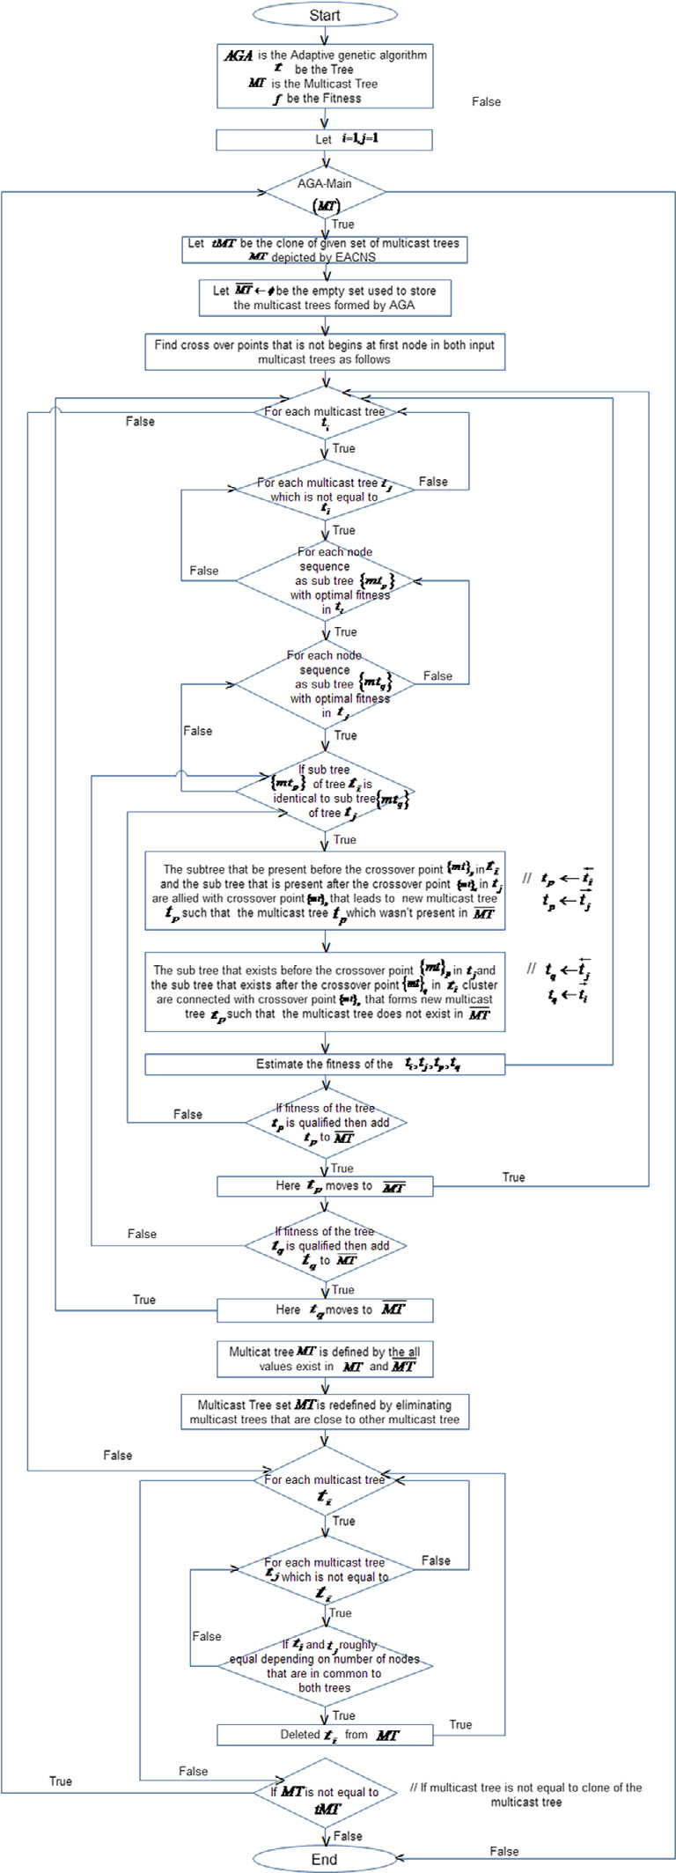

Fig. 1. The optimal multicast route discovery function.

3.4.1. The optimal multicast route discovery function

AGA-Main (MT) Begin   
Let tMT be the clone of given set of multicast trees MT

depicted by EACNSLet MT/ be the empty set used to store the multicast trees formed by AGAFind cross over points (common node sequence with fitness greater than the given threshold in given both multicast trees) that is not begin at first node in both input multicast trees as follows.

1. 8jtCLj i¼1fti9ti 2 tMTg Begin // for each multi cast tree ti   
2. 8jtMTj j¼1ftj9tj 2 tMT ^ i–jg Begin// for each multicast tree tj, which is not the other tree ti   
3. for eachffmtgp9fmtgp 2 ti ^ p ¼ 1tojtijgBegin //node   
 sequence as sub tree fmtgp with optimal fitness in   
 multicast tree ti   
4. for eachffmtgq9fmtgq 2 tj ^ q ¼ 1tojtjjgBegin //node   
 sequence as sub tree fmtgq optimal fitness in multicast tree tj   
5. If ðfmtgp � fmtgq ^ p–1Þ Begin// if subtree fmtgp of tree ti is identical to subtree fmtgq of tree tj  
� The subtree that be present before the crossover point fmtgp in ti and the sub tree that is present after the cross- over point fmtgq in tj are allied with crossover point fmtgp that leads to new multicast tree tp such that the multicast tree tp which wasn’t present in MT

tpti

tptj !

� The sub tree that exists before the crossover point fmtgp in tj and the sub tree that exists after the crossover point fmtgp in cluster ti are connected with crossover point fmtgp that forms new multicast tree tq such that the mul-ticast tree tq does not exist in MT

tqtj

tqti !

� Estimate the fitness of the ti; tj; tp; tq (see Section 3.3)� If ðf tp� 1Þ //if fitness of the tree tp is qualified then add tp to ~~MT~~

MTtp  
� If ðf tq� 1Þ //if fitness of the tree tq is qualified then add tq to ~~MT~~

MTtq   
 End If // of step 5   
6. End For //of step 4   
7. End For //of step 3   
8. End For//of step 2   
9. End For//of step 1

10. MTMT [ MT 11. Multicast Tree set MT is redefined by eliminating   
 multicast trees that are close to other multicast tree if any, using the following steps   
12. 8jMTj i¼1fti9ti 2 MTg Begin   
13. 8jMTj j¼1ftj9tj 2 MT ^ i–jg Begin   
14. If ðti,tjÞ then // ti and tj roughly equal depending on number of nodes that are in common to both trees

15. End If //of step 14 MTMT n ti // delete ti from MT

16. End For //of step 13

(continued on next page)

126 N. Papanna et al. / Applied Computing and Informatics 15 (2019) 120–128

17. End For //of step 12   
18. If ðMT–tMTÞ then AGA-Main (MT) 19. End Function AGA-Main   
This signifies each stable and optimal clusters, and then select the multicast tree from MT under contextual requirements.

3.4.2. Selecting best fit multicast route   
 Upon completion of the adaptive genetic algorithm process, the resultant multicast trees can be ordered in the priority of descend-ing order of energy consumption and ascending order of multicast scope in sequence and then the best fit Multicast Route among the MT will be selected.

4. Empirical analysis and results exploration

In terms of conducting the experimentation of the process, in an area of 1000 mts � 1000 mts, set of nodes placed in a random man-ner, and using the Network Simulator [38] the testing process has been carried out. In the testing process, an ad hoc network simu-lated with randomly placed nodes with pause time of 2 s interval during their mobility from present location. Metrics that consid-ered for the simulation depicted in Table 1.

In the placement of each node, with 25%, 50%, 75% and broad-cast range with four distinct multicast groups are spawned, which can lead to process that is more emphatic. Also, the power sum is normalized in order to reduce the minimum heuristic solution to 1. The results that discussed about average numbers over 100 sets and routes formed with the range of nodes between 10 and 45.

4.1. Performance analysis

Many metrics like energy consumption, thorough put delay, and the network lifetime processes are adapted, which could affect the network performance to great extent. Also, the outcome from the experimental results is depicted for the five models, and the com-parative analysis of all the five models has also been depicted in the experimental results.

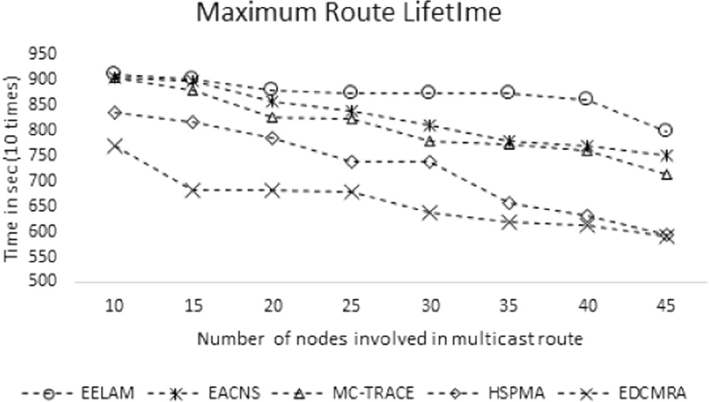

Fig. 2. Max life time of the routes with divergent number of nodes observed for EELAM and benchmarking models.

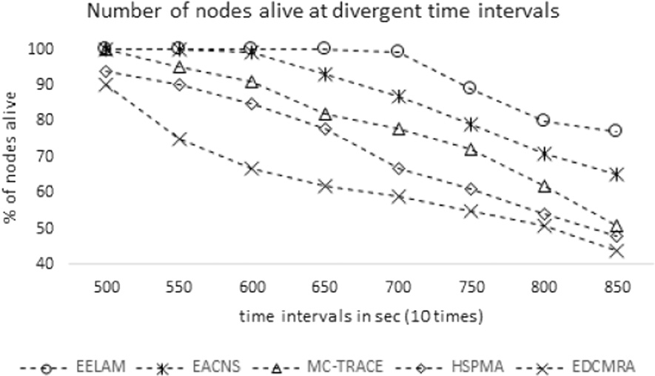

Fig. 3. Percentage of nodes alive in selected route observed for EELAM and benchmarking models at different intervals.

longer tenure, than the other models. When the group size has been managed to 40, the output from EELAM is about managing the nodes alive for a period of 8530 sec, which is significantly high that compared to the other benchmarking models (see Fig. 2). Fig. 3 reflects the kind of nodes that are alive during the simulation time (indicating in the multicast routes selected under each of the benchmarking models). The outcome from EELAM results has been depicting the better performance among the models that observed

4.2. Network lifetime at different time intervals (see Fig. 3).

For the experimental study, nodes in the range of 10 to 45 cho-sen, and the nodes have been deployed within the defined area. Around 5–20 packets/sec has been sent between the nodes, and all the nodes moved at 2 mts/sec. The group quantum and the age of network depicted in Fig. 2, while engaged, the results affirm the performance of EELAM in keeping most of nodes alive for

Table 1   
Metrics and the related values adapted for simulation.

|  |  |
| --- | --- |
| Metric | Value |
| Simulation time  Network Range  Transmission power Voltage  Traffic type  CBR packet size  Mobility  Frequency  Channel capacity  Transmission range Idle power  Node mobility  Receiving power  Pause time  Group size | 2000 s  1000 � 1000 mts  1400 mW  5 V  CBR  512 bytes  model Random waypoint 2.4 GHz  2 Mbps  150 mts  830 mW  0–20 mts/sec  1000 mW  1 sec  3, 6, 9, 12, 15 |

4.3. Energy consumption

In Fig. 4, the emphasis is on Energy Consumption ratio for var-ied time instances that presumes no energy consumption occurs initially. The results depicted n Fig. 4 evincing that EELAM is opti-mal that compared to other benchmarking models. The node level energy dissipation in EELAM is linearly proportionate to transmis-

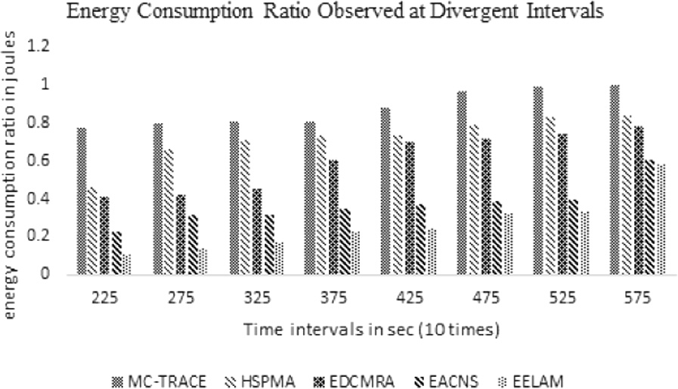

Fig. 4. Comparison of Energy Consumption Ratio observed for EELAM and benchmarking models at divergent time intervals.

N. Papanna et al. / Applied Computing and Informatics 15 (2019) 120–128 127

sion time. Hence, the EELAM evinced the less consumption that compared to the other models.

4.4. Throughput

When dense number (here in experiments 45) mobile nodes are involved in route with varied node mobility speeds in range of 0 to 30 mts/sec and transmitting 5 packets per second, it is imperative that the mobility is vice versa to throughput. In the tests, results EELAM has worked well in the range of node mobility ranges 0–30 mts/sec and other models considered evinced significant down-fall in throughput proportionate to the increase in speed (see Fig. 5). From the review of the experimental results, it is imperative that the minimal fall in throughput along with the increasing mobility of the nodes evinced for EELAM.

4.5. End-to-end delay

End-to-end delay can be termed as time consumption for a packet to travel amidst source to destination. In the test condition with mobile nodes positioned in various locations in the defined areas, and with the node mobility capability of 8–30 mts/sec, transmitting the data at 5 packets/sec. Fig. 6 depicts the delay at different time intervals observed for multicast routes traced by EELAM and other benchmark models. The EELAM has transmitted the data at significantly low that compared to the other (see Fig. 6).

Using the metrics of Reserve Battery Life, Packet Delivery Ration and End-to-End delay ratio, the EELAM performance also analyzed for multicast trees formed by divergent number of nodes. From the metric volumes that are obtained in the networks build with diver-gent count of nodes reflecting the fact that EELAM is scalable and robust. Inputs and metrics observed depicted in Figs. 7–9.

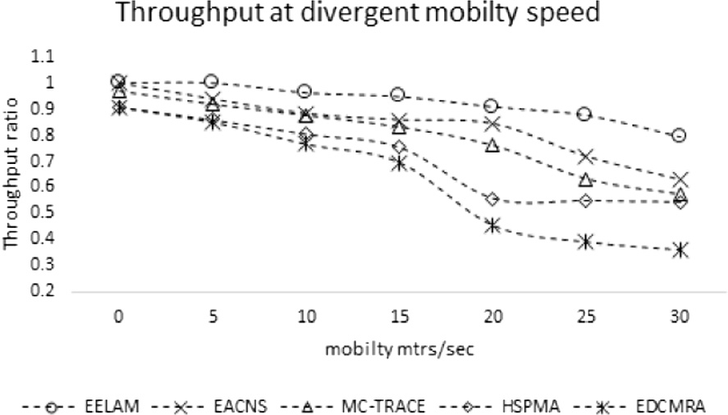

Fig. 5. Comparison of throughput observed for EELAM and benchmarking models at divergent mobility speed.

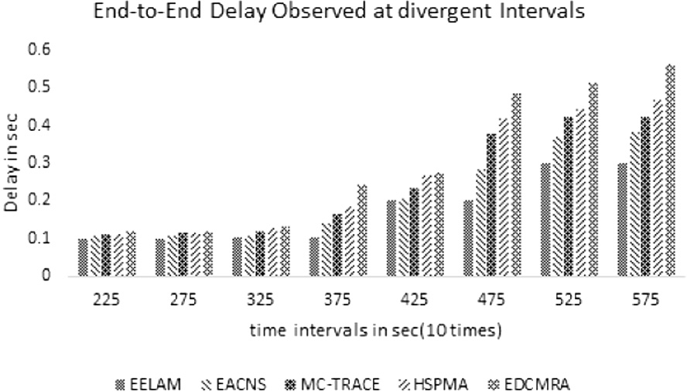

Fig. 6. Comparative analysis of end-to-end delay observed for EELAM and bench-marking models at divergent time intervals.

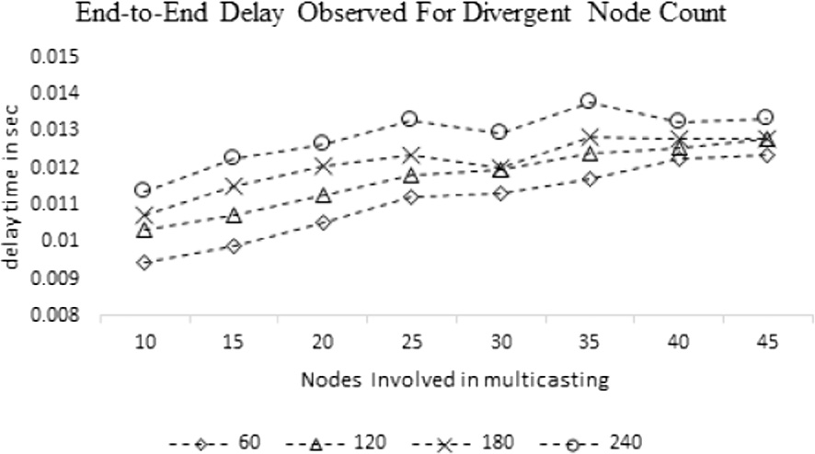

Fig. 7. Comparison of End-to-End Delay observed for routes formed by divergent count of nodes.

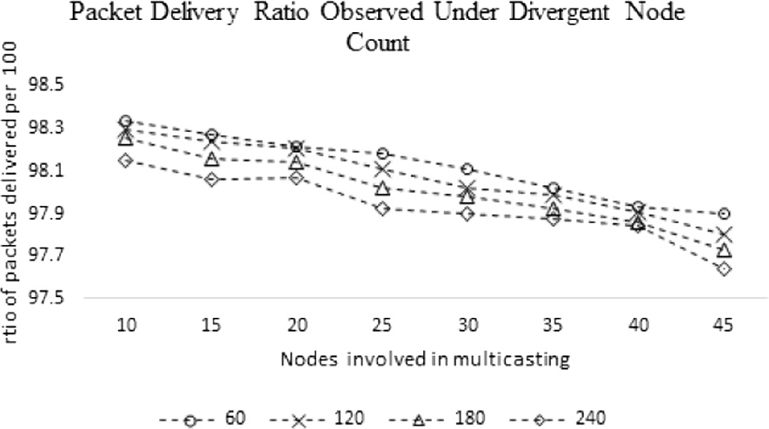

Fig. 8. Comparative analysis of Packet Delivery Ratio observed for routes formed by divergent count of nodes.

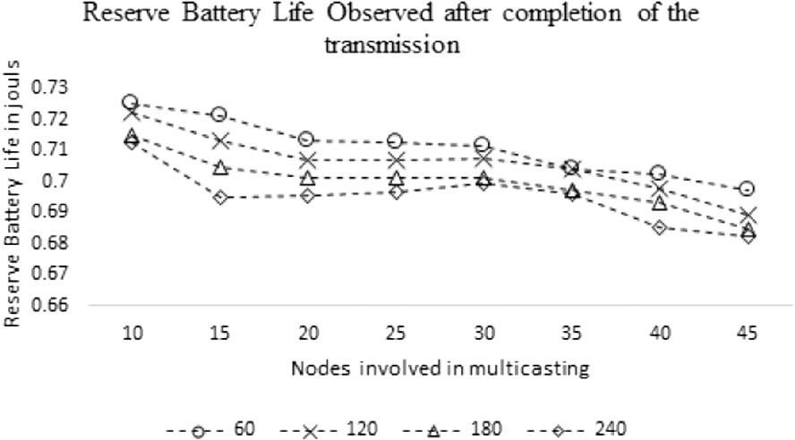

Fig. 9. Energy Reserves Ratio observed at different simulation intervals.

5. Conclusion

Energy Efficient and Lifetime aware Multicast (EELAM) route discovery for mobile ad hoc networks is the model that designed to address the issues pertaining to curtailing the consumption of energy and maximizing the route lifetime. The proposed topology EELAM is effective in terms of assessing the optimality of the mul-ticast tree by ensuring that three crucial metrics Reserve Battery Life, Energy Consumption Ratio and multicast scope evaluated. The adaptive genetic algorithm is used to identify energy efficient lifetime aware multicast tree, which is balancing the process over-head by selecting sub-trees having dynamic number of nodes with optimal fitness as crossover points and further refining input chro-mosomes by comparing the fitness with child chromosomes formed. The significance of the EELAM assessed through the simu-lations build by network simulator called NS2. In order to this, the routing performance metrics, such as packet delivery ratio, end-to-end delay, throughput versus mobility, and energy consumption

128 N. Papanna et al. / Applied Computing and Informatics 15 (2019) 120–128

ratio used. The results obtained for these metrics from the multi-cast route discovered by EELAM compared to the other bench marking models such as EACNS, EDCMRA, HSPMA, and MC-TRACE. These metrics were also compared between the multicast routes formed with divergent count of nodes those discovered by EELAM, which is in order to evince the scalability and efficacy of the proposed model. Insights learnt from this model motivating us to redefine the Adaptive Genetic Algorithm, such that the fitness function can use fuzzy reasoning to estimate the fitness of the given multicast route.

[16] Bin Wang, Sandeep K.S. Gupta, G-REMiT: an algorithm for building energy efficient multicast trees in wireless ad hoc networks, in: Second IEEE International Symposium on Network Computing and Applications, 2003, NCA 2003, IEEE, 2003.

[17] [Pariza Kamboj, A.K. Sharma, Power aware multicast reactive routing protocol](http://refhub.elsevier.com/S2210-8327(17)30230-2/h0085)  [(PAMRRP), IJCSNS 8 (8) (2008) 351](http://refhub.elsevier.com/S2210-8327(17)30230-2/h0085).

[18] [Sufen Zhao, Liansheng Tan, Jie Li, A distributed energy efficient multicas](http://refhub.elsevier.com/S2210-8327(17)30230-2/h0090)t [routing algorithm for MANETs, Int. J. Sensor Networks 2 (1-2) (2007) 62–67](http://refhub.elsevier.com/S2210-8327(17)30230-2/h0090). [19] Wen-Lin Yang, Constructing energy-efficient multicast trees with delay constraints in ad hoc networks, in: Advanced Information Networking and Applications, 2005, AINA 2005, 19th International Conference on, vol. 1, IEEE, 2005.

[20] Juan J. Gálvez, Pedro M. Ruiz, Antonio F.G. Skarmeta, Spatially disjoint multipath routing protocol without location information, in: Local Computer

|  |  |
| --- | --- |
| References | Networks, 2008, LCN 2008, 33rd IEEE Conference on, IEEE, 2008.  [21] Elizabeth M. Royer, Charles E. Perkins, Multicast operation of the ad-hoc on- |

[1] Mario Cˇagalj, Jean-Pierre Hubaux, Christian Enz, Minimum-energy broadcast

|  |  |  |  |  |  |  |  |  |  |  |  |
| --- | --- | --- | --- | --- | --- | --- | --- | --- | --- | --- | --- |
| in | all-wireless | | networks: | | NP-completeness | | and | distribution | issues, | | in: |
| Proceedings | | of | the | 8th | Annual | International | | Conference | on | Mobile | |

Computing and Networking, ACM, 2002.

[2] Intae Kang, Radha Poovendran, Maximizing static network lifetime of wireless

|  |  |  |  |  |  |  |  |  |
| --- | --- | --- | --- | --- | --- | --- | --- | --- |
| broadcast | ad | hoc | networks, | in: | IEEE | International | Conference | on |

Communications, 2003, ICC’03, vol. 3, IEEE, 2003.

[3] [Jeffrey E. Wieselthier, Gam D. Nguyen, Anthony Ephremides, Algorithms for energy-efficient multicasting in static ad hoc wireless networks, Mob](http://refhub.elsevier.com/S2210-8327(17)30230-2/h0015). [Networks Appl. 6 (3) (2001) 251–263](http://refhub.elsevier.com/S2210-8327(17)30230-2/h0015).

[4] Wei-Hsiang Cheng, Chung-Yi Wen, Kai-Ten Feng, Power-controlled hybrid multicast routing protocol for mobile ad hoc networks, in: IEEE 63rd Vehicular Technology Conference, 2006, VTC 2006-Spring, vol. 3, IEEE, 2006.

[5] Suresh Singh, Mike Woo, Cauligi S. Raghavendra, Power-aware routing in mobile ad hoc networks, in: Proceedings of the 4th Annual ACM/IEEE International Conference on Mobile Computing and Networking, ACM, 1998.

|  |  |  |  |  |  |  |  |  |
| --- | --- | --- | --- | --- | --- | --- | --- | --- |
| [6] [Weifa](http://refhub.elsevier.com/S2210-8327(17)30230-2/h0030) | [Liang,](http://refhub.elsevier.com/S2210-8327(17)30230-2/h0030) | [Xiaoxing](http://refhub.elsevier.com/S2210-8327(17)30230-2/h0030) | [Guo,](http://refhub.elsevier.com/S2210-8327(17)30230-2/h0030) | [Online](http://refhub.elsevier.com/S2210-8327(17)30230-2/h0030) | [multicasting](http://refhub.elsevier.com/S2210-8327(17)30230-2/h0030) | [for](http://refhub.elsevier.com/S2210-8327(17)30230-2/h0030) | [network](http://refhub.elsevier.com/S2210-8327(17)30230-2/h0030) | [capacity](http://refhub.elsevier.com/S2210-8327(17)30230-2/h0030) |

[maximization in energy-constrained ad hoc networks, IEEE Trans. Mob. Comput. 5 (9) (2006) 1215–1227](http://refhub.elsevier.com/S2210-8327(17)30230-2/h0030).

|  |  |  |  |  |  |  |  |  |  |
| --- | --- | --- | --- | --- | --- | --- | --- | --- | --- |
| [7] Jeffrey | E. | Wieselthier, | Gam | D. | Nguyen, | Anthony | Ephremides, | On | the |

construction of energy-efficient broadcast and multicast trees in wireless networks, in: INFOCOM 2000, Nineteenth Annual Joint Conference of the IEEE Computer and Communications Societies, Proceedings, IEEE, vol. 2, IEEE, 2000. [8] [Shengbo Yang, Chai Kiat Yeo, Bu-Sung Lee, Toward reliable data delivery for highly dynamic mobile ad hoc networks, IEEE Trans. Mob. Comput. 11 (1) (2012) 111–124](http://refhub.elsevier.com/S2210-8327(17)30230-2/h0040).

[9] Youngmin Kim, Sanghyun Ahn, Jaehwoon Lee, An efficient multicast data forwarding scheme for mobile ad hoc networks, in: ICOIN, 2005.

[10] Floriano De Rango et al., Multicast QoS core-based tree routing protocol and genetic algorithm over an HAP-satellite architecture, IEEE Trans. Veh. Technol. 58(8) (2009) 4447–4461.

[11] Ernestina Cianca et al., Integrated satellite-HAP systems, IEEE Commun. Mag. 43(12) (2005) supl-33.

[12] Hui Cheng, Shengxiang Yang, Genetic algorithms for dynamic routing problems in mobile ad hoc networks, in: Evolutionary Computation for Dynamic Optimization Problems, Springer, Berlin, Heidelberg, 2013, pp. 343–375.

[13] [Floriano De Rango, Francesca Guerriero, Peppino Fazio, Link-stability and energy aware routing protocol in distributed wireless networks, IEEE Trans. Parallel Distrib. Syst. 23 (4) (2012) 713–726](http://refhub.elsevier.com/S2210-8327(17)30230-2/h0065).

[14] N. Papanna, A. Rama Mohan Reddy, M. Seetha, Exploratory assessment based child nodes selection (EACNS): energy efficient multicast routing topology for mobile ad hoc networks, in: Proceedings of International Conference on Communication and Networks, Springer, Singapore, 2017.

[15] [B. Wang, S.K.S. Gupta, S-REMiT: an algorithm for enhancing energy-efficienc](http://refhub.elsevier.com/S2210-8327(17)30230-2/h0075)y [of multicast trees in wireless ad hoc networks, Proc. IEEE (2003) 3519–3524](http://refhub.elsevier.com/S2210-8327(17)30230-2/h0075).

demand distance vector routing protocol, in: Proceedings of the 5th Annual ACM/IEEE International Conference on Mobile Computing and Networking, ACM, 1999.

[22] N. Kamal, A study of energy efficiency of multicast routing protocols for manet, 2013.

[23] [Bulent Tavli, Wendi Heinzelman, Energy-efficient real-time multicast routin](http://refhub.elsevier.com/S2210-8327(17)30230-2/h0115)g [in mobile ad hoc networks, IEEE Trans. Comput. 60 (5) (2011) 707–722](http://refhub.elsevier.com/S2210-8327(17)30230-2/h0115).

[24] [Bülent Tavli, Wendi B. Heinzelman, MH-TRACE: multihop time reservation using adaptive control for energy efficiency, IEEE J. Sel. Areas Commun. 22 (5](http://refhub.elsevier.com/S2210-8327(17)30230-2/h0120)) [(2004) 942–953](http://refhub.elsevier.com/S2210-8327(17)30230-2/h0120).

[25] [Sung-Ju Lee, William Su, Mario Gerla, On-demand multicast routing protocol in multihop wireless mobile networks, Mob. Networks Appl. 7 (6) (2002) 441–453](http://refhub.elsevier.com/S2210-8327(17)30230-2/h0125).

[26] [Golla Varaprasad, High stable power aware multicast algorithm for mobile ad](http://refhub.elsevier.com/S2210-8327(17)30230-2/h0130)  [hoc networks, IEEE Sens. J. 13 (5) (2013) 1442–1446](http://refhub.elsevier.com/S2210-8327(17)30230-2/h0130).

[27] [Ting Lu, Jie Zhu, Genetic algorithm for energy-efficient QoS multicast routing](http://refhub.elsevier.com/S2210-8327(17)30230-2/h0135), [IEEE Commun. Lett. 17 (1) (2013) 31–34](http://refhub.elsevier.com/S2210-8327(17)30230-2/h0135).

[28] [Xiaojing Xiang, Xin Wang, Yuanyuan Yang, Supporting efficient and scalabl](http://refhub.elsevier.com/S2210-8327(17)30230-2/h0140)e [multicasting over mobile ad hoc networks, IEEE Trans. Mob. Comput. 10 (4) (2011) 544–559](http://refhub.elsevier.com/S2210-8327(17)30230-2/h0140).

[29] [Alireza shams Shafigh, Kamran Abdollahi, Marjan Kouchaki, Improvin](http://refhub.elsevier.com/S2210-8327(17)30230-2/h0145)g [performance of on demand multicast routing protocol by fuzzy logic, World Appl. Sci. J. 13 11 (2011) 2323–2337](http://refhub.elsevier.com/S2210-8327(17)30230-2/h0145).

[30] [Song Guo, Oliver Yang, Localized operations for distributed minimum energy multicast algorithm in mobile ad hoc networks, IEEE Trans. Parallel Distrib. Syst. 18 (2) (2007) 186–198](http://refhub.elsevier.com/S2210-8327(17)30230-2/h0150).

[31] [Yunnan Wu, Philip A. Chou, Sun-Yuan Kung, Minimum-energy multicast in mobile ad hoc networks using network coding, IEEE Trans. Commun. 53 (11) (2005) 1906–1918](http://refhub.elsevier.com/S2210-8327(17)30230-2/h0155).

[32] [Weifa Liang et al., Minimum-energy all-to-all multicasting in wireless ad hoc](http://refhub.elsevier.com/S2210-8327(17)30230-2/h0160)  [networks, IEEE Trans. Wireless Commun. 8.11 (2009)](http://refhub.elsevier.com/S2210-8327(17)30230-2/h0160).

[33] [N. Fareena, A. Shunmuga Priya Mala, K. Ramar, Mobility based energy efficien](http://refhub.elsevier.com/S2210-8327(17)30230-2/h0165)t [multicast protocol for MANET, Proc. Eng. 38 (2012) 2473–2483](http://refhub.elsevier.com/S2210-8327(17)30230-2/h0165).

[34] [Pariza Kamboj, Ashok K. Sharma, Energy efficient multicast routing protoco](http://refhub.elsevier.com/S2210-8327(17)30230-2/h0170)l [for MANET with minimum control overhead (EEMPMO), Energy 8.7 (2010)](http://refhub.elsevier.com/S2210-8327(17)30230-2/h0170). [35] Ajita Sethi et al., A survey of QoS multicast protocols for MANETs, J. Network Commun. Emerg. Technol. (JNCET) 6(3) (2016). [www.jncet.org](http://www.jncet.org).

[36] [Mandavilli Srinivas, Lalit M. Patnaik, Adaptive probabilities of crossover and mutation in genetic algorithms, IEEE Trans. Syst. Man Cybernet. 24 (4) (1994) 656–667](http://refhub.elsevier.com/S2210-8327(17)30230-2/h0180).

[37] [Jun Zhang, Henry Shu-Hung Chung, Wai-Lun Lo, Clustering-based adaptive crossover and mutation probabilities for genetic algorithms, IEEE Trans. Evol. Comput. 11 (3) (2007) 326–335](http://refhub.elsevier.com/S2210-8327(17)30230-2/h0185).

[38] Teerawat Issariyakul, Ekram Hossain, Introduction to Network Simulator NS2, Springer Science & Business Media, 2011.