|  |  |  |  |
| --- | --- | --- | --- |
|  |  | Available online at www.sciencedirect.com |  |
| **ScienceDirect** |
| AASRI Procedia 9 ( 2014 ) 57 – 63 |
| 2014 4 AASRI C onference o on Circuit an nd Signal P Processing ( | | | CSP 2014) |
| Eddy Current t Sensor Modelin ng For th he Nond destructiv ve  Eval luation o of Stress s Intensit ty Facto r  Sala aheddine H Harzallah* , Mohamed d Chabaat  *Built Environm mental Research L Lab., Civil Engine eering Faculty, U University of Scien nces and Technol logy Houari Boum mediene,* | | | |

*B.P 32 El Al ia Bab Ezzouar, A Algiers 16111 Alg geria.*

**Abst tract**

In th his paper, a non ndestructive eva aluation by sen nsor Eddy curre ent is used as a a tool to contro ol cracks and m microcracks in

mate erials. A simula ation by a num merical approac ch such as the e finite element t method is em mployed to det tect cracks in

mate erials and event tually to study t their propagatio on using a cruc cial parameter s such as a Stress s Intensity Facto or (SIF). This

|  |  |  |  |
| --- | --- | --- | --- |
| meth hod has emerge ed as one of th he most efficie ent techniques | | | for prospecting g cracks in ma aterials, evaluat ting SIFs and |
| analy yzing crack’s gr rowth in the co ontext of linear | | elastic fracture e mechanics (LE EFM). This tec hnique uses ex trapolation of | |
| displ lacements from m results compar red with those | | obtained by the e integral intera action. On the o other hand, cra ck’sgrowth is | |
| analy yzed as a mode el by combining g the maximum m circumferenti ial stress criteri ia with the crit tical plane for p predicting the | | | |
| direc ction of crack g growth. In this | research, a co nstant crack gr rowth incremen nt is determined d using the cla assical Paris’s | | |
| mode el, or the so-cal lled modified P aris’s model. It t is also shown | | | herein that stre ss intensity fact tors needed for r these models |
| are c calculated using g the domain for rm of the J-inte egral interaction ns.  © 2014 The Authors. Published by Elsevier B. V. This is an open access article under the CC BY-NC-ND license © 20 014Harzallah S. and Chaba aat M. .Publish hed by Elsevie er B.V.  (http://creativecommons.org/licenses/by-nc-nd/3.0/). Sele ection and/or p peer review un nder responsib bility of Amer rican Applied Science Rese earch Institute  Peer-review under responsibility of Scientific Committee of American Applied Science Research Institute  *Keyw words:* Nondest tructive evaluatio on, Eddy curren nts, complex im mpedance, Stres s Intensity Fact tor. | | | |
| * Corresponding a author. Tel.: +213 3-772-771-071; fa ax: +0-000-000-0 0000 | | | |

*E-mail address:*ha arzallahozil@yaho oo.fr.

2212-6716 © 2014 The Authors. Published by Elsevier B. V. This is an open access article under the CC BY-NC-ND license

(http://creativecommons.org/licenses/by-nc-nd/3.0/).

Peer-review under responsibility of Scientific Committee of American Applied Science Research Institute

doi: 10.1016/j.aasri.2014.09.011

58  *Salaheddine Harzallah and Mohamed Chabaat / AASRI Procedia 9 ( 2014 ) 57 – 63*

**1. Introduction**

Stress Intensity Factor (SIF) is an important parameter in Linear Elastic Fracture Mechanics (LEFM) for the structural integrity assessment of structures containing cracks and singular stress fields [1]. SIF gives a measure of the intensity of the stress field in the crack tip region. It gives also the possibility to analyze a crack growth or a catastrophic failure if a load is applied to the structure [2]. The stress intensity factors can be calculated using stress and strain analysis or parameters that measure the energy released by crack growth. SIF can be estimated analytically or using numerical techniques [3, 4].Analytical methods are more complex to calculate SIF, however, they have some advantage; an analytical solution can be applied for a range of crack lengths and on the other hand, numerical techniques require the calculation of stress or strain field for each crack length corresponding to each value of SIF.

Stress and strain fields for a given structure can be calculated using several techniques [5]. The most common and available ones can be found in several commercial packages employing the Finite Element Method (FEM) [6] or the Boundary Element Method (BEM) [7]. Nowadays, new techniques based on mesh less methods such as the Extended Finite Element Model (XFEM), are emerging and have several advantages compared to the traditional methods, particularly in problems of fracture mechanics [8].

**2. J-Integral**

To determine the energy quantity that describes the elastic-plastic behavior of materials, Rice [9]

|  |
| --- |
| introduced a contour integral or a line integral that encloses the crack front as shown in Figure 1.   �� � �*�* ���� � �����~~���~~��*� (1)*    where J, w, ds, ��, �, and n are the effective energy release rate, the elastic strain energy density (or plastic clockwise contour, and the outward unit normal to �, respectively.  In using J-integral method, a program is developed to calculate the stress intensity factors,   �� � �~~����� � ��~~ *(2)* |

|  |  |
| --- | --- |
| *Salaheddine Harzallah and Mohamed Chabaat / AASRI Procedia 9 ( 2014 ) 57 – 63*  thePoisson’s ratio and i = 1, 2. Here, ��correspond to the stress intensity factor,���is the J-Integral value, E is the Young modulus, �is | 59 |

**3. Displacement extrapolation**

The displacement extrapolation method was developed to obtain crack tip singular stresses and stress intensity factors using only nodal displacements of elements around the crack tip [10]. The near crack tip displacement field may be expressed as a series function of the stress intensity factor, the position to the crack

|  |
| --- |
| tip as well as the orientation to the crack propagation direction.  This technique is used when the model includes singular elements and where extrapolation can be done ��� � �� ����������������� ���������������  ��������������  �������������� �����  ����� � �  ��������������  ���������������~~����~~ ����� � *(4)*  � *(3)*  can determine the SIF by detecting the crack opening displacements������� ������ ����� �����. These latest are nodes�� �,��� �[2] **4. Basic equations** |

Fundamental laws of electromagnetism govern the distribution of the magnetic fields and the currents induced in a conducting material. These laws are given by Maxwell's equations [12] as follows;

|  |  |  |  |  |  |  |  |  |  |  |  |
| --- | --- | --- | --- | --- | --- | --- | --- | --- | --- | --- | --- |
| rot( | | � E ) | | � | | | � �  � | | � B |  | *(5)* |
| t |  |  |
| � rot(H ) | | | � | � J | � �  � | | | � D | | *(6)* |
| t | | �is the vector density of current. E | *(7)* |
| � div(B ) | | | | � | | 0 | | | |
| �whereH | � ,B | �are vectors magnetic field and induction, respectively. J | | | | | | | | �andD |

correspond to the vectors of electric flux field and density, respectively. In the above equations,

|  |  |  |  |  |  |
| --- | --- | --- | --- | --- | --- |
| � B | �� *H*� | | | � H� | *(8)* |
| � D | | � | � � . E | | *(9)* |
| � J | �� | | � E | | *(10)* |
| where� H� � is the absolute permeability of the material for the field H, � is the permittivity of the material | | | | | |

60  *Salaheddine Harzallah and Mohamed Chabaat / AASRI Procedia 9 ( 2014 ) 57 – 63*

and �is the conductivity of the material .In addition, the magnetic potential vector is given by:

|  |  |  |  |
| --- | --- | --- | --- |
| � B | � | � rot( A) | *(11)* |

Substituting equation (11) into equation (5) and considering the scalar potential, yields:

|  |  |  |  |  |
| --- | --- | --- | --- | --- |
| � E | � | � � | � A |  |
|  |  | � | t | *(12)* |

and combining equation (10) with equation (12) leads to the following equation:

|  |  |  |  |  |  |  |  |
| --- | --- | --- | --- | --- | --- | --- | --- |
| � J | � | � | � | � | � A | |  |
|  |  |  |  | � | | t | *(13)* |

One can notice from equations (12) and (13) that the magnetic potential and the density of the induced currents are in the same direction. Induced currents have only one component, which can be obtained by substituting equations (8) into equation (11) and equation (13) into equation (6);

|  |  |  |  |  |  |  |  |  |  |  |
| --- | --- | --- | --- | --- | --- | --- | --- | --- | --- | --- |
| rot�rot A� � | � | � | � | � | � | � A | | � | � J |  |
|  |  |  |  |  | � | | t |  | *s* | *(14)* |

Where Js represents the density of the current sources. Equation (14) refers to the magneto-dynamic equation. All the above expressions are written in a form such that they can be used in the finite element formulation using electromagnetic equations. This weak form is considered as being a boundary integral, which makes it possible to define natural boundary conditions. Then, discretization of the latest uses polynomial of order two, which can lead to the following system;

� �. A� � j�� T� �. A� � T� � J� � *(15)*

where[A] is the vector column sum of values of*A*� , [J] is the matrix vectors of source. [S]and[T]are square matrixes starting from the geometry of the device.

**5. Simulation of one (sensor - plate non-magnetic) without crack**

Consider the test of a non-magnetic tube without a crack, characterized by a permeability equal to unity, a high conductivity 36.7ms, excited by a sinusoidal current of density J = 2.67 106 A/m, and a frequency of 1 kHz. The results of simulation are shown in figures 2, 3, and 4. The control by Eddy currents requires the use of very high frequencies.

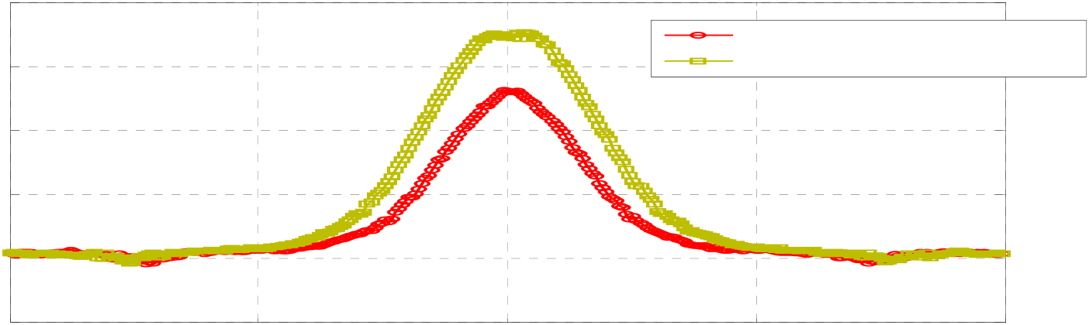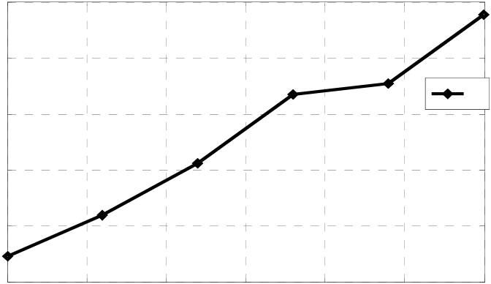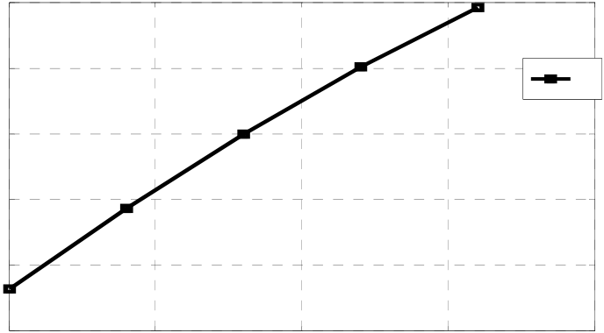

*Salaheddine Harzallah and Mohamed Chabaat / AASRI Procedia 9 ( 2014 ) 57 – 63*  61

8

cracks w=5mm

6 cracks propagation

4

2

0

|  |  |  |  |  |
| --- | --- | --- | --- | --- |
| -2  -2 | -1 | 0 | 1 | 2 |

Fig. 2:Shapeof Z for f =10 kH

35

20

15

10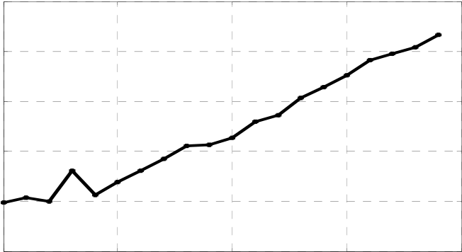

30

25

0 1 2 3 4

x 10-3

4500

2500 2000 1500 1000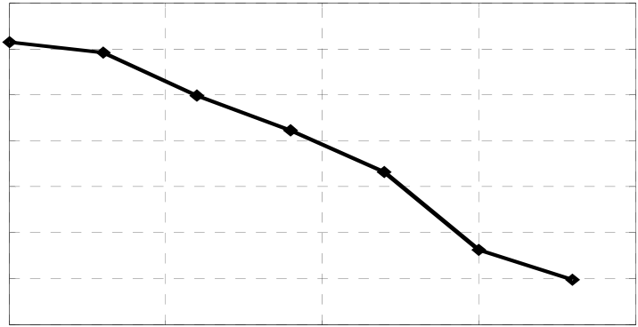

4000   
3500   
3000

0 1 2 3 4 x 10-3

Fig. 3: Simulation of a non-magnetic sensor-plate containing external cracks under mode I Pace of impedance Z vs. crack’s propagation in mode I, b) SIF in mode I vs. crack’slength.

|  |  |  |  |  |  |  |  |  |  |  |  |
| --- | --- | --- | --- | --- | --- | --- | --- | --- | --- | --- | --- |
| 8.5 | 0.5 | 1 | 1.5 | 2 | 2.5 | a | 2500 | 0.5 | 1 | 1.5 | b |
| 8 |
| 2000 |
| 7.5 |
| 1500 |
| 7 | 3 | 2 |
| 1000 |
| 6.5 | 500 |
| 6  0 | 0  0 |
| x 10-3 | x 10-3 |

Fig. 4: Simulation of non-magnetic sensor-plate containing external cracks under mode II; a) Pace of impedance Z vs. crack’s propagation in mode II, b) SIF in mode II vs. crack’s length.

**6. Results interpretation**

Figure3 shows the variation of the impedance Z and KI with respect to the propagation of crack’s depth. It is obvious that the difference in impedance �Z is dependent on the crack’s depth. The latter is proportional to the increase of �Z. Moreover, SIF KI is evaluated when the depth decreases with �Z leading to a decrease of KI. Then, the depth of defection influences the impedance. Figure 4 shows the variation of the impedance Z

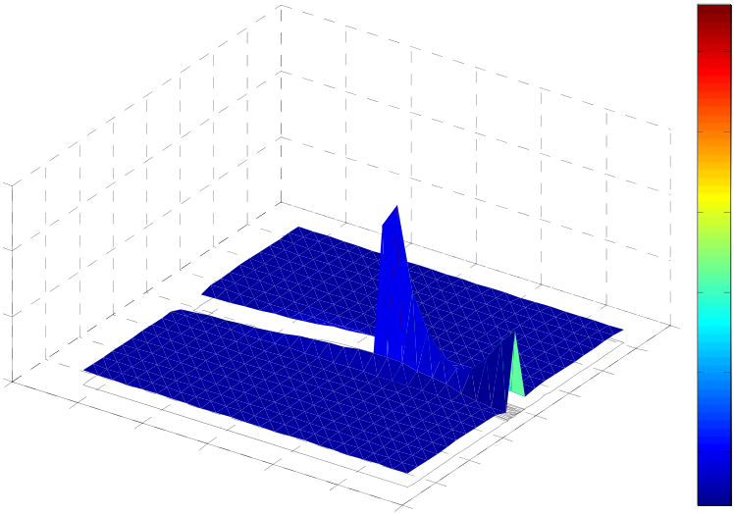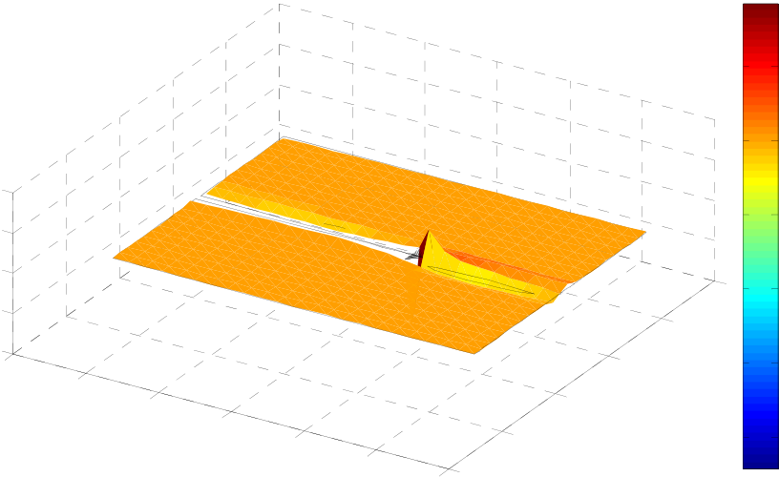

62  *Salaheddine Harzallah and Mohamed Chabaat / AASRI Procedia 9 ( 2014 ) 57 – 63*

and KII with respect to the crack’s width. We observe that the difference in impedance �Z is dependent on the

crack’s width; when the latter increases �Z decreases, and vice versa.

Color: von Mises Height: von Mises

12000

10000

15000

8000

10000

6000

5000

0.09

|  |  |  |  |  |  |  |  |  |  |  |  |  |  |  |  |
| --- | --- | --- | --- | --- | --- | --- | --- | --- | --- | --- | --- | --- | --- | --- | --- |
| 0 | 0.045 | 0.044 | 0.043 | 0.042 | 0.041 | 0.04 | 0.01 | 0.02 | 0.03 | 0.04 | 0.05 | 0.06 | 0.07 | 0.08 | 4000 |
| 0.046 | 2000 |

Color: exy Height: exy

0.02

0

0.1

|  |  |
| --- | --- |
| 0.05 | -0.02 |

0

0.1 -0.04

-0.05

0.08

|  |  |  |
| --- | --- | --- |
| -0.1 | 0.06 | -0.06 |
| 0.046 |

0.045

|  |  |  |  |  |  |  |  |  |
| --- | --- | --- | --- | --- | --- | --- | --- | --- |
| 0.044 | 0.043 | 0.042 | 0.041 | 0.04 | 0 | 0.02 | 0.04 | -0.08 |

Fig. 5: a) Stress Fields. b) Displacement fields.

**7. Conclusion**

In this paper, we studied the usefulness of Eddy current sensors as a tool to control cracks and micro cracks

in materials. The simulations performed in this study led to the following conclusions:

- Determination of the impedance in only one point is not enough to confirm the presence or the

absence of a defect for two types of materials (non-magnetic or magnetic). This behavior leads us to

the evaluation of the impedance along the tube.

- Detection of an external defect requires the energy of the sensor using high frequencies.

- The position of defect (internal, middle or external) has a large effect on the impedance. Obtained

results show the great sensitivity of the differential sensor with respect to the detection of the surface

defects. However, the major disadvantage of this type of sensor lies in the fact that it is unable to

detect a defect located between two reels.

- Determination of SIF is an important parameter in detecting singularities in a given model.

*Salaheddine Harzallah and Mohamed Chabaat / AASRI Procedia 9 ( 2014 ) 57 – 63*  63

**References**

[1] A.Zaoui, H.Menana, M.Feliachi,G.Berthiau; Inverse Problem in Nondestructive Testing Using Arrayed Eddy Current Sensors, Sensors 2010, 10, 8696-8704   
[2] S. Harzallah, M. Chabaat; Nondestructive Technique for the Determination of Cracks Parameters by Eddy Current in Differential Mode, Journal of Applied Mechanics and Materials, Vol. 532, pp. 81-87, (2014). [3] Y. Liu, S.Mahadevan;Threshold stress intensity factor and crack growthratepredictionunder mixed mode loading, Engineering FractureMechanics, Vol. 74, 2007, pp. 332-345.

[4] M. H.Aliabadi;Boundary element method;Application in solidsandstructures, Vol. 2, p. 580 Chester, Ed. John Wiley&sons, 2002.

[5] K.Dréau, N. Chevaugeon,N.Moë;Studied X-FEM enrichmentto handle materialinterfaceswithhigher order finite element, Computer Methods in AppliedMechanicsand Engineering, Vol. 199, 2010.

[6] O. C. Zienkiewiczand R. L. Taylor; The finite element method;McGrawHillBookCompany, London, 4thedition, 1994.

[7] F. París, J. Cañas; Boundary element method; Fundamentalsandapplications, Oxford University Press, 1997.

[8] S. Bordas, B. Moran; Enrichedfinite elements andlevel sets fordamagetolerance assessment of complex structures. Engineering FractureMechanics, 73:9, pp. 1176-1201, 2006.

[9]J. R. Rice; J. Appl. Mech. 35 (1968) 379-386   
[10] P. C. Paris and G. C. Sih; Stress analysis of cracks. In FractureToughnessTestingandits Applications, ASTM STP 381, pp. 30-83, Philadelphia, 1965. ASTM (American Society forTestingandMaterials).

[11] M. Chabaat, H. Seddiki; Stress Analysis during Crack-Crazing Patterns Interactions: A Mathematical Approach, International Journal of Key Engineering Materials, Vol. 345-346, pp. 1617-1620, 2007.

[12] A. Skarlatos, G. Pichenot, D. Lesselier, M. Lambert and B. Duchêne; Electromagneticmodeling of a damagedferromagneticmetaltube via a volume integralformulation. IEEE Trans. Mag, Vol. 44, pp. 623-632, 2008.