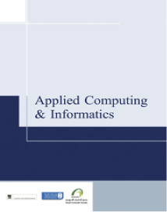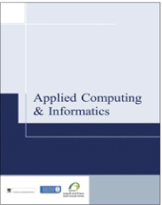

Applied Computing and Informatics (2016) 12, vi

|  |  |  |  |
| --- | --- | --- | --- |
|  | |  | | --- | | Saudi Computer Society, King Saud University |   Applied Computing and Informatics   |  | | --- | | (http://computer.org.sa)  www.ksu.edu.sa  www.sciencedirect.com | |

Foreword

|  |  |
| --- | --- |
|  | Dear Colleagues,  Applied Computing and Informatics (ACI) was established as Saudi Computer Society’s official journal over 13 years ago. Throughout its journey, the journal has seen ups and downs. Nevertheless, it’s still standing as the only official journal of the Saudi Computer Society (SCS). Being so means a great responsi-bility to strive for quality, integrity, publishing ethics and universality.  Since I accepted the responsibility as EiC of the ACI journal two years ago, we have received 292 Manuscripts from 39 Countries. With Elsevier as our publisher, and King Saud University as our main support, the Journal is picking up more |

momentum and gaining reputation. Reviewers remain an integral part of processing and publishing articles for ACI. We received the support of 632 reviewers from 66 countries to provide us valued comments and suggestions and hence keeping the quality of the manuscripts.

Our future challenges include:

|  |  |
| --- | --- |
| • • • | Finding sponsoring organizations to support this and other journals to come from the Saudi Computer Society.  Sustaining quality to achieve further desired outcomes such as international and academic indexing.  Encouraging international researchers, editors, advisors, and authors to utilize ACI as a plat- |

form to propagate innovation and creativity. Incentives such as a best paper award can help achieve this.

With the newly elected Saudi Computer Society (SCS) council members, I have great hopes that the only direction for our journal is up.

With best regards   
Prof. Hatim A. Aboalsamh   
Editor-in-chief

http://dx.doi.org/10.1016/S2210-8327(15)00033-2