|  |  |  |
| --- | --- | --- |
|  | Available online at www.sciencedirect.com |  |
|  |
| AASRI Procedia 3 ( 2012 ) 381 – 386 |

2012 AASRI Conference on Modelling, Identification and Control

Green building materials evaluation and empirical research based on the regional endowment

Lei Lia* , Ping Wanga, Hua Wanga, Meng Zhanga

*a: School of Management and Economics, Tianjin University, Tianjin, China*

**Abstract**

This article points out the importance of the using of green building materials in China. The selection of green building materials has deep relationship of the regional endowments differences. It requires a combination consider of regional to build the index system. This paper introduces the data envelope method to solve the evaluation of green building materials. The proposed evaluation process also been given.

© 2012 Lei Li. Published by Elsevier B.V. Open access under [CC BY-NC-ND license.](http://creativecommons.org/licenses/by-nc-nd/3.0/)

Selection and/or peer review under responsibility of American Applied Science Research Institute

*Keywords:*the regional endowments; green building materials; evaluation; DEA

**1.Introduction**

UArea Non-equilibrium Development Sial development has made brilliant achievements after 30 years of reform and opening up. However, the consequent widening gaps between the levels of regional economic drawback the wealth polarization of serious inefficient allocation of resources. They also make many other social problems [1]. Especially in the field of construction, the large number using of high energy consumption and high pollution building materials caused tremendous damage to the social environment.

* Corresponding author. Tel.: +86-138-2126-0061; fax: +86-022-27401810. *E-mail address:* lilei@tju.edu.cn.

2212-6716 © 2012 The Authors. Published by Elsevier B.V. Open access under [CC BY-NC-ND license.](http://creativecommons.org/licenses/by-nc-nd/3.0/) Selection and/or peer review under responsibility of American Applied Science Research Institute doi: 10.1016/j.aasri.2012.11.060

382  *Lei Li et al. / AASRI Procedia 3 ( 2012 ) 381 – 386*

With the rapid development of the construction industry, the building materials used in the construction enterprise are more and more. The quantity to the type and functional direction keeps increasing as well as the requirements of building materials. In the study of the problems in China, most scholars reached a conclusion: "Consensus of the various regions in China due to be adjusted according to its own characteristics of building

nal differences in physical geography and economic geography [2]. The differences determine the regional economic condition and factor endowments in the broad sense. Thus, they determine the various regions in the country and the division status in the world economy. These differences include: the latitude and longitude, waterfront location, climatic zone, the temperature, rainfall, topography, mineral, property, the environment, industry characteristics, construction characteristics, population, ethnicity, socio-system and economic fiscal position. The second aspect is the level of economic development. It means the regional economic development of the economies of scale with the current dynamic [3]. The first factor of endowments difference is the determinants of regional economic differences. The second aspect of the differences is in factor endowments differences [4-5]. The main raw material of green building materials belongs to the natural resources. Thus it is an important part of the regional factor endowments. Study on green building materials and regional natural endowments characteristics is of great significance for further development. It is also important to improvement of regional architectural development theory.

**2.Green building materials theory**

The application of building materials theory includes green building materials, bio-materials and eco-friendly materials theory. It builds strategy in the China region economic development and provides a theoretical basis. However, there are many problems to be solved, such as: one-sided emphasis on inter-regional differences inevitability and absolute; ignoring the positive role of balanced development; lack of the development of non-equilibrium representative theoretical contradictions; the three forces in promoting the development of housing construction: inherent laws of economic development, market mechanisms and government intervention; the optimal limit [6]. Neoclassical regional opposition balanced economic development theory based on a series of assumptions: regional economic development and the role of the market mechanism. The theory is satisfied through the accumulation of capital in the region and inter-regional flow of production factors will eventually tend toward equilibrium. However, the regional differences theory in natural endowments contradicts the reality hindrance of the flow of production factors. The market mechanism alone is difficult to achieve a balanced development of the regional economy. However, the objective laws of economic development and practical experience shows that China is still in non-equilibrium for a long period. The use of the non-equilibrium development theory guides the development of the regional economy. Especially, the use of the process of building materials must be combined with the regional economic characteristics. Eastern coastal areas should continue to play a leading role. The Central special preferential policies are also basically unchanged. In short, the using of building materials and regional resource endowments has a close relationship. There are significant differences in regional resource endowments. Overall equilibrium development objectives of the national economy or the regional economy are bound to achieve through local non-equilibrium development. Successful examples of economic development, such as the United States, Australia and other countries also confirm this conclusion [7]. The equilibrium development theory and non-equilibrium development theory are involved the coordinated development of the concept. The ultimate goal of them is to achieve a balance of overall economic and social. The use of building construction costs and the needs of relevant are also delivered to the building construction materials. It is necessary to give full consideration to these aspects. These considerations also provide a reference to the evaluation method of green building materials.

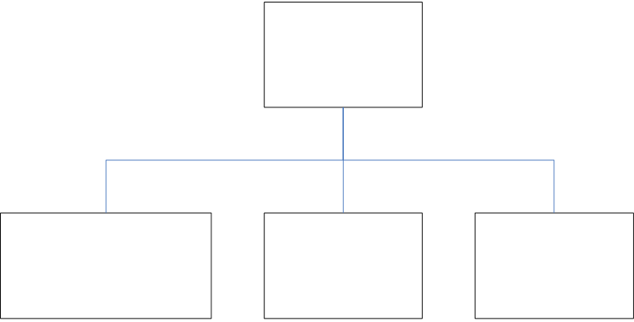

*Lei Li et al. / AASRI Procedia 3 ( 2012 ) 381 – 386*  383

**3.The evaluation methodology of green building materials**

*3.1.Index system*

The process of selection of building materials must correctly handle the relationship between costs and profits. It gives full play to the complementary role of the market mechanism and government intervention in the allocation of resources. It also reduces or even eliminates the waste of resources. The selection should achieve the sustainable development of the regional architecture. New building materials, green building materials, environmentally friendly materials all are important material to achieve green building goals [8]. The effective use of the regional is a necessary condition for the coordinated development of regional construction. Building materials is the important products of the building enterprises. They have great significance to the continued development. The ecological economists long-term focus attention of the problems, which include inadequate use of new materials and space are unevenly distributed, the degradation of architectural function, excessive use of non-environmentally friendly materials [9].

We chose the four elements as input indicators. They are the raw materials, the cost of the parts, protection measures and construction technology.

Input   
Indicators

|  |  |  |  |
| --- | --- | --- | --- |
| Raw | The parts | Protection | Construction |
| materials | cost | measures | technology |

Fig. 1. Green building materials input indicators.

Output indicators include the energy-saving effects, material profits and social benefits.

Output   
Indicators

|  |  |  |
| --- | --- | --- |
| The energy | Material | Social |
| Saving effects | Profits | Benefits |

Fig. 2. Green building materials output indicators.

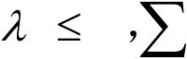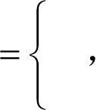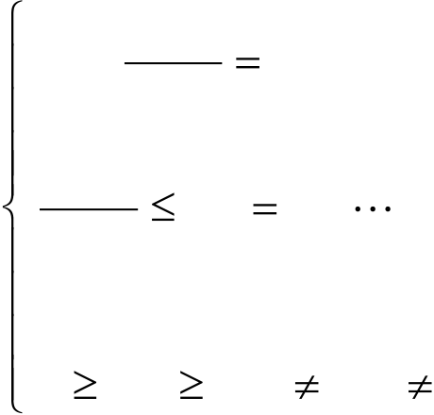

384  *Lei Li et al. / AASRI Procedia 3 ( 2012 ) 381 – 386*

We chose date envelopment analysis (DEA) method. This method establishes comprehensive evaluation index system. It is based on consideration of the efficiency of the input and output of the project.

*3.2.Date envelopment analysis(DEA) method*

The DEA method takes an economic system or a production process as an activity. It puts a certain number of factors of production and the output of the "product" as entities (units). Each entity (unit) is known as a decision-making unit (DMU). Many DMUs constitute to be respective evaluation groups. The DMU's input or output indicators and ratio for the variable should been evaluated operation. It determine the effective production frontier, and according to the distance of each DMU efficient production frontier situation [10]. It also determines whether each DMU effective projection method can also be used at the same time and pointed out the direction. In this method, the extension of non-DEA effective or weak DEA effective DMU and should be improved. [11]   
 Assume there are *n* decision making units, each decision making unit has *m* kinds of input and *s* kinds of

|  |  |  |  |  |  |  |  |  |  |  |  |  |  |  |  |  |
| --- | --- | --- | --- | --- | --- | --- | --- | --- | --- | --- | --- | --- | --- | --- | --- | --- |
| outcome. | | *j* | | ,1 | | | |  | , | *n* | is the input and output vector of the *j* th decision making unit. | | | | | *ijx* is the *i* th kind |
| input of the *j* th decision making unit. Define *v*  ( *v v* 1 2 ,  and *u*  ( *u u* 1 2 ,, *usT* as the weight vector of output. | | | | | | | | | | | | | , | *vmT* | as the weight vector of input | |
| The basic | | | | *C*2*R* | | | | model is: | | | | | | | | |
| max | | | *u* | *T* | *y* | 0 | | *h* 0 | | | | | | | | |
| *v x T* | | | 0 | |
| *u* | *T* | *y* | *j* | ,1 | | | *j* | ,2,1 | | | , , | *(1)* | | | | |
| *v* | *T* | *x* |
| *j* |
| *u* | | ,0 | | *v* | | ,0 | | *u* | ,0 | | *v* | .0 | | | | |

The DEA model is produced from unchanged output and reduced input [12]. The green building materials production possibility set for:

|  |  |  |  |  |  |  |  |  |  |  |  |  |  |  |  |  |  |  |  |  |  |
| --- | --- | --- | --- | --- | --- | --- | --- | --- | --- | --- | --- | --- | --- | --- | --- | --- | --- | --- | --- | --- | --- |
|  |  |  |  |  | *n* |  |  |  |  | *n* |  |  |  |  |  |  |  |  |  |  |  |
| *T* | ( | *X* | *Y* | ) | *j* | 1 | *X* | *jj* | *X*   *j* |  | 1 | *X* | *j* | *j* | *Y* | *j* | 0 | *J* | ,2,1 | *n* | *(2)* |

*3.3.The process of green building materials evaluation*

Comprehensive evaluation of green building materials is applied by the analysis of DEA method. The model used in the evaluation of green building materials called the efficiency of input evaluation model. It is primarily used to determine the DMU whether to achieve the scale efficient and effective technology at the same time. It will get final results in accordance with the process shown in Figure 3.

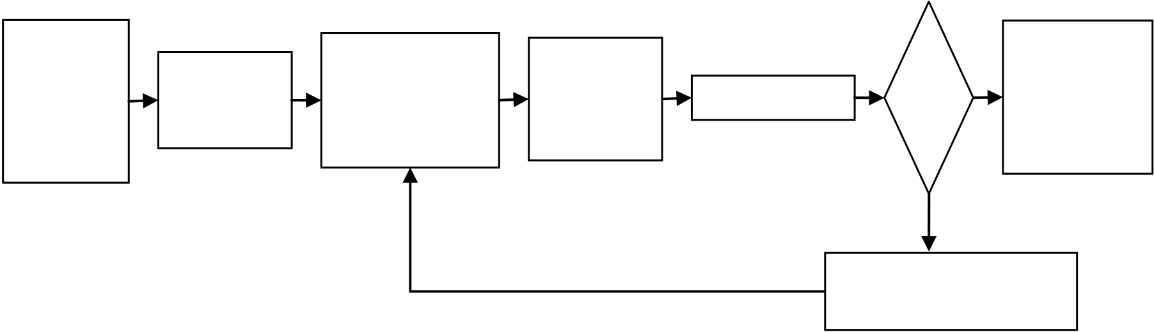

|  |  |  |  |  |  |  |  |
| --- | --- | --- | --- | --- | --- | --- | --- |
| The | DMU | *Lei Li et al. / AASRI Procedia 3 ( 2012 ) 381 – 386* | | | Ok | Green | 385 |
| evaluation | Input & Output | Model | Calculation | building |
| target of | Index system | materials |
| Selection |
| green | Selection | evaluation |
| building | output |

materials

No

Adjust the indicators

Fig. 3. The create process charts of green building materials evaluation index system.

**4.Conclusion**

Our world resources are increasingly depleted. We are changing from relying solely on resources to achieving sustainable development. Promotion of green building materials is important to our society. It can achieve energy-saving, water-saving, materials and environmental protection. We can understand the efficiency of green building materials in the use of green building materials evaluation. This result also has a significant role in the subsequent improvements.

**Acknowledgements**

This work was partially supported by the National Natural Science Foundation of China (Grant No. 71203153, 70871085); Research Fund for the Doctoral Program of Higher Education of China (Grant No. 20100032120031). The authors are grateful for this support.

**References**

[1] Yang Zhushen, Evolution of Regional Theory of Non-equilibrium Coordinated Development in China. Business Research [J], 2010 (06): 99-103.

[2] Wu Xiulun, On the evolution of China's regional economic development strategy and layout transmutation. Modern business trade industry [J], 2010 (07): 95.

[3] Agrawal, A., SUSTAINABLE GOVERNANCE OF COMMON-POOL RESOURCES: Context, Methods, and Politics. Annual Review of Anthropology[J], 2003. 32(1): 243-262.

[4] Cha Hongwang, A Third Theory of Regional Economic Development: Non-equilibrium and Harmonious Development. Academic monthly [J], 2008 (10): 71-77.

[5] Zhang Juhua, Research on Sustainable Regional Economic Development in Non-equilibrium Situation [D], Tianjin University, 2003: 89-92.

[6] Zhong youlin, Li Jiyou, Evolution of the balanced development theory of the regional economy and innovation. Qiusuo [J], 2009 (01): 40-41, 186.

[7] Fisher, J.B., L. Fortmann, Governing the data commons: Policy, practice, and the advancement of science. Information & Management[J], 2010. 47(4): 237-245.

386  *Lei Li et al. / AASRI Procedia 3 ( 2012 ) 381 – 386*

[8] Wang Jun, Practice of green building in China. China building industry publishing house, 2007. [9] Pu Yide, Green building technology guide. China building industry publishing house, 2008.

[10] A. Charnes, W. W. Cooper, E. Rhodes, Measuring the efficiency of decision making units. European Journal of Operations Research [J], 1978 (2): 429-444.

[11]Lei Li, Xingyu Zhu, Yongchao Kou, Zhengxu Ren,Research on the application of remarkable achievements based on DEA quantification analysis to manufacturing industry. Industrial Engineering Journal [J], 2009(2):110-113.

[12] Z. Sinuany-Stern, A. Mehrez, A. Barboy, Academic departments efficiency in DEA, Computers and Operations Research, 1994 (5): 543-556.