|  |  |  |
| --- | --- | --- |
|  | Available online at www.sciencedirect.com |  |
| **ScienceDirect** |
| AASRI Procedia 5 ( 2013 ) 287 – 291 |

2013 AASRI Conference on Parallel and Distributed Computing and Systems

Micro-blog Information Regulatory Mechanism Based on Ontology Modeling

Baoxiang Xu1a, Xinyuan Wang*2b, Shu Zhang3c

*aBaoxiang Xu,School of Management, Jilin University, Changchun Jilin and130022, China bXinyuan Wang,School of Management, Jilin University, Changchun Jilin and130022, China* c*School of Economic and Management, Northeast Dianli University, Jilin Jilinand132012 ,China axubaoxiang@sohu.com, bwangxinyuan201301@163.com,cczstian0816@163.com*

**Abstract**

With the rapid development, micro-blog has become a social phenomenon, and the micro-blog supervision is imperative. The existing micro-blog information regulation relies on the user's self-regulation and legislation, and it’s rarely related at the technical level. From the view of the micro-blog information modeling, this article fulfills the effective supervision with the use of ontology technology and combined with the folksonomy, through monitoring the organization's norms and micro-blog information dissemination process, and proposes specific ideas and methods at the technical level, which is feasibility and forward-looking.

© 2013 The Authors. Published by Elsevier B.V.© 2013 Published by Elsevier B.V. Open access under [CC BY-NC-ND license.](http://creativecommons.org/licenses/by-nc-nd/3.0/)

Selection and/or peer review under responsibility of American Applied Science Research Institute Selection and/or peer review under responsibility of American Applied Science Research Institute

*Keywords:* Folksonomy; Ontology; Micro-ontology; Micro-blog;

**1. Main text**

Since its inception, micro-blog becomes the new hotting darling of the network application and user's favor with its real-time and convenience of use. Gathering a large number of users on the micro-blog and relative freedom of speech information, mirco-blog proves to be a powerful tool to grasp the pulse of the community. In 2011, the number of users of the micro-blog more than 195 million, a growth rate of 208.9 percent, was the explosive growth [1].Moreover, micro-blog application range is more extensive, such as micro-blog tracing of

|  |  |  |  |
| --- | --- | --- | --- |
| Fukushima earthquake |  | hot events | micro interviews, reflects the dense humanity atmosphere and strong |

social influence. The media storm as micro-blog fission propagation effects, can easily lead to enormous

2212-6716 © 2013 The Authors. Published by Elsevier B.V. Open access under [CC BY-NC-ND license.](http://creativecommons.org/licenses/by-nc-nd/3.0/) Selection and/or peer review under responsibility of American Applied Science Research Institute doi: 10.1016/j.aasri.2013.10.091

288  *Baoxiang Xu et al. / AASRI Procedia 5 ( 2013 ) 287 – 291*

influence, the slightest mistake will lead to a strong negative effect, ethical issues it raises also gradually apparent and increasingly grim, the prominent problem is that micro- blog might trigger the moral space disorder and moral behavior anomie [2]. At the same time, the academic community has gradually begun to attach importance to research the effective supervision of the micro-blog and yielded some results, such as the development of the micro-blog service and self-discipline convention; guiding micro-blog operators to adopt measures to ensure micro-blog content management; proposing micro-blog users to improve their moral consciousness, strengthening self-discipline, and actively supervising the activities of the micro-blog to find objectionable information, to improve their own moral accomplishment, etc. [3].

**2. Structure**

In these studies, however, just up from a macro point of view to regulate the use of micro-blog, pinning its hopes on the society's power to regulate the behavior of the users of the micro-blog, small amount of the micro-blog information organization and dissemination of regulatory studies only put forward the general idea, and did not give a feasible solution. This study attempts to regulate the organization and dissemination of micro-blog information using information modeling theory, to build the micro-blog information organization model and propagation model is technically the appropriate solution to achieve regulatory micro-blog.

 First point:Micro-blog information supervision mechanism of self-organization and ontology modeling Seen from the practice of these years, regardless of the difference of the core content of these micro-blog sites, as long as they allow users to self-production of content, information on regulatory issues can not be avoided. This paper studies micro-blog regulatory focused on the technical level, the main tags focuses on the micro-blog information organization and micro-blog information dissemination two tags, trying to spread the micro-blog norms and information modeling idea combing to achieve the purpose of the micro-blog regulation.

Unlike traditional blog, micro-blog is a mini blog; users can rely on a variety of Internet tools to release news instantly, the update time in seconds. Because each time a user can only send 140 characters, so in the early days the information usually appear "fragmentized", in the "self speaking" state. However, with the increase of users, information transmission frequency is also a substantial increase in its spread or "presents" will be grouped in the form of a "hot topic". Information from the initial stage of "fragmentized", to the stage of development of the information classification, polymerization, transmission, can use for reference in the field of natural science self-organization theory to analysis. "Self-organization" is a kind of system from disorder to order, from the lower order to advanced orderly evolution and development of the phenomenon. In fact, micro-blog as an information production system, can be regarded as an "information self-organizing" process [4].

As a kind of effective performance concept structure semantic model, ontology through the acquisition of the related field knowledge, standardize the formal definition, form definition, provide for the common understanding of domain knowledge and provide a clear definition for modeling.

This paper rises to strengthen the supervision of the micro-blog information based on self-organization and ontology modeling theory. In the concrete realization, the self-organization and ontology modeling theory to the micro-blog information organization standardization process, forming a structured information organization structure into the micro-blog information transmission stage, again through the ontology modeling theory to transmission of information to the modeling, the propagation process of constraints and control, so as to achieve in the technical level strengthen micro-blog information supervision purpose.

 Second point:Ontology specification micro-blog information organizations

*Baoxiang Xu et al. / AASRI Procedia 5 ( 2013 ) 287 – 291*  289

Combining self-organization theory, there is no specific intervention in information self-organizing external conditions, the system is out of external imposed any instruction. The micro-blog now in the technology uses on Folksonomy to micro-blog information organization, Folksonomy helps users to store and manage their information resources through the Tag technology, and provides the sharing and communication platform. They providing users with based on the Tag technology information management mode has also become a kind of new type of network information organization tool: users choose words resource dimension according to their own needs , each adding a word called for resources to add a "Tag" ; Each Tag is equivalent to the user a classification of resources, resources according to the different Tags are organized to different classifications. All users, resources are in a shared platform, the same Tag can also polymerize the same classification of resources from different users. Such information organization pattern has two obvious characteristics: one is in the process of adding Tag to resources, the user need not follow any previously defined for classification or vocabulary; the second is the activity space of each user is not isolated and closed, but opening, sharing, so also is interaction.

In order to achieve the purpose of easy to use, free classification is cancelled for the control means to language. Although based on the label of the method can easily and efficiently achieve similar resources polymerization, the lack of the relationship between semantic relationship between semantic control and category cause the inconvenience to browse and search. Without any increase in the cost of users, the application of the system can adopt certain technical means, through combining with other information organization methods or other information organization methods for free concept, optimization of free classification, in order to improve the effect of browsing and searching, enhance the user experience. At present, foreign researchers have actively spread a variety of test, mining the data label level at the same time constructing ontology based on free classification is the main technical method now.

However, it is complex and difficult to realize the construction of ontology. At present, ontology have concept updated delay problems to get concept in the network environment, it makes that ontology construction and ontology using phase separation, unable to form effective feedback. Author thinks that, the fusion of Ontology and Folksonomy, should be a new integration based on both advantages and disadvantages, construct a similar body structure based on Folksonomy.

|  |  |
| --- | --- |
| In the specific implementation, firstly user labels oneself or others | micro-blog information through the |

Folksonomy, namely for micro-blog information resources on Tag, the Tag in essence is a kind of metadata by users, and have many different types of metadata functions, including resource description, positioning, rights management, etc. In the user plane, metadata representative by label is very simple, completely using natural language, has no difference among the theme, the author or source elements, also does not have controlled vocabulary limited. And in the system level, can use a particular metadata format to carry on the description, in order to make better use of the label information to realize appreciation of this simple metadata from users. Because the Tag number and the constantly changing ,for each Tag constructing ontology is impossible, only can we optimize the popular tags to construct ontology.

In order to meet the needs of building ontology by Folksonomy, the author simplifies the ontology structure , only keeps concept, attribute, examples and related semantic information, the ontology structure based on Folksonomy simplify the existing ontology construction model, only guarantee the micro-blog information this small ontology semantic property, called "micro ontology" by author. Micro ontology construction is easy to realize by RSS push and ontology structure . RSS provides gathering different information to a single page technology platform, so that different sites sharing content.

In the above technical background, micro ontology construction process is as follows: in the concept for link, in a wide range of user participation, through the social tagging system obtain the corresponding term set; In the concept semantic relations established link, through the statistical method, clustering tools technology on tags for clustering, get class hierarchical relationships, and for the clustering of concept named; In the link

290  *Baoxiang Xu et al. / AASRI Procedia 5 ( 2013 ) 287 – 291*

of class attribute and examples establishing , according to the actual needs, select tags for attributes, supply to class attribute and examples as an example to resources, get ontology prototype.

At the moment of using, this kind of micro ontology structure according to the concept system determined before organizes step by step , the users browse through the way of layer upon layer traversal, until find the information clues they need, and then through the information clues linked to the corresponding network information resources, in the query algorithm can we use theme tree search rules.

As for the micro ontology update is implemented by the RSS. Since RSS information is dynamic, generally sort according to the information releasing time, in order to ensure the latest micro-blog information gathering, formed the real-time on the real significance.

Third point: Ontology specification of micro-blog information dissemination   
 The characteristics of micro-blog information in spreading are in the following aspects. (1) Information fragmentized, compared with the blog, micro-blog is a more rapid communication mode. Users spend very little time and thinking with short speech production communication content;(2) polymerization of the audience; (3) real-time communication; (4) information delivery, micro-blog information not only can be searched and browsed by the user, but also can use RSS technology to push.

Because of these characteristics, the existence of micro-blog spread influential trend and innovation diffusion theory of S type curve are very similar. Network communication S type diffusion rule illustrates: information value has a "critical point", in the region near the center of the critical point, information value change has a tremendous influence on transmission range; And the area far away from the critical point in both ends, the propagation difference range caused by information value will converge to a relatively small difference value range.

The author from the view of information modeling, by monitoring the micro-blog information dissemination ontology from the extraction of micro-blog information in order to achieve the purpose of the warning of micro-blog information dissemination.

In the above background, this article putting forward to the micro-blog information dissemination supervision translates into ontology of micro-blog information dissemination ontology library monitoring. In the specific implementation, but to the micro-blog information dissemination ontology in the original case, the number of new instance number and examples of the rapid growth of its accumulated time monitoring, especially in unit time jumps on the spread of the case body attention, once found the breakthrough point of the trend will be alarmed.

In fact, for micro-blog information dissemination, the hot spot is the need to control and warn of the content. So we only need to test the micro body in a certain time increasing number of examples can know micro-blog dissemination of information, so as to effectively supervise popular micro-blog dissemination of information, and take corresponding measures, such as reducing RSS information delivery and so on in the technical level controlling micro-blog dissemination of information. Figure 1 shows this paper structures micro-blog information supervision model, this model proposes in the technical supervision mode and methods of the micro-blog information, converts the regulation of the micro-blog information for micro ontology and micro-blog information communication ontology to realize the monitoring technology, this has very strong feasibility.

And so on:Verify and epilogue   
 The author in order to validate the feasibility of the above ideas, relying on the ministry of education humanities and social science research program fund project——high energy consumption industry carbon emissions warning index system and countermeasures study constructs a low carbon channel website, and on the website constructs a micro-blog simulation system, creates a kind of application of micro ontology form ——carbon emissions index ontology, extracts information of carbon emissions warning and constructs carbon emissions warning index ontology from the low carbon participants description of the early warning

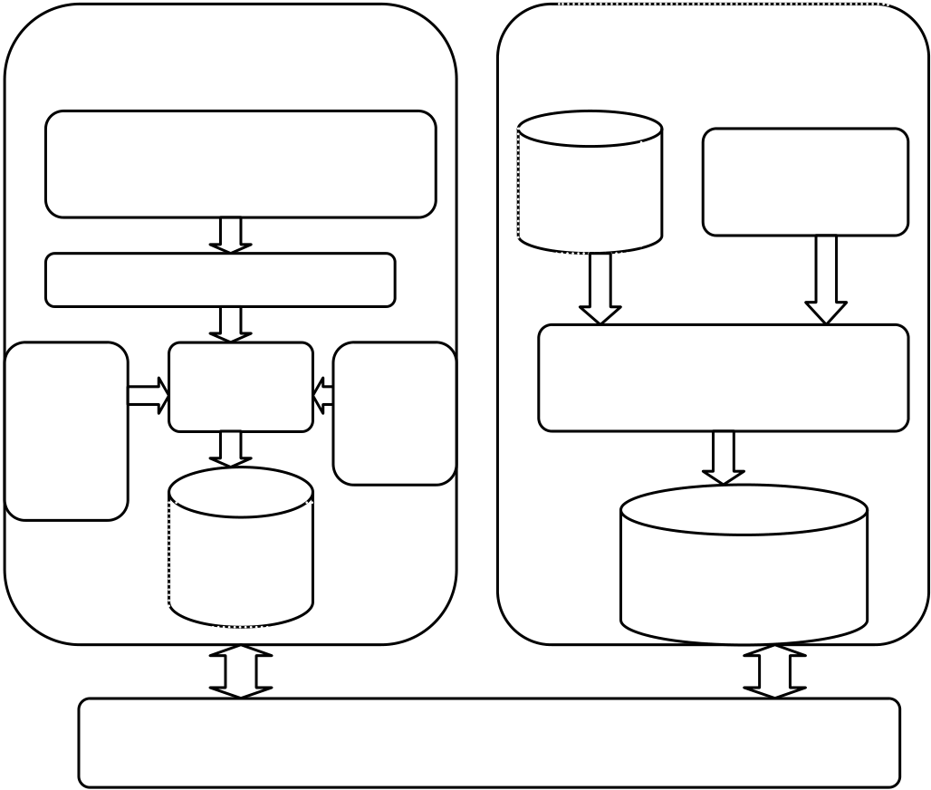

*Baoxiang Xu et al. / AASRI Procedia 5 ( 2013 ) 287 – 291*  291

system, and stratified index form reaction on the website, the effect is good. Due to the technology limitations of the authors, micro-blog information dissemination ontology construction and the overall micro-blog supervision system have no practice verification; this will be the future research direction.

Micro-blog information   
organization supervision

|  |  |  |
| --- | --- | --- |
| i | ti | i i |

Micro-blog information   
dissemination supervision

|  |  |  |
| --- | --- | --- |
| New release, forward, reviews | Micro | RSS Delivery |
| micro-blog information | ontology |
| information |
| library |

After optimization of the

|  |  |  |  |
| --- | --- | --- | --- |
| Ontolo | Micro | Free | Micro-blog information |
| dissemination ontology |
| gy | ontology | classifi |
| structu | cation |

re

|  |  |
| --- | --- |
| Micro  ontology  library | Spread micro  ontology library |

Micro-blog supervision information technology platform

Fig. 1. Micro-blog information transmission technology

**References**

[1] Wang Yangong. Critical thinking about micro-blog [J]. Journal of southeast, 2010;(12) : 36 - 38. [2] Hu Lei. Self-discipline of Internet information service in China problems and countermeasures study [J].

Journal of intelligence, 2010;(2) : 153-156   
[3] Sun Qingshan,Shan Shi. A new information transmission model and its simulation [J]. Journal of book intelligence work. 2010;(6) : 52-79   
[4] He Xiaoyuan Hu Xiaofeng. Network information transmission dynamics modeling study [J], journal of system simulation, 2011;(11) : 2511-2518