|  |  |  |  |
| --- | --- | --- | --- |
|  |  | Available online at www.sciencedirect.com |  |
| **ScienceDirect** |
| AASRI Procedia 9 ( 2014 ) 114 – 122 |

2014 AASRI Conference on Circuit and Signal Processing (CSP 2014)

On Qualitative Properties of Incompressible Cluster Flow on the Ring Network

Buslaev A.P.a*, Strusinskiy P.M.b

*aMoscow State Automobile and Road Technical University, 125319, Moscow, Russia, Leningradskiy avenue 64*

**Abstract**

Simulation cluster flow modeling is considered on ring networks. Cluster behavior is investigated in every network, theoretical and numerical results are obtained, theorems and proofs are formulated, program model results are obtained.

|  |
| --- |
| © 2014 The Authors. Published by Elsevier B. V. This is an open access article under the CC BY-NC-ND license © 2014 Buslaev A.P., Strusinskiy P.M. Published by Elsevier B.V.  (http://creativecommons.org/licenses/by-nc-nd/3.0/). Selection and/or peer review under responsibility of American Applied Science Research Institute  Peer-review under responsibility of Scientific Committee of American Applied Science Research Institute |

*Keywords:* Cluster; ring network; flow; simulation model.

**1.Introduction: Cluster on the ring**

**A cluster** is a segment [*a,b*] of particles with a density of *y*, 0 ≤ *y* ≤ 1 and a length of *x*�*b*�*a* . The cluster moves in certain direction on the ring with a velocity of   
*v* �*F*(*y*) . If there are obstacles, it stops (incompressible). *F* is a state function.   
 *Example of state function.*

* Corresponding author. Tel.: +7-499-1550436.   
*E-mail address:* apal2006@yandex.ru.

2212-6716 © 2014 The Authors. Published by Elsevier B. V. This is an open access article under the CC BY-NC-ND license (http://creativecommons.org/licenses/by-nc-nd/3.0/).

Peer-review under responsibility of Scientific Committee of American Applied Science Research Institute doi: 10.1016/j.aasri.2014.09.019

|  |  |  |  |  |  |  |  |  |  |  |
| --- | --- | --- | --- | --- | --- | --- | --- | --- | --- | --- |
| *A.P. Buslaev and P.M. Strusinskiy / AASRI Procedia 9 ( 2014 ) 114 – 122* | | | | | | | | | | 115 |
| *v y* ( ) | � | *v* | � | *y* max | � | *y* | � | *p* | , |
|  | max | �� | *y* max | |  | �� |  |  |
| |  |  | | --- | --- | | where p is parameter, 0 < p < ∞. |  | | | | | | | | | | |

Fig.1. Cluster on the ring, 0-network

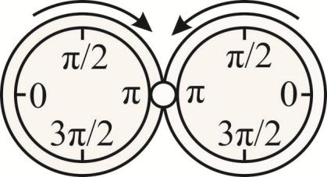

Fig.2. 1-network is a molecule

**2.Ring network**

**A ring network** is a set of rings on the plane. Rings touch each other in the common nodes. Multiplicity (number) of touches in one node is not more than two. Let’s classify ring networks by *number of touches, number of common nodes for one ring*. This value is constant, except rings, which are located on the border of the network. Besides, the notion "*regular networks*" includes *equidistribution* of common nodes on the ring.

**3.Isolated movement of uniform clusters**

**Isolated movement** of clusters in the ring network is a movement of each cluster on its own ring in a certain direction with the rule *FIFO (first input, first output)* of common nodes. Let all clusters be **uniform**. That is, they have *equal density* and, therefore *equal velocity*. Since the relative measure of the set of initial conditions, that lead to the competition of clusters for a common node within a limited period of time, equal to zero, we will not consider possible scenarios of settling conflicts. However, if it is significant, we can consider the *equiprobable method of regulating movement of two clusters through a common node*.

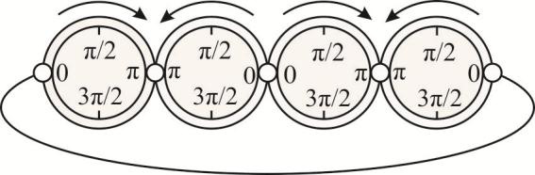

Fig.3. 2-network is a necklace

116  *A.P. Buslaev and P.M. Strusinskiy / AASRI Procedia 9 ( 2014 ) 114 – 122*

**4.Quantitative characteristics of movement**

Quantitative characteristics of movement both on a separate contour and in the network as a whole are considered. As previous researches have shown[1],[2],[3], the movement in such networks, and for close movement rules of masses, has a number of interesting properties, such as self-adjustment of the system with minimization of conflicts (**synergy**), complete stoppage of movement (**collapse**), spectrum of velocities and others.

Further **the average velocity in the network***v* nw* is a relative measure of moving clusters in the fixed moment. Since each cluster either stops or moves with equal velocity, the average velocity is equal to constant *v0* with relative measure of those part of clusters, which is moving now. Further let be *v*0 �1 .

Similarly, **the average velocity on the ring**, with assumptions we have made above, is a relative measure of time in movement conditions of appropriate cluster. There are possible local manifestations of synergy and collapse, and other scenarios of complicated movement, which is also an object of research.

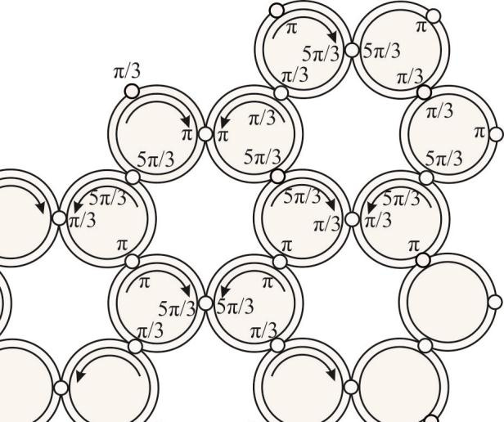

Fig.4. 3-network is a honeycomb

*A.P. Buslaev and P.M. Strusinskiy / AASRI Procedia 9 ( 2014 ) 114 – 122*  117

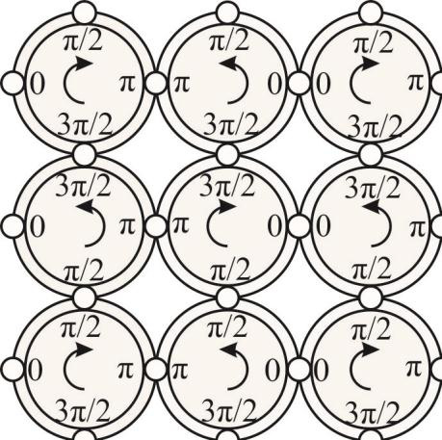

Fig.5. 4-network is a chain mail

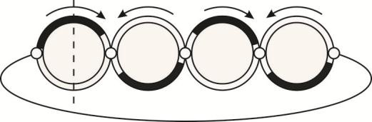

Fig.6. Conflict-free movement with maximal velocity on 2-network



Fig.7. Collapse on 2-network

**5.Two-element open necklace (molecule)**   
 The considered network consists of rings with one common node. Thus, the network structure is defined.

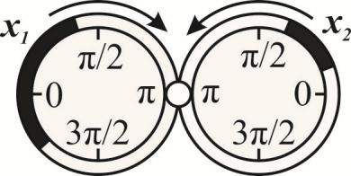

Fig.8. Two-element open necklace, 1-network

118  *A.P. Buslaev and P.M. Strusinskiy / AASRI Procedia 9 ( 2014 ) 114 – 122*

If *xi*, 0 ≤ *i* ≤ 1 are the lengths of clusters, every initial condition where a common node belongs to only one cluster is acceptable.

**Proposition 5.1:** If *x1 + x2≤ 2π*, then for all acceptable initial positions, the system goes into a synergy state during the time of a complete turn.

*Proof:* Is evident.

**Proposition 5.2:** If *x1 + x2 > 2π*, then

|  |  |  |  |  |  |
| --- | --- | --- | --- | --- | --- |
| *v* * | � | 2� | | | *(1)* |
| *nw* |  | *x* 1 | � | *x* 2 |  |

*Proof:* The time of the clusters passage through the common node is equal to *x1 + x2*, with velocity equal to 1. The time of a complete turn of each cluster during free movement is equal to 2π. Thus, the relative part of movement is defined by equation (1).

**6.Two-element closed necklace**

The simple variant of the network with two nodes on each contour is considered.

**Proposition 6.1:** If *x1 + x2≤ 2π*, then synergy starts after limited period of time for all initial conditions. *Proof:* Is evident.

**Proposition 6.2:** If *min(x1,x2)* >*π*, then collapse starts for all acceptable initial conditions.

*Proof:* If the cluster *K2* is approaching common node B. Then *K1* must go through this node at this period of time, since node A is occupied by *K2*. Obviously, *K2* can't go through B and stops, so *K1* can't go through A.

**Proposition 6.3:** If *min(x1,x2)* < *π*, then

|  |  |  |  |  |  |  |  |
| --- | --- | --- | --- | --- | --- | --- | --- |
| *v* * | � | 2� | | | � | 0.5 | *(2)* |
| *nw* |  | *x* 1 | � | *x* 2 |  |  |  |

*Proof:* Similar to the proof of proposition 5.2.

**7.Open necklace with 2*n* rings**

|  |  |  |  |  |  |  |  |  |  |  |  |  |  |  |  |  |  |  |  |  |  |  |  |  |  |  |
| --- | --- | --- | --- | --- | --- | --- | --- | --- | --- | --- | --- | --- | --- | --- | --- | --- | --- | --- | --- | --- | --- | --- | --- | --- | --- | --- |
| For comparison movements in the closed and open necklaces, agreed direction of movement and agreed coordinates on the contours are assumed. *x* � *x* 1 ,..., *x n* ) Is a vector of cluster lengths.  **Proposition 7.1:** If | | | | | | | | | | | | | | | | | | | | | | | | | | |
| then | *vnw* * � | .5.0 | *x l*�2 | | | | | | | *n* | � | | max 1� � | | 2 | *n* | | *x i* | | � | � | | | | | |
| *Proof:* For all contours we have | | | | | | | | | | | | | | | | | | | | | | | | | | |
| *v i* | | | � | 2� |  | 2� | |  |  | �1 | | � | |  | 2� | | | | | *x i* |  | *F y* ( ) | � | *F y* ( ) | � | 0.5, |
|  | � | *x i* | �1 | � | *x i* | 2�� | *x i* | | �1 | | � | �1 |  |  | 2 |  |  |
|  | *F y* ( ) |  | *F y* ( ) | |  | *F y* ( ) | | |  |  |  |  |  |  |  |

so *F(y)=1, xi + xi+1≤ 2π.*

*A.P. Buslaev and P.M. Strusinskiy / AASRI Procedia 9 ( 2014 ) 114 – 122*  119

**Proposition 7.2:** If � *I* = 1, …, 2n– 1; *xi + xi+1 < 2π,* then there are initial conditions, that are leading to synergy.

*Proof:* The biggest cluster is selected. Further, it is connected to the neighbor cluster. Each neighbor is connected to their neighbor cluster and this gets a conflict-free distribution for the open necklace at the initial moment of time.

**Proposition 7.3:** If � I, 1 ≤ I ≤ 2n – 1so, that *xi + xi+1 > 2π,* then *vnwx* )�1�*F y* ( ).

*Proof:* Proper neighbor node can’t supply both clusters during any period of time, if cluster movement is free.

**8.Closed necklace with 2*n* rings**

**Proposition 8.1:** If

|  |  |  |  |  |
| --- | --- | --- | --- | --- |
| *x l*��� | min | *x i* | � | � |

then there are initial conditions, that are leading to collapse for a short period of time.

*Proof:* Structure from Fig. 5. It is significant to note that any cluster can be turned against the direction of movement and the system goes from partial to absolute collapse.

**Proposition 8.2:** If

|  |  |
| --- | --- |
| *xi l*2*n*��� | � |

then for all initial conditions the collapse will start in a time period equal to half of the turnover period.

*Proof:* If any *i*-cluster is located in both nodes, then at the current time *(i-1)* and *(i+1)* clusters are located in one node and the same arrangement with appropriate neighbor clusters. Then there is a cluster with length greater than π. This cluster is the last one without a node in this odd chain, so we receive a contradiction.

**Proposition 8.3:** If

|  |
| --- |
| *xi l*2*n*��� |

then there are initial conditions, that are leading to synergy.

*Proof:* Follow from Fig. 5.

**Proposition 8.4:** If � *I,* 1 ≤ *I*≤ 2n then *xi + xi+1≤2π*, is true and there are initial conditions that lead to synergy in a time period, equal to the turnover period.

*Proof:* The structure from Fig. 5. All clusters are located symmetrically to (for example) position π/2 at the initial period of time.

**9.Potential flow function**

A closed necklace consisting of 2*n* rings is considered. The location of the cluster has been described on each contour by the indicator function *f (t,x,K) =* {*1, x* � *K; 0, x* � *K*}*, Ki =* [*ai (t),bi (t)*]*, fi (t,x) = f (t,x,Ki).*

*The potential flow function* is a function

|  |  |  |  |  |  |  |  |  |  |  |  |  |
| --- | --- | --- | --- | --- | --- | --- | --- | --- | --- | --- | --- | --- |
| *U t x* ( , ) | � | 1 | 2� | � | � | *f t x* ( , ) | � | *f t x* ( , ) | � | 2 | *dx* , | *(3* |
|  |  | 2 | �0 | *i j* |  | *i* |  | *j* |  |  |  | *(3* |

where all contour pairs with one common node are summate. Some properties for function *U* are specified.

120  *A.P. Buslaev and P.M. Strusinskiy / AASRI Procedia 9 ( 2014 ) 114 – 122*

**Proposition 9.1:**   
(1)*U(t) ≥ 0,* and *U(t)=0* � *Ki≡ Kj*, for any two contours with common node.

(2)If at some interval of time *(t0–δ, t0 + δ)* clusters *Ki* and *Kj* are moving and *i,j* have common node,

|  |  |  |  |  |  |  |  |  |  |  |  |  |  |  |  |  |  |  |  |  |  |  |  |  |
| --- | --- | --- | --- | --- | --- | --- | --- | --- | --- | --- | --- | --- | --- | --- | --- | --- | --- | --- | --- | --- | --- | --- | --- | --- |
| then | *U* | *ij* | ( ) | � | �0 � 2� | *f* | *i* | � | *f* | *j* | � | 2 | *dx* | � | *Const t* | � | ( *t* | 0 | � | �, | *t* | 0 | � | �) |

(3)*Uij(t)* is a continuous piecewise-linear function of time with a tilt tangent of 0, ±1.

*Proof:* Is evident.

**Proposition 9.2:** If |*Ki*| ≡ *d*, *i*=1,..2*n*, and *d*≤ π. Then the function: (1)*U(t)* does not decrease.

(2) For any initial conditions by the limit period of time *T* any pair of neighbor clusters *Ki* and *Kj* doesn't intersect and *U(t)* is equal to the maximum possible value 2*nd*.

*Proof:* For both closed and open two-element necklaces this feature is verified using the following method: currently, each node is assigned one of three values *Xi*:1, if the proper item is nearly equal to *t* and is constant. Thus, there is a defined partially-linear function in the ordered and consecutively numbered set of nodes with values 0,1,-1, according to vectors *X* = (*X1*,..., *X2n*). It's easy to see, that the sum of coordinates of this periodical vector gives us a criterion of monotony *U(t)*:

|  |  |  |  |  |  |
| --- | --- | --- | --- | --- | --- |
| *i*�2 *n*  �  *i*�1 | *X t i* ( ) | � | 0, | �*t* | . |

There is a one-to-one correspondence between each coordinate -1 of vector *X* and coordinate 1. Indeed, coordinate -1 means, that neighbor contours don't interact, and are in anti-phase, moreover one of the clusters is located before the node, for example, on the right. Thus, on the right of coordinate -1 there is coordinate 1. While on the left of coordinate -1 there can't be coordinate -1. So, the sum of coordinates of vector *X* is non-negative. From another point, there are nodes with interacting contours if the system didn't reach maximal value. In this case, in order for the rate of change of the potential function to be equal to zero, it is necessary for interacting clusters and neighbor clusters with a negative velocity to be located in a definite location, that

|  |
| --- |
| excludes constancy of the potential function.  **Proposition 9.3:** If |*Ki*| = *d*, *i*=1,..2*n*, *d*≤ π, then for every initial condition � *T\** < ∞, that *V(t)*≡ 2*nd* =  *maxV(t)*� *t* > *T\**. |

**10.Program modeling**

The newly developed *NODE model* software allows for the creation of a cluster movement simulation in a closed necklace consisting of 2*n* rings. You can locate clusters, specify length and density of clusters and set the number of rings in the necklace *n*. Adjacent nodes are marked by a vertical line, which is crossing proper contours.

The software calculates and simulates a movement of clusters and creates a diagram of the potential function *U(t)*.

As a result, by means of the *NODE model* software, some statements about the potential function *U(t)*, previously specified, are proven. Particularly, we proved that the function *U(t)* is a monotonous function and it reaches its maximal value 2*nd* in all initial conditions in a limited period of time.

*A.P. Buslaev and P.M. Strusinskiy / AASRI Procedia 9 ( 2014 ) 114 – 122*  121

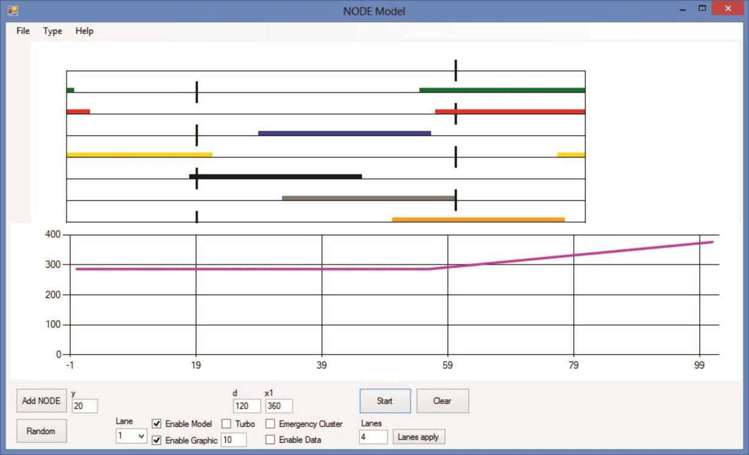

Fig.9. Software interface

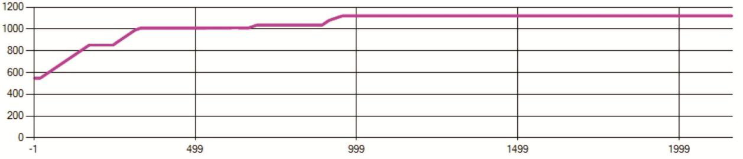

Fig.10. Potential function had reached the maximal value by time T=1700 tics

**11.Conclusion**

In the article qualitative properties of incompressible cluster flow on the ring network is considered, main properties and simulation results are formulated. Propositions and proofs of this results and properties are obtained. Newly developed software simulates cluster movement on the ring network and proves this results by simulation.

122  *A.P. Buslaev and P.M. Strusinskiy / AASRI Procedia 9 ( 2014 ) 114 – 122*

**Acknowledgements**

This work has been supported by the Russian Foundation for Basic Research, grant No. 14-01-31553a.

**References**

[1] V.V. Kozlov, A.P. Buslaev, A.G. Tatashev. Monotonic random walks and clusters flows on networks. Models and traffic applications. Lambert Academic Publishing, 2013; 300.

[2] A.S. Bugaev, A.P. Buslaev, A.G. Tatashev. On simulation of two-lane particles flow segregation. Mathematical modeling RAS, V. 20., № 9., 2008; 111-119.

[3] V.V. Kozlov, A.P. Buslaev, A.G. Tatashev. On Synergy of totally-connected flows on chainmails. Proc. of the 13 International Conference on Computational and Mathematical Methods in Science and Engineering, Almeria, Spain, V. 3, 2013; 861-874.

[4] A.P. Buslaev, P.M. Strusinskiy. Computer simulation analysis of cluster model of totally-connected flows on the chain mail. New Results in Dependability and Computer Systems, Proceedings of the 8th International Conference Dependability and Complex Systems DepCoS-RELCOMEX'13, Springer, Brunow, Poland, 2013; 63-74.

[5] A.S. Bugaev, A.P. Buslaev, V.V. Kozlov, M.V. Yashina. Some mathematical and information systems of traffic modeling. T-Comm. Telecommunications and traffic, No. 4, 2011; 29-31.