|  |  |  |  |
| --- | --- | --- | --- |
|  | Available online at www.sciencedirect.com **ScienceDirect**  AASRI Procedia 4 ( 2013 ) 18 – 25 | |  |
| 2013 AAS SRI Confere ence on Inte elligent Syst tems and Co ontrol  PD D-Fuzzy C Control of a Stai ir Climb bing Whe eelchair | | |
| N.M.A Gh hani*, A.N | .K Nasir, M M.A.H Has ssan, M.O Tokhi | |
| *Automatic C Control and Syste em Engineering d department, Sheff ffield,United King gdom* | | |
|  | | | |

**Abst tract**

This paper focuses o on the developm ment of a contr rol strategy of a a compact stair climbing whee lchair to mainta ain stable and

balan nce while nego otiating staircas ses in confined spaces for the e elderly and di isabled. The V Visual Nastran 4 4D is used to

deve lop a simulatio on models and l linked with Mat tlab platform fo or control and v visual assessme ent purposes. Th he challenges

are to o control front a and rear motors s as well as tilt angle to ensure e system stabilit ty and maintain n smoothness of f the climbing

proce ess. PD-Fuzzy controls are d developed, test ted and associa ated performan nces are assess ed through int tensive visual

appro oach.

|  |  |  |  |  |
| --- | --- | --- | --- | --- |
| © 2013 The Authors. Published by Elsevier B.V.© 20 013. Published d by Elsevier B.V. | | Open access under [CC BY-NC-ND license.](http://creativecommons.org/licenses/by-nc-nd/3.0/) | | |
| |  | | --- | | Selection and/or peer review under responsibility of American Applied Science Research Institute earch Institute  *Keyw words :* Stair climb bing; Climbing w wheelchair; Fuzzy y logic; Stability control | | **1.In ntroduction** | | | | | |
| There are total of 11.2 millio on disabled pe ersons, of wh om 0.8 millio on are children n, 5.2 million | | | | are working |
| adul lts and 5.2 mi illion are abo ve their pens ion age accor rding to 2010 0/2011 disabil ity prevalence e estimation | | | | |
| data | in Great Brit ain(Disability y factsheet, 20 011)[1]. This s has caused h high demand o on some form | | | of transport |
| mech hanism and t thus wheelcha airs continue | | to play a vita al role.Comm mon mobility | assistive tech hniques and | |
| recen nt advances in n curb and sta air climbing de evices are des scribed in this paper. A prop posal for a hig gh step stair- | | | | |
| * N.M.A Ghani. T Tel.: +44 (0)114 2 222 5250; fax: +4 | | 4 (0)114 222 568 83. | | |

*E-mail address: ni iha.ghani@sheffi eld.ac.uk*

2212-6716 © 2013 The Authors. Published by Elsevier B.V. Open access under [CC BY-NC-ND license.](http://creativecommons.org/licenses/by-nc-nd/3.0/)

Selection and/or peer review under responsibility of American Applied Science Research Institute

doi: 10.1016/j.aasri.2013.10.004

*N.M.A. Ghani et al. / AASRI Procedia 4 ( 2013 ) 18 – 25*  19

climbing mechanism based on wheelchair in confined spaces and indoor usage is presented and its feasibility demonstrated in the paper.

There are several types of stair climbing wheelchair and the mechanical design in these three different categories are varies from one another. It can be classified into three categories; crawler type [2-6], wheeled type [7-9] and legged type [10].The approaches adopted in crawler types are non-slip rubber track based on a single and dual section track mechanisms. The control strategy used is fuzzy logic control as an optimal estimation algorithm to estimate the proportion of various factors that affect the track tension. However, it is hard to turn in narrow and small aisle due to its huge structureandthe high pressure that exerted at the edge of each stairs can cause stairs damage. Stability control is not considered to the extensive level in a wheeled type and some of them are just based on the inverse kinematic derivation for motion planning. Nakajima has introduced a legged mechanism in 2011 with simulation and experiment validation [11]. It uses supporting polygon to maintain the level of the wheelchair body on at least three points while performing stair climbing. However this mechanism does not seem practical to be used in a place where it has more than two steps and high stairs slope.

Articulated wheel clusters has been used by iBOT 3000 Transporter to overcome the stairs climbing task [12]. The iBOT system then has been replicated by Japanese researchers from University of Tokyo, and they have introduced similar stair climbing wheelchair recently (NOBOROT 2012) [13]. Another recent development reported by the authors is a design using MSC Visual Nastran 4D (VN) environment in year 2012 [14], where actual weight of human and the overall stability of the wheelchair were taken into account. The mechanism is quite simple and thus can be used for indoor purposes without the user needing to hold the guardrails all the times or requiring an assistant. However, the climbing structure was based on pre-determined angle for link1 and link 2 in order to step up the first and further stairs respectively to perform stairs ascending task. The compact wheelchair design presented in this work improves in several ways but maintains the same behavior as in [14].

**2. Wheelchair model**

The equation of motion of the stair climbing wheelchair is too complex to derive due to the nonlinearity of the system. All important variables might be left out when simplification approach is introduced when establishing a mathematical model of the system. A simplified equation of motion is not sufficient to represent a complex stair climbing mechanism with the changing of centre of gravity, COG of human mass. Therefore, the system is designed as close as the standard wheelchair and transformed in a 4D software called Visual Nastran (VN) so that all the nonlinear features will be maintained.

The VN software environment can provide a visualization including the motion of negotiating each stairs, stabilization of the overall wheelchair mechanism, and other functional features. It allows designing and simulation of rigid body dynamics, determining collision response, choosing materials type and identifying input/output of control signal for control purposes when integrating with Matlab/Simulink environment. The gravitational force is taken into consideration as well, thus approximating the real system. There are few researches which embark VN software as a first stage before deploy actual system [15]. A modified and simplified version of wheelchair model using wheels rotation instead of cluster mechanism [14] was designed using VN software. Fig 1 shows the schematic diagram and specific location of the motors required in the wheelchair model. All dimensions were taken from standard wheelchair size except the wheels which were adopted from the iBOT system due to its well known commercial stair climbing wheelchair mechanism.

Main motor namely front motor,*F*, rear motor, *R*and seat motors, *S*are shown in the figure. Three different sensors; one at the vertical cylinder rod for tilt angle control, distance sensor at each wheels to measure distance between wheels and stairs and angular sensor at each links for control measurement. The

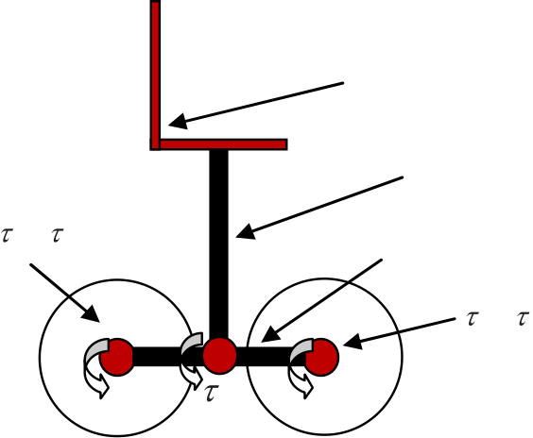

|  |  |
| --- | --- |
| 20 | *N.M.A. Ghani et al. / AASRI Procedia 4 ( 2013 ) 18 – 25*  input signals applied to the wheelchair model are both right and left front and rear motor torques,  *FL FR* and    *RL RR* to lift link while the seat torque, *S*is to control the tilt angle. The measured outputs are angular position of Link (degree) for climbing steps as well as tilt angle (degree). |

Seat

Tilt

|  |  |  |  |
| --- | --- | --- | --- |
| *FL*,*FR* | Link | *FL*, | *FR* |

*S*

Front wheels Rear wheels

Figure 1. Schematic diagram of wheelchair.

The humanoid model using the anthropometric data is approximated and designed [16]. In this work, the

humanoid model is developed as a rigid body with 1.5 m in height and weight of approximately 71 kg. There

are many types of stairs that have been used, and because they are inherently hazardous, the design must

follow standard dimensions and structure to allow safe product manoeuvrability and feasibility (Canadian

Centre for Occupational Safety and Health, 2010) [17]. Straight stairway with a slope of 500 was tested in this

work and have a height of 8 inch, tread of 12.6 inch and width of 30 inch.

**3. Controller Structure**

Fuzzy Logic control (FLC) is adopted in this wheelchair system and Mamdani-type fuzzy rules with multi-

input single output, (MISO) structure is considered with error and change of error as the input as shown in Fig.

2. The angular position of two links (Link 1 and Link 2) are controlled independently with PD-fuzzy logic

structures that have equal rule bases. Thus, there are two independent FLCs (FLC 1 and FLC2), one for each

link incorporating two inputs and one output for each FLC (*R*,*L* ) ,while another FLC3 is for the tilt angle,

*S*. Both FLCs use angular position error, *e*1 and change of angular position error of Link 1, *e*1 . In order

to give smooth transition and response of the climbing task, Gaussian membership function was used. The

five membership levels used are Positive Big (PB), Positive Small (PS), Zero (Z), Negative Small (NS) and

Negative Big (NB) for both error and change of error. Fig. 3(a) shows the implemented 25 fuzzy rules. Noted

that for this fuzzy control structure, the same design is used for all the FLCs, thus only one fuzzy logic

controller need to be designed and implementable to all situations. The rules are typically fired as :

‘If *e*1 is **NB** and *e*1 is **NB** then the Torque is **PB**’

‘If *e*1 is **NB** and *e*1 is **PB** then the Torque is **Z**’

‘If *e*1 is **NB** and *e*1 is **PS** then the Torque is **PS**’

.....

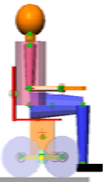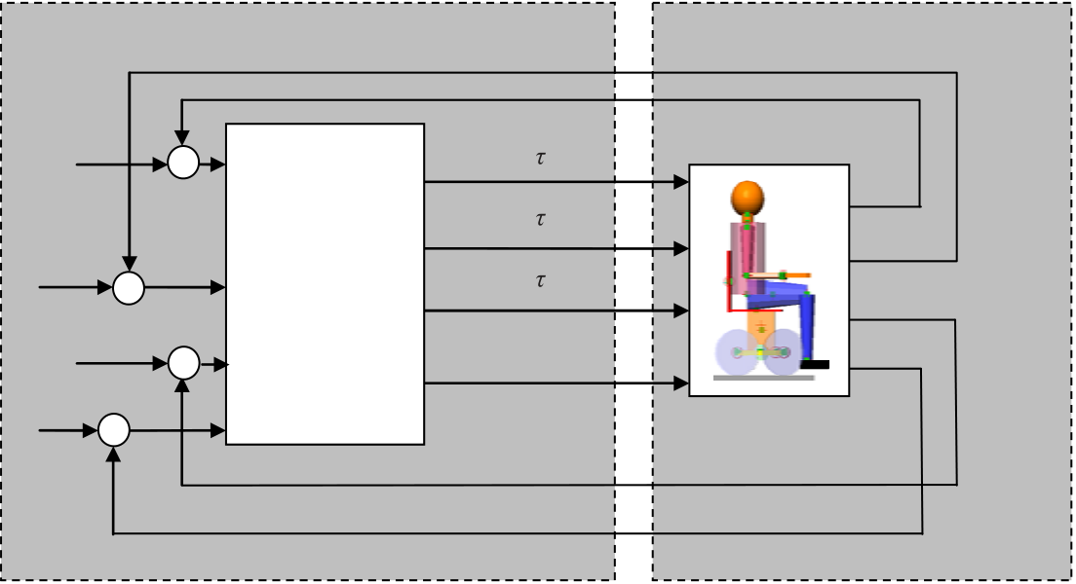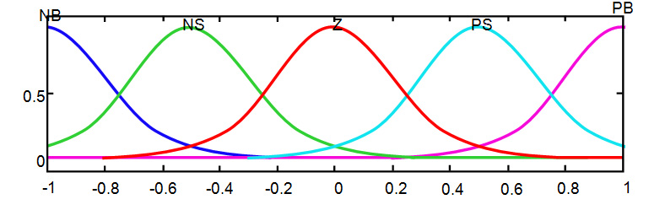

|  |  |  |
| --- | --- | --- |
| Degree of membership | *N.M.A. Ghani et al. / AASRI Procedia 4 ( 2013 ) 18 – 25* | 21 |

Figure 2:Input output structure and MFs of MISO system

PD-Fuzzy Logic was implemented in Matlab integrated with VN, and the control structure is as shown in Fig. 3(b). The scaling factors for Fuzzy Logic and PD gains were tuned heuristically. The control objective is to produce sufficient torque to front and rear motors for lifting the rear wheels over the front wheels and the other wheels using cluster called ‘Link’ mechanism while maintaining the human body on the seat levelled. These tasks need to ensure that there will be no levitation or significant displacement of the overall wheelchair mechanism while performing stair climbing operation smoothly.

Position of front wheel

|  |  |  |  |  |  |
| --- | --- | --- | --- | --- | --- |
| Set point | + | + | -  PD-Fuzzy | *F* | Position of rear wheel |
| Set point | - | *R* | Tilt angle |
| + | *S* |
| Set point | - | Control | *v C* | Cluster angle |
| + |

Set point   
 -

Matlab/Simulink Visual Nastran

Figure 3: Control system structure

**4. Simulations**

Fig. 4 shows visualization of the wheelchair performance while ascending step 1 and step 2. Initially, the wheelchair stays in four-wheeled configuration on the ground as shown in Fig. 4 (a), then front motor torque,

*F*lifts link 1 for positioning rear wheels on the upper step, Fig. 4(b). This mechanism is a two-wheeled configuration during which stabilization of the system is realized as in Fig. 4(c). Then, rear motor torque, *R* will lift link 2 in order to transfer the whole wheelchair to the second step as shown in Fig. 4 (d-f). At this stage, the rear motor cater for stability of the overall mechanism and maintain both wheels at the same position. The challenges are to develop suitable control torques for the respective motors and prevent the whole system including human (amounting up to 100kg) from falling or slipping. As can be seen, seat motor torque, *S* stabilized the seat in the upright position during the whole process at all times. The whole process

22  *N.M.A. Ghani et al. / AASRI Procedia 4 ( 2013 ) 18 – 25*

is then repeated for climbing on further steps. The associated simulations can be seen in Fig. 5 where Fig. 5(a-b) shows the orientation of the control input signal, link 1 and link 2 for both steps respectively which were set to the desired angle depending on specifications of the stairs. It took the system a total of approximately 2.7s to climb the first staircase before continue to climb second staircase for up to 6s. Fig. 5(c-d) shows the front and rear wheel positions while climbing step 1 and step 2 whereas both wheels only got affected when front motor was performed during climbing step 1 and vice versa. It shows that both wheels maintained stable at the same position without levitating during the overall operation. Furthermore, the tilt angle was maintained levelled throughout the process with a small variation, (-0.5o to 0.5o) as in Fig. 5 (e). Figure 5(f) shows the simulation of the wheelchair during completing final step after performing few stair ascending task. The acting wheels are shown as highlighted in green colour as in Fig. 4 (g) it has some travelled distance in order to perform the final landing process due to the wheel rotation.

**5. Conclusion**

A stair climbing wheelchair has been successfully developed in VN using a standard sized wheelchair. A humanoid model with approximate weight of 71kg and standard sized stairs have been adopted. A Fuzzy control approach has been implemented to perform stair climbing task in an automatic mode wheelchair system. The results presented proved that the FLC works well in controlling highly interchangeable systems which incorporated front and rear motors to perform stair climbing task. It has been demonstrated that the control system is able to perform effectively in order to ensure user comfort and smoothness of the manoeuvring tasks. Future work will look at the stairs descending process, optimization of the control scaling parameters and linear motion.

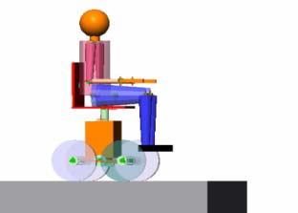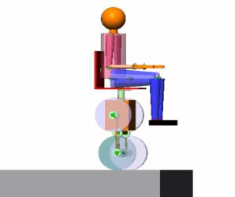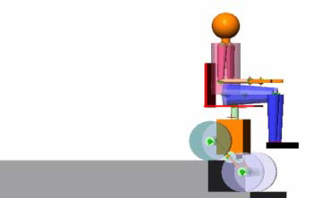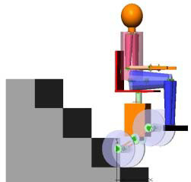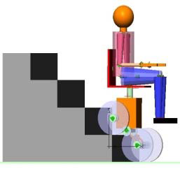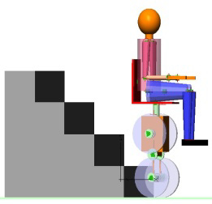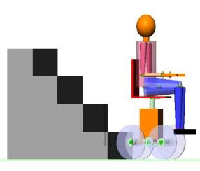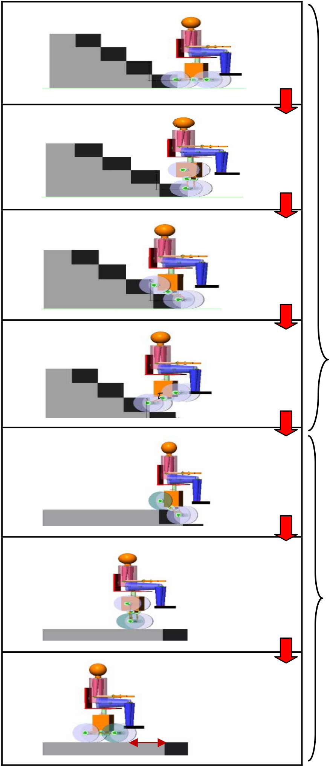

*N.M.A. Ghani et al. / AASRI Procedia 4 ( 2013 ) 18 – 25*  23

(a)

(b)

(c)

|  |  |  |
| --- | --- | --- |
| (d) | *S* | Perform stair climbing task |

(e)

|  |  |
| --- | --- |
| (f) | Complete final step |

(g)

***d***

Figure 4. Ascending stairs

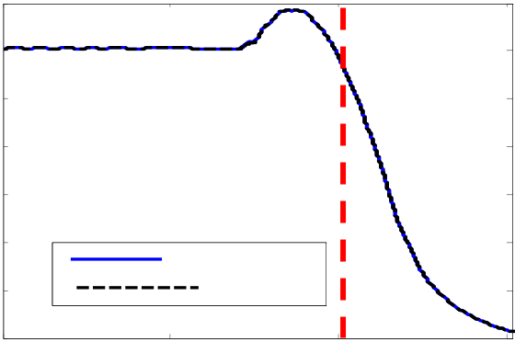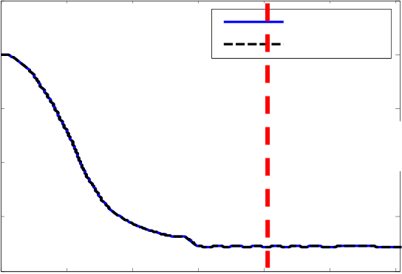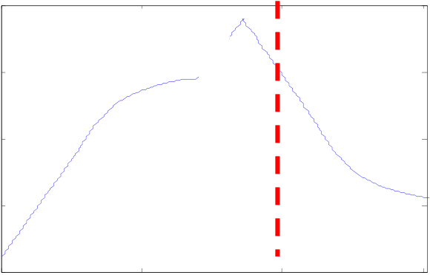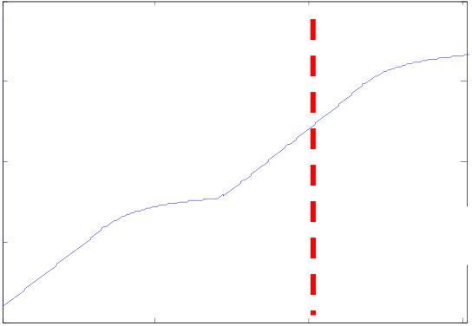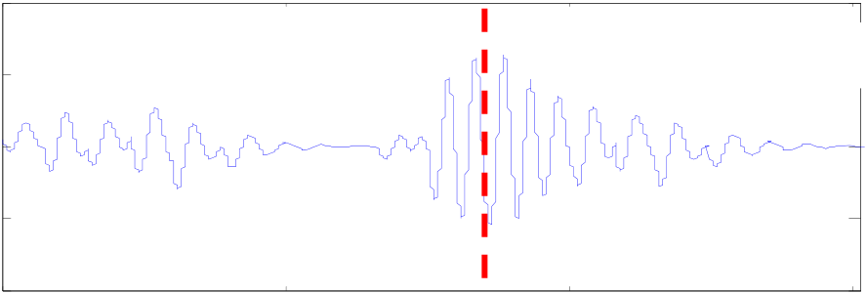

|  |  |  |  |  |  |  |  |  |  |  |  |  |  |  |
| --- | --- | --- | --- | --- | --- | --- | --- | --- | --- | --- | --- | --- | --- | --- |
| 24 | Angular position of link 1 (degree) | 100 | 0 | Step1 | 2 | Time (s) | *N.M.A. Ghani et al. / AASRI Procedia 4 ( 2013 ) 18 – 25* | | | | | | Step2 | 6 |
| 200 | | | | | |
| 4 | 6 | Angular position of link 2 (degree) | 100 | 0 | 2 |
| 50 |
| 0 | 0 |
| -50 | -100 |
| -100 | -200 | 4 |
| Time (s) | | | | | |

(a) Angular positions of link 1 (b) Angular positions of link 2

|  |  |  |  |  |  |  |  |  |  |  |  |  |  |  |  |
| --- | --- | --- | --- | --- | --- | --- | --- | --- | --- | --- | --- | --- | --- | --- | --- |
| Front wheel position (m) | 0.1 | 0 | Step1 | left wheel | 4 | 6 | Rear wheel position (m) | 0.6 | 0 | 1 | 2 | 3 | left wheel | | 6 |
| 0 | 0.4 |
| right wheel | |
| -0.1 | 0.2 | Step2 | |
| -0.2 |
| -0.3 | 0 |
| -0.4 |
| -0.2 |
| -0.5 |
| right wheel |
| -0.6 | 2 | -0.4 | 4 | 5 |
| Time (s) | Time (s) |

(c) Front wheel position (d) Right wheel position

1

|  |  |  |  |  |  |  |  |
| --- | --- | --- | --- | --- | --- | --- | --- |
| Tilt angle (degree)  Tilt angle, (degree) | 0.5 | 0 | Step1 | 2 | 4 | Step2 | 6 |
| 0 |
| -0.5 |
| -1 |

Time (s)

(e) Tilt angle during climbing steps

|  |  |  |  |  |  |  |  |
| --- | --- | --- | --- | --- | --- | --- | --- |
| Angular position of tilt angle (degree)  Tilt angle, (degree) | 0.5 |  | | | | | |
| 0 |
| -0.5 |
| -1 |
| 0 | 1 | 2 | 3 | 4 | 5 |

Time (s)

(f) Tilt angle in completing final step

Figure 5. Wheelchair performance in completing ascending task

*N.M.A. Ghani et al. / AASRI Procedia 4 ( 2013 ) 18 – 25*  25

**References**

|  |  |
| --- | --- |
| [1]  [2]  [3] | Disability Factsheet (2010). Office for Disability Issues (9th November 2012), [Available from]  http://odi.dwp.gov.uk/disability-statistics-and-research/disability-facts-and-figures.php  Sunwa Co.Ltd (2006). (1st April 2012), [Available from] http://www.sunwa-jp.co.jp/en/accessibility/. Top Chair, (2003). The first stair-climbing powered wheelchair, (1st April 2012), [Available from] |

http://www.topchair.fr/.

[4] Lawn, M. J., Sakai, T., Kuroiwa, M. & Ishimatsu, T. (2001). Development and practical application of a stairclimbing wheelchair in Nagasaki. Journal of HWRS-ERC, 2, 33-39.

|  |  |
| --- | --- |
| [5] | Teng, Y., Wang, T., Yao, C. & Li, X. (2010). The Research of Tension Optimal Estimation and Stair-Climbing Ability of Transformation Wheelchair Robot. Proceeding of 29th Chinese Control |

Conference, 3716-3721.

[6] Morales, R., Feliu, V. & González, A. (2010). Optimized obstacle avoidance trajectory generation for a reconfigurable staircase climbing wheelchair. Robotics and Autonomous Systems, 58, 97-114. [7] Lawn, M. & Takeda, T. (1998). Design of a robotic-hybrid wheelchair for operation in barrier present environments. Proceeding of IEEE International Conference on Medicine and Biology Society, 2678-2681.

[8] Quaglia, G., Franco, W. & Oderio, R. (2009). Wheelchair. q, a mechanical concept for a stair climbing wheelchair. Proceeding of IEEE International Conference on Robotics and Biomimetics, Guilin, China, 800-805.

[9] Sugahara, Y., Yonezawa, N. & Kosuge, K. (2010). A novel stair-climbing wheelchair with transformable wheeled four-bar linkages. Proceeding of IEEE/RSJ International Conference on Intelligent Robots and Systems, 3333-3339.

[10] Sugahara, Y., Ohta, A., Hashimoto, K., Sunazuka, H., Kawase, M., Tanaka, C., Hun-Ok, L. & Takanishi, A. (2005). Walking up and down stairs carrying a human by a biped locomotor with parallel mechanism, Proceeding of IEEE/RSJ International Conference on Intelligent Robots and Systems, 1489-1494.

[11] Nakajima, S. (2010). Proposal for step-up gait of RT-Mover, a four wheel-type mobile robot for rough terrain with simple leg mechanism. Proceeding of IEEE International Conference on Robotics and Biomimetics, 351-356.

|  |  |
| --- | --- |
| [12] [13] | Ding, D. & Cooper, R. A. (2005). Electric powered wheelchairs. A review of current technology and insight into future directions*. IEEE Control Systems Magazine,* 25, 22-34.  Noborot (2012). Robotic vehicle could lead to stair-climbing wheelchair by 2017, (6th November |

2012), [Available from] http://www.gizmag.com/nororot-stair-climbing-robotic-vehicle/24878/ .

[14] Ghani, N.M.A., Tokhi, M.O. & Nasir, A.N.K (2012). Control of a stair climbing wheelchair, *Proceeding of 12th Annual Workshop on Computational Intelligence (UKCI 2012),* Edinburgh.

|  |  |
| --- | --- |
| [15] | Gnoni, D., Grieco. Antonio & Pacella. M. (2002).A CAD environment for the numerical simulation of servo pneumatic actuator systems, *Proceeding of 7th International Workshop on Advanced Motion* |

*Control*,593-598.

[16] Winter, D.A. (1990). Biomechanics and Motor Control of Human Movement. *Wiley-Interscience*, New York.

[17] Canadian Centre For Occupational Safety AndHealth (2010). (28th November 2012), [Available from] http://www.ccohs.ca/oshanswers/safety_haz/stairs_fallprevention.html