|  |  |  |
| --- | --- | --- |
|  | Available online at www.sciencedirect.com | AASRI |
|  |
|  | Procedia |
|  | AASRI Procedia 1 ( 2012 ) 213 – 219 | www.elsevier.com/locate/procedia |

2012 AASRI Conference on Computational Intelligence Bioinformatics

Radar Emitter Recognition Based on PSO-BP Network

Yu Zhi-fu*, Li Jun-wu, Liu Kai

*Hefei Electronic Engineering Institute, 460 Huangshan Rd.,Hefei, Anhui,P.R.China*

**Abstract**

According to the problem of emitter characteristic parameters are showed by interval and uneasy to identify, an emitter fusion recognition method based on the PSO-BP neural network is proposed. The method train the network by training samples which are reasonable structured according to the distribution in the interval, so as to determine the network structure and confirm the emitter type through the emitter characteristics parameters. At the same time, the BP neural network is optimized by Particle Swarm Optimization (PSO) algorithm. The coding method of the network output, training data size and deviation rate on the influence of the recognition are researched by simulation, and the validity of this method are verified by the results.

© 2012 Published by Elsevier B.V. Open access under [CC BY-NC-ND license.](http://creativecommons.org/licenses/by-nc-nd/3.0/)

Selection and/or peer review under responsibility of American Applied Science Research Institute

*Keywords:* Particle Swarm Optimization (PSO), BP neural network, emitter recognition, data fusion;

**1.Introduction**

In the modern electronic reconnaissance, the battlefield environment is complicated. The hostility will take all kinds of measures against in the fight. So radar emitter characteristic parameters have some random and fuzzy because of all kinds of the existence of the interference and reconnaissance and the error of measurement of equipment itself. How to recognize the radar emitter in a complicated electromagnetic environment of reconnaissance has very important military significance [1]. There are a lot of existing classic

* Corresponding author. Tel.: +8613866141852   
*E-mail address:* zhifuyu@sohu.com

2212-6716 © 2012 Published by Elsevier Ltd. Open access under [CC BY-NC-ND license.](http://creativecommons.org/licenses/by-nc-nd/3.0/) doi: 10.1016/j.aasri.2012.06.033



214  *Yu Zhi-fu et al. / AASRI Procedia 1 ( 2012 ) 213 – 219*

methods, including method based on the bayesian theory, method based on the fuzzy pattern recognition,

method based on the rough set theory [2], method based on evidence theory, method based on artificial neural

network, and so on. These methods have relatively successful applications in recognition of radiation sources.

But these methods are generally aim at the measured parameters showed by the scalar form, and solve the

problem of radar emitter recognition whose parameters are measured with some error. For another case of the

measured parameters are interval type is less discussion.

This article mainly aims at the radar parameters of template library for the interval representation and

measured values for the scalar form, focus on recognition problem that characteristic parameters are interval

type using BP neural network. But the BP neural network easy to get local optimal, and the convergence

speed slower in late training, so using the PSO algorithm to optimize the BP neural network to find the

optimal weights and thresholds of the network before training in the paper, thus speeding up the convergence

speed of training and effectively avoiding algorithm into local optimal at the same time.

**2.PSO-BP neural network**

*2.1.PSO algorithm*

Particle Swarm Optimization (PSO) algorithm [3] was proposed by Kennedy and Eberhart in 1995. The

hypothesis in a *D* dimension target search space, *M* particles of representative problem potential solution

constitute one species **x** �[ , 2 ,..., **x** *M*] . The *i* particle information can represented by *D* dimensional

vector **x**�*i*  [ *x i* 1 , *x i* 2 ,..., *x iD* ]*T* , its velocity is **v**�*i*  [ *v i* 1 , *v i* 2 ,..., *v iD* ]*T* . The particles exchange information by

tracking 2 extreme values in each of iteration. One of extreme values is the optimal solution which found by

the *i* particle itself, called individual extreme value, denoted by **p**�*i*  [ *p i* 1 , *p i* 2 ,..., *p iD* ]*T* . Another is all

particles found in the optimal solution, called group extreme value, denoted by **p**�*g*  [ *p g* 1 , *p g* 2 ,..., *p gD* ]*T* .

Particles update the 2 extreme values according to formula *(1)* and *(2)* to update their velocities and positions.

**v** *t*

*i*� �*w* **v** *t*

*i*�*c r* 1 1 ( **p** *t*

*i*�**x** *t*

*i* )�*c r* 2 2 ( **p** *t*

*g*�**x** *t*

*i* ) *(1)*

**x** *t*

*i*�1�**x** *t*

*i*�**v** *t*

*i*�1 *(2)*

Where *t* represents the current number of iterations, **v**�*t* 1

*i* represents the velocity values of *i* particle in the

*t* �1 iteration. 1 *r r* are uniformly distributed random number between [0,1]. ,2 *c c* are called the learning 1 ,2

factors. *w* is the inertia weight, generally in the range of 0.1 to 0.9 values. *w* �0.5 in the standard PSO

algorithm. In the practical applications, need to limit the scope of **x** to [ *X* min , *X* max ] . Similarly, **v** is also

required limited within a certain range [�*V* max , *V* max ] , usually *V*max take 10% ~ 20% of the **x** domain.

*2.2. BP neural network*

The three layers of the BP neural network are used in this article. The input layer node number as same of

the number of radar characteristic parameters, the output layer nodes number is the number of radar type plus

one, the number of hidden layer nodes is determined by the empirical formula *(3)*.

*H*��

� *I O*�

��*O*  *(3)*

Where, , *I H O* respective for the BP neural network nodes of input layer, hidden layer and output layer.

� � indicates the rounding to �� direction. The most significant feature of the BP neural network is that it no

needs the exact mathematical expressions between input and output, it only need to be trained by a certain

amount of sample data, then it will be able to establish the mapping relationship between the input and output.

*Yu Zhi-fu et al. / AASRI Procedia 1 ( 2012 ) 213 – 219*  215

However, the BP neural network is easy to fall into local optimum in the training process. In order to overcome the deficiencies of the BP neural network, the PSO algorithm are used to obtain the optimal initial value of the network weights and thresholds. Using the PSO algorithm to train the BP network, the particles in the PSO algorithm need to be encoded. The dimension of each particle is equal to all the BP neural network connection weights number and thresholds number. The dimension number is

|  |  |  |  |  |  |  |  |  |  |  |  |  |  |  |
| --- | --- | --- | --- | --- | --- | --- | --- | --- | --- | --- | --- | --- | --- | --- |
| *D* | � | *I* | * | *H* | � | *H* | * | *O* | � | *H* | � | *O* | �*O* | *(4)* |
| Where, * | | | | | | *H* | � | *H* | * | *O* | is the number of connection weights, *H* | | is the thresholds number. Using PSO |

algorithm to search the optimal position is to make the mean square error index defined in the formula *(5)* reach the minimum, and the index is used as fitness function in PSO algorithm.

|  |  |  |  |  |  |  |  |  |  |  |  |  |  |  |  |  |  |  |
| --- | --- | --- | --- | --- | --- | --- | --- | --- | --- | --- | --- | --- | --- | --- | --- | --- | --- | --- |
| fitness | � | | 1 | *O* � | [ | *d* |  | � | *f* |  | *H* � | *w y* |  | � | *b* | )] 2 | *(5)* | |
|  | *O* | i 1� |  | *i* |  |  |  | *j*�1 | *ji* | *j* |  | *i* |
| Where, | | *ib* and | | | | *id* , respectively stand for *i* output node of the threshold and the ideal output value. | | | | | | | | | | | | *w* is *ji* |
| the weight of *j* hidden layer nodes to *i* output node. | | | | | | | | | | | | | | | | | *jy* is the output value of the hidden layer node *j* , and | |

its expression is

|  |  |  |  |  |  |  |  |  |  |  |  |
| --- | --- | --- | --- | --- | --- | --- | --- | --- | --- | --- | --- |
| *y* | *j* | � | *f* | ( | *I* �  *k*�1 | | *w x kj*  *k* | � | �*j* | ) | *(6)* � is the threshold of the *j* hidden *j* |
| Where, | | | | | *w* is the weight of *k* input node to *j* hidden layer node, *kj* | | | | | |
| layer node, | | | | | | *kx* is the value of the *k* input node. | | | | |

*2.3.The steps of the PSO algorithm optimize the BP network*

|  |  |  |  |  |  |  |  |  |  |  |  |  |  |  |  |  |  |  |  |  |  |  |  |  |  |  |  |  |  |  |  |  |  |  |  |  |  |  |  |  |
| --- | --- | --- | --- | --- | --- | --- | --- | --- | --- | --- | --- | --- | --- | --- | --- | --- | --- | --- | --- | --- | --- | --- | --- | --- | --- | --- | --- | --- | --- | --- | --- | --- | --- | --- | --- | --- | --- | --- | --- | --- |
| *Step-1* Initialize the PSO algorithm parameters. Random initialize particle position | | | | | | | | | | | | | | | | | | | | | | | | | | | | | | | | | | | | *i***x** in the interval | | | | |
| [ | *X* | min | , | *X* | max | ] | and set each dimension of the velocity | | | | | | | | | | | | | | | | | | *i***v** for random number in | | | | | | [�*V* max | | , | *V* max | | ] | . Initialization of | | | |
| individual extreme values of | | | | | | | | | | | | | | | | *i***p** and the global extreme values | | | | | | | | | | | | **p** and calculate the corresponding fitness *g* | | | | | | | | | | | | |
| value | | | | *fitness* **p***i*) | | | | | | | and | *fitness* **p***g*) | | | | | | . | | | | | | | | | | | | | | | | | | | | | | |
| *Step-2* Update the position | | | | | | | | | | | | | | | *i***x** and the global extreme value | | | | | | | | | | | | **p** via iterations. *g* | | | | | | | | | | | | | |
| � Update the velocity of the particle | | | | | | | | | | | | | | | | | | | | | | **v**�*i k* 1 | according to equation *(1)*. If one dimension of velocity | | | | | | | | | | | | | | | | | *ijv* is |
| more than | | | | | | *V*max | | | | , then take | | | | *ijv* as | | *V*max | | | . | | | | | | | | | | | | | | | | | | | | | |
| � Update the position of the particle | | | | | | | | | | | | | | | | | | | | *i***x** according to equation *(2)*. If one dimension of | | | | | | | | | | | | | | | | *i***x** value | | *ijx* over its | | |
| domain, then randomly initialize | | | | | | | | | | | | | | | | | *ijx* again in its domain. | | | | | | | | | | | | | | | | | | | | | | | |
| � Go to the equation *(5)* to seek fitness value | | | | | | | | | | | | | | | | | | | | | | | | *fitness* **x***i* ( ) | | | , if | *fitness* **x***i* ( ) | | is less than | | | | | *fitness* **p***i*) | | | , then let | | |
| *i***p** equal to | | | | | | | | *i***x** and update the | | | | | | | *fitness* **p***i*) | | | | | | . If | | *fitness* **p***i*) | | | is less than | | | *fitness* **p***g*) | | | , then let | | | | **p** equal to *g* | | | *i***p** and | |
| to update the | | | | | | | | | *fitness* **p***g*) | | | | . | | | | | | | | | | | | | | | | | | | | | | | | | | | |

*Step-3* Judge whether to meet the termination condition, if not satisfied, then go to step 2. If satisfied, then output the results of optimization, algorithm over.

**3.Fusion recognition model**

This article focuses on the type of radar emitter recognition problem. So-called radiation source recognition is the process of matching emitter characteristic parameters detected and in the radar template library so as to

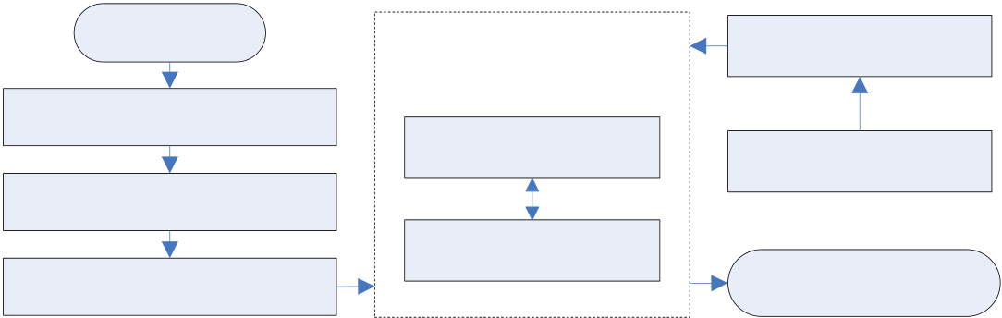

216  *Yu Zhi-fu et al. / AASRI Procedia 1 ( 2012 ) 213 – 219*

obtain the radiation source type [4]. From the point of view of neural network classification, its purpose is to

confirm the nonlinear mapping of parameter feature space and radiation source models space. The

characteristic parameters mainly are carrier frequency RF (radio frequency), pulse width of the PW (The pulse

width), pulse repetition interval PRI (The pulse the repeat interval), the modulation of the MOP (pulse

modulation on the in radar pulse) [5], and so on.

Assume there are types of radar **R R** 1 2 ,..., **R** in the radar template library, where in each type *n*

**R** *ii*�1,2,..., ) has *m* characteristic parameters, namely **R**�*i*  ( *x i* 1 , *x i* 2 ,..., *x im* ) . *ijx* ( *j*�1,2,..., *m* ) indicates the

*j* characteristic parameters of the *i* class template radar. So we can establish a corresponding index set

**U** which contain *m n*� elements.

**U**�[ *uij* ], *i*�1,2,..., ; *n j*�1,2,..., *m*  *(7)*

Where, *u* represent the value of the *j* characteristics parameters of the class *i* of the radar template. RF, *ij*

PW and PRI are selected for characteristic parameters, which are interval type indicator. Therefore for each

*u* have bilateral constraint *ij*  [ *C u*  *ij*

min , *C u ij*

max ] , so expectations *E uij*) can as the median of constraint condition.

The maximum deviation rate � which referred to the deviation rate is defined at formula (8) to measure the *ij*

degree of value deviates from its median value.

� �*ij*  max��*C u*  *ij*

min�*E u ij* ) ,� �*C u ij*

max�*E u ij* )��/ *E u ij* )  *(8)*

Deviation rate � is closely related to the target recognition rate� . Large deviation rate show that a wide *ij*

range of features parameter values. It means that the possible overlap parts are more among different types of

radiation source characteristic parameter ranges, and less conducive to the target identification. Therefore, it

can be concluded that the bigger deviation rate, the lower recognition rate. Recognition rate can defined as

� �*Nr*/ *N* 0  *(9)*

Where, *N* is the correct identification number, and *r*  *N* is the total number of identification. This paper 0

reasonable constructs training samples according to the distribution of the radiation source characteristics

parameters in the range. In this process, the neural network is equivalent to the data fusion center. The fusion

recognition model is shown as Fig.1.

|  |  |  |
| --- | --- | --- |
| Emitter | Fusion center | Training samples |
| Detection equipment | BP neural network | Template radar data |

Characteristics parameters

|  |  |  |
| --- | --- | --- |
| Data normalization | PSO algorithm | Recognition result |

Fig.1. Fusion recognition model based on PSO-BP neural network

Data normalization in the map aim to avoid a different dimension affects the stability of the network, and

this article through the utility function for data normalization. Considering *m* radar parameters, the vector of

all classes of radar corresponding characteristic parameters value defined by

|  |  |  |  |  |  |  |  |  |  |  |  |  |  |  |  |
| --- | --- | --- | --- | --- | --- | --- | --- | --- | --- | --- | --- | --- | --- | --- | --- |
| **d** | max | � | ( *d* | 1 | *d* | 2 | , ..., | *d* | max *m*) | ), | *j* | � | 1,2,..., | *n* | *(10)* |
| max , | max |
| � | is the maximum value of *i* characteristic parameter of all *n* class |
| Where, | | | *d* | *i* | max( *C u ij*  max | | | |
| max |

*Yu Zhi-fu et al. / AASRI Procedia 1 ( 2012 ) 213 – 219*  217

radar. The minimum characteristic parameter vector corresponds to all kinds of *n* class radars is

|  |  |  |  |  |  |  |  |  |  |  |  |  |  |  |  |  |
| --- | --- | --- | --- | --- | --- | --- | --- | --- | --- | --- | --- | --- | --- | --- | --- | --- |
| **d** | min | � | ( *d* | | 1 | , *d* | 2 | , ..., | *d* | min *m*) | ), | *j* | � | 1,2,..., | *n* | *(11)* |
| min | min |
| is the minimum value of *i* characteristic parameters of all *n* class |
| Where, | | | | *d* | *i* | � | min( *C u ij*  min | | | |
| min |

radar. The utility function is

|  |  |  |  |  |  |  |  |  |  |  |  |  |  |  |  |  |  |  |  |  |  |  |
| --- | --- | --- | --- | --- | --- | --- | --- | --- | --- | --- | --- | --- | --- | --- | --- | --- | --- | --- | --- | --- | --- | --- |
| *f d i*  *i* | ) | � | ( *d i* | � | *d* | *i* | )/( *d* | *i* | � | *d* | *i* | ), | *d i* | � | ( | *d* | *i* | , | *d* | *i* | ) | *(12)* |
| min | max | min | min | max |

**4.Simulation and analysis**

In order to verify this algorithm performance, the emitter recognition simulation was carried out. Proposed there are 3 species of radar in the template radar library, the characteristic parameters of the radar as RF, PRI and PW. According to the literature [1], the specific parameters are shown in Table 1.

Table 1. The parameters of template radar

|  |  |  |  |  |  |  |  |  |  |
| --- | --- | --- | --- | --- | --- | --- | --- | --- | --- |
| Radar | | R1 | R2 | R3 | [ **d** | min , | **d** | max | ] |
| RF(MHz) | | [5060 5180] | [5000 5120] | [4940 5060] | [4940 5180] | | | | |
| PRI ( | � ) | [3820 3870] | [3890 4080] | [3850 3910] | [3820 4080] | | | | |
| PW ( | � ) | [0.9 1.5] | [0.3 0.9] | [1.4 2.3] | [0.3 2.3] | | | | |

*Simulation A:* 1500 emitter samples to be identified are structured based on data in Table 1, corresponding to 500 samples per radar, and randomly selected half of them as training samples, the other half as test samples. Assuming the emitter characteristic parameter values uniformly distributed in the range, then to identify emitter samples are uniform random sampling in the known characteristic parameter value range of template radar. Training samples are normalized and used as the input of BP neural network and PSO-BP neural network. The input nodes of neural network are as same as the number of radar types, and the output node number is 1. The corresponding relations are shown in the Table 3 of PSO-BP1. The number of hidden nodes identified as 3 according to the empirical formula *(3).* Parameter settings in the PSO algorithm are

|  |  |  |
| --- | --- | --- |
| shown in Table 2. | *t*max | in the table is the maximum number of iterations. The remaining parameters are |

described in 1.1 above. Particle dimension is determined by the formula *(4)*.

Table 2. PSO algorithm parameters Settings

|  |  |  |  |  |  |
| --- | --- | --- | --- | --- | --- |
| *M* | *D* | 1*c* | 2*c* | *w* | *t*max |
| 10 | 16 | 2 | 2 | 0.5 | 30 |

In order to study the optimization effect of PSO algorithm to BP neural network, drawing training error convergence curve of BP neural network and PSO-BP neural network in the condition of the same target error and no limiting the number of iterations in Fig.2(a). The results show that the BP neural network is easy to fall into local minima in the latter period of training, while the PSO-BP neural network can achieve the accuracy requirements with seldom number of iterations, and its convergence velocity is faster than PSO-BP neural network. Drawing training error convergence curve of both two methods in the condition of the same number of iterations as 20 times but no limiting target error in Fig. 3, the results show that the PSO-BP neural network can achieve higher accuracy in the same number of iterations. Fig.2(a) and Fig.2(b) show that the PSO algorithm can effectively overcome the deficiencies of the BP neural network. Curves are the experimental results of 20 times of Monte-Carlo. During the experiment in Fig.2(a).

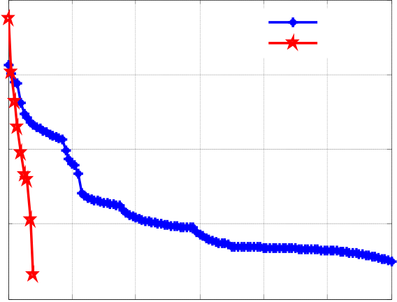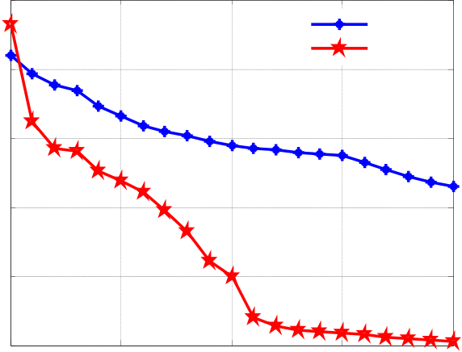

|  |  |  |  |  |
| --- | --- | --- | --- | --- |
| 218 | 2  10 | *Yu Zhi-fu et al. / AASRI Procedia 1 ( 2012 ) 213 – 219* | | BP |
| 2  10 | |
| BP | |
| 0  10 | PSO-BP | 0  10 | PSO-BP |

-2   
10

|  |  |  |  |  |  |  |  |  |  |  |  |  |  |  |  |
| --- | --- | --- | --- | --- | --- | --- | --- | --- | --- | --- | --- | --- | --- | --- | --- |
| MSE | -2 10 | 0 | 20 | 40 | 60 | 80 | 100 | 120 | MSE | -4 10 | 0 | 5 | 10 | 15 | 20 |
| -4 10 | -6 10 |
| -6 10 | -8 10 |
| iterations | iterations |

Fig.2. (a) Convergence curve of the same target error; (b) Convergence curve of the same training times

*Simulation B:* In order to study the deviation rate influence on recognition rate, while maintaining the data in Table 1 median value unchanged, assume all kinds of radar deviation rate are the same. When the emitter characteristic parameters obey uniform distribution in the interval, then according to the mean value and deviation rate can determine characteristic parameters range and construct the training samples. The number of samples is as same as simulation A. The curve of recognition rate in the different deviation rate is shown in Fig.4(a). Label PSO-BP1, PSO-BP2 and PSO-BP4 on behalf respectively of the output node number of 1, 2 and 4. The figure aims to study the different coding method influence on recognition rate. The corresponding relationship is shown in Table 3, and the symbol O in the table on behalf of the output layer nodes.

Table 3. Coding method list

|  |  |  |  |  |  |
| --- | --- | --- | --- | --- | --- |
| Coding method | R1 | R2 | R2 | unknown | *O* |
| PSO-BP1 | 1 | 2 | 3 | others | 1 |
| PSO-BP2 | 00 | 01 | 10 | 11 | 2 |
| PSO-BP4 | 1000 | 0100 | 0010 | 0001 | 4 |

According to the Fig.4(a), it is obvious that the smaller of deviation rate of characteristic parameters the higher recognition rate, which is consistent with theoretical analysis results. In addition, the recognition rate of different curves in Fig.4(a) is different, which indicates that the number of different encoding methods and network output nodes have influence on recognition rate. The more number encoded bits, the higher recognition rate. But the increasing of encoded bits will enlarge the complexity of the network, and eventually result in increasing running time.

*Simulation C:* In addition to the number of the training samples, the rest of the simulation conditions are the same with simulation B of PSO-BP2 method. Fusion recognition results under different population sizes and different method are shown in Fig.4(b) and the curves in the figure are the result of the 20 Monte-Carlo experiments. The graph annotation of PSO-BP2-500 represents second kinds of coding method and each kind of radar is constructed of 500 samples. The rest of the annotation can reason by analogy. PSO-BP2-500 of Fig.4(b) is corresponding to PSO-BP2 of Fig.4(a). The simulation results show that the increase of training data size can improve the recognition rate. But the more number of training samples, the longer time of training network. Different training times of neural network corresponding to different sample number are shown in the Table 4.

Table 4. Training time of different sample number

|  |  |  |  |  |
| --- | --- | --- | --- | --- |
| Sample number | 50 | 100 | 500 | 5000 |

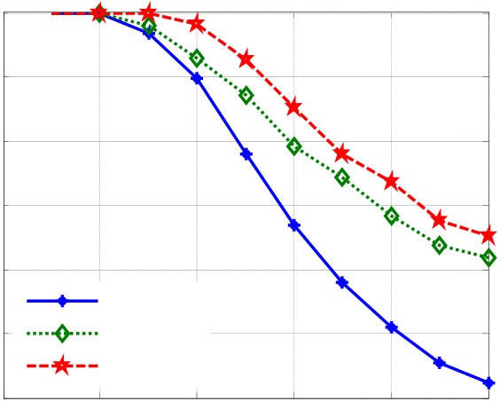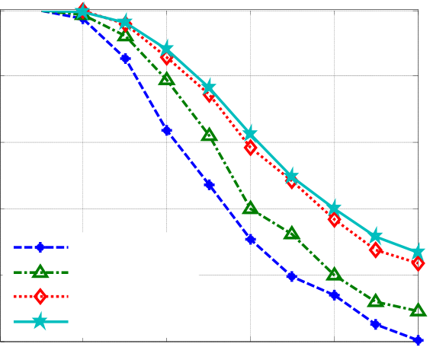

|  |  |  |  |  |  |  |  |  |  |  |  |  |  |  |  |  |  |  |
| --- | --- | --- | --- | --- | --- | --- | --- | --- | --- | --- | --- | --- | --- | --- | --- | --- | --- | --- |
|  |  |  | *Yu Zhi-fu et al. / AASRI Procedia 1 ( 2012 ) 213 – 219* | | | | | | | | | | | | |  |  | 219 |
| Training time/s | | | | 0.3054 | 0.4407 | | | | 0.8531 | | 3.5744 | |
|  |  |  |  |  |  |
| recognition rate/% | 100 | 0 | 0.4 | 0.5 |  |
| 100 | | | | | | | | | | | | |
| 90 | 90 | | | | | | | | | | | | |
| 80 | PSO-BP1 | | | recognition rate/% | | | | 80 | | | PSO-BP2-50 | | |
| 70 | 70 | | |
| 60 |
| 50 | PSO-BP2 | | | 60 | | | PSO-BP2-100 | | |
| PSO-BP2-500 | | |
| 40 | PSO-BP4 | | | PSO-BP2-5000 | | | | | | | | | |
| 0.1 | 0.2 0.3  deviation rate | 0.4 | 0.5 | | | 50 | | 0 | | 0.1 | 0.2 | 0.3 |
| deviation rate | |

Fig.4. (a) Different coding influence on recognition rate; (b) Data size influence on recognition rate

**5.Conclusion**

A kind of emitter recognition method based on PSO-BP neural network is proposed. The biggest difference related to the method of fixed value of characteristic parameters is the construction of sample data. The deviation rate is defined in the model to reflect the degree of the value of the characteristic parameters deviate from its center, and then the deviation rate influence on recognition rate is studied in the simulation. PSO algorithm is applied to improve the BP neural network. The simulation results show that the PSO algorithm can effectively overcome the defects of the BP neural network. Simulation experiments also studied the influence of the neural network output coding and sample data size to recognition rate. The final results show that the proposed target recognition method is effective and it has some value in engineering. The main problem of model is no considering the characteristic parameters with discrete value in the selection of emitter parameters, such as modulation information MOP. The next research focus is to construct model of more general while without losing practicality.

**References**

[1]Liu Hai-jun Liu Zheng Jiang Wen-li. A Method for Emitter Recognition Based on Cloud Model [J]. Journal of Electronics & Information Technology, 2009, 31(9):110-112.

[2]Guan Xin, He You, Yi Xiao. A novel rough set emitter signal recognition model [J].Journal of Astronautics, 2007, 28(3):685-688.

[3]Kenney J, Eberhart R C. Particle Swarm Optimization[C]. Proc IEEE international conference on Neural Networks. Perth, USA, 1995:123-125.

[4]LIU Hai-jun, LIU Zheng, JIANG Wen-li. Approach Based on Cloud Model and Vector Neural Network for Emitter Identification [J]. Acta Electronica Sinica, 2010, 38(12): 2798- 2804.

[5]Shieh Ching-sung and Lin Chin-teng. A vector neural network for emitter identification [J]. IEEE Transactions on Antennas and Propagation, 2002, 50(8):1120-1127.