|  |  |  |
| --- | --- | --- |
|  | Available online at www.sciencedirect.com | AASRI |
|  |
|  | Procedia |
|  | AASRI Procedia 1 ( 2012 ) 87 – 91 | www.elsevier.com/locate/procedia |

2012 AASRI Conference on Computational Intelligence and Bioinformatics

Research on the Semantic Web Reasoning Technology

Zhu ChuangLu a*

*aDepartment of Mathematics and information science, Weinan Teachers College Weinan, 714000, China*

**Abstract**

With the increase of Internet information, information processing requirements have more intelligent. The semantic Web is based on description logic, so it can be intelligent handling information with the logic. This paper mainly research Description Logic and inference machine and other parts from the semantic Web reasoning technology. It researches the relative technologies of existing ontology reasoning and analyzes the transforming relationship between different reasoning. Ontology reasoning service system which focuses on Description Logic is achieved. This system is combined with the semantic Web based on the DL inference machine. That can improve the traditional rule-based reasoning system. © 2012 Published by Elsevier B.V. Selection and/or peer review under responsibility of American Applied Science Research Institute

© 2012 Published by Elsevier B.V. Open access under [CC BY-NC-ND license.](http://creativecommons.org/licenses/by-nc-nd/3.0/)

Selection and/or peer review under responsibility of American Applied Science Research Institute

*Keywords:* Semantic Web; OWL DL; Reasoner; Description Logic ;

**1.Introduction**

The Semantic Web helps to give supporting materials of semantic feature to web; it is an innovation and extension of the World-Wide-Web. Its aim is to make all web resources have semanteme [1]. And it helps computers to know the semanteme to a certain extent in which makes sharing resources and computers cooperative intelligence more efficient. These information above shows that the research priorities of the

* Corresponding author. Tel.: +86 132 8141 5370   
*E-mail address:* wnsyzcl@126.com.

2212-6716 © 2012 Published by Elsevier Ltd. Open access under [CC BY-NC-ND license.](http://creativecommons.org/licenses/by-nc-nd/3.0/) doi: 10.1016/j.aasri.2012.06.016

88  *Zhu ChuangLu / AASRI Procedia 1 ( 2012 ) 87 – 91*

Semantic Web is how to make information have semanteme so that the computer can understand and process it.

**2.The Semantic Web and the Description Logic**

The Description Logic is a decidable subset of the first-order-predication logic. It is based on logic and its function on knowledge expressing is powerful. Meanwhile, the Description Logic is the logical foundation of the Semantic Web [2,3]. It is established based on the concept and role. Concept is defined as a collection of objects; role is defined as the binary relationship between objects.

Compare the axiom of the OWL DL with the syntax of the Description Logic(DL) [4,5], we can easily find out the corresponding relationship between the OWL DL and the Description Logic. Table 1 and 2 show us the comparing result [6].

Table 1. OWL DL construction operator and DL syntax

|  |  |
| --- | --- |
| **Construction operator** | **DL syntax** |
| intersectionOf | C1 � … � C n |
| unionOf | C1 � … � C n |
| complementOf | � C |
| one of | {x1…xn } |
| hasValue | P.C |
| allValuesFrom | � P.C |
| someValuesFrom | � P.C |
| maxCardinality | � nP |
| minCardinality | � nP |

Table 2. OWL DL axiom and DL syntax

|  |  |
| --- | --- |
| **Axiom** | **DL syntax** |
| subClassOf | C1 � C2 |
| equivalentClass | C1 � C2 |
| disjoinWith | C1 � � C2 |
| sameIndividualAs | {x1} � {x2} |
| differentFrom | {x1} � � {x2} |
| subPropertyOf | P1 � P2 |
| equivalentProperty | P1�P2 |
| inverseOf(P1) | P�P1- |
| transitiveProperty | P+ � P |
| functionalProperty | T � � 1P |
| Inverse- FunctionalProperty | T � � 1P- |
| Symmetric | P � P- |

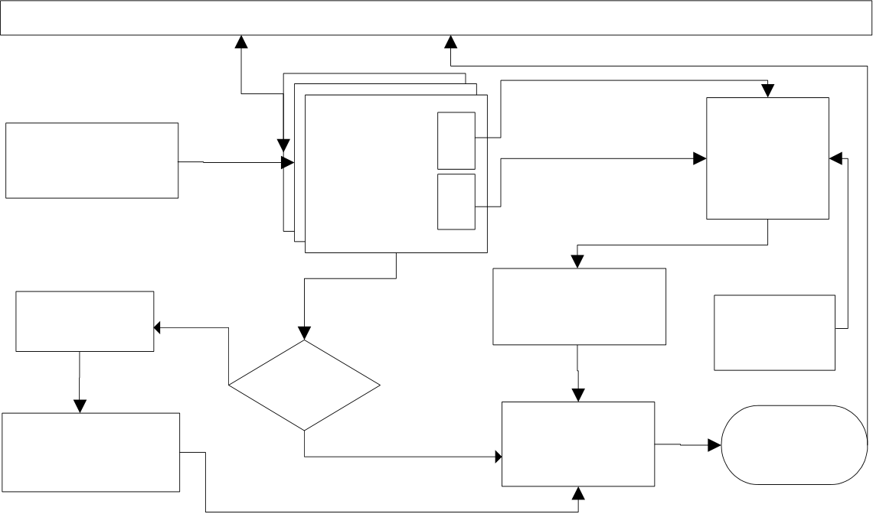

*Zhu ChuangLu / AASRI Procedia 1 ( 2012 ) 87 – 91*  89

From the two Tables, we can find that the construction operator and axiom of the OWL DL have corresponding relationship with the Description Logic to a certain extent. Table 1 and Table 2 are listed by combining the intension of the Description Logic based on the function of DWL DL [7]. We can see that the ontology is described in the description logic way. While the corresponding relationship between the Description Logic and OWL DL exactly demonstrates this point[8]. That’s to say, we can apply the theories of the Description Logic to build a knowledge base KB, that is KB= (T, B) [9]. Then reason the KB according to the reasoning method of the Description Logic and rearrange the knowledge base to find out the conflicts and implicit information.

**3.The Design of the Reasoning system of the Semantic Web**

��������������

|  |  |  |  |
| --- | --- | --- | --- |
| ������� | �������� | T | SWRL |
| ��������� | ���� |

A

�������

|  |  |  |  |
| --- | --- | --- | --- |
| �������� | ��� | ���������� | ���� |

���������

|  |  |  |  |  |
| --- | --- | --- | --- | --- |
| ������� | ��� | �� | ���������� | ������ |
| ���������� | ������ |

Fig.1. The inference system base on semantic Web

The semantic reasoning system begins from two aspects (refer with: Fig. 1). For one thing, the ontology reasoning is used to reduce the redundancy of information in knowledge base and to find out the conflicts of in the knowledge content. For another one, the ontology, which is reasoning operated by DL, combines with correlated rules to get a rule documents which is described by SWRL as the rule base of inference engine. This method can emerge the correlated rules of inference engine effectively. Because these rules are got through the ontology inference service, they can be intergraded closely with the knowledge base. The specific reasoning procedure begins from 3 aspects. First, design domain ontology and design the rules based on the domain ontology. Next, transfer the domain ontology of the OWL and SWRL rules into acceptable form for the inference engine. Finally, import knowledge and rules into the inference engine and then carry on reasoning.

We apply this system to automatic course-arranging system. At the very beginning, build ontology of teaching materials. This ontology not only can provide reasoning service for related resources but also make domain knowledge be reused conveniently. Then, set rules of course and test arrangement to carry through reasoning service. The main process is as follows:   
 (1) Build ontology of teaching materials.

(2) Use Jena base on DL to carry on reasoning about this ontology and find out the semantic conflicts in knowledge base.

(3) Set rules with the algorithm of course arrangement and describe it with SWRL language.

90  *Zhu ChuangLu / AASRI Procedia 1 ( 2012 ) 87 – 91*

(4) Transfer the format of the ontology and rules into the ontology and rules in JESS inference machine and then begin reasoning on the basis of rules.

There are several main factors which will influence the result of the course arrangement. The classroom must meet the requirements of the machine and suit to the quantity limit; and the classroom hasn’t been arranged to use yet. In addition, one class can’t be arranged to have two lessons. If a requirement is satisfied, one item of the course can be put into the class schedule. Use operator � on these obtained rules which is generated from those restricted condition. Then we will get a basic rule of course arrangement as follows: course(?c) �classroomIs(?c, null) �equipmentIs(?c, ?e1) �Equipment(?e1) �Classroom(?r) �classroomtimeIsfree(?r, ?t) �Time(?t) �equipmentIs(?r, ?e2) �Equipment(?e2) �swrlb�equal(?el,?e2) �sizeIs(?r, ?b) �sizels(?c, ?a) �swrlb�greaterThanOrEqual(?b, ?a)   
 ->arrangeclassroomls(?c, ?r) �arrangetimeIs(?c, ?t) �classroomtimeIsbusy(?r, ?t)   
 After the reasoning finished, the new fact which results from reasoning can be added to the ontology according to the need. The JESSTab function which manages the ontology can add, modify and delete some contents of its type, attribution and example. These management functions can be used with rules. If the entire preconditions are met, those operations are carried out. For instance, the restricted conditions of course arrangement are met, the conditions of course arrangement established. But this method is just adding a new fact to JESS; the ontology will not record the new fact proactively. For this reason, we can import this data into the ontology as needed, or we can import it into other application programs according to the API data provided by JESS. For instance, we can import this data into the knowledge base so that the people in charge of course arrangement can visit this data by user interface. In addition, we can put this data online so that those related people can inquire it conveniently.

**4.Summary**

The Semantic Web is considered to be a web of next generation. But there are many difficulties and challenges in realizing the Semantic Web, such as semantic interconnection, semantic reasoning and intelligent polymerization and other theoretical or technical barriers. Generally speaking, there are 2 aspects in the study of semantic reasoning. One is how to established the rules when building an ontology; how to reveal the implied relation in the knowledge organization systems better; how to balance the dominant expression of semantic relations and complexity of building the ontology. The other is how to carry through the semantic reasoning more efficient and exactly during the stage of designing and implementation about the system. This paper is concentrated on how to make semantic reasoning efficient. It builds the prototype system of semantic reasoning and uses subsystem of the Description Logic reasoning to conduct the semantic reasoning. In future, we can focus on the construction mechanism about the rules of the semantic reasoning when building the ontology. And we need to combine it with the designing and implementation of the system in order to provide references for the semantic reasoning of various knowledge service systems in future.

**Acknowledgements**

This paper is one of the research results of education department of Shaanxi provincial government special research project(11JK1067).

**References**

[1]Van Kralingen R. W., Visser P. R. S., Bench-Capon T. J. M., and Herik H. J., "A principled approach to

*Zhu ChuangLu / AASRI Procedia 1 ( 2012 ) 87 – 91*  91

developing legal knowledge systems", International Journal of Human-Computer Studies, December 1999, Vol. 51, No. 6, pages 1127-1154.

[2]Trevor J. M. Bench-Capon, "Ontologies in legal information systems: the need for explicit specifications of domain conceptualizations", International Conference on Artificial Intelligence and Law, 1997, pages 132-141.

[3]Neches R., Fikes R. E., Gruber T. R., "Enabling Technology for Knowledge Sharing", AI Magazine, 1991, Vol. 12, No. 3, pages 36-56.

[4]Thomas R. Gruber, "A Translation Approach to Portable Ontology Specifications", Knowledge Acquisition, 1993, Vol.5, No.2 pages199-220.

[5]Borst P., "Construction of Engineering Ontologies for Knowledge Sharing and Reuse", PhD thesis, Tweente University, 1997.

[6]Studer R., Benjamins V. R., Fense I. D., "Knowledge Engineering, Principles and Methods", Data and Knowledge Engineering, 1998, Vol.25, No.12, pages 161-197.

[7]OWL Web Ontology Language Semantics and Abstract Syntax, W3C Recommendation, 10 February 2004, http://www.w3.org/TR/owl-semantics/   
[8]Tom Gruber, "Toward Principles for the Design of Ontologies Used for Knowledge Sharing", International Journal of Human-Computer Studies, 1993, Vol.43, No.5-6, pages 907-928.

[9]Natalya F. Noy, Sintek M., Decker S., Crubezy M., Fergerson R. W., and Musen M. A., "Creating Semantic Web contents with Protege-2000", IEEE Intelligent Systems, 2001, Vol.16, No.2, pages 60–71.