|  |  |  |
| --- | --- | --- |
|  | Available online at www.sciencedirect.com | AASRI |
|  |
|  | Procedia |
|  | AASRI Procedia 2 ( 2012 ) 223 – 228 | www.elsevier.com/locate/procedia |

2012 AASRI Conference on Power and Energy Systems

Seawave Power Farm Design: A Case Study

V. Franzittaa, A. Violaa and M. Trapaneseb*

*aUniversità di Palermo –Dipartimento di Ricerche Energetiche e Ambientali- Palermo-Italy*   
*bUniversità di Palermo – Dipartimento di Ingegneria Elettrica, Elettronica e delle Telecomunicazioni – Palermo – Italy.*

**Abstract**

Current energy crisis and general concerns on environmental issues have triggered an ever increasing effort on harvesting renewable energies.

Amongst renewable energy sources, sea wave energy is definitely the one that has been less utilised.

© 2012 Published by Elsevier B.V. Selection and/or peer review under responsibility of American Applied Science Research Institute This is probably caused by two reasons: i) the strong technical novelties that are required to extract the energy that is contained in a highly and stochastically variable motion; ii) the difficulty o find a suitable electrical system able to convert the energy contained in the motion of the sea into electrical energy.

In this paper we propose an approach to set up a general methodology toward the design of a seawave farm. The first step is explained how to choose the conversion system, in the second step is discussed the connection scheme among the converters, in the third step is reported a case study of a whole seawave farm.

© 2012 The Authors. Published by Elsevier B.V.

© 2012 Published by Elsevier B.V. Selection and/or peer review under responsibility of American Applied Science Research Institute Selection and/o[r peer review under](http://creativecommons.org/licenses/by-nc-nd/3.0/) responsibility of American Applied Science Research Institute Open access under [CC BY-NC-ND license.](http://creativecommons.org/licenses/by-nc-nd/3.0/)

*Keywords:*seawave; linear generator; power farm;

**1.Introduction**

Public concerns on environmental issues have stimulated an ever increasing effort on harvesting renewable energies [1-5].Among them, several approaches to harvest sea wave energy have been proposed; almost all of them introduce a mechanical conversion device between the waves and the electromagnetic generator. [6]

* Corresponding author. Tel.: +39-091-23860292 fax: +39-091-488452.   
*E-mail address:*marco.trapanese@unipa.it.

2212-6716 © 2012 Published by Elsevier B.V. Selection and/or peer review under responsibility of American Applied Science Research Institute Open access under [CC BY-NC-ND license.](http://creativecommons.org/licenses/by-nc-nd/3.0/) doi: 10.1016/j.aasri.2012.09.038

224  *V. Franzitta et al. / AASRI Procedia 2 ( 2012 ) 223 – 228*

To generate a substantial amount of power, Wave Energy Converters have been proposed. Several solutions have been discussed, some consider a single energy absorber others consider several abosrbing unit. In this case, the absorbing units are arranged in several rowsor in a farm.Such units may generate 10–100 [kW] depending on their size and wave spectrum. A larger buoy may absorb more energy but a too large buoy will not rise, only sways.[7]   
 This stage converts the mechanical energy contained in the waves into a more usable mechanical energy; it can be a hydraulic coupling device or a mechanical gear and, in any case, introduces additional losses and additional maintenance requirements. In order to reduce these losses a generator directly coupled to the sea waves should be used. Linear electrical generator has been recently studied for the exploitation of sea wave energy. Most of these projects considers mechanical converters in MWs scale and therefore not very suitable for a sea like Mediterranean sea where the energy density is lower than in the ocean. Moreover a general methodology to design a seawave power farm has not been fully established.

In this paper we discuss an approach to design a seawave farm through a case study. This case is located in north west part of sicily.

**2.Description of the proposed design approach**

The first step to approach the general design of a seawave farm is the choice of the converter. In order to perform this task one must consider the characteristics (in terms of waves, sea depth, currents etc) of the area where the generator will be located. In the case under study the waves are not very high (as it is shown in a following section we are in the mediterranean sea) as a result one must use a converter that is able to exploit such a limited source. It can be seen that in this case the best solution is represented by a conversion system has the structure of fig.1. Other conversion topologies can be realized but the one of fig.1 captures the essential features of the most of conversion systems.

|  |
| --- |
|  |

Fig. 1. Schematic description of conversion system based on PM linear generator

In this device the slider of the PM linear generator is driven from a buoyant (that is rigidly connected to the slider) and counteracted by a spring. The generated emf is produced from the motion of the vertical level of the sea. The typical frequency of sea waves is in the range of the tenth of Hz and as a result a machine with a high number of poles is needed in order to obtain an output whose average frequency is in a range that is easily convertible.

The choice of the technology is the input for the design of the farm, which is split in 8 steps.

The first step deals with the site evaluation and preparation: the characteristics of waves are measured and are used to chose the detailed design of the converter to be used and the preparation which are needed in the installation area.

*V. Franzitta et al. / AASRI Procedia 2 ( 2012 ) 223 – 228*  225

In the second step, the mechanical installation requirements are specified and the mechanical drawing of the installation are specified.

In the third step the level of low voltage is chosen. In the fourth section the distribution equipment to be used is identified. In this section a discussion on the maintenance strategy to be used in the farm is given. In section fifth and sixth losses and voltage drop and power quality are calculated.

In this section the energy requirements needed are calculated. The evaluation of section 4, 5 and 6 are used in section 7 to design the protective relays to be used in the farm. Finally, in section 8 a business plan of the plant is presented.

Following the above outlined steps, a power farm has been designed and its size has been chosen in order to maximize the energy extraction in the waters of west Sicily. The data used to optimize the converter and the farm are some experimental data on the energy density of seawes on a point located on the north west part of Sicily in the middle of Mediterranean sea. The numerical results and optimization of this procedure is illustrated in this paper[1].

**3.Generator structure and interconnection scheme**

The design approach above outlined has led to design a power farm based on several low power units electrically interconnected.

The parameters of the first prototype are shown in the following table:

Table 1.Characteristics of the PM generator obtained

|  |  |
| --- | --- |
| **Geometric Parameter** | **Value** |
| Pole pitch [mm]  Slot height  Number of phases  Number of slots per pole per phase  Stator slot width [mm]  Tooth height [mm]  Stator yoke height [mm]  Length of the magnet [mm] | 150  70  1/3  3/1  12.5  12.5  60  50 |

The prototype has been manufactured and is shown in fig.2.

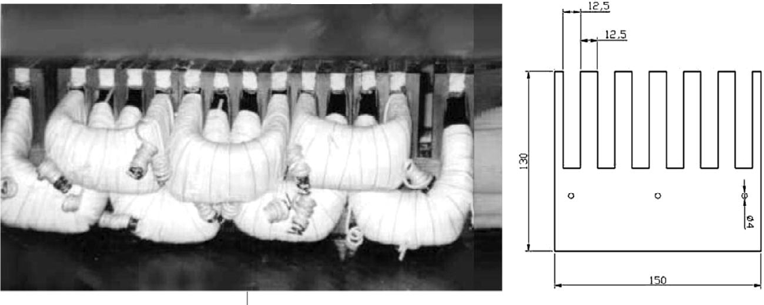

Fig.2 a) Half of the stator of the machine and b) cross section of one of modules that compose the stator. Two interconnection schemes have been chosen and compared-They are shown in fig.3

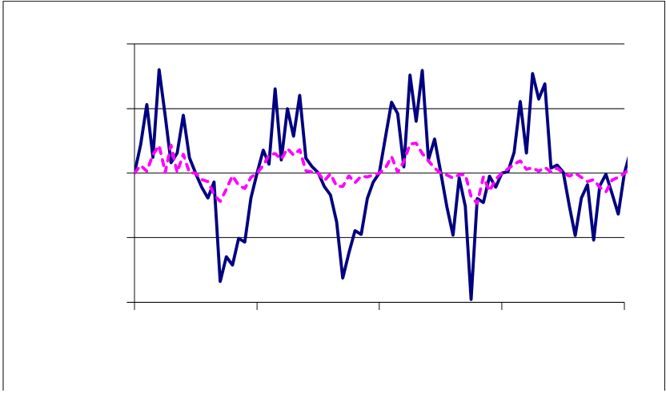

226  *V. Franzitta et al. / AASRI Procedia 2 ( 2012 ) 223 – 228*



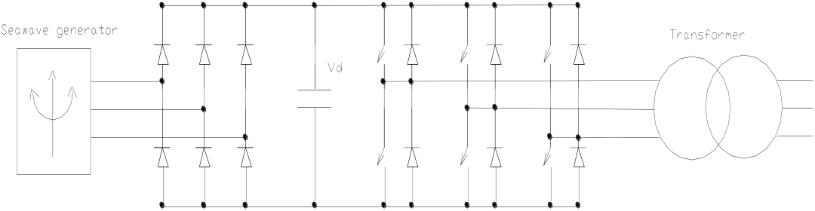



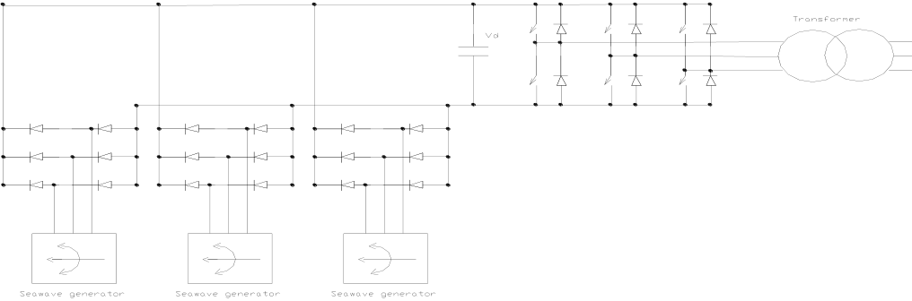

Fig.3 Interconnection schemes   
 The converter were simulated by assuming a standard numerical model of the inverter. The parameters that we have considered is the ripple in dc link, the time of use of each inverter the continuity of the generation. The simulation was run many times and in each run each generator was exposed to a set of waveform generated as illustrated. Each generator had the characteristics of the one reported above.

In fig. 4 the ripples of the dc link for the two approaches are compared. In fig. 4 the voltage ripple of the dc link of the centralized approach is compared to the typical voltage ripple of a single generic converter in the case of the decentralized approach. It can be clearly seen that in all respects the partially centralized approach guarantees a more reliable and efficient operating condition. Moreover, the requirement on the buffer capacitance are less tight because the dc link continuously receives power from some generators of the farm and, therefore, its voltage is more easily kept at the value required to generate power in optimum condition.

As far as the use of each inverter is concerned, in the partially centralized approach the inverter is used constantly even if the energy carried by the seawaves is small, for the decentralized approach the inverter are used discontinuously and for a percentage of time lower than 50 %. The continuity and the smoothness of the generation is enormously higher in the partially centralized approach. This is due to the fact that a common dc link can have a higher buffer capacitance and therefore it is much more stable than a dc link connected to a single generator.

2

1,5

|  |  |
| --- | --- |
| **Vd** | 1 |

0,5

0

|  |  |  |  |  |
| --- | --- | --- | --- | --- |
| 0 | 0,1 | 0,2 | 0,3 | 0,4 |

**t**

*V. Franzitta et al. / AASRI Procedia 2 ( 2012 ) 223 – 228*  227

Fig. 4Voltage ripple of the dc link (continuos line decentralized approach, dotted line semi centralized approach)

**4.Case study**

The previous solutions have been chosen with the methodology above outlined in order to be installed on the north west part of sicily.   
 The location is shown in fig. 5

|  |  |
| --- | --- |
|  |  |

Fig. 5 Geographical location of seawave farm

The power farm will not connected to the grid but it will be used to produce hydrogen. That will be used to produce electricity through a fuel cell.

**5.Conclusions**

In this paper we present an approach to the design of seawave power farm. The generators used in the farm are Permanent Magnet (PM) linear generators driven by the seawavesand, therefore, they generate highly distorted emfs. We propose and compare two possible ways to connect the generator to the grid. One is a decentralized approach where for each generator there is a conversion subsystem that permits the direct connection of the generator to the a.c. grid, the other one is based on partially centralized approach where an a.c.-d.c. rectifier is connected to the generator and the rectifier outputs is pumped into a dc link that can receive the power from other units and that can supply a dc-ac converter directly connected to the power grid. We compare the performances of the two approaches in terms of ripple of the dc link voltage, the time of use of each inverter and the continuity of the generation and we show that the partially centralized approach is definitely more efficient and reliable of the centralized approach.

Finally we present the location of a case study in north west part of Sicily (Italy)

**Acknowledgment**

This work was funded in part by "IMPETUS" program of Italian "Ministerodell'ambiente"

228  *V. Franzitta et al. / AASRI Procedia 2 ( 2012 ) 223 – 228*

**References**

[1] Bonanno, A., Franzitta, V., Muzio, F.P., Trapanese, M. A multiphysics approach to the design of a seawave energy conversion system. Proceedings of ICEST, Singapore, 2008: 2197.

[2] Di Dio, V., Franzitta, V., Muzio, F., Scaccianoce, G., Trapanese, M. The use of sea waves for generation of electrical energy and hydrogen. MTS/IEEE Biloxi - Marine Technology for Our Future: Global and Local Challenges, OCEANS, 2009.

[3] Franzitta, V., La Gennusa, M., Peri, G., Rizzo, G., Scaccianoce, G.– A Toward a European Eco-label brand for residential buildings: Holistic or by-components approaches? Energy 2011;36:4 -1884.

[4] Franzitta, V., Rizzo, G., Renewable energy sources: A mediterranean perspective ICBEE 2010 - 2nd International Conference on Chemical, Biological and Environmental Engineering, Proceedings : 48. [5]Lo Brano V. , Orioli A., Ciulla G., Culotta S.Quality of wind speed fitting distributions for the urban area of Palermo, Renew Energy 2011;36:3- 1026.

[6] Beels C., Troch P., Kofoed J.P, Frigaard P., Kringelum J.V., Kromann P.C., Donovan M.H., De Rouck J., De Backer G.A methodology for production and cost assessment of a farm of wave energy converters. Renew Energy 2011;36- 3402.

[7] ThorburnK.,Leijon M., Farm size comparison with analytical model of linear generator wave energy converters- Ocean Eng 2007;34-908.