

|  |  |  |
| --- | --- | --- |
|  | Available online at www.sciencedirect.com |  |
| **ScienceDirect** |
| AASRI Procedia 7 ( 2014 ) 20 – 25 |

2013 2nd AASRI Conference on Power and Energy Systems

Trading with Renewable Energy Sources in Slovakia

Adriana Csikosova*, Maria Antosova, Katarina Culkova

*Technical university of Košice, Faculty BERG, Park Komenského 19, 042 01 Košice, Slovakia*

**Abstract**

We can discuss about renewable energy sources from various points of view and with orientation to the various partial problematic. Extent of the contribution no way allows approaching the problematic in its whole complexity. In spite of this we will look at one of its side, mainly trading with renewable energy sources (RES) in area of electrical engineering. Goal of the contribution is to search main factors, influencing trading with chosen RES in Slovakian energetic market with closer orientation to the market with electricity, where influencing factors present energetic legislation, system of support for electricity production from RES, price regulation, final price of electricity with tariff of system’s service.

|  |
| --- |
| © 2014 The Authors. Published by Elsevier B. V. Open access under [CC BY-NC-ND license.](http://creativecommons.org/licenses/by-nc-nd/3.0/)© 2013 Published by Elsevier B.V.  Peer-review under responsibility of Scientific Committee of American Applied Science Research Institute Selection and/or peer review under responsibility of American Applied Science Research Institute |

*Keywords:* Renewable energy sources, market with electricity, energetic legislation, support tools at RES market

**Introduction**

Renewable energy sources (RES) became in last time one of the main theme during discussions about energetic. Goals of European Union to 2020 had become one of the impulses for their gradual dominance in public interviews, among which we can speak about goal to achieve 20% rate of RES on energetic mix to 2020. Electricity production from RES is one of the particular forms of electricity production that has preferred access, guaranteed by legislation and connection to the system, as well as preferred transition or distribution and taking of produced electricity that serves for covering of losses in distribution system (BNSR,

* Corresponding author. Tel.: +421-55-602-2929   
*E-mail address:* adriana.csikosova@tuke.sk

2212-6716 © 2014 The Authors. Published by Elsevier B. V. Open access under [CC BY-NC-ND license.](http://creativecommons.org/licenses/by-nc-nd/3.0/) Peer-review under responsibility of Scientific Committee of American Applied Science Research Institute doi: 10.1016/j.aasri.2014.05.023

*Adriana Csikosova et al. / AASRI Procedia 7 ( 2014 ) 20 – 25*  21

2012).

**1. Slovak market with electricity produced from RES**

Production of electricity from RES is one of the special forms of electric energy production that has guaranteed and preferred access and connection to the system, preferred transition or distribution, as well as takes off produced electricity that serves for covering of losses in distribution system. Electricity, produced from RES is using for covering of losses in regional distribution systems for fixed prices, given by Bureau of net sector regulation (BNSRS) decree. Difference among fix prices of electricity and market prices of electricity on losses is paid to operator of distribution system through tariff of system’s service. Determination or accreditation of ways, processes and conditions of prices creation for electricity production from RES is in the hand of BNSR that is organ of state administration of price regulation in net sector together with Council for regulation (Tauš, Taušová, 2009).

In Slovakia, similarly as in majority of EU membership states there are used regulating processes that revived RES market. In 2009 method of price roof started to be used instead of revenue method, or so-called “revenue cap”. Method of price roof is considered as “price cap, by which stabilization of prices during whole regulating period is achieved with considering of new investments to net industry in electro energetic and gas industry (BNSR, 2010).

One of the possible supporting of production of electricity from RES means ***providing of surcharge*** for produced electric energy from RES (***so-called green bonus, surplus***). In spite official conception of “green bonus” is not used in Slovakia, its principle means producer sales produced electricity to final client or businessman with electricity, and moreover he has right to cash from operator of regional distribution system green bonuses. Such system started to be applied in Slovakia by acceptance of amending act No. 309/2009 Z. z. about RES support and highly effective combined production.

***New price of electricity,*** determined by BNSR for following period (not more then 3 years) ***cannot be less then 90 % of price, relevant in running period.*** This establishment is not relating to the determination of electric energy price for equipment of electricity producer, using solar or wind energy (Law No. 309/2009).

Table 1 summarizes construction of electricity price for electricity, produced from RES, which consists from price of electricity on loss and surcharge. At the same time table 1 illustrates way of calculation of individual items and specification of correspondent paragraph of Law No. 309/2009 Z. z. about RES support and highly effective combined production, to which all correspondent items relate.

Table 1. Price of electricity, produced from RES

|  |  |  |  |  |
| --- | --- | --- | --- | --- |
| **Price of electricity from RES** |  | **Price of electricity for covering of losses** |  | **Surcharge** |
| § 6 article 1a) Law No. 309/2009 Z. z. |  | § 6 article 1b) Law No. 309/2009 Z. z. |  | § 6 article 1c) Law No. 309/2009 Z. z. |

|  |  |
| --- | --- |
| 22 | *Adriana Csikosova et al. / AASRI Procedia 7 ( 2014 ) 20 – 25* |

|  |  |  |  |  |
| --- | --- | --- | --- | --- |
| Approved or defined by ÚRSO according § 12 article 1a) Law No. 276/2001 Z. z. about regulation in net industry and about change and completion of some legislation  according later decrees | **=** | Arithmetical average of electricity prices for covering of losses for all operators of regional distribution systems (approved or defined by BNSR) | **+** | Difference between electricity price and price of electricity for losses that operator of regional distribution system pays to electricity producer, where equipment of electricity producer is connected to the system, or it is existing at the limited area |

Source: Law No 309/20009 Z. z.

Following table 2 illustrates prices of electricity, produced from chosen RES, mainly small hydroelectric plant, solar energy, wind energy and biomass.

Table 2. Review of purchase prices of electricity from RES in Slovakia in 2013

|  |  |  |
| --- | --- | --- |
| **Source** |  | **Purchase prices in €/MWh** |
| Water energy with total installed capacity of electricity producer’s equipment | to 1 MW including | 109,80 |
| from 1 MW to 5 MW including | 97,98 |
| over 5 MW | 61,72 |
| Solar energy with total installed capacity of electricity producer’s equipment to 100 kW that is placed on roof construction or circuit covering of one building, connected with earth by fix basis | | 119,11 |
| Wind energy | | 79,29 |
| Common burning or common burning by combined production: | 1. deliberately cultivated biomass | 112,24 |
| 2. other waste biomass | 122,64 |
| 3. corny straw | 154,27 |
| 4. bio liquid | 115,01 |

Source: Announcement BNSR NO. 184/2012

Except of undeniable convenience of system for purchase prices by guarantee of investors stability, this system brings also several risks, mainly considerable increasing of final price of electricity. In spite developing competition on market in area of electricity sale partially decreases final price of electricity, its height is considerably influenced by tariff of system’s operation. Growth of tariff price during last period had been characteristic mainly due to the RES support, meanwhile greatest part of support belong to photovoltaic power plants.

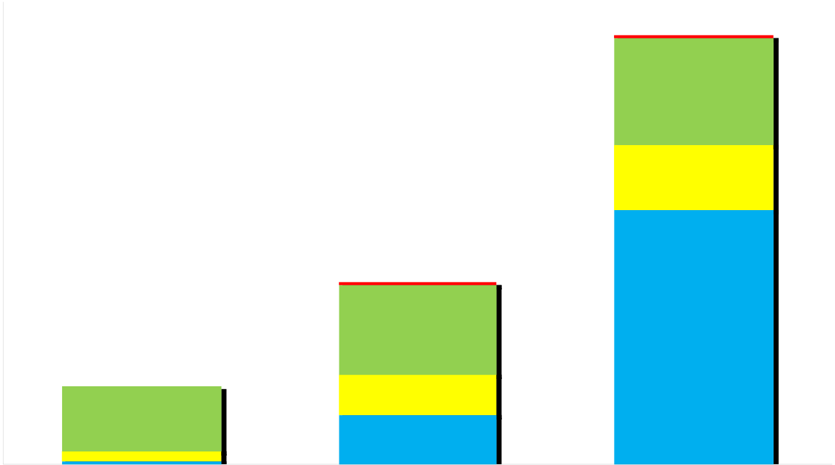

*Adriana Csikosova et al. / AASRI Procedia 7 ( 2014 ) 20 – 25*  23

**2. Support tools on RES market**

RES market is given by demand and supply. Supply consists from supplement and costs of RES and it is defined in investment and production phase of given project, orientated to RES using. On the other hand demand on RES is stimulated by tools, orientated to consumption.

Next relations can be observed among price and volume. One group of tools has influence to the RES prices, or it strikes for easy trading with RES on market by price surcharges, the other group has legal characteristic and it prescribes minimal volume of energy, produced from RES that has to be produced or consumed (Dijk 2003).

Intensity of RES development in individual EU states is rather different. It depends partially on geographical place and natural givenness of the country, but mainly on power of supportive tools applying.

Development of support of RES energy production in 2009-2011 is documented by Figure 1, from which results significantly increased RES support in 2011, manifested also at final prices of electricity, meanwhile biggest rate of electricity production from RES belongs to photovoltaic (illustrated at Figure 2).

|  |  |  |  |  |  |  |  |  |  |  |  |  |  |  |  |  |  |  |  |  |  |  |  |  |  |  |  |  |  |
| --- | --- | --- | --- | --- | --- | --- | --- | --- | --- | --- | --- | --- | --- | --- | --- | --- | --- | --- | --- | --- | --- | --- | --- | --- | --- | --- | --- | --- | --- |
| 16   **0,1093** 14   **3,6934** 12   |  |  |  |  | | --- | --- | --- | --- | | **eur/MWh** | 10 | **0,0777** | **2,2306** | | 8 | | 6 | | 4 | **3,0969** | **8,8048** |   **0,0000**   |  |  |  |  |  |  |  |  |  |  | | --- | --- | --- | --- | --- | --- | --- | --- | --- | --- | | 2 | **2,2574** | RES |  | CPEH | **1,4073** | |  | OSME | **2011** | | 0 | **0,1161 0,3484** | **1,7022** | | | **2009** | **2010** | | |  |  | PPNO | |

Fig. 1. Structure of traffic for system’s operation in 2009-2011 (Holjen�ík, 2011)

Legend: RES – Renewable energy sources   
 CPEH – Combined production of electricity and heat   
 PPNO – power plant Nováky   
 OSME – Organizations of short term market with energy

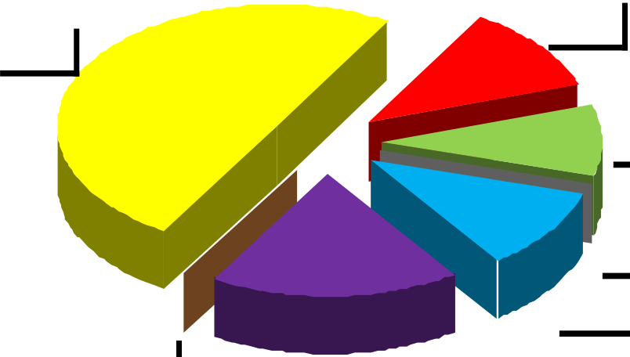

|  |  |
| --- | --- |
| 24 | *Adriana Csikosova et al. / AASRI Procedia 7 ( 2014 ) 20 – 25* |

|  |  |  |  |  |  |  |  |  |  |  |  |  |  |  |  |  |  |  |  |  |  |
| --- | --- | --- | --- | --- | --- | --- | --- | --- | --- | --- | --- | --- | --- | --- | --- | --- | --- | --- | --- | --- | --- |
| |  |  |  |  |  |  | | --- | --- | --- | --- | --- | --- | | **49,63%** | **0,04%** | **18,47%** | **11,78%** |  | Biomass | | **9,26%** |  | | Biogas | |  | Wind | | **0,05%** |  | Water | |  | CPEH | |  | Geothermal | | **10,77%** |  | Solar | |

Fig. 2. Rate of RES and combined production support in tariff for system operation (Holjen�ík 2011)

From the mentioned we can deduce that in spite in 2011 individual items of electric energy price were not increased, there was even occurring of several items decrease, not excluding power electricity, there occurred increasing of final price of electric energy for households averagely about 4,82% as a whole.

**3. Conclusion**

System of support of electricity production from RES connects very closely with RES trading in area of energetic. Prevailing and mostly used support tool is system of purchase prices, many times in combination with surcharges to market price that is used in majority of EU countries. Similarly effective seems to be also support by the way of investment donations and tax measurements that are used in large measure as well. System of obligatory quota in combination with trading green certificates is used as main system of support in Belgium, Romania, Poland, Italy and Great Britain. System of tender is less used tool for RES support and in present time it is realized in Ireland, Latvia, Italy or Great Britain. In connection with dominated purchase prices we can discuss about convenience of this system, since according some opinions this system of support deforms market and it is not sufficiently effective. System of obligatory quota is trying to be forefront as well as system of green certificates, which could bring more of market environment and at the same time more intensive development of electricity production from RES. But new member states are against that, since they apply system of purchase prices and creation of market system with green certificates would be in short time very demanding, till unrealizable. Due to the mentioned new member states are orientated rather to the increasing of quality of present supporting systems.

Companies, acting in Slovakian energetic sector would welcome finishing of regulation of energy prices in areas, where various suppliers exist, since by this way product’s competition would be enabled. Price deregulation presents trend that is promoting also by European Commission. In case we consider fact that price of commodity element would be created in area, where there are no natural monopoly, according demand and offer, it lead to the decreasing of final price of energy. From the determined findings we can generalize that open markets with properly acting competition cannot exist in long time with regulated final prices of energy.

*Adriana Csikosova et al. / AASRI Procedia 7 ( 2014 ) 20 – 25*  25

**Acknowledgements**

Contribution is partial result of project solving VEGA MŠVVaŠ SR 1/0176/13 and 1/1033/12.

**References**

[1] Dijk, A. L. et al. 2003. *Renewable Energy Policies and Market Developments*. Brusel: European Commission, 56 p.

[2] Holjen�ík, J. 2011. *Regula�ná politika na nastávajúce regula�né obdobie 2012 – 2016.* Bratislava, Rada pre reguláciu, [on-line] http://www.urso.gov.sk/sk/rpr/regulacna-politika   
[3] Bureau of net sector regulation (BNSR). 2012. *Správa o dodržiavaní pravidiel pre fungovanie trhu s elektrinou a plynom za rok 2011 a o opatreniach na ich dodržiavanie.* [on-line]   
http://www.urso.gov.sk/doc/dokumenty/Sprava-o-dodrziavani_PTE_PTP.pdf   
[4] BNSR. 2010. *Výro�ná správa 2010*. [on-line] http://www.urso.gov.sk/doc/vs/VS2010_sk.pdf   
[5] Tauš, P. , Taušová, M. 2009. *Economical analysis of FV power plants according installed performance*.

In: Acta Montanistica Slovaca, 14, No. 1 (2009), pp. 92-97. ISSN 1335-1788   
[6] Law No. 309/2009 Z. z. o podpore obnovite�ných zdrojov energie a vysoko ú�innej kombinovanej výroby.