Available online at [www.sciencedirect.com](http://www.sciencedirect.com/)



**ScienceDirect**

AASRI Procedia 8 (2014) 118 – 122

2014 AASRI Conference on Sports Engineering and Computer Science (SECS 2014)

A New Algorithm for Tone Detection

Chao-Ping Chua, Li-Te Shena, Shaw-Hwa Hwanga *

*a#1, Sec. 3, Chung-hsiao East Rd., Taipei, Taiwan, ROC*

**Abstract**

This study presents a new algorithm for detecting dual-tone multi-frequency (DTMF) signals. The discrete multi- frequency transform (DMFT) method with optimal phase was employed to reduce the DTMF detection computations. With the DMFT approach, the pass-band ripple is employed as a cost function, and the optimal phase can be obtained using the open-loop search method. Compared to the traditional discrete Fourier transform (DFT) approach, not only is a computational saving of 75% to 83% achieved, but spectrum efficiency is also maintained. These experimental results demonstrate the excellent performance of the DMFT method.

© 2014 Published by Elsevier B. V. This is an open access article under the CC BY-NC-ND license ([http://creativecommons.org/licenses/by-nc-nd/3.0/).](http://creativecommons.org/licenses/by-nc-nd/3.0/))

© 2014 Published by Elsevier B.V.

Selection and/or peer review under responsibility of American Applied Science Research Institute

Peer-review under responsibility of Scientific Committee of American Applied Science Research Institute

*Keywords*: Tone Detection, Goertzel Algorithm, DFT, FFT, DTMF.

# 1. Introduction

In a public switched telecommunications network (PSTN), dual-tone multi-frequency (DTMF) signaling is widely employed for analog telephone dialing, data entry, voicemail systems, and remote control of various consumer electronics. DTMF signaling is used to transfer digital numbers. The PSTN system also defines additional tones to indicate the status of the calling process.

The International Telecommunications Union (ITU) specifications allow a frequency tolerance of approximately ±1.5% for valid DTMF tones. Thus, tones with an offset of ±3.5% must be rejected. However,

* Corresponding author. Tel.: +886-2-27712171#2167

*E-mail address:* [t100319011@ntut.edu.tw.](mailto:t100319011@ntut.edu.tw)

2212-6716 © 2014 Published by Elsevier B. V. This is an open access article under the CC BY-NC-ND license ([http://creativecommons.org/licenses/by-nc-nd/3.0/).](http://creativecommons.org/licenses/by-nc-nd/3.0/))

Peer-review under responsibility of Scientific Committee of American Applied Science Research Institute doi:10.1016/j.aasri.2014.08.020

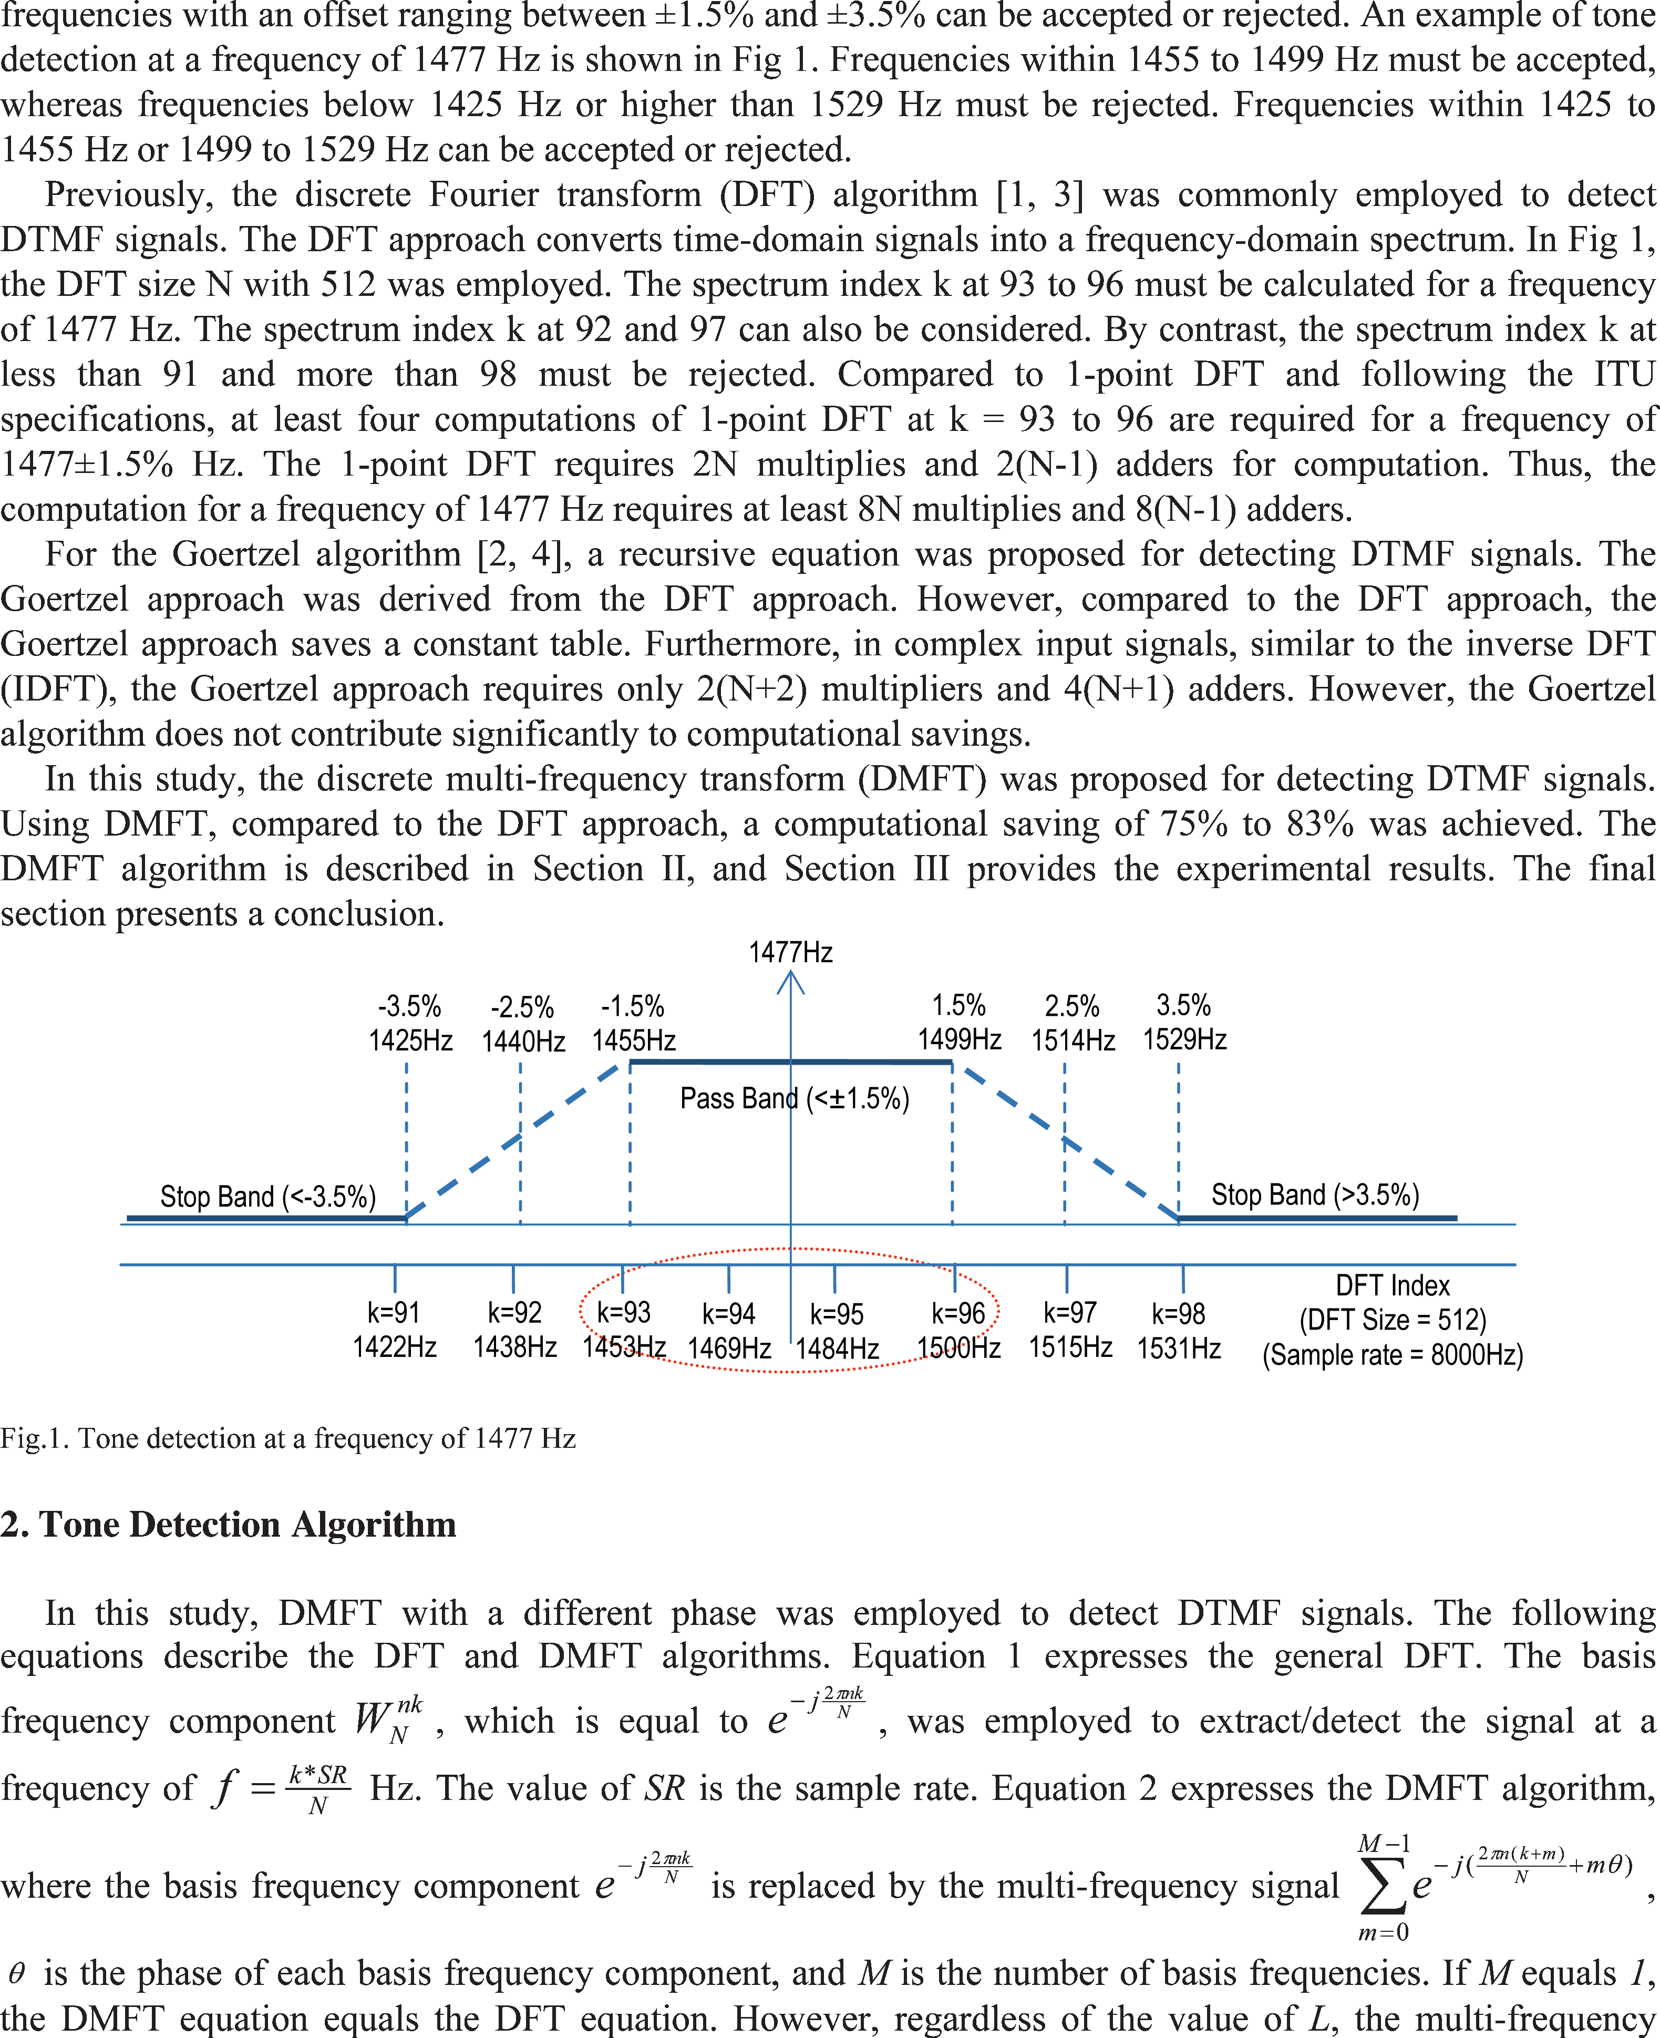

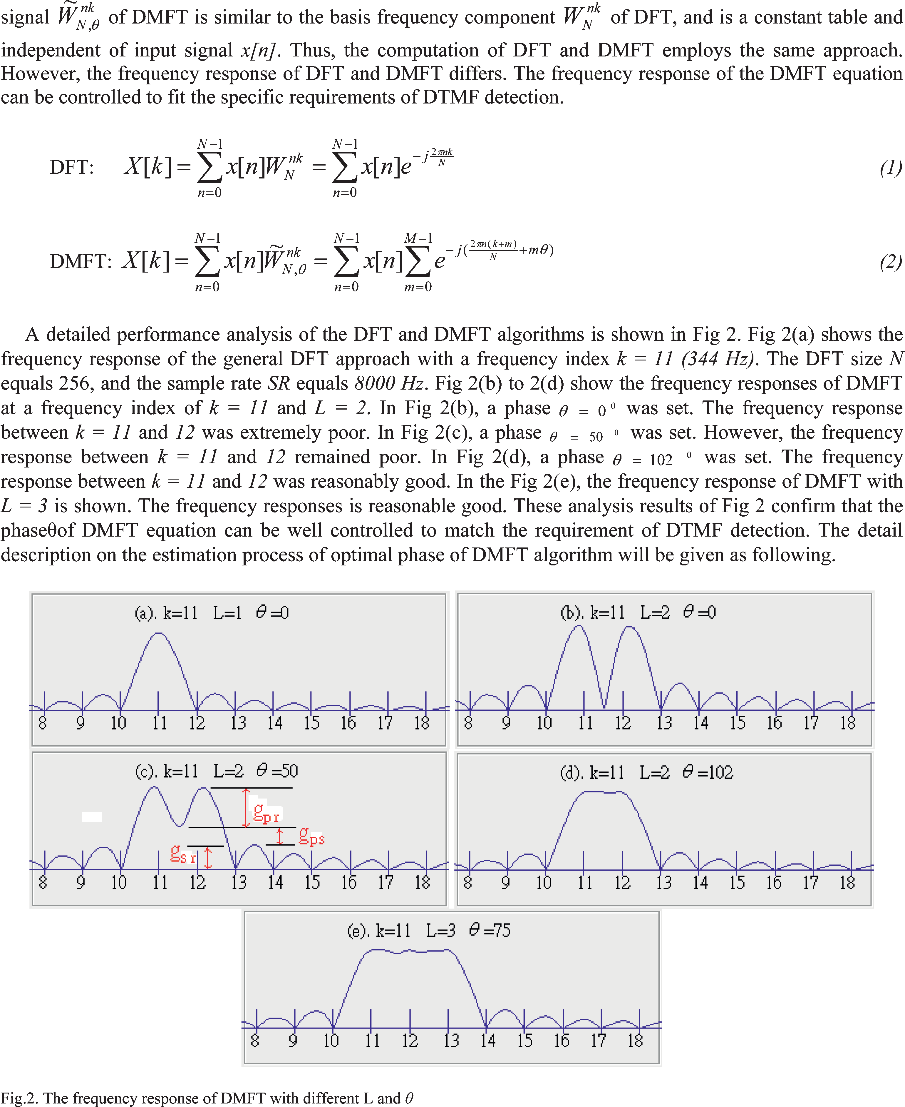

Two cost functions, as shown in Fig 2(c) and defined below, were identified to determine the optimal phase *θ*ˆ . *θ*ˆ ={ min(*gpr*) | 0  *θ*  360 0 }, The *gpr* is the pass-band ripple, which is the frequency response range between frequency indices *k* and *k* + ( *L* – 1 ). *gpr* is also shown in Fig 2(c).

# 3. Experiment Results

The DMFT method was proposed to improve DTMF detection computations. The computational requirements of the DFT method, Goertzel algorithm, and DMFT method are listed in Table 1. The computational savings provided by DMFT are superior to those of the traditional DFT and Goertzel approach. In general cases of DFT-based DTMF detection, the basis frequencies number approximately 4 to 6. Thus, using the DMFT approach, the computational saving is approximately 75% to 83%; this is a reasonably satisfactory result.

Table 1. The computations (* , +) of each method

|  |  |  |  |
| --- | --- | --- | --- |
|  | DFT | Goertzel | DMFT |
| *L* = 1 | (2N,2N-2) | (N+2,2N+1) | (2N,2N-2) |
| *L* = 2 | (4N,4N-4) | (2N+4,4N+2) | (2N,2N-2) |
| *L* = 3 | (6N,6N-6) | (3N+6,6N+3) | (2N,2N-2) |
| *L* = 4 | (8N,8N-8) | (4N+8,8N+4) | (2N,2N-2) |
| *L* = 5 | (10N,10N-10) | (5N+10,10N+5) | (2N,2N-2) |
| *L* = 6 | (12N,12N-12) | (6N+12,12N+6) | (2N,2N-2) |

The frequency responses of the DMFT approach were also thoroughly analyzed. The stop-band ripple g*sr*, pass-band ripple g*pr*, and differential gain g*ps* between the pass-band and stop-band and the optimal phase *θ*ˆ are listed in Table 2. A frequency index of *k* = 11 and an FFT size of 256 were set. When *L =* 1, a general DFT approach was indicated. The stop-band ripple g*sr* was -9.89 dB. The differential gain g*ps* between the stop-band and pass-band equaled 6.88 dB. When *L =* 2, the stop-band ripple g*sr* was -9.75 dB. The differential gain g*ps* between the stop-band and pass-band equaled 6.70 dB. As shown in Table 4, the stop-band ripple, pass-band ripple, and differential gain for each *L* value are almost identical. This indicates that the frequency response performances of DFT and DMFT are almost the same. However, the computational savings provided by DMFT are greater, as shown in Table 1.

Table 2. The stop-band ripple, pass-band ripple, differential gain, and optimal phase for each *L* value

g*sr* g*pr* g*ps θ*ˆ

|  |  |  |  |
| --- | --- | --- | --- |
| *k* = 11, *L* = 1 | -9.89 dB |  | 6.88 dB |
| *k* = 11, *L* = 2 | -9.75 dB | 0.07 dB | 6.70 dB 1020 |
| *k* = 11, *L* = 3 | -9.55 dB | 0.19 dB | 6.38 dB 750 |
| *k* = 11, *L* = 4 | -10.62 dB | 0.26 dB | 7.55 dB 1290 |
| *k* = 11, *L* = 5 | -10.45 dB | 0.26 dB | 7.32 dB 1090 |
| *k* = 11, *L* = 6 | -10.28 dB | 0.38 dB | 7.13 dB 2640 |

# 4. Conclusions

The DMFT method with an optimal phase was proposed to reduce DTMF detection computations. A computational saving of 75% to 83% was achieved without declination of spectrum efficiency. The results showed that the performance of the DMFT method was superior to that of the DFT and Goertzel approaches. In the future, the phase and gain of the basis frequency components of the DMFT approach can be controlled more precisely to further improve DTMF detection.

# Acknowledgements

These and the Reference headings are in bold but have no numbers. Text below continues as normal.

# References

1. M. D. Felder, J. C. Mason, and B. L. Evans, “Efficient dual-tone multi-frequency detection using the nonuniform discrete Fourier transform,” IEEE Signal Processing Lett., vol. 5, no. 7, pp. 160–163, July 1998.
2. Robert Beck, A. G. Dempster and I. Kale “Finite-Precision Goertzel Filters Used for Signal Tone Detection”, IEEE Trans. On Circuits and Systems-II:, Vol.48, No.6, Jun. 2001.
3. E. Jacobsen and R. Lyons, “The sliding DFT,” IEEE Signal Processing Magazine, vol. 20, no. 2, pp. 74– 80, Mar. 2003.
4. J. H. Kim, J. G. Kim, Y. H. Ji, Y. C. Jung and C. Y. Won, “An Islanding Detection Method for a Grid- Connected System Based on the Goertzel Algorithm”, IEEE Trans. On Power Electronics, Vol.26, No.4, Apr., 2011.