Available online at [www.sciencedirect.com](http://www.sciencedirect.com/)



AASRI Procedia 2 (2012) 121 – 126

AASRI

Procedia

[www.elsevier.com/locate/procedia](http://www.elsevier.com/locate/procedia)

2012 AASRI Conference on Power and Energy Systems

# A Statistical Approach of Wind Power Forecasting for Grid

Scale

Chen Yinga*, Ding Yuyua, Ding Jiea, Chan Zhibaoa, Sun Rongfub, Zhou Haia

*aChina Electric Power Research Institute, Haidian District, Beijing 100192, China*

*bJibei Electric Power Company Limited, Xicheng District, Beijing 100053, China*

Abstract

Grid Scale Wind Power Forecast is an effective way to increase acceptable wind power capacity and improve the Reliability and Security of power system integrated with large scale of wind power. In this paper, modelling technology for Grid scale wind power forecasting is discussed firstly. Using correlation matrix of output power and forecast accuracy coefficient, representative wind farms are selected and weight coefficient of each farm is determined. Then grid scale wind power forecast method based on the power output of representative farm is presented. And then the method is validated by the running data of a grid connected wind farm. The experiment result indicates the feasibility and effectiveness of the method presented in this paper, with RMSE as 12.91%, MAE as only 9.9%, and usable data rate reached 87.2%. The forecasting accuracy meets the application demands of projects and far ahead of the demands of industrial standard. This method is able to economize the computing resource, reduce the dependency to the data integrity of single wind farm of grid scale wind power forecast modelling, and has high practical value.

© 2012 Published by Elsevier B.V. Selection and/or peer review under responsibility of American Applied Science Research Institute

© 2012 Published by Elsevier B.V. Selection and/or peer review under responsibility of American Applied Science Research Institute

© 2012 Chen Ying et al. Published by Elsevier B.V.

Selection and/or peer review under responsibility of American Applied Science Research Institute

Open access under [CC BY-NC-ND license.](http://creativecommons.org/licenses/by-nc-nd/3.0/)

*Keywords: Wind Farm; Grid Scale; Wind Power Forecast*

1. Introduction

Compared conventional power sources such as hydropower and fossil fuel, wind power brings new challenges to the power grid dispatching and operation due to its intermittent, fluctuating and stochastically

* Corresponding author. Tel.: +86-25-83092808; fax: +86-25-83092877.

*E-mail* [*address:*chenying2@epri.sgcc.com.cn.](mailto:chenying2@epri.sgcc.com.cn)

2212-6716 © 2012 Published by Elsevier B.V. Selection and/or peer review under responsibility of American Applied Science Research Institute

Open access under [CC BY-NC-ND license.](http://creativecommons.org/licenses/by-nc-nd/3.0/) doi:10.1016/j.aasri.2012.09.023

nature (Sun R. et al., 2011; Goransson L. et al., 2010; Billinton R. et al., 2004). With accurate forecasting of wind power, power dispatch department is able to obtain understanding of the wind farm output changes in advance, and make adjustments to the dispatching scheduling as well as wind turbine control scheme, thereby reducing the spinning reserve capacity of the system, and reducing the running costs of the power system (Giebel G. et al., 2003). With the rapid development of China's wind power, the power of a single wind farm forecasting cannot fully meet the demand for scheduling applications, and it is an urgent need to carry out the research group of wind power for regional wind farm forecast.

At present, study on the single wind farm power forecasting has been actively carried out both at home and abroad, and certain results has been achieved by physical or statistical approaches. Wind power forecasting systems based on physical approach have been developed and put in to operation in Denmark, Germany, Spain and China, such as Prediktor (Landberg L., 1994), Previento (Focken U. et al., 2001), and LocalPred- RegioPred (Marti Perez I, 2002). The Previento forecasting system, which is developed and operated in Germany, has achieved regional wind power forecast in Germany using upscaling method based on single wind farm power forecast. The hourly RMSE of Previento is about 4-7%, which is a remarkable improvement in accuracy compared to the error of single wind farm forecast. Reason of the improvement may be the spatial smooth effect (Pierre P. et al., 2003; Focken U. et al., 2001). However, the linear upscaling method and representative wind farm selection method based on installed capacity studied by (Focken U. et al., 2001), is difficult to adapt to the Chinese current situation including the rapid wind farm development and poor data integrity. In china, researches on the grid scale wind power forecast is rare, for instance, BAI Y. et al., (2010) studied regional wind power forecast for inner Mongolia using summation of single wind farm forecast, but did not present the regional forecast result in the paper. With the rapid development of China's wind power; there will be a short period of time in which large number of wind farms will be put into operation. To ensure the security and reliability of grid with large-scale wind power integration, the research on grid scale wind power forecast is very critical.

There are two different technique approaches of grid scale wind power forecasting: the first approach is the summation of all wind farm power forecasts in the entire grid; the second one is statistical approach based on representative wind farm power forecasts. Compared to the second method, the first approach has apparent limitation, including: 1) power forecasting for all wind farms will course a huge waste of computing resource and storage space; 2) construction of forecast model for each wind farm will cost significant human resources and extend the project; 3) it is difficult to construct a accurate forecast model for a wind farm without enough preparation data, and it will influent the regional forecast accuracy.

In this paper, a regional power grid which includes 41 wind farms in China is investigated, and a regional wind power forecasting system is constructed based on 9 representative wind farms. The forecast results can well meet the requirements of the industrial standards (Q/GDW 588-2011), which indicate a high significance of practical engineering.

1. Method of the Grid Scale Wind Power Forecasting
   1. *Roadmap*

In this paper, a statistical approach of grid scale wind power forecasting based on representative wind farms is developed in order to reduce human and computing costs, as well as increase forecasting accuracy. The roadmap of this approach includes two steps: 1) develop forecast model for wind farms which meet the modeling requirement; 2) select representative wind farms, calculate weight coefficient for each representative farm, and finally construct the regional wind farm power forecasting model.

* + 1. *Single Farm Wind Power Forecasting*

The single wind farm short-term power forecast could be modeled using physical approach (Feng S., et al., 2010). Wind speed of wind farm is forecasted based on numerical weather prediction (NWP), at the same time the energy transferring model is constructed taking into account the influence of surface roughness, topography, and wake effects on wind energy capturing.

* + 1. *Grid Scale Wind Power Forecasting*

Analyze the correlation between each wind farm output and power of the entire grid, then select wind farms with high correlation to the entire grid and high forecast accuracy as representative farms. Calculating the weight coefficient of each representative wind farm using statistical method, and derive the regional wind power forecast using weighted summation of representative wind farms power forecasts. The diagram of the forecast is shown in Fig.1.

Fig.1 Schematic Diagram of Grid Scale Forecasting



*Forecasting for Single Wind Farm*

*Forecasting for Grid ScaleWind Power*

* 1. *Method*
     1. *Representative Selection*

The selected representative wind farms must meet two basic requirements: good correlation with the wind power of the entire grid, and good power forecast accuracy (RMSE < 30% and MAE < 25%). Analyze the correlation coefficient matrix of each wind farm power to the power of the entire grid, and the forecast accuracy of each wind farm, then select wind farms which meet the criteria listed above as representative farms.

* + 1. *Grid Scale Forecast*

Every representative wind farms take part in the calculation of grid scale wind power forecasting according to their weight coefficients. The previous studies of mainly determine the typical wind farm weight coefficient using wind farms installed capacity, while in this paper used forecast accuracy index to determine the weight coefficient to increase the accuracy of grid scale wind power forecasting. The algorithm for calculating weight coefficient is presented as below:

*Qi*  *F*

*Capi* (1 *RMSEi* )

*(1)*

[*Capi* (1 *RMSEi* )]

*i*1

In the equation, RMSEi represents the RMSE of the i-th wind farm, Capi represents the installed capacity of the i-th wind farm, Qi represents the weight coefficient of the i-th wind farm, F represents the total number of representative wind farms.

Grid scale wind power forecasting could be derived by weighted sum of all representative wind farms as below:

*F*

 *PiQi*

*P*  *i*1 *Cap*

*F*

*G*

*T*

*(2)*

*CapiQi*

*i*1

Where the PG represents the forecasted grid scale wind power, Pi represents the power forecast of the i-th wind farm; CapT represents the maximum of running wind power capacity in the grid.

1. Results and Discussion
   1. *Description of Experiment*

There are 41 wind farms integrated into the grid with the capacity of 4187MW, until Jun. 2012. The wind power is mainly concentrated in two regions, which are ZJK and CD region, with the capacity of 2935MW and 1088MW separately. There are 26 wind farms, with the capacity of 2652MW, have implemented the Wind Power Forecast System more than 6 months. In this paper, we have certified the grid scale forecast method based on these data. The time resolution of the NWP data is 5min. The wind power data was acquired from SCADA per second, and then was processed into the 5min data, for the consistency with NWP data.

Based on the data of Jan. to Mar. 2011, representative farms were selected and the weight coefficient was calculated. And then in this paper, the grid scale forecast method was certified, base on the data of Apr. to Jun. 2011.

* 1. *Representative Farms and Weight Coefficient*

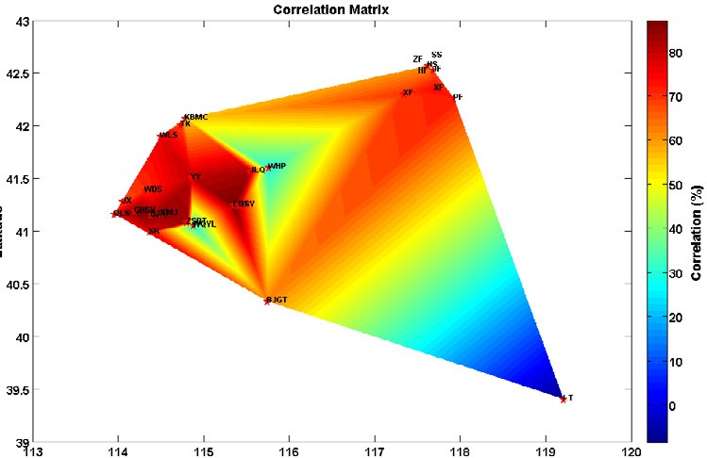

**CD Region**

**ZJK Region**

**BJ Region**

Fig.2 The relationship of power output between a single wind farm and the grid output

In order to realize the grid scale forecasting, representative farms and the weight coefficients must be determined firstly. The wind power data and forecast result of the 26 wind farms, which have the wind power forecast system, were analyzed. As shown in Fig.2, the wind farms strongly correlate (RGF>0.75) to the wind power output of the whole grid are mainly concentrated in ZJK region. In this paper, the representative farms was selected from the strongly correlated farms, in addition with good forecasting performance (RMSE<30% and MAE<25%) is also indispensable. The list of representative farms is shown in Tab.1.

Based on the measured and forecasted wind power data, started from Jan. and ended at Mar. 2011, the RGF and RMSE of each representative farm was calculated and shown in Tab.1, and then the weight coefficient can be acquired according to the formula (1).

Tab.1 Parameters of the representative wind farms

|  |  |  |  |  |  |
| --- | --- | --- | --- | --- | --- |
| No. | Farm Name | Cap. (MW) | RMSE (%) | MAE (%) | RGF (%) |
| 1 | XMJ | 193.5 | 22.05 | 15.74 | 85.01 |
| 2 | SR | 75 | 28.41 | 20.85 | 77.22 |
| 3 | LHT | 199.5 | 32.23 | 24.23 | 87.15 |
| 4 | DJH | 200 | 23.61 | 17.55 | 86.54 |
| 5 | GHSY | 183 | 23.08 | 16.29 | 87.11 |
| 6 | JLQ | 100 | 24.44 | 17.53 | 82.63 |
| 7 | WLS | 79.5 | 22.03 | 16.03 | 76.95 |
| 8 | QLS | 150 | 29.41 | 22.03 | 75.81 |
| 9 | YY | 100.5 | 25.10 | 17.29 | 80.53 |

*2.3 Grid Scale Forecast Result*

Based on the data of grid scale and single farms, started from Jan. and ended at Mar. 2011, the weight coefficients were calculated. And the maximum wind output of the whole grid (CapT) was fixed on, that is 2687MW. The forecast result for grid scale can be achieved according to the formula (2).

Fig.3 depicts the forecast result for grid scale. The forecast result of 5min time-resolution is very good, with RMSE as 12.91%, MAE as 9.9%, and usable data rate research 87.2%. The forecast accuracy is much better than the requirements of industrial standard. Compared Fig.3 with Tab.1, the forecast accuracy of grid scale is always better than single farms, due to the regional smooth effect (Focken U. et al., 2001).

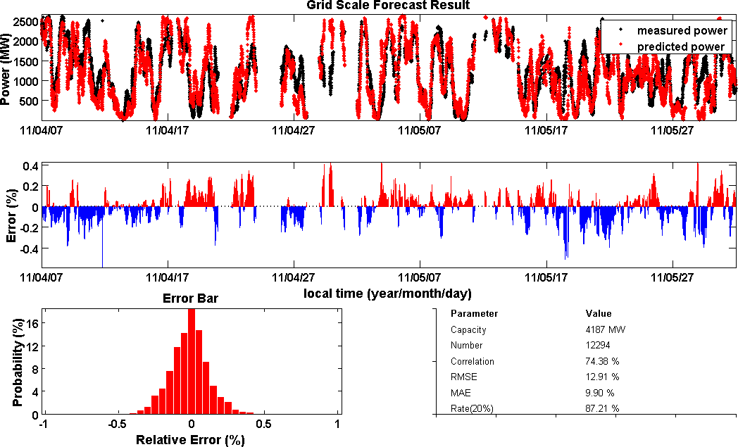

Fig.3 Grid Scale Forecast Result

1. Conclusion

Since the rapid development of wind power in china, wind power forecast is one of the key methods to ensure the efficiency, sustainability, stabilization, and safety of power grid.

In this paper, the grid scale wind power forecast model was constructed by statistic approach, based on the several representative farms. Historical data, from Jan. to Jun. 2011, was used to validate the model.

The experiment result indicates the feasibility and effectiveness of the method presented in this paper. The forecast accuracy of grid scale is always better than single farms, due to the regional smooth effect. And the grid scale forecasting accuracy meets the application demands of projects and far ahead of the demands of industrial standard.

The grid scale wind power forecast approach, presented in this paper, is able to economize the computing resource, reduce the dependency to the data integrity of single wind farm, and has high practical value.

Acknowledgements

This work was funded by the National Key Technology R&D Program (2011AA05A104). This research was partly supported by the Research Project of State Grid Corporation of China (SG11021).

References

1. Sun Rongfu, Zhang Tao, Liang Ji. Evaluation and Application of Wind Power Integration Capacity in Power Grid. Proceedings of the CSEE, 2011; 35(4): 70-76(in Chinese).
2. Goransson L., Jonhnsson F. Large scale integration of wind power moderating thermal power plant cycling. Wind Engineering, 2010; 28(2): 1-15.
3. Billinton R, Bai G. Generating capacity adequacy associated with wind energy. IEEE Trans on Energy Conversion, 2004; 19(3): 641-646.
4. Giebel G., Landberg L., Kariniotakis G. State-of-the-art on methods and software tools for short-term prediction of wind energy production. European Wind Energy Conference & Exhibition, Madrid, Spain, 2003.
5. Landberg L. Short-term prediction of local wind conditions. Roskilde˖Risø National Laboratory, 1994.
6. Focken U., Lange M., Waldl H.P. Previento - A Wind Power Prediction System with an Innovative Upscaling Algorithm. European Wind Energy Conference & Exhibition, Copenhagen, 2003.
7. Marti Perez I. Wind forecasting activities. The First IEA Joint Action Symposium on Wind Forecasting Techniques, Norrköping, Sweden, 2002.
8. Pinson P., Siebert N., Kariniotakis G. Forecasting of Regional Wind Generation by a Dynamic Fuzzy- Neural Networks Based Upscaling Approach. European Wind Energy Conference & Exhibition, Madrid, Spain, 2003.
9. BAI Yongxiang, FANG Dazhong, HOU Youhua, ZHU Changsheng. Regional Wind Power Forecasting System for Inner Mongolia Power Grid. Power System Technology, 2010; 34(10): 157-162(in Chinese).
10. Q/GDW 588-2011. Function specification of wind power forecasting, (in Chinese).
11. Feng Shuang-lei, Wang Wei-sheng, Liu Chun, Dai Hui-zhu. Study on the Physical Approach to Wind Power Prediction. Proceedings of the CSEE, 2010; 30(2): 1-6(in Chinese).