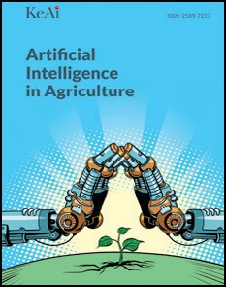[Artificial Intelligence in Agriculture 8 (2023) 20–29](https://doi.org/10.1016/j.aiia.2023.03.003)

Contents lists available at [ScienceDirect](http://www.sciencedirect.com/science/journal/)

Artificial Intelligence in Agriculture

journal homepage: [http://www.keaipublishing.com/en/journa ls/artificial- intelligence- in-agriculture/](http://www.keaipublishing.com/en/journals/artificial-intelligence-in-agriculture/)

[](http://crossmark.crossref.org/dialog/?doi=10.1016/j.aiia.2023.03.003&domain=pdf)A deep learning method for monitoring spatial distribution of cage-free hens

Xiao Yang, Ramesh Bist, Sachin Subedi, Lilong Chai ⁎

*Department of Poultry Science, University of Georgia, Athens, GA 30602, USA*

a r t i c l e i n f o

*Article history:*

Received 16 January 2023

Received in revised form 28 March 2023 Accepted 29 March 2023

Available online 3 April 2023

*Keywords:*

Cage-free system Precision farming Spatial distribution Deep learning

a b s t r a c t

The spatial distribution of laying hens in cage-free houses is an indicator of flock's health and welfare. While larger space allows chickens to perform more natural behaviors such as dustbathing, foraging, and perching in cage-free houses, an inherent challenge is evaluating chickens' locomotion and spatial distribution (e.g., real- time birds' number on perches or in nesting boxes). Manual inspection of hen's spatial distribution requires closer observation, which is labor intensive, time consuming, subject to human errors, and stress causing on birds. Therefore, an automated monitoring system is required to track the spatial distribution of hens for early detection of animal welfare and health concerns. In this study, a non–intrusive machine vision method was de- veloped to monitor hens' spatial distribution automatically. An improved You Only Look Once version 5 (YOLOv5) method was developed and trained to test hens' distribution in research cage-free facilities (e.g., 200 hens per house). The spatial distribution of hens the system monitored includes perch zone, feeding zone, drink- ing zone, and nesting zone. The dataset contains a whole growth period of chickens from day 1 to day 252. About 3000 images were extracted randomly from recorded videos for model training, validation, and testing. About 2400 images were used for training and 600 images for testing, respectively. Results show that the accuracy of the new model were 87–94% for tracking distribution in different zones for different ages of hens/pullets. Birds' age affected the performance of the model as younger birds had smaller body size and were hard to be de- tected due to blackness or occultation by equipment. The performance of the model was 0.891 and 0.942 for baby chicks (≤10 days old) and older birds (> 10 days) in detecting perching behaviors; 0.874 and 0.932 in detecting feeding/drinking behaviors. Miss detection happened when the flock density was high (>18 birds/m2) and chicken body was occluded by other facilities (e.g., nest boxes, feeders, and perches). Further studies such as chicken behavior identification works in commercial housing system should be combined with the model to reach an automatic detection system.

© 2023 The Authors. Publishing services by Elsevier B.V. on behalf of KeAi Communications Co., Ltd. This is an open access article under the CC BY-NC-ND license (<http://creativecommons.org/licenses/by-nc-nd/4.0/>).

1. Introduction

Poultry distribution and activities are key information in assessing animal's welfare and flock production (Li et al., 2017; Guo et al., 2020a, 2020b, 2022). In cage-free laying hen houses, chickens have more space to move and perform natural behaviors as compared to con- ventional cage houses (Ben Sassi et al., 2016; Wang et al., 2017; Chai et al., 2018, 2019; Li et al., 2020; Bist and Chai, 2022; Castro et al., 2023). While larger space allows chickens to perform more natural be- haviors such as dustbathing, foraging, and perching in cage-free houses, an inherent challenge is evaluating chickens' health, welfare, and spe- cific behaviors such as locomotion and spatial distribution (e.g., real- time birds' number on perches or in nesting boxes) (Chai et al., 2019;

* Corresponding author.

*E-mail address:* [lchai@uga.edu](mailto:lchai@uga.edu) (L. Chai).

Oliveira et al., 2019; Bist et al., 2023). Au automated monitoring system is required to track the spatial distribution of hens for early detection of animal welfare and health concerns (Subedi et al., 2023a, 2023b).

In the past years, computer vision has gained fast – paced advances

from human detection to animal monitoring (Aydin et al., 2010; Porto et al., 2015; Lao et al., 2012, 2016; Subedi et al., 2023a). The computer vi- sion system provides a non – intrusive method in livestock monitoring (i.e., swine, cattle, and sheep) (Hitelman et al., 2022; Li et al., 2014; Nasirahmadi et al., 2017). For poultry housing, computer vision or deep learning models (e.g., convolutional neural network - CNN) have been applied to track individual bird for analyzing behaviors (Fang et al., 2020; Pereira et al., 2013; Subedi et al., 2023a). Some studies have fo- cused on chickens' floor distribution (i.e., feeding, drinking and walking zones) (Aydin et al., 2010; Guo et al., 2020a, 2021; Yang et al., 2022). The CNN image processing algorithms showed high accuracy in monitor- ing floor distribution (two dimensions). Guo et al. (2022) compared

<https://doi.org/10.1016/j.aiia.2023.03.003>

2589-7217/© 2023 The Authors. Publishing services by Elsevier B.V. on behalf of KeAi Communications Co., Ltd. This is an open access article under the CC BY-NC-ND license ([http://](http://creativecommons.org/licenses/by-nc-nd/4.0/) [creativecommons.org/licenses/by-nc-nd/4.0/](http://creativecommons.org/licenses/by-nc-nd/4.0/)).

different CNN models (i.e., ResNet-152, ResNeXt-101 and ECA- DenseNet-264) in monitoring broilers' behaviors. The models showed 88–97% of accuracies. The YOLO (you only look once) is a one-stage CNN algorithm that has been applied to monitor poultry behaviors (Guo et al., 2022; Yang et al., 2022; Jocher et al., 2021). Ding et al. (2019) developed detector to monitor heat stress conditions of broilers by using YOLOv3 (Ding et al., 2019). Ye et al. (2020) proposed a CNN al- gorithm (YOLO + multilayer residual module (MRW) to detect white feather broilers stunning states. Subedi et al. (2023a) developed You Only Look Once version 5 (YOLOv5)-pecking models to track hens' pecking behaviors and improved accuracy of the model to 85–90%.

However, existing models have limitations (i.e., low speed detection and one – time total number of detected chickens is restricted in track- ing spatial distribution of chickens (i.e., floor distribution + vertical distribution). Vertical distribution patterns of chickens are critical infor- mation for understanding hens' performance and behaviors in cage-free housing system, an emerging egg production system in the US and EU countries (Chai et al., 2019). The objectives of this study were to:

(1) develop a deep learning method for monitoring the spatial distribu- tion of cage-free hens/pullets; (2) quantify the real-time birds' number in different zones automatically; and (3) optimize the performance of the model by incorporating camera angles, chicken ages and flock den- sities.

1. Material and methods
   1. *Experimental design and data collection*

About 800 day-old chicks (Hy-Line W-36) were raised in four research chamber rooms (each was measured as 7.3 m long × 6.1 m wide × 3 m high) at the Poultry Science Center at the University of Georgia (UGA). Cameras (Swann Communications, Santa Fe Spring, CA) were installed with two different angles (i.e., vertically and horizon- tally) to record the spatial distribution of birds (Fig. 1). The recorded videos were transferred to massive hard devices for analyzing video quality and converting to JPG format in the Department of Poultry Science at UGA.

Feeders, nipple drinkers, nest boxes (Bestnestbox company, Hudson, Ohio, USA) and a A-frame hen perch were installed in each of research chamber rooms by referring the dimension suggested by commercial farms (Chai et al., 2019). The research room was divided virtually into perching, nesting, drinking, feeding zones for the deep learning algo- rithm to identify the distribution of chickens (Fig. 2). Husbandry and management were following Hy-line W-36 management guides. Ani- mal management was approved by the Institutional Animal care and Use Committee (IACUC) at the University of Georgia.

* 1. *Methods for chicken detection*

In this study, an improved YOLOv5 model was developed for chicken detection. The architecture consisted of three parts, i.e., backbone, neck, and head (Fig. 3). The improved YOLOv5 model is based on CNN network that can take in an input image and capture its spatial characters (learnable weights) to train the network to de- tect object (Liu et al., 2022). In backbone, four different models are used to extract basic features. In neck, feature pyramids and atten- tion mechanism module were utilized to recognize same target under separate size and scales. Besides, three attention mechanism modules were added to enhance small targets detection. In model head, three individual feature maps were used to detect target (i.e., hens in different zones). According to Fig. 3, there are four main modules in backbone for extracting features from given pic- tures, including FOCUS, Conv + Bottle Neck + Hard Switch (CBH), cross stage partial (CSP) and spatial pyramid pooling (SPP). After each module, the pixels of pics changed from 608 × 608 pixels to 76 × 76 pixels, 38 × 38 pixels, and 19 × 19 pixels (Zhang et al., 2022). With these decreased feature maps, the neck network applies CSP and CBH to generate feature pyramids to aggregate on the fea- tures and submit it to head. However, during the pass progress, the contextual information will decrease. To obtain more accurate infor- mation and minimize the information loss, an attention mechanism was introduced to this improved YOLOv5 method (with red back- ground in Fig. 3). The attention mechanism is combined with C3Ghost and Ghost modules to enhance the dominated channel

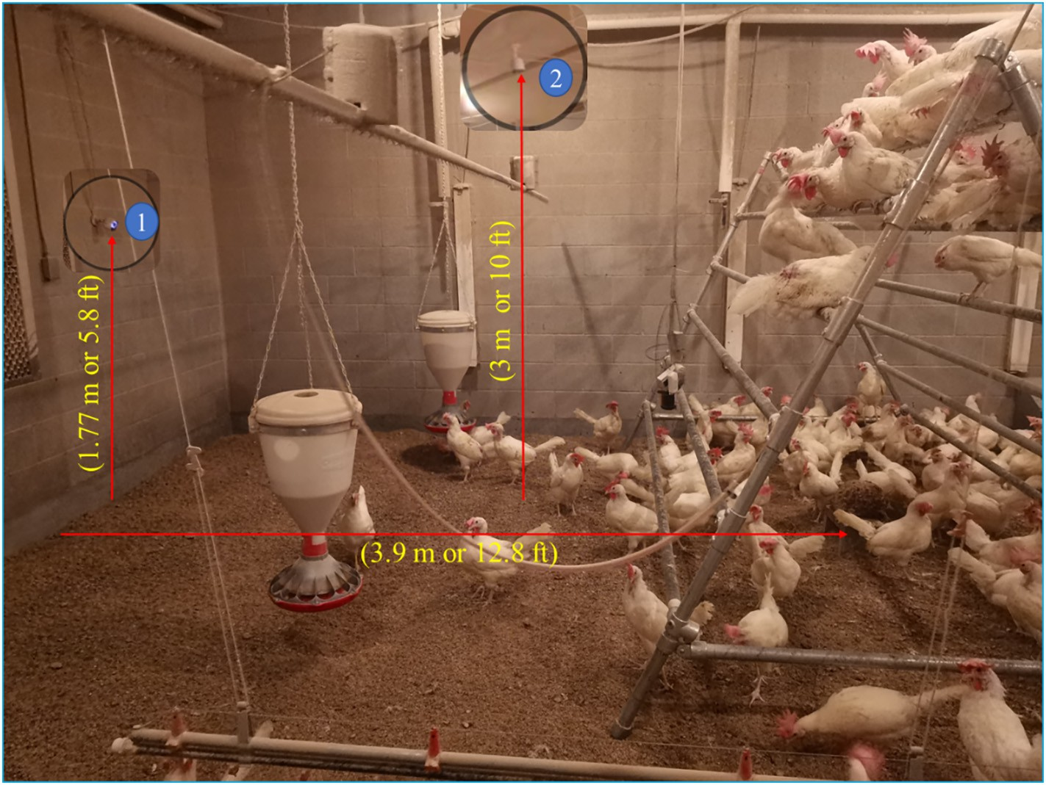

Fig. 1. Experimental setup for collecting laying hens' spatial distribution dataset.

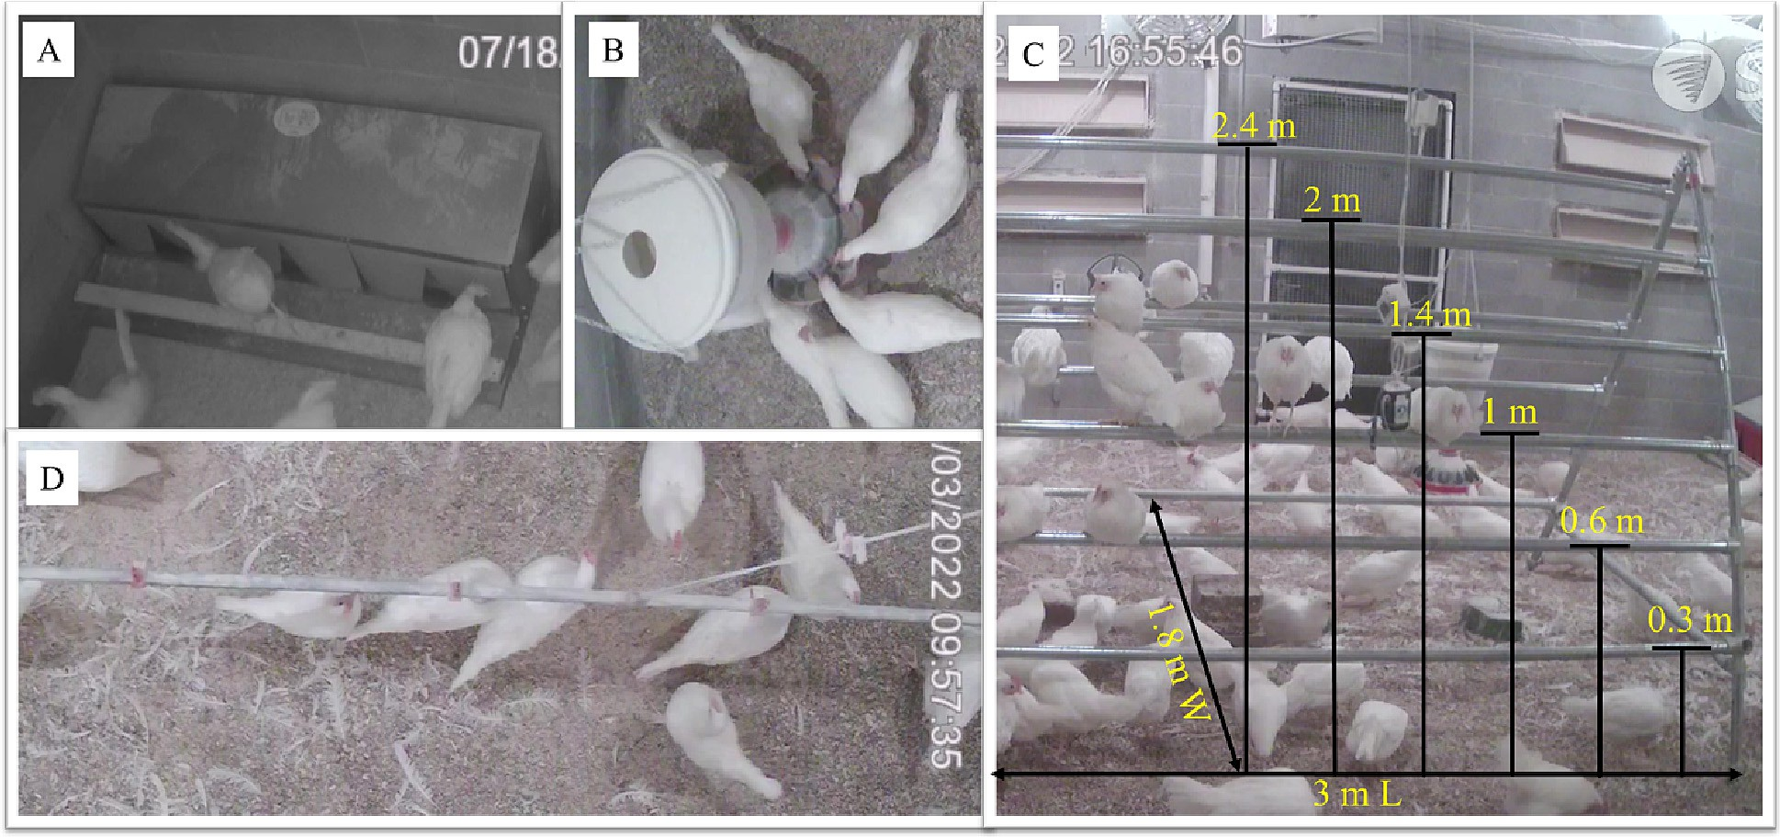

Fig. 2. The definition of different zones. A. nesting zone; B. feeding zone; C. perching zone (3 m long, 1.8 m wide, 6 different heigh for birds to perch from 0.3 m to 2.4 m); and D. drinking zone.

attention(Woo et al., 2018). The aim of C3Ghost module is to reduce heavy computational burden as the Ghost applied into YOLOv5 neck network.

The Ghost module focuses on generating more feature maps by using fewer parameters. In this study, the Ghost was adopted to process hen's feature maps(Han et al., 2020). The original hen's feature map is blurry after YOLOv5 neck network. However, with the Ghost module,

the channel number of hen's feature maps improved, and an enhanced hen's feature pyramid developed. The structure of it is shown in Fig. 4. In the neck, the three dimension of input feature map is a × b × c, after the neck, the output feature map is a1 × b1 × c1, and the size of kernel is n × n, where a and a1 are heights of feature map, b and b1 are widths of feature map. Comparing to the convolutional layer, the Ghost module processes the ordinary convolution in two steps. During the

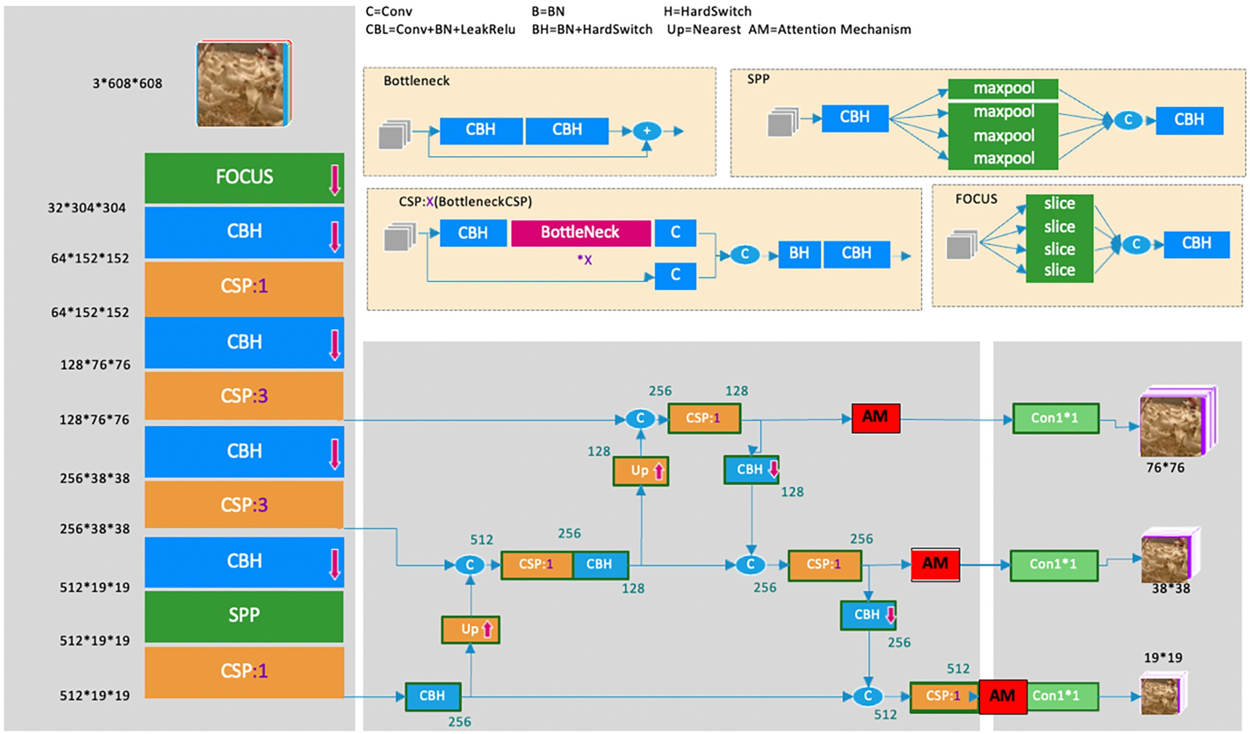

Fig. 3. The network structure of improved YOLOv5 for tracking spatial distribution of chickens in cage-free houses.

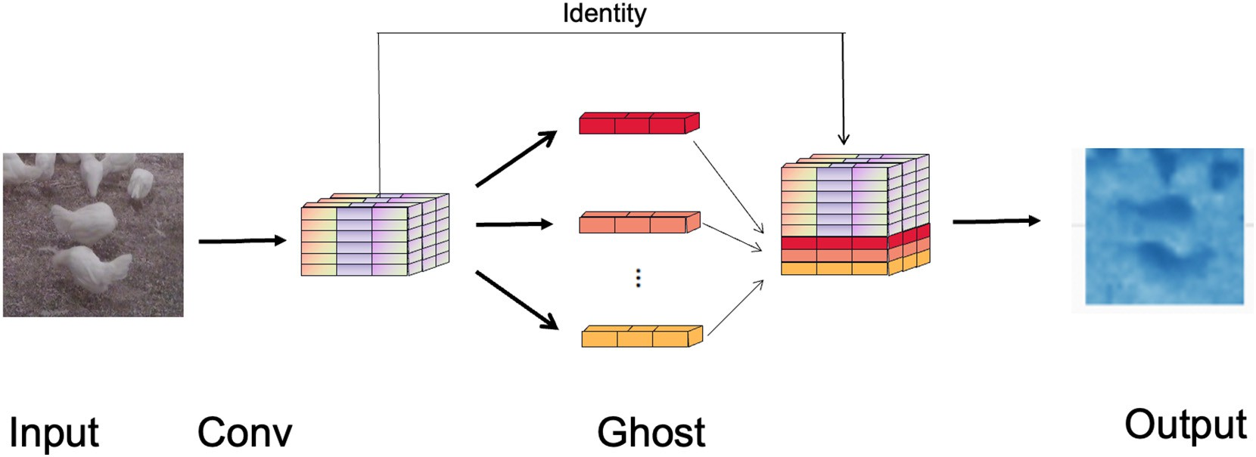

Fig. 4. A demonstration of two steps Ghost module that used in this study for processing poultry images.

convolutional layer, the basic number of floating-point operation (FLOPs) is a1 × b1 × c1 × c × n × n, which is usually over 105 when the channel number c is 256 and multiplies the filter number c1. The overload FLOPs lead the critical information of inputted imagines (Ren et al., 2022). In the two steps of Ghost module, a cheap transformation procedure was utilized in generating intrinsic feature maps and needs fewer filters. Therefore, the new structure can obtain a notable perfor- mance.

*FLOPs* = a1 × b1 × c1 × c × n × n (1)

Where a1, b1, and c1 are the output feature map's height, width, and channels after the convolution operation. C represents the number of channels in the feature map input. N represents the size of the convolutional kernel employed during the convolution operation.

* 1. *Methods for tracking chickens in different zones*

A whole vision dataset (horizontal and vertical) and an interface were used to recognize spatial distribution of birds in different zones (Fig. 5). The graphical user interface (GUI) was developed with Python binding for the Qt5 application framework (PyQt5) (Fig. 6), which en- hances the process of selecting target zones (nesting, perching, feeding and drinking) (Xie et al., 2022). The zones of each bird in the picture

were designed firstly, then the whole area in the image was used as the reference area to estimate the number of birds in the selected zones, the equation is showed below.

N~ *i* = *ni* , 1 ≤ *i* ≤ *x* (2)

*n*

(See Fig. 7.)

Where Ñ*i* (birds/m2) is the average number of the target zones after normalization, *ni* is the number of the target zones in the *i*th picture, *n* (m2) is the reference value of whole spatial area, and *x* is the number of zones recognized in the picture.

* 1. *Dataset and setting*

A laying hens' dataset was constructed to evaluate the performance of the improved YOLOv5 on the detection of birds. The dataset contains whole growth period of bird from 1 week to 36 weeks (baby chicks to hens) and consisting of 3000 pics that were extracted randomly from recorded videos. All the pics were labeled by LabelImg Windos_v1.6.1 version. Birds under 2 weeks of age were labeled as baby chicks, and birds 2 weeks or older were labeled as pullets/hens. 2400 pics and 600 pics were used during training section and testing section separately. The training was run under in Python Qt5 application framework for 300 epochs with a learning rate 0.01 and a batch size of 16. The

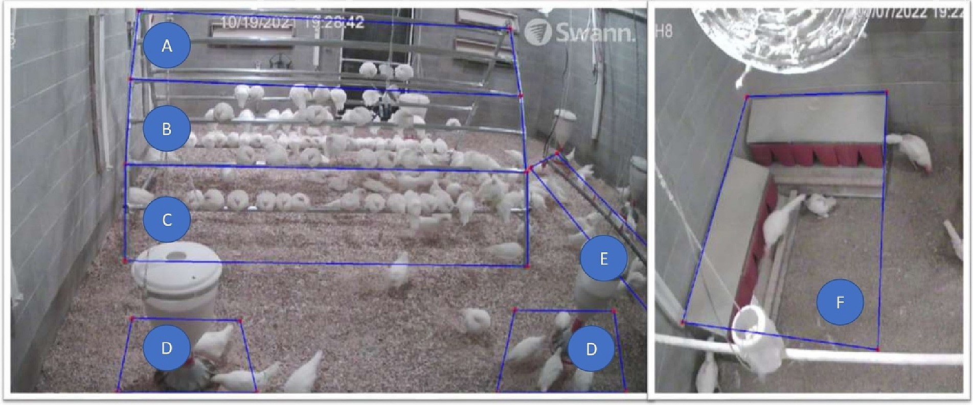

Fig. 5. The selected zones in the picture. The blue bullet A to C represents the different high perching zone varying from 7.9 ft. to 0 ft.; the two blue bullet D represent the feeding zone; the blue bullet E represents drinking zone; the blue bullet F represents the nesting zone.

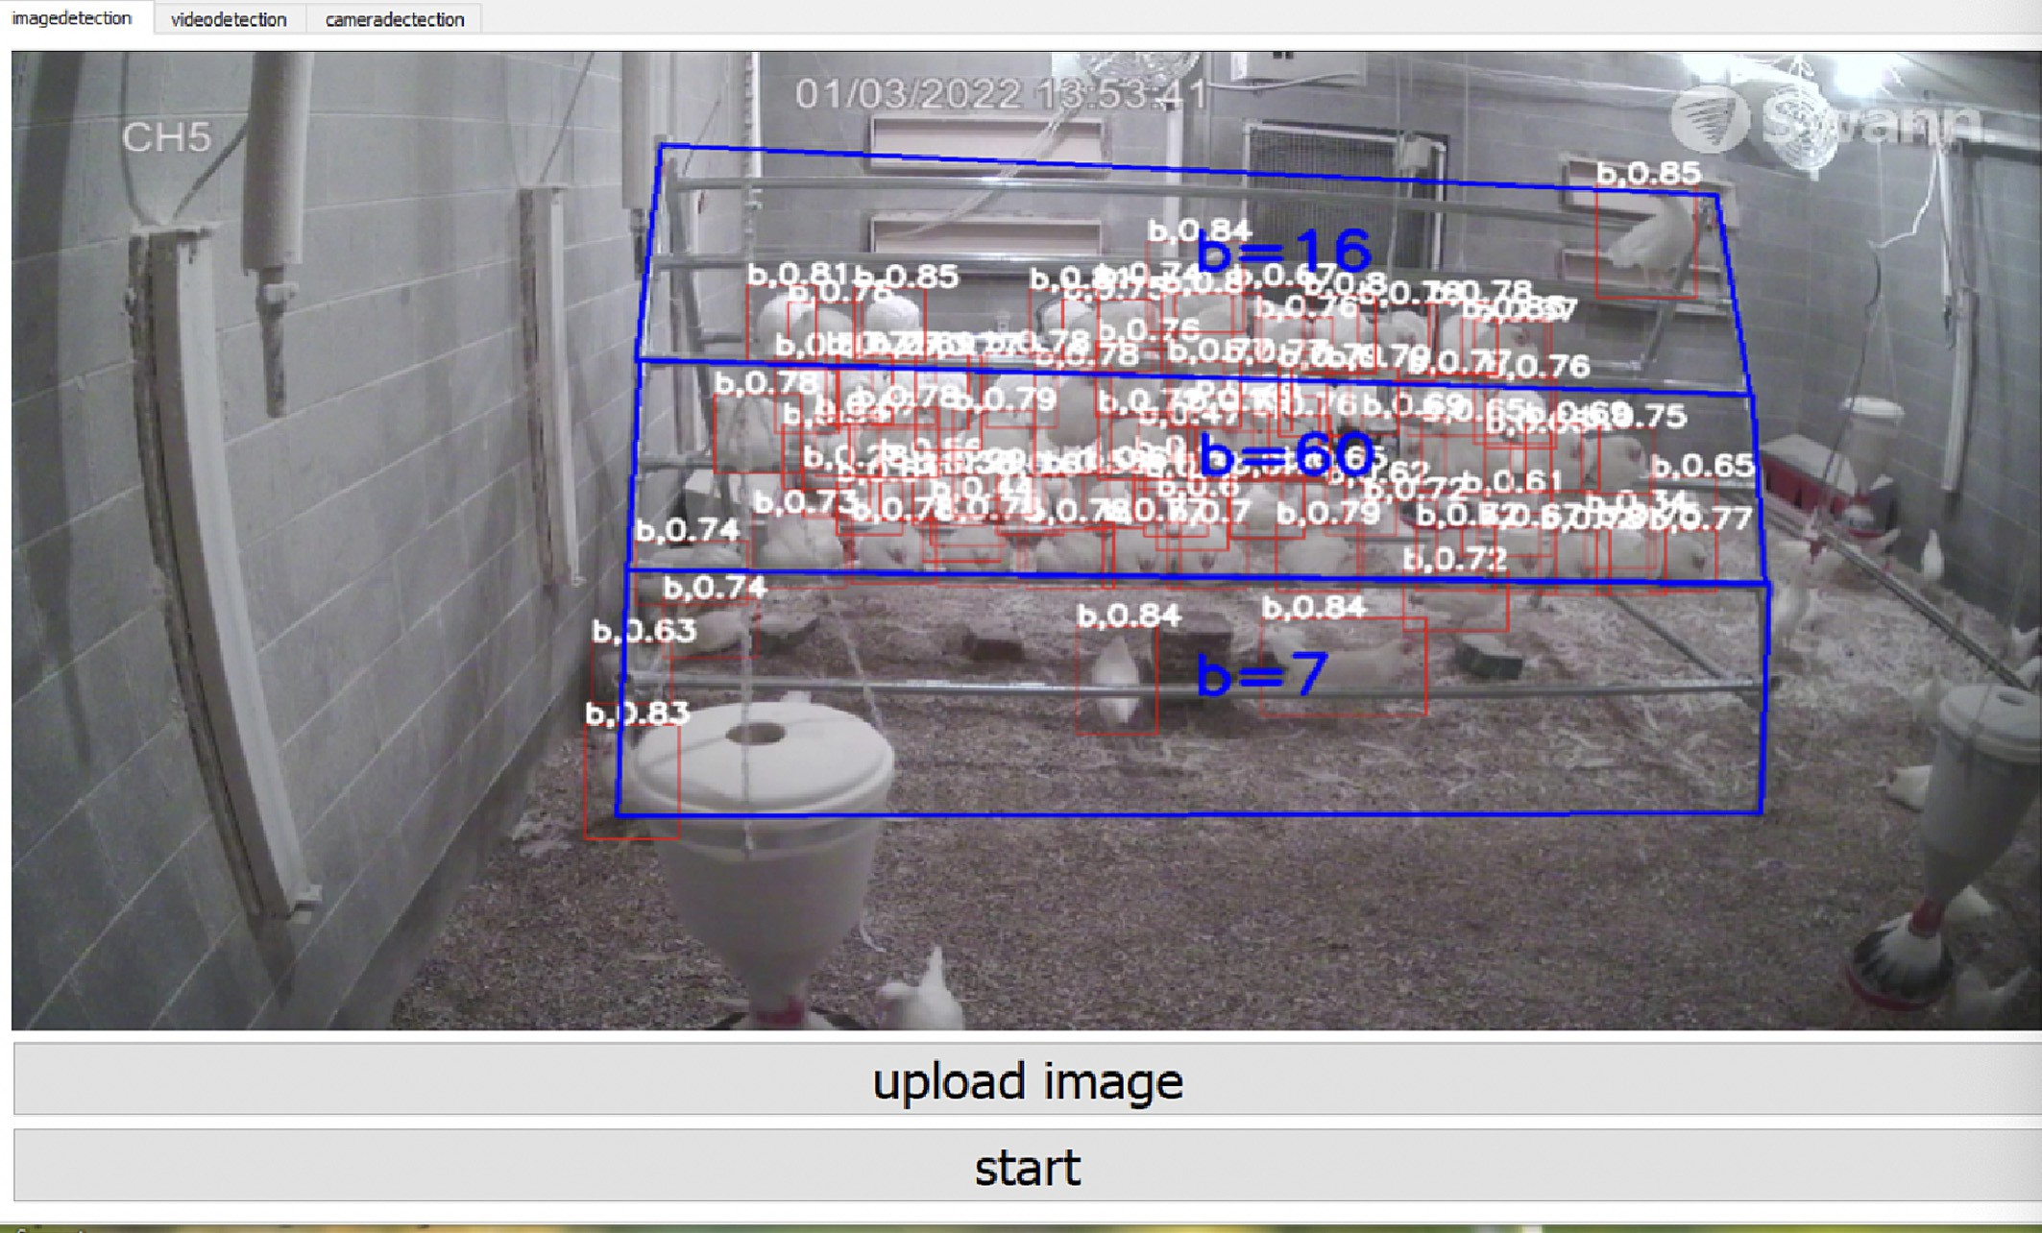

Fig. 6. The GUI developing by PyQt5 (b is pullets/hens >10 days; s – baby chicks ≤10 days).

confidence threshold is set to 0.25, which means that objects with a similarity of 0.25 or above can be considered interesting and marks will be assigned.

*TP*

*Recall* (100%) =

(*TP* + *FN*)

× 100 (4)

* 1. *Model evaluation and statistical analysis*

To compare the performance of improved YOLOv5 with other methods, the precision, recall and F1 score were used as evaluation parameters. The equations of them are showed below:

*F*1 *score* (100%) = (2∗*Precision*∗*Recall*) × 100 (5) (*Precision* + *Recall*)

The true positive (TP) is the test result correctly predicts the pres- ence of a characteristic, false positive (FP) is the test result wrongly indicates an attribute is present and false negative (FN) is the test

*Precision* (100%) = *TP*

(*TP* + *FP*)

× 100 (3)

result that falsely predicts a particular condition is absent.

To assess model performance under different situations (i.e., ages, various high of perching zone, flock density and the distributional zones), a one-way ANOVA and Turkey HSD were conducted by JMP software. The significant difference was set at 0.05.

1. Results and discussions
   1. *Model performance in detecting chickens*

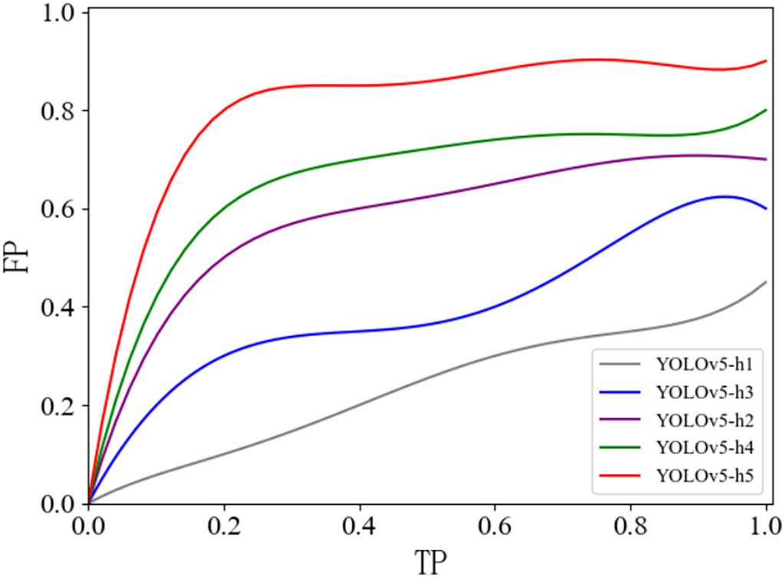Fig. 7. ROC curve comparison results of different detector based on deep learning.

To evaluate the model performance and explore optimal setting pa- rameters, the YOLOv5 – x method and several training parameters were applied. These parameters include image size (e.g., 640 and 320) and datasets (e.g., individual type dataset and mixed type dataset). The sum- mary outcomes are shown in Table 1. Five experiments were conducted to explore the best model performance among whole chicken group by setting different parameters (image size, dataset, and attention mecha- nism). image size represents the inputted image, and the epochs repre- sents the training times. Individual type dataset has two categories (i.e., baby chicks (< 1 week old) and pullet/hens that are older than 1 week), mixed type dataset is all age of chickens is considered as one type. We separate baby chicks from pullets/hens because 1 week or young chicks had smaller body size and have more challenges to be de- tected than older birds.

Table 1

The adjustment methods and results.

|  |  |  |  |  |  |  |
| --- | --- | --- | --- | --- | --- | --- |
| Model | Dataset | Image Size | Epochs | Precision | Accuracy | F1 score |
| YOLOv5-h1 | Baby chicks | 640 | 200 | 63.0% (s) | 23.5% (s) | 34.2% (s) |
|  | Pullets/hens |  |  | 76.0% (b) | 80.1% (b) | 77.8% (b) |
| YOLOv5-h2 | Baby chicks | 640 | 200 | 62.5% (s) | 33.8% (s) | 43.9% (s) |
|  | Pullets/hens |  |  | 83.6% (b) | 84.6% (b) | 84.1% (b) |
| YOLOv5-h3 | Baby chicks | 320 | 200 | 65.8% (s) | 22.5% (s) | 33.5% (s) |
|  | Pullets/hens |  |  | 71.4% (b) | 83.6% (b) | 77.0% (b) |
| YOLOv5-h4 | Mixed type | 320 | 200 | 91.7% (all) | 80.2% (all) | 85.6% (all) |
| YOLOv5-h5 | Mixed type | 320 | 200 | 90.2% (all) | 91.6% (all) | 90.9% (all) |

Note: *s* – baby chicks ≤10 days; *b* – Pullets/hens >10 days. YOLOv5-h1 means the experiment parameters are image size 640, dataset is individual type; YOLOv5-h2 means the experiment parameters are image size 640, dataset is individual type with attention mechanism; YOLOv5-h3 means the experiment parameters are image size 320, dataset is individual type; YOLOv5- h4 means the experiment parameters are image size 320, dataset is mixed type; YOLOv5-h5 means the experiment parameters are image size 320, dataset is mixed type with attention mechanism.

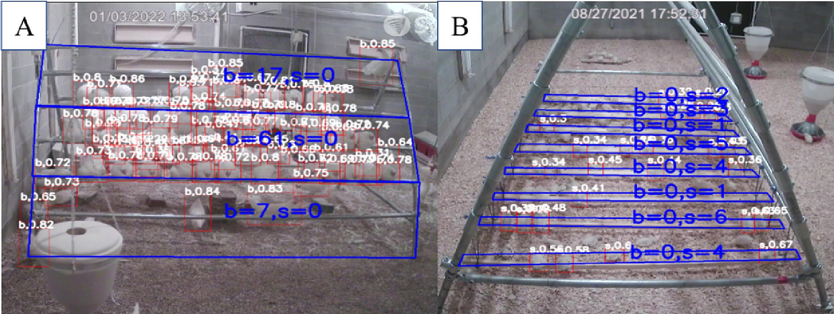

Fig. 8. Chickens' distribution in perching zones detected by improved YOLOv5. (A) adult hens (133 days of old) detected; (B) baby chicks detected (8 days of old). The letter *b* in blue means older birds (> 10 days old) and the letter *s* in blue represents baby chicks (≤ 10 days old).

During the experiments, the loss function values toward to be stable when the epoch approached to 200, so the epoch was 200. From the Table 1, we discovered a) improved YOLOv5 method had better detec- tion comparing to original YOLOv5 on both individual and mixed datasets, b) mixed dataset has better performance comparing to indi- vidual dataset when trained with improved YOLOv5 and original YOLOv5 methods, c) increase the imagine size improved the overall model precision. These confirmed our setting parameters. The Receiver Operating Characteristic (ROC) curve shows the sensitivity and specifity of different detector (Fig. 7).

1. Chicken distribution identiﬁcation in perching zones

Fig. 8 shows the birds detected by improved YOLOv5 model. In the perching zone (Fig. 8A), the model monitored perched chickens from 0 to 2.4 m and summed up them to three different levels (the number of hens in three levels were 7, 61, and 17 from bottom to top of the

perch frame), respectively. For baby chicks' perching (Fig. 8B), there were 8 hardwood perching boards. The number of detected chicks in each perching board was 2, 3, 1, 5, 4, 1, 6 and 4, respectively, from far to close in the Fig. 8B.

To test the performance of improved YOLOv5 model in monitoring birds in perching zones, about 200 images were randomly selected (chickens' age ranged from week 1 to week 20) to test the model (Table 2). The performance of the model was 0.891 and 0.942 for baby chicks (≤10 days old) and older birds (> 10 days), respectively. The miss detection rates of hens and baby chicks were 0.054 and 0.102, re- spectively. Errors or miss detections were caused by high density chickens (pilling or crowding) and interreferences of perch frame and feeders. In general, the mew model fitted well in the perching zone (R*ture* = 0.891 and 0.942).

A back propagation (BP) neural network algorithm was used to identify the chicken distribution in drinking and feeding zones, the missed detection also comes from chicken crowding behaviors and

Table 2

Tested performance of improved YOLOv5 on perch zone.

|  |  |  |  |  |  |  |  |  |  |
| --- | --- | --- | --- | --- | --- | --- | --- | --- | --- |
| Zone | Target Chickens | True Detection | Miss Detection |  |  | False | Rtrue | Rmiss | Rfalse |
|  |  |  | Overlap | Occlusion | others |  |  |  |  |
| Perch (*s*) | 1987 | 1872 | 46 | 41 | 20 | 8 | 0.942 | 0.054 | 0.004 |
| Perch (*b*) | 866 | 772 | 30 | 27 | 31 | 6 | 0.891 | 0.102 | 0.007 |

Note: Rtrue, Rmiss and Rfalse rates were evaluated by true detection number/target chickens' number, miss detection number/target chickens' number and false detection number/target chickens' number respectively; *s* means baby chicks; *b* means hens.

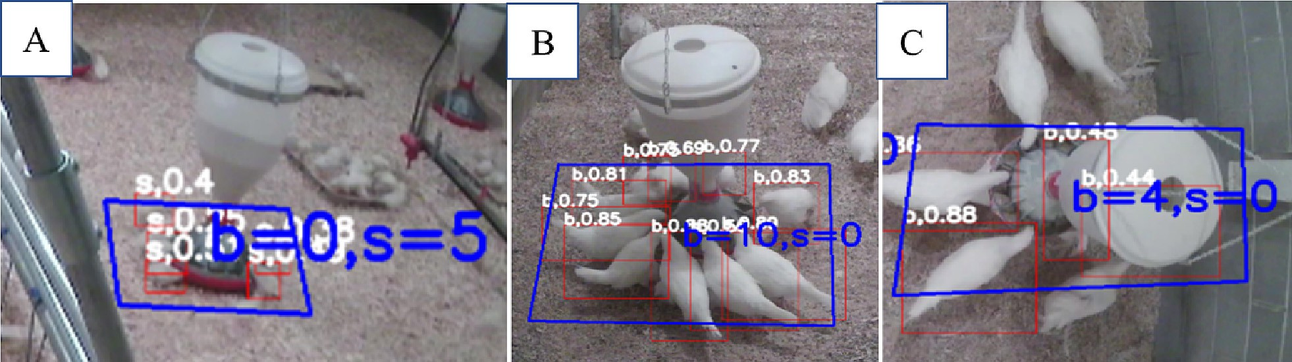

Fig. 9. Chickens' distribution in the feeding zone at different ages (A – chickens were 10 days old; B and C – chickens were 122 days old (*b* means birds were > 10 days; *s* means birds were ≤ 10 day).

collusion problems(Yang et al., 2022). Other flaws in our method are original from the horizonal vison factor (when baby chicks are too small under horizontal scale, the miss detection happens) and designed perch zone (when the perch zone is designed narrower than the real sit- uation, there will be less perch chicks included into the perch zone, so the chicks were missed). The false detection rates were 0.004 and

0.007 respectively. This were also the common drawback of other vision based algorithms (Abdanan Mehdizadeh et al., 2015).

* 1. *Chicken distribution in feeding and drinking zones*

Fig. 9 demonstrates the distribution of detected birds in feeding zones monitored by improved YOLOv5 model. For each pic, the number

of chickens in targeted areas were analyzed. From Fig. 9A, we can iden- tify the distribution of baby chicks (i.e., 10 days old) in feeding zone in 100% accuracy. For Fig. 9B and C, the model detected larger chickens (i.e., 122 day old) in 100% accuracy as well. From Fig. 10A and B, the dis- tribution of 122 days old of hens in drinking areas collected from two different angles. The detection efficiency was 100% in the Fig. 10B as there was no osculation. For Fig. 10A, the feeder (low right corner) could block some chickens during the study.

To investigate a larger number of chickens, we used about 200 im- ages to test the model performance in feeding and drinking zones (Table 3). The overall accuracy for baby chicks and older chickens were 0.874 and 0.932, respectively. Comparing to accuracy of perch zones, detecting baby chicks of feeding and drinking zones was more

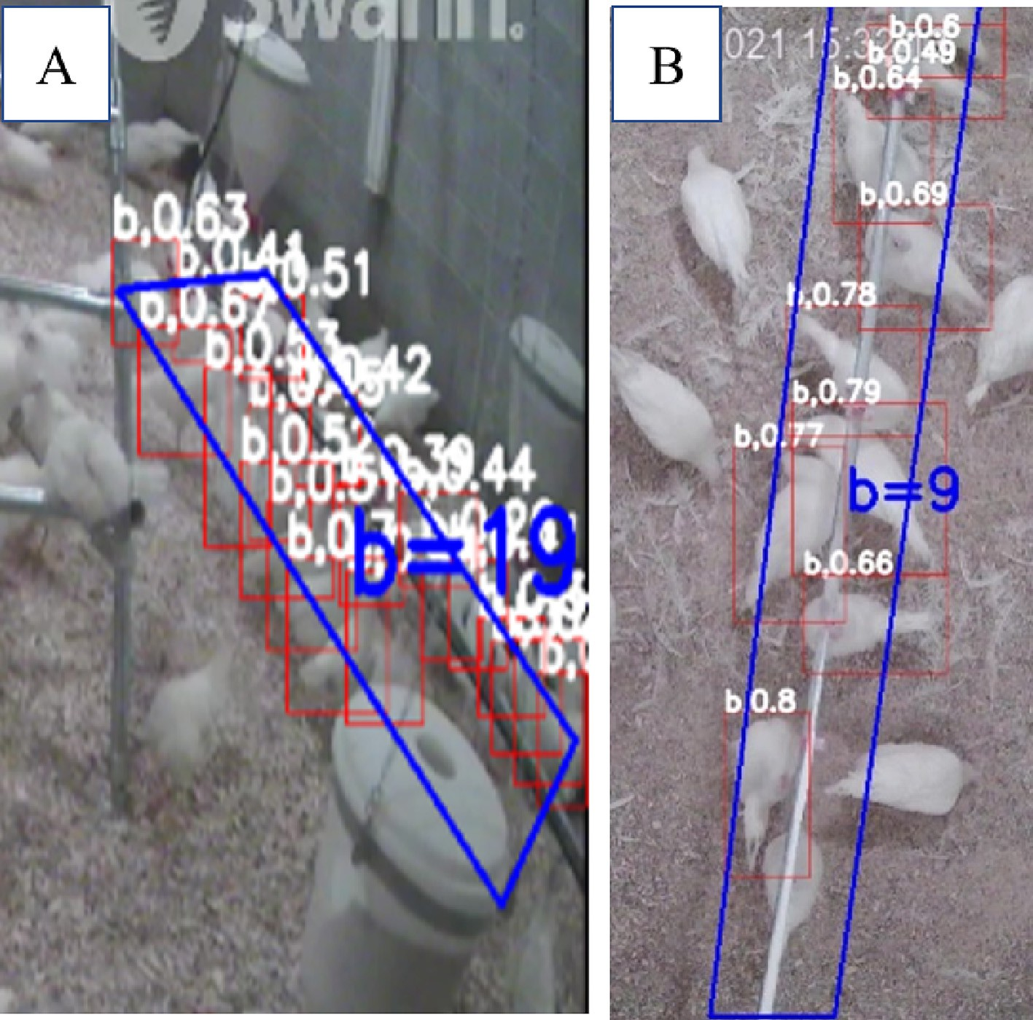

Fig. 10. The distribution of chickens (i.e., 122 days old) in the drinking zone at different angles: chickens in A (side view in 45 degree) and B (top view) (*b* means birds were > 10 days;

*s* means birds were ≤ 10 day).

Table 3

Tested performance of improved YOLOv5 on feeding and drinking zones.

|  |  |  |  |  |  |  |  |  |  |
| --- | --- | --- | --- | --- | --- | --- | --- | --- | --- |
| Birds | Target Chickens | True Detection | Miss Detection |  |  | False detection | Rtrue | Rmiss | Rfalse |
|  |  |  | Overlap | Occlusion | others |  |  |  |  |
| *s* | 1027 | 898 | 20 | 19 | 19 | 71 | 0.874 | 0.056 | 0.069 |
| *b* | 768 | 716 | 17 | 15 | 15 | 6 | 0.932 | 0.061 | 0.008 |

Note: Rtrue, Rmiss and Rfalse rates were evaluated by true detection number/target chickens' number, miss detection number/target chickens' number and false detection number/target chickens' number respectively; *s* means baby chicks ≤10 days; *b* means older birds >10 days.

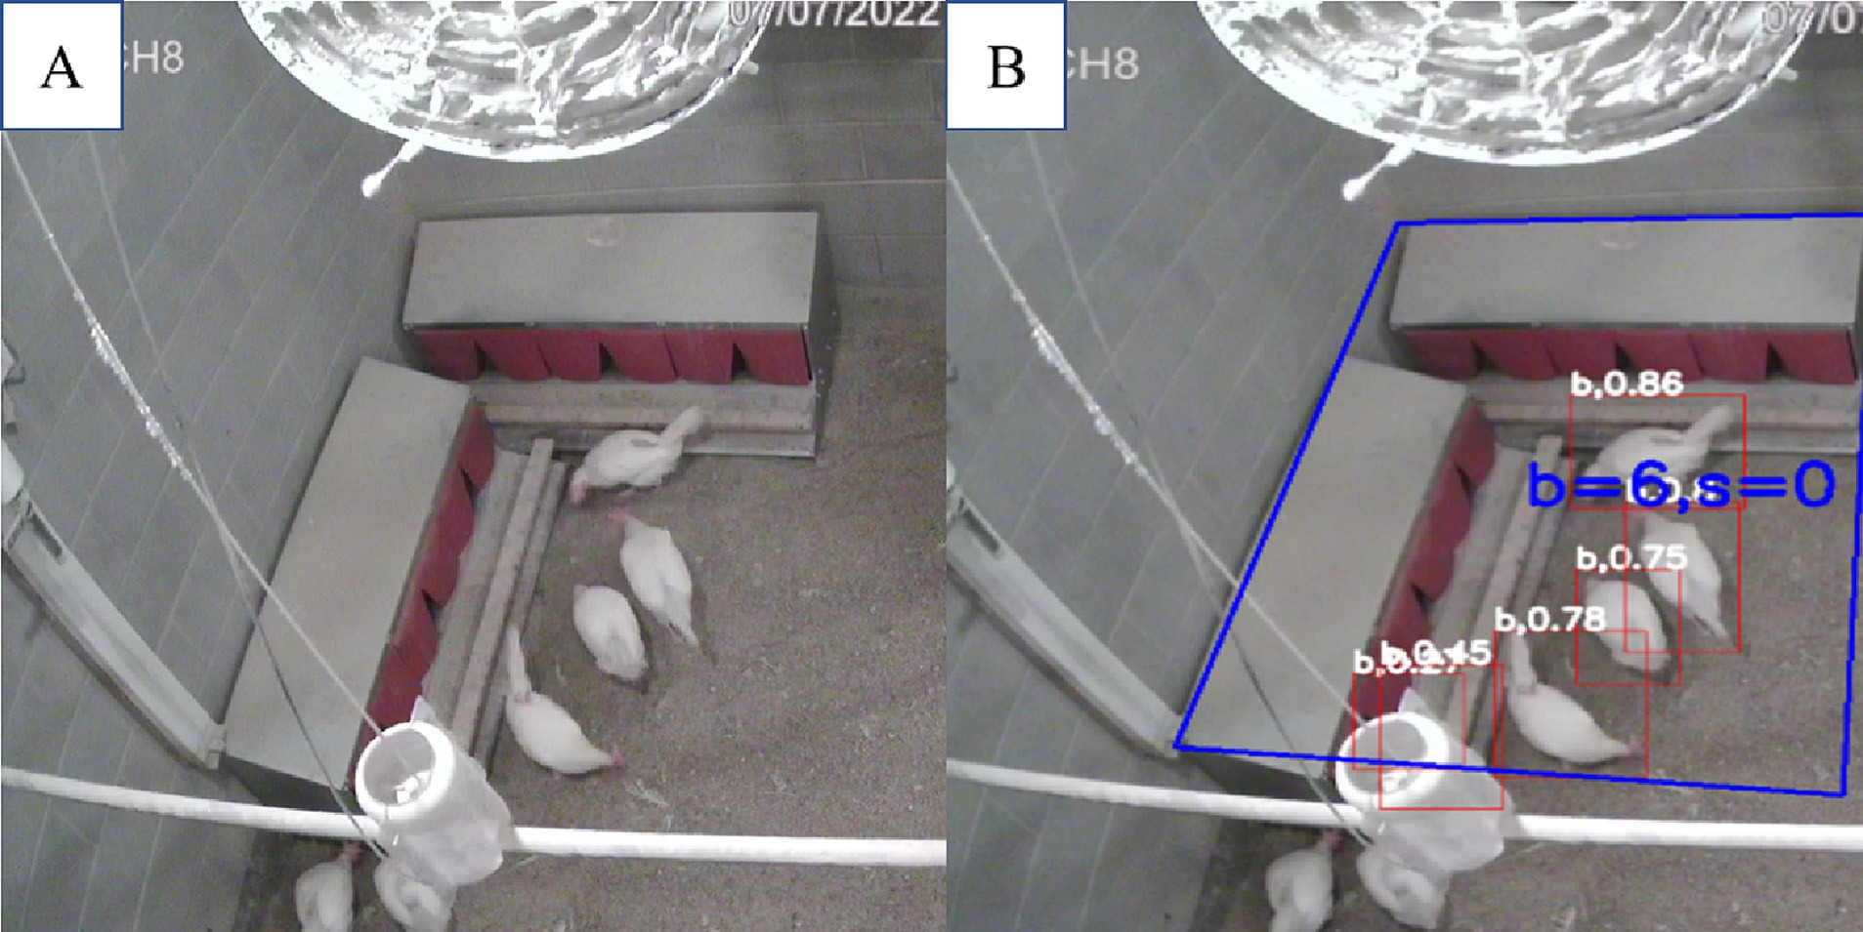

Fig. 11. Chicken distribution in nesting zone. (A) original image of nesting area and (B) detected nesting area.

challenging due to smaller size of body and interferences of equipment. When a higher number of birds were assembled at the same feeder or drinker, birds standing in front of the feeder or drinker had higher pos- sibility to be recognized than those close at sides of feeder and drinker. In addition, lighting affected image quality and model's performance. Apart from these, birds' density has been reported affect deep learning model's performance (Maselyne et al., 2016).

* 1. *Chicken distribution in nesting zone*

In this study, most hens started to lay their first eggs at around 18 weeks of age. The nesting behaviors of hens was analyzed with our newly developed model because it's important identify if there are floor eggs or not (Gonzalez-Mora et al., 2022). Monitoring hens' distri- bution in nesting zones helps to minimize losses from laying eggs on the floor. Fig. 11 shows the distribution of detected hens in nesting zones with our improved YOLOv5 model. Fig. 11A is the original image of nesting area. Fig. 11B demonstrates the detected hens in

nesting zone. The model performed with over 90% accuracy in detecting hens in nesting zones.

To evaluate model's performance in nesting zone for hens' detection systemically, over 200 images were randomly selected from video dataset to improve targeted hens' dataset (Table 4). The tested accuracy rate in nesting zone reached 0.906, which is slightly less than that in others zones (i.e., perching, feeding, and drinking zones), because there was an equipment hanging above the nesting zone.

Comparing to other computer vision-based tools for monitoring nesting zone, our model has a higher precision. For instance, a 0.825 of accuracy was reported in a research focusing on monitoring eggs and birds in nesting zone (Lubich et al., 2019; Hui et al., 2021). In previous studies, the best YOLO model reached an accuracy of 0.885. In this study, our improved YOLOv5 model performed better than most of existing YOLO models and other CNN models. However, the model missed some detections under high density of hens' flock due to occlu- sion of hanging line or equipment on nesting boxes and zones. Further studies are need to enhance model's performance, especially under

Table 4

Tested performance of improved YOLOv5 on nesting zone.

|  |  |  |  |  |  |  |  |  |  |
| --- | --- | --- | --- | --- | --- | --- | --- | --- | --- |
| Zone | Target Chickens | True Detection | Miss Detection |  |  | False detection | Rtrue | Rmiss | Rfalse |
|  |  |  | Overlap | Occlusion | others |  |  |  |  |
| Nest(*b*) | 873 | 791 | 8 | 13 | 7 | 54 | 0.906 | 0.061 | 0.008 |

Note: Rtrue, Rmiss and Rfalse rates were evaluated by true detection number/target chickens' number, miss detection number/target chickens' number and false detection number/target chickens' number respectively; *b* means hens. There were no baby chicks (*s*) because only hens would lay eggs.

environment of high density of laying hens because commercial house tend to have thousands hens on the floor (Huang et al., 2022; Subedi et al., 2023a).

1. Conclusions

In this study, an improved deep learning model was developed based on YOLOv5 structure to monitor cage – free hens' spatial and floor distributions, including the real-time number of birds in perching zone, feeding zone, drinking zone, and nesting zone. The accuracies of the new model were 87–94% for all ages of chickens across zones. Birds' age affected the performance of the model as younger birds had smaller body size and were hard to be detected due to blackness or oc- cultation by equipment. The performance of the model was 0.891 and 0.942 for baby chicks (≤10 days old) and older birds (> 10 days) in de- tecting perching behaviors; 0.874 and 0.932 in detecting feeding/drink- ing behaviors. The different zones in the chicken house (perch zone, feeding zone, drinking zone, and nesting zone) are related to specific be- haviors of the chickens. For example, some chickens are expected to perch during the night, while during the day they move around the house and visit the feeding and drinking zones. Nesting behavior occurs when hens are about to lay eggs. The current findings provide refer- ences for automatically monitoring cage – free laying hens' spatial dis- tribution in all age level (from baby chicks to hens). More future chicken behavior identification works could be combined with the model to reach an automatic detection system.

Authors credit statement

Lilong Chai (L.C.) contributed the research method and resources; Xiao Yang (X.Y.) conducted the experiment and collected the data; X.Y., Ramesh Bist (R.B.) and Sachin Subedi (S.S.) contributed to the data collection; X.Y. and L.C wrote the main manuscript. All authors re- viewed the manuscript.

Declaration of Competing Interest

The authors declare that they have no known competing financial interests or personal relationships that could have appeared to influ- ence the work reported in this paper.

Acknowledgments

The study was sponsored by the Egg Industry Center; Georgia Re- search Alliance (Venture Fund); UGA CAES Dean's Office Research Fund; UGA COVID Recovery Research Fund; UGA Provost Office Rural Eng- agement Fund; and USDA-NIFA; Hatch projects: Future Challenges in Animal Production Systems: Seeking Solutions through Focused Facili- tation (GEO00895; Accession Number: 1021519) & Enhancing Poultry Production Systems through Emerging Technologies and Husbandry Practices (GEO00894; Accession Number: 1021518).

References

Abdanan Mehdizadeh, S., Neves, D.P., Tscharke, M., Nääs, I.A., Banhazi, T.M., 2015. Image analysis method to evaluate beak and head motion of broiler chickens during feeding. Comput. Electron. Agric. 114, 88–95. <https://doi.org/10.1016/j.compag.2015.03.017>.

Aydin, A., Cangar, O., Ozcan, S.E., Bahr, C., Berckmans, D., 2010. Application of a fully auto- matic analysis tool to assess the activity of broiler chickens with different gait scores. Comput. Electron. Agric. 73, 194–199. <https://doi.org/10.1016/j.compag.2010.05.004>. Ben Sassi, N., Averós, X., Estevez, I., 2016. Technology and poultry welfare. Animals 6, 62.

<https://doi.org/10.3390/ani6100062>.

Bist, R.B., Chai, L., 2022. [Advanced Strategies for Mitigating Particulate Matter Generations](http://refhub.elsevier.com/S2589-7217(23)00012-0/optOfaDCCvoAA) [in Poultry Houses. Applied Sciences 12 (22), 1132](http://refhub.elsevier.com/S2589-7217(23)00012-0/optOfaDCCvoAA)3.

Bist, R.B., Subedi, S., Chai, L., Yang, X., 2023. [Ammonia emissions, impacts, and mitigation](http://refhub.elsevier.com/S2589-7217(23)00012-0/optFt4aN6igY4) [strategies for poultry production: A critical review. Journal of Environmental Man-](http://refhub.elsevier.com/S2589-7217(23)00012-0/optFt4aN6igY4) [agement 328, 116919](http://refhub.elsevier.com/S2589-7217(23)00012-0/optFt4aN6igY4).

Castro, F.L.S., Chai, L., Arango, J., Owens, C.M., Smith, P.A., Reichelt, S., DuBois, C., Menconi, A., 2023. [Poultry industry paradigms: connecting the dots. Journal of Applied Poultry](http://refhub.elsevier.com/S2589-7217(23)00012-0/optLW8lpnTabh) [Research 32 (1), 100310](http://refhub.elsevier.com/S2589-7217(23)00012-0/optLW8lpnTabh).

Chai, L., Xin, H., Wang, Y., Oliveira, J., Wang, K., Zhao, Y., 2019. [Mitigating particulate mat-](http://refhub.elsevier.com/S2589-7217(23)00012-0/optl5Zv5rciIj) [ter generation in a commercial cage-free hen house. Transactions of the ASABE 62](http://refhub.elsevier.com/S2589-7217(23)00012-0/optl5Zv5rciIj) [(4), 877–88](http://refhub.elsevier.com/S2589-7217(23)00012-0/optl5Zv5rciIj)6.

Chai, L., Xin, H., Zhao, Y., Wang, T., Soupir, M., Liu, K., 2018. [Mitigating ammonia and PM](http://refhub.elsevier.com/S2589-7217(23)00012-0/optRPML3TgvQ8) [generation of cage-free henhouse litter with solid additive and liquid spray. Transac-](http://refhub.elsevier.com/S2589-7217(23)00012-0/optRPML3TgvQ8) [tions of the ASABE 61 (1), 287–29](http://refhub.elsevier.com/S2589-7217(23)00012-0/optRPML3TgvQ8)4.

Ding, A., Zhang, X., Zou, X., Qian, Y., Yao, H., Zhang, S., Wei, Y., 2019. A novel method for the group characteristics analysis of yellow feather broilers under the heat stress based on object detection and transfer learning. INMATEH Agric. Eng. 58, 49–58. <https://doi.org/10.35633/INMATEH-59-06>.

Fang, C., Huang, J., Cuan, K., Zhuang, X., Zhang, T., 2020. Comparative study on poultry tar- get tracking algorithms based on a deep regression network. Biosyst. Eng. 190, 176–183. <https://doi.org/10.1016/j.biosystemseng.2019.12.002>.

Gonzalez-Mora, A.F., Rousseau, A.N., Larios, A.D., Godbout, S., Fournel, S., 2022. Assessing environmental control strategies in cage-free aviary housing systems: egg production analysis and random Forest modeling. Comput. Electron. Agric. 196, 106854. [https://](https://doi.org/10.1016/j.compag.2022.106854) [doi.org/10.1016/j.compag.2022.106854](https://doi.org/10.1016/j.compag.2022.106854).

Guo, Y., Aggrey, S.E., Oladeinde, A., Johnson, J., Zock, G., Chai, L., 2021. [A machine vision-](http://refhub.elsevier.com/S2589-7217(23)00012-0/opt9QZi5tJaeg) [based method optimized for restoring broiler chicken images occluded by feeding](http://refhub.elsevier.com/S2589-7217(23)00012-0/opt9QZi5tJaeg) [and drinking equipment. Animals 11 (1), 12](http://refhub.elsevier.com/S2589-7217(23)00012-0/opt9QZi5tJaeg)3.

Guo, Y., Aggrey, S.E., Wang, P., Oladeinde, A., Chai, L., 2022. [Monitoring Behaviors of](http://refhub.elsevier.com/S2589-7217(23)00012-0/opt7kXSD425go) [Broiler Chickens at Different Ages with Deep Learning. Animals 12 (23), 339](http://refhub.elsevier.com/S2589-7217(23)00012-0/opt7kXSD425go)0.

Guo, Y., Chai, L., Aggrey, S.E., Oladeinde, A., Johnson, J., Zock, G., 2020a. [A machine vision-](http://refhub.elsevier.com/S2589-7217(23)00012-0/optZnFeDYbeyw) [based method for monitoring broiler chicken floor distribution. Sensors 20 (11),](http://refhub.elsevier.com/S2589-7217(23)00012-0/optZnFeDYbeyw) [3179](http://refhub.elsevier.com/S2589-7217(23)00012-0/optZnFeDYbeyw).

Guo, Y., He, D., Chai, L., 2020b. [A machine vision-based method for monitoring scene-](http://refhub.elsevier.com/S2589-7217(23)00012-0/optexpdXOj1CZ) [interactive behaviors of dairy calf. Animals 10 (2), 190](http://refhub.elsevier.com/S2589-7217(23)00012-0/optexpdXOj1CZ).

Han, K., Wang, Y., Tian, Q., Guo, J., Xu, Chunjing, Xu, Chang, 2020. GhostNet: More Features from Cheap Operations. <https://doi.org/10.1109/CVPR42600.2020.00165>.

Hitelman, A., Edan, Y., Godo, A., Berenstein, R., Lepar, J., Halachmi, I., 2022. Biometric iden- tification of sheep via a machine-vision system. Comput. Electron. Agric. 194, 106713. <https://doi.org/10.1016/j.compag.2022.106713>.

Huang, Y., Yang, X., Guo, J., Cheng, J., Qu, H., Ma, J., Li, L., 2022. A high-precision method for 100-day-old classification of chickens in edge computing scenarios based on feder- ated computing. Animals 12, 3450. <https://doi.org/10.3390/ani12243450>.

Hui, Z., Jian, Z., Yuran, C., Su, J., Di, W. and Hao, D., 2021, August. Intelligent bird’s nest haz- ard detection of transmission line based on RetinaNet model. In *Journal of Physics: Conference Series* (Vol. 2005, No. 1, p. 012235). IOP Publishing.

Jocher, G., Stoken, A., Borovec, J., Chaurasia, A., Changyu, L., Laughing, A., Hogan, A., Hajek, J., Diaconu, L., Marc, Y., 2021. [Ultralytics/yolov5: v5. 0-YOLOv5-P6 1280 models AWS](http://refhub.elsevier.com/S2589-7217(23)00012-0/rf0055) [supervise. ly and YouTube integrations. Zenodo 1](http://refhub.elsevier.com/S2589-7217(23)00012-0/rf0055)1.

Lao, F., Brown-Brandl, T., Stinn, J.P., Liu, K., Teng, G., Xin, H., 2016. [Automatic recognition of](http://refhub.elsevier.com/S2589-7217(23)00012-0/optHgvOYaOwcn) [lactating sow behaviors through depth image processing. Computers and Electronics](http://refhub.elsevier.com/S2589-7217(23)00012-0/optHgvOYaOwcn) [in Agriculture 125, 56–62](http://refhub.elsevier.com/S2589-7217(23)00012-0/optHgvOYaOwcn).

Lao, F., Teng, G., Li, J., Yu, L., Li, Z., 2012. Behavior recognition method for individual laying hen based on computer vision. Trans. Chin. Soc. Agric. Eng. 28, 157–163. [https://doi.](https://doi.org/10.3969/j.issn.1002-6819.2012.24.022) [org/10.3969/j.issn.1002-6819.2012.24.022](https://doi.org/10.3969/j.issn.1002-6819.2012.24.022).

Li, Z., Luo, C., Teng, G., Liu, T., 2014. Estimation of pig weight by machine vision: A review. In: Li, D., Chen, Y. (Eds.), Computer and Computing Technologies in Agriculture VII, IFIP Advances in Information and Communication Technology. Springer, Berlin, Hei- delberg, pp. 42–49. <https://doi.org/10.1007/978-3-642-54341-8_5>.

Li, N., Ren, Z., Li, D., Zeng, L., 2020. Review: automated techniques for monitoring the be- haviour and welfare of broilers and laying hens: towards the goal of precision live- stock farming. Animal 14, 617–625. <https://doi.org/10.1017/S1751731119002155>.

Li, L., Zhao, Y., Oliveira, J., Verhoijsen, W., Liu, K., Xin, H., 2017. [A UHF RFID system for](http://refhub.elsevier.com/S2589-7217(23)00012-0/opt2jpHHN6zn9) [studying individual feeding and nesting behaviors of group-housed laying hens.](http://refhub.elsevier.com/S2589-7217(23)00012-0/opt2jpHHN6zn9) [Transactions of the ASABE 60 (4), 1337–1347](http://refhub.elsevier.com/S2589-7217(23)00012-0/opt2jpHHN6zn9).

Liu, T., Luo, R., Xu, L., Feng, D., Cao, L., Liu, S., Guo, J., 2022. Spatial channel attention for deep convolutional neural networks. Mathematics 10, 1750. [https://doi.org/10.](https://doi.org/10.3390/math10101750) [3390/math10101750](https://doi.org/10.3390/math10101750).

Lubich, J., Thomas, K., Engels, D.W., 2019. [Identification and Classification of Poultry Eggs:](http://refhub.elsevier.com/S2589-7217(23)00012-0/rf0080) [A Case Study Utilizing Computer Vision and Machine Learning. 2 p. 25](http://refhub.elsevier.com/S2589-7217(23)00012-0/rf0080).

Maselyne, J., Saeys, W., Briene, P., Mertens, K., Vangeyte, J., De Ketelaere, B., Hessel, E.F., Sonck, B., Van Nuffel, A., 2016. Methods to construct feeding visits from RFID registra- tions of growing-finishing pigs at the feed trough. Comput. Electron. Agric. 128, 9–19. <https://doi.org/10.1016/j.compag.2016.08.010>.

Nasirahmadi, A., Edwards, S.A., Sturm, B., 2017. Implementation of machine vision for de- tecting behaviour of cattle and pigs. Livest. Sci. 202, 25–38. [https://doi.org/10.1016/j.](https://doi.org/10.1016/j.livsci.2017.05.014) [livsci.2017.05.014](https://doi.org/10.1016/j.livsci.2017.05.014).

Oliveira, J.L., Xin, H., Chai, L., Millman, S.T., 2019. [Effects of litter floor access and inclusion](http://refhub.elsevier.com/S2589-7217(23)00012-0/optLRNag0DgZa) [of experienced hens in aviary housing on floor eggs, litter condition, air quality, and](http://refhub.elsevier.com/S2589-7217(23)00012-0/optLRNag0DgZa) [hen welfare. Poultry Science 98 (4), 1664–1677](http://refhub.elsevier.com/S2589-7217(23)00012-0/optLRNag0DgZa).

Pereira, D.F., Miyamoto, B.C.B., Maia, G.D.N., Tatiana Sales, G., Magalhães, M.M., Gates, R.S., 2013. Machine vision to identify broiler breeder behavior. Comput. Electron. Agric. 99, 194–199. <https://doi.org/10.1016/j.compag.2013.09.012>.

Porto, S.M.C., Arcidiacono, C., Anguzza, U., Cascone, G., 2015. The automatic detection of dairy cow feeding and standing behaviours in free-stall barns by a computer vision-based system. Biosyst. Eng. 133, 46–55. [https://doi.org/10.1016/j.](https://doi.org/10.1016/j.biosystemseng.2015.02.012) [biosystemseng.2015.02.012](https://doi.org/10.1016/j.biosystemseng.2015.02.012).

Ren, J., Wang, Z., Zhang, Y., Liao, L., 2022. YOLOv5-R: lightweight real-time detection based on improved YOLOv5. J. Electron. Imaging 31, 033033. [https://doi.org/10.](https://doi.org/10.1117/1.JEI.31.3.033033) [1117/1.JEI.31.3.033033](https://doi.org/10.1117/1.JEI.31.3.033033).

Subedi, S., Bist, R., Yang, X., Chai, L., 2023a. Tracking pecking behaviors and damages of cage-free laying hens with machine vision technologies. Comput. Electron. Agric. 204, 107545. <https://doi.org/10.1016/j.compag.2022.107545>.

Subedi, S., Bist, R., Yang, X., Chai, L., 2023b. Tracking floor eggs with machine vision in cage-free hen houses. Poult. Sci. 102637. <https://doi.org/10.1016/j.psj.2023.102637>.

Wang, K., Zhao, X., He, Y., 2017. [Review on noninvasive monitoring technology of poultry](http://refhub.elsevier.com/S2589-7217(23)00012-0/rf0120) [behavior and physiological information. Trans. Chin. Soc. Agric. Eng. 33, 197–209](http://refhub.elsevier.com/S2589-7217(23)00012-0/rf0120).

Woo, S., Park, J., Lee, J.-Y., Kweon, I.S., 2018. CBAM: convolutional block attention module. Presented at the Proceedings of the European Conference on Computer Vision (ECCV), pp. 3–19. <https://doi.org/10.48550/arXiv.1807.06521>.

Xie, J., Jin, Huilong, Wen, T., Du, R., 2022. Gesture recognition controls image style transfer based on improved YOLOV5s algorithm. In: Jin, H., Liu, C., Pathan, A.S.K., Fadlullah, Z.M., Choudhury, S. (Eds.), Cognitive Radio Oriented Wireless Networks and Wireless Internet. Springer International Publishing Ag, Cham, pp. 203–212. [https://doi.org/10.](https://doi.org/10.1007/978-3-030-98002-3_15) [1007/978-3-030-98002-3_15](https://doi.org/10.1007/978-3-030-98002-3_15).

Yang, X., Chai, L., Bist, R.B., Subedi, S., Wu, Z., 2022. A deep learning model for detecting cage-free hens on the litter floor. Animals 12, 1983. [https://doi.org/10.3390/](https://doi.org/10.3390/ani12151983) [ani12151983](https://doi.org/10.3390/ani12151983).

Ye, A., Pang, B., Jin, Y., & Cui, J. (2020, December). A YOLO-based neural network with VAE for intelligent garbage detection and classification. In *2020 3rd International Confer- ence on Algorithms, Computing and Artificial Intelligence* (pp. 1-7).

Zhang, Y., Li, M., Ma, X., Wu, X., Wang, Y., 2022. [High-precision wheat head detection](http://refhub.elsevier.com/S2589-7217(23)00012-0/rf0140) [model based on one-stage network and GAN model. Front. Plant Sci. 13](http://refhub.elsevier.com/S2589-7217(23)00012-0/rf0140).