[](Journal%20logo)[Artificial Intelligence in Agriculture 4 (2020) 116–126](https://doi.org/10.1016/j.aiia.2020.06.004)

Contents lists available at [ScienceDirect](http://www.sciencedirect.com/science/journal/25897217)

Artificial Intelligence in Agriculture

journal homepage: [http://www.keaipublishing.com/en/j ournals/artificial- intelligence-in-agriculture/](http://www.keaipublishing.com/en/journals/artificial-intelligence-in-agriculture/)

[](http://crossmark.crossref.org/dialog/?doi=10.1016/j.aiia.2020.06.004&domain=pdf)A fuzzy logic algorithm derived mechatronic concept prototype for crop damage avoidance during eco-friendly eradication of intra-row weeds

Satya Prakash Kumar a,⁎, V.K. Tewari b, Abhilash K. Chandel c, C.R. Mehta a, Brajesh Nare d, C.R. Chethan e,

Kaustubh Mundhada b, Prateek Shrivastava b, Chanchal Gupta b, Smrutilipi Hota b

a *Indian Council of Agricultural Research (ICAR), Central Institute of Agricultural Engineering, Bhopal, India*

b *Indian Institute of Technology, Kharagpur 721302, India*

c *Biological Systems Engineering, Washington State University, Pullman 99164, WA, USA*

d *ICAR-Central Potato Research Station, Jalandhar 144026, India*

e *ICAR-Directorate of Weed Research, Jabalpur 482004, India*

a r t i c l e i n f o

*Article history:*

Received 16 May 2020

Received in revised form 25 June 2020

Accepted 25 June 2020

Available online 28 June 2020

*Keywords:*

Intra-row weed control Mechatronic prototype Fuzzy logic algorithm Plant damage

Weeding efficiency

a b s t r a c t

Crop damage during the intra-row weed eradiation is one of the biggest challenges in intercultural agricultural operations. Several available mechanical systems provide effective weeding but result in excess crop damage. On the other hand, chemical based systems have been raising serious environmental and food concerns. This study presents development of a cost-effective mechatronic prototype for intra-row weeding operation. The pri- mary focus was on incurring minimal crop damage. The system integrates time of flight and inductive sensing into fuzzy logic algorithm for electronic control of a four-bar linkage mechanism (FBLM). The crank of FBLM was connected to the vertical rotary weed control shaft with weeding blades. The crop sensing triggers the elec- tronic control to laterally shift the control shaft away from crop, proportional to the forward speed and soil con- ditions. The developed algorithm incorporates varied conditions of soil, forward speed, and plant spacing to calculate dynamic lateral shift speed (SRPM). The prototype was evaluated to determine the relationships be- tween the operating conditions and electronic control parameters. Moreover, the plant damage was assessed under varied conditions of plant spacing, forward speeds, soil cone index, operational depth and electronic con- trol parameters. The derived SRPM was established as the ultimate governing factor for avoiding crop damage that varied significantly with electronic response time and soil strength (*P* b *0.05*). Plant damage increased signif- icantly under higher forward speeds and lower plant spacing (*P* b *0.05*). Preliminary field evaluation of the devel- oped prototype showed a significant potential of this system for effective control on weeds (N65%) and crop damage (b25%).

© 2020 The Authors. Publishing services by Elsevier B.V. on behalf of KeAi Communications Co. Ltd. This is an open

access article under the CC BY-NC-ND license (<http://creativecommons.org/licenses/by-nc-nd/4.0/>).

1. Introduction

Weeds are the non-native species of plants that restrict or deterio- rate the quality crop production in agriculture (Tu et al., 2001). Weeds compete against crops for nutrients, water, sunlight etc. (Slaughter et al., 2008) and significantly reduce the crop yield. In the row crops, the field is invaded by inter and intra-row weeds. Weeds in the intra- row zone reduce cop yield up to 33% or more (Knezevic, 2002; Peruzzi et al., 2007). Therefore, timely and well-planned management practices are essential. Several systems are available that provide effective weed control in the inter-row zone, whereas, weed control in the intra-row zone is still a huge challenge. The biggest challenge during intra-row weed control is damage to main crop plants. A tractor hitched light weight weeding equipment is reported to incur a maximum yield loss

* Corresponding author.

*E-mail address:* [satyaprakash.kr@icar.gov.in](mailto:satyaprakash.kr@icar.gov.in) (S.P. Kumar).

below 4%. This is in comparison to the yield from zero post-drilling field traffic treatment. On the other side, heavy weeding equipment has been reported to incur yield losses between 1.2% and 8.7% (Van Dooren, 1994; Kouwenhoven, 1997). Such situation demands systems that are light weight and efficient in intra-row weed control without any interference with main crop plants.

Manual methods of weed control are the smoothest but demand ex- cessive labor and costs. Besides, manual methods demand continuous human bending and at times exposure to infectious weeds species. Overall, manual methods pose health risks and have been therefore abandoned in major developed countries (Tewari et al., 1993; Tu et al., 2001; Weide et al., 2008; Tewari et al., 2014a; Tewari et al., 2014b; Chandel et al., 2018a; Chethan et al., 2018a, 2018b). Several mechanical systems have been developed and modified for intra-row weed control while intending no crop interference. These include finger weeder, tor- sion weeder, brush weeder, spring tine harrows, rotary weeder and cul- tivators. However, these require specialized conditions of soil and plants

<https://doi.org/10.1016/j.aiia.2020.06.004>

2589-7217/© 2020 The Authors. Publishing services by Elsevier B.V. on behalf of KeAi Communications Co. Ltd. This is an open access article under the CC BY-NC-ND license ([http://](http://creativecommons.org/licenses/by-nc-nd/4.0/) [creativecommons.org/licenses/by-nc-nd/4.0/](http://creativecommons.org/licenses/by-nc-nd/4.0/)).

conditions, failing to which may result in severe crop damage (Bleeker et al., 2002; Rasmussen et al., 2008; Kumar et al., 2019). Chemical methods of weed control have also been extensively explored. How- ever, increasing health hazards, environmental concerns, herbicide re- sistant weed species, demand for low cost and chemical free production have challenged researchers to explore alternative ap- proaches for weed control (Astrand and Baerveldt, 2002; Kurstjens, 2007; Dedousis et al., 2007; Tillett et al., 2008; Norremark et al., 2008; Chethan et al., 2019). Biological methods have also been explored for weed control, but target distraction and uncontrolled insects result in poor efficacy (Harris, 1971). Soil steaming, laser radiation and flaming are other approaches of intra-row weed control and keeping heat toler- ant crop plants unaffected (Raffaelli et al., 2013; Fontanelli et al., 2015). These methods are effective only under particular soil and plant condi- tions. Moreover, demand for extra steam and flame generation systems make them excess fuel consuming and expensive (Melander and Kristensen, 2011; Marx et al., 2012).

Based on the current state of intra-row weed control, advent of non- invasive sensors and instrumentation integrated to mechanical actuator systems (Tewari et al., 2017; ; Chandel et al., 2018a, 2018b; Chethan et al., 2018a, 2018b; Tewari et al., 2018; Nare et al., 2019; Ranjan et al., 2019) may provide reliable crop damage control during the operation. Such mechatronic systems can potentially provide site and species- specific weed-plant discrimination. Autonomous decision-making algo- rithms can assist in effective plant damage and weed control without environmental risks (Slaughter et al., 2008; Christensen et al., 2009; Bakker et al., 2010; Shaner and Beckie, 2013; Young et al., 2014; Bajwa et al., 2015). Some of the recently developed mechatronic sys- tems for intra-row weed control are robovator (Frank Poulsen Engi- neering Aps., Hvalsø, Denmark), robocrop (Tillett and Hague Technology Ltd., England), IC-cultivator (Machinefabriek Steketee BV, Netherlands) and remoweed (Costruzioni Meccaniche Ferrari, Italy), (O'Dogherty et al., 2007; Tillett et al., 2008). All these intelligent intra- row weeding systems incorporate extensive imaging, processing and control systems. Although a satisfactory control over crop damage is achievable, a wide plantation spacing is required. This compromises crop yield without any significant difference in weeding as compared to the non-intelligent systems (Fennimore et al., 2014; Melander et al., 2015). Inclusion of expensive cameras, electronic and hydraulic controls further increase the system and operations costs (Melander et al., 2015). Crop damage persists to be the major challenge during intra-row weed control. Crop damage due to sensing and actuation errors during

weeding have been reported within 5% to 23.7% (Norremark et al., 2008; Cordill and Grift, 2011; Manuel et al., 2014). However, several low-cost non-invasive sensors available today can potentially discrimi- nate weed and crop plants under varied field conditions. Recent studies have reported a significant difference between crop and weed heights during the weeding recommended period. This is prominent for major- ity of the widely spaced crops (Van der et al., 2006; Mcdonald et al., 2009; Karimmojeni et al., 2010; Andujar et al., 2012). The study utilizes this concept, to integrate low cost time of flight sensors to discriminate crop and weeds during the intra-row weed control process. Specific ob- jectives are (1) development of an intra-row weeding prototype with mechanical, electronic and algorithmic controls for real time crop detec- tion, and damage avoidance and, (2) assessment of the system actuation parameters and varied operating conditions on crop damage along with preliminary field evaluations.

1. Material and methods

The study is focused on development of a weeding system that can avoid crop interference in real time through sensors and automated fuzzy logic control algorithms. Steps toward development of such sys- tem and its evaluation are described below.

* 1. *Design of intra-row weeder for crop interference avoidance*

A prototype of intra-row weeder was developed with four bar link- age (FBL) mechanical actuator, electronic, sensing and control systems (Fig. 1). The actuator unit consists of a vertical axis rotary shaft that ro- tates about its own axis and shifts laterally about the FBL axis. This shaft mounts an iron ring towards the ground end. This ring has weeding blades mounted at its periphery, perpendicular to the plane of rotation. Shaft rotation about its own axis is aimed at weed eradication in the intra-row zone. Whereas, the lateral shift is meant to avoid the crop in- terference during the operation (Fig. 2). The working principle for weed control shaft is shown through a block diagram (Fig. 3. The system func- tioning is initiated by the crop plant detection using an ultrasonic sensor in real time (28015 PING, Parallax Inc., Rocklin, CA, USA). Ultrasonic sen- sor was used for its low cost and capability of sensing the significant dif- ferences in crop and weed height during the weeding period. The ultrasonic sensor was placed on a telescopic rod at a certain distance ahead of the weeding shaft. This distance was calculated from the oper- ating delay associated with signal processing and control system. The

[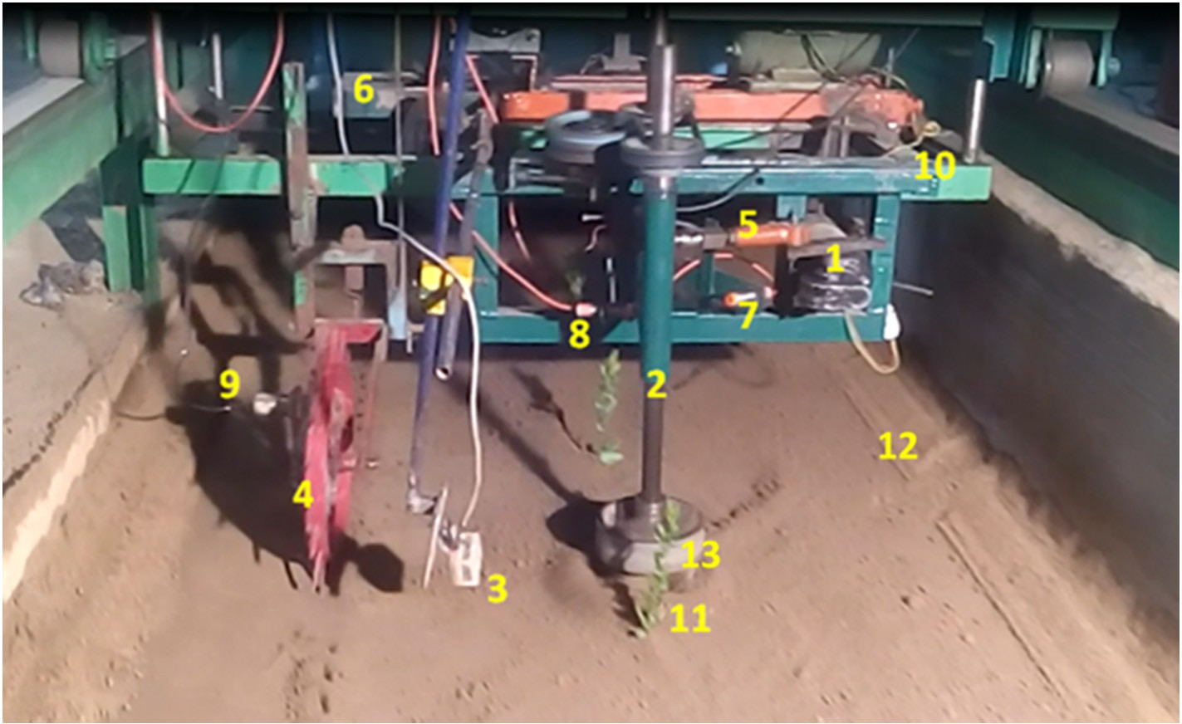](Image%20of%20Fig.%201)

Fig. 1. Prototype of intra-row weeder including (1) PWM DC motor, (2) vertical axis rotary shaft, (3) position sensor, (4) ground wheel, (5) crank mechanism, (6) controller circuitry, (7, 8, 9) proximity sensors, (10) implement trolley, (11) virtual plantation, (12) soil bin and (13) weeding blade ring assembly.

[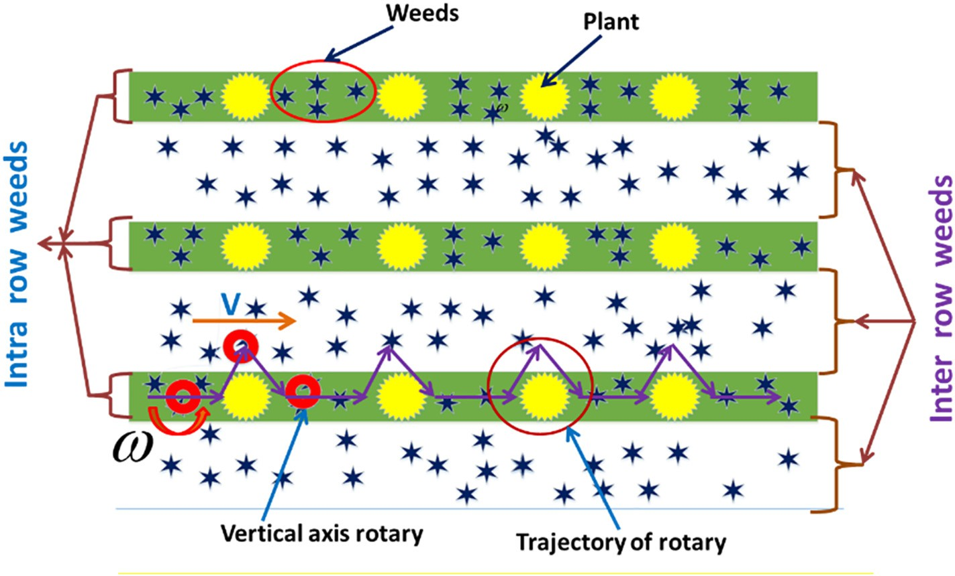](Image%20of%20Fig.%202)

Fig. 2. The working outline of the intra-row weeding unit.

sensor was placed above the average crop-weed height difference within the field and is customizable based on the crop conditions. The time of flight is sensed for interference and signal is transmitted to a mi- croprocessor (ATmega 2560). Fuzzy logic algorithm developed in the microprocessor environment calculates the actuation parameters based on sensor response, soil, forward speed and plantation conditions. Actuation signal is then transmitted to the motor controller (HB-25, Par- allax Inc., Rocklin, CA, USA). The controller then actuates the DC motor (WORMDRV-G200-12, Parramatta, NSW, Australia) through pulse width modulation (PWM) for lateral shift of the rotary arm for the time, estimated from algorithm.

Three inductive type proximity sensors (18–14 DP2, Autonics, Navi

Mumbai, India) were also integrated within the system for position sensing. First proximity sensor (P1) was mounted on a ground wheel to calculate the forward translation speed of the system. This dynamic parameter is used as an input to the control algorithm. Rest two

proximity sensors (P2 and P3) were placed at extreme ends to restrict the shaft movement within the operating zone.

* 1. *Fuzzy logic algorithm for plant damage avoidance*

Mechanical systems for weed control do provide an acceptable weeding efficiency however, the major disadvantage is high plant dam- age. Plant damage can be prevented by pulling out the weeding instru- ment (tool or rotary shaft) from the crop row at right time. Such control is possible with electronic sensing and appropriate algorithm directed controls. Therefore, a fuzzy logic algorithm was integrated to the devel- oped weeding system to direct shaft withdrawal (i.e. lateral shifting) from the crop row within the safe time. The developed algorithm is ini- tiated by a continuous signal stream received from the ultrasonic sensor on detection of crop plant presence. Other dynamic operating parame- ters in the algorithm include forward speed of operation, intra-row

[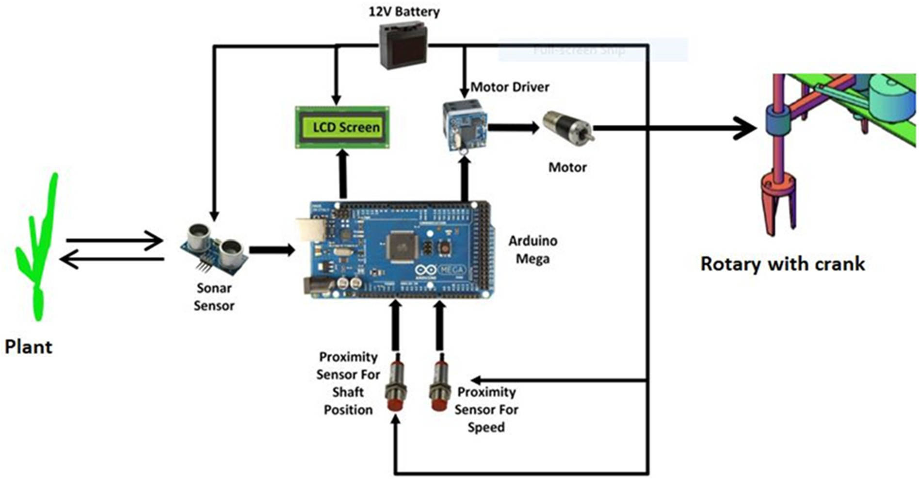](Image%20of%20Fig.%203)

Fig. 3. Mechatronic block diagram of the intra-row weeding system.

[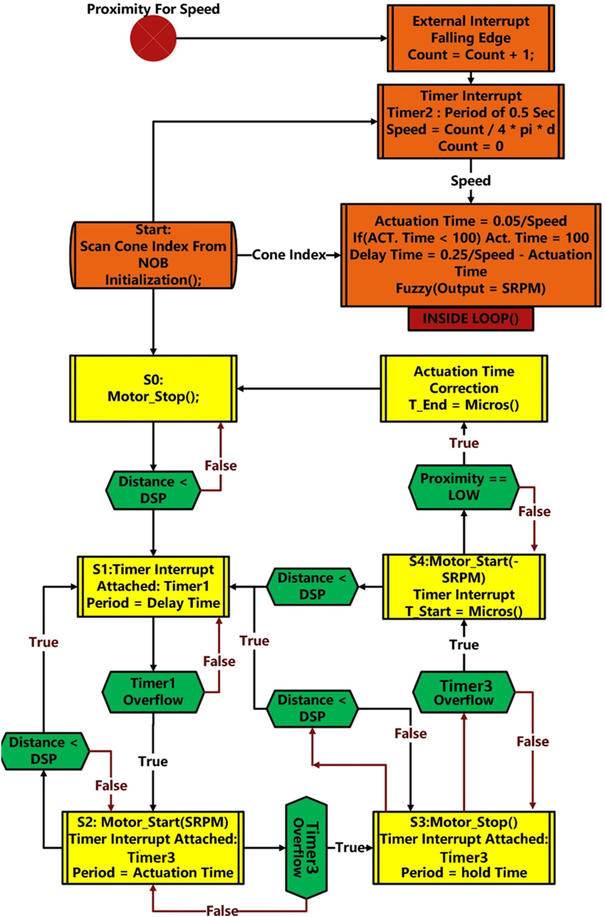](Image%20of%20Fig.%204)

Fig. 4. Fuzzy logic-based decision-making process for controlled lateral shift of the weeding shaft.

crop spacing and control shaft position. Electronic control parameters of total response (TRT), actuation (AT), delay (DT) and hold times (HT) are

Table 1

Fuzzy matrix for angular speed of shaft (SRPM).

then calculated on plant to plant basis. The flow chart of integrated *AT*

fuzzy logic algorithm is presented in Fig. 4. *CI*

Low

(100 ms)

Medium (175 ms)

High (250 ms)

As per the stated view of intra-row weeder as a finite state system, the control process is divided into five sequential states (1) plant not de- tected and control shaft in crop row (S0), (2) plant detected but control shaft in crop row (S1), (3) control shaft shifting away from crop row (S2), (4) control shaft held at an extreme position from crop row (S3) and (5) control shaft position retaining towards the crop row (S4). These states are initiated by three independent timers (Timer1, Timer2 and Timer3) interfaced to the microcontroller. Firstly, (setup

Low (300 kPa) High Medium Low

Medium (400 kPa) High Medium Low

High (500 kPa) High Medium Medium

control process was calculated as the summation of AT, HT and DT (Eq. (5)). The schematic showing AT, HT and DT presented in Fig. 5.

()) all the initializations were made and a timer interrupt of one second was configured in Timer2 to rescan the soil cone index (CI) and forward speed and calculate all delay intervals. Secondly, instantaneous lateral shift speed of the control shaft (SRPM) is calculated as a function of for-

*v* = 8∗π∗*D*

*count*

0.05

(1)

ward speed and CI within same interrupt. This process utilizes fuzzification and defuzzification equations derived from simple me-

*AT* =

*v* (2)

chanics. Thirdly, the distance between crop plant and ultrasonic sensor

is compared with the set threshold distance (DSP) in each iteration. DSP selection is based on excluding the sensor values at two conditions

*DT* = *x*−0.05 −*AT* (3)

*v*

(1) no crop plant in front of sensor and (2) crop plant in front of sensor. If the distance is less than the DSP, then the state S1 is switched by

*HT* = *y*

*v*

(4)

Timer1 at an interval equal to delay time (DT). After DT, the system state is switched from S1 to S2 where the DC motor actuates for time AT configured in Timer3. After AT, the system state shifts to S3 and the DC motor halts for a hold time (HT) configured in Timer3. The hold position is detected by the P3. Passage of HT shifts the system state to S4 where DC motor actuation reverses (-SRPM) to retain the control shaft in the intra-row zone. Retainment continues until a nega- tive external interrupt is received from P2 at the initial shaft position. The error time between S3 and S4 is also recorded for the current cycle and incorporated in the next actuation cycle. After the external in- terrupt is received from P2, the DC motor stops and system state shifts to S0 for next actuation cycle.

* + 1. *Process parameters for the electronic shaft control*

The forward speed of operation (*v*, m/s) was consistently calculated

(1) from a falling edge external interrupt P1 during system state varia- tion. P1 counts the metal bids (count) per second, placed at eight dia- metrical ends on ground wheel (diameter = D, m). The AT (ms) is then calculated (Eq. (2)) as an inverse function of forward speed. Mini- mum AT was set to 100 ms and actuation was set to start 50 mm before the crop plant location to avoid interference. The DT for shaft actuation 50 mm before the crop plant is calculated as a function of forward speed and distance between ultrasonic sensor and control shaft (*x*, m). An ad- ditional time interval of HT (ms) is also calculated to hold the control shaft at extreme end, off the crop row. HT is calculated as a function of forward speed (v) and crop length (calculated from a series of ultrasonic sensor signals, *y*, m). The total response time (TRT) during the shaft

*TRT* = *DT* + 2*AT* + *HT* (5)

The next critical shaft control parameter is the rotary speed of the FBL crank (SRPM) that was calculated using the fuzzy logic algorithm as a weighted function of cone index (CI) and AT. CI is the measure of soil strength that may affect the forward speed of operation and SRPM. SRPM will be apparently higher for a lesser actuation time and higher CI. The fuzzy matrix (Table 1) was designed for three ranges of CI and AT. The triangular membership functions (Eqs. (6), (7)) were found suitable for CI and AT fuzzifications (Fig. 6) among trapezoidal, Gaussian and triangular functions. The weightage matrix (Table 2) was then constructed by using minima (Eq. (8)) of CI and AT functions from their corresponding low, medium and high range values. Similarly, the SRPM defuzzification was calculated using maxima of the CI and AT membership functions (Eqs. (9), (10), (11)). SRPM was then calculated using combinations of fuzzification and defuzzification equations (Eq. (12)) (Witold, 1994; Victor et al., 2013).

*W*.*CI* [3] = *W*.*CIlow*, *W*.*CImed*, *W*.*CIhigh*} (6)

*W*.*AT* [3] = *W*.*ATlow*, *W*.*ATmed*, *W*.*AThigh*} (7)

*Wi*,*j* = *min* (*W*.*CI* [*i*], *W*.*AT* [*j*]) (8)

*Wlow*,*SRPM* = max (*W*0,2 , *W*1,2) (9)

*WMedium*,*SRPM* = max (*W*0,1, *W*1,1, W2,1, *W*2,2) (10)

[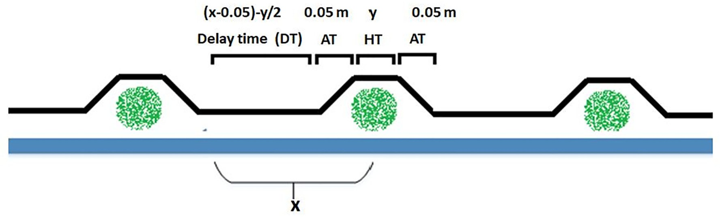](Image%20of%20Fig.%205)

Fig. 5. Schematic of the different time intervals considered for lateral shift of the weeding shaft.

[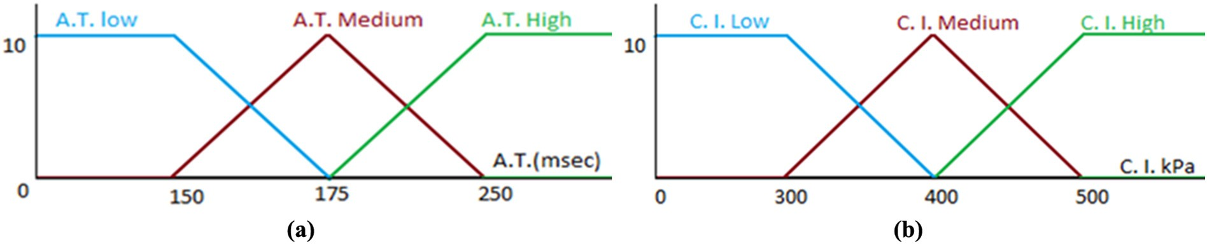](Image%20of%20Fig.%206)

Fig. 6. Triangular membership functions for (a) actuation time (AT) and (b) cone index (CI).

*WHigh*,*SRPM* = max (*W*0,0 , *W*1,0, *W*2,0) (11)

Table 3

Operation and plantation conditions for evaluation of intra-row weeder in the soil bin

*SRPM*

*Wlow*,*SRPM* ∗*SRPMlow* + *WMedium*,*SRPM* ∗*SRPMMedium* + *WHigh*,*SRPM* ∗*SRPMHigh*

= *Wlow*,*SRPM* + *WMedium*,*SRPM* + *WHigh*,*SRPM*

(12)

laboratory.

Independent parameters Dependent parameters

Parameters Levels Plant damage (%) and

Plant spacing (mm) 300, 400, 500 SRPM

where, *W*.*CIlow*, *W*.*CImed*, *W*.*CIhigh* are the weights of low, medium and high CI ranges and *W*.*ATlow*, *W*.*ATmed*, *W*.*AThigh* are the weights of low, medium and high AT ranges. The values for *i* and *j* range from 0 to 2,

Speed of operation (km/h)

Depth of operation

(mm)

0.96, 1.71, 2.58

20,40, 60

*Wlow*, *Wmedium* and *Whigh* are the weights at three levels of SRPM.

* 1. *Performance evaluation of the instrumented prototype in soil bin*

The developed prototype was tested in the instrumented soil bin under varied operating conditions. Firstly, the effect of operating condi- tions on electronic control parameters was evaluated. Secondly, the sys- tem behavioral parameters such as torque employed during weeding ring operation in soil, draft force encountered during lateral shift of con- trol shaft were observed. Lastly, the effect of system and operating con- ditions was observed on the plant damage.

* + 1. *Instrumentation arrangement for system evaluation*

The developed prototype was mounted on externally controlled me- chanical trolley provisioned for a varied range of forward speeds and depth arrangements. A torque transducer of 200 Nm capacity (T20WN, Hottinger Baldwin Mesurements, Darmstadt, Germany) was also installed between the DC motor and final drive mechanism to de- termine the torque employed during the weeding ring operation in the soil. Two load cells (L1 and L2) of 12 kN capacity (F 214, Novatech Measurements Limited, East Sussex, England) were installed between the implement trolley and prototype to measure the draft force encoun- tered during the operation. An additional load cell (L3) was installed be- tween the DC motor and control shaft to measure the force encountered during the lateral shifting. All the transducers were connected to a data logger (1-MX840-PAKEASY, Hottinger Baldwin Mesurements, Darm- stadt, Germany) that was interfaced to a remote computer for real time data recording. A liquid crystal display (LCD) was installed with the control system inboard the developed prototype to display the lat- eral shift speed(SRPM), AT, TRT and DT.

* + 1. *Operating conditions setup*

The soil bin setup was prepared as per the field conditions typically as observed during the weeding recommended period. Sandy clay loam

Cone index (kPa) 300 (±20), 400 (±20), 500

(±20)

soil was collected from the research farm and prepared for a bed depth of 0.5 m and a moisture content of 15–18% dry bulk. To establish the var- ied soil conditions, soil compactness (strength, CI) was varied using var- ious tillage and soil preparation implements on-board the trolley. The CI was then measured using a cone penetrometer with a calibrated ring transducer. A series of well grown plants were then planted in the soil bin for evaluation of effects on plant damage. The heights of these plants were maintained well above the generalized weed heights. Moreover, the plantation heights and widths were maintained non-uniformly to ensure dynamicity during system evaluation. The ultrasonic sensor height was then adjusted to the minimum plant height amongst the planted series.

* + 1. *Evaluation*

The evaluation study was designed for four independent operating parameters viz. forward speed, plantation spacing, operational depth and cone index. These parameters were divided individually into three different levels to determine the most suitable plantation, soil and sys- tem conditions for minimum plant damage during weeding operation. Three operational speeds of 0.96, 1.71 and 2.58 km/h were selected that were within the recommended ranges (Dedousis et al., 2007; Ahmad, 2012). Similarly, CIs of 300 kPa, 400 kPa and 500 kPa were se- lected for soil conditions. Operational depths of 20 mm, 40 mm and 60 mm and plantation spacings of 300 mm, 400 mm and 500 mm were selected for prototype evaluation. A total of 81 operating condi- tions were obtained (Table 3) and evaluation at each condition was rep- licated thrice. As a result, the percentage damaged plants (Eq. (13)) and SRPM behavior were recorded as response variables during the experi- mental trials. A plant was considered to be damaged if uprooted by the control shaft during the operation. The effects of operating parameters

Table 2

Weightage matrix to calculate SRPM for CI and AT fuzzification.

*AT* Low Medium High

*CI*

Low *Min* (*W*.*CI* [0], *W*.*AT* [0])a *Min* (*W*.*CI* [0], *W*.*AT* [1]) *Min* (*W*.*CI* [0], *W*.*AT* [2])

Medium *Min* (*W*.*CI* [1], *W*.*AT* [0]) *Min* (*W*.*CI* [1], *W*.*AT* [1]) *Min* (*W*.*CI* [1], *W*.*AT* [2])

High *Min* (*W*.*CI* [2], *W*.*AT* [0]) *Min* (*W*.*CI* [2], *W*.*AT* [1]) *Min* (*W*.*CI* [2], *W*.*AT* [2])

a 0, 1, and 2 indicate three ranges of cone index and actuation times as discussed in Eqs. (8)–(11) and Table 1.

[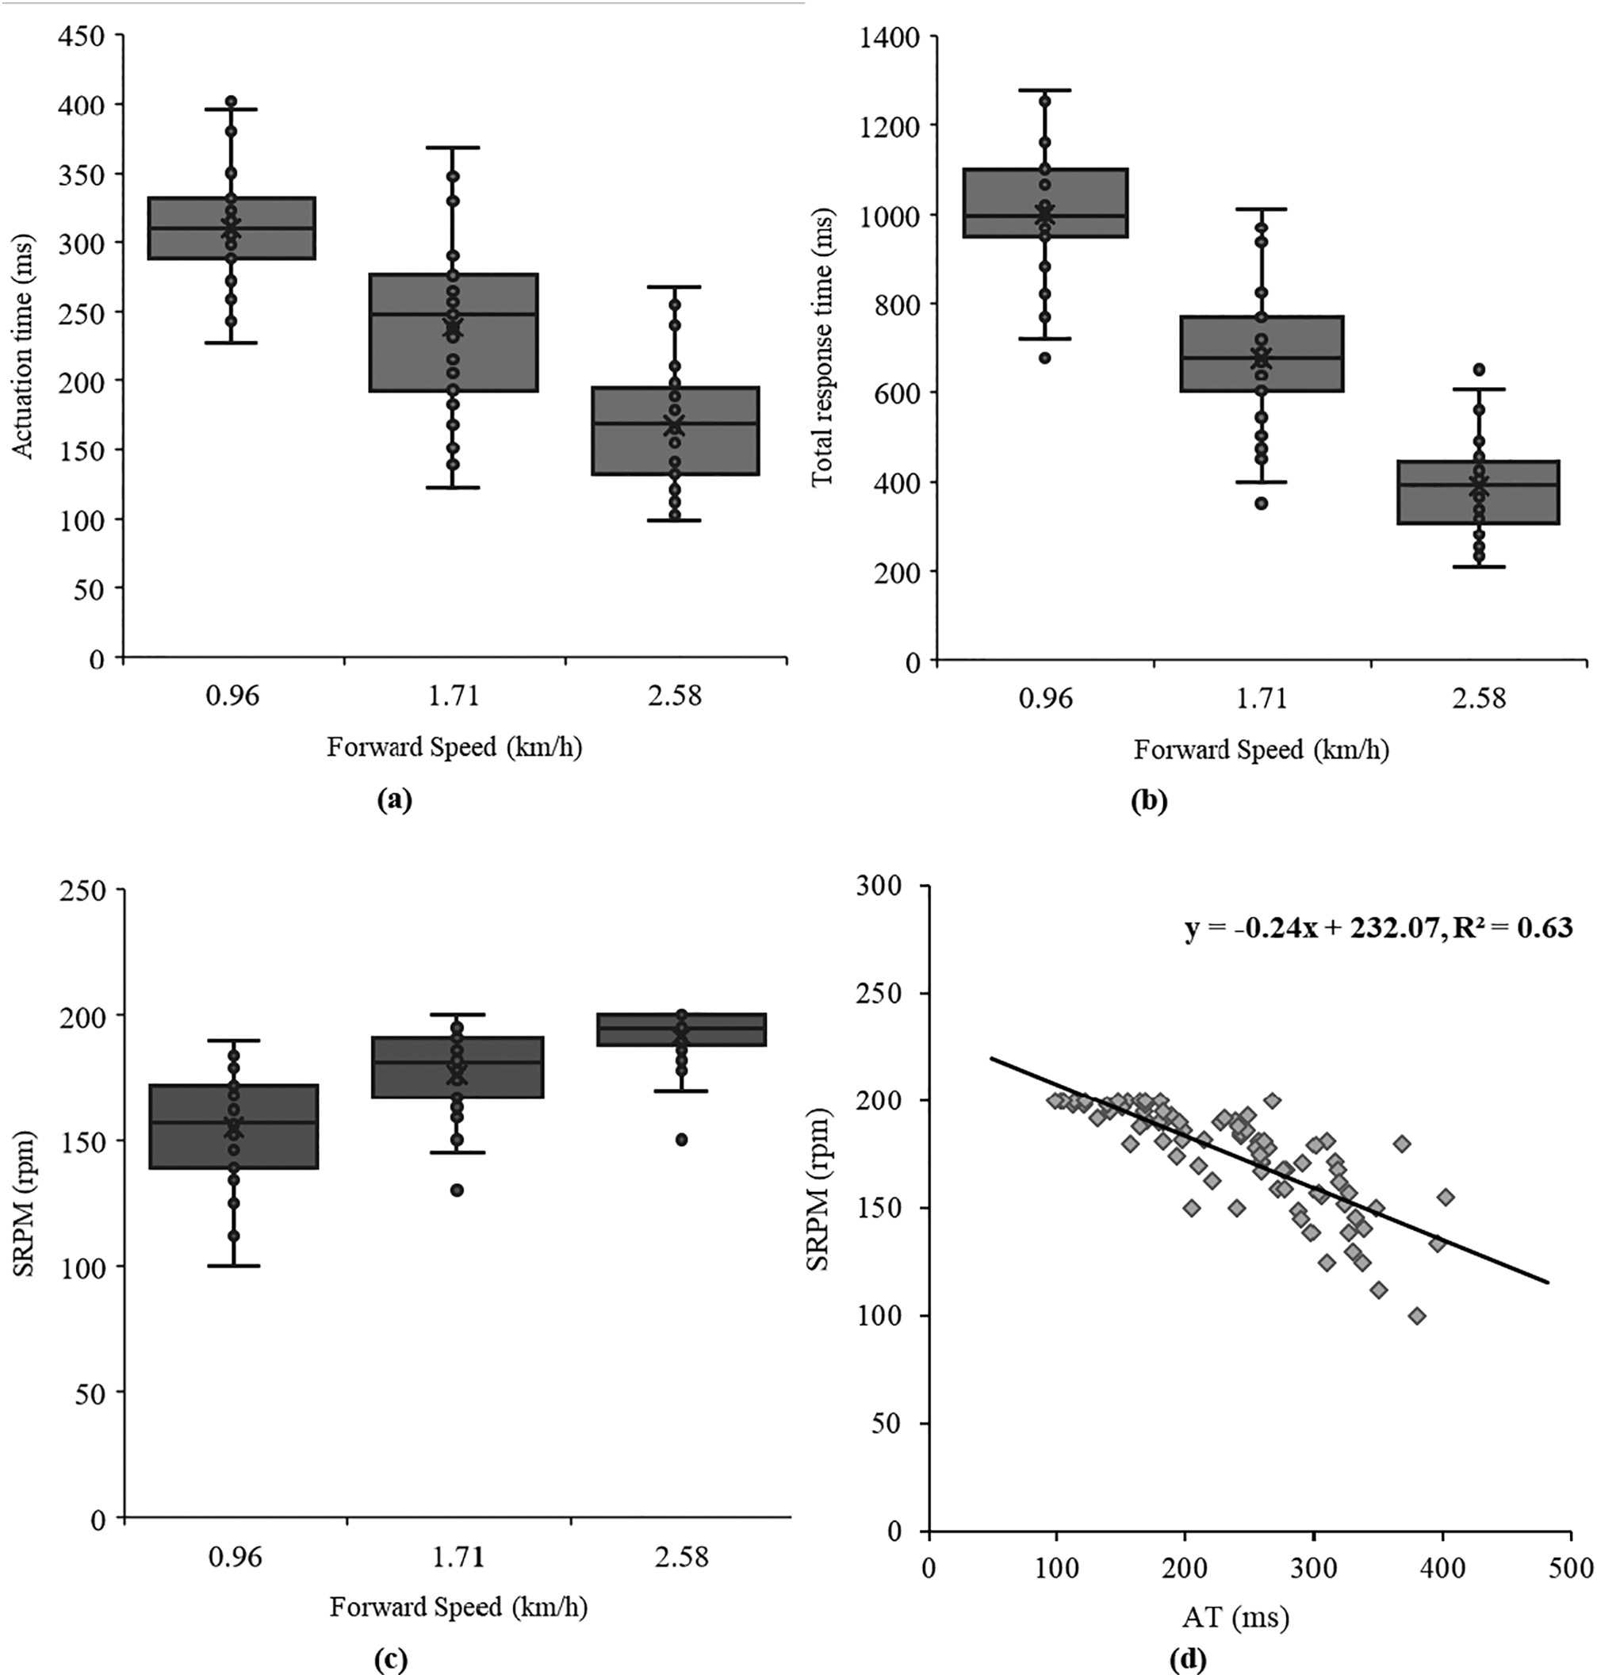](Image%20of%20Fig.%207)

Fig. 7. Response curves of (a) actuation time, (b) total response time, (c) crank speed as a function of forward speed and (d) crank speed as a function of actuation time.

on electronic control parameters (AT and TRT) were also observed dur- ing the evaluation.

point linkage. The rotary motion was provided by the tractor PTO. The average soil compaction of 473.42 kPa was observed from 10 random samples within the field. The tractor was operated at the best speed of

*DP* = *Q* 2∗100

*Q* 1

(13)

operation observed from the soil bin evaluations (1.8 km/h) and corre- sponding SRPM of 175 rpm was selected. This is also the speed which is recommended for general weeding operations (Dedousis et al., 2007;

where, DP is the damaged plants (%), Q1 is the total number of plants before operation and Q2 is the number of plants uprooted during the operation (Table 3).

The developed system was also preliminarily evaluated in the field plots planted with green chili and tomato crops. The field was uniformly prepared using the primary and secondary tillage equipment. The crops were planted at an inter and intra-row spacings of 50 cm. The developed arrangement was mounted on a frame and then on to the tractor three-

Ahmad, 2012). The operation depths were set to 20 and 40 mm for all the speeds of operation and were approximately maintained using the calibrated position and draft control levers on the tractor. The weeding efficiency (Eq. (14)) was calculated based on the number of weeds be- fore and after the operation. The average weeding efficiency for all trials was calculated from 5 random locations, sampled using the aluminum frames. Moreover, the plant damage (%) was also assessed from 10 rows of operations for both the crops. Each row was planted with 50

plants and the non-germinated plants were not accounted for damage assessments.

*WE* = *Wb*−*Wa* ∗100% (14)

*Wb*

where, *Wb* and *Wa* are the number of weeds before and after weeding.

* 1. *Data analysis*

The acquired data of TRT, AT, DP at varied conditions of forward speeds, operational depths, plantation spacings and CI was statistically analyzed at significance level of 5% in the Microsoft® Excel data analysis tool pack and R-studio (Version 1.0.153, Boston, MA, USA). The relation- ships obtained for AT and TRT were first verified using one-way ANOVA at different operating conditions. Secondly, the SRPM modelled from

fuzzy logic algorithm was analyzed using stepwise multiple regression analysis as a function of independent operating parameters and their in- teractions. Similarly, the DP was also analyzed using stepwise multiple regression. Lastly, the effect of SRPM on DP was also analyzed. Fitness of resultant regression models were assessed using ANOVA. A two- sample *t*-test was used to compare the weeding efficiencies and plant damages for field evaluations.

1. Results and discussion
   1. *Fuzzy logic algorithm derived control shaft lateral shift speed pramaters*

The lateral shift of control shaft was observed for an average AT (Fig. 7a) of 310.07 ms (SE: ±8.35 ms) at a forward speed of 0.96 km/

h. Similarly, the average lateral shift ATs of 238.63 ms (SE: ± 11.62 ms) and 167.89 ms (SE: ±8.64 ms) were recorded at the forward

[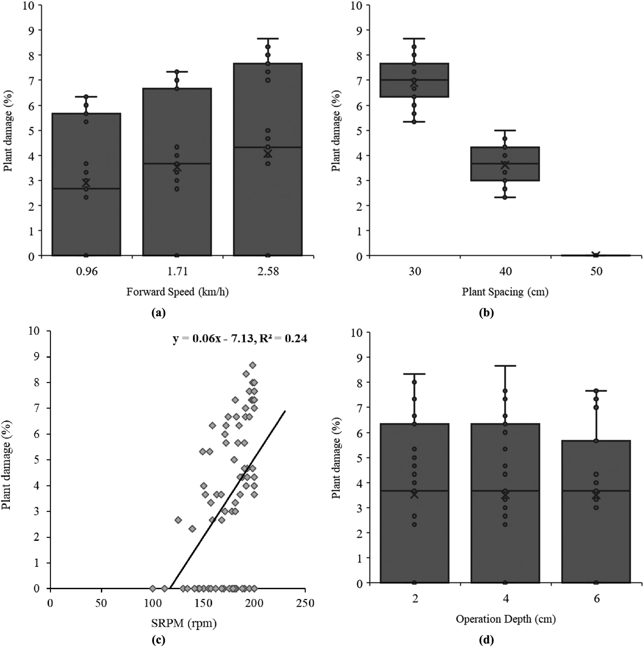](Image%20of%20Fig.%208)

Fig. 8. Plant damage as a function of (a) forward speed (b) intra-row plant spacing (c) crank speed and (d) operational depth.

[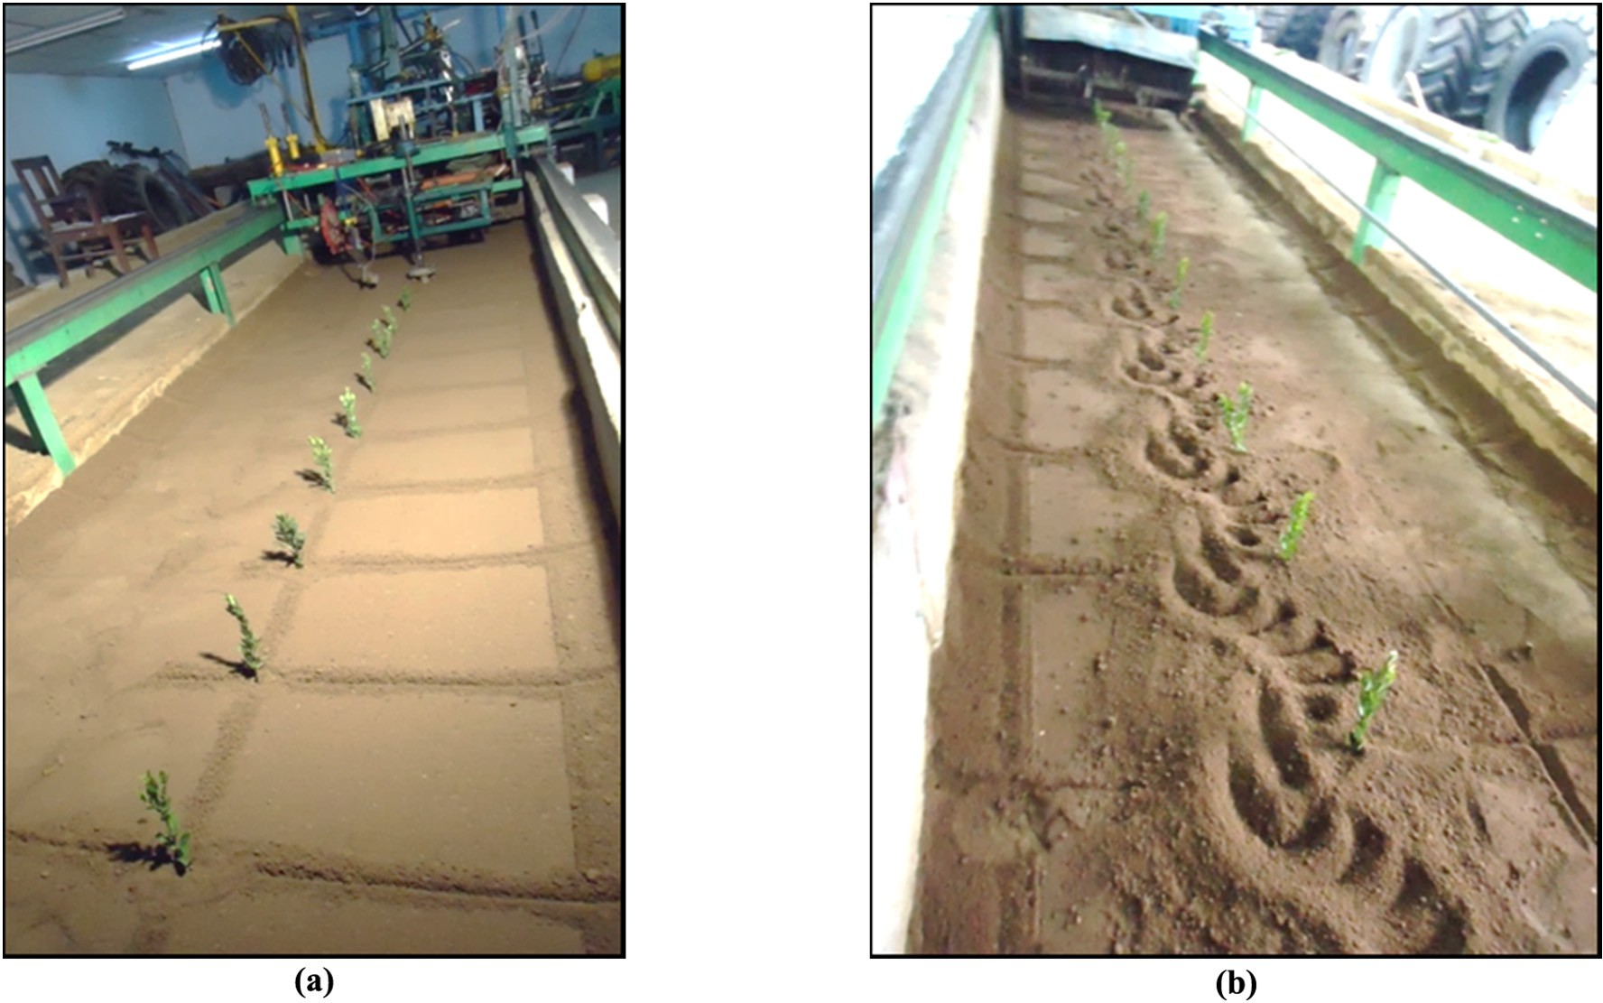](Image%20of%20Fig.%209)

Fig. 9. Soil profile (a) before and (b) after operation of intra-row weeder prototype.

speeds of 1.71 and 2.58 km/h, respectively. The average lateral shift TRTs (Fig. 7b) of 1000.22 ms (SE: ±29.13 ms), 676.23 ms (SE: ±

30.80 ms) and 386.89 ms (SE: ±21.19 ms) were recorded at forward speeds of 0.96, 1.71 and 2.58 km/h, respectively. Similarly, the average lateral shift SRPMs (Fig. 7c) of 154.85 rpm (SE: ±4.38 rpm),

176.41 rpm (SE: ±3.44 rpm) and 191.60 rpm (SE: ±2.24 rpm) were ob- tained at the forward operational speeds of 0.96, 1.71 and 2.58 km/h, re- spectively. Furthermore, the SRPMs modelled from the fuzzy algorithm increased with decreasing AT (Fig. 7d) and increasing CI. The average SRPM values of 163.41 rpm (SE: ±5.03 rpm), 173.77 rpm (SE: ± 4.42 rpm) and 183.67 rpm (SE: ±3.33 rpm) were obtained at CIs of 300 kPa, 400 kPa and 500 kPa, respectively. The results of one-way ANOVA indicate variation in AT to be significantly dependent on for- ward speed of operation (*F*1,79 = 109.38, *P* b 0.001). Similarly, the TRT of the entire lateral shift movement was also affected by the forward speed of operation (One-way *ANOVA*, *F*1,79 = 248.65, *P* b 0.001). The multiple regression analysis further verified that the SRPM modelled in the fuzzy algorithm was significantly affected by the combination of AT and CI (*R*2 = *0.65*, *F*2,78 = 71.92, *P* b 0.001), however, their interac- tion was insignificant. Since, AT had strong dependence on forward

speed, the SRPM was also found to be dependent on forward speed (Ahmad, 2012; Home, 2003). Furthermore, SRPM was unaffected by the operational depth. Since, the AT, TRT, SRPM held strong relation- ships with the forward speed, it was solely used to avoid cofounding ef- fect in the multiple regression analysis. The relationships designed for system parameters within the fuzzy logic algorithm were verified under all operating conditions. SRPM was obtained as an indirect dy- namic function of forward speed that is entirely dependent on soil prop- erties, system slippage and other unknown internal and external mechanical interactions. Therefore, SRPM is the ultimate parameter that guides the control shaft for efficient weed removal while also avoiding crop plant interference (i.e. DP). This SRPM may be more sen- sitive under dynamic field conditions (Abidine et al., 2004). However, these conditions are more likely to be within the range of operating con- ditions considered during the system evaluation.

* 1. *Effects of electronic control and operating parameters on plant damage*

The analysis of crop plant damage was conducted as an effect of prominent electronic control and operating conditions. The crop plant

[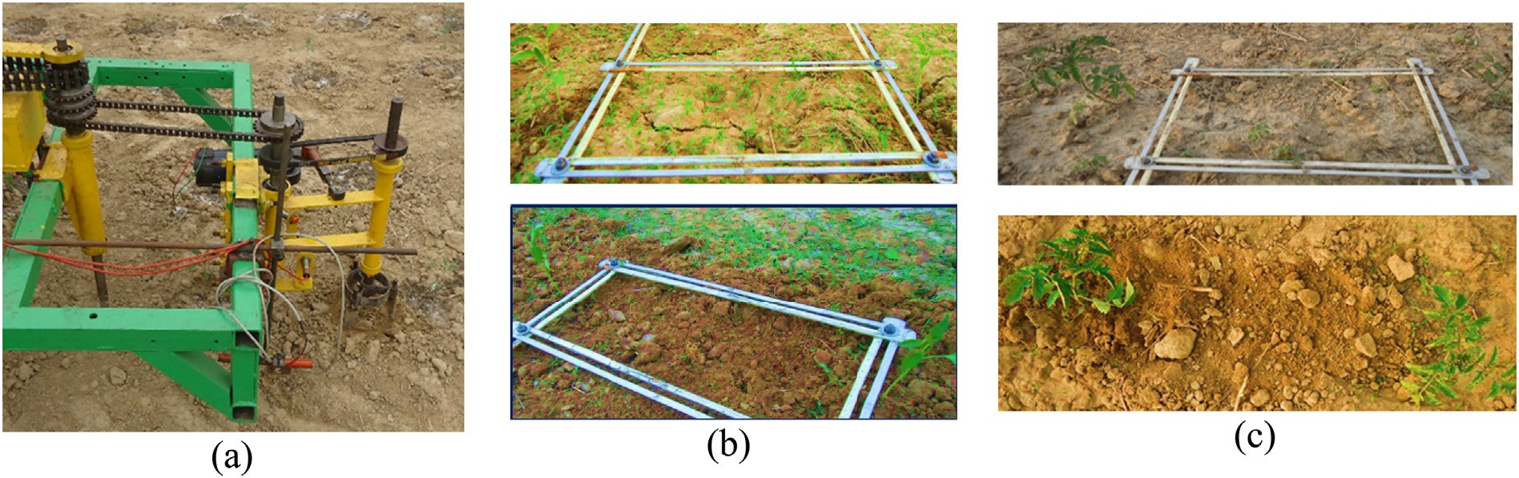](Image%20of%20Fig.%2010)

Fig. 10. Preliminary field evaluation showing (a) developed intra-row weeding prototype, and before and after pertinent weeding operation in (b) green chili and (c) tomato plantations.

damage (Fig. 8) increased significantly with the forward speed of oper- ation, intra-row plant spacing and their interactions (*Multiple Regres- sion*, *R*2 = *0.98*, *F*3,77 = 1530, *P* b 0.001) (Home, 2003; Abidine et al., 2004; Perez-Ruiz et al., 2012). The average plant damages of 2.90% (SE: ±0.47%), 3.53% (SE: ±0.56%) and 4.07% (SE: ±0.63%) were ob-

served at forward operational speeds of 0.96, 1.71 and 2.58 km/h, re- spectively. Similarly, the average plant damages of 6.89% (SE: ± 0.18%), 3.62% (SE: ±0.15%) and 0% were observed at the intra-row plan- tation spacings of 300 mm, 400 mm and 500 mm, respectively. The plant damage was significantly affected by the SRPM (*Linear Regression*, *F*1,79 = 24.91, *P* b 0.001) but remained unaffected by the operational depths. This analysis reveals that the plantation spacings and forward speed of operation need to be optimized in order to achieve minimum plant damage (Ahmad, 2012). However, the dynamic field conditions may demand more accurate selection of these parameters. The dynamic forces (draft and lateral shift) and torque encountered during control shaft lateral movement were also assessed. The values were well within the recommended limits of weeding operation. A cycloid soil profile (Fig. 9) obtained after the system operation indicated the intended mo- tion of the control shaft to avoid any plant interference (i.e. damage).

During the preliminary field evaluation of the system (Fig. 10), aver-

age weeding efficiencies of 77.54 (±2.45) and 79.07% (±3.75) were ob- served for operation depths of 20 and 40 mm, respectively in the green chili plantation. However, these differences were non-significant (*Two*- *sample t*-*test*, *t*18 = −1.08, *P* = 0.15). Similarly, the average plant dam- ages of 15.04 (±2.82) and 16.59 (±3.58) were observed at pertinent depths and were not significantly different (*Two*-*sample t*-*test*, *t*18 =

−1.07, *P* = 0.30). In the tomato plantation, average weeding efficiencies of 65.64 (±3.30) and 64.87 (±3.07) and average plant damages of 18.4 (±2.03) and 25.52 (±2.19) were observed at respective depths of 20 and 40 mm of operation. The difference in weeding efficiencies were non-significant (*Two*-*sample t*-*test*, *t*18 = 0.54, *P* = 0.60) whereas, that in plant damages were significant for the tomato plantation (*Two*-*sam- ple t*-*test*, *t*18 = −7.53, *P* b 0.001). The plant damage was slightly higher and weeding efficiency was slightly lower for the tomato plantation as compared to chili plantation (Fig. 11). This can be attributed to the higher soil moisture level visible in the tomato crops that would resist the free rotation of the weeding blade. Moreover, the larger spread of

[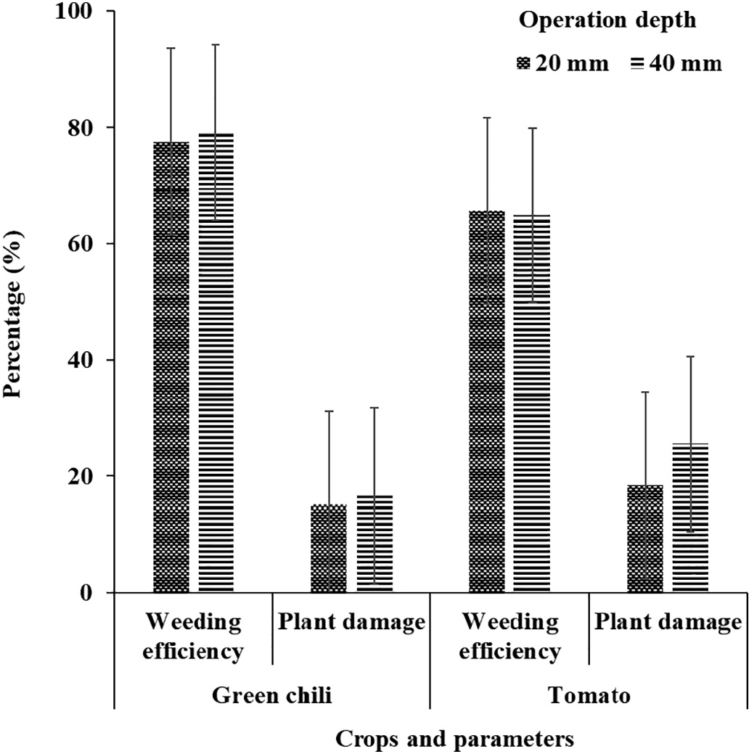](Image%20of%20Fig.%2011)

Fig. 11. Weeding efficiency and plant damage in green chili and tomato plantations observed during the intra-row weeding operation.

roots of the tomato crop could have also resulted in the excess crop damage. This suggests for crop specific feature additions in the operat- ing fuzzy algorithm for intra-row shaft shifting. Further detailed analy- sis on the agronomic causal factors for resultant plant damage and weeding efficiency was out of the scope of this study. A uniform soil bed preparation with uniform plantation will be critical for efficient op- eration of the intra-row weeding systems. Future scope will include in- corporation of an automated provision to measure the soil compaction levels in real time for real time adjustments of the SRPM. Overall, suffi- cient weeding efficiency and plant damage avoidance was achieved by the developed system. The unique four bar linkage actuated weeding shaft can be integrated to various other sensor networks for effective eradication of the weeds in the intra-row region. Our future studies will also include assessment of the soil properties in various sections of the field and their impact on intra row weeding operation. Moreover, the impact of the tractor wheel slippage on weeding efficiency and plant damage would also be assessed. These parameters will be considered for further refinement of the system as per the crop and field dynamics.

1. Conclusions

The fuzzy logic algorithm based on time of flight and positions sen- sors provided significant inputs for electronic control of the four-bar linkage mechanism. Pertinent actuation response timings and lateral shift speed (SRPM) parameters were found to be significantly depen- dent on forward operation speed, system and soil parameters. The crop plant damage was found to be significantly affected by the forward operation speeds and plantation spacing and was considerably high for higher forward speeds (higher SRPM) and lower plant spacing. Prelim- inary field evaluations showed this system to be effective for intra-row weed (N65%) and plant damage control (b25%) at optimum operational parameters. However, challenges pertinent to dynamic synchronization of the electronic control, mechanical actuations and plantation charac- teristics may be consistently explored and optimized for effective intra-row weeding in row crops.

CRediT authorship contribution statement

Satya Prakash Kumar: Conceptualization, Software, Data curation, Laboratory & field evaluation, Writing - original draft. V.K. Tewari: Su- pervision, Writing - review & editing. Abhilash K. Chandel: Software, Formal analysis, Investigation, Writing - original draft, Writing - review & editing. C.R. Mehta: Writing - review & editing. Brajesh Nare: Soft- ware, Investigation. C.R. Chethan: Software, Investigation. Kaustubh Mundhada: Software. Prateek Shrivastava: Laboratory & field evalua- tion. Chanchal Gupta: Laboratory & field evaluation. Smrutilipi Hota: Software, Data curation.

Declaration of competing interest

The authors declare no conflict of interest.

Acknowledgements

This study was funded by the All India Coordinated Research Project (AICRP) on Farm Implements and Machinery, Indian Council of Agricul- tural Research, Govt. of India, New Delhi. Authors are also thankful to Mr. Utpal Ekka, Mr. Gajendra Singh, Mr. Chaitanya Pareek, Mr. Naveen Kumar and Miss. Sneha Jha for their assistance in conducting this study.

References

Abidine, A.Z., Heidman, B.C., Upadhyaya, S.K., Hills, D.J., 2004. [Auto guidance system oper-](http://refhub.elsevier.com/S2589-7217(20)30019-2/rf0005) [ated at high speed causes almost no tomato damage. Calif. Agr. 58, 44–47](http://refhub.elsevier.com/S2589-7217(20)30019-2/rf0005).

Ahmad, M.T., 2012. [Development of an Automated Mechanical Intra-row Weeder for](http://refhub.elsevier.com/S2589-7217(20)30019-2/rf0010) [Vegetable Crops. Iowa State University, USA, Masters Dissertation](http://refhub.elsevier.com/S2589-7217(20)30019-2/rf0010).

Andujar, D., Weis, M., Gerhards, R., 2012. [An ultrasonic system for weed detection in ce-](http://refhub.elsevier.com/S2589-7217(20)30019-2/rf0015) [real crops. Sensors 12, 17343–17357](http://refhub.elsevier.com/S2589-7217(20)30019-2/rf0015).

Astrand, B., Baerveldt, A., 2002. [An agricultural mobile robot with vision-based perception](http://refhub.elsevier.com/S2589-7217(20)30019-2/rf0020) [for mechanical weed control. Auton. Robots 13, 21–35](http://refhub.elsevier.com/S2589-7217(20)30019-2/rf0020).

Bajwa, A.A., Mahajan, G., Chauhan, B.S., 2015. [Non-conventional weed management strat-](http://refhub.elsevier.com/S2589-7217(20)30019-2/rf0025) [egies for modern agriculture. Weed Sci. 63, 723–747](http://refhub.elsevier.com/S2589-7217(20)30019-2/rf0025).

Bakker, T., van Asselt, K., Bontsema, J., Müller, J., van Straten, G., 2010. [Systematic design of](http://refhub.elsevier.com/S2589-7217(20)30019-2/rf0030) [an autonomous platform for robotic weeding. J. Terramechanics 47, 63–73](http://refhub.elsevier.com/S2589-7217(20)30019-2/rf0030).

Bleeker, P.O., Van der, W.R.Y., Kurstjens, D.A.G., 2002. [Experiences and experiments with](http://refhub.elsevier.com/S2589-7217(20)30019-2/rf0035) [new intra-row weeders. Proceedings of the 5th EWRS workshop on Physical and Cul-](http://refhub.elsevier.com/S2589-7217(20)30019-2/rf0035) [tural Weed Control, pp. 97–10](http://refhub.elsevier.com/S2589-7217(20)30019-2/rf0035)0.

Chandel, A.K., Tewari, V.K., Kumar, S.P., Nare, B., Agarwal, A., 2018a. [On-the-go position](http://refhub.elsevier.com/S2589-7217(20)30019-2/rf0040) [sensing and controller predicated contact-type weed eradicator. Curr. Sci. 114 (7),](http://refhub.elsevier.com/S2589-7217(20)30019-2/rf0040) [1485–1494](http://refhub.elsevier.com/S2589-7217(20)30019-2/rf0040).

Chandel, A.K., Khot, L.R., Osroosh, Y., Peters, T., 2018b. [Thermal-RGB imager derived in-](http://refhub.elsevier.com/S2589-7217(20)30019-2/rf0045) [field apple surface temperature estimates for sunburn management. Agric. For.](http://refhub.elsevier.com/S2589-7217(20)30019-2/rf0045) [Meteorol. 254, 132–140](http://refhub.elsevier.com/S2589-7217(20)30019-2/rf0045).

Chethan, C.R., Chander, S., Kumar, S.P., 2018a. [Dynamic strength based dryland weeders-](http://refhub.elsevier.com/S2589-7217(20)30019-2/rf0050) [ergonomic and performance evaluation. Indian J. Weed Sci. 50 (4), 382–38](http://refhub.elsevier.com/S2589-7217(20)30019-2/rf0050)7.

Chethan, C.R., Tewari, V.K., Nare, B., Kumar, S.P., 2018b. [Transducers for measurement of](http://refhub.elsevier.com/S2589-7217(20)30019-2/rf0055) [draft and torque of tractor-implement system - a review. AMA-Agr, Mech. Asia Af.](http://refhub.elsevier.com/S2589-7217(20)30019-2/rf0055) [49 (4), 81–87](http://refhub.elsevier.com/S2589-7217(20)30019-2/rf0055).

Chethan, C.R., Tewari, V.K., Srivastava, A.K., Kumar, S.P., Nare, B., Chauhan, A., Singh, P.K., 2019. [Effect of herbicides on weed control and potato tuber yield under different](http://refhub.elsevier.com/S2589-7217(20)30019-2/rf0060) [tuber eye orientations. Indian J. Weed Sci. 51 (4), 358–38](http://refhub.elsevier.com/S2589-7217(20)30019-2/rf0060)9.

Christensen, S., Søgaard, H.T., Kudsk, P., Nørremark, M., Lund, I., Nadimi, E.S., Jørgensen, R., 2009. [Site-specific weed control technologies. Weed Res. 49, 233–24](http://refhub.elsevier.com/S2589-7217(20)30019-2/rf0065)1.

Cordill, C., Grift, T.E., 2011. [Design and testing of an intra-row mechanical weeding ma-](http://refhub.elsevier.com/S2589-7217(20)30019-2/rf0070) [chine for corn. Biosyst. Eng. 110, 247–25](http://refhub.elsevier.com/S2589-7217(20)30019-2/rf0070)2.

Dedousis, A.P., Godwin, R.J., O’Dogherty, M.J., Tillett, N.D., Grundy, A.C., 2007. [Inter and](http://refhub.elsevier.com/S2589-7217(20)30019-2/rf0075) [Intra-row Mechanical Weed Control With Rotating Discs. Wageningen Academic](http://refhub.elsevier.com/S2589-7217(20)30019-2/rf0075) [Publishers, Precision Agriculture, pp. 493–49](http://refhub.elsevier.com/S2589-7217(20)30019-2/rf0075)8.

Fennimore, S.A., Smith, R.F., Tourte, L., LeStrange, M., Rachuy, J.S., 2014. [Evaluation and](http://refhub.elsevier.com/S2589-7217(20)30019-2/rf0080) [economics of a rotating cultivator in bokchoy, celery, lattuce, and radicchio. Weed](http://refhub.elsevier.com/S2589-7217(20)30019-2/rf0080) [Technol. 28, 176–18](http://refhub.elsevier.com/S2589-7217(20)30019-2/rf0080)8.

Fontanelli, M., Frasconi, C., Martelloni, L., Pirchio, M., Raffaelli, M., Peruzzi, A., 2015. [Inno-](http://refhub.elsevier.com/S2589-7217(20)30019-2/rf0085) [vative strategies and machines for physical weed control in organic and integrated](http://refhub.elsevier.com/S2589-7217(20)30019-2/rf0085) [vegetable crops. Chem. Eng. T. 44, 211–21](http://refhub.elsevier.com/S2589-7217(20)30019-2/rf0085)6.

Harris, P., 1971. [Biological control of weeds. Weeds biological control, Environ. Letters 2,](http://refhub.elsevier.com/S2589-7217(20)30019-2/rf0090) [75–88](http://refhub.elsevier.com/S2589-7217(20)30019-2/rf0090).

Home, M., 2003. [An Investigation Into the Design of Cultivation Systems for Inter-and](http://refhub.elsevier.com/S2589-7217(20)30019-2/rf0095) [Intra-row Weed Control. Cranfield University, Silsoe, UK, EngD thesis](http://refhub.elsevier.com/S2589-7217(20)30019-2/rf0095).

Karimmojeni, H., Mashhadi, H.R., Shahbazi, S., Taab, A., Alizadeh, H.M., 2010. [Competitive](http://refhub.elsevier.com/S2589-7217(20)30019-2/rf0100) [interaction between maize, Xanthium strumarium and Datura stramonium affecting](http://refhub.elsevier.com/S2589-7217(20)30019-2/rf0100) [some canopy characteristics. Aust. J. Crop. Sci. 4 (9), 684–69](http://refhub.elsevier.com/S2589-7217(20)30019-2/rf0100)1.

Knezevic, S.Z., 2002. [The Concept of Critical Period of Weed Control. Cooperative Exten-](http://refhub.elsevier.com/S2589-7217(20)30019-2/rf0105) [sion, University of Nebraska, Integrated Weed Management, pp. 30–40](http://refhub.elsevier.com/S2589-7217(20)30019-2/rf0105).

Kouwenhoven, J.K., 1997. [Intra-row mechanical weed control-possibilities and problems.](http://refhub.elsevier.com/S2589-7217(20)30019-2/rf0110)

[Soil Tillage Res. 41, 87–10](http://refhub.elsevier.com/S2589-7217(20)30019-2/rf0110)4.

Kumar, S.P., Tewari, V.K., Chethan, C.R., Mehta, C.R., Nare, B., Chandel, A.K., 2019. [Develop-](http://refhub.elsevier.com/S2589-7217(20)30019-2/rf0115) [ment of non-powered self-propelling vertical axis inter row rotary weeder. Indian](http://refhub.elsevier.com/S2589-7217(20)30019-2/rf0115)

[J. Weed Sci. 51 (3), 284–28](http://refhub.elsevier.com/S2589-7217(20)30019-2/rf0115)9.

Kurstjens, D.A.G., 2007. [Precise tillage systems for enhanced non-chemical weed manage-](http://refhub.elsevier.com/S2589-7217(20)30019-2/rf0120) [ment. Soil Tillage Res. 97, 293–305](http://refhub.elsevier.com/S2589-7217(20)30019-2/rf0120).

Manuel, P.R., David, C.S., Fadi, A.F., Chris, J.G., Brandon, J.M., 2014. [Co-robotic intra-row](http://refhub.elsevier.com/S2589-7217(20)30019-2/rf0125) [weed control system. Biosyst. Eng. 126, 45–55](http://refhub.elsevier.com/S2589-7217(20)30019-2/rf0125).

Marx, C., Barcikowski, S., Hustedt, M., Haferkamp, H., Rath, T., 2012. [Design and applica-](http://refhub.elsevier.com/S2589-7217(20)30019-2/rf0130) [tion of a weed damage model for laser-based weed control. Biosyst. Eng. 113,](http://refhub.elsevier.com/S2589-7217(20)30019-2/rf0130) [148–15](http://refhub.elsevier.com/S2589-7217(20)30019-2/rf0130)7.

Mcdonald, A.J., Riha, S.J., Ditommaso, A., 2009. [Early season height differences as robust](http://refhub.elsevier.com/S2589-7217(20)30019-2/rf0135) [predictors of weed growth potential in maize: new avenues for adaptive manage-](http://refhub.elsevier.com/S2589-7217(20)30019-2/rf0135) [ment. Weed Res. 50, 110–11](http://refhub.elsevier.com/S2589-7217(20)30019-2/rf0135)9.

Melander, B., Kristensen, J.K., 2011. [Soil steaming on weed seedling emergence under the](http://refhub.elsevier.com/S2589-7217(20)30019-2/rf0140) [influence of soil type, soil moisture, soil structure and heat duration. Ann. Appl. Biol.](http://refhub.elsevier.com/S2589-7217(20)30019-2/rf0140) [158, 194–20](http://refhub.elsevier.com/S2589-7217(20)30019-2/rf0140)3.

Melander, B., Lattanzi, B., Pannacci, E., 2015. [Intelligent versus non-intelligent mechanical](http://refhub.elsevier.com/S2589-7217(20)30019-2/rf0145) [intra-row weed control in transplanted onion and cabbage. Crop Prot. 72, 1–](http://refhub.elsevier.com/S2589-7217(20)30019-2/rf0145)8.

Nare, B., Tewari, V.K., Chandel, A.K., Kumar, S.P., Chethan, C.R., 2019. [A mechatronically in-](http://refhub.elsevier.com/S2589-7217(20)30019-2/rf0150) [tegrated autonomous seed material generation system for sugarcane: a crop of indus-](http://refhub.elsevier.com/S2589-7217(20)30019-2/rf0150) [trial significance. Ind. Crop. Prod. 128, 1–12](http://refhub.elsevier.com/S2589-7217(20)30019-2/rf0150).

Norremark, M., Griepentrog, H.W., Nielsen, J., Soegaard, H.T., 2008. [The development and](http://refhub.elsevier.com/S2589-7217(20)30019-2/rf0155) [assessment of the accuracy of an autonomous GPS-based system for intra row me-](http://refhub.elsevier.com/S2589-7217(20)30019-2/rf0155) [chanical weed control in row crops. Biosyst. Eng. 101, 396–41](http://refhub.elsevier.com/S2589-7217(20)30019-2/rf0155)0.

O’Dogherty, M.J., Godwin, R.J., Dedousis, A.P., Brighton, L.J., Tillet, N.D., 2007. [A mathemat-](http://refhub.elsevier.com/S2589-7217(20)30019-2/rf0160) [ical model of the kinematics of a rotating disc for inter- and intra-row hoeing. Biosyst.](http://refhub.elsevier.com/S2589-7217(20)30019-2/rf0160) [Eng. 99, 169–17](http://refhub.elsevier.com/S2589-7217(20)30019-2/rf0160)9.

Perez-Ruiz, M., Slaughter, D.C., Gliever, C.J., Upadhayaya, S.K., 2012. [Automatic GPS based](http://refhub.elsevier.com/S2589-7217(20)30019-2/rf0165) [intra-row weed knife control system for transplanted row crops. Comput. Electron.](http://refhub.elsevier.com/S2589-7217(20)30019-2/rf0165) [Agric. 80, 41–49](http://refhub.elsevier.com/S2589-7217(20)30019-2/rf0165).

Peruzzi, A., Ginanni, M., Raffaelli, M., Fontanelli, M., 2007. [Physical weed control in organic](http://refhub.elsevier.com/S2589-7217(20)30019-2/rf0170) [fennel cultivated in the Fucino Valley (South Italy). Proceedings of the 7th Workshop](http://refhub.elsevier.com/S2589-7217(20)30019-2/rf0170) [of the EWRS Working Group on Physical and Cultural Weed Control. Salem,](http://refhub.elsevier.com/S2589-7217(20)30019-2/rf0170) [Germany. 11–14, pp. 32–40](http://refhub.elsevier.com/S2589-7217(20)30019-2/rf0170).

Raffaelli, M., Martelloni, L., Frasconi, C., Fontanelli, M., Peruzzi, A., 2013. [Development of](http://refhub.elsevier.com/S2589-7217(20)30019-2/rf0175) [machines for flaming weed control on hard surfaces. Appl. Eng. Agric. 29 (5),](http://refhub.elsevier.com/S2589-7217(20)30019-2/rf0175) [663–67](http://refhub.elsevier.com/S2589-7217(20)30019-2/rf0175)3.

Ranjan, R., Chandel, A.K., Khot, L.R., Bahlol, H.Y., Zhou, J., Boydston, R.A., Miklas, P.N., 2019. [Irrigated pinto bean crop stress and yield assessment using ground based low alti-](http://refhub.elsevier.com/S2589-7217(20)30019-2/rf0180) [tude remote sensing technology. Inf. Process. Agric. 6 (4), 502–51](http://refhub.elsevier.com/S2589-7217(20)30019-2/rf0180)4.

Rasmussen, J., Bibby, B.M., Schouw, A.P., 2008. [Investigating the selectivity of weed](http://refhub.elsevier.com/S2589-7217(20)30019-2/rf0185) [harrowing with new methods. Weed Res. 48, 523–53](http://refhub.elsevier.com/S2589-7217(20)30019-2/rf0185)2.

Shaner, D.L., Beckie, H.J., 2013. [The future for weed control and technology. Pest Manag.](http://refhub.elsevier.com/S2589-7217(20)30019-2/rf0190)

[Sci. 70, 1329–1339](http://refhub.elsevier.com/S2589-7217(20)30019-2/rf0190).

Slaughter, D., Giles, D., Downey, D., 2008. [Autonomous robotic weed control systems: a](http://refhub.elsevier.com/S2589-7217(20)30019-2/rf0195) [review. Comput. Electron. Agric. 61, 63–78](http://refhub.elsevier.com/S2589-7217(20)30019-2/rf0195).

Tewari, V.K., Datta, R.K., Murthy, A.S.R., 1993. [Field performance of weeding blades of a](http://refhub.elsevier.com/S2589-7217(20)30019-2/rf0200) [manually operated push-pull weeder. J. Agric. Eng. Res. 55, 129–14](http://refhub.elsevier.com/S2589-7217(20)30019-2/rf0200)1.

Tewari, V.K., Kumar, A., Nare, B., Kumar, S.P., Tyagi, A., 2014a. [Microcontroller based roller](http://refhub.elsevier.com/S2589-7217(20)30019-2/rf0205) [contact type herbicide applicator for weed control under row crops. Comput. Elec-](http://refhub.elsevier.com/S2589-7217(20)30019-2/rf0205) [tron. Agric. 104, 40–45](http://refhub.elsevier.com/S2589-7217(20)30019-2/rf0205).

Tewari, V.K., Nare, B., Kumar, S.P., Chandel, A.K., Tyagi, A., 2014b. [A six-row tractor](http://refhub.elsevier.com/S2589-7217(20)30019-2/rf0210) [mounted microprocessor based herbicide applicator for weed control in row crops.](http://refhub.elsevier.com/S2589-7217(20)30019-2/rf0210) [International Pest Control 56 (3), 162–16](http://refhub.elsevier.com/S2589-7217(20)30019-2/rf0210)4.

Tewari, V.K., Chandel, A.K., Hota, S., Nare, B., 2017. [Micro-processor and sonar sensor](http://refhub.elsevier.com/S2589-7217(20)30019-2/rf0215) [based predictor for digital health display. Agric. Eng. Today 41 (4), 46–51](http://refhub.elsevier.com/S2589-7217(20)30019-2/rf0215).

Tewari, V.K., Chandel, A.K., Nare, B., Kumar, S.P., 2018. [Sonar sensing predicated automatic](http://refhub.elsevier.com/S2589-7217(20)30019-2/rf0220) [spraying technology for orchards. Curr. Sci. 115 (6), 1115–1123](http://refhub.elsevier.com/S2589-7217(20)30019-2/rf0220).

Tillett, N.D., Hague, T., Grundy, A.C., Dedousis, A.P., 2008. [Mechanical within-row weed](http://refhub.elsevier.com/S2589-7217(20)30019-2/rf0225) [control for transplanted crops using computer vision. Precision Agric. 99, 171–17](http://refhub.elsevier.com/S2589-7217(20)30019-2/rf0225)8.

Tu, M., Callie, H., John, M.R., 2001. [Weed Control Methods Handbook (Tools and Tech-](http://refhub.elsevier.com/S2589-7217(20)30019-2/rf0230) [niques for Use in Natural Areas)](http://refhub.elsevier.com/S2589-7217(20)30019-2/rf0230).

Van der, S., Bleeker, D., Molendijk, P., Plentinger, L., van der, M., Weide, R., Lotz, B., Bauermeister, R., Total, D., Baumann, T., 2006. Practical Weed Control in Arable Farm- ing and Outdoor Vegetable Cultivation Without Chemicals. Applied Plant Research, PPO Publication 532, Wageningen University, Lelystad, The Netherlands, 77.

Van Dooren, H.J., 1994. Onderzoek in suikerbieten naar de invloed van berijden tijdens de verzorgingsfase: effecten op grond en gewas (The Influence of Post-drilling Field Traffic for Weed Control on Soil and Sugar Beet Crop). M.Sc. thesis, Tillage Laboratory, Wageningen Agric. Univ., 33 pp.

Victor, R., Martin, W., Martina, K., Dionisio, A., Roland, G., 2013. [Development and testing](http://refhub.elsevier.com/S2589-7217(20)30019-2/rf0235) [of a decision making based method to adjust automatically the harrowing intensity.](http://refhub.elsevier.com/S2589-7217(20)30019-2/rf0235) [Sensors 13, 6254–6271](http://refhub.elsevier.com/S2589-7217(20)30019-2/rf0235).

Weide, R.Y.V.D., Bleeker, P.O., Achten, V.T.J.M., Lotz, L.A.P., Fogelberg, F., Melander, B., 2008. [Innovation in mechanical weed control in crop rows. Weed Res. 48 (3),](http://refhub.elsevier.com/S2589-7217(20)30019-2/rf0240) [215–22](http://refhub.elsevier.com/S2589-7217(20)30019-2/rf0240)4.

Witold, P., 1994. [Why triangular membership functions? Fuzzy Sets Syst. 64, 21–30](http://refhub.elsevier.com/S2589-7217(20)30019-2/rf0245).

Young, S.L., Meyer, G.E., Woldt, W.E., 2014. [Future directions for automated weed man-](http://refhub.elsevier.com/S2589-7217(20)30019-2/rf0250) [agement in precision agriculture. Automation, the Future of Weed Control in](http://refhub.elsevier.com/S2589-7217(20)30019-2/rf0250) [Cropping Systems. The Netherlands, Springer, Dordrech](http://refhub.elsevier.com/S2589-7217(20)30019-2/rf0250)t.