[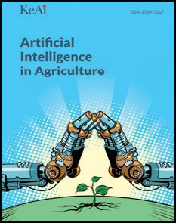](Journal%20logo)[Artificial Intelligence in Agriculture 4 (2020) 150–152](https://doi.org/10.1016/j.aiia.2020.08.001)

Contents lists available at [ScienceDirect](http://www.sciencedirect.com/science/journal/25897217)

Artificial Intelligence in Agriculture

journal homepage: [http://www.keaipublishing.com/en/j ournals/artificial-](http://www.keaipublishing.com/en/journals/artificial-) intelligence-in-agriculture/

[](http://crossmark.crossref.org/dialog/?doi=10.1016/j.aiia.2020.08.001&domain=pdf)Agri-BIGDATA: A smart pathway for crop nitrogen inputs

Guijun Yang a,b, Yanbo Huang c, Chunjiang Zhao b,⁎

a *Key Laboratory of Quantitative Remote Sensing in Agriculture of Ministry of Agriculture, Beijing Research Center for Information Technology in Agriculture, Beijing, China*

b *National Engineering Research Center for Information Technology in Agriculture, Beijing, China*

c *Crop Production Systems Research Unit, United States Department of Agriculture-Agricultural Research Service, Stoneville, MS, United States*

# a r t i c l e i n f o

*Article history:*

Received 30 May 2020

Received in revised form 4 August 2020

Accepted 4 August 2020

Available online 8 August 2020

*Keywords:*

Big data Smart farming

Nitrogen requirement

# a b s t r a c t

Big data provide a pathway to lower crop nitrogen inputs from genetic breeding to field production. Moreover, multidisciplinary efforts from plant health sensing, deep machine learning and cloud computing can integrate multi-source data to form information and knowledge. So big data analysis as a prospective optimal method, will make leaps towards addressing future issues of sustainable agriculture.

© 2020 The Authors. Publishing services by Elsevier B.V. on behalf of KeAi Communications Co. Ltd. This is an open access article under the CC BY-NC-ND license (<http://creativecommons.org/licenses/by-nc-nd/4.0/>).

The challenge to increase food production in an economically viable way while retaining environmental quality will face a balance control in food systems. Achieving synchrony between nitrogen supply and crop (e.g. wheat, maize and rice) demand without excess or deficiency is the key to optimize tradeoffs amongst yield, profit, and environmental protection. In recent years, a large number of innovations appear for the efficient use of nutrients from all aspects, including biology, breed- ing, farming, cultivation and crop production management. However, if some of the links mentioned above are not effective, the overall nutri- ent utilization cannot be optimized at all costs. Therefore, it is necessary for integrating the local feasible links to form a comprehensive crop ni- trogen optimized approach from crop breeding to crop production. Fi- nally, the goal of maintaining stable crop yield and grain quality can be reached through reduction of crop nitrogen inputs.

We found the article by Swarbreck et al. (2019) proposed an inter- esting and valuable idea which introduces a roadmap for the reduction of crop nitrogen inputs by the joint effort of farmers, breeders and scien- tists, while sustaining cereal yields and reducing greenhouse gas emis- sions. We fully agree with this opinion, but there is also an urgent need to provide an achievable pathway for smart crop nitrogen man- agement as described in the literature (Swarbreck et al., 2019). With this letter, we mainly emphasize the role of an integrated and compre- hensive agricultural big data (Agri-BIGDATA) framework, which can provide effective guidance for crop cultivation practices, including low- ering crop production nitrogen requirement. In the agriculture commu- nity, Agri-BIGDATA is generally viewed as a combination of technology

* Corresponding author.

*E-mail addresses:* [yanggj@nercita.org.cn](mailto:yanggj@nercita.org.cn) (G. Yang), [zhaocj@nercita.org.cn](mailto:zhaocj@nercita.org.cn) (C. Zhao).

and analytics that can collect and compile novel data, and process data in a more useful and timely way to assist decision-making (The AIMS Team from FAO of the United Nations, n.d.). Therefore, this Agri- BIGDATA often generated by geneticists, breeders, agronomists, and plant scientists, consists of genotype-phenotype related variety traits and cultivation knowledge, remote sensing observations, and meteoro- logical and soil databases. The applications and practices of Agri- BIGDATA are creating a new era of ‘smart farming’ for the world to be- hold (The AIMS Team from FAO of the United Nations, n.d.; Gilpin, 2015).

Why can big data analysis provide solutions for lowering crop nitro- gen application for smart farming? As Swarbreck et al. (2019) has con- cluded, optimal decisions of lowering nitrogen requirement need to be made according to many factors specific for each cropping system, in- cluding fertilizer cost, expected yield, and variety-specific agronomic in- formation and training in cultivation techniques. However, nitrogen related information of crop breeding or cultivation form the massive and complex big data collected by sensors, farmers and experts. Obvi- ously, it is difficult for ordinary farmers to timely master these huge data and to retrieve relevant knowledge. So, it is necessary to establish an interdisciplinary Agri-BIGDATA platform, which could provide top- down intelligent decision-making solutions based on data/information chains. Moreover, with rapid development and maturity of the latest In- ternet of Things, 5G communication, big data, and artificial intelligence technologies, farming practices will become increasingly data driven and data-enabled. Undoubtedly, now is the best time in history to de- velop and apply Agri-BIGDATA, not only for lowering nitrogen inputs, but for the entire crop production management. Thus, Agri-BIGDATA enables data to be more efficiently translated into knowledge to serve

<https://doi.org/10.1016/j.aiia.2020.08.001>

2589-7217/© 2020 The Authors. Publishing services by Elsevier B.V. on behalf of KeAi Communications Co. Ltd. This is an open access article under the CC BY-NC-ND license ([http://](http://creativecommons.org/licenses/by-nc-nd/4.0/) [creativecommons.org/licenses/by-nc-nd/4.0/](http://creativecommons.org/licenses/by-nc-nd/4.0/)).

*G. Yang et al. / Artificial Intelligence in Agriculture 4 (2020) 150*–*152* 151

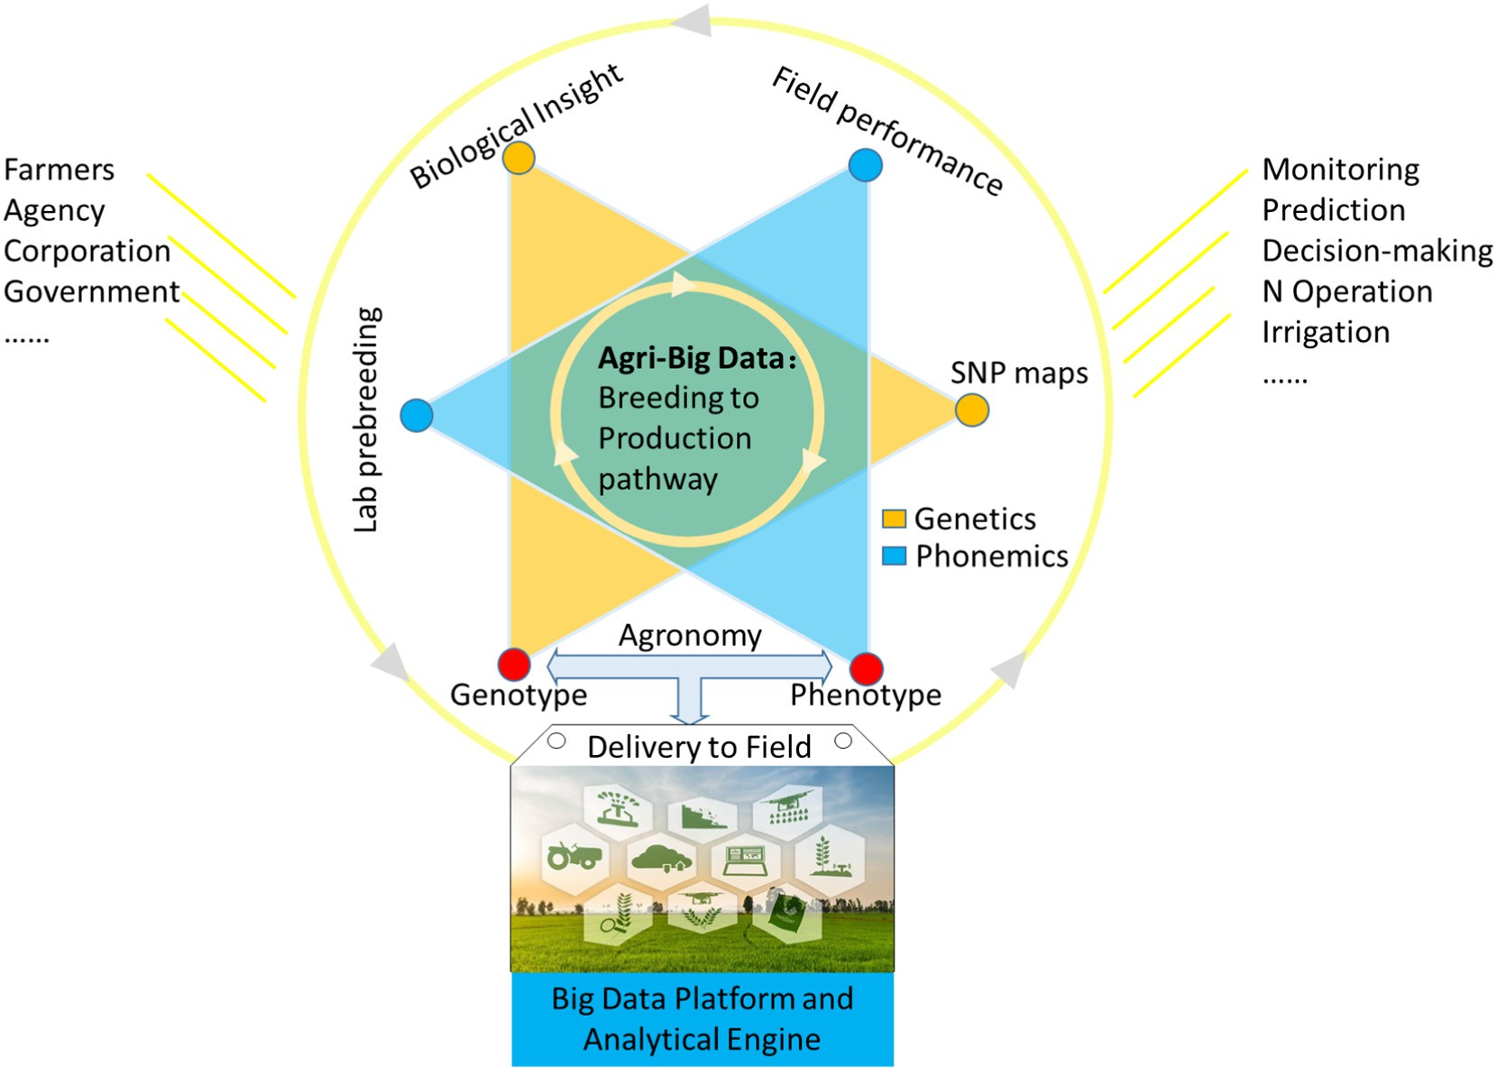

Fig. 1. Framework for big data in agriculture to support smart crop production. The agricultural big data platform connects scientists, engineers, farmers, and business managers, leveraging all the technologies, data, knowledge, and skills that are related to the entire crop growth process, from breeding to harvest.

an enormous number of agricultural producers even real-time online by intelligent communication or vividly augmented reality (AR) technologies.

The accurate guidance based on big data can help producers with streamlined decision-making and precision nitrogen management. The most typical case of big data in agriculture is the Gene Bank (Mascher et al., 2019), which links catalogs of crop genetic variation and enquiries into biological mechanisms of plant performance. For ex- ample, once the genotype and phenotype parameters related to crop ni- trogen utilization are determined, they can be connected directly to develop the virtual reality breeding tool with the crop growth model (e.g. DSSAT) (Araus et al., 2018). With this tool, breeders and re- searchers can visualize how the plants grow in advance and greatly op- timize breeding procedure for the goal of high-efficiency nitrogen use. The United States Department of Agriculture (USDA) plans to aggregate and manage agricultural big data created by connected farming equip- ment, unmanned aerial vehicles (UAVs), and even satellites to ensure food security and agricultural sustainability. USDA launched the GODAN (Global Open Data for Agriculture and Nutrition) program (Wolfert et al., 2017) to support the sharing of open data to improve ability of crop monitoring and decision making. In particular, many open-source satellite imagery datasets are accessible through platforms such as Amazon Web Services S3 (AWS) and Google Earth Engine to serve precision agriculture (Shelestov et al., 2017). An infrastructural framework based on a three-layer nice-level remote sensing cube was proposed to monitor the status of agricultural fields (Huang et al., 2018). Similarly, the Monsanto Corporation acquired by Bayer also launched a suite of digital tools, called Integrated Field Systems (IFS), for collecting and analyzing farm data in soil conditions, varieties and weather to generate digital nutrient mapping (Monsanto, 2014). AgSpace (Swindon, UK) can seamlessly connect their business with thousands of farms and use technologies to provide scientific farmland zoning scheme, the best fertilizer prescription and the fertilizer procure- ment time according to the fluctuation of market price (Agspace, n.d.). Based on the mode of government-led, enterprise-run agricultural big

data service, a national agricultural science and education cloud plat- form has also been promoted and developed in China (ht[tp://njtg.](http://njtg/) nercita.org.cn/, n.d.). This platform has gathered various agricultural data and information resources to provide online learning, interactive communication and service docking for farmers. For nitrogen manage- ment, a scientific fertilizer prescription for strong or weak gluten wheat can be determined according to big data of crop gluten- associated phenotyping, meteorological, soil and farmland resources with while considering the optimization of fertilizer and water operations.

In addition, online social media (e.g., Twitter, Wechat, and Google Search) as an important source of big data, for example, to learn fertiliz- ing operation, collect fertilizer and grain market information. On the one hand, more and more users are timely sharing agriculture-related infor- mation (e.g., nutritional diagnosis, fertilization prescriptions, yield and quality, food consumption, profit information etc.). On the other hand, advanced production experience, consumer interests and food market- ing trends can be retrieved from social media platforms, which are valu- able references for farmers.

Big data provides a good solution for the precise management in ag- ricultural production, including fertilizers and pesticides applications, although it has many urgent problems to solve, especially in terms of privacy and security, quality and traceability, and integration and norm (Semantic Community, 2015). In this aspect we have two other emphases that require extensive attention. Firstly, attention should be paid to the Agri-BIGDATA derived mechanistic models based on agron- omy, informatics and statistics because they are the key blocks for agri- cultural big data analysis and application. Once the mechanistic research is done, it will be possible to better interpret and utilize the data to fill current knowledge gaps. Secondly, the crop nitrogen man- agement involves a large number of spatial-temporal big data generated by remote sensing from satellites, UAVs and ground-based systems, which exhibit spatiotemporal auto-correlation and non-stationarity. The current spatial statistical methods (e.g., spatial auto-regression) do not scale up to big datasets due to their computational complexity.

152 *G. Yang et al. / Artificial Intelligence in Agriculture 4 (2020) 150*–*152*

So, there is a great need to develop scalable spatiotemporal data analyt- ics to validate hypotheses with the aid of Agri-BIGDATA.

In conclusion, to make leaps towards addressing issues of future ag- ricultural production and sustainable development, agricultural big data will certainly play a key role and will be aided by innovations in data sci- ence and technology. Moreover, multi-disciplinary driven cloud com- puting, big data and deep learning technologies will provide comprehensive solutions of various agricultural problems (see Fig. 1), including proper input and effective use of nitrogen. We are convinced that Agri-BIGDATA as an achievable pathway is undoubtedly the prior- ity in developing smart agriculture in the near future.

CRediT authorship contribution statement

Chunjiang Zhao: conceptualization. Guijun Yang: writing - original draft. Yangbo Huang: writing - review & editing. All authors read and approved the final manuscript.

Acknowledgments

This work was supported by the National Key Research and Develop- ment Program of China (2017YFE0122500) and the Beijing Natural Sci- ence Foundation (6182011).

References

Agspace, d. Unparalleled farming data. <https://agspace.com/innovation/>. (Accessed 15 July 2019). .

Araus, J.L., et al., 2018. [Translating high-throughput phenotyping into genetic gain. Trends](http://refhub.elsevier.com/S2589-7217(20)30022-2/rf0010) [Plant Sci. 23, 451–46](http://refhub.elsevier.com/S2589-7217(20)30022-2/rf0010)6.

Gilpin, L., 2015. How Big Data is going to help feed nine billion people by 2050.

TechRepublic[http://www.techrepublic.com/article/how-big-data-is-going-to-](http://www.techrepublic.com/article/how-big-data-is-going-to-helpfeed-9-billion-people-by-2050/) [helpfeed-9-billion-people-by-2050/](http://www.techrepublic.com/article/how-big-data-is-going-to-helpfeed-9-billion-people-by-2050/). (Accessed 7 July 2019). .

China National Agricultural Science and Education cloud platform. [http://njtg.nercita.org.](http://njtg.nercita.org.cn/) [cn/](http://njtg.nercita.org.cn/). (Accessed 20 July 2019). .

Huang, Y., et al., 2018. [Agricultural remote sensing big data: management and applica-](http://refhub.elsevier.com/S2589-7217(20)30022-2/rf0025) [tions. J. Integr. Agric. 17 (9), 1915–1931](http://refhub.elsevier.com/S2589-7217(20)30022-2/rf0025).

Mascher, M., et al., 2019. Genebank genomics bridges the gap between the conservation of crop diversity and plant breeding. Nature Genetics 51, 1. [https://doi.org/10.1038/](https://doi.org/10.1038/s41588-019-0443-6) [s41588-019-0443-6](https://doi.org/10.1038/s41588-019-0443-6).

Monsanto, 2014. Fieldscripts. [http://www.monsanto.com/products/pages/fieldscripts.](http://www.monsanto.com/products/pages/fieldscripts.aspx) [aspx](http://www.monsanto.com/products/pages/fieldscripts.aspx). (Accessed 15 July 2019). .

Semantic Community, 2015. Big Data science for precision farming business. [http://](http://semanticommunity.info/Data_Science/Big_Data_Science_for_Precision_Farming_Business) [semanticommunity.info/Data_Science/Big_Data_Science_for_Precision_Farming_](http://semanticommunity.info/Data_Science/Big_Data_Science_for_Precision_Farming_Business) [Business](http://semanticommunity.info/Data_Science/Big_Data_Science_for_Precision_Farming_Business). (Accessed 20 July 2019). .

Shelestov, A., et al., 2017. Exploring Google Earth engine platform for big data processing: classification of multi-temporal satellite imagery for crop mapping. Front. Earth Sci. 5,

17. <https://doi.org/10.3389/feart.2017.00017>.

Swarbreck, S.M., et al., 2019. A roadmap for lowering crop nitrogen requirement. Trends Plant Sci. <https://doi.org/10.1016/j.tplants.2019.06.006>.

The AIMS Team from FAO of the United Nations, d. Big Data: unlocking the future for Ag- riculture. <http://aims.fao.org/activity/blog/big-data-unlocking-future-agriculture>. (Accessed 7 July 2019). .

Wolfert, S., et al., 2017. [Big data in smart farming – a review. Agric. Syst. 153, 69–80](http://refhub.elsevier.com/S2589-7217(20)30022-2/rf0060).