Available online at [www.sciencedirect.com](http://www.sciencedirect.com/)



AASRI Procedia 1 (2012) 353 – 358

AASRI

Procedia

[www.elsevier.com/locate/procedia](http://www.elsevier.com/locate/procedia)

2012 AASRI Conference on Computational Intelligence and Bioinformatics

# An Improved Algorithm of Automatic Fall Detection

Hong Liu*,Changling Zuo

*Education Ministry Key Laboratory of Intelligent Computing and Signal Processing,Anhui University HeFei, 230039, China*

**Abstract**

Fall detection is an important problem in the application research of video surveillance. Quick and effective ways of getting the information of the people falling to the ground can help the people get timely assistance to reduce further injury. This paper proposes an improved algorithm of automatic fall detection. Three features — human aspect ratio, effective area ratio and center variation rate are used in the proposed algorithm, which can effectively prevent misjudgments and greatly increase the accuracy of detection results. This algorithm has a less computing complexity and is easy to implement. Experimental results show that the algorithm has good robustness.

2012 Published by Elsevier B.V. Selection and/or peer review under responsibility of American Applied Science Research Institute Open access under [CC BY-NC-ND license.](http://creativecommons.org/licenses/by-nc-nd/3.0/)

*Keywords:* video surveillance; fall detection; human aspect ratio; effective area ratio; center variation rate;

## Introduction

Falls are important public health problems. The damage they cause and the treatment expenditure for this both depend on the length of the aid response time[1]. Quick and effective ways of getting the information of the people falling to the ground can help the person get timely assistance to reduce further injury.

Many existing fall detection systems are wearable devices with special designs, and the high cost and inconvenience of wearable devices limit the popularity of these systems, but fall detection method based on video is a more convenient and effective method[2-4]. Rougier proposed a tracking method based on the

* Corresponding author. Hong Liu *E-mail address:* [liuhong@ahu.edu.cn.](mailto:liuhong@ahu.edu.cn)

2212-6716 © 2012 Published by Elsevier Ltd. Open access under [CC BY-NC-ND license.](http://creativecommons.org/licenses/by-nc-nd/3.0/)

doi:10.1016/j.aasri.2012.06.054

movement trajectory of the head of a person to detect a fall incident[5], but by using this method, the position of the head part has to be initialized first and then to be tracked, and this algorithm is of high complexity, high calculation and high misjudgment rate.

This paper proposes an improved algorithm of automatic fall detection. Three features — human aspect ratio, effective area ratio and center variation rate are used in the proposed algorithm, which can effectively prevent misjudgments and greatly increase the accuracy of detection results. Experimental results show that the algorithm has good robustness.

## Improved Algorithm of Fall Detection

* 1. *Algorithm of fall detection*

Fall detection algorithm based on video mainly includes five steps: image segmentation, shadow suppression, image denoising, characteristic analysis and fall conditions judgment and alarm.

The image segmentation part adopts the background subtraction method, which does difference between current image and background model, and then with the help of the threshold, it should be made clear what pixels in difference image are of the type of background pixels and what pixels are of the type of foreground pixels to lock the target area. After extracting foreground pixels, use the shadow suppression method proposed by Elgammal to suppress the shadow[6]. The foreground image still has some small holes and noise, mathematical morphology expansion and corrosion operators have to be adopted to deal with this problem[7]. Finally, we get binary movement image after using a threshold.

* 1. *Improved algorithm of fall detection*

The fall detection algorithm proposed by this paper uses three features of human body — human aspect ratio, effective area ratio and center variation rate to analyze human behaviors. It can detect fall behavior correctly and suppress misjudgments effectively.

* + - Human aspect ratio

The minimum circumscribed rectangle box of the human body is defined as the rectangular box surrounding the human body, the area of which is the smallest. Human aspect ratio is defined as the ratio of the width of minimum circumscribed rectangle box to the height of it[8]. When a man is standing, the figure of the height is higher than that of its width, so the ratio is less than one. When a man fall down, the figure of the width is higher than that of his height, and the ratio is higher than one. In most cases, whether the man is standing or fall down, it can be judged correctly by using this feature, but in some special conditions such as the man being in a statement of squat or movement etc, such a method will produce some misjudgments.

* + - Effective area ratio

Effective area ratio is defined as the ratio of the area of a person in minimum circumscribed rectangle box to the area of the whole rectangle:

*EA*  *Ratio*  *SP*

*SR*

*(1)*

EA-Ratio is effective area ratio, and SP is the number of pixels in binary image rectangle box, whose pixel value is one, SR is the sum of pixels whose pixel value is one and those whose pixel value is zero in binary image rectangle box. When the human body occupies most area of the rectangle box, the effective area

ratio is big; conversely, the effective area ratio is small.

When a person does some exercises, the aspect ratio may be bigger than 1. Judging the condition of a person by only using the aspect ratio condition will produce misjudgment. In this case, the minimum circumscribed rectangle box will become bigger, and the effective area ratio of the person will become smaller correspondingly. So, according to this feature, combined with the aspect ratio with effective area ratio, misjudgment can be avoided effectively.

* + - Center variation rate

When a man is falling down, the variation rate of the center is very big, that is, the distance of two centers of two adjacent frames is very big, and the slope will change also. The three features of aspect ratio, effective area ratio and center variation rate combined, those misjudged actions like sudden squat down and sitting down will be avoided. Assume that A and B are the centers of two adjacent frames respectively, the coordinates of A and B are (*x*0 , *y*0 ), (*x*1 , *y*1 ) respectively, the slope KAB between A point and B point was

defined as center variation rate:

*y*1  *y*0 *x*1  *x*0

KAB



*(2)*

*AB* 

(*x*  *x* )2  ( *y*  *y* )2

1 0

1 0

*(3)*

## Experimental Results and Analysis

A series of video data are taken indoors by Canon A3200IS Camera. The camera resolution is 640*480 and it is fixed about 2 to 5 meters away from a person. Experiments have been run in VC++ 6.0 software platform. In video screenshots, the person’s normal behaviors are described in a blue rectangle box. Once there happens a fall incident, the behavior is described in red rectangle box and a “Target Tumble” will be shown on screen to tell carers there is a fall incident. Fig.1 shows the detection results by using the aspect ratio condition only.

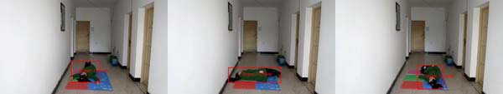

(a) (b) (c)

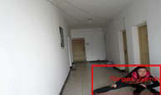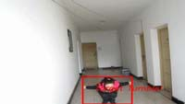

(d) (e)

Fig. 1.Detection results by using the aspect ratio condition only: (a) forward fall, (b) side fall, (c) backward fall, (d) sports action, (e) squat down action

From Fig.1, by using human’s aspect ratio condition only, some fall conditions such as forward fall, backward fall and side fall and so on can be correctly detected, as shown in figures (a), (b) and (c). But there

are also some misjudgments, as shown in figures (d) and (e).

In this paper, the first 900 frames of a video sequence are tested, and the information statistics of the human body’s aspect ratio and that of the effective area ratio are done respectively, as shown in Fig.2 and Fig.3. In Fig.2, there are 6 places where the aspect ratio is bigger than one, and they exist respectively near Frame 30, Frame 260, Frame 420, Frame 520, Frame 580 and Frame700. Those actions existing in the first 5 places are normal behaviors, and there is only 1 fall incident existing near Frame 700. It is obvious that there will be 5 misjudgements if using the aspect ratio condition only to judge those actions.

From Fig.2 and Fig.3, it can be seen that in those misjudged images, all aspect ratios are bigger than one, but their corresponding effective ratios are smaller (smaller than 0.4), so, combining the two conditions— the aspect ratio and the effective area ratio, misjudgements as described in the above can be removed effectively. In the neighbouring area of Frame 700, the aspect ratio is bigger than one and the effective area ratio satisfies the fall condition (bigger than 0.5), then the fall incident can be detected correctly. In those situations aspect ratios are bigger than one, it can be seen that their corresponding effective area ratios are bigger (bigger than 0.5), so they can be considered as normal movements.

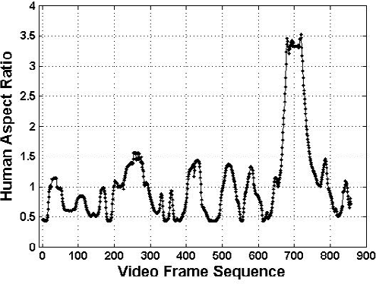

Fig. 2. human aspect ratio statistical graph

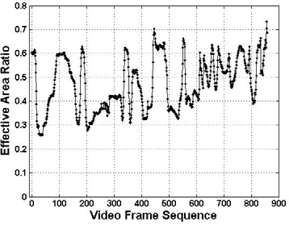

Fig. 3. effective area ratio statistical graph

Fig.4 is a center variation rate statistical graph of first 900 frames of another video sequence. Between Frame 290 and Frame 310, there is a sudden squat down action as shown in Fig.1(e), it is obvious that the aspect ratio and the effective area ratio all satisfy the fall conditions (aspect ratio bigger than 1 and effective

area ratio bigger than 0.5), so, if using these two conditions to judge human’s behaviors, misjudgments will appear. At this time, analysis has to be done by combing center variation rate. Due to the fact that the negative infinity and positive infinity can't be shown in the chart, in Fig.4, negative infinity is described by -10 and positive infinity is described by 10. From Fig.4, it can be seen that the center variation rates between Frame 290 and Frame 310 are negative infinity, which is a squat down action, so it can be excluded from the fall incident.

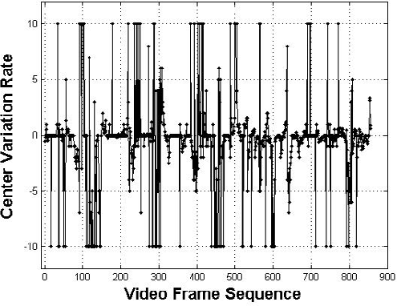

Fig. 4. center variation rate statistical graph

From the above, combined with human aspect ratio, effective area ratio and center variation rate, the three characteristics in the judgment, misjudgement can be avoided effectively and the accuracy of detection results will be increased greatly.

## Conclusion

An improved algorithm of automatic fall detection is proposed in this paper. Three features — human aspect ratio, effective area ratio and center variation rate — are used in the proposed algorithm, which can effectively prevent misjudgments and greatly increase the accuracy of detection results. This algorithm has a less computing complexity and is easy to implement. Experimental results show that this algorithm has good robustness. Using this algorithm, video monitoring systems can be widely used in families, hospitals, nursing homes, kindergartens and so on.

## Acknowledgements

This paper is supported by the National Natural Science Foundation of China under Grant NO. KJ2009A60 and the Research Fund for the Doctoral Program of Higher Education nder Grant No.33190049.

## References

1. N. Noury, A. Fleury, P. Rumeau, A.K. Bourke, G. Ó ,Laighin, V. Rialle, J.E. Lundy. Fall detection – Principles and Methods.J. Proceedings of the 29th Annual International Conference of the IEEE EMBS Cité Internationale, Lyon, France August 23-26, 2007.
2. Homa Foroughi, Baharak Shakeri Aski, and Hamidreza Pourreza. Intelligent Video Surveillance for

Monitoring Fall Detection of Elderly in Home Environments. J. Proceedings of 11th International Conference on Computer and Information Technology (ICCIT 2008) 25-27 December, 2008, Khulna, Bangladesh.

1. H.Nart-Charif and S.J.Mckenna. Activity summarisation and fall detection in a supportive home environment. J. ICPR, 2004.
2. Homa Foroughi, Baharak Shakeri Aski, and Hamidreza Pourreza. Intelligent Video Surveillance for Monitoring Fall Detection of Elderly in Home Environments. J. Proceedings of 11th International Conference on Computer and Information Technology (ICCIT 2008) 25-27 December, 2008, Khulna, Bangladesh.
3. C. Rougier, J. Meunier, A. St-Arnaud, J. Rousseau. Monocular 3D head tracking to detect falls of elderly people. J. 28th EMBC, pp. 6384-6387, Aug.2006.
4. Elgammal A, Harwood D, Davis L. Non-Parametric model for background subtraction. J. In:Proc.of the 6th European Conf.on ComPuter Vision. DublinIreland, 2000.
5. Rafaael C.Gonzalez. Digital Image Processing(the second edition). M .Beijing: Electronic Industry Press, 2004.
6. V. Vaidehi, Kirupa Ganapathy, K. Mohan, A. Aldrin, K. Nirmal. Video Based Automatic Fall Detection In Indoor Environment. J. IEEE-International Conference on Recent Trends in Information Technology, ICRTIT 2011.