[Applied Computing and Informatics 14 (2018) 37–47](http://dx.doi.org/10.1016/j.aci.2017.05.004)



Contents lists available at [ScienceDirect](http://www.sciencedirect.com/science/journal/22108327)

Applied Computing and Informatics

journal homepage: [www.sciencedirect.com](http://www.sciencedirect.com/)

An analytical study of mobile applications for Hajj and Umrah services



Esam Ali Khan, Mohd Khaled Yousef Shambour ⇑

*Umm Al-Qura University, Mecca, Saudi Arabia*

a r t i c l e i n f o

*Article history:*

Received 10 December 2016

Revised 13 April 2017

Accepted 14 May 2017

Available online 18 May 2017

a b s t r a c t

Millions of Muslims come to Makkah in Saudi Arabia annually to perform Hajj, an Islamic pilgrimage ritual. Many government, private companies, and individuals provide various services and facilities to overcome difficulties that may be encountered by pilgrims. Currently, technology has gained increasing attention as a major means to provide services. In particular, mobile applications (apps) are contempo- rary technologies used provide various services. Several organizations and individuals developed a num- ber of Islamic apps that can be used on smart mobile devices to assist pilgrims to comfortably perform their Islamic rituals. This paper presents an analytical study of Hajj-related mobile apps offered by Google Play. The collected apps are analyzed using four main criteria, namely, services offered, languages supported, installation rates, and repetition of services and names of the app. The ‘‘Hajj ritual” service is found in 68.7% of the target apps, with English as the main language (51.7%). Apps supporting live video services are the most downloaded, with frequency exceeding one million times. Results also reveal a number of repetitive apps in terms of application names and services; for example, 12 apps use the same label ‘‘Hajj Guide,” and 11 application versions issued by the same publisher are found. Finally, a case study is performed to rate the quality of 10 apps selected based on five basic criteria, namely, engage- ment, functionality, aesthetics, information, and subjective quality. ‘‘Mutawef” and ‘‘Manasikana” apps have achieved the highest average scores, with 2.69 and 2.62 out of 3 acceptance rates, respectively.

© 2017 The Authors. Production and hosting by Elsevier B.V. on behalf of King Saud University. This is an

open access article under the CC BY-NC-ND license (<http://creativecommons.org/licenses/by-nc-nd/4.0/>).

Contents

1. Introduction 38
2. Literature review 38
3. Methodology 39
4. Hajj and Umrah mobile apps 40
   1. Offered mobile application services 40
   2. Languages supported by mobile applications 40
   3. Installation rates of mobile applications 40
   4. Repetitive apps 40
   5. Observation notes 41
5. Case study: assessment of Hajj mobile apps 42
   1. Mobile application selection criteria 42
   2. Questionnaire design and data collection 42
   3. Analysis and discussion 44

* Corresponding author.

*E-mail addresses:* [Eakhan@uqu.edu.sa](mailto:Eakhan@uqu.edu.sa) (E.A. Khan), [Myshambour@uqu.edu.sa](mailto:Myshambour@uqu.edu.sa) (M.K.Y. Shambour).

Peer review under responsibility of King Saud University.

**Production and hosting by Elsevier**

<http://dx.doi.org/10.1016/j.aci.2017.05.004>

2210-8327/© 2017 The Authors. Production and hosting by Elsevier B.V. on behalf of King Saud University.

This is an open access article under the CC BY-NC-ND license (<http://creativecommons.org/licenses/by-nc-nd/4.0/>).

1. Conclusion 44

Appendix A 44

References 46

1. Introduction

In Islam, all Muslims worldwide are requested to perform Hajj once in their lifetime as long as they have the capability to do so. Hajj is a ritual journey to Makkah and considered the fifth essential pillar in Islam. This ritual is conducted on the 12th month of the lunar Islamic calendar, namely, ‘‘Dhul Hijjah.” Hajj includes many rites, which must be performed according to the sequence of events. The rituals start by making intentions and wearing Ihram at Miqats before arriving in Makkah. Pilgrims then wait for the eighth day of Dhul Hijjah to move to Mina. On the ninth day of Dhul Hijjah, all pilgrims proceed to Arafat and stay until sunset before moving to Muzdalifah. Throwing of stones is performed in Al-Jamarat the 10th to 13th days of Dhul Hijjah. Finally, Hajj ends by performing farewell circling (Tawaf al-Wadaa) around the holy house (Ka’bah) and leaving Makkah. During this holy journey, many rituals must be performed in different places at a specific time. Fig. 1 shows a map of places where the Hajj rituals should be performed.

Many pilgrims also aim to visit Al-Madinah (the city of the pro- phet Mohammed, peace be upon him) before or after performing Hajj. The Umrah, another ritual related to Hajj, can be performed anytime through the year; however, many pilgrims perform this ritual directly before Hajj.

Many services, such as guidance, awareness, transportation, and accommodation, are required during Hajj and Umrah seasons because of the huge number of pilgrims and the diversity of rituals that they have to perform. Government and private agencies and individuals compete to provide services in different ways. Every year, new services are developed by exploiting advances in tech- nologies and service industries.

One of the modern technologies evolving is software applica- tions, commonly known as ‘‘apps,” for mobile devices. Hundreds of apps are available online on iPhone and Android platforms to help people who are planning to perform Hajj or Umrah. These apps should be studied and evaluated using specific criteria to maximize their benefits. However, different criteria of Islamic apps

have been rarely investigated and are thus the focus of the present research.

This paper is organized into two major parts. In the first part, all apps designed for Hajj and Umrah services and published by ‘‘Goo- gle Play,” are surveyed and analyzed. In the second part, the criteria of 10 apps selected are evaluated using a recently developed method, namely, mobile app rating scale (MARS) [15].

The rest of this paper is structured as follows. Section 2 dis- cusses previous related works. Section 3 presents the proposed methodology. Section 4 provides an analysis and comparison of apps dedicated for Hajj and Umrah. Section 5 displays the results of the assessment of the apps. Section 6 concludes the paper.

1. Literature review

Scholars have designed and evaluated a number of mobile applications. Delikostidis et al [26] study the usability of mobile applications in virtual environments according to some criteria, such as efficiency and effectiveness of task completion, number of errors made by the users, and satisfaction while using the appli- cation. Moumane et al [27] performed an empirical study using a set of measures to evaluate the usability of mobile applications running on different mobile operating systems. A previous study by Harleen et al [28] elucidated key characteristics that define mobile applications to facilitate the delivery of exceptional, valu- able, and user-friendly mobile apps that satisfy the requirements of users.

A systematic literature review was conducted by Méndez et al

[30] to identify and accumulate evidence regarding automated testing of mobile applications. Usability is measured in terms of three attributes, namely, effectiveness, efficiency, and satisfaction; as such, other attributes, such as cognitive load, may be disre- garded. To address the limitations of existing usability models when applied to mobile devices, Rachel et al [31] proposed a usability model, namely, people at the center of mobile application development.

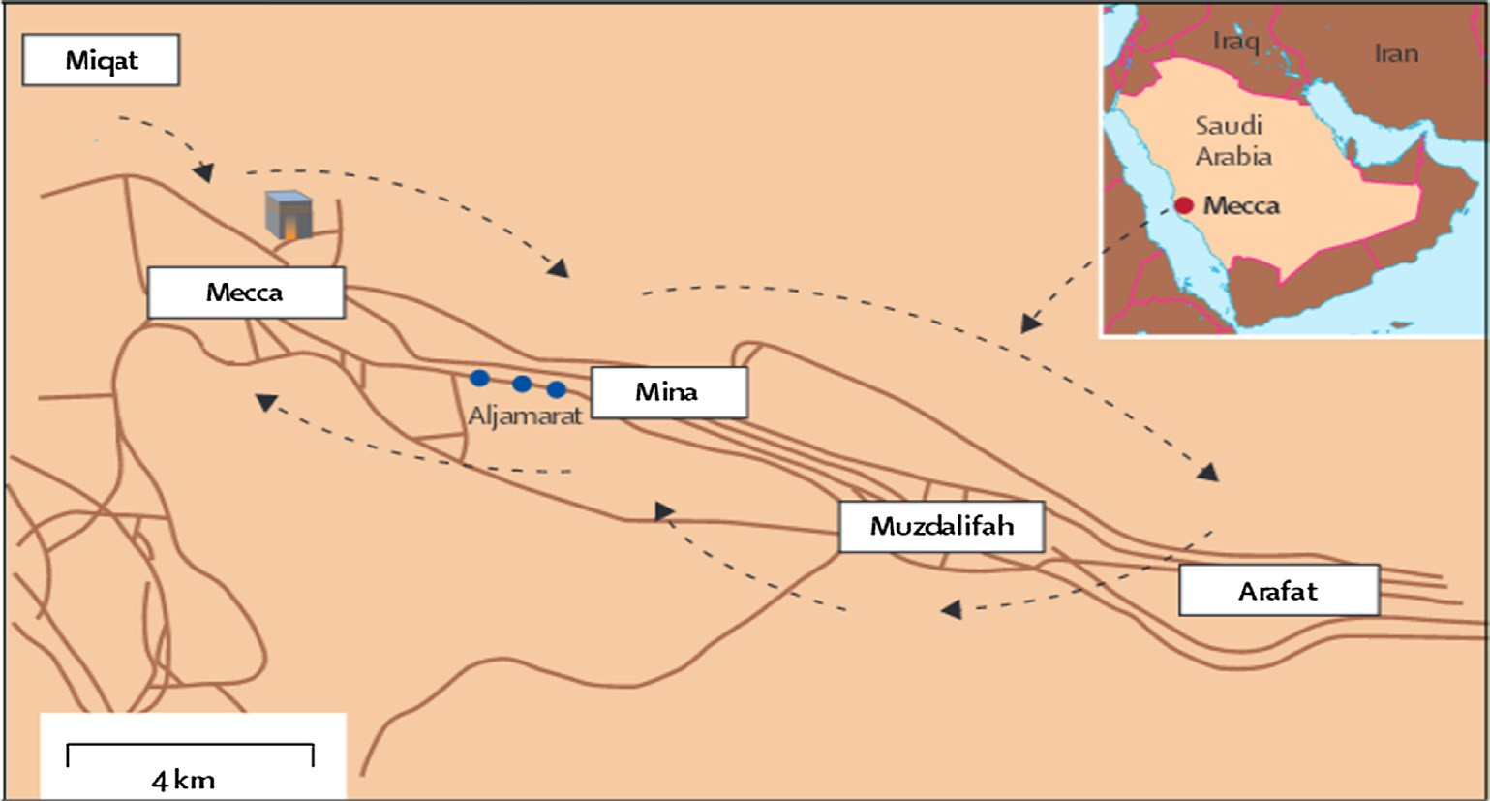

Fig. 1. Hajj journey [Ahmed, 06].

Scholars also reviewed mobile applications for a specific field. Various mobile applications have been developed for health ser- vices, such as cardiology [24], heart failure symptoms [25], and diabetes [35]. Another study conducted by Boudreaux et al [29] where seven strategies for evaluating and selecting health- related applications are proposed.

Mobile applications are also used in education, particularly in language learning [38,39], m-learning [41,42], and use of smart- phone applications by undergraduate students [40]. These applica- tions are also used to support children diagnosed with autism spectrum disorders to enhance their abilities to understand, inter- act, and communicate with other people by using the Arabic lan- guage [34].

Studies investigated mobile applications for tourism [32,33] and for religious and spiritual services [36,37]. However, no study has reviewed mobile applications for pilgrimage.

Some researchers developed mobile applications for different Hajj and Umrah services. A number of master theses were con- ducted to build mobile applications to guide Malaysian pilgrims [1,11–14]. In another MSc thesis by Mayada [9], augmented reality was proposed to guide pilgrims. Ahmed et al [2,3] developed a mobile applications to help pilgrims read Hajj and Umrah prayers and understand their meanings by translating them into the lan- guage of the pilgrims. Akhlaq et al [4] proposed a framework that serves as a crowd-sourcing platform to define the requirements of pilgrims for services. The proposed framework uses mobile sensory data to define the context of the users. This framework was used to develop a mobile application for many spatio-temporal services. Also, a mobile application was proposed in [5] to serve as a dic- tionary for pilgrims who speak the Malay language. This applica- tion can translate among languages, namely, Malay, Arabic, and English.

In another study, Aladdein and Qasem [6] proposed the use of a mobile phone as a tracking device. This strategy can be used by the guide (Mutawwif) of a group of pilgrims to recognize their

movements and determine their location. Fathi and Christian [7] developed a dynamic signage system implemented as a mobile application to inform pilgrims about the crowd status around the Holy Ka’bah. This system can also be used as an automatic counter for the number of Tawaf rounds. Hasimah [8] proposed another mobile application that can be used to guide pilgrims when per- forming Hajj and Umrah services. The application also functions as location tracker and Tawaf counter. Location identification service for Hajj was proposed by Mohamed et al [10]. This mobile application service was developed to collect information about the location of pilgrims to identify and track them.

A recent study by Abdelazeez and Shaout [21] developed a mobile translation application to facilitate the communications between pilgrimages. This application is available in many lan- guages and employs text and voice recognition technologies to assist pilgrims in finding and displaying the translation of the tar- get words. Shaout and Khan [22] introduced the ‘‘Al-Hajj” mobile application to allow pilgrims to understand Hajj-related activities. The supported application exhibits four interactive features, namely, checklist, map, contact list, and motivational messages. The possibility of using smartphone apps to conduct surveys is studied by Alqahtani et al [23]. The study focused on collecting rel- evant data and information during mass gatherings, which play an important role in improving public health by reinforcing knowl- edge associated with disease prevention.

Based on this literature review, no study has evaluated and ana- lyzed mobile applications for Hajj and Umrah services. Hence, this study is of considerable importance.

1. Methodology

The research methodology used in this study consists of two parts as illustrated in Fig. 2. The first part presents a review of the properties of the Google Play apps. This part starts by review- ing the literature about the apps that are directed to Hajj and

**Part 1: Review Process**

**Part 2: Case Study**

Fig. 2. Research methodology.

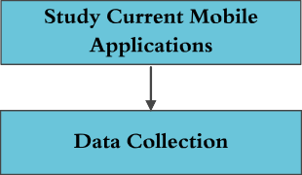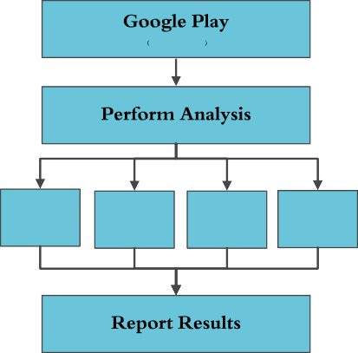

**Repetition**

**Cases**

**Installation**

**Rates**

**Supported Languages**

**Provided**

**Services**

*11-30 Sep.2016*

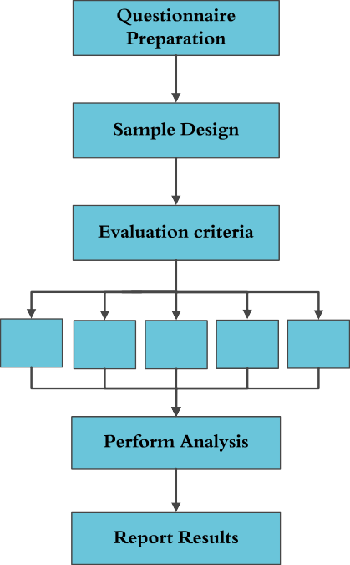

**Engagement Functionality Aesthetics Information Information**

Umrah rituals. Then, the apps that include the word ‘‘Hajj” in the title or description of the apps are studied during the period September 9–30, 2016. Afterward, data collection is built based on the app features where each app has its own record, including access date, app names, supported services and languages, pub- lisher name, the frequency of installation, and the reference that offered the apps. After the data collection, a statistical analysis is performed on four main criteria, namely, services provided, lan- guages supported, installation rates, and repetition cases. Finally, an analysis study of the collected app records is performed, and the results are reported.

The second part presents a case study for ten apps selected according to particular criteria. A questionnaire based on mobile app rating scale [16] evaluation criteria is prepared and sent to a number of contributors. The contributors who participated in this study have different experiences, backgrounds, and educational levels, thus enriching this evaluation study. Then, the question- naire data are collected to perform a statistical analysis. Finally, the achieved results are reported.

1. Hajj and Umrah mobile apps

A survey was conducted, during Hajj season (2016), for all apps supported by Google Play during the period September 9–30, 2016. The number of apps covered in this survey was 246, and the observed apps reached 51 services. Table 1 displays the various services provided by the apps targeted in this study and the num- ber of apps that share the same service.

* 1. *Offered mobile application services*

The results show that the ‘‘Hajj ritual” service has the largest portion compared with other services provided by the apps where the ‘‘Hajj ritual” service is found in 68.7% of targeted apps, followed by ‘‘Umrah ritual” and ‘‘supplications” with 47.5% and 32.5%, respectively. Moreover, ‘‘funeral provisions,” ‘‘Hajj portal,” ‘‘statis- tics,” and ‘‘crowd status” have the lowest portion of 0.4% for each. Each mobile application can contain one or more services, up to 23 services as found in the ‘‘Mutawef” apps. Fig. 3 shows the relation- ship between the numbers of apps that share a specific service.

* 1. *Languages supported by mobile applications*

The studied apps support 24 languages in total, covering the languages used by most of the Muslims around the world. In Fig. 4, more than 51.7% of the apps support the English language. Most of the apps support a single language. The results show that 87.4% of apps support only one language, 7.3% of apps support two languages, and 5.3% of apps support three to sixteen languages. The observed apps, the number of services supported, and languages supported are indicated in Appendix A, Table A.1. (Note that the keyword ‘‘multi” in the languages column means supporting more than two languages.)

* 1. *Installation rates of mobile applications*

A good indicator of the usability of a mobile application is the number of downloads, which is mainly due to providing a variety of services and languages. Fig. 5 shows the number of apps catego- rized by the number of downloads. This figure shows that most apps were downloaded between 10,000 and 50,000 times. We found that the least downloaded apps are non-free apps, such as the ‘‘Hajj player I URDU-INDIA” app.

Moreover, the results show that apps supporting live video ser- vices are the most preferred by users. The application ‘‘Watch Live Makkah 24 Hours HD,” which supports live video services, has been downloaded for over one million times. Furthermore, apps supporting images and wallpaper services are widely used and downloaded by over 100,000 times.

* 1. *Repetitive apps*

The results show that a number of apps that provide the same services and emerge from the same publisher are presented in Table 2. In addition, some apps have the same name (i.e., exact names) as depicted in Fig. 6. The phrase ‘‘Hajj Guide” is the most frequent application name used, reaching 12 times with different publishers and supported services. We consider that the matched phrases, such as ‘‘Hajj and Umrah,” ‘‘Hajj o Umrah,” and ‘‘Hajj & Umrah,” are different phrases.

Table 1

Mobile application services.

|  |  |  |  |  |  |  |  |  |
| --- | --- | --- | --- | --- | --- | --- | --- | --- |
| Abbr. | Service Name | No of Apps s | Abbr. | Service Name | No of Apps s | Abbr. | Service Name | No of Apps s |
| S1 | Hajj ritual | 169 | S19 | Compass | 13 | S37 | Hajj program and scheduling | 5 |
| S2 | Umrah ritual | 117 | S20 | Do and don’t | 11 | S38 | Dictionary | 5 |
| S3 | Supplications | 80 | S21 | 3D | 11 | S39 | Tasbeeh counter | 4 |
| S4 | Photos and footage/diagrams/ | 60 | S22 | Religious or regular tips | 10 | S40 | Hajj/Umrah handbook | 4 |
| S5 | wallpapers  Maps | 59 | S23 | Tawaf counter | 10 | S41 | Audio tutorial | 4 |
| S6 | Visit Al-Madina | 33 | S24 | Temperature and weather | 10 | S42 | Accommodation locator | 3 |
| S7 | Prayer schedule & timing | 26 | S25 | Lost & found services | 10 | S43 | Hajj or Islamic History | 3 |
| S8 | Video tutorial/ TV episode | 25 | S26 | Communicate with the | 10 | S44 | Traffic conditions | 3 |
| S9 | Places to visit/ services | 24 | S27 | campaign  Messenger & SMS | 9 | S45 | Hajj tour | 3 |
| S10 | Q & A/ Fatwa | 23 | S28 | Hajj news | 9 | S46 | Track Hajj progress | 2 |
| S11 | Information on Hajj (phone  numbers) | 21 | S29 | Complaint services | 7 | S47 | Information about Tawafa  institutions | 2 |
| S12 | Audio supplications | 19 | S30 | Hajj and Umrah agency | 7 | S48 | Funeral Provisions | 1 |
| S13 | GIS/Bluetooth -based guidance | 17 | S31 | services  Health services & | 7 | S49 | Hajj portal (links) | 1 |
| S14 | Hajj tweets, social media | 17 | S32 | information  Hajj in Quran | 6 | S50 | Statistics | 1 |
| S15 | Travel tips and checklist | 15 | S33 | Currency conversion | 6 | S51 | Crowd status | 1 |
| S16 | Emergency services | 15 | S34 | Hajj in Hadith | 5 |  |  |  |
| S17 | Complete Quran | 14 | S35 | Translation and text to | 5 |  |  |  |
| S18 | Live video | 14 | S36 | speech  Photo editor/ frames | 5 |  |  |  |

* 1. *Observation notes*

In preparing this study for the apps offered in the Google store, we found a number of apps that are no longer available in the store during Hajj season 2016 (Table 3) despite some of these apps, such as ‘‘Mecca Hajj live wallpaper” app, having a high application

download frequency. We found that some of the missed apps con- tain special and interesting modern services, such as ‘‘augmented reality.” ‘‘Augmented reality” is not available in all studied apps. Moreover, the study relived a weakness in presenting interactive features, such as virtual communicating system (e.g., fatwa chat- ting), pilgrim crowd management, and real-time map updating.

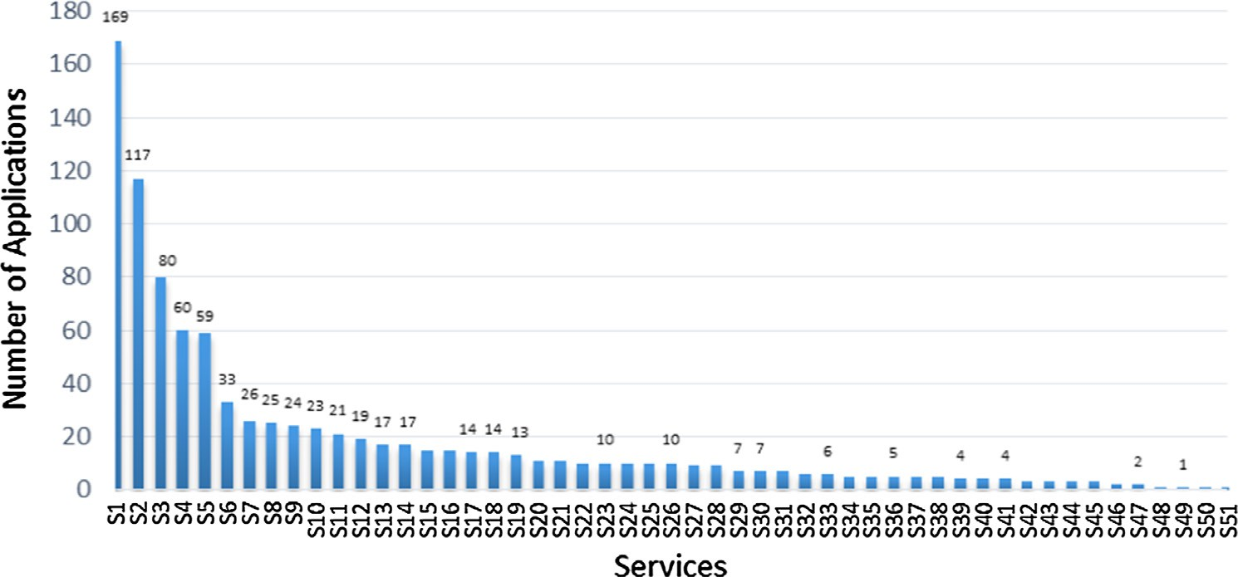

Fig. 3. The number of apps providing a specific service.

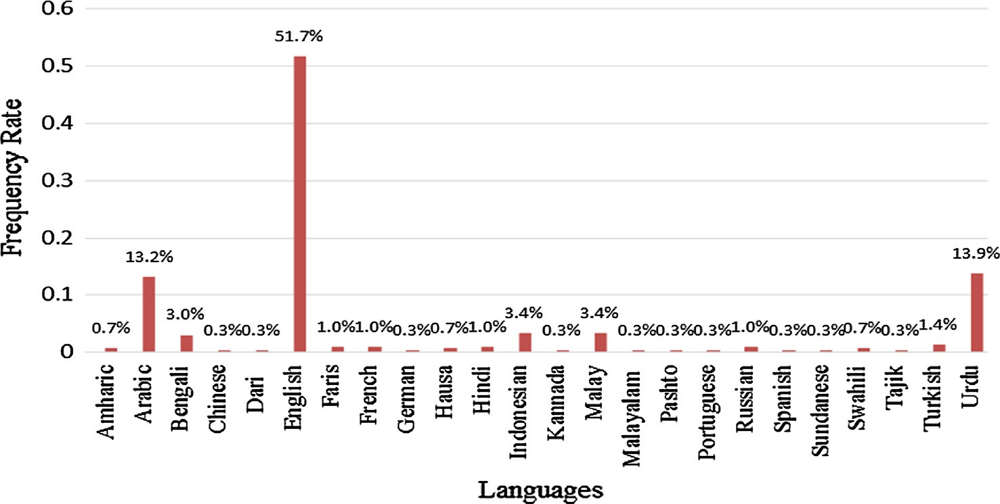

Fig. 4. Percentage rates of the supported languages in all apps.

1,000,000 - 5,000,000 1

500,000 - 1,000,000 2

100,000 - 500,000 10

50,000 - 100,000 14

10,000 - 50,000 49

**Download Scale**

5,000 - 10,000 18

1,000 - 5,000 53

500 - 1,000 13

100 - 500 52

50 - 100 11

10 - 50 16

5 - 10 3

1 - 5 3

0 10 20 30 40 50 60

# Number of mobile applications

Fig. 5. The number of apps for each download scale.

Table 2

Classification of apps according to the publishers and supported services.

|  |  |  |  |  |
| --- | --- | --- | --- | --- |
| Similar Apps | Publisher | Number of supported languages | Number of services | Number of versions |
| Umrah Selfie Frames | AppGenie202 | 1 | 1 | 2 |
| Hajj Selfie Frames | AppGenie202 | 1 | 1 | 2 |
| Kaaba Wallpapers | CreativeOne | 1 | 1 | 2 |
| Mecca Hajj Live Wallpaper | CreativeOne | 1 | 1 | 2 |
| Hajj step by step | islaamlight | 11 | 1 | 11 |
| ﺍﻟﺤﺞ ﺧﻄﻮﺓ ﺧﻄﻮﺓ | islaamlight | 11 | 1 | 11 |
| 朝觐一步一步地 | islaamlight | 11 | 1 | 11 |
| ধাপেধাপেহজ | islaamlight | 11 | 1 | 11 |
| ﺣﺞ ﻣﺮﺣﻠﺔ ﺑﺎ ﻣﺮﺣﻠﺔ | islaamlight | 11 | 1 | 11 |
| Xal;iaupaiauov | islaamlight | 11 | 1 | 11 |
| Le Pèlerinage pas à pas | islaamlight | 11 | 1 | 11 |
| ADIM ADIM HAC | islaamlight | 11 | 1 | 11 |
| Hajji DakiDaki | islaamlight | 11 | 1 | 11 |
| Haji langkah demi langkah | islaamlight | 11 | 1 | 11 |
| HIJA HATUA KWA HATUA | islaamlight | 11 | 1 | 11 |
| eHajj | Mizan Applications | 1 | 14–17 | 2 |
| eHajj Plus | Mizan Applications | 1 | 14–17 | 2 |
| Virtual Hajj & Umrah Guide 3D | Special Android Applications | 1 | 6–7 | 6 |
| Virtual Hajj Guide and Umrah | Special Android Applications | 1 | 6–7 | 6 |
| Virtual Umrah Guide Pro | Special Android Applications | 1 | 6–7 | 6 |
| VR Hajj Umrah Guide Pro | Special Android Applications | 1 | 6–7 | 6 |
| VR Umrah Guide Pro | Special Android Applications | 1 | 6–7 | 6 |
| VR Hajj Umrah Guide Free | Special Android Applications | 1 | 6–7 | 6 |
| Hajj player I ENGLISH | YUSUF YI_G˘ I_TALP | 5 | 4 | 5 |
| Hajj player I MELAYU | YUSUF YI_G˘ I_TALP | 5 | 4 | 5 |
| Hajj player I ARABIC | YUSUF YI_G˘ I_TALP | 5 | 4 | 5 |
| Hajj player I URDU-INDIA | YUSUF YI_G˘ I_TALP | 5 | 4 | 5 |

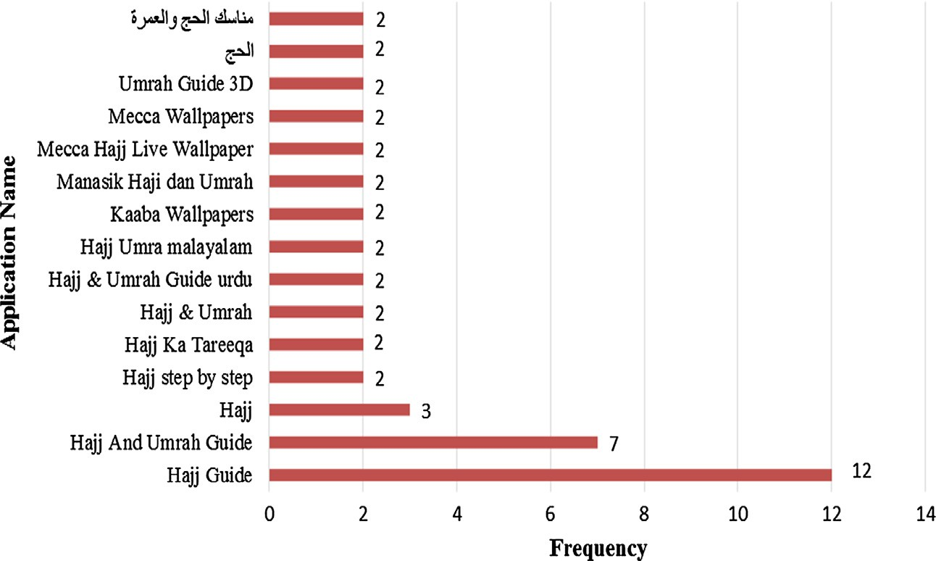

Fig. 6. The frequent of the mobile application names.

Another important missed service is that no app can offer services to blind or low-vision users.

1. Case study: assessment of Hajj mobile apps

This section is directed to study and to evaluate some of the sur- veyed apps. A questionnaire is prepared to collect data from users for the selected apps. The criteria for selecting particular apps are discussed in the following subsection.

* 1. *Mobile application selection criteria*

Ten apps were selected as the case study. We selected the apps that fit the two criteria as follows:

* + - Providing at least two services,
    - Published by governmental or private organizations; i.e., we exclude apps published by individuals and non-organizational agencies.

The selected apps and their relative information are presented in Table 4. As can be seen in the table, four out of ten apps pub- lished their last updated versions after starting Hajj activities in Hajj season 2016, and two apps published their last updated ver- sions during Hajj season 2015. The apps discussed in this study do not mean that they are the best among other offered apps.

* 1. *Questionnaire design and data collection*

After we determined the target apps, we prepared a survey to evaluate the quality of the selected apps. A number of methods are designed to evaluate different special purpose apps.

Table 3

Missed apps during Hajj season 2016.

|  |  |  |  |  |
| --- | --- | --- | --- | --- |
| Application Name | Publisher | Supported Language | Download time | No of Services |
| Aurto ka Hajj umrah in Urdu | Oracle Developers | Urdu | 1000–5000 | 2 |
| Hajj | Genesis Creative Applications | Urdu | 500–1000 | 2 |
| Hajj | Appsspacess | Bengali | 100–500 | 2 |
| Hajj & Umrah | Nanosoft Technologies | English | 10,000–50,000 | 5 |
| Hajj and Umrah | Smart devtech | Arabic | 1000–5000 | 4 |
| Hajj AR App | Mobily | Arabic | 10,000–50,000 | 4 |
| Hajj aur Umrah in Urdu | Oracle Developers | Urdu | 10,000–50,000 | 4 |
| Hajj Guide Urdu | Readers | Urdu | 100–500 | 1 |
| Hajj Guide(হজ্জ্ব গাইড) | Hello Tech | Bengali | 5000–10,000 | 5 |
| Hajj Ka Tariqa | Traditional Apps | Urdu | 500–1000 | 2 |
| Hajj ke 5 Din | On Demand Apps | Urdu | 1000–5000 | 1 |
| Hajj Mini Guide | Euphrates Media | English | 10,000–50,000 | 3 |
| Hajj Umrah - Hajj aur Umrah | On Demand Apps | Urdu | 5000–10,000 | 2 |
| Mecca Hajj Live Wallpaper | Peaksel | English | 500,000–1,000,000 | 1 |
| BCE O XAL:E | A,y Xakbl Lauecnayb | Russian | 5000–10,000 | 2 |
| Mecca 3D - A Journey To Islam | Brainseed Factory | English | 100,000–500,000 | 5 |
| Hajj and Umrah Guide 2016 | Muslim ELibrary | English | 500–1000 | 4 |
| ﺩﻟﻴﻞ ﺍﻟﺤﺞ ﻭﺍﻟﻌﻤﺮﺓ - Guide Hajj | M7com.com | Arabic, English | 100–500 | 4 |

Table 4

|  |  |  |  |  |  |
| --- | --- | --- | --- | --- | --- |
| Specifications of the selected apps. |  | | | | |
| Application Name | Publisher | Provider | Reviews rate/# of Reviewers | Last Update | Download times |
| 1 Smart Hajj | GIS Technology Innovation Center | Umm Al-Qura University | 4.6/270 | 3/28/2016 | 10,000–50,000 |
| 2 Salam | Hajjnet | Saudi Arabian Ministry of Social Affairs | 4.6/11,809 | 9/15/2016 | 100,000–500,000 |
| 3 Almurshid | Holymakkah | Holy Makkah Municipality | 4.2/13 | 9/20/2015 | 500–1000 |
| 1. Hajj and Umrah 2. Mutawef | I.T. Department of DawateIslami  Madar Software | Faizan-e-Madina (Global Islamic Center), pakistan  General Presidency for the affairs of the | 4.8/1626  4.5/6167 | 8/4/2016  8/30/2016 | 50,000–100,000  100,000–500,000 |
| 6 Manasikana | Ministry of Haj & Umrah | Grand Mosque and the Prophet’s Mosque  Ministry of Haj & Umrah | 4.7/213 | 9/10/2016 | 5000–10,000 |
| 7 Tarwiah | National Water Company | National Water Company | 4.7/84 | 9/8/2016 | 1000–5000 |
| 8 AlMaqsad | NaviBees | NaviBees company | 4.7/1106 | 6/20/2016 | 50,000–100,000 |
| 9 Hajj and Umrah | Saudi Post | Saudi Post | 4.3/109 | 9/8/2016 | 1000–5000 |
| Navigator  10 Navi Hajj | Urbsoft | Tech Company | 4.7/176 | 9/18/2015 | 5000–10,000 |

One of the useful methods used to assess apps is the MARS pro- posed by Stoyanov et al. [15]. The criteria defined in the MARS evaluation method can cover the main dimensions of the app qual- ity in our study. However, the MARS method is originally designed to rate the quality of mobile health apps and has been used in many recent studies [17–20].

The MARS method contains four categories, namely, engage- ment, functionality, aesthetics, and information quality, for assess- ing the quality of apps. Rating the apps according to these categories will provide better app evaluation compared with the user ratings in the app store. The subjective quality of each cate- gory contains a number of items as shown in Table 5.

The study is regarding the accuracy of the evaluation apps; therefore, the sample of this study is nominated according to their prior knowledge and experience in using different apps in general and for Islamic apps in particular.

Two groups of expert users were involved in evaluating the selected apps. Group A comprises of 10 specialists working as the custodians of the Two Holy Mosques Institute for Hajj and Umrah Research, whereas Group B consists of 11 specialists working in the Information Technology Center of the General Presidency of the Affairs of the Holy Mosque and the Prophet’s Mosque. The partici- pants of the questionnaire hold different academic degrees and practical experiences in their fields.

Table 5

Items of MARS Categories [Stoyanov, 15].

Category Items

Engagement Entertainment Interest Customization Interactivity Target group

Functionality Performance Ease of use Navigation Gestural design

Aesthetics Layout

Graphics

Visual appeal: How good does the app look?

Information Accuracy of app description Goals

Quality of information Quantity of information Visual information Credibility

Evidence base

Subjective quality Would you recommend this app?

Amount of time that you spend on an app? Would you pay for this app?

What is your overall star rating of the app?

Smart Hajj

Manasikana

**3.0**

## 2.66

**2.5**

Hajj and Umrah Nav

Mutawef

## 2.73

**2.0**

**1.5**

## 1.88

## 2.42

Salam

Navi Hajj

## 2.08

## 2.04

**1.0**

## 1.02

## 1.76

2.22

AlMurshed

AlMaqsad

## 2.30

Hajj and Umrah

Tarwiah

Fig. 7. Total average score of four MARS categories.

Manasikana

**3.0**

1. Conclusion

Smart Hajj

Mutawef

## 2.55

## 1.56

**2.5**

**2.0**

**1.5**

**1.0**

2.43

1.38

1.00 1.28

Hajj and Umrah Nav

Salam

## 1.88

In this paper, we conducted a survey for the available Islamic apps related to Hajj and Umrah. The paper provided a detailed study of all features and services of the surveyed apps.

The behavior trends of the mobile application providers and users are studied. The results showed that most of the app provi- ders focused on developing Hajj and Umrah ritual services in a basic and non-interactive manner, whereas the attitudes of the

Navi Hajj

AlMaqsad

## 1.44

1.90

1.73

AlMurshed

Hajj and Umrah

users are directed toward the visualized app services.

The result demonstrated that the most downloaded mobile application is for the live video service application, namely, ‘‘Watch Live Makkah 24 Hours HD,” with more than one million download times. Furthermore, the results for the popular downloaded apps

(apps that were downloaded more than 100,000 times) showed that

Tarwiah

Fig. 8. Average score of subjective quality MARS score.

* 1. *Analysis and discussion*

We averaged the scores of the collected application surveys according to the MARS categories. Each MARS item uses a three- point scale, a score for each category is calculated as the mean of all belonging items, and the overall score is calculated as an aver- age across the categories.

Fig. 7 illustrates the total average score of each MARS category (engagement, functionality, aesthetics, and information) for the selected app. The results demonstrate that the ‘‘Mutawef” app has the highest rank MARS scores with 2.73, and then ‘‘Mana- sikana” and ‘‘Salam” apps with 2.66 and 2.42, respectively. More- over, the results show that the ‘‘Smart Hajj” app has the lowest rank among others (1.02) because of disabling all its functions dur- ing the period of this study.

Fig. 8 depicts the average score of the ‘‘subjective quality” MARS score; the highest average is observed for ‘‘Mutawef” app with 2.55, then ‘‘Manasikana,” ‘‘Tarwiah,” and ‘‘Salam,” which reflects the overall satisfaction and acceptance of a user while using the app. The results also show that the average score of 4 out of 10 apps is below 1.5, indicating that the users are not feeling enjoy- able while using the app features.

apps supporting images and wallpaper services are the most widely used apps and are preferred by users. Furthermore, the least down- loaded apps are the non-free apps, such as ‘‘Hajj player I URDU- INDIA” app. Also, more than 87% of studied apps support only one language even though some of them include interesting features such as ‘‘Mutawef” and ‘‘Virtual Hajj & Umrah Guide 3D” apps.

This study also performed a case study for some apps selected according to specific criteria. The results showed that the ‘‘Mutawef” mobile application had the best average MARS score among the other apps with 2.73 out of 3, followed by ‘‘Mana- sikana” mobile application with 2.66 average MARS score. In addi- tion, the observed results revealed important issues regarding the overall satisfaction of the users in using the selected apps, where the average subjective quality score for some of the studied apps does not reach the mid-average score (1.5), which should be con- sidered in improving the provided services and functions in the future.

Finally, we expect that this study can provide good directions to researchers and application developers in improving the services provided for Muslim pilgrims and visitors and consider the most desirable features targeted and desired by users.

Appendix A

See Table A.1.

Table A.1

Apps and their features.

|  |  |  |  |  |  |  |  |
| --- | --- | --- | --- | --- | --- | --- | --- |
| Abbr. | Application Name | No of Services | Languages | Abbr. | Application Name | No of Services | Languages |
| A1 | Mutawef | 23 | Arabic | A41 | Hajj Muaavin | 6 | English |
| A2 | Smart Hajj | 17 | Multi | A42 | ﺩﻟﻴﻞ ﺍﻟﺤﺎﺝ ﻭﺍﻟﻤﻌﺘﻤﺮ | 6 | Arabic |
| A3 | eHajj Plus | 17 | Indonesian | A43 | Virtual Hajj & Umrah Guide 3D | 6 | English |
| A4 | Perform Hajj & Umrah | 14 | Multi | A44 | VR Umrah Guide Pro | 6 | English |
| A5 | Haji Pintar | 14 | Indonesian | A45 | TelkomselIbadah | 6 | Malay |
| A6 | eHajj | 14 | Indonesian | A46 | Jaidi Hajj | 6 | English |
| A7 | পিলগ্রিম গাইড (বিটা সংস্করণ) | 12 | Bengali | A47 | Hajj and Umrah Guide | 6 | English |
| A8 | Salam: Hajj & Umrah Guide | 12 | Multi | A48 | Hajj and Umrah Guide | 6 | English |
| A9 | Manasikana | 12 | Multi | A49 | Hajj Mabror | 6 | English |
| A10 | Noor Hajj w find me locator | 11 | Multi | A50 | Al-Hajj | 6 | English |
| A11 | ﺣﺞ ﮐﻼﺱ Class Hajj | 10 | Farisi | A51 | ﺣﺞ ﺍﻟﻌﺎﺷﻘﻴﻦ | 6 | Arabic |
| A12 | Hajj and Umrah | 10 | English,Urdu | A52 | Hajj story | 5 | Arabic |
| A13 | Al Hajj Guide | 10 | English | A53 | Hajj Guide Step By Step Live | 5 | Urdu |
| A14 | Navi Hajj | 10 | English | A54 | Al Hajj Guide | 5 | Arabic |
| A15 | Hajj and Umrah Guide with Dua | 9 | English | A55 | Hajj & Umrah | 5 | English |
| A16 | Hajj Help | 8 | English | A56 | Hajj Guide | 5 | English |
| A17 | হজ্জ সহায়িকা (Hajj Essential) | 8 | Bengali | A57 | AplikasiPanduanIbadah Haji | 5 | Indonesian |
| A18 | Makkah Explorer Hajj & Umrah | 8 | English | A58 | HacUmreRehberi | 5 | Turkish |
| A19 | HajjAp | 8 | English | A59 | Hajj Messenger | 5 | English |
| A20 | Hajj & Umrah with Audio | 7 | English | A60 | ﻣﻨﺎﺳﻚ ﺍﻟﺤﺞ ﻭﺍﻟﻌﻤﺮﺓ | 5 | Arabic |
| A21 | Al-Islam Hajj and Umrah | 7 | English | A61 | Hajj Super Guide | 5 | English |
| A22 | Rehnuma-e-Hajj | 7 | Urdu | A62 | Hajj Umrah Guide Free | 5 | English |
| A23 | Mecca Guide Map Hotels Weather | 7 | English | A63 | Hajj Guide | 5 | English |
| A24 | Ziyarates - Hajj and Umrah | 7 | English | A64 | Umrah & Hajj Guide | 5 | English |
| A25 | Sohba Hajj & Umrah Traveler | 7 | English | A65 | Diary Of Hajj | 5 | English |
| A26 | HAJJ GUIDE | 7 | English | A66 | Hajj and Umrah Navigator | 6 | Multi |
| A27 | ﺃﺩﻋﻴﺔ ﺍﻟﺤﺞ ﻭﺍﻟﻌﻤﺮﺓ | 7 | Arabic | A67 | Hajj & Umrah Guide urdu | 5 | Urdu |
| A28 | Durrar Al-Hajj and Umra | 7 | Multi | A68 | Al Khair | 5 | English |
| A29 | Islamic Life | 7 | English | A69 | Hajj Umrah Guide | 5 | English |
| A30 | Virtual Hajj Guide and Umrah | 7 | English | A70 | Hajj Fiqh | 5 | English |
| A31 | Virtual Umrah Guide Pro | 7 | English | A71 | Hajj Companion | 5 | English |
| A32 | VR Hajj Umrah Guide Pro | 7 | English | A72 | Hajj Umramalayalam | 5 | Hindi |
| A33 | VR Hajj Umrah Guide Free | 7 | English | A73 | Zia e Hajj and Umrah | 5 | Urdu |
| A34 | Wajibati - Hajj & Umrah | 7 | English | A74 | Learn Hajj | 4 | English |
| A35 | ﺣﺞ - Hajj | 6 | Arabic | A75 | Hajjandumrah guide in english | 4 | English |
| A36 | Easy Hajj Umrah Guide | 6 | Urdu | A76 | Hajj Emergency Services Plus | 4 | English,Arabic |
| A37 | Hajj and Umrah Guide - urdu | 6 | Urdu | A77 | ﻣﻨﺎﺳﻚ ﺍﻟﺤﺞ ﻭﺍﻟﻌﻤﺮﺓ | 4 | Arabic |
| A38 | HAJJ GUIDE | 6 | English | A78 | Hajj Umrah Guide English FREE | 4 | English |
| A39 | Hajj Health Companion | 6 | English,Arabic | A79 | Hajj and Umrah Guide | 4 | English |
| A40 | Tarwiah | 6 | Multi | A80 | Mecca 3D - A Journey To Islam | 4 | English |
| A81 | Indian Haji Accom. Locator | 4 | English | A125 | Hajj and Umrah Guide | 3 | English,Urdu |
| A82 | Le guide du Hajj et de la Omra | 4 | French | A126 | LABBAIYK ALLAWHUMMA LABBAIYK | 3 | Urdu Latin alphabet |
| A83 | Hajj Guide | 4 | English, Arabic | A127 | Tawaf and Sai in Hajj and Umra | 3 | English |
| A84 | Hajj e Mabroor | 4 | Multi | A128 | Hajj Guide | 3 | Urdu |
| A85 | Hajj Pilgrimage Guide | 4 | English | A129 | Hajj and Umrah Guide app | 3 | English |
| A86 | Rituals Hajj - ﻣﻨﺎﺳﻚ ﺍﻟﺤﺞ | 4 | Arabic | A130 | Hajj african | 3 | English |
| A87 | Fiqh al-Ibadat images- Hajj | 4 | English | A131 | Panduan Haji dan Umrah | 3 | Malay,English |
| A88 | Hajj 2016 - Five blessed days | 4 | English | A132 | Hajj waUmrrahQadam ba Qadam | 3 | English |
| A89 | Hajj- ﺣﺞ | 4 | Multi | A133 | Hajj and Umrah Guide 2016 | 3 | English |
| A90 | Hajj Malayalam Guide | 4 | Malayalam | A134 | Hajj Umrah Best Guide | 3 | English, Arabic |
| A91 | በሥዕልየተደገፈ - ሐጅ | 4 | Multi | A135 | ﻭﺟﻮﺍﺏ ﻟﺤﺞ ﻭﺍﻟﻌﻤﺮﺓ - 891 ﺳﺆﺍﻝ | 3 | Arabic |
| A92 | ﺩﻟﻴﻞ ﺍﻟﺤﺞ ﻭﺍﻟﻌﻤﺮﺓ - Guide Hajj | 4 | Arabic,English | A136 | Labbaik: Hajj & Umrah Guid | 3 | Bengali, English |
| A93 | ﺍﻟﺤﺞ | 4 | Arabic | A137 | Bayyin Al Hajj | 3 | English, Arabic |
| A94 | Manasik Haji dan Umrah | 4 | Malay | A138 | Umrah Guide 3D | 3 | English |
| A95 | Hajj For Women | 4 | English | A139 | Keywords of Hajj &Umrah | 3 | English |
| A96 | Manasik Haji dan Umrah | 4 | Indonesian | A140 | Hajj & Umrah Urdu Guide | 3 | Urdu |
| A97 | Hajj And Umrah Guide | 4 | English | A141 | Hajj | 3 | Multi |
| A98 | ﻣﻨﺎﺳﻚ ﺍﻟﺤﺞ - Al-Hajj Manasek | 4 | Arabic | A142 | Smart Hajj Group | 3 | Indonesian |
| A99 | Hajj Guide Complete | 4 | Urdu | A143 | Xal; b yvpa | 3 | Russian |
| A100 | Al Hajj wal Umrah | 4 | English | A144 | Guide to Hajj and Umrah | 2 | English |
| A101 | Makkah Window | 4 | English | A145 | Walking Hajj | 2 | English |
| A102 | Haj Tours | 4 | English | A146 | Masail-o-Maloomaat-e-Hajj-Top | 2 | Urdu |
| A103 | Hac player I TÜRKÇE | 4 | Turkish | A147 | ﻣﻨﺎﺳﻚ ﺍﻟﺤﺞ ﻭﻣﻠﺤﻘﺎﺗﻬﺎ | 2 | Arabic |
| A104 | Hajj player I ARABIC | 4 | Arabic | A148 | Labbaik: Hajj and Umrah Audio | 2 | English |
| A105 | Hajj player I ENGLISH | 4 | English | A149 | ﺳﻬﻠﺔ ﻣﻨﺎﺳﻚ ﺍﻟﺤﺞ ﻭﺍﻟﻌﻤﺮﺓ ﺑﻄﺮﻳﻘﺔ | 2 | Arabic |
| A106 | Hajj player I MELAYU | 4 | Malay | A150 | Hajj And Umrah Guide In urdu | 2 | Urdu |
| A107 | Hajj player I URDU-INDIA | 4 | Urdu | A151 | Umrah Guide 3D | 2 | English |
| A108 | MZahid - Hajj Umrah Packages | 3 | English | A152 | Mecca Live Wallpaper | 2 | English |
| A109 | HAJJ DA UMRAH | 3 | Hausa | A153 | Hajj Guide | 2 | English |
| A110 | Hajj, Umra and visiting | 3 | English,Arabic | A154 | ﺣﺞ ﮔﺎﺋﯿﮉ | 2 | Urdu |
| A111 | Al Hajj Wa Al Umrah | 3 | Arabic | A155 | Hajj Kit | 2 | English |
| A112 | Hajj and Umrah | 3 | Arabic | A156 | HAJJ AMHARIC | 2 | Amharic (Ethiopian) |
| A113 | Ahkam-e-Hajj | 3 | Urdu | A157 | Hajj Guide with Places In urdu | 2 | Urdu |
| A114 | ﻋﻤﺮﮦ ﮔﺎﺋﯿﮉ | 3 | Urdu | A158 | Hajj Tech | 2 | English |
|  |  |  |  |  |  |  | (*continued on next page*) |

Table A.1 (*continued*)

|  |  |  |  |  |  |  |  |
| --- | --- | --- | --- | --- | --- | --- | --- |
| Abbr. | Application Name | No of Services | Languages | Abbr. | Application Name | No of Services | Languages |
| A115 | Hajj and Umrah Handbook | 3 | English | A159 | Hajj step by step | 2 | English |
| A116 | Hajj & Umrah | 3 | English | A160 | Hajj Umrah Guide | 2 | English, Urdu |
| A117 | Hajj And Umrah Guide | 3 | English | A161 | ﺍﻟﺤﺞ | 2 | Arabic |
| A118 | Kumpulan Doa Haji dan Umrah | 3 | Indonesian | A162 | Hajj o Umrah | 2 | Urdu |
| A119 | Hajj aurumrahkatariqa | 3 | Urdu | A163 | ﺍﻟﻤﻜﺮﻣﺔ ﺍﻟﻤﺮﺷﺪ ﺍﻟﺠﻐﺮﺍﻓﻲ ﻟﻤﻜﺔ | 3 | Arabic, English |
| A120 | hindi Hajj & Umrah guide | 3 | Hindi | A164 | Salat and Hajj | 2 | English |
| A121 | Hajj Maps | 3 | English | A165 | Hajj Guide | 2 | English |
| A122 | Hajj arabic Dictionary | 3 | Multi | A166 | Hajj Guide (Islam) | 2 | English |
| A123 | Hajj | 3 | Arabic | A167 | Hajj step by step | 2 | English |
| A124 | Hajj E Islam | 3 | English | A168 | Hajj and Umrah from A to Z | 2 | English |
| A169 | Hajj Ka Tareeqa | 2 | Urdu | A213 | Hajj Tips in Bangla (হজ্ব টিপস) | 1 | Bengali |
| A170 | Z - Xal;b | 2 | Russian | A214 | Hajj Live Auto Wallpaper Full | 1 | English |
| A171 | Hajj Kwa Kiswahili | 2 | Swahili | A215 | Hajj Guide | 1 | English |
| A172 | Virtual Hajj | 2 | English | A216 | Hajj Qadam Ba Qadam | 1 | Urdu |
| A173 | Umra e-services | 2 | English | A217 | ﺍﺩﻋﻴﺔ ﺍﻟﺤﺞ ﻭ ﺍﻟﻌﻤﺮ | 1 | Arabic |
| A174 | ﻣﻨﺎﺳﻚ ﺍﻟﺤﺞ ﺍﻟﺴﻴﺴﺘﺎﻧﻲ | 2 | Arabic | A218 | AdkarKitabBurda-Swalat-Dua | 1 | English |
| A175 | Hajj StepByStep | 2 | Urdu, English | A219 | Hajj Umrah Adkar (malayalam) | 1 | English |
| A176 | AlMaqsad - AlHaram Navigation | 2 | Multi | A220 | ALLAH Makkah HQ Live Wallpaper | 1 | English |
| A177 | HariRaya Haji AidilAdha | 2 | Malay | A221 | Mecca Wallpapers | 1 | English |
| A178 | Muslim Dua Now - Dua&Azkar | 2 | English,Urdu | A222 | Hajj Navigator | 2 | English |
| A179 | Find your Travel mates (Hajj) | 2 | English | A223 | ﺍﻟﺤﺞ ﺧﻄﻮﺓ ﺧﻄﻮﺓ | 1 | Arabic |
| A180 | Al Hajj | 2 | Urdu | A224 | Kaaba Wallpaper | 1 | English |
| A181 | Islamic-Ease:Utility App | 2 | English | A225 | Hajj kaTareeqa | 1 | Urdu |
| A182 | Hajj VR | 2 | English | A226 | HAJJ UMRAH ADHKAR (KANNADA) | 1 | Kannada |
| A183 | Green Hajj Indonesia | 2 | English | A227 | Mecca Hajj Live Wallpaper | 1 | English |
| A184 | Duas for Hajj and Umrah | 2 | English | A228 | Zad e Rah (Al-Huda Int.) | 1 | Multi |
| A185 | ﺭﻓﯿﻖ ﺍﻟﺤﺮﻣﯿﻦ RafiqulHaramain | 2 | Farisi | A229 | Islamic Photo Frames | 1 | English |
| A186 | Hajj Guide | 2 | English | A230 | Hajj Guide | 1 | English |
| A187 | Hajj aur Umrah Guide | 2 | Urdu | A231 | Hajj Ka Tariqa Video | 1 | Urdu |
| A188 | Hajj & Umrah Picture Guide | 2 | English | A232 | Hajj and Umrah (Audio) Mp3 | 1 | Malay |
| A189 | Hajj & Umrah Guide | 2 | English | A233 | হজ্জও ওমরাহ্ | Hajj Bangla | 1 | Bengali |
| A190 | VR Masjid Al-Haram Tour - Hajj | 1 | English | A234 | A GUIDE TO HAJJ AND UMRAH | 1 | English |
| A191 | Dheen Hajj Service | 1 | English | A235 | Shohoj Bangla Hajj Guide | 1 | Bengali |
| A192 | 3D Hajj Photo Frames | 1 | English | A236 | Mina Locator | 2 | English,Urdu |
| A193 | Fatwa regarding Hajj and Umra | 1 | English | A237 | Hajj Complaints Lodging System | 1 | English |
| A194 | Hajj | 1 | English | A238 | Hajj Umra App | 1 | English |
| A195 | Pilgrimage (Hajj) | 1 | English | A239 | Hajj Guide | 1 | English |
| A196 | ﻣﻜﺔ ﺍﻟﻤﻜﺮﻣﺔ HD Photos Makkah | 1 | English | A240 | Hajj and Umrah Duain | 1 | Urdu |
| A197 | Panduan Haji Bergambar | 1 | Malay | A241 | HAJJ kiAasaniyan (URDU) | 1 | Urdu |
| A198 | Bismillah Hajj | 1 | English | A242 | Hisnul Muslim arabic | 1 | Arabic |
| A199 | Umrah Selfie Frames | 1 | English | A243 | Islamic Questions Answers | 1 | English |
| A200 | Hajj Selfie Frames | 1 | English | A244 | Kaaba Wallpapers | 1 | English |
| A201 | হজ্জ Hajj Details | 1 | Bengali | A245 | ﺣﺞ ﻣﺒﺮﻭﺭ | 1 | Arabic |
| A202 | Makkah Live + Madinah Live HD | 1 | English | A246 | Hajj Live | 1 | English |
| A203 | Supplications of Hajj & Umrah | 1 | English |  |  |  |  |
| A204 | ﺣﺞ ﻭ ﻋﻤﺮﮦ ﮐﯽ ﺩﻋﺎﺋﯿﮟ | 1 | Urdu |  |  |  |  |
| A205 | Mekka Hajj 3D Video Wallpaper | 1 | English |  |  |  |  |
| A206 | Makkah &Madinah live | 1 | English |  |  |  |  |
| A207 | Hajj Ka Tarika In urdu | 1 | Urdu |  |  |  |  |
| A208 | Hajj & Umrah Historical Pics | 1 | English |  |  |  |  |
| A209 | Kaaba Wallpapers | 1 | English |  |  |  |  |
| A210 | Mecca Hajj Live Wallpaper | 1 | English |  |  |  |  |
| A211 | Mecca Wallpapers | 1 | English |  |  |  |  |
| A212 | MarbelDoa Haji & Umrah | 1 | Indonesian |  |  |  |  |

References

1. Abdalma K al. alssayh, Mobile Hajj Guide for Malaysian Pilgrims (M.Sc. thesis), University Utara Malaysia, 2009.
2. Ahmed Sheikh A. Al-Aidaroos, Ariffin Abdul Mutalib, Multiple input modality mobile application for pilgrims, in: Knowledge Management International Conference (KMICe), 12–15 August 2014, Langkawi, Malaysia, pp. 512–517.
3. [Ahmed Sheikh Abdullah Al-Aidaroos, Abdul Nasir Zulkifli, Ruzinoor Che Mat,](http://refhub.elsevier.com/S2210-8327(16)30127-2/h0015) [Development of Mobile Dua and Zikr for Hajj (MDZ4H), Telkomnika 11 (5)](http://refhub.elsevier.com/S2210-8327(16)30127-2/h0015) [(2013) 2723–2730](http://refhub.elsevier.com/S2210-8327(16)30127-2/h0015).
4. Akhlaq Ahmad, Md. Abdur Rahman, Faizan Ur Rehman, Imad Afyouni, Saleh Basalamah, Mohamed Ridza Wahiddin, Towards a mobile and context-aware framework from crowdsourced data, in: IEEE International Conference on Information and Communication Technology for the Muslims World (ICT4M), Kuching, Sarawak, Malaysia, 17–19 November 2014, pp. 1–6.
5. Akram M. Zeki, Hassen Alsafi, Rasheed M. Nassr, Teddy Mantoro, A mobile dictionary for pilgrims, in: 2012 IEEE International Conference on Information Technology and e-Services (ICITeS), Sousse, Tunisia, 24–26 March 2012, pp. 1–5.
6. [Aladdein Amro, Qasem Abdel-Muti Nijem, Pilgrims ‘‘Hajj”](http://refhub.elsevier.com/S2210-8327(16)30127-2/h0030) [tracking system](http://refhub.elsevier.com/S2210-8327(16)30127-2/h0030) [(e-Mutawwif), Contemp. Eng. Sci. 5 (9) (2012) 437–446](http://refhub.elsevier.com/S2210-8327(16)30127-2/h0030).
7. [Fathi Hamhoum, Christian Kray, Supporting pilgrims in navigating densely](http://refhub.elsevier.com/S2210-8327(16)30127-2/h0035) [crowded religious sites, Pers. Ubiquit. Comput. (16) (2012) 1013–1023](http://refhub.elsevier.com/S2210-8327(16)30127-2/h0035).
8. Hasimah Hj Mohamed, Muhammad Rafie Mohd Arshad, Wahidah Husain, Zurinahni Zainol, Nur’aini Abdul Rashid, Omar Abd Majid, Munirah Ghazali, Md Yusoff Abdul Rahim, and Abdul Rhaffor hj Mahmod, M-Umrah: an android- based application to help pilgrims in performing Umrah, in: 2013 IEEE International Conference on Advanced Computer Science Applications and Technologies (ACSAT), Kuching, Malaysia, 23–24 Dec. 2013, pp. 385–389.
9. Mayada Ahmmad Al-Massre, The Use of Augmented Reality as Assistive Services for Pilgrims (M.sc. thesis), King Abdul Aziz University, 2011.
10. [Mohamed Mohandes, Pilgrim tracking and identification using the mobile](http://refhub.elsevier.com/S2210-8327(16)30127-2/h0050) [phone, in: 2011 IEEE 15th International Symposium on Consumer Electronics](http://refhub.elsevier.com/S2210-8327(16)30127-2/h0050) [(ISCE), Singapore, 14–17 June 2011,](http://refhub.elsevier.com/S2210-8327(16)30127-2/h0050) [2011, pp. 196–199](http://refhub.elsevier.com/S2210-8327(16)30127-2/h0050).
11. Mohammed Morad Anad, A Mobile Application to Guide Hajj Pilgrims (M.Sc. thesis), University Utara Malaysia, 2009.
12. Owaidah A. Almoaid, Hajj crowd management via a mobile augmented reality application: a case of The Hajj event, Saudi Arabia (M.Sc. thesis), University of Glasgow, 2014.
13. Sakina M.A. Makhzoom, The four basic pillars of Hajj’s mobile system (M.Sc. thesis), University Utara Malaysia, 2011.
14. [T. Mantoro, M. Akhtaruzzaman, M. Mahmud, M.A. Ayu, Design and](http://refhub.elsevier.com/S2210-8327(16)30127-2/h0070) [development of an interactive monitoring system for pilgrims in](http://refhub.elsevier.com/S2210-8327(16)30127-2/h0070) [congregation of Hajj Ritual, J. Converg. Inf. Technol. (JCIT) 10 (1) (2015) 28–57](http://refhub.elsevier.com/S2210-8327(16)30127-2/h0070).
15. [Qanta A. Ahmed, Yaseen M. Arabi, Ziad A. Memish, Health risks at the Hajj,](http://refhub.elsevier.com/S2210-8327(16)30127-2/h0075) [Lancet 367 (9515) (2006) 1008–1015](http://refhub.elsevier.com/S2210-8327(16)30127-2/h0075).
16. [S. Stoyanov, L. Hides, D. Kavanagh, D. Tjondronegoro, O. Zelenko, M. Mani,](http://refhub.elsevier.com/S2210-8327(16)30127-2/h0080) [Mobile app rating scale: a new tool for assessing the quality of health-related](http://refhub.elsevier.com/S2210-8327(16)30127-2/h0080) [mobile apps, JMIR mhealth uhealth 3 (1) (2015) e27](http://refhub.elsevier.com/S2210-8327(16)30127-2/h0080).
17. M. Mani, D.J. Kavanagh, L. Hides, S.R. Stoyanov, Review and evaluation of mindfulness-based iphone apps. Eysenbach G, ed., JMIR mHealth uHealth 3 (3) (2015) e82, <http://dx.doi.org/10.2196/mhealth.432>.
18. [Raja Patel et al., Smartphone apps for weight loss and smoking cessation:](http://refhub.elsevier.com/S2210-8327(16)30127-2/h0090) [quality ranking of 120 apps, New Zeal. Med. J. 128 (1421) (2015) 73–76](http://refhub.elsevier.com/S2210-8327(16)30127-2/h0090).
19. H. Wilson, S.R. Stoyanov, S. Gandabhai, A. Baldwin, The quality and accuracy of mobile apps to prevent driving after drinking alcohol. Eysenbach G, ed., JMIR mHealth uHealth 4 (3) (2016) e98, <http://dx.doi.org/10.2196/mhealth.5961>.
20. [Becky K. White et al., Theory-based design and development of a socially](http://refhub.elsevier.com/S2210-8327(16)30127-2/h0100) [connected](http://refhub.elsevier.com/S2210-8327(16)30127-2/h0100)⁄ [gamified mobile app for men about breastfeeding (Milk Man),](http://refhub.elsevier.com/S2210-8327(16)30127-2/h0100) [JMIR mHealth uHealth 4 (2) (2016)](http://refhub.elsevier.com/S2210-8327(16)30127-2/h0100).
21. [Malak A. Abdelazeez, Adnan Shaout, Pilgrim communication using mobile](http://refhub.elsevier.com/S2210-8327(16)30127-2/h0105) [phones, J. Image Graphics 4 (1) (2016)](http://refhub.elsevier.com/S2210-8327(16)30127-2/h0105).
22. [Adnan Shaout, Shahzeb Khan, AlHajj–Hajj app for iOS, IIUM Eng. J. 17 (1)](http://refhub.elsevier.com/S2210-8327(16)30127-2/h0110) [(2016) 1–27](http://refhub.elsevier.com/S2210-8327(16)30127-2/h0110).
23. [Amani S. Alqahtani et al., Pilot use of a novel smartphone application to track](http://refhub.elsevier.com/S2210-8327(16)30127-2/h0115) [traveller health behaviour and collect infectious disease data during a mass](http://refhub.elsevier.com/S2210-8327(16)30127-2/h0115) [gathering: Hajj pilgrimage 2014, J. Epidemiol. Global Health (2015)](http://refhub.elsevier.com/S2210-8327(16)30127-2/h0115).
24. Borja Martínez-Pérez, Isabel de la Torre-Díez, Miguel López-Coronado, Jesús Herreros-González, Mobile apps in cardiology: review, JMIR Mhealth Uhealth 1 (2) (2013) e15, <http://dx.doi.org/10.2196/mhealth.2737>.
25. R.M. Masterson Creber, M.S. Maurer, M. Reading, G. Hiraldo, K.T. Hickey, S. Iribarren, Review and analysis of existing mobile phone apps to support heart failure symptom monitoring and self-care management using the Mobile Application Rating Scale (MARS), JMIR Mhealth Uhealth 4 (2) (2016) e74, <http://dx.doi.org/10.2196/mhealth.5882>.
26. Delikostidis, Ioannis, Thore Fechner, Holger Fritze, Ahmed Mahmoud AbdelMouty and Christian Kray, Evaluating mobile applications in virtual environments: a survey, IJMHCI 5.4 (2013): 1–19. Web. 28 Mar. 2017. doi: <http://dx.doi.org/10.4018/ijmhci.2013100101>.
27. K. Moumane, A. Idri, A. Abran, Usability evaluation of mobile applications using ISO 9241 and ISO 25062 standards, SpringerPlus 5 (1) (2016) 1–15, <http://dx.doi.org/10.1186/s40064-016-2171-z>.
28. Harleen K. Flora, Xiaofeng Wang, Swati V. Chande, An investigation on the characteristics of mobile applications: a survey study, Int. J. Inf. Technol. Comput. Sci. 6 (11) (2014) 21–27, <http://dx.doi.org/10.5815/ijitcs.2014.11.03>, 10/2014.
29. E.D. Boudreaux, M.E. Waring, R.B. Hayes, R.S. Sadasivam, S. Mullen, S. Pagoto, Evaluating and selecting mobile health apps: strategies for healthcare providers and healthcare organizations, Translational Behav. Med. 4 (4) (2014) 363–371, <http://dx.doi.org/10.1007/s13142-014-0293-9>.
30. A. Méndez-Porras, C. Quesada-López, M. Jenkins, Automated testing of mobile applications: a systematic map and review, in: InXVIII Ibero-American Conference on Software Engineering, Lima-Peru 2015 Apr, pp. 195–208.
31. Rachel Harrison, Derek Flood, David Duce, Usability of mobile applications: literature review and rationale for a new usability model, J. Interact. Sci. 1 (1) (2013) 1–16, <http://dx.doi.org/10.1186/2194-0827-1-1>.
32. Tutunea Mihaela Filofteia, Mobile applications for tourism. study regarding their use by romanians, Annals of the ‘‘Constantin Brâncus i” University of Târgu Jiu, Economy Series, Issue 4/2016, 78–84.
33. [Roberto Peretta, Evaluating mobile applications for urban tourism,](http://refhub.elsevier.com/S2210-8327(16)30127-2/h0165) [Almatourism – J. Tourism Cult. Territorial Dev. [S.l.] 5 (1) (2014) 13–35](http://refhub.elsevier.com/S2210-8327(16)30127-2/h0165).
34. [Lyan Al-Wakeel, Amjad Al-Ghanim, Shaden Al-Zeer, Khalid Al-Nafjan, A](http://refhub.elsevier.com/S2210-8327(16)30127-2/h0170) [usability evaluation of arabic mobile applications designed for children with](http://refhub.elsevier.com/S2210-8327(16)30127-2/h0170) [special needs – autism, Lect. Notes Softw. Eng. 3 (3) (2015) 203–209,](http://refhub.elsevier.com/S2210-8327(16)30127-2/h0170) [Singapore](http://refhub.elsevier.com/S2210-8327(16)30127-2/h0170).
35. Dari Alhuwail, Diabetes applications for arabic speakers: a critical review of available apps for android and IOS Operated smartphones, studies in health technology and informatics, Nurs. Inform. 225 (2016) 587–591, [http://dx.doi.](http://dx.doi.org/10.3233/978-1-61499-658-3-587) [org/10.3233/978-1-61499-658-3-587](http://dx.doi.org/10.3233/978-1-61499-658-3-587).
36. Heidi A. Campbell, Brian Altenhofen, Wendi Bellar, Kyong James Cho, There’s a religious app for that! A framework for studying religious mobile applications, Mobile Media Commun. 2 (2) (2014) 154–172, [http://dx.doi.org/10.1177/](http://dx.doi.org/10.1177/2050157914520846) [2050157914520846](http://dx.doi.org/10.1177/2050157914520846), First published date: April-16-2014.
37. [N.A. Ahmad, A. Zainal, S. Kahar, M.A.A. Hassan, R. Setik, Exploring the needs of](http://refhub.elsevier.com/S2210-8327(16)30127-2/h0185) [older adult users for spiritual mobile applications, J. Theoret. Appl. Inf.](http://refhub.elsevier.com/S2210-8327(16)30127-2/h0185) [Technol. 88 (1) (2016) 154–160](http://refhub.elsevier.com/S2210-8327(16)30127-2/h0185).
38. Fernando Rosell-Aguilar, State of the app: a taxonomy and framework for evaluating language learning mobile applications, CALICO J. 34 (2) (2017), <http://dx.doi.org/10.1558/cj.27623>.
39. [Robert Godwin-Jones, Mobile apps for language learning, Lang. Learn. Technol.](http://refhub.elsevier.com/S2210-8327(16)30127-2/h0195) [15 (2) (2011) 2](http://refhub.elsevier.com/S2210-8327(16)30127-2/h0195).
40. Catharine Reese Bomhold, Educational use of smart phone technology: a survey of mobile phone application use by undergraduate university students, Program 47 (4) (2013) 424–436, [http://dx.doi.org/10.1108/PROG-01-2013-](http://dx.doi.org/10.1108/PROG-01-2013-0003)

[0003](http://dx.doi.org/10.1108/PROG-01-2013-0003).

1. [Luvai F. Motiwalla, Mobile learning: a framework and evaluation, Comput.](http://refhub.elsevier.com/S2210-8327(16)30127-2/h0205) [Educ. 49 (3) (2007) 581–596](http://refhub.elsevier.com/S2210-8327(16)30127-2/h0205).
2. Orlando R.E. Pereira, Joel J.P.C. Rodrigues, Survey and analysis of current mobile learning applications and technologies, ACM Comput. Surv. 46 (2) (2013) 35, <http://dx.doi.org/10.1145/2543581.2543594>, Article 27 (December

2013).