[Array 8 (2020) 100040](https://doi.org/10.1016/j.array.2020.100040)

 

Contents lists available at [ScienceDirect](http://www.sciencedirect.com/science/journal/25900056)

Array

journal homepage: [www.elsevier.com/journals/array/2590-0056/open-access-journal](http://www.elsevier.com/journals/array/2590-0056/open-access-journal)

An automated license plate detection and recognition system based on wavelet decomposition and CNN

Ibtissam Slimani *, Abdelmoghit Zaarane, Wahban Al Okaishi, Issam Atouf, Abdellatif Hamdoun

*LTI Lab, Department of Physics, Faculty of Sciences Ben M*’*Sik, Hassan II University Of Casablanca, Morocco*

A R T I C L E I N F O

*Keywords:*

Image processing License plate detection Character recognition Wavlet transform Vertical edges

Local entropy Connected component CNN

A B S T R A C T

The License Plate detection and recognition (LPDR) is a challenging task that plays a significant role in intelligent transportation systems (ITS). Where it could be used as a core in various applications, such as security, traffic control, and electronic payment systems (e.g. freeway toll payment and parking fee payment). A variety of al- gorithms are developed for this work and each one has advantages and disadvantages for extracting plates in images under different circumstances. However, the complexity of some methods requires a high calculation cost and this could be time-consuming. In the current paper, a simple and efficient method is proposed to tackle the issue of license plate detection and character recognition. The license plate is detected first based on the two- dimensional wavelet transform to extract the vertical edges of the input image. The high density of vertical edges is computed first to detect the potential areas of the license plate. Then these potential areas are verified by using a plate/non-plate CNN classifier. After the license plate is detected, the characters are segmented by using a simple method that is based on the empty distance between the characters. Finally, these character candidates are classified by training another CNN classifier. The experiments were done on vehicles that carry Moroccan license plates and showed high accuracy, where the results obtained go up to 99.43% in term of localization and 98.9% in term of recognition. Besides, the efficiency and the high accuracy of the proposed method were proved by per- forming a comparison with other works from the literature on different datasets. All processes of the proposed method were implemented on a Hardware Processor System (HPS) located in a VEEK-MT2S provided by TERASIC.

1. Introduction

Year after year, traffic problems are increasing rapidly due to rapid urban development and increasing car ownership. Traffic congestion, traffic violations, stealing cars, and fugitive criminals impose big chal- lenges on traffic management systems. Several systems are developed to solve these problems such as self-driving systems [1], Traffic surveillance systems [2,3], Tracking vehicle systems and Vehicle speed detection systems [4,5]. License plate detection and character recognition (LPDR) is one of the most important topics in intelligent infrastructure systems, like electronic payment systems (for tolls, parking, and public trans- portation). The LPDR system is an image processing technology used to identify vehicles using their license plate to help the traffic management

department for monitoring purposes. Usually, a license plate detection and character recognition (LPDR) system has mainly three phases. The first phase is image pre-processing, once the image is captured further processing of the image is carried out like converting the image from a color space to another, resizing the image resolution, and removing noises. The second phase is license plate localization, the region of in- terest is detected based on some license plate characteristics and image features. The final phase is the optical character recognition, this phase is considered the most crucial step because it helps to read the plate number and identify the vehicle.

To detect license plates, various methods have been proposed based on image processing. The most common proposed methods include some image features such as color information [6–8], edges information and,

*Abbreviations:* LPDR, License Plate Detection and Recognition; LP, License Plate; ITS, Intelligent Transportation Systems; 2D-WD, two dimensional wavelet decomposition; CTC, connectionist temporal classification; CCA, connected component analysis; CNN, Convolutional neural network; HPS, Hardware Processor System; SVM, support vector machine; AdaBoost, Adaptive boosting; FPGA, Field Programmable Gate Arrays; AC, access control; LE, traffic law enforcement; RP, road patrol.

* Corresponding author.

*E-mail addresses:* [ibtissamslimani7@gmail.com](mailto:ibtissamslimani7@gmail.com) (I. Slimani), [z.abdelmoghit@gmail.com](mailto:z.abdelmoghit@gmail.com) (A. Zaarane).

<https://doi.org/10.1016/j.array.2020.100040>

Received 1 May 2020; Received in revised form 26 August 2020; Accepted 27 August 2020

Available online 3 September 2020

2590-0056/© 2020 The Authors. Published by Elsevier Inc. This is an open access article under the CC BY license (<http://creativecommons.org/licenses/by/4.0/>).

textures information [9,10]. Jia et al. [11], relied on three features to extract the candidate of license plate (LP), rectangularity, aspect ratio, and edge density. They first used the mean shift to filter and segment color images into candidate regions, then they utilized Mahalanobis classifier to classify license plate candidates and non-license plate can- didates based on the three features mentioned previously. Davis et al. [12], used vertical edges features to localize the LP. They first convert the color image into a gray image, then they use an adaptive thresholding technique to binarize the image, after that they used an algorithm called vertical edges detection algorithm (VEDA) to extract the vertical edges and finally, they use the highlighting desired details (HDD) algorithm for highlighting the license plate area. Ashtari et al. [8] proposed a modified template matching technique to localize the LP based on color informa- tion. They detect the LP based on finding a blue rectangle that appears on the side of an Iranian and some European license plates and then they cropped the LP in the same direction as that of the width of the blue pixel. Other methods are relied on combining multiple methods to localize the LP to increase the precision rate. Rashedi et al. [13] relied on four methods to locate the LP, including an edge-based method, a method based on cascade classifiers, and local binary pattern (LBP) features, a color-based method, and a contrast-based method.

To recognize the characters of the LP, two processes should be done. The first process includes character segmentation and the second one includes character classification, where the segmented characters should be classified into 36 classes (26 capital letters and 10 digits). Several classifiers are used in the field of license plate recognition such as support vector machine (SVM), Adaptive boosting (AdaBoost) and Convolutional neural network (CNN). In Ref. [14], the characters are segmented first by using different treatments including 2D convolution, morphological operation, and some equations for region segmentation. Then a feature selection is applied by using entropy to select the most relevant features. Finally, these features are classified through SVM for character recogni- tion. In Ref. [15] they first calibrate the LP tilt, and then they use the projection method to segment the characters. Finally, they based on the back-propagation neural network to recognize each character. In Ref. [16], they proposed two different methods, the first one performs the character segmentation first and then character recognition. The other one is character string recognition, all characters are recognized in the license plate one-off. In the first proposition, the cropped candidate li- cense plate is binarized first to increases the image contrast. Then, the characters are segmented by applying the connected component algo- rithm and classified by using CNN classifier. In the second proposition, the features are extracted first by using a pre-trained 9-layer CNN model, then a sequence labeling is applied by using bidirectional-RNNs, and finally, sequence decoding is performed by applying connectionist tem- poral classification (CTC).

Although there is a lot of research on the license plate detection and recognition, most of the proposed methods have some restrictions and perform well only under certain predefined conditions. Some common restrictions include illumination problems, complex scenes and the presence of blur or distortions on the license plate. Moreover, the toughness of this task resides in the huge variety of characters shapes, like different fonts, forms sizes and colors of each character through the different license plates in each country.

The goal of this paper is to establish a low-cost, highly efficient automatic vehicle license plate detection and recognition system. The idea presented in this paper is divided into two stages: license plate localization and character recognition. In the first stage, the license plate regions are extracted from the input image. The potential license plates are extracted based on vertical edges where the high density of these edges is inside the LP. To extract the vertical edges from the input image, we have used the two-dimensional wavelet decomposition (2D-WD). The 2D-WD divides the image into four sub-bands where the vertical edges are in one of these sub-bands. After getting the vertical edges, we extract the license plate candidates by looking for the high density of vertical edges. Finally, to verify the correctness of these candidates, a plate/non-

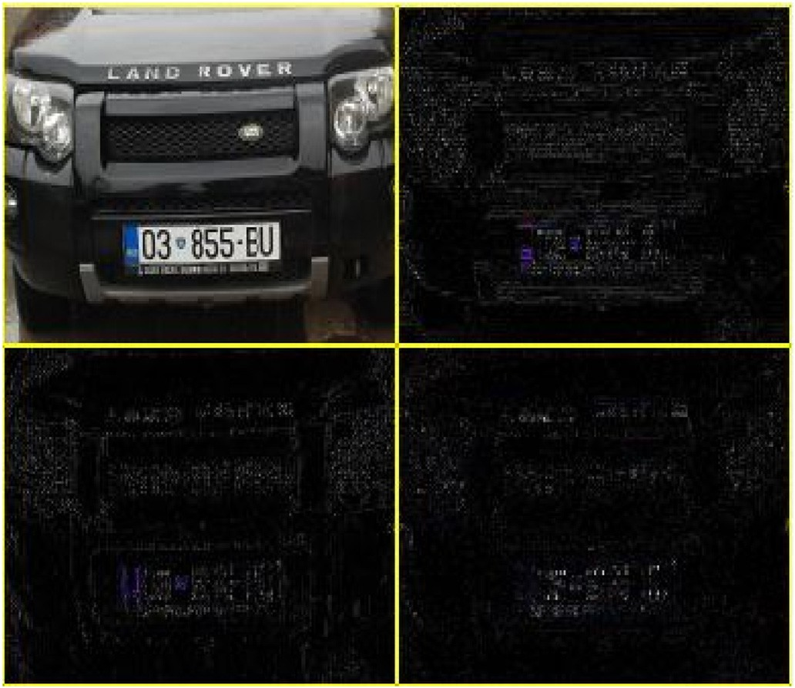

Fig. 1. Sub-bands of 2D-WD.

plate CNN classifier is trained to remove the false positive. In the second stage, the separating columns between the characters are extracted to segment the license plate characters and to generate the segmented candidates. Finally, these character candidates are classified by training another CNN classifier.

This paper is organized as follows: In Section II, the license plate detection process is detailed. Section III presents the character recogni- tion process in detail. Experimental evaluations are presented in Section

IV. Finally, Section V concludes the paper.

1. Proposed method
   1. *License plate detection*

License plate detection is a very important step in the proposed method, where its efficiency plays a big role in the detection and recognition of license plate characters. The principle of this step is to look for the potential license plate locations in the input image (zones of in- terest) then verify these locations as a license plate or not. In our prop- osition, we have based on vertical edges to detect the potential license plate candidates. First, the 2D-WD is used to extract the vertical edges. Then, the high density of the vertical edges is calculated to detect the potential license plate candidates. These candidates are then classified by training a plate/non-plate CNN classifier to remove the false positive.

* + 1. *License plate candidates*

For license plate detection, the license plate candidates need to be generated first. To extract the regions where it could be the license plate, we have based on extracting the vertical edges of the input image (Fig. 2(a)). The horizontal and vertical edges are one of the best features that can be extracted in the image processing domain. However, in this paper, we focus just on the vertical edges which the high density of the vertical edges in a vehicle is inside the license plate because of the shape of the license plate characters. To extract these features, the two- dimensional wavelet transform [17] is applied after converting the input image to a gray level.

* + - 1. *Two-dimensional wavelet decomposition*

The 2D-WD [18] divides an image into four sub-bands as shown in Fig. 1, each sub-band contains different information of the original image. Three sub-bands for detail coefficients “vertical detail, horizontal

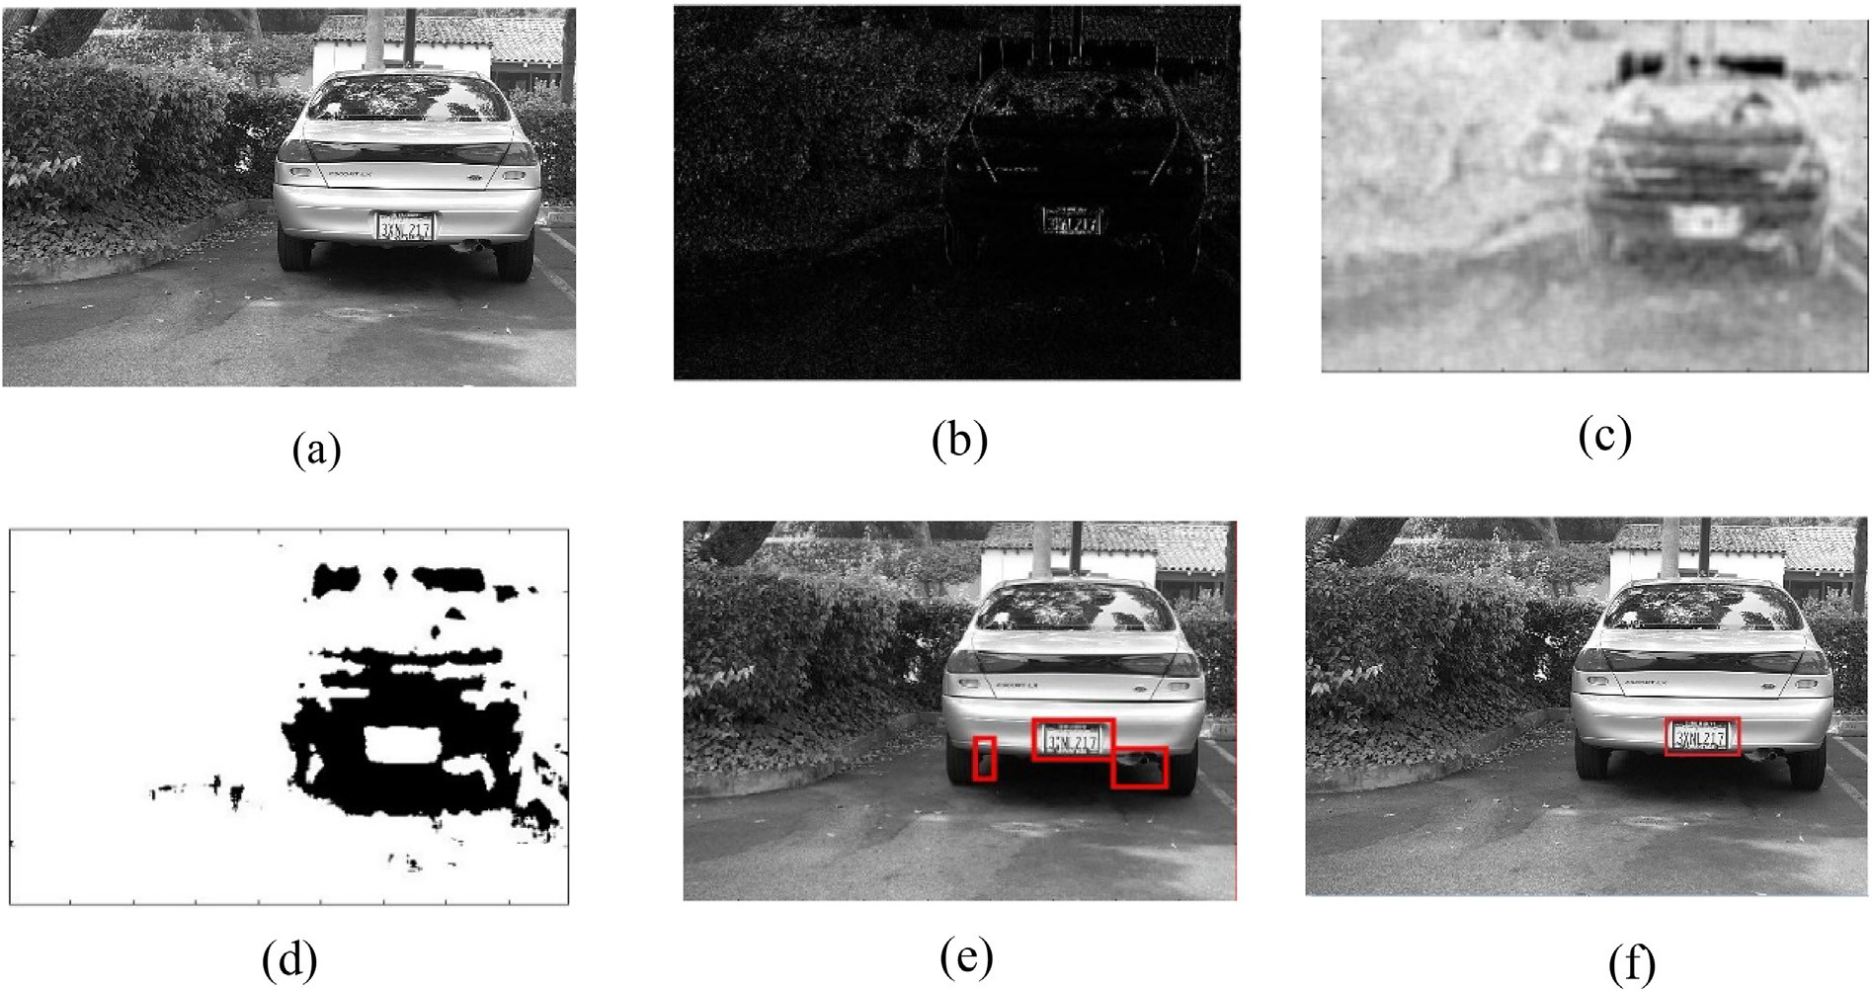

Fig. 2. Following steps for license plate detection (a) the input grayscale image; (b) the vertical detail of 2D-DW; (c) the image after applying the entropy area al- gorithm; (d) image binarized; (e) the extracted connected component; (f) the result after CNN classifier.

detail and diagonal detail” and the fourth sub-band for the approxima- tion coefficients. Detail coefficients represent the high frequency of the input image, approximation coefficients represent the low frequency. Therefore, in this paper, we take just the vertical detail (Fig. 2(b)) which represents the vertical edges of the input image.

* + - 1. *High vertical edge density extraction*

To extract the high vertical edge density areas, we have based on calculating the maximum entropy areas. The entropy is a measure of disorder or randomness of a system, it measures the degree of disorder or uncertainty associated with a random variable. Therefore, the area where the entropy is maximum returns to the areas where there is a high vertical edge density. Entropy is usually calculated from an image using Shannon entropy, where the probability distribution could be easily estimated from image histogram [19]. The entropy formula is given as follows (1):

*E* ¼ — X *pk log*2*pk* (1)

*L*

1

with a color value (index k ¼ 1, …, L) that occurs with a probability *pk*. Where *pk* contains the normalized histogram counts. In this paper, we calculate the local entropy of the grayscale image, where each pixel of the

resulted image contains the entropy value of the 9-by-9 neighborhood around the corresponding pixel in the input image.

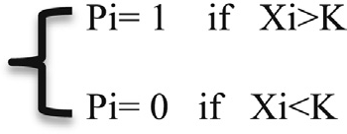After computing the locale entropy, the resulted image (Fig. 2(c)) is converted to a binary image (Fig. 2(d)) by using a predefined threshold K to define the areas that have the maximum entropy (2).

(2)

where Pi is the new pixel and Xi is the value of each pixel of the image after computing the local entropy.

Unfortunately, in the binary image, we find some noisy holes and some broken areas where the region of interest might be divided into two regions. To solve this problem, a morphological operation is used. The closing operation (dilation followed by erosion) is performed to recover these holes.

To extract the regions of interest, the connected component analysis (CCA) is applied. The connected component analysis is an important task used in several image processing domains to detect linked regions in binary images. The principle of this method is based on a crossing win- dow that crosses the entire input image from the left to the right from the top to the bottom. The algorithm.1 illustrates the whole technique used to generate the CCA. Therefore, based on the length, the height, and coordinates of each connected component, the bounding box is drawn. Based on the area, the small and the big bounding box are eliminated. The area is the number of white pixels in each connected component and the length and the height are computed from the minimum and the maximum coordinates of each connected component along the vertical and the horizontal axes. Fig. 2(e) shows the image resulted after applying the CCA and drawing bounding box.

Algorithm.1

* Let Im denotes the input image having size LxC
* For y 1 to C do
* For x 1 to L do
* If Im (x,y) ¼ 1 do
* Scan pixels around Im (x,y).
* When all pixels around are black, a new label is assigned to Im (x,y).
* If one of the pixels around is white, its label is assigned to Im (x,y).
* If more than one of the pixels around are white, one of their labels is assigned to Im (x,y) and the other labels are taken as notes.
* Each pixel’s label and its corresponding labels in the note are mixed and considered as one label.
* Each connected component is represented by a label.
  + 1. *License plate verification*

To verify the license plate candidates, The CNN classifier is trained, to represent the image for classification of a license plate and non-license plate, with positive samples of gray-scale license plates that are taken from diverse countries. Some positive samples are cropped from real images, and some negative samples are set up by images of some general text strings as well as some images of rectangles. Finally, the images that are classified as license plate (see Fig. 2(f)) are fed to the next step.

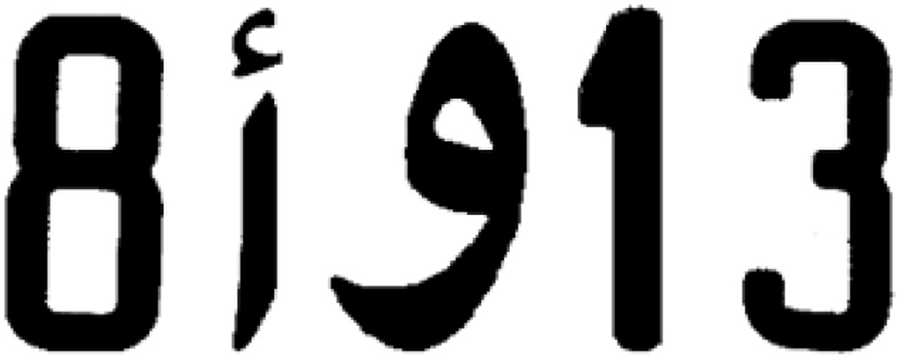

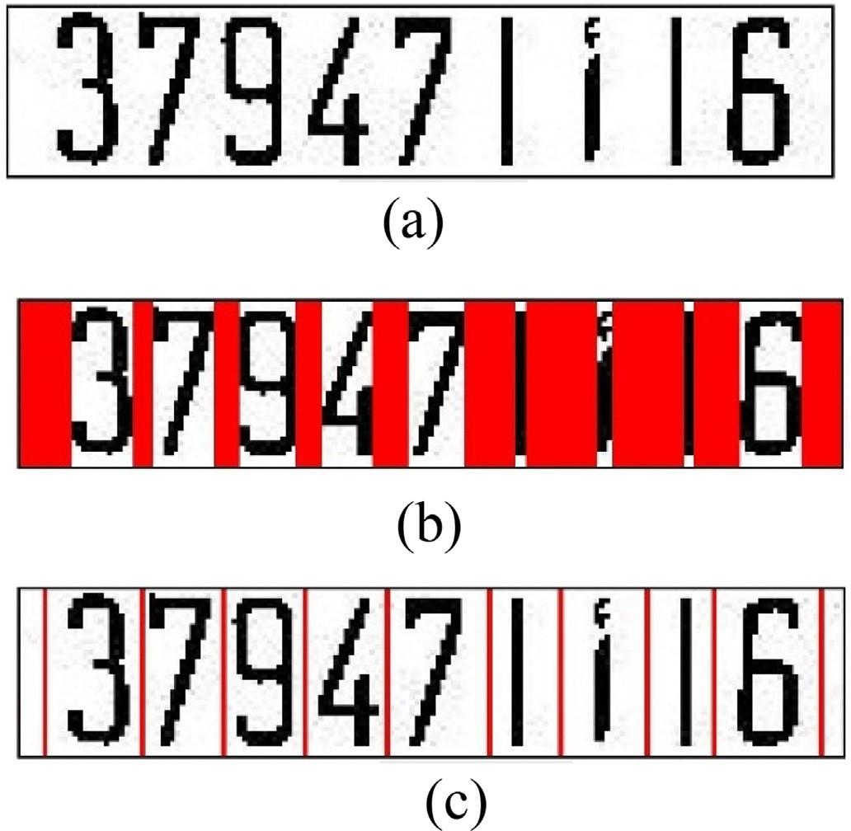Fig. 3. License plate segmentation; (a) the input image; (b) segmentation col- umns; (c) final segmentation.

Convolutional neural network (CNN) is a special architecture of artificial neural networks and the best performing model to classify im- ages. It is divided into two main parts, Convolutional layers and fully connected layers. The convolutional layer is the building block of CNN, it is responsible for features extraction from images by applying convolu- tion filtering operations. However, the fully connected layers are responsible for the prediction part. With one or more fully connected layers that are fed by the output of the convolution layers the prediction part is done. The CNN computes the score of each class using the features extracted from the previous layers. However, training convolutional neural networks are very expensive because they require a significant amount of data and resources in training. Therefore, there are several open-source pre-trained models like Inception-v3, ResNet-50, and VGG16 which are the most utilized [20].

In this paper, we have based on the Inception-v3 model that is a model formed by Google. This model is formed on about 1.2 million images per 1000 categories which represent classes of objects from our daily life. This model consists of 42 layers, which are considered as symmetric and asymmetric blocks, including convolutional, average pooling, max pooling, dropouts, and fully connected layers. We have chosen the inception v3 model because it performs well in terms of precision and does not require a lot of calculation in the processing phase, which makes it much easier to use this system on average performance computers. In addition, this model is highly recommended by most data scientists.

* 1. License plate recognition

After the localization, the license plates are cropped from their orig- inal image and classified. Then they go through the recognition process for classifying and recognizing their letters and numbers. Where the principle of this step is to look for the characters candidates in the detected license plate then match them with the characters. In the pro- posed method, the empty lines between the characters are detected to segment the license plate characters and generate the segmented candi- dates. Then, these segmented candidates are classified by training CNN classifier to recognize the license plate characters.

Fig. 4. Some examples of character templates.

Table 1

The experimental conditions.

Scenes Highways, urban roadways

Weather Sunny, foggy, shady

Time Day and night time

Camera specs 2160p/30fps video

License plate sizes and designe Different sizes with single row

Vehicle colors Different colors

* + 1. *License plate segmentation*

The license plate characters are generally separated and each char- acter is far from the other character by the same distance. Based on this separation space, the characters have been segmented in this work. The idea is to scan the detected license plate vertically, column by column from top to the bottom and compute the number of black pixels in each column. If the number of successive black pixels in the column reaches more than a predefined value of black pixels, we consider this column as a part of a character then we move directly to the next column to reduce the computational cost. Otherwise, the column is saved as a potential separating column and the black pixels of this column are considered as noise. All potential separating columns segmenting the license plate image are printed in red color as shown in Fig. 3(b). Successive potential separating columns are considered as a separating distance between the characters and the average value is considered as the separating column as shown in Fig. 3(c). Fig. 3 shows an example of a segmented license plate.

* + 1. *Characters recognition*

The characters, after the segmentation, are cropped from their license plate image by using the separating columns. To recognize these char- acters, another 42-class CNN classifier is trained, 10 digits, 26 upper letters plus 6 Arabic letters. In our work, we have used Moroccan license plates to test the performance of our system, for this reason, the Arabic characters used in Moroccan license plates are treated too (Fig. 4). The open-source pre-trained CNN model Inception-v3, formed by Google, is used to classify these characters.

1. Results and discussion

The proposed system was implemented using C++ and OpenCV on

1.2 GHz Dual-core ARM Cortex-A9 (HPS) that runs under LXDE desktop with 1.0 GB memory DDR3. The HPS is located in a VEEKMT2S that is composed of DE10 standard FPGA and the MTLC2 module provided by TERASIC.

1. Datasets

Two experiments have been done to test the performance of the proposed detection and recognition system. The first experiment was done on Moroccan License Plates using real traffic video sequences collected from different situations in different lighting conditions. As

Table 2

License plate detection and character recognition accuracies.

|  |  |  |
| --- | --- | --- |
| Video Sequences | Detection accuracy (%) | Recognition accuracy (%) |
| 1 | 98.4 | 98.9 |
| 2 | 96.23 | 98.5 |
| 3 | 97.4 | 97.9 |

shown in Table 1, we have three video sequences corresponding to different situations. The first sequence was taken on the highways in normal daylight conditions. The second one was taken on urban road- ways. In contrast, the third one was recorded during the night. The experimental conditions of the collected sequences are described in Table 1.

The second experiment was done using the Caltech cars dataset (Rear) [21] and the AOLP dataset. The Caltech cars dataset consists of 126 images with a resolution of 890 × 592 pixels taken during the day from complex outside scenes, each of which contains only one vehicle.

The second dataset, the application-oriented license plate (AOLP), in- cludes 2049 images of vehicles. It is categorized into three subsets: access control (AC), traffic law enforcement (LE), and road patrol (RP) that are available in Ref. [22].

For the classification, we have used a pre-trained CNN model, so that we do not need a large training dataset for successful classification. For license plate detection, the first CNN model was re-trained using 200 license plate images and 200 non-license plate images that were cropped by ourselves from Caltech [21] and AOLP [22] datasets. For license plate recognition, about 600 images of cropped characters from the Caltech and AOLP datasets and some images of Arabic letters taken from images of Moroccan cars, as well as about 600 samples of non-characters from different scenes under different conditions, are used to re-train the sec- ond CNN model.

1. Performance metrics

To evaluate the proposed system’s effectiveness, three different testing cases using Moroccan car video sequences from several scenes at different conditions are used. The license plate detection accuracies and

the character recognition accuracies of this evaluation were recorded and listed in Table 2.

For the rating Criteria, the proposed system is evaluated by calcu- lating the accuracy of the detection and the recognition which is defined as the number of correctly detected license plates divided by the number of correctly detected plus the number of incorrectly detected.

*Accuracy* = true positive

true positive + false positive

The results listed in Table 2 show that the proposed method gives high accuracy for the three sequences and confirms that it can effectively detect the license plate and recognize its characters in different situa- tions. Detection accuracy goes up to 98.4% and recognition accuracy goes up to 98.9% in some cases. Fig. 5 shows some results of the detection and recognition process of Moroccan license plates.

1. Evaluation results
   1. *Evaluation of license plate detection*

For license plate detection, the performance has been evaluated using three methods to compare our work with. Rashedi et al. [13] have been detecting the license plate based on combining four methods, the Contrast-based method, Color-based method, Edge-based method, and a method uses cascade classifiers and local binary pattern (LBP). Yuan et al.

[23] have based their work on connecting the high-density regions in the binary edge image using a novel line density filter to localize license plates. Davis et al. [12] have been detecting the license plates based on

Table 3

Evaluation results of the license plate detection.

|  |  |
| --- | --- |
| Methods | Detection Accuracy (%) |
| Yuan et al. [23] | 91.27 |
| Rashedi et al. [13] | 93.32 |
| Davis et al. [12] | 88.05 |
| Proposed method | 96.72 |

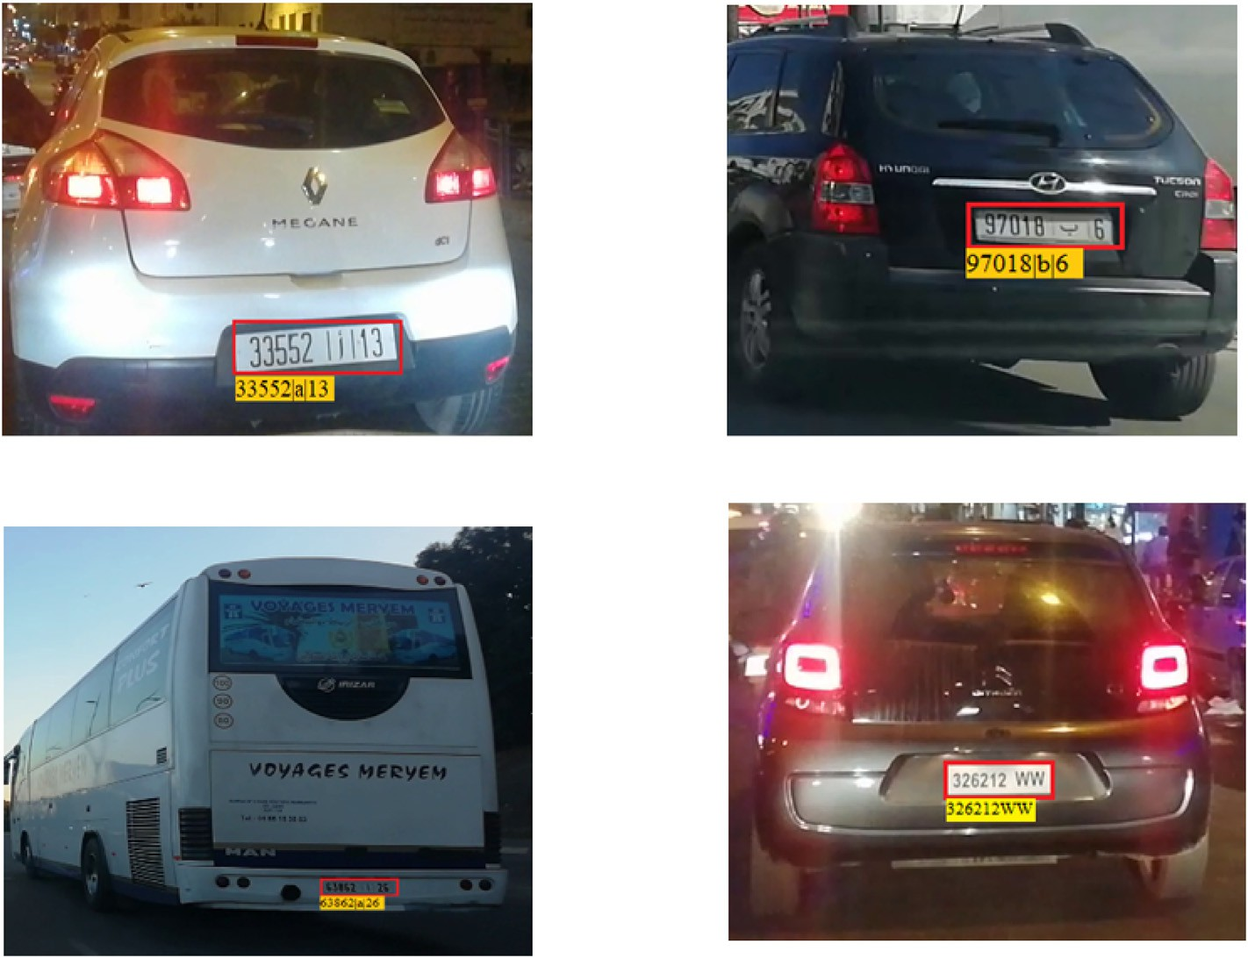

Fig. 5. Some results of the localization and recognition of Moroccan license plates.

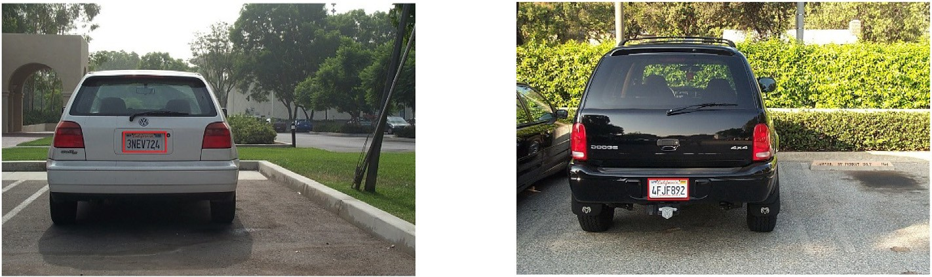

Fig. 6. Some results of the detection process performed on the Caltech dataset.

Table 4

Evaluation results of the character recognition process.

Methods Accuracy (%)

AC LE RP

Hui Li et al. [16] 97.84 97.27 95.57

Proposed method 98,03 97,9 96,11

detecting vertical edges using the VEDA algorithm. Table 3 shows the result of the comparison between these methods and our proposed method using the Caltech cars dataset. Furthermore, according to Table 3, the comparison shows that our proposed method gives high accuracy and efficiently detect the license plate and outperforms the other methods in terms of detection accuracy which achieves a detection rate of 96.72% and a 3.4% improvement over the best method proposed by Rashedi et al. [13].

There are many reasons for this improvement in the results of the proposed method. For example, the features extracted using 2D-WD (vertical details) are very important and significantly improve the accu- racy of the results of the proposed method instead of using an ordinary edge detector which helps to reduce the false detection rate and also to

reduce the processing time. Unlike other methods, they rely only on binarization to extract features. Besides, the use of the entropy function helps a lot to detect potential regions more than the other proven algo- rithm. This combination of useful algorithms reduces the error rate and improves the generated true candidates. Also, the classification of these generated candidates using CNN classifier is one of the main reasons that improved accuracy.

Some examples of the license plate detection results using the Caltech cars dataset are shown in Fig. 6.

* 1. *Evaluation of character recognition*

For character recognition, our work has been compared with Hui Li et al. [16] using the AOLP dataset. Hui Li et al. [16] have used a recog- nition technique, which treats the license plate characters as an unseg- mented sequence, and trained 36-class convolutional neural network (CNN) to recognize the characters. The comparison data listed in Table 4 shows that the proposed method accuracy is slightly better than the other method. Some examples of the license plates recognition results for the AOLP dataset are shown in Fig. 7.

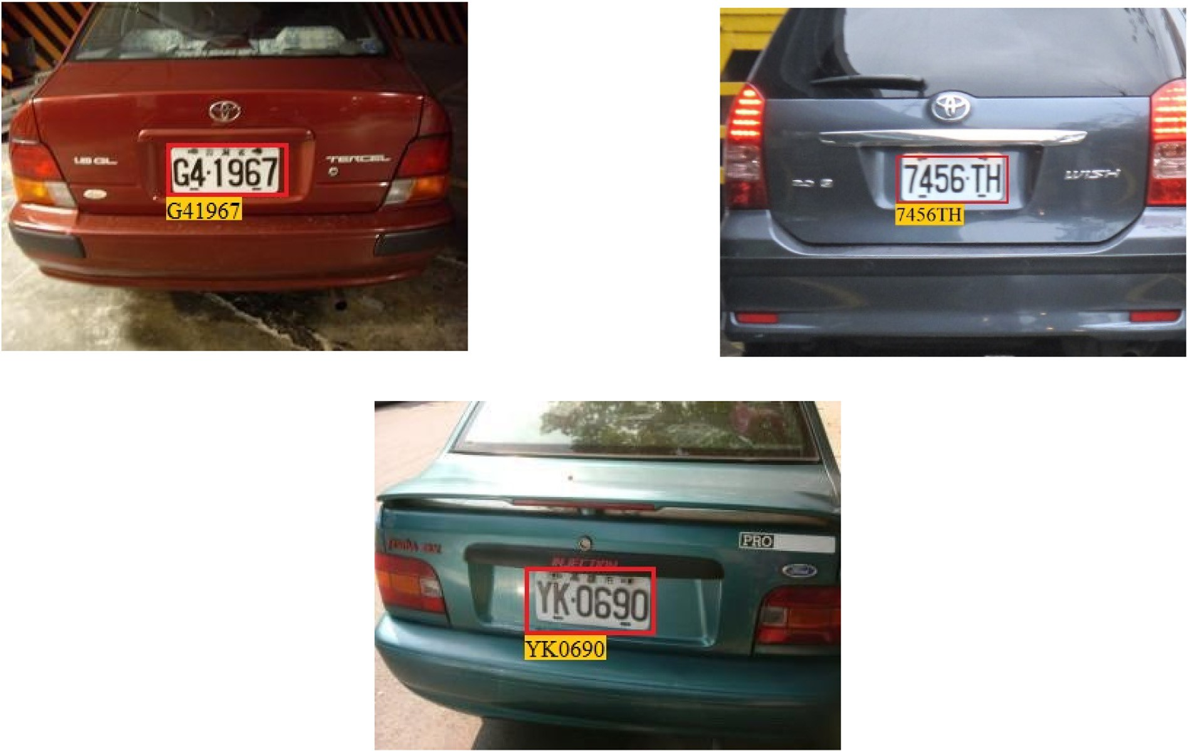

Fig. 7. Some results of the recognition process performed on the AOLP dataset.

1. Conclusion

A license plate detection and recognition system is proposed in this paper. The proposed system included two stages: the license plate detection stage and the character recognition stage. In the first stage, the license plate candidates are generated based on vertical edges to detect the potential license plate candidates. First, the 2D-WD is used to extract the vertical edges. Then, the high-density areas of the vertical edges are extracted by calculating the maximum entropy areas to detect the po- tential license plate candidates. These candidates are then classified by training a plate/non-plate CNN classifier to remove the false positive. In the second stage, the characters are segmented first by detecting the empty lines between the characters then these segmented candidates are classified by training 42-class CNN classifier to recognize the license plate characters. The proposed system was tested first on Moroccan cars using three collected videos in different situations and it gives very encour- aging results where the high accuracy has gotten is 98,36% in term of detection and 98,9% in term of recognition. Thus, a comparative study has done using different works from the literature and shows that our work outperforms the other works. The comparative study of the license plate localization process was done on the Caltech dataset and shows the performance of our work. For character recognition, the comparative study was done on the AOLP dataset and also gives satisfying results. The experiment results are satisfied and encouraging and show the efficiency of the proposed system.

Declaration of competing interest

The authors declare that they have no known competing financial interests or personal relationships that could have appeared to influence the work reported in this paper.

Author Contribution Statement

Ibtissam Slimani: Conceptualization, Methodology, Resources, Software, Formal analysis, Writing - Original Draft, Writing - Review & Editing. Abdelmoghit Zaarane: Methodology, Software, Formal anal- ysis, Writing - Original Draft, Writing - Review & Editing. Wahban Al Okaishi: Investigation, Resources, Writing - Review & Editing. Issam Atouf: Validation, Visualization, Supervision. Abdellatif Hamdoun: Validation, Visualization, Supervision.

Funding

We have no funding resources.

Availability of data and materials

The data used to support the findings of this study are included within the article [21,22]. Please contact author for more requests.

Acknowledgments

Thanks to all those who have suggested and given guidance for this article.

References

1. Zaarane A, Slimani I, Hamdoun A, Atouf I. Real-Time vehicle detection using cross- correlation and 2D-DWT for feature extraction. J. Electr. Comput. Eng. 2019:1–9. <https://doi.org/10.1155/2019/6375176>. Jan. 2019.
2. [Slimani I, Zaarane A, Hamdoun A, Atouf I. Traffic surveillance system for vehicle](http://refhub.elsevier.com/S2590-0056(20)30025-4/sref2) [detection using discrete wavelet transform. J Theor Appl Inf Technol 2018;96(17):](http://refhub.elsevier.com/S2590-0056(20)30025-4/sref2) [5905](http://refhub.elsevier.com/S2590-0056(20)30025-4/sref2)–[17](http://refhub.elsevier.com/S2590-0056(20)30025-4/sref2).
3. [AL Okaishi W, Zaarane A, Slimani I, Atouf I, Benrabh M. Vehicular queue length](http://refhub.elsevier.com/S2590-0056(20)30025-4/sref3) [measurement based on edge detection and vehicle feature extraction. J Theor Appl](http://refhub.elsevier.com/S2590-0056(20)30025-4/sref3) [Inf Technol 2019;97(5):1595](http://refhub.elsevier.com/S2590-0056(20)30025-4/sref3)–[603](http://refhub.elsevier.com/S2590-0056(20)30025-4/sref3).
4. Zaarane A, Slimani I, Hamdoun A, Atouf I. “Vehicle to vehicle distance measurement for self-driving systems. In: 2019 6th international conference on control, decision and information technologies. CoDIT; 2019. [https://doi.org/](https://doi.org/10.1109/CoDIT.2019.8820572) [10.1109/CoDIT.2019.8820572](https://doi.org/10.1109/CoDIT.2019.8820572). 2019.
5. Zaarane A, Slimani I, Al Okaishi W, Atouf I, Hamdoun A. Distance measurement system for autonomous vehicles using stereo camera. Array Jan. 2020:100016. <https://doi.org/10.1016/J.ARRAY.2020.100016>.
6. Shi X, Zhao W, Shen Y. Automatic license plate recognition system based on color image processing. Lect Notes Comput Sci 2005;3483(IV):1159–68. [https://doi.org/](https://doi.org/10.1007/11424925_121) [10.1007/11424925_121](https://doi.org/10.1007/11424925_121).
7. Dun J, Zhang S, Ye X, Zhang Y. Chinese license plate localization in multi-lane with complex background based on concomitant colors. IEEE Intell. Transp. Syst. Mag. Sep. 2015;7(3):51–61. <https://doi.org/10.1109/MITS.2015.2412146>.
8. Ashtari AH, Nordin MJ, Fathy M. An Iranian license plate recognition system based on color features. IEEE Trans Intell Transport Syst 2014;15(4):1690–705. [https://](https://doi.org/10.1109/TITS.2014.2304515) [doi.org/10.1109/TITS.2014.2304515](https://doi.org/10.1109/TITS.2014.2304515).
9. Zheng D, Zhao Y, Wang J. An efficient method of license plate location. Pattern Recogn Lett Nov. 2005;26(15):2431–8. [https://doi.org/10.1016/](https://doi.org/10.1016/j.patrec.2005.04.014) [j.patrec.2005.04.014](https://doi.org/10.1016/j.patrec.2005.04.014).
10. Deb K, Chae HU, Jo KH. Vehicle license plate detection method based on sliding concentric windows and histogram. J Comput 2009;4(8):771–7. [https://doi.org/](https://doi.org/10.4304/jcp.4.8.771-777) [10.4304/jcp.4.8.771-777](https://doi.org/10.4304/jcp.4.8.771-777).
11. Jia W, Zhang H, He X, Piccardi M. “Mean shift for accurate license plate localization,” in *IEEE Conference on Intelligent Transportation Systems*. Proceedings, ITSC 2005;2005:566–71. <https://doi.org/10.1109/ITSC.2005.1520110>.
12. Davis AM, Arunvinodh C, Arathy Menon NP. “Automatic license plate detection using vertical edge detection method. In: ICIIECS 2015 - 2015 IEEE international conference on innovations in information, embedded and communication systems; Aug. 2015. <https://doi.org/10.1109/ICIIECS.2015.7193073>.
13. Rashedi E, Nezamabadi-pour H. A hierarchical algorithm for vehicle license plate localization. Multimed Tool Appl Jan. 2018;77(2):2771–90. [https://doi.org/](https://doi.org/10.1007/s11042-017-4429-z) [10.1007/s11042-017-4429-z](https://doi.org/10.1007/s11042-017-4429-z).
14. Khan MA, Sharif M, Javed MY, Akram T, Yasmin M, Saba T. License number plate recognition system using entropy-based features selection approach with SVM. IET Image Process Feb. 2018;12(2):200–9. <https://doi.org/10.1049/iet-ipr.2017.0368>.
15. Hung KM, Hsieh CT. A real-time mobile vehicle license plate detection and recognition. Tamkang J Sci Eng 2010. <https://doi.org/10.6180/jase.2010.13.4.09>.
16. Li H, Wang P, You M, Shen C. Reading car license plates using deep neural networks. Image Vis Comput 2018. <https://doi.org/10.1016/j.imavis.2018.02.002>.
17. Daubechies I. The wavelet transform, time-frequency localization and signal analysis. IEEE Trans Inf Theor 1990. <https://doi.org/10.1109/18.57199>.
18. Slimani I, Zaarane A, Hamdoun A. Convolution algorithm for implementing 2D discrete wavelet transform on the FPGA. In: Proceedings of IEEE/ACS international conference on computer systems and applications. AICCSA; 2016. [https://doi.org/](https://doi.org/10.1109/AICCSA.2016.7945831) [10.1109/AICCSA.2016.7945831](https://doi.org/10.1109/AICCSA.2016.7945831).
19. Silva LEV, Filho ACSS, Fazan VPS, Felipe JC, Murta LO. Two-dimensional sample entropy: assessing image texture through irregularity. Biomed. Phys. Eng. Express 2016. <https://doi.org/10.1088/2057-1976/2/4/045002>.
20. Nogueira K, Penatti OAB, dos Santos JA. Towards better exploiting convolutional neural networks for remote sensing scene classification. *Pattern Recognit.*; 2017. <https://doi.org/10.1016/j.patcog.2016.07.001>.
21. “The Caltech Database (Computational Vision at California Institute of Technology, Pasadena),.” [http://www.vision.caltech.edu/archive.html.](http://www.vision.caltech.edu/archive.html)
22. Hsu GS, Chen JC, Chung YZ. Application-oriented license plate recognition. IEEE Trans Veh Technol 2013. <https://doi.org/10.1109/TVT.2012.2226218>.
23. Yuan Y, Zou W, Zhao Y, Wang X, Hu X, Komodakis N. A robust and efficient approach to license plate detection. IEEE Trans Image Process 2017. [https://](https://doi.org/10.1109/TIP.2016.2631901) [doi.org/10.1109/TIP.2016.2631901](https://doi.org/10.1109/TIP.2016.2631901).