Available online at [www.sciencedirect.com](http://www.sciencedirect.com/)



AASRI Procedia 3 (2012) 328 – 334

2012 AASRI Conference on Modeling, Identification and Control

Analysis and Simulation of Laser Polarization Characteristics on Metal Surface in Short-Range Detection

Yu-ying Yanga,b,*, Zhan-zhong Cuia, Shuang-cheng Weia

*aState Key Lab of Mechatronics Engineering and Control, Beijing Institute of Technology, Beijing 100081, PR China*

*bDepartment of Arms Engineering, Academy of Armored Force Engineering, Beijing 100072, PR China*

**Abstract**

In view of using only the intensity information of retroreflection wave and poor capacity of anti-interference in laser short-range detection, this paper analyzes the polarization characteristics of laser beam on the metal surface and establishes reflection model of polarized laser. A target detection method based on polarization characteristics of reflection laser is putted forward and the simulation of polarization characteristics on the surface of several typical metal targets is implemented at last.

© 2012 The Authors. Published by Elsevier B.V. Open access under [CC BY-NC-ND license.](http://creativecommons.org/licenses/by-nc-nd/3.0/)

© 2012 Published by Elsevier B.V. Selection and/or peer rev[iew under responsi](http://creativecommons.org/licenses/by-nc-nd/3.0/)bility of American Applied Science Research Institute

Selection and/or peer review under responsibility of American Applied Science Research Institute

*Keywords:* Short-range Detection, Polarization Characteristics, Stokes Parameters, Metal Target

# Introduction

Short-range detection with laser usually irradiates target by using laser beam and obtains target distance according to the intensity information of retroreflection wave. However, target and background objects usually intermix together in complex battlefield environment, and the laser reflected by background objects cause false alarm frequently when detecting target. Because of using only the intensity information of laser for detection, it is difficult for the detector to effectively distinguish between target and background objects, and

* Corresponding author. Tel.: +86 18911131431; fax: +86 01068918503.

*E-mail address:* [wangling@bit.edu.cn](mailto:wangling@bit.edu.cn) .

2212-6716 © 2012 The Authors. Published by Elsevier B.V. Open access under [CC BY-NC-ND license.](http://creativecommons.org/licenses/by-nc-nd/3.0/) Selection and/or peer review under responsibility of American Applied Science Research Institute doi:10.1016/j.aasri.2012.11.052

the anti-interference capability of detection system is low. As an important attribute of laser as well as intensity, frequency and coherent, polarization effectively expand the laser detection information dimension and has attracted great attention widely in the world, and research focus distributes in military target detection

[1] [2] [3], remote sensing [4] [5], medical imaging [6] and other fields. Domestic research on laser polarization is also mainly focused on these fields and pays little attention to short-range detection, especially detection model, of ground objects. This paper mainly models and analyzes the laser polarization characteristic on the surface of metal target, and the simulation of polarization characteristics on the surface of several typical metal targets is also implemented.

# The stokes polarization parameters

Any polarization state of light, including completely polarized light, unpolarized light and partly polarized light, can be completely described by stokes parameters [*S*0;*S*1;*S*2;*S*3]. Because of monochromatic approximation for a plane wave, the Stokes parameters of polarized laser are obtained from the formulas:

*S * *E E * *E E S * *E E * *E E*

0 *p p s s*

1. *p p s s*

*(1)*

*S * *E E * *E E S * *i*(*E E * *E E* )

1. *p s s p* 3 *p s s p*

where *Ep*=*E*0*p*exp(*p*) and *Es*=*E*0*s*exp(*s*) are complex amplitudes. The subscripts *s* and *p* refer to the components in the *s* and *p* directions, which are orthogonal; *E*0*s*, *E*0*p* are the maximum amplitudes, and *s*, *p* are the phases, respectively. The parameter *S*0 is the total intensity of the light, the parameter *S*1 represents the amount of linear horizontal or vertical polarization, the parameter *S*2 represents the amount of linear +45 or –45 polarization, and the parameter *S*3 represents the mount of right or left. In addition, degree of polarization *P*, ellipticity *D* and orientation angle  is defined as [7]

*S* 2 *S* 2 *S* 2

1 2 3

/ *S*

*P*

/ *S D * *S*

 arctan(*S*

/ *S* ) / 2

*(2)*

# Polarization reflection characteristics of metal target

2 1

0

3 0

The surface of metal target is quite smooth, and the echo consists mainly of low-order reflection component. Thus, this paper only considers polarization reflection characteristics, without considering higher- order scattering caused by rough surface.

* 1. *Polarization reflection model of metal target*

Because of conductivity 0, metal is lossy dielectric. Part of the electromagnetic energy is transformed to heat and consumed. Therefore, Fresnel s equations for reflection becomes [8]

*n* cos   *n* cos

*n* cos   *n* cos 

*r * 1 1 2 2

*p*

*r * 2 1 1 2

*(3)*

*s n* cos   *n* cos

*n* cos   *n* cos

1 1 2 2 2 1 1 2

In (3) *n* ,  are the complex refractive index and the complex refractive angle of metal; *n*1, 1are the

2

2

refractive index and the refractive angle of incident media, which is air in this paper.

As an absorbing optical media, metal is characterized by a complex refractive index

*n* of the

2

form *n * *n*(1  *ik* ) , where *n* is the refractive index of metal, and *k* is the extinction coefficient. Similarly,

2

2 2

*n* cos

2 2

can also be expressed as *n*

cos

 *l * *im* , where *l* and *m* are two unknown real variables. The

formulas for calculating *l* and *m* can be derived by coordinating formula (3) and refraction law.

*l*



*n*2 *n*2 *k* 2

*n*2 sin2

1

1

(*n*2

2

*n*2 *k* 2

*n*2 sin2

1

1

)2

4*n*4 *k* 2

*(4)*

*m*



(*n*2

*n*2 *k* 2

*n*2 sin2

1

1

) (*n*2

2

*n*2 *k* 2

*n*2 sin2

1

1

)2

4*n*4 *k* 2

In order to analyze the changes of laser polarization, the incident polarized laser must be decomposed on the *s* and *p* directions, as shown in Figure 1.



*E*

(*i* )

*E*(*i* )

*p*

*E* (*i* )

*s*

*E*(*r* )

*p*

*E*(*r* )

Incident

angle

*E* ( *r* )

*s*

Incident light

Reflected light

Metal

Figure 1 Polarization changes of laser onto metal surface

According to formulas (3) and (4), the reflectivity and phase change of polarized laser on *s* and *p* directions can be calculated respectively.

(*n* cos   *l*)2  *m*2



*R*

*R*

*r r * 1 1

*s s s*

1 1

(*n* cos 

 *l*)2  *m*2

[*n*2 (1  *k* 2 ) cos   *n l*]2  (2*n*2 *k* cos   *n m*)2

*r r * 1 1 1 1

*p p p*

[*n*2 (1  *k* 2 ) cos

  *n l*]2  (2*n*2 *k* cos   *n m*)2

1 1 1 1

2*mn* cos 

*(5)*

 arctan 1 1

*s l* 2

1 1

 *m*2  *n*2 cos2 

2*n n*2 cos  [2*kl * *m*(1  *k* 2 )]

 arctan 1 1

*p n*4 (1

1 1

 *k* 2 )2 cos2 

 *n*2 (*l* 2

 *m*2 )

where *Rs*, *Rp*, *s* and *p* is the reflectivity and the phase change on *s* and *p* directions respectively; the superscript  represents the complex conjugate. The total reflectively can be written as *Rtotal*=*Rp*cos2+*Rs*sin2, where  is the angle between the incident plane and polarization direction of incident light [7].

* 1. *Muller matrix description of reflection on metal surface*

According to the above analysis of reflection characteristics on metal surface, both the reflectivity and the phase of *s* and *p* components change in different degrees. In general, incident linear polarized laser beam becomes elliptically polarized on reflection from metal. According to the definition of stokes parameters, the changes of polarization on reflection from metal can be described by Muller matrix which can represent the process of reflection. Assuming that the Stokes vector of the incident light is [*S i* ; *S i* ; *S i* ; *S i* ] , and the Stokes vector of reflected light is [*S r* ; *S r* ; *S r* ; *S r* ] . The Muller matrix for reflection on metal surface can be derived by coordinating formulas (1) and (5).

0 1 2 3

0 1 2 3

*r* 2  *r* 2 *r* 2  *r* 2

*s p p s* 0 0

*S*

*S*

*S*

*r*

*i*

*i*

0 2 2 0 0

*S r r* 2  *r* 2 *r* 2  *r* 2

*S i S i*

1 *p s s p* 0 0

*r* 2 2

*S*

2

1 *M* 1

*i i*

*S*

*S*

2 2

*(6)*

*S r* 0 0

*r r* cos 

*r r* sin  *S i S i*

1. *p s p s* 3 3

0 0 *r r* sin  *r r* cos

*p s p s*

where *=s*–*p* and *rs*, *rp* are the absolute values of reflection coefficients *rs* and *rp* . Thus, transformation matrix *M* is the Muller matrix for reflection on metal surface.

* 1. *Detection principle using polarization*

Due to the differences in object material, roughness of surface, laser wavelength and incident angle, the polarization of reflected light changes in different degrees. By detecting the Stokes parameters of reflected light, the information of target can be extracted and the target can be detected from background objects.

Linear Polarized *i i s*

*E*

*E*

Laser



Detector p

Detector s

*i p*

Linear *r*

*E*

*E*

*p*

Polarizer p *r*

*E*

*p p s r x y*

*t*

*t*

*E*

*s s*

*t*

*t*

*x y*

Linear Polarizer s

Metal Surface

*i*

Figure 2 Principle of short-range detection using polarization laser

As shown in Figure 2, linearly polarized laser irradiates the surface of metal, and the detector receives the reflected light. The transmission axes of polarizer *s* and *p* are orthogonal. Therefore, the detectors *s* and *p* receive *s* and *p* components of reflected light respectively and output voltage signals. According to the signals,

the reflectivity of *s* and *p* components can be calculated and then different materials, including metal and nonmetal, will be distinguished.

# Simulations for polarization reflection characterize of typical metal

The formula (5), which represents the reflectivity and the phase changes of reflected polarized light on the surface of metal, only has one variable 1. As the 1 changes, the reflectivity and the phase on *s* and *p* direction also change. According to formula (5), the reflectivity and angle changes of reflected light on copper, aluminum, iron, steel and water can be calculated, and the related optical parameters are shown in table 1.

Table 1 Optical parameters of several materials (=589.3nm) [7][8]

|  |  |  |  |
| --- | --- | --- | --- |
| Material | *n* | *nk* | Observer |
| cooper(Cu) | 0.62 | 2.57 | Oppitz |
| aluminum (Al) | 1.44 | 5.23 | Drude |
| Iron(Fe) | 3.03 | 1.78 | Shea |
| steel | 2.41 | 3.40 | Drude |
| water(20  ) | 1.33 | - | - |

Figure 3 shows plots of reflectivity variations. When 1=0 or 1=90 the reflectivity on *s* and *p* directions of each material have the same value. Because of different materials, the initial values of these materials are not the same, and the initial reflectivity of metal is obviously higher than the water s. Meanwhile, initial values of these metals are not the same, and aluminum has the highest while iron has the lowest. All of the values of s component increase until unity with the incident angle increases, and the curve of water is the most violent in the five. As the incident angle increases, the values of *p* component decrease at first, and subsequently increase after some angle; the curve of water is also the most violent in the five.

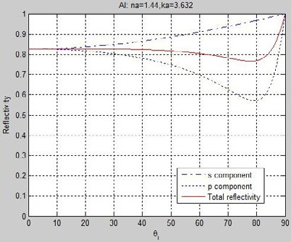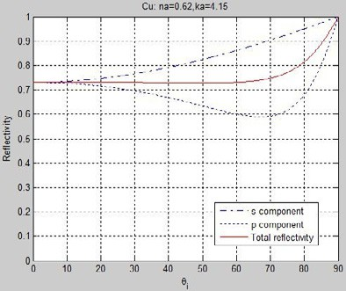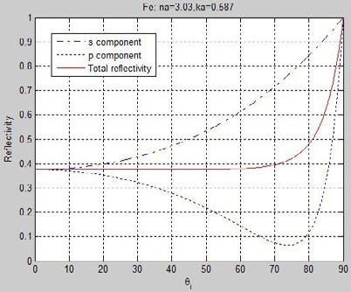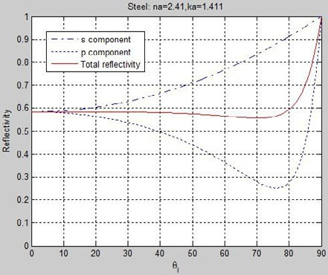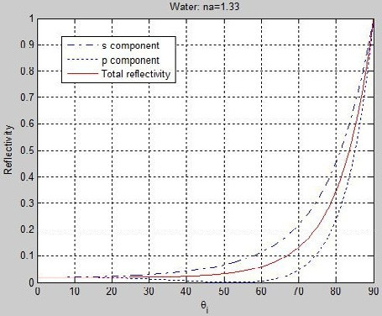

Figure 3 Reflectivity on the surface of cooper, aluminum, iron, steel and water on s and p directions

When the laser beam irradiates onto the surface of target, the energy is redistributed on the s and p directions. The energy of s and p components is different because of different materials, and the difference between s and p component is also not the same. As shown in figure 4(a), Y-axis is the value of *Rs* minus *Rp*, and the differences increase with the incident angle increases, and the order of differences from largest to smallest is iron, steel, cooper, aluminum and water. As shown in figure 4(b), Y-axis is the ration between *Rs* and *Rp*, and the ratios of different materials become more obvious with the incident angle increases. The maximum ratio of iron is nearly six times the size of the maximum ratio of aluminum.

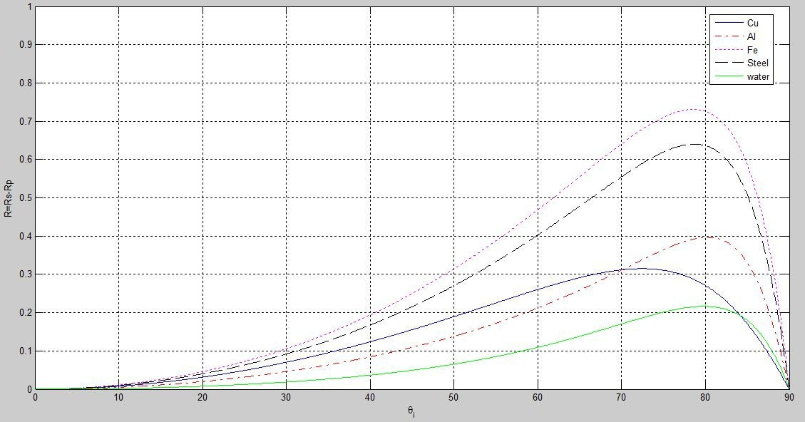

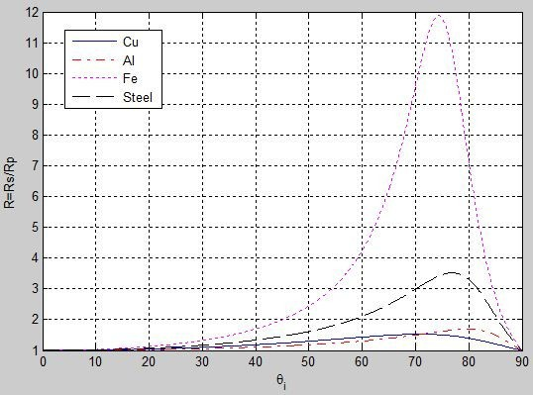

Figure 4 (a)Plot of the reflectivity difference between the s and the p component. The materials are cooper, aluminum, iron, steel and water. (b)Plot of the reflectivity ratio between the s and the p component. The materials are cooper, aluminum, iron and steel.

# Conclusions

From the simulations for polarization reflection characteristics of different materials, two conclusions can be reached without considering the scattering components on the smooth surface of metal:

1. The reflectivity and the phase on s and p directions will change and the degrees of changes are different because of materials when the polarized laser irradiates the surface of metal.
2. From figures 3, 4, 5, the polarization reflection characterizes of magnetic metal, nonmagnetic metal and nonmetal can be used to distinguish the material of the object. Combined with the reflected light intensity information, the detector can be more effective to distinguish different objects.

# References

1. W G Egan, M J Duggin. Optical enhancement of aircraft detection using polarization. Proc.SPIE,2000, 4133:172178
2. W G Egan. Detection of vehicles and personnel using polarization. Proc.SPIE,2000,4133:233237.
3. Frank Cremer, Wim de Jong, Klamer Schutte. Infrared polarization measurements and modeling applied to surface-laid antipersonnel landmines. Proc.SPIE,2002,3286:1021  1032.
4. Itaru Sano. Optical thickness and Angstrom exponent of aerosols over the land and ocean from space-

borne polarimetric data. Advances in Space Research,2004,34:833837.

1. Gilles Roy, Xiaoping Cao, Robert Bernier. On linear and circular depolarization LIDAR signatures in remote sensing of bioaerosols: experimental validation of the Mueller matrix for randomly oriented particles. Optical Engineering,2011,50(1260001):112.
2. Isabella Chiara Buscemi, Steve Guyot. A new imaging technique for the study of polarimetric properties using light polarization Biomedical Applications of Light Scattering. Proc.SPIE,82301A:17.
3. Max Born, E wolf. Principles of Optics. 7th ed. Beijing: Publish house of electronics industry; 2005.
4. Chen Jun. Electromagnetic Theories of Optics. Beijing: Science Press; 2005.
5. Dennis Goldstein. Polarized Light. New York: Marcel Dekker Inc.; 2005.

Yu-ying Yang, [wangling@bit.edu.cn,](mailto:wangling@bit.edu.cn) 18911131431