Available online at [www.sciencedirect.com](http://www.sciencedirect.com/)



AASRI Procedia 2 (2012) 229 – 234

AASRI

Procedia

[www.elsevier.com/locate/procedia](http://www.elsevier.com/locate/procedia)

2012 AASRI Conference on Power and Energy Systems

# Analysis for Effects of Load Characteristics on Power System Voltage Stability

Pei-Hwa Huang*, Ta-Hsiu Tseng

*Depatment of Electrical Engineering, National Taiwan Ocean University, 2 Pei-Ning Road, Keelung 20224, Taiwan*

Abstract

Load characteristics will be changing from time to time and may affect the system voltage stability to some extent. In order to investigate the effects of load characteristics on the system voltage stability, the static ZIP load model is used to describe the load characteristics and the method of P-V curve is adopted to analyze the system voltage stability under both normal operation and contingencies to find the maximum margin of real power transfer. System studies include the analysis of effects from different load models with three types of compositions and those with three kinds of single composition on the system voltage stability of a large power system under normal operation and contingencies. The results will be of use to the practices of system planning and operation.

© 2012 Published by Elsevier B.V. Selection and/or peer review under responsibility of American Applied Science Research Institute

© 2012 Published by Elsevier B.V. Selection and/or peer review under responsibility of American Applied Science Research Institute

© 2012 Pei-Hwa Huang, Ta-Hsiu Tseng. Published by Elsevier B.V.

Selection and/or peer review under responsibility of American Applied Science Research Institute

Open access under [CC BY-NC-ND license.](http://creativecommons.org/licenses/by-nc-nd/3.0/)

*Keywords:* Power System Voltage Stability; Load Characteristics; Power Margin; P-V Curve;

1. Introduction

Voltage instability incidents have frequently occurred around the world in recent years as reported in Kundur, 1994 and Grigsby, 2007. The voltage stability and the reactive power margin are crucial to the security and reliability of a power system. Voltage control and stability problems are being received more

* Corresponding author. Tel.: +886-2-24622192ext6205.

*E-mail address:* [B0104@ntou.edu.tw.](mailto:B0104@ntou.edu.tw)

2212-6716 © 2012 Published by Elsevier B.V. Selection and/or peer review under responsibility of American Applied Science Research Institute

Open access under [CC BY-NC-ND license.](http://creativecommons.org/licenses/by-nc-nd/3.0/) doi:10.1016/j.aasri.2012.09.039

attentions in power system operation and planning. With heavy system loading and weak interconnection ties the problem of voltage instability becomes more likely to happen.

Voltage instability and voltage collapse might cause an outage in a local system, or even result in a system wide blackout. Voltage stability is concerned with the ability of a power system to maintain steady voltages at all buses in the system under normal operating conditions as well as after being subjected to a disturbance. Voltage collapse is the process by which the sequence of events accompanying voltage instability leads to a low unacceptable voltage level. Taylor, 1994, Van Custem, 2008 and Huang, Tseng and Ke, 2010 indicate when a power system is subjected to a contingency, the reactive power demand will increase and lead the system to an unstable situation.

The method of PV analysis is a power flow based approach used to assess voltage variations with changes in active power. The maximum loading corresponds to a singularity of the Jacobian of the power flow equations. At the knee of PV curve, the voltage drops rapidly with an increase in load demand. Operation at the stability limit is impractical and a satisfactory operation condition is ensured by allowing a sufficient power margin.

Voltage instability is typically associated with relatively slow variation in network and load characteristic. Power system loads include the subtransmission and distribution networks that connect consumers to the transmission networks and generation. Since loads are aggregates of many different devices, it is important to identification of load composition by Grigsby, 2007. Xu et al., 1997 and Ranade et al., 2001 demonstrated load characteristic from field test.

This paper aims to analyze the effect of load characteristic on the system voltage stability. The load models are traditionally classified into two broad categories, which are static models and dynamic models. In this paper, the different proportions of each component of static ZIP models are used to describe load characteristic. The method of P-V curves is adopted to analyze the system voltage stability under normal operation and contingencies to find the maximum transfer real power margin and the bus reactive power margin.

1. PV Curve Analysis

The purpose of the method of PV curve is to figure out the ability of a power system to maintain voltage stability at all the buses in the system under normal and abnormal steady state operating conditions. It points out the voltage collapse point of the buses in the power system network and the maximum transfer of power between buses at the point of voltage collapse.. As power transfer is increased, voltage decreased at some buses on the transfer path. Transfer can continue to increase until the solution identifies a condition of voltage collapse. Fig. 1(a) shows a two-terminal electrical network from Kundur, 1994. The power flow relationship between the source and the load can be summarized by (1) and (2).

*Z*  *E* 2

*PR*  *VR I* cos**  *LD*  *S*  cos** *(1)*

*F*  *ZLN* 

1 *Z*  *Z* 2

 *Z* 

*VR* 



*F ZLN*

*LD ES* , where

*F*  1   *LD*   2  *LD* cos(**  **)

 *ZLN*   *ZLN* 

*(2)*

From (1), when *ZLD* is decreased gradually, the load *PR* power will increase. Thus, the power transmitted will increase. When *ZLD* approaches *ZLN* , the value of *PR* starts to decrease gradually due to *F* . And from (2), as *ZLD* decreases the receiving voltage *VR* decreases gradually. The relationships between the voltage at the receiving and the load power can be demonstrated by Fig. 1(b) which is referred to as the PV curve. Voltage

instability occurs at the knee points of the PV curve where the voltage drops even rapidly with an increase in the transfer power flow.

*Voltage*

Voltage Low Voltage Limit Collapse Point

Low Voltage Transfer Limit

Voltage Collapse Transfer Limit

*Incremental Transfer*

*ES*

*Z* **

*LN*

*VR*

*I*

*PR*  *jQR*

*ZLD***

Fig. 1. (a) Two terminal simple network; (b) Relationship of voltage and incremental power transfer

The following steps constitute the procedure of PV curve analysis. The base case denotes the initial steady state operating point of the studied system.

* Apply the contingency to the base case solution at the initial transfer level and solve the power flow.
* In the solved contingency case at the initial transfer level, increment the transfer to transfer level 1 (with an increment of 10 MW) and solve the power flow.
* From the solved contingency case at transfer level 1, increment the transfer to transfer level 2 and solve the

power flow.

* Repeat the above steps until a convergent solution of power flow cannot be attained.

1. Static Load Model

Stable operation of a power system depends on the ability to continuously match the electrical output of generating units to the electrical load on the system. Therefore, load characteristic plays an important role on system stability. Static load model represents the active and reactive load components at each bus by a combination of constant impendence, constant current, and constant power components. A polynomial load model which is made up of three components is ZIP model. The ZIP model which has been widely used to represent the voltage dependency of loads is as follows:

  *V* 2  *V*  

*P*  *P*0 *Kp*1  *V*   *Kp*2  *V*   *Kp*3 

*(4)*

  0   0  

  *V* 2  *V*  

*Q*  *Q*0 *Kq*1  *V*   *Kq*2  *V*   *Kq*3 

*(5)*

  0   0  

This model is composed of constant impendence (Z), constant current (I), and constant power (P) components. The parameters of the model are the coefficients *Kp* 1 to *Kp* 3 and *Kq* 1 to *Kq* 3 , which define the proportion of each component, and *Kp*1  *Kp* 2  *Kp* 3  *Kq* 1 *Kq* 2  *Kq* 3 1 . In this paper, three kinds load models are applied to analyze the system voltage stability:

* Model 1 is a high percentage of constant impendence load model, and *Kp*1  *Kp* 2  *Kp* 3 .
* Model 2 is a high percentage of constant current load model, and *Kp* 2  *Kp*1  *Kp* 3 ;
* Model 3 is a high percentage of constant power load model, and *Kp* 3  *Kp*1  *Kp* 2 ;

1. Simulation Results

The study system has 33 load feeders, which the voltage level is 69kV. Constant current model is used for the real power model based on the assumption that typical loads are resistive loads. Table 1 shows the high percentage of constant current load model (as Model 2) of study system. The example uses three kinds ZIP model with different proportions of components as mention in section 3. There are 11 contingencies considered in this work and shown in Table 2. Table 3 shows the transfer power margin on Bus 1900 with constant current, constant power, constant impendence, and three kinds load models. Since the line from Bus 1900 to Bus 2100 is a main transfer line, it is observed that the transfer power margin is less than other contingencies. Moreover, the transfer power margin from high to low is Model 1, Model 2, and then Model 3. This result is the same as constant impendence, constant current, and constant power.

Table 1. Model 2 component percentage

Load #

Real Power Load Model

Component Load #

Real Power Load Model

Component Load #

Real Power Load Model Component

|  |  |  |  |  |  |  |  |  |  |  |  |
| --- | --- | --- | --- | --- | --- | --- | --- | --- | --- | --- | --- |
|  | *Kp* 1 | *Kp* 2 | *Kp* 3 |  | *Kp* 1 | *Kp* 2 | *Kp* 3 |  | *Kp* 1 | *Kp* 2 | *Kp* 3 |
| 1 | 0.11 | 0.72 | 0.17 | 12 | 0.19 | 0.57 | 0.24 | 23 | 0.11 | 0.81 | 0.08 |
| 2 | 0.01 | 0.81 | 0.18 | 13 | 0.14 | 0.79 | 0.07 | 24 | 0.01 | 0.70 | 0.30 |
| 3 | 0.18 | 0.67 | 0.15 | 14 | -0.02 | 0.86 | 0.16 | 25 | 0.10 | 0.80 | 0.10 |
| 4 | 0.15 | 0.71 | 0.14 | 15 | 0.07 | 0.72 | 0.21 | 26 | -0.01 | 0.86 | 0.15 |
| 5 | 0.02 | 0.70 | 0.28 | 16 | 0.15 | 0.67 | 0.18 | 27 | 0.21 | 0.74 | 0.05 |
| 6 | 0.04 | 0.70 | 0.26 | 17 | 0.35 | 0.56 | 0.09 | 28 | 0.09 | 0.72 | 0.19 |
| 7 | 0.04 | 0.73 | 0.23 | 18 | 0.08 | 0.70 | 0.22 | 29 | 0.14 | 0.77 | 0.09 |
| 8 | 0.03 | 0.80 | 0.17 | 19 | 0.19 | 0.74 | 0.07 | 30 | -0.03 | 0.80 | 0.23 |
| 9 | 0.08 | 0.82 | -0.10 | 20 | 0.11 | 0.72 | 0.18 | 31 | 0.05 | 0.81 | 0.14 |
| 10 | 0.26 | 0.61 | 0.13 | 21 | 0.05 | 0.83 | 0.12 | 32 | 0.02 | 0.33 | 0.65 |
| 11 | 0.25 | 0.61 | 0.14 | 22 | 0.26 | 0.57 | 0.17 | 33 | 0.06 | 0.81 | 0.13 |

Table 2. Contingencies studied

|  |  |  |  |
| --- | --- | --- | --- |
| No. / Contingency | Condition (Open Line) | No. / Contingency | Condition (Open Line) |
| #1 / N-1 | Bus 1580 - Bus 1670 | #7 / N-2 | Bus 1750 – Bus 9160, Bus 40 – Bus 1650 |
| #2 / N-1 | Bus 1900 - Bus 2100 | #8 / N-2 | Bus 1900 – Bus 2100, Bus 100 – Bus 1650 |
| #3 / N-1 | Bus 1500 - Bus 9410 | #9 / N-2 | Bus 1550 – Bus 1700, Bus 40 – Bus 1650 |
| #4 / N-1 | Bus 1910 - Bus 2030 | #10 / N-2 | Bus 1910 – Bus 2030, Bus 10 – Bus 1750 |
| #5 / N-1 | Bus 700 - Bus 3000 | #11 / N-2 | Bus 2150 – Bus 2480, Bus 700 – Bus 3000 |
| #6 / N-1 | Bus 2140 - Bus 2150 |  |  |

Table 3. Maximum transfer power margin (MW)

|  |  |  |  |  |  |  |
| --- | --- | --- | --- | --- | --- | --- |
| Contingency Constant Impendence | | Constant Current | Constant Power Model 1 Model 2 Model 3 | | | |
|  | Model | Model | Model |  |  |  |
| N-0 | 1500 | 1243 | 1043 | 1456 | 1293 | 1131 |
| #1 / N-1 | 1412 | 1143 | 943 | 1362 | 1200 | 1031 |
| #2 / N-1 | 1350 | 1075 | 881 | 1306 | 1150 | 975 |
| #3 / N-1 | 1325 | 1112 | 862 | 1281 | 1118 | 950 |
| #4 / N-1 | 1375 | 1162 | 912 | 1331 | 1168 | 1000 |
| #5 / N-1 | 1493 | 1232 | 1027 | 1450 | 1287 | 1123 |
| #6 / N-1 | 1480 | 1238 | 1001 | 1450 | 1293 | 1131 |
| #7 / N-2 | 1412 | 1200 | 950 | 1368 | 1211 | 1043 |
| #8 / N-2 | 1300 | 975 | 800 | 1250 | 1081 | 900 |
| #9 / N-2 | 1406 | 1193 | 937 | 1362 | 1200 | 1031 |
| #10 / N-2 | 1318 | 1093 | 837 | 1268 | 1100 | 925 |
| #11 / N-2 | 1456 | 1107 | 975 | 1407 | 1241 | 1068 |

Figs. 2 to 4 show the PV curves of Bus 1900 with different load model under 11 contingencies. From Table 3 and Figs. 2 to 4, it is observed that the transfer power margin form high to low is Model 1, Model 2, and then Model 3.

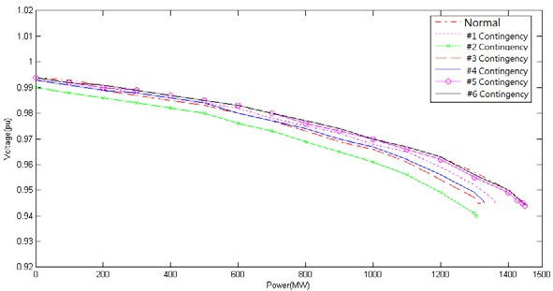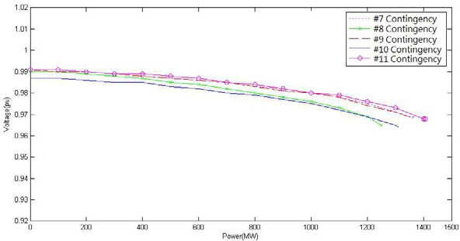

Fig. 2. (a) PV curves of Bus 1900 with Model 1 (N-1 Contingency). (b) PV curves of Bus 1900 with Model 1(N-2 Contingency).

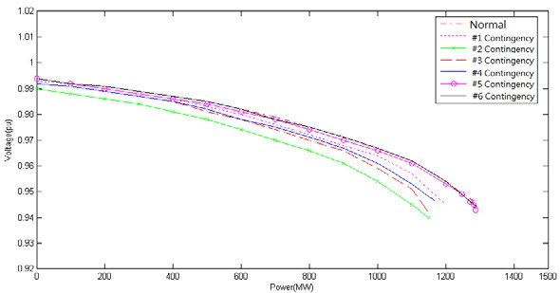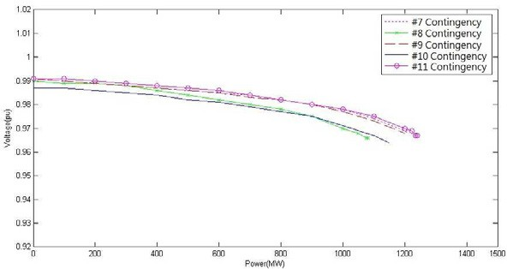

Fig. 3. (a) PV curves of Bus 1900 with Model 2 (N-1 Contingency). (b) PV curves of Bus 1900 with Model 2 (N-2 Contingency)

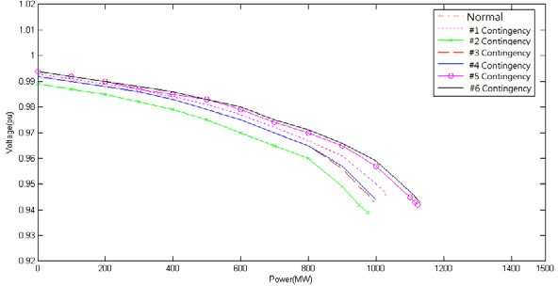 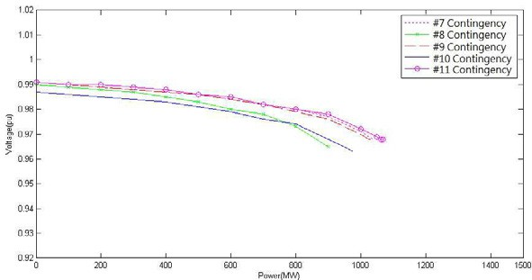

Fig. 4. PV curves of Bus 1900 with Model 3 (N-1 Contingency). (b) PV curves of Bus 1900 with Model 3 (N-2 Contingency)

1. Conclusion

The main purpose of this paper is to examine the effect of load characteristics on the system voltage stability. The method of P-V curves is adopted to analyze the system voltage stability under normal operation and contingencies to find the maximum margin of real power transfer. Three kinds of models are employed to describe the load characteristics, which are Model 1 (high constant impendence proportion), Model 2 (high constant current proportion), and Model 3 (high constant power proportion). The results reveal that when the system is subject to N-1 or N-2 contingencies, the transfer power margin from high to low is Model 1, Model 2, and then Model 3.

Acknowledgements

This work was supported in part by the National Science Council under Grants NSC 100-3113-P-194-001 and NSC 100-2221-E-019-002. The authors would also like to thank Mr. Zi-Jie Zhan and Mr. Zong-Lin Wu for the help with this work.

References

1. Kundur P. Power system stability and control. New York: McGraw-Hill; 1994.
2. Grigsby LL. Power system stability and control. 2nd ed. Boca Raton: CRC Press; 2007.
3. Taylor CW. Power system voltage stability. New York: McGraw-Hill; 1994.
4. Van Cutsem T. Voltage stability of electric power systems. New York: Springer; 2008.
5. Huang PH, Tseng TH, Ke YK. Static var compensator using remote signal. Proc. of 2010 SICE Annual Conference 2010;1:307-310.
6. Xu W, Vaahedi E, Mansour Y, Tamby J. Voltage stability load parameter determination from field tests on BC Hydro's system. IEEE Trans. on Power Systems 1997; 12:1290-1297.
7. Ranade SJ, Ellis A, Mechenbier J. The development of power system load models from measurements. Proc. of 2001 IEEE/PES Transmission and Distribution Conference and Exposition 2001;1:201-206.