[Artificial Intelligence in the Life Sciences 1 (2021) 100012](https://doi.org/10.1016/j.ailsci.2021.100012)

 

Contents lists available at [ScienceDirect](http://www.ScienceDirect.com/)

Artificial Intelligence in the Life Sciences

journal homepage: [www.elsevier.com/locate/ailsci](http://www.elsevier.com/locate/ailsci)

Research Article

AutoOmics: New multimodal approach for multi-omics research

Chi Xua,#, Denghui Liua,#, Lei Zhanga,#, Zhimeng Xua,#, Wenjun He a, Hualiang Jiangb,c,

Mingyue Zheng b, Nan Qiaoa,∗

a *Laboratory of Health Intelligence, Huawei Technologies Co., Ltd., China*

b *Drug Discovery and Design Center, State Key Laboratory of Drug Research, Shanghai Institute of Materia Medica, Chinese Academy of Sciences, 555 Zuchongzhi Road,*

*Shanghai 201203, China*

c *Shanghai Institute for Advanced Immunochemical Studies, and School of Life Science and Technology, ShanghaiTech University, Shanghai 200031, China*

a r t i c l e i n f o a b s t r a c t

*Keywords:*

Multi-omics Cancer genomics

Integrative analysis Automatic machine learning Deep learning

Deep learning is very promising in solving problems in omics research, such as genomics, epigenomics, pro- teomics, and metabolics. The design of neural network architecture is very important in modeling omics data against different scientific problems. Residual fully-connected neural network (RFCN) was proposed to provide better neural network architectures for modeling omics data. The next challenge for omics research is how to integrate information from different omics data using deep learning, so that information from different molecular system levels could be combined to predict the target. In this paper, we present a novel multi-omics integration approach named AutoOmics that could eﬃciently integrate information from different omics data and achieve better accuracy than previous approaches. We evaluated our method on four different tasks: drug repositioning, target gene prediction, breast cancer subtyping and cancer type prediction, and all the four tasks achieved state of art performances.

# Introduction

With the development of sequencing technologies, researchers have extended the large scale whole genome profiling experiments from ge- nomics to epigenetics, proteomics and metabolics. To obtain whole omics profiling data from a single sample or individual is more and more popular in biomedical researches [1]. It helps researchers to ex- tract evidences from different molecular system levels, to explore and understand the underlying biological mechanisms. For example, in can- cer research, researchers need to confirm evidences from cancer cell gene expression, gene mutations, gene copy number variations and gene methylations to form a proper hypothesis, tools like oncoplot is devel- oped to help visualize and analyze the multi-omics data [2].

Deep learning is very popular in genomics research recently [3]. Pre- vious work have proved the advantage of Deep Neural Network (DNN) against traditional machine learning methods, such as support vector machine (SVM), logistic regression and Xgboost in single-omics area[4– 6]. How to apply deep learning in multi-omics research is a new chal- lenging area for researchers.

The simplest way to integrate multi-omics data is to concatenate all the omics data as the input to the DNN. For example, DeepSynergy

[7] concatenates fingerprints of molecular structures of chemicals and

∗ Corresponding author.

*E-mail address:* [qiaonan3@huawei.com](mailto:qiaonan3@huawei.com) (N. Qiao).

# These authors contributed equally

omics data of cancer cell lines directly as input for the Multi-layer per- ception (MLP) neuron network. The problem is that the data distribution of different omics data vary a lot, some omics data even have different data types, which makes the DNN diﬃcult to fit a good model.

The advanced approach is to use sub-networks for each omics data, and concatenate the output of the sub-networks to predict the targets. For example, MOLI [8] uses three MLP sub-networks for three omics data (cancer cell line gene expression, mutation and CNV in GDSC [9]), then concatenates the sub-networks together for prediction. PaccMann

[5] extends this approach by using three sub-networks to model molec- ular structures, omics data and gene interaction networks separately. The limitation is that it cannot fine tune or optimize the sub-networks independently.

The more sophisticated approach is to train DNN separately for each omics data, and then concatenate the embedding layers together to make the final predictions, for example, DeepDR [6] trains autoencoder (AE) for gene expression and gene mutation separately, the latent spaces are then concatenated and forwarded with a MLP to make the final pre- diction.

The proposal of residual fully-connected neural network (RFCN) im- plemented in AutoGenome [10] have shown us a good framework to model the single-omics data, we want to go further to extend it to multi- omics research, by considering a. the advantage of RFCN neural network architectures; b. the AutoML features from AutoGenome; c. novel multi-

<https://doi.org/10.1016/j.ailsci.2021.100012>

Received 2 October 2021; Received in revised form 6 November 2021; Accepted 6 November 2021

Available online 18 November 2021

2667-3185/© 2021 The Authors. Published by Elsevier B.V. This is an open access article under the CC BY-NC-ND license (<http://creativecommons.org/licenses/by-nc-nd/4.0/>)

**Fig. 1.** Integrative analysis of multi-omics data from multiple-origin samples and build- ing AI models for biomedicine research.





model approaches to integrate different multi-omics data. AutoOmics is developed for this purpose, users specify the location of the input omics data and the learning targets, AutoML is then used to train the DNN model automatically, after an optimal model is trained, model interpre- tation module will be used to explain the influence of each gene to the learning targets. AutoOmics supports both regression and classification tasks, it doesn’t require the users to master tensorflow [11] or pytorch



[12] to start with.

We evaluated the performances of AutoOmics on four different multi-omics biomedical tasks: a. drug response prediction, b. gene de- pendency prediction, c. breast cancer subtype prediction and d. pan- cancer patient stratification, and AutoOmics outperformed all the exist- ing methods. The results showed that AutoOmics could eﬃciently inte- grate large scale multi-omics data and generate explainable AI models. We envision AutoOmics to become a popular method in multi-omics research.

# Results

*Overview of AutoOmics*

Researchers from hospitals, pharmaceutical companies and aca- demic institutes usually use patient tissues, animal models and cell lines in their research to study biomedical problems. To uncover the molecu- lar level mechanisms, high throughput sequencing technologies are used to profile multiple types of omics data, such as gene expression, gene mutation, copy number variation (CNV), DNA methylation, microRNA and histone modification (Fig. 1). By analyzing the multi-omics data, re- searchers could formulate new hypothesis or create mathematical mod- els for forecasting, such as drug sensitivity prediction, gene dependency

prediction, patient stratifications, and so on. Multi-omics data represent molecular phenotypes at different molecular systems, each omics data have different distributions, which makes it very challenging to model with.

AutoOmics provides a convenient framework to help researchers to build the best multi-model deep neural networks for their researches. There are four steps in AutoOmics pipeline (Fig. 2). **Step 1**: Prepare DNN input, different omics data are prepared into normalized 2-dimensional matrixes with samples and genes. **Step 2**: AutoML is used to search for the best DNN models for each single-omics data against the learning target, the neuron network architectures used in AutoML search space include MLP, RFCN-ResNet, RFCN-DenseNet and Random-wired RFCN

[10] (Methods). **Step 3**: The last hidden layers from the single-omics models are concatenated together as the input for the final multi-omics DNN model. **Step 4**: AutoML is used again to train the final multi-omics DNN model against the learning target.

To help researchers investigate the DNN model and learn about the impacts of each gene toward each learning target, we implement SHap- ley Additive exPlanations (SHAP) [13] – a popular model explanation module into AutoOmics, which calculates marginal contribution of each feature to overall predictions, and summarizs the SHAP value to indicate potential feature importance to the final biological meanings of interest. To systematically evaluate the performances of AutoOmics, we ap- plied AutoOmics on four different multi-omics tasks: a. drug response prediction, b. gene dependency prediction, c. breast cancer subtype pre- diction and d. pan-cancer patient stratification, the performances were compared with both popular multi-omics and single-omics approaches. The results showed significant improvements of AutoOmics against the other approaches, and indicated AutoOmics to be a promising method

in multi-omics studies.





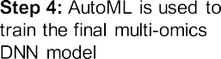



**Fig. 2.** Scheme of AutoOmics for automatic multi-omics integration for AI model construction. Step 1: Collecting multi-omics data. Take multi-omics data of 4 data types as example, a gene expression matrix, a gene mutation matrix, a copy number variation (CNV) matrix and a DNA methylation matrix. Step 2: Use each single-type omics data respectively as input to train a model for the learning targets. Four network structure classes (MLP, ResNet, DenseNet and ENAS), numbers of layers, numbers of neurons per layer and hyperparameter combinations (batch size, learning rate and optimizers) was performed to search for a model with the highest performance evaluation scores as optimal single-omics models for this single-type omics data. Then, weights of the all optimal models were fixed, and stopped updating in the following steps. Step 3: Concatenate latent layers from all the optimal single-omics models. Here we chose all the last latent layers and extract the corresponding vector values into a concatenated vector as the input for Step 4. Step 4: Use the concatenated vector as input to train a model for the learning targets again. Same to the process in Step 2, search for optimal multi-omics model. Then, weights of this optimal model was fixed. All the optimal single-omics (from Step 2) and multi-omics (from Step 4) models were combined together into a whole network, as the final AutoOmics-based AI model.

*Drug response prediction*

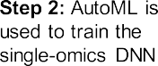

New complex diseases arise along with changes in lifestyles and en- vironment, creating new challenges and demands for new biomedicine treatments[14–16]. Although billions of dollars and tens of years have been spent on per de novo drug R&D, the success rate remains quite low. The main reason comes from safety issues and unclear mechanisms of actions for new drug candidates [14]. Drug repositioning, discovering new uses for existing FDA-approved drugs, can avoid the safety issues and skip toxicity testing, shorten time cost in R&D and increase success rate [15]. Famous examples e.g. Sildenafil initially for pulmonary arte- rial hypertension treatment is later found to treat erectile dysfunction [17].

Large scale screen projects for cell lines under drug treatments offer rich resources for drug repositioning. Genomics of Drug Sensitivity in

centration (IC50). IC50 represents drug sensitivity scores for ∼900 can- Cancers (GDSC) [18] database measures half maximal inhibitory con-

cer cell lines under each of 265 anticancer drug treatments. GDSC also provides basal gene expression, gene mutation, DNA methylation etc.

for the ∼900 cell lines before drug treatments. Based on GDSC, we aim

to build an anticancer drug sensitivity prediction model. We took the

gene expression and mutation profiles as features, and the IC50 values of 265 drugs as learning targets for each cell line to ran AutoOmics.

We implemented the optimal modeling by scanning structures of MLP, RFCN-ResNet and RFCN-DenseNet with various layer and neu- ron number setting, and found that RFCN-DenseNet-based networks

achieved the best performance for both gene expression and mutation single-omics models than other structures. Both of these two networks harbored single dense blocks (Fig. 3B) with a net growth rate of 128 and 512 respectively; for the optimal multi-omics model part, a direct FC (Fig. 3B) of MLP rather than RFCN-ResNet and RFCN-DenseNet was found to be the best option (Fig. 3A). Search strategy and search spaces are summarized in Methods Section. The above three searched models in total comprised the anticancer drug sensitivity prediction model.

Mean squared error (MSE) and spearman correlation coeﬃcient (SCC) of the optimal single-omics models of gene expression were 1.532 and 0.8717, and 1.9 and 0.8463 for gene mutation model. MSE and SCC of the optimal multi-omics model were obviously improved, with an ob- viously decreasing MSE 0.3266 and increasing SCC 0.967 (Supplemen-

tary Figure 3A). We utilized log-transformed IC50 *<* -2 (approximately

0.135 *𝜇*M) as standard threshold [19] to define drug sensitive (posi-

tive) and resistant (negative) groups, and found that the multi-omics

model also outperformed single-omics models in area under the receiver operating characteristic curve (AUROC), precision, recall and accuracy (Supplementary Figure 3A). Our results demonstrated a significant im- provement by multi-omics data integration using AutoOmics than only using single omics data for deep learning modeling.

We compared the AutoOmics based drug response prediction model with popular existing models - DeepDR [6], PaccMann [5] and MOLI [8]. DeepDR reports MSE as 1.96 in the original paper [6]. We re- produced the network architecture of DeepDR and achieved a MSE as 1.8793 and F1 as 0.7283 using the same data for AutoOmics, which was significantly outperformed by AutoOmics (MSE 0.3266, F1 0.8907, Fig. 3C). For PaccMann, we randomly queried 28 drugs for IC50 pre- dictions from its webserver to compare with AutoOmics predictions, and found that AutoOmics showed higher AUROC, area under pre- cision recall curve (AUPRC) and accuracy in both cell-wise (AUROC 0.998 vs. 0.702, AUPROC 0.854 vs. 0.792, accuracy 0.982 vs. 0.768)

and drug-wise (AUROC 0.987 vs. 0.708, AUPROC 0.764 vs. 0.742, ac- curacy 0.978 vs. 0.705) levels (Fig. 3D). For MOLI, it trained response prediction models for 4 drugs (Paclitaxel, Gemcitabine, Cetuximab, Er- lotinib) using GDSC data, and evaluated in a patient-derived xenograft (PDX) mice data set [20]. The PDX data includes gene expression, mu- tation and copy number variation (CNV) profiles for 399 mice and uses tumor size reduction as drug response index to 63 drug treatments. To compare with MOLI, we predicted responses for the 4 drugs by inputting the PDX mice gene expression and mutation into the AutoOmics model and obtained predictions for the 4 drugs. The results showed that Au- toOmics achieved higher AUPRC value for the 4 drugs than MOLI (Pa- clitaxel 0.616 vs. 0.24, Gemcitabine 0.558 vs. 0.49, Cetuximab 0.771 vs.

0.11, Erlotinib 0.7 vs. 0.33, Fig. 3E).

data integration: concatenated raw input + MLP (F1: 0.707), VAE la- In addition, we compared AutoOmics with other strategies of omics tent + MLP (F1: 0.728), VAE recon + MLP ((F1: 0.733), and raw in- put + AutoGenome (F1: 0.725), gene expression + AutoGenome (F1: 0.7315) and gene mutation + AutoGenome (F1: 0.708), and we found

that AutoOmics showed the highest F1 score as 0.891 among all (Sup- plementary Figure 3B). Interestingly, the F1 scores were sorted as: Au-

toOmics *>* AutoGenome for gene expression *>* AutoGenome for gene

expression and mutation concatenation *>* AutoGenome for gene mu- tation (F1: 0.8907 *>* 0.7315 *>* 0.7253 *>* 0.7075). It indicated that

integrating multi-omics raw input data directly caused neutralization of good-performance data (gene expression, F1: 0.7315) and poorly- performance data (gene mutation, F1: 0.7075), leading to worse predic- tions (F1: 0.7253) than that of the good-performance one. In contrast, AutoOmics largely promoted the performance (F1: 0.8907) better than using each single data (Supplementary Figure 3B).

When analyzing importance of features contributing to the final prediction, we listed top gene expressions and gene mutations ranked by SHAP values that showed highest importance to all 265 drug re- sponse predictions (Figs. 3F and 4G). Functional enrichment analysis showed that top-50 ranked gene expressions were enriched in doxoru-

bicin or daunorubicin metabolic process, regulations of cell prolifera- tion, growth factor activity and Wnt signaling pathway etc.; and the top-50 ranked gene mutations were enriched in regulations of gene ex- pression, cell proliferation and apoptotic process and typical signal path- way in cancers. Genes of the expression features enriched in location of extracellular space and exosome. Interestingly, unlike gene expression, the mutation feature genes were enriched in location of mitochondrion and endoplasmic reticulum.

Besides, we tested AutoOmics on gene dependency prediction. With the help of single-gene perturbation techniques e.g. RNA inference (RNAi) and CRISPR gene editing, researchers can perturb genomes to study effect of single gene on diseases or biological processes (e.g. by measuring mortality rate of cancer cells following by a gene RNAi) [21]. Through integrating basal multi-omics data of samples of interest before gene perturbations and linking to learning targets of phenotype data af- ter gene perturbation, researchers can train a gene dependency model to predict which genes play essential roles for the phenotype. In this way, the researchers needn’t to actual perturb genes. The Cancer De- pendency Map (DepMap) [21] includes CRISPR screen results on 17,635 genes for cancer cell lines and corresponding basal omics datasets for each cell. To focus on cancer causal genes, we narrowed down the screen results to 610 studied pan-cancer or cancer-type-specific prior- ity gene targets [22], and used gene expression and mutation profiles as features to run AutoOmics. AutoOmics firstly scanned network struc- tures of MLP, RFCN-ResNet and RFCN-DenseNet with different num- bers of layers and neurons, and outputted RFCN-DenseNet-based struc- tures with 4 and 5 dense blocks, with net growth rates as 16 and 8 respectively, as the best models for gene expression and mutation pro- files (Supplementary Figure 4A), which achieved MSE as 0.04011 and 0.04495, and SCC as 0.8610 and 0.8521 respectively (Supplementary Figure 4B). Then AutoOmics scanned best net structures following con- catenating the last hidden layers of the above two models, and returned a three-layer MLP with neuron numbers of 32, 32 and 610 (Supple-

and 0.8777 (Supplementary Figure 4B). Gene dependency score *<* -0.6 mentary Figure 4A), which achieved a better MSE and SCC as 0.03428

standard threshold [21] were set to define gene perturbation sensitive (positive) and resistant (negative) groups. And the multi-omics model also outperformed single-omics models in five classification evaluation indexes, which demonstrated improvement by multi-omics data integra- tion using AutoOmics for the task than only using single omics data. For performance comparison, we constructed trials same to that of drug sen- sitivity prediction, and it showed AutoOmics-based model outperformed all other methods for gene dependency prediction task (Supplementary Figure 4C).

We also listed top gene expressions and gene mutations ranked by SHAP values that showed highest importance to all 610 gene depen- dency predictions (Supplementary Figures 4D and 4E). Functional en- richment analysis showed that top-50 ranked gene expressions were en- riched in regulations in signal transduction and cell proliferation, im- mune response and renin-angiotensin system etc, and the location was enriched in extracellular exosome and space. The top-50 mutation fea- ture genes were enriched in location of cortical cytoskeleton.

*Breast cancer subtype prediction*

Large-scale accumulation of multi-omics data and electronic med- ical records of patient individuals makes it possible to study precision medicine, that is, to specify medicine treatments for each patient accord- ing to their personal clinical responses and physiological and genomics features. These features may include susceptibility to diseases, mecha- nisms of onsets, prognosis conditions, responses to specific treatments and genetics background etc [23]. For complex diseases e.g. cancer, al- though patients may belong to the same cancer types based on pathol- ogy, their responses to drugs or immune therapy often vary largely. This is maybe due to their difference in genetics background [24]. Therefore,



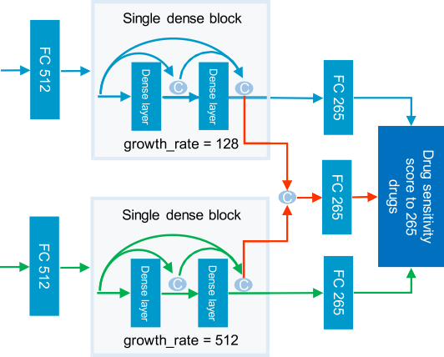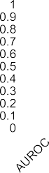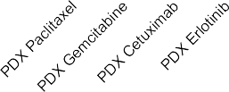

 











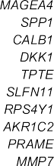**Fig. 3.** AutoOmics-based drug response prediction model.

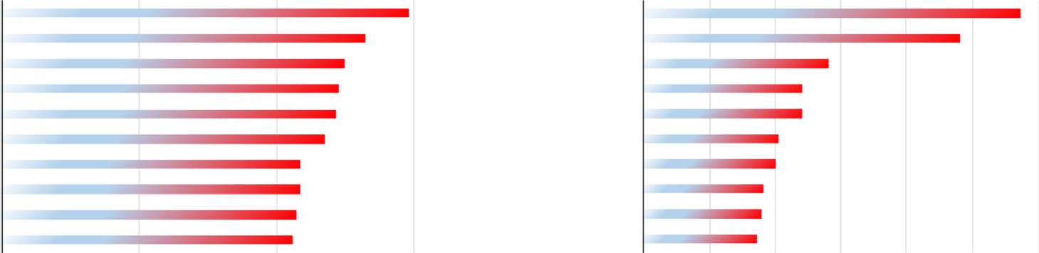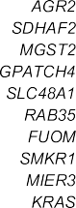

1. Illustration of AutoOmics-based drug sensitivity prediction model using GDSC cancer cell line gene expression and mutation profiles to predict sensitivity scores to 265 anticancer drugs.
2. Illustration of Automics basic net units – dense layer units for DenseNet and FC units.
3. Comparison of AutoOmics based drug sensitivity model to DeepDR using GDSC data. GDSC IC50 values were used as golden-standard positives. F1 score and MSE score were used for evaluation comparison.
4. Comparison of AutoOmics based drug sensitivity model to PaccMann using GDSC data. We used SMILES of 28 drugs and 936 cell lines shared in training sets of both our model and PaccMann for comparison. GDSC IC50 values were used as golden-standard positives. Evaluation comparison were performed in both cell-wise and drug-wise.
5. Independent validation of AutoOmics based drug sensitivity model in a PDX mice data set and comparison to MOLI. Independent validation of AutoOmics in a mice PDX data set. We tested the GDSC-IC50-trained AutoOmics model on a mice PDX data, which uses tumor size reduction as learning targets. Here tumor size reduction quantity was used as ground truths for performance evaluation. 4 drugs shared between our model and MOLI were used for comparison
6. Top-10 gene expression ranked by impact on model output for AutoOmics based drug sensitivity model
7. Top-10 gene mutation ranked by impact on model output for AutoOmics based drug sensitivity model.

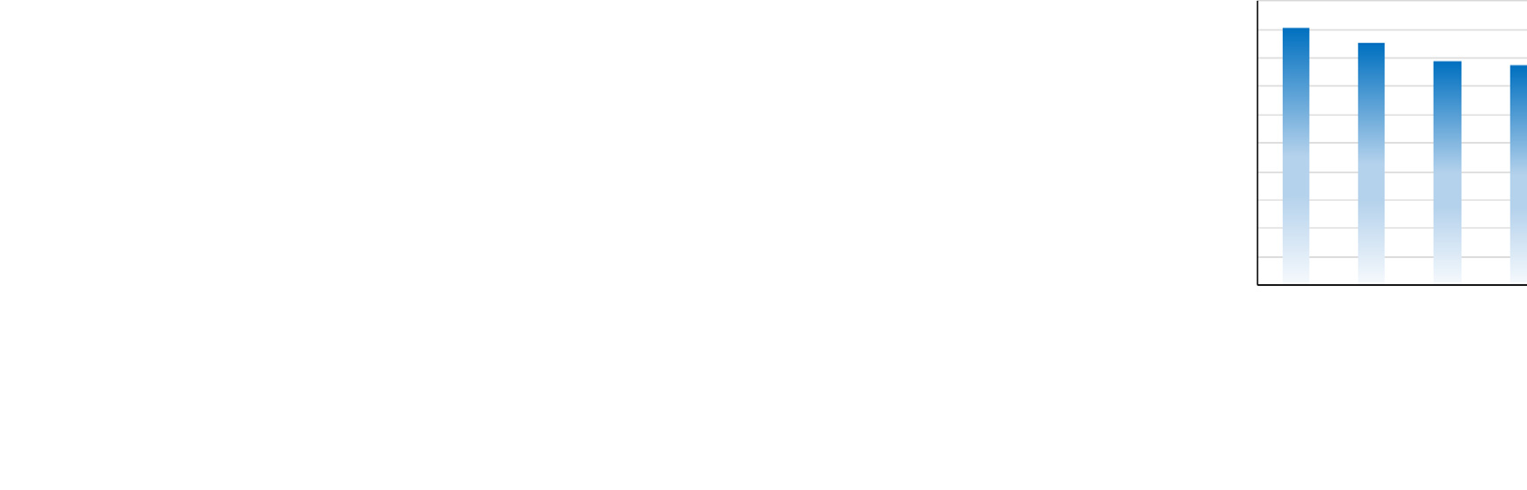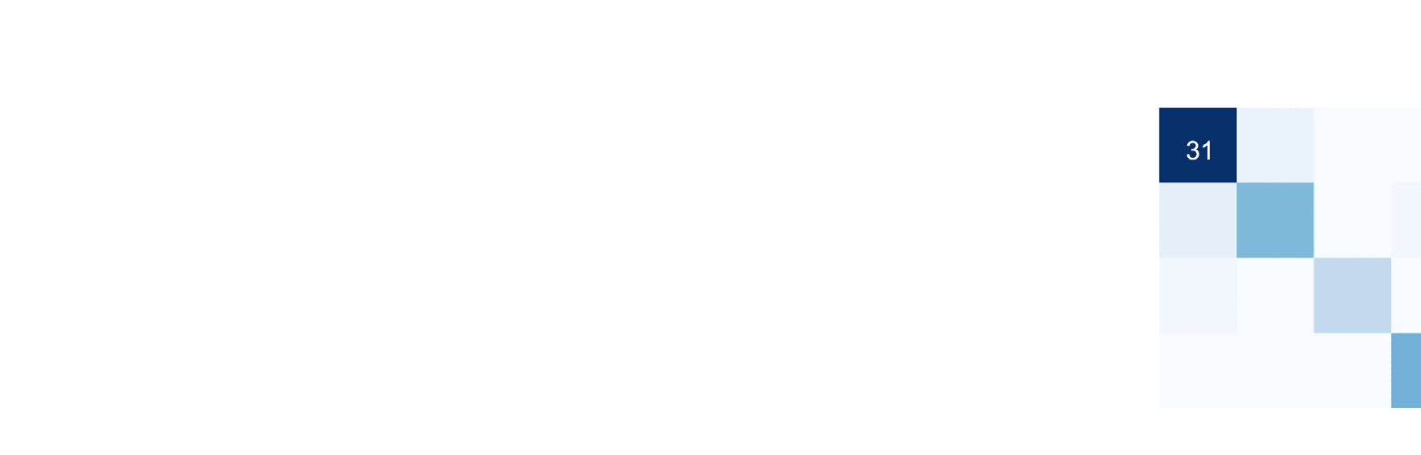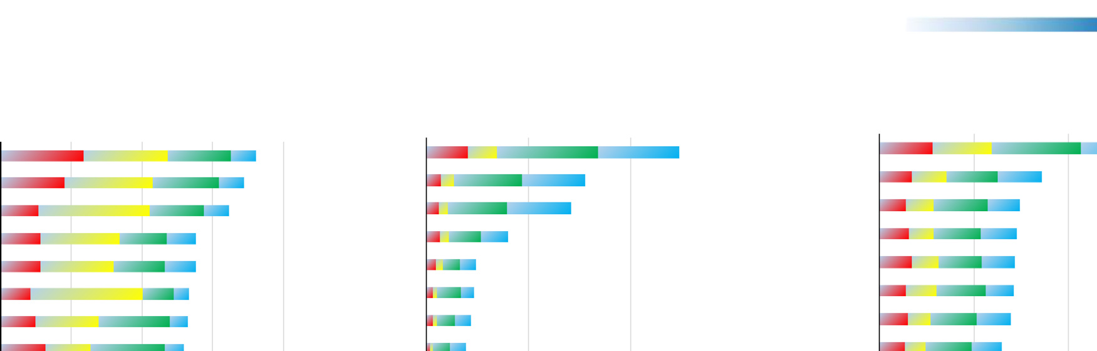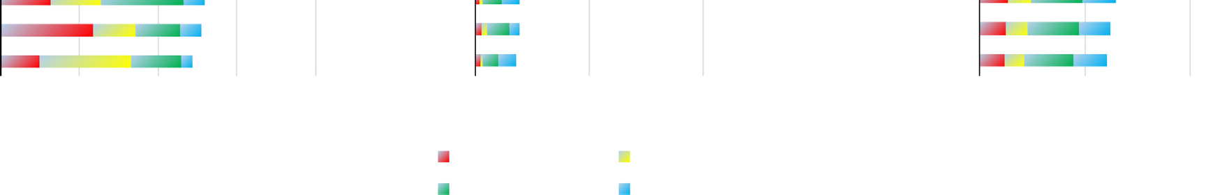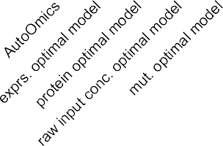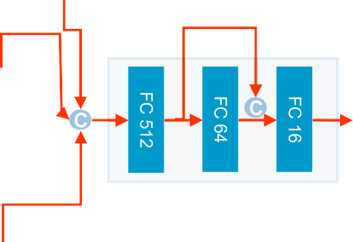

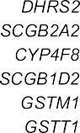**Fig. 4.** AutoOmics-based cancer subtyping prediction model.

1. Illustration of AutoOmics-based cancer subtyping prediction model using TCGA breast cancer patient gene expression, gene mutation and protein expression profiles to predict four breast cancer subtypes.
2. Performance comparison between AutoOmics steps using top-1 accuracy. Total data were randomly separated in 7:2:1 ratio for training, evaluation and test datasets. The test dataset was used for top-1 accuracy calculation.
3. Confusion matrix using predictions of AutoOmics-based cancer subtyping prediction model. True labels are in the row and predictions are in the column. Top-1 accuracy for each of the four breast cancer subtypes and total top-1 accuracy are indicated.
4. Feature importance analysis. Top-10 features ranked by impact on model output are performed for gene expression (left), gene mutation (middle) and protein expression (right).

it is necessary to take advantage of patients’ multi-omics data for cancer subtyping.

The Cancer Genome Atlas (TCGA) database includes six types of omics data in patient individual level for more than 20 cancer types [25]. Here we implemented AutoOmics to build a classification model for breast cancer subtype prediction using patients’ gene expression, gene mutation and protein expression profiles as features, and focused on four subtypes of PAM50-profiling-test based, luminal A, luminal B,

triple-negative and HER2-enriched [26]. Apart from searching optimal models using MLP, RFCN-ResNet and RFCN-DenseNet structures, we also included ENAS randomly-generated structures for this classifica- tion task, and found it showed outstanding performance than RFCN- DenseNet and RFCN-ResNet. For optimal single-omics model of gene expression, AutoOmics returned an ENAS-based model containing 4 FC layers with 2048, 128, 256 and 256 neurons per layer and one skip con- nection concatenating the 128- and 256-neuron layer outputs as input

of the 256-neuron layer (Fig. 4A). It achieved top-1 accuracy 0.8533 for breast cancer subtyping (Fig. 4B), better than published graph deep learning based model using the same origin of dataset (with an accu- racy of 0.8319) [27]. For optimal single-omics models of gene mutation and protein expression, AutoOmics returned both ENAS models with three layers and one skip connections (Fig. 4A), showing top-1 accu- racy as 0.573 and 0.787 respectively, lower than that of gene expression (Fig. 4B). Then AutoOmics linked all the three models and again gen- erated an optimal model for data integration as an ENAS-based three- FC-layer network with 512, 64 and 16 neurons (Fig. 4A), with an im- proved top-1 accuracy as 0.907 (Luminal A: 0.939, Luminal B: 0.778, HER2-enriched: 0.889, Basal-like: 1), significantly better than each of the single-omics model (Fig. 4B and 4C). It outperformed a published approach using SMO-MKL, which achieved a 0.798 average accuracy of any two immunohistochemistry marker based subtypes [28]. When di- rectly concatenating three omics data together, the top-1 accuracy was 0.773, better than that of gene mutation and worse than gene expression and protein expression (Fig. 4B).

Then we analyzed importance scores represented by SHAP values for each feature to the model outputs. SHAP value in gene expression showed that *RBM20* gene expression contributed more in luminal B subtype than other subtypes (Fig. 4D). The finding is accordant with the public results which proves that *RBM20* gene expression is corre- lated with PDCD4-AS1/PDCD4, a tumor suppressor in TNBC cell lines

[29] and a subset of TNBC potentially benefits therapy targeting lu- minal subtype’s typical pathways [30]. In other examples, the SHAP value of *TFAP2B* shows it is an important gene feature in breast can- cer (Fig. 4D). It is proven by the HMAN PROTEIN ATLAS which shows *TFAP2B* (ENSG00000008196) is a cancer-related gene and its expres- sion is highest in breast cancer pathology data and enriched in breast cancer. Besides, SHAP value of *TFAP2B* is highest in luminal A, which is in agreement with that *TFAP2B* is associated with WNT/ß-catenin pathway in luminal breast cancer, and its encoding protein AP-2 tran- scription factor regulates luminal breast cancer genes [31].

In protein expression level, based on SHAP values, ER-alpha ranked top 1 among all protein expression and showed important contribution to all four subtypes in breast cancer (Fig. 4D). This phenomenon is in accordance with the research of estrogen receptors which is a very im- portant marker for prognosis and a marker that is predictive of response to endocrine therapy in breast cancer [32]. The loss of ER expression portends a poor prognosis and, in a significant fraction of breast can- cers, this repression is a result of the hypermethylation of CpG islands within the ER-alpha [33].

To systematically analyze the reliability of feature importance re- sults, we used SHAP-ranking top features to represent samples and checked inner- and intra-subtype similarity of samples. It showed that compared to using all features representing samples, SHAP-top-ranked features could better cluster samples of the same subtypes together and distinguish between intra subtypes, which was quantified by silhouette score (Supplementary Figures 5–8). The scores achieved highest using top features (top 70, 40 and 10 for gene expression, gene mutation and protein expression), and then decreased when more bottom-ranked fea- tures were included (Supplementary Figure 5). It demonstrated that top- ranked features by SHAP values played a direct role to improve breast cancer subtype classification.

Additionally, we built a 24 cancer type prediction model using TCGA pancancer omics data. AutoOmics trained a 6-FC-layer and 4-skip- connection ENAS network for gene expression profiles with top-1 accu- racy 0.963, and a 4-FC-layer and 2-skip-connection ENAS network for gene mutation profiles with top-1 accuracy 0.681 (Supplementary Fig- ure 9A and 9B). AutoOmics linked the two networks using a 3-FC-layer and 1-skip-connection ENAS network, achieving an improved top-1 ac- curacy 0.973 (Supplementary Figure 9A and 9B). For comparison, we also performed stacked ensemble learning to link the two networks by using their softmax target layers rather than last hidden layers as a new network input. We tested both ENAS and MLP for the ensemble learning

way, and the top-1 accuracy was consistently round 0.857, which lied in between that of gene expression ENAS network and the gene mutation ENAS one, lower than that of AutoOmics (Supplementary Figure 9B). It demonstrated that AutoOmics outperformed stacked ensemble learning in this task.

# Discussion

Genomics data are widely accumulated using high-throughput se- quencing for cell lines, animal models and patient individuals. Different omics data types can reflect different aspects of features for samples, thus it is important to integrate all omics data for one sample at the same time. To address it, we developed a multi-omics data integration method – AutoOmics. AutoOmics firstly builds single-omics models for each sin- gle data, and the latent spaces extracted from single-omics models were combined together and then are subjected to deep learning modeling.

Weights of single-omics models are frozen once finished training. They are no longer updated in the stage of multi-omics modeling us- ing combined latents. Unlike AutoOmics, published methods e.g. MOLI treat each of single-omics data as a branch of networks (subnetworks) [5], that is to say, weights of certain subnetworks are dependent on other’s subnetworks, and they are kept updating simultaneously follow- ing the whole network training. This difference may be the reason why AutoOmics is outstanding for eﬃcient data integration. AutoOmics may maximally extract latent that can best represent learning targets for each data individually. Our three prediction tasks also demonstrate the ex- cellent performance of AutoOmics over other methods. DeepDR uses AE to reduce dimension of omics data. AE is an unsupervised learning method, in contrast the data representation modules of AutoOmics are a supervised learning way – to learn the latent spaces of omics data most relevant to learning targets. We believe that difference in the data representation ways of DeepDR and AutoOmics make a key role in the performance difference between them.

Our data integration idea is similar to stacking ensemble learning

[34] but not the same. Stacking ensemble emphasizes combining pre- dictions of individual models not the latent spaces as we have pro- posed. Furthermore, traditional methods take all the multi-omics data as a whole input for a model, but in this paper, we demonstrate that taking each of single-omics data to build independent models and then performing combination as a whole are better choices. The effective- ness of our method is probably because that batch effect, difference in source of data and value ranges among data cannot be well removed by normalization. Direct combining raw values of different data types will lead to unexpected bias, thus degrade performance of the model (Fig. 4B, Supplementary Figure 3B, Supplementary Figure 4B and Sup- plementary Figure 9B).

As we have claimed on AutoGenome [10], CNN and RNN are not suitable to modeling genomics profiles because features of genomics data are non-Euclidean, thus pure FC is better. Published methods mainly utilize MLP, where layers only link neighboring layers[4–6]. It is not eﬃcient to model biological regulations and feedback loops be- tween different levels. Thus we introduced skip connections in our net- work design. We tried RFCN-ResNet and RFCN-DenseNet – two classical network structures with skip connections. In our experiments, RFCN- DenseNet was proved to be better than RFCN-ResNet in both drug sen- sitivity and gene dependency tasks. This is may be due to that densely skip-connections in RFCN-DenseNet may cover more possible interac- tion combinations than RFCN-ResNet. Interestingly, RFCN-DenseNet for drug sensitivity is wider (with more number of neurons per layer) and shallower (with less number of layers) than that for gene dependency task, no matter using gene expression or mutation data (Fig. 3A and Sup- plementary Figure 4A), which may imply that these anticancer drugs can influence more targets and pathways initially than single gene perturbations, but the latter one can expand deeply in biological net- work. However RFCN-DenseNet cannot keep good performance in can- cer subtyping classification task, both RFCN-ResNet and RFCN-DenseNet

showed low accuracy and ENAS-based randomly-generated network sig- nificantly outperformed them. It imply that ENAS can achieve a larger searchable space than RFCN-DenseNet, where the structure of the latter one can only be extended in a fixed manner.

Taking all above, AutoOmics is a brand new integration method for multi-omics research. It comprises novel network units and network architectures specifically designed for genomics data. And it also in- tegrates built-in novel multi-omics integration method for eﬃciently taking advantages of multi-omics data. Besides, AutoOmics also pro- vides biological explanation for predicted results by SHAP, which can help biologist to discover interesting biological markers for research. AutoOmics can surely speed up bioinformatics and genomics study and aid in dissecting important findings for biological researchers.

# Methods

**Hyper-parameter search.** Hyper-parameter search method refers to our previous described approach in AutoGenome [10]. The hyper- parameters in search space are learning rate, total batch size, momen- tum, weight decay, number of layers in neural networks and number of neurons in each layers.

**RFCN-ResNet Search Space.** Search space are as followings. 1) The number of blocks for ResNet, default value is [1, 2, 3, 5, 6]. 2) The

number of neuros in each layer, default value is [8, 16, 32, 64, 128,

256, 512, 1024, 2048]. 3) The drop-out ratio of the first layer compared

with the input layer, selected from [0.6, 0.8, 1.0]

**RFCN-DenseNet Search Space.** Search space are as followings. 1) The blocks structure for DenseNet, default value is [2, 3, 4,3, 4, 5]. 2) The growth rate of neuros in each block, default value is [8, 16, 32, 64, 128, 256, 512, 1024, 2048]. 3) The drop-out ratio of the first layer compared with the input layer, selected from [0.6, 0.8, 1.0].

**Efficient Neural Architecture Search.** ENAS search method refers to our previous described approach in AutoGenome [10]. Search space are as followings. 1) The number of neurons in from the 2rd layer to the last layer, selected from [16, 32, 64, 128, 256, 512, 1024, 2048]. 2) The connection relationship between different layers.

**Data collection and preprocessing.** For drug sensitivity and gene dependency prediction tasks, we downloaded gene expression and mutation data, drug response data and CRISPR-based gene depen- dency data from GDSC ([https://www.cancerrxgene.org](https://www.cancerrxgene.org/)) and DepMap (<https://depmap.org/portal/download/>) web resources. Gene expres- sion profile includes 1018 cancer cell lines and 17,418 genes. Values were log2-transformed. Gene mutation data covers 974 cancer cell lines. We set discrete values of 1 and 0 indicating somatic mutated or wide- type status and removed silent mutation cases, remaining union set of 19,350 genes for analysis. Drug response data includes log-transformed IC50 values for 990 cancer cell lines representing response to 265 sin- gle anticancer drug treatments. K-nearest-neighbor algorithms was per- formed to fill in missing values for the IC50 response data by R function knn. Gene dependency data covers 558 cancer cell lines and response to CRISPR perturbation of 17,634 human genes. To focus on cancer prior- ity gene targets [22], 610 gene CRISPR cases were remained for analysis. Cell lines were mapped using identifiers of Catalogue Of Somatic Mu- tations In Cancer (COSMIC) between datasets, thus remained 936 cell lines for drug sensitivity task and 324 for gene dependency task.

For cancer subtyping prediction task, breast cancer patients’ gene ex-

pression, mutation and protein expression data were downloaded from TCGA (<https://gdac.broadinstitute.org/>), where feature numbers were 20,531 genes, 16,806 somatic mutated genes and 226 proteins respec- tively. Gene expression values were log2-transformed and silent muta- tions were removed from gene mutation data. PAM50-based subtypes for patients were downloaded from published paper [35]. 396 patients shared between the feature data and subtype data were used for cancer subtyping prediction task. For pancancer type prediction, 5780 patient samples with gene expression and somatic mutated gene profiles were used for modeling.

**Model training, evaluation and explanation.** For drug sensitivity and gene dependency tasks, data were randomly separated into 8:1:1 ratio for training, evaluation and test data. Evaluation was performed based on 10-fold cross validation to calculate MSE and SCC. Precision, recall, accuracy and AUROC were calculated when using a threshold to group positives and negatives. For cancer subtyping task, the ratio was set as 6:2:2 in ENAS-based modeling, since evaluation data was used to update and determine net architectures for ENAS. Data were splitted in a stratified manner to make percentage of subtypes equal between data sets. Top-1 accuracy for the test data was used as final evaluation. All evaluation scores were calculated using python sklearn module. Model explanation is performed by “SHAP” module implemented within Auto- Genome. AutoGenome take the best model and raw data as input, when calling with “autogenome.explain()”. And then AutoGenome will auto- matically return the SHAP value of each feature for each sample for further interpretation.

# Author contributions

N.Q. designed and conceived the project. C.X., D.L., L.Z. and Z.X. implemented the AutoOmics python package and perform data exper- iment with the help from W.H. under the guidance of N.Q. C.X., D.L.,

L.Z and N.Q. wrote the paper. N.Q. and M.Z. revised the manuscript. All authors read and approved the final manuscript.

# Competing interests statement

The authors declare no competing interests.

# Declaration of Competing Interests

The authors declare that they have no known competing financial interests or personal relationships that could have appeared to influence the work reported in this paper.

# Code availability

The [software website could be accessed from https://autogenome. com.cn/AutoOmics/AutoOmics.html, which contains the](https://autogenome.com.cn/AutoOmics/AutoOmics.html) software introduction, installation and software usage. The protocols for specific experiments are also provided as notebook examples on the website.

# Acknowledgments

We thank Prof. Mingyue Zheng for critical reading and suggestions for revision.

# References

1. [Yngvadottir B, MacArthur DG, Jin H, Tyler-Smith C. The promise and reality of personal genomics. Genome Biol 2009;10:237.](http://refhub.elsevier.com/S2667-3185(21)00012-X/sbref0001)
2. Mayakonda A, Koeﬄer HP. Maftools: Eﬃcient analysis, visualization and sum- marization of MAF files from large-scale cohort based cancer studies. bioRxiv 2016;052662. doi:[10.1101/052662](https://doi.org/10.1101/052662).
3. [Zou J](http://refhub.elsevier.com/S2667-3185(21)00012-X/sbref0003), [et al.](http://refhub.elsevier.com/S2667-3185(21)00012-X/sbref0003) [A primer on deep learning in genomics. Nat Genet 2019;51:12–18](http://refhub.elsevier.com/S2667-3185(21)00012-X/sbref0003).
4. [Sharifi-Noghabi H, Zolotareva O, Collins CC, Ester M. MOLI: multi-omics late in- tegration with deep neural networks for drug response prediction. Bioinformatics 2019;35:i501–9.](http://refhub.elsevier.com/S2667-3185(21)00012-X/sbref0004)
5. [1811.06802] PaccMann: Prediction of anticancer compound sensitivity with multi- modal attention-based neural networks. <https://arxiv.org/abs/1811.06802>.
6. [Chiu Y-C, et al. Predicting drug response of tumors from integrated genomic profiles by deep neural networks. BMC Med Genomics 2019;12:18.](http://refhub.elsevier.com/S2667-3185(21)00012-X/sbref0006)
7. [Preuer K, et al. DeepSynergy: predicting anti-cancer drug synergy with deep learn- ing. Bioinformatics 2017;34:1538–46.](http://refhub.elsevier.com/S2667-3185(21)00012-X/sbref0007)
8. [Sharifi-Noghabi H, Zolotareva O, Collins CC, Ester M. MOLI: multi-omics late in- tegration with deep neural networks for drug response prediction. Bioinformatics 2019;35:i501–9.](http://refhub.elsevier.com/S2667-3185(21)00012-X/sbref0008)
9. [Yang W, et al. Genomics of drug sensitivity in cancer (GDSC): a resource for thera- peutic biomarker discovery in cancer cells. Nucleic Acids Res 2012;41:D955–61.](http://refhub.elsevier.com/S2667-3185(21)00012-X/sbref0009)
10. Liu D, et al. AutoGenome: an AutoML tool for genomic research. bioRxiv 2019;842526. doi:[10.1101/842526](https://doi.org/10.1101/842526).
11. [Abadi M, et al. TensorFlow: a system for large-scale machine learning. In: 12th USENIX Symposium on Operating Systems Design and Implementation (OSDI 16). USENIX Association; 2016. p. 265–83.](http://refhub.elsevier.com/S2667-3185(21)00012-X/sbref0011)
12. [Paszke A, et al. PyTorch: an imperative style, high-performance deep learning li- brary. In: Wallach H, et al., editors. Advances in neural information processing sys- tems 32. Curran Associates, Inc.; 2019. p. 8026–37.](http://refhub.elsevier.com/S2667-3185(21)00012-X/sbref0012)
13. [Lundberg SM, Lee S-I, et al. A unified approach to interpreting model predictions. In: Guyon I, et al., editors. Advances in neural information processing systems 30. Curran Associates, Inc.; 2017. p. 4765–74.](http://refhub.elsevier.com/S2667-3185(21)00012-X/sbref0013)
14. [Ashburn TT, Thor KB. Drug repositioning: identifying and developing new uses for existing drugs. Nat Rev Drug Discov 2004;3:673–83.](http://refhub.elsevier.com/S2667-3185(21)00012-X/sbref0014)
15. [Wu Z, Wang Y, Chen L. Network-based drug repositioning. Mol Biosyst 2013;9:1268–81.](http://refhub.elsevier.com/S2667-3185(21)00012-X/sbref0015)
16. [Xu C, et al. Accurate drug repositioning through non-tissue-specific core signatures from cancer transcriptomes. Cell Rep 2018;25:523–35 e5.](http://refhub.elsevier.com/S2667-3185(21)00012-X/sbref0016)
17. [Langtry HD](http://refhub.elsevier.com/S2667-3185(21)00012-X/sbref0017), [Markham ASildenafil. Drugs 1999;57:967–89](http://refhub.elsevier.com/S2667-3185(21)00012-X/sbref0017).
18. [Yang W, et al. Genomics of drug sensitivity in cancer (GDSC): a resource for thera- peutic biomarker discovery in cancer cells. Nucleic Acids Res 2013;41:D955–61.](http://refhub.elsevier.com/S2667-3185(21)00012-X/sbref0018)
19. [Chang Y, et al. Cancer drug response profile scan (CDRscan): a deep learning model that predicts drug effectiveness from cancer genomic signature. Sci Rep 2018;8:8857.](http://refhub.elsevier.com/S2667-3185(21)00012-X/sbref0019)
20. [Gao H, et al. High-throughput screening using patient-derived tumor xenografts to predict clinical trial drug response. Nat Med 2015;21:1318–25.](http://refhub.elsevier.com/S2667-3185(21)00012-X/sbref0020)
21. [McFarland JM, et al. Improved estimation of cancer dependencies from large-scale RNAi screens using model-based normalization and data integration. Nat Commun 2018;9:1–13.](http://refhub.elsevier.com/S2667-3185(21)00012-X/sbref0021)
22. [Behan FM, et al. Prioritization of cancer therapeutic targets using CRISPR–Cas9 screens. Nature 2019;568:511–16.](http://refhub.elsevier.com/S2667-3185(21)00012-X/sbref0022)
23. [Lu Y-F, Goldstein DB, Angrist M, Cavalleri G. Personalized medicine and human genetic diversity. Cold spring harb. Perspect Med 2014;4.](http://refhub.elsevier.com/S2667-3185(21)00012-X/sbref0023)
24. [Wirapati P, et al. Meta-analysis of gene expression profiles in breast cancer: toward a unified understanding of breast cancer subtyping and prognosis signatures. Breast Cancer Res 2008;10:R65.](http://refhub.elsevier.com/S2667-3185(21)00012-X/sbref0024)
25. [Hudson (Chairperson) TJ, et al. International network of cancer genome projects. Nature 2010;464:993–8.](http://refhub.elsevier.com/S2667-3185(21)00012-X/sbref0025)
26. [Bastien RR, et al. PAM50 breast cancer subtyping by RT-qPCR and concordance with standard clinical molecular markers. BMC Med Genomics 2012;5:44.](http://refhub.elsevier.com/S2667-3185(21)00012-X/sbref0026)
27. Rhee, S., Seo, S. & Kim, S. Hybrid approach of relation network and localized graph convolutional filtering for breast cancer subtype classification. ArXiv171105859 Cs (2017).
28. [Tao M, et al. Classifying breast cancer subtypes using multiple kernel learning based on omics data. Genes 2019;10:200.](http://refhub.elsevier.com/S2667-3185(21)00012-X/sbref0028)
29. [Jadaliha M, et al. A natural antisense lncRNA controls breast cancer progression by promoting tumor suppressor gene mRNA stability. PLOS Genet 2018;14:e1007802.](http://refhub.elsevier.com/S2667-3185(21)00012-X/sbref0029)
30. [Hon JDC, et al. Breast cancer molecular subtypes: from TNBC to QNBC. Am J Cancer Res 2016;6:1864–72.](http://refhub.elsevier.com/S2667-3185(21)00012-X/sbref0030)
31. [Bogachek MV, et al. Sumoylation pathway is required to maintain the basal breast cancer subtype. Cancer Cell 2014;25:748–61.](http://refhub.elsevier.com/S2667-3185(21)00012-X/sbref0031)
32. [Hua H, Zhang H, Kong Q, Jiang Y. Mechanisms for estrogen receptor expression in human cancer. Exp Hematol Oncol 2018;7 24–24.](http://refhub.elsevier.com/S2667-3185(21)00012-X/sbref0032)
33. [Giacinti L, Claudio PP, Lopez M, Giordano A. Epigenetic information and estrogen receptor alpha expression in breast cancer. Oncologist 2006;11:1–8.](http://refhub.elsevier.com/S2667-3185(21)00012-X/sbref0033)
34. [Wang G, Hao J, Ma J, Jiang H. A comparative assessment of ensemble learning for credit scoring. Expert Syst Appl 2011;38:223–30.](http://refhub.elsevier.com/S2667-3185(21)00012-X/sbref0034)
35. [Koboldt DC, et al. Comprehensive molecular portraits of human breast tumours. Nature 2012;490:61–70.](http://refhub.elsevier.com/S2667-3185(21)00012-X/sbref0035)