[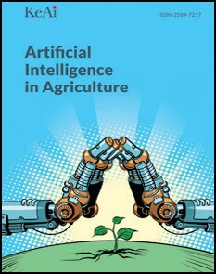](Journal%20logo)[Artificial Intelligence in Agriculture 4 (2020) 140–149](https://doi.org/10.1016/j.aiia.2020.07.002)

Contents lists available at [ScienceDirect](http://www.sciencedirect.com/science/journal/25897217)

Artificial Intelligence in Agriculture

journal homepage: [http://www.keaipublishing.com/en/j ournals/artificial- intelligence-in-agriculture/](http://www.keaipublishing.com/en/journals/artificial-intelligence-in-agriculture/)

[](http://crossmark.crossref.org/dialog/?doi=10.1016/j.aiia.2020.07.002&domain=pdf)Carbon sequestration and emissions mitigation in paddy fields based on the DNDC model: A review

Shan Yin a,c,d,e,1, Xianxian Zhang b,f,1, Junyao Lyu a,c,d, Yuee Zhi a,e, Feng Chen g, Longqin Wang h,

Chunjiang Liu a,c,d,e,⁎, Sheng Zhou b,f,⁎⁎

a *School of Agriculture and Biology, Shanghai Jiao Tong University, 800 Dongchuan Rd., Shanghai 200240, China*

b *Eco-Environmental Protection Research Institute, Shanghai Academy of Agricultural Sciences, 1000 Jinqi Rd, Shanghai 201403, China*

c *Shanghai Yangtze River Delta Eco-environmental Change and Management Observation and Research Station, Ministry of Education, 800 Dongchuan Rd, Shanghai 200240, China*

d *Shanghai Urban Forest Ecosystem Research Station, National Forestry and Grassland Administration, 800 Dongchuan Rd., Shanghai 200240, China*

e *Key Laboratory for Urban Agriculture, Ministry of Agriculture and Rural Affairs, 800 Dongchuan Rd., Shanghai 200240, China*

f *Shanghai Engineering Research Centre of Low-carbon Agriculture (SERCLA), 1000 Jinqi Rd, Shanghai 201403, China*

g *Shanghai Chongming Modern Agricultural Park Management Committee, 2 Chongming Beishougeng Rd, Shanghai 202163, China*

h *Shanghai Songlin Food (Group) CO. LTD, 2268 East Rongle Rd, Shanghai 201613, China*

a r t i c l e i n f o

*Article history:*

Received 1 June 2020

Received in revised form 14 July 2020

Accepted 15 July 2020

Available online 22 July 2020

*Keywords:*

Soil organic carbon Greenhouse gas emissions Exogenous carbon addition Tillage practices

Water and fertilizer management

a b s t r a c t

The DeNitrification–DeComposition (DNDC) model is a process model with a series of carbon and nitrogen bio- geochemistry in agro-ecosystems. It incorporates the driving factors of the ecological environment and aims to simulate the carbon and nitrogen cycle in the terrestrial ecosystem. Furthermore, the model can be applied effec- tively in a paddy ecosystem. Based on an investigation and literature review, this study summarized and analyzed the impact of agricultural practices such as water management, fertilizer application, and straw incorporation on greenhouse gas emissions and soil carbon storage. After years of improvement, the DNDC model can presently be used effectively to evaluate the carbon sequestration and emissions mitigation potential of various agricultural practices. However, the related details of scientific processes of agricultural management, such as biochar incor- poration and plastic mulching in paddy fields, should be added or modified and combined with experimental cases of actual agricultural practices to complete the calibration of the model, provide theoretical support for its promotion, and establish a reliable method of evaluating carbon sequestration and emissions mitigation in paddy fields.

© 2020 The Authors. Publishing services by Elsevier B.V. on behalf of KeAi Communications Co. Ltd. This is an open access article under the CC BY-NC-ND license (<http://creativecommons.org/licenses/by-nc-nd/4.0/>).

Contents

1. Introduction 141
2. Biogeochemical process of the DNDC model 141
   1. Soil climate 141
   2. Plant growth 142
   3. Carbon dynamics 143
   4. Greenhouse gas emissions 143
3. Carbon sequestration and emissions mitigation of paddy fields 144
   1. Carbon sequestration potential of a paddy ecosystem 144
      1. Effect of exogenous carbon addition on the carbon sequestration potential of a paddy ecosystem 144
      2. Effect of tillage practices on the carbon sequestration potential of a paddy ecosystem 146
   2. Greenhouse gas emissions mitigation potential of a paddy ecosystem 146
      1. Effects of water management measures on the emissions mitigation potential of a paddy ecosystem 146
      2. Effect of nitrogen management on emissions mitigation potential of a paddy ecosystem 146

* Correspondence to: C. Liu, School of Agriculture and Biology, Shanghai Jiao Tong University, 800 Dongchuan Rd., Shanghai 200240, China.

⁎⁎ Correspondence to: S. Zhou, Eco-Environmental Protection Research Institute, Shanghai Academy of Agricultural Sciences, 1000 Jinqi Rd, Shanghai 201403, China.

*E-mail addresses:* [chjliu@sjtu.edu.cn](mailto:chjliu@sjtu.edu.cn) (C. Liu), [zhous@outlook.com](mailto:zhous@outlook.com) (S. Zhou).

1These authors have contributed equally to this work.

<https://doi.org/10.1016/j.aiia.2020.07.002>

2589-7217/© 2020 The Authors. Publishing services by Elsevier B.V. on behalf of KeAi Communications Co. Ltd. This is an open access article under the CC BY-NC-ND license ([http://](http://creativecommons.org/licenses/by-nc-nd/4.0/) [creativecommons.org/licenses/by-nc-nd/4.0/](http://creativecommons.org/licenses/by-nc-nd/4.0/)).

* + 1. Effect of exogenous carbon addition on the emissions mitigation potential of a paddy ecosystem 146
    2. Effect of coupling agricultural practices on the emissions mitigation potential of a paddy ecosystem 147

1. Conclusion 147

CRediT author statement 147

Acknowledgements 147

References 148

1. Introduction

The agricultural ecosystem provides the food people require and also crucially carries carbon (C) and nitrogen (N) in the C and N cycle. The ecosystem is affected by numerous natural and human factors, such as soil, climate, crops, and agricultural practices. All these factors are connected to each other through substance and energy exchange, forming a complex biogeochemical system. However, because of human activities, the agricultural ecosystem is a critical source of non- carbon dioxide (non-CO2) greenhouse gases (GHGs), which account for 56% of anthropogenic emissions of non-CO2 GHGs (IPCC, 2014). Methane (CH4) emissions from the global agricultural ecosystems are

3.22 × 106 Gg CO2-eq yr−1 and nitrous oxide (N2O) emissions are

5.99 × 106 Gg CO2-eq yr−1 (FAO, 2020). Paddy fields are vital parts of an agricultural ecosystem, and their harvest area accounts for 23% of the total area of cereal crop cultivation worldwide (FAO, 2020). Because of prolonged flood water management, soil has been maintained in an anaerobic reduction condition during rice growing seasons, which pro- vides favorable conditions for CH4 production. CH4 emissions from paddy fields account for 18% of emissions from agricultural sources (FAO, 2020). In addition, the application of N fertilizer, water-saving ir- rigation, and certain other agricultural practices promote N2O emissions from paddy fields. Annual N2O emissions in China are approximately 33 Gg N, accounting for 14% of the emissions from agricultural soils (Aliyu et al., 2019). Furthermore, the improvement of the C storage of paddy fields is crucial in mitigating global warming. The C storage of upper paddy soil (0–30 cm) in China is 1.6 Pg C, and the C sequestration poten- tial is 0.9 Pg C (Qin et al., 2013). Therefore, when stabilizing rice produc- tion, the adoption of agricultural practices that increase the C pool content of paddy soil and reduce GHG emissions (C sequestration and emissions mitigation for short) is a crucial measure for coping with global climate change.

To accurately assess the impact of agricultural practices on the C se- questration and emissions mitigation potential of paddy ecosystems, un- derstanding the C and N cycle of paddy ecosystems is crucial. Much basic data has been accumulated through field observation and simulation ex- periments for understanding the scientific process of the C and N cycle in terrestrial ecosystems. With the continuous improvement of science and technology as well as the deepening awareness of the C and N cycle's mechanisms, scientists have begun to develop models to quantify and predict the substance flow of ecosystems. Among them, the process- oriented model, based on the biogeochemical process of C and N dynamic migration, collects the key processes and their control factors in the agri- cultural ecosystem. The process-based model can effectively expand the scope of analysis from limited site experiments to unlimited scales in time and space and also provide a practical method for quantitative mea- surements of the C and N cycle in the agricultural ecosystem.

At present, a series of process models are recommended in IPCC guidelines for national GHG inventories, including the Century, RothC, CH4MOD, and DNDC-Rice (originating from the DNDC model) models. The DNDC model, developed by Li et al. (1992), has been used in various countries and regions to simulate the C and N cycle in agricultural, wet- land, forest, and grassland ecosystems. In a paddy ecosystem, the DNDC model is mainly used to evaluate soil C and N dynamics and GHG emis- sions. After years of development, the DNDC model can perform simula- tions effectively and its efficacy has been recognized by numerous researchers.

Based on a series of biogeochemical processes, the DNDC model combines ecological driving factors, environmental factors, and corre- sponding physical and chemical processes to study the C and N cycle in the terrestrial ecosystem. In the past few decades, many scholars have jointly used and developed the DNDC model, adding new submodules and biogeochemical process formulas and parameters. The function of the model has been continually expanded, forming mul- tiple forms such as Manure-DNDC, DNDC-online model, which can be used to evaluate C and N dynamics, GHG emissions, nonpoint source pollution, GHG economic benefits, and other data (Gao et al., 2014; Gilhespy et al., 2014; Jiang et al., 2017), and it has been widely verified and applied worldwide. This review mainly introduces the research progress regarding the DNDC model in evaluating the effects of agricul- tural practices on C sequestration and emissions mitigation in paddy ecosystems.

1. Biogeochemical process of the DNDC model

The DNDC model is composed of an input interface, biogeochemical field, and core process. Users input the environmental driving factors (including meteorological data, soil parameters, crop parameters, and agricultural practices) of the target ecosystem through the input inter- face. The target environmental characteristics are used to build the bio- geochemical field and to transform the driving factors into driving forces of chemical element movement. The core process determines the biogeochemical reactions before finally completing the calculation and simulation of C, N, and moisture in the ecosystem. In the book *Bio- geochemistry: Scientific Basis and Model Method* (Fig. 1), Li (2016) elabo- rated the detailed submodules and processing mechanism process of the model and also discussed the scientific basis and calculation process supporting the model.

* 1. *Soil climate*

DNDC model can be used to simulate the gas from soil, such as CO2, CH4, N2O, NH3, etc. The formation of CO2, CH4, and N2O in soil is mainly the result of soil microbial activities, which are impacted by soil envi- ronment. Therefore, correct simulations of soil climate, including soil temperature, moisture, pH, and electrical potential (Eh) and related substrate concentration, are critical for tracking GHG emissions.

The model uses the parameters of heat transfer rate, specific heat ca- pacity, and thermal conductivity of soil to calculate soil temperature layer by layer and balances the relationship of input water and output water to calculate the soil moisture of each layer. In the paddy ecosys- tem, the key to simulating CH4 and N2O emissions accurately is to com- bine soil temperature, water dynamics, and gas flux. To fit the model to a cold and snowy environment, the rain–snow submodule was modi- fied and agricultural snow cover model (snowMAUS) was embedded in the DNDC model, enabling it to more effectively simulate the effects of rain and snow on soil temperature and moisture (Cui and Wang, 2019). The DNDC-Rice model improved the simulation of soil leakage and evapotranspiration and it calculates the soil water content layer by layer in an hourly step, alters the soil water content with the param- eters of irrigation time and duration, and defines the water leakage rate (leakage to the 50-cm-deep soil layer at 1 mm day-1 rate), thereby implementing the dynamic simulation of water in continuous flooding and alternating dry–wet treatment (Katayanagi et al., 2012). To

[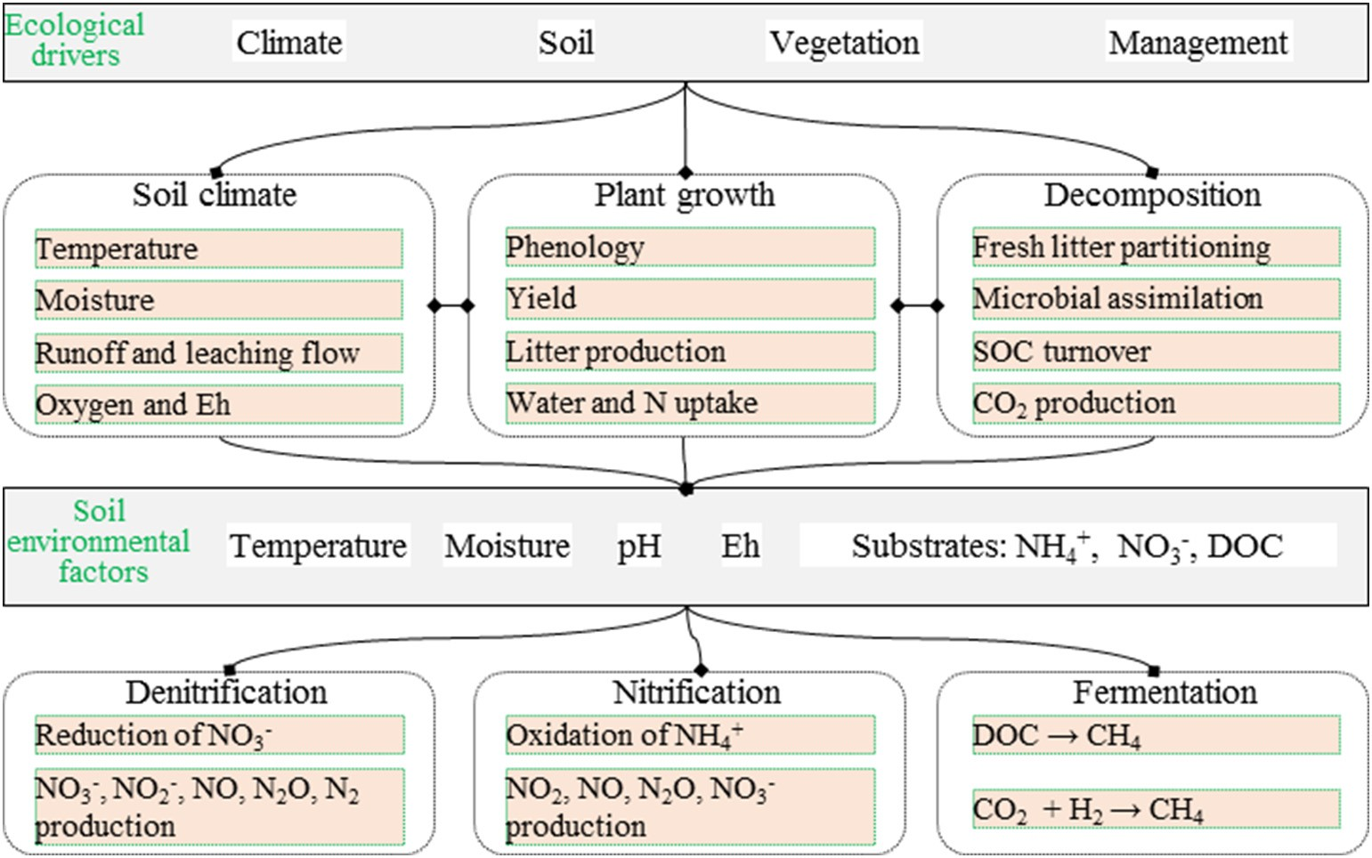](Image%20of%20Fig.%201)

Fig. 1. Structure of the DNDC model (Li, 2016).

accurately simulate the GHG emissions of paddy fields in India, Pathak et al. (2005) increased the leakage rate of certain reaction substrates in soil in the model, such as dissolved organic carbon (DOC) and nitrate. The results of the optimized model greatly reduced CH4 emissions at the high leakage point but had no effect on those at the low or medium leakage point.

* 1. *Plant growth*

Plant growth is closely related to the dynamics of C and N in the ter- restrial ecosystem, which is also the basic step for the DNDC model to correctly simulate the dynamics of C and N in the soil–crop–atmosphere cycle. To accurately simulate crop growth, the model developers established crop submodules and integrated relevant crop growth models, such as the simple empirical equation, PnET (Photosynthesis- Evapotranspiration), EFEM (Economic Farm Emission Model), NEST (Northern Ecosystem Soil Temperature), and general crop model MACROS (Modules of an Annual CROp Simulator) (Zhang et al., 2002; Li et al., 2004; Zhang and Niu, 2016).

The optimized model can simulate the daily growth of crops, the ab- sorption of soil water and N elements by crops, the potential productiv- ity of crops, the growth of crops under the conditions of water and nutrient constraints, and the DOC of a reaction substrate transported into soil by plant root secretions (Fig. 2). Furthermore, the optimized model can track the circulation of C, N, and water in the ecosystem dur- ing plant growth. It uses nine crop parameters (maximum biomass pro- duction; biomass fraction of grain, leaf, stem, and root; biomass C/N ratio; annual N demand; thermal degree days for maturity; water de- mand; N fixation index; optimum temperature; and vascularity) to de- fine rice plant and simulate the daily growth and potential productivity of rice. The DNDC model calculates the stress index of water and N to evaluate the absorption of soil water and N by crops. The DOC of a reac- tion substrate transported to soil by plant root secretion is calculated to track the circulation of C, N, and water in the ecosystem during rice growth. At present, crop parameters in the DNDC model mainly come from observed values in North America and China. Users can use the de- fault values or create their own simulated crops. Katayanagi et al. (2013) verified the N balance in the DNDC-Rice model using rice crop parameters in Japan. The results indicated that the observed values of

[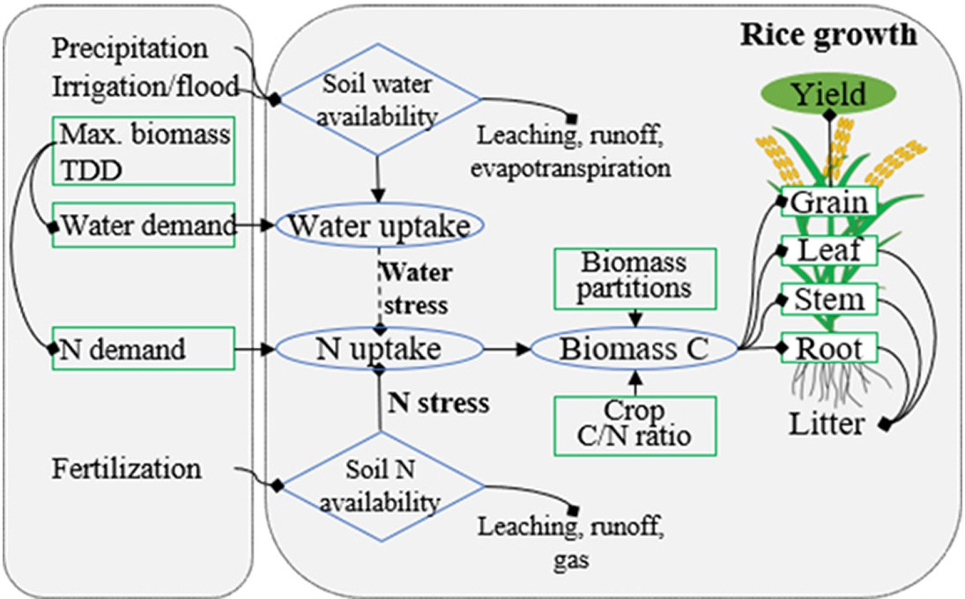](Image%20of%20Fig.%202)

Fig. 2. Rice growth submodel in DNDC.

[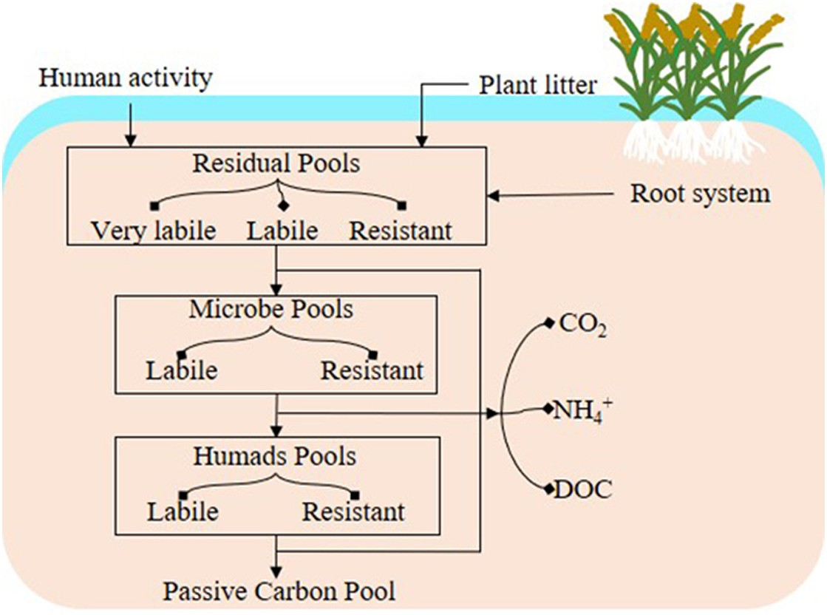](Image%20of%20Fig.%203)

Fig. 3. Carbon dynamics in DNDC model.

grain, stem, and root biomass were consistent with the simulated values (root-mean-square error [RMSE] = 13, 16, and 7%, respectively), but the leaf area index, leaf biomass, and leaf N content were overestimated (RMSE = 125, 60, and 37%, respectively), mainly because of the overes- timation of rice N absorption and leaf N assimilation.

* 1. *Carbon dynamics*

Soil organic carbon (SOC) content is a crucial indicator of soil fertil- ity. In DNDC model, soil organic carbon residues in agro-ecosystem di- vide into 4 major pools: residues, microbe, humads, and passive carbon (Fig. 3). Each pool has 2 or 3 sub-pools with specific default de- composition rates, which affected by soil temperature, soil moisture, soil texture and substrate concentration, etc. SOC is utilized by plants and microorganisms and finally participates in the C and N cycle. The ac- cumulation of crop residues, manure, biochar, and microbial residues in paddy soil constitutes a critical source of soil's SOC pool. According to their physical and chemical properties, exogenous carbon sources are allocated to different subpools of SOC with default decomposition

rates. The decomposition process is affected by many factors, such as or- ganic matter type and soil texture (Li, 2016). The DNDC model can accu- rately simulate SOC and its dynamic change under specific climates (R2 = 0.96) and can also complete long-term estimation (Zhang and Shao, 2017; Ku et al., 2019).

* 1. *Greenhouse gas emissions*

The production and consumption of CO2, CH4, and N2O in soil occur through different redox reactions (decomposition, nitrification/denitri- fication, and methane production) (Fig. 4). Eh determines whether a re- action can occur. The model constructs the “anaerobic balloon,” uses the Nernst equation to calculate Eh in the system, and then uses Eh to judge which redox reaction should occur. The balloon uses the Michaelis– Menten equation to quantify the kinetic effect of substrate concentra- tion on the reaction rate, realizing the conjugate calculation of the ther- modynamics and kinetics of the redox reaction generated by GHGs. Moreover, the model defines the interior of the balloon as a relatively reduced soil microarea and the exterior as an oxidized one and allocates

[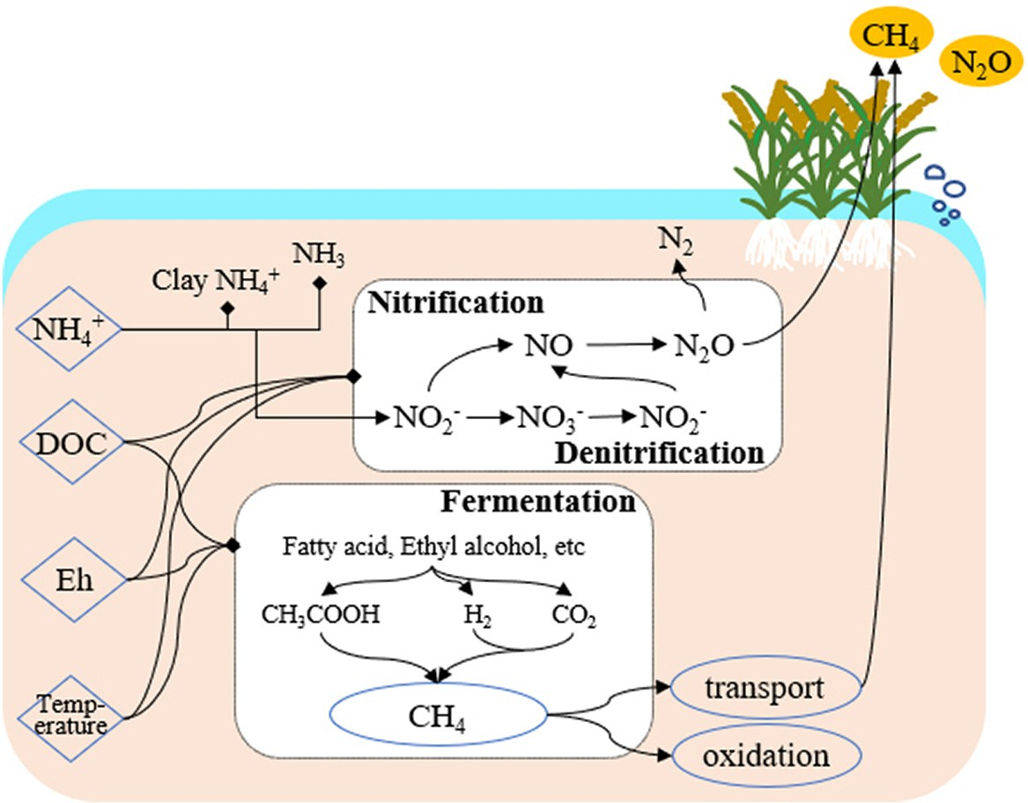](Image%20of%20Fig.%204)

Fig. 4. The process of greenhouse gas emissions in DNDC model.

the reaction substrate (such as DOC, NH+, NO−, and O ) to the interior

calculating the C output (soil respiration and DOC leaching) and C

4 3 2

and exterior of the balloon proportionally to produce reduction or oxi- dation reactions, respectively. The DNDC model calculates the con- sumption and concentration changes of DOC, O2, NO−, NO−, NO, N O,

3

2

2

Mn+, Fe+, SO2−, and H in various reactions to track the changes of

input (such as straw return, plant litter, and manure input) of soil daily and accumulates the daily change in SOC storage to obtain the an- nual change (Li, 2016).

Exogenous C input, such as straw return, manure input, or biochar

4 3 4 2

CO2, CH4, and N2O (Li et al., 2004).

Because of the special water management mode of paddy fields, the soil water fluctuates frequently between states of saturation and unsaturation, and the range of Eh variation can be from +650 to

−350 mV. CH4 and N2O can only be produced under specific Eh condi-

tions (CH4, −300 to −150 mV; N2O, 200 to 500 mV) (Li, 2016). In the model, O2, NO−, Mn4+, Fe3+, and SO2− are added as electron acceptors

3

4

application, can promote the accumulation of soil SOC. Yan et al. (2011) found that the average organic C content in the surface soil (0–20 cm) of cropland in China increased from 11.95 g kg−1 during 1979–1982 to 12.67 g kg−1 during 2007–2008, with an average annual growth rate of 0.22%. Based on the Geographic Information System (GIS) database of soil properties and agricultural management systems, the C sequestration of farmland soil for the next 30 years was estimated.

and H2 and DOC are used as electron donors to more effectively track the change of soil Eh, determine the reaction rate of each oxidation/re- duction reaction, and calculate the generation and consumption of CH4 and N2O (Fumoto et al., 2008; Katayanagi et al., 2012).

1. Carbon sequestration and emissions mitigation of paddy ﬁelds

The DNDC model employs the climate, soil, crop, and agricultural management of the ecosystem as the environmental driving factors; constructs the soil biogeochemical field, including temperature, mois- ture, pH, Eh, and substrate concentration; adopts the biogeochemical process in the C and N cycle as the core process; and finally, completes the dynamic simulation of the C and N cycle of the ecosystem. The DNDC model combines agricultural practices such as crop growth, water management, fertilizer management, and tillage. After agricul- tural practices are input, the change of the biogeochemical field in the model affects the C and N cycle in the system, thereby affecting the C se- questration and emissions mitigation effect of the paddy ecosystem (Fig. 5). In a paddy ecosystem, agricultural practices affect the C and N cycle and have a critical impact on its C sequestration and emissions mitigation potential (Table 1).

* 1. *Carbon sequestration potential of a paddy ecosystem*
     1. *Effect of exogenous carbon addition on the carbon sequestration po- tential of a paddy ecosystem*

Agricultural practices are the main reason for SOC change. SOC change is induced by two processes: (1) the consumption of SOC by mi- croorganisms through heterotrophic respiration and (2) the addition of exogenous C. The model calculates the daily change in SOC storage by

The estimations revealed that the soil in East Sichuan is in a state of con- tinuous C sequestration under current management practices (Zhang and Shao, 2017). The main reason is the increase of crop yield and exog- enous C caused by straw return, which is an effective measure for soil C sequestration. With the increase of the straw return proportion in China, SOC will continue to increase; however, the decomposition rate of straw left on the surface is higher than that of straw buried in the soil, which is not conducive to the accumulation of SOC. Adding tillage methods and the amount of straw return to the model can help simulate and evaluate the effect of different depths of straw return on C sequestration.

Without straw return or manure application, the SOC of a paddy field will continue to decrease. Fresh straw return and decomposed straw manure application can increase soil SOC content by 9% and 11%, respectively (Ku et al., 2019). Manure application can promote the increase of soil SOC content mainly because its decomposition rate is lower than that of fresh straw. The combined simulation results of DSSAT crop model and the DNDC model indicate that soil SOC stock can be increased by 28% with the combined application of chemical fer- tilizer and manure (Naher et al., 2020). When straw and other biomass are cracked into biochar, their properties become stable and they are beneficial for C sequestration when applied to cropland. Stable biochar can fix more C in the soil. A meta-analysis revealed that biochar could significantly increase the SOC content of farmland surface soil (Liu et al., 2016). In the model, biochar is classified into inert C pools with low decomposition rates. However, biochar contains some easily de- composable components, and its stability varies depending on the source. Therefore, determining how to use the model to evaluate the C sequestration potential of soil after biochar application remains to be completed.

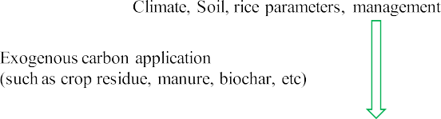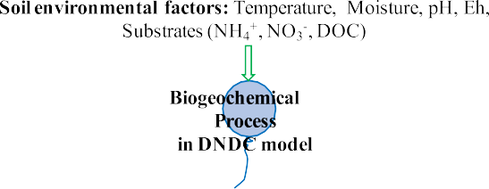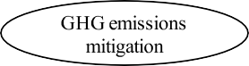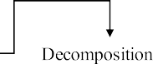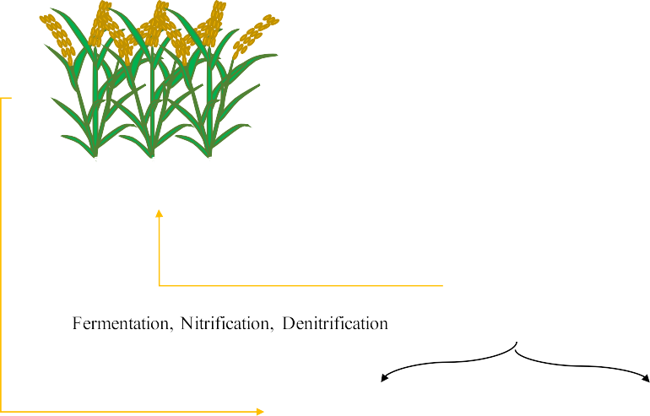

Fig. 5. DNDC application in GHG C sequestration and emissions mitigation in paddy fields.

Table 1

Statistics for evaluating the performance of DNDC model for rice yield, GHG emissions, and carbon stock in paddy fields over the past 10 years.

|  |  |  |  |  |  |
| --- | --- | --- | --- | --- | --- |
| Location | Agricultural management | Variation | Statistical index | Aims | Reference |
| Shanghai, China | Organic+inorganic | CH4 | R2: 0.76, ME: | Spatial scale, GHG mitigation | (Zhao et al., 2020) |
| Punjab, India | fertilizer  Fertilizer management | N2O SOC | 0.71  R2: 0.71, ME:  0.67  R2: 0.78 | Spatial scale, C sequestration | (Singh and Benbi, |
| Zhejiang, China | Fertilizer management | Rice | R2: 0.88, rRMSE: | IPCC scenarios, GHG mitigation | 2020)  (Chen et al., 2020) |
|  |  | yield | 0.12 |  |  |
| Zhejiang, China | Fertilizer management | CH4 N2O  Rice | Similar pattern Similar pattern  R2: 0.90, ME: | Spatial scale, C sequestration and | (Zhu et al., 2019) |
|  |  | yield  SOC | 0.75  R2: 0.71, ME: | GHG mitigation |  |
| Jiangxi, China | Land use change | content  CH4 | 0.75  R2: 0.80– 0.89 | GHG mitigation | (Zhao et al., |
| Shanghai, China | Rotation system | N2O  Rice | R2: 0.16– 0.71  R2: 0.96, ME: | Spatial scale, GHG mitigation | 2019a)  (Zhang et al., |
| Heilongjiang, China | Traditional | yield CH4  N2O CH4 | 0.70– 0.86  R2: 0.88, ME:  0.41– 0.56  ME: −0.23 to  −7.88  R2: 0.89, ME: | Spatial scale, IPCC scenarios, GHG | 2019b)  (Nie et al., 2019) |
|  | management |  | 0.87 | mitigation |  |
| Iksan, South Korea | Straw incorporation | Rice | ME: −5.5– 0 | Time scale; C sequestration | (Ku et al., 2019) |
|  |  | yield |  |  |  |
| Jianghan Plain, China | Rotation system | SOC CH4 | ME: 0– 0.37  R2: 0.92– 0.93, RAE: | Spatial scale, GHG mitigation | (Zou et al., 2018) |
|  |  | N2O | 8.29– 15.31%  R2: 0.85– 0.98 RAE: |  |  |
|  |  |  | 12.13– 16.42% |  |  |
| China | Traditional | Rice | RAE: 0– 8.14% | Spatial scale, GHG mitigation | (Tian et al., 2018) |
| Shandong, China | management  Traditional | yield  SOC | R2: 0.48– 0.94, | Spatial scale, C sequestration | (Chen et al., 2018) |
| Red River Delta, Vietnam | management  Traditional | content  CH4 | ME: 0.35– 0.83  R2: 0.95 | Spatial scale, IPCC scenarios | (Torbick et al., |
| Central Thailand | management  Traditional | Rice | R2: 0.99 | Spatial scale, IPCC scenarios, CH4 | 2017)  (Minamikawa |
|  | management | yield  CH4 | R2: 0.96 | mitigation | et al., 2016) |
| Beijing, China | Fertilizer management | SOC | R: 0.45– 0.78 | C sequestration | (Li et al., 2016) |
|  |  | content |  |  |  |
| Henan, China | Fertilizer management | SOC | R: 0.41– 0.73 | C sequestration | (Li et al., 2016) |
|  |  | content |  |  |  |
| Japan  (Hokkaido, Tohoku, Hokuriku, Kanto, Tokai-kinki, | Water management | CH4 | R: 0.85– 0.89 | CH4 simulation | (Katayanagi et al.,  2016) |
| Chugoku-Shikoku, Kyushu-OKinawa) |  |  |  |  |  |
| Jiangsu, China | Water management | N2O | R: 0.48– 0.79 | N2O simulation | (Hou et al., 2016) |
| Shanghai, China | Fertilizer management | Rice | R2: 0.89 | C sequestration and GHG | (Gao et al., 2016) |
|  |  | yield  CH4 | R2: 0.87 | mitigation |  |
|  |  | SOC | R2: 0.76 |  |  |
|  |  | stock |  |  |  |
| Gimje, South Korea | Water management | CH4 | ME: 0.24– 0.65 | CH4 mitigation | (Chun et al., 2016) |
| China | Water and nitrogen | Rice | R2: 0.79– 0.84 | Spatial scale, GHG mitigation | (Chen et al., 2016) |
| (Hunan, Chongqing, Guangxi, Shanghai, Jiangsu, | management | yield |  |  |  |
| Heilongjiang)  Califonia, USA | Direct-seeded rice | CH4 N2O  Rice | Similar pattern  Similar pattern R2: 0.30– 0.78 | GHG mitigation | (Simmonds et al., |
|  | system | yield  CH4 | R2: 0.85 |  | 2015) |
| Tai-Lake region, China | Traditional | N2O  SOC | R2: 0.31  R: 0.2– 0.5 | Spatial scale | (Zhang et al., |
| Jiangsu, China | management Traditional  management | content N2O | R2: 0.89 | Model performance | 2014)  (Wu and Zhang, 2014) |
| China | Traditional | SOC | R: 0.40– 0.99 | Spatial scale, C sequestration | (Xu et al., 2012a) |
| Sanjiang Plain, China | management  Fertilizer management | content  CH4 | R2: 0.85– 0.91, | Spatial scale, CH4 simulation | (Zhang et al., |
|  |  |  | ME: 0.84– 0.87 |  | 2011) |

Note: R2, coefficient of determination; ME, Nash–Sutcliffe index of model efficiency; rRMSE, relative root mean square error; RAE, relative absolute error.

* + 1. *Effect of tillage practices on the carbon sequestration potential of a paddy ecosystem*

In addition to the application of exogenous C, the long-term use of plowing tillage, rotary tillage, and other traditional tillage methods in the agricultural ecosystem has effects on soil mineralization, thereby af- fecting SOC accumulation. No-tillage practices can fix C by reducing the disturbance of soil and the decomposition rate of the C pool. However, according to the results of the DNDC model, the potential of no tillage for soil C sequestration is highly limited. In Jiangsu, China, the soil C se- questration potential at 0–30 cm soil depth under reduced tillage, no tillage, and combined tillage (reduced tillage and 30% straw incorpora- tion), was quantitatively estimated, which indicated that the applica- tion of reduced tillage and no tillage could increase the accumulation of SOC in some paddy fields, and combined tillage had twice potential for C sequestration than in reduced tillage (Xu et al., 2012b). Site exper- iment and model simulation results in Ningxia and Hunan province also showed that the effect of no tillage combined with straw return on soil C sequestration was superior to that of no tillage only (Huang et al., 2012). However, some studies have confirmed that no tillage practices lead to soil hardening and affect soil aeration and crop yield (Pittelkow et al., 2015). Therefore, comprehensive consideration is required when assessing the C sequestration potential of tillage practices.

* 1. *Greenhouse gas emissions mitigation potential of a paddy ecosystem*
     1. *Effects of water management measures on the emissions mitigation potential of a paddy ecosystem*

CH4 is produced by methanogenic bacteria using soil humus, rice root exudates, soil microbial residues, and organic materials as sub- strates. In the root exudation area (around the root) or soil micro- oxidation area, some CH4 is oxidized to CO2 and H2O by methanotrophic bacteria, and some CH4 that is not oxidized is discharged into the atmo- sphere through rice plants, bubbles, and liquid diffusion. The model builds a module based on an anaerobic balloon, which can effectively implement and stimulate CH4 and N2O emissions in flooded paddy fields.

Flooded paddy fields are a critical source of CH4 emissions, and the key to reducing such emissions is to optimize water management. Mid-season drainage not only inhibits the ineffective tillering of rice through water stress but also reduces CH4 emissions through promoting the oxidation of CH4. Compared with continuous flooding, mid-season drainage can significantly reduce the total CH4 emissions from paddy fields by 36% to 77% (Zou et al., 2005; Wang et al., 2012b). Li et al. (2004, 2005) used the DNDC model to evaluate the potential of paddy emissions mitigation in China, and their results indicated that mid- season drainage water management could reduce CH4 emissions by

4.2–4.7 Tg CH4-C yr-1 while increasing N2O emissions by 0.13–0.20 Tg

N2O-N yr-1 from paddy fields in China. Compared with the practice of single drainage, multiple drainage can further reduce CH4 emissions during rice growth (Sander et al., 2016), which is consistent with simu- lation results of the model (Minamikawa et al., 2016). Compared with flooding, single and multiple drainage in 2051–2060 reduced CH4 emis- sions by 21.9–22.9% and 53.5–55.2%, respectively, under the RCP4.5 sce- nario (Minamikawa et al., 2016).

In addition, the DNDC model can define numerous water manage- ment modes. This enables the simulation analysis of GHG emission sce- narios under various types of water management to effectively predict their emissions mitigation potential in time and space scales. After pa- rameterizing two rice varieties, namely M206 (a high-yield and semi- dwarf variety) and Koshihikari (a traditional variety), Simmonds et al. (2015) simulated the grain yield and CH4 and N2O emissions of rice under different N loads and water management types with water- seeding and dry-seeding cultivation. The results indicated that DNDC could distinguish the rice yield of the two varieties and reproduce the CH4 emission dynamics under different management scenarios. Water-saving irrigation management, such as controlled irrigation and

alternate wetting and drying, can significantly reduce CH4 emissions but may also promote N2O emissions (Zhou et al., 2020). Field experi- ment and model evaluation results revealed that alternate wetting and drying effectively reduced CH4 emissions during rice growing sea- sons but also simultaneously stimulated N2O emissions; furthermore, the comprehensive global warming potential (GWP) was only one- third of that under flooding management (Katayanagi et al., 2012). The model could also effectively simulate the dynamics of CH4 emission peak values in the rice–dry crop rotation system, which was basically consistent with field observation results (Zhang, 2013; Chun et al., 2016).

* + 1. *Effect of nitrogen management on emissions mitigation potential of a paddy ecosystem*

Chemical N fertilizer and manure provide the substrate source for soil nitrification and denitrification microorganisms, which is the most critical factor affecting N2O emissions. The global annual N2O emissions from the application of chemical N fertilizer and manure were 2.0 ± 0.8 Tg N and 0.6 ± 0.4 Tg N, respectively (Li and Ju, 2020). The N2O emis- sions caused by the field fertilization practice accounted for 33% of total N2O emissions. The continuously increasing amount of fertilizer being applied has been the main reason for the global N2O emissions in- crease. Many studies have confirmed that soil N2O emissions increase linearly or exponentially with the increase of N application (Shcherbak et al., 2014; Wang et al., 2018).

To reduce the application amount of N fertilizer, improve the utiliza- tion rate, and reduce the N2O emissions of cropland soil, many scientists have summarized a concept and technology based on the optimization of N management called the 4Rs: right fertilizer rate, right application time, right place, and right source. The submodule of N application in the model includes factors such as the type, amount, time, and mode of application, which provide a foundation for the estimation of the im- pact of 4R technology on GHG emissions.

Based on DNDC model, the simulated value of crop yield was fitted the measured value well in rice-wheat rotation system under different N application, which reflected the relationship between crop yield and N application; when N fertilizer application reached 60% of the conven- tional amount, the increase in N no longer promoted a significant in- crease in crop yield, whereas the comprehensive greenhouse effect decreased by 43% compared with the conventional practice (Li, 2012). After the rice varieties were parameterized by Simmonds et al. (2015), the model could reproduce the CH4 emission dynamics under different amounts of N fertilizer and different flooding times. The results of DNDC estimation indicated that GHG emissions could be reduced without af- fecting the crop yield through reducing the amount of N applied based on the current amount. At present, a large potential exists for reducing the use of chemical N fertilizer in China. The paddy yield will be stabi- lized when the amount of N fertilizer is reduced by 0.88 Tg per year. In the main rice growing regions of China, such as Jiangsu, Yunnan, Gui- zhou, and Hubei provinces, GHG emissions can be reduced by as much as 40% through N fertilizer reduction (Chen et al., 2016).

* + 1. *Effect of exogenous carbon addition on the emissions mitigation po- tential of a paddy ecosystem*

The reasonable addition of exogenous C can affect CH4 emissions in paddy fields. Numerous studies have shown that all types of exogenous C, such as straw, green manure, and organic manure, provide rich sub- strates for methanogens and can significantly promote CH4 emissions from rice fields (Wang et al., 2012b; Zhou et al., 2020). Compared with no exogenous carbon addition, manure input and straw incorpora- tion enhanced CH4 emission per unit of rice yield significantly, with 54% and 107% increase respectively (Zhao et al., 2019b). Straw return or ma- nure application can suddenly increase the content of soil organic mat- ter, but it will be gradually decomposed by soil microorganisms, providing a rich substrate for methanogens and other microorganisms. The model constructed the effect of environmental conditions on

microbial decomposition activity, which can accurately reproduce the biogeochemical process of exogenous C addition.

In addition, CH4 emissions increased significantly under the scenar- ios of high straw return and manure application (Wang et al., 2012a). The results of model simulations and field experiments indicated that N2O emissions were affected by straw return amount, return type, and return depth. Returning straw to the field after incineration resulted in significantly higher N2O emissions than returning to the field directly (Chen et al., 2015). After the indices of alfalfa and broad bean were pa- rameterized in the DNDC model, the observed values and simulated re- sults of Gao et al. (2016) revealed that the application of alfalfa and broad bean straw during rice growing season significantly increased CH4 emissions, and the effect of broad bean straw was greater than that of Alfalfa straw. In different rice rotation systems, the GHG emission of a rice–Chinese milk vetch rotation system was lower than that of a rice–wheat rotation system (Zhang et al., 2019b). However, the model cannot accurately express the effect of biochar treatment on CH4 and N2O because no specific input parameter exists for biochar in the model (Wang, 2013).

* + 1. *Effect of coupling agricultural practices on the emissions mitigation potential of a paddy ecosystem*

In actual rice production, the pairing of water and fertilizer and other agricultural practices is often used to stabilize the yield and reduce GHG emissions. A reduction in N application by 15.7% would not reduce rice yield in China, and the combination of shallow irrigation and appropri- ate fertilization could reduce GHG emissions by 34.3% while increasing the rice yield by 1.7% (Chen et al., 2016). The most effective measures for GHG emission mitigation in paddy fields are upland rice cultivation N shallow irrigation N use of ammonium sulfate instead of urea or am- monium bicarbonate N medium-term sun drying N straw return in nonrice-growing season N application of slow-release fertilizer N contin- uous flooding irrigation (Li et al., 2006). Tian et al. (2018) paired the DNDC model with the DSSAT model and Agro-Ecological Zone model to evaluate the balance relationship between GHG emissions and yield under Chinese rice-planting conditions. The simulation results showed that CH4 and N2O emissions could be reduced while the yield was guar- anteed under the double management measures of mid-season drain- age and balanced fertilization. The DNDC model can also be used to analyze the N balance and N use efficiency of paddy fields under differ- ent irrigation, fertilization, and controlled drainage conditions. When water-saving irrigation is applied and the amount of N applied does not exceed 180 kg N ha-1, the soil N pool of paddy field is loss (54.7–- 127.6 kg N ha-1). Except for shallow irrigation–deep storage–medium level N application and shallow irrigation–deep storage–high N applica- tion, the N deficit of controlled drainage treatment was greater than that in conventional drainage treatment. The combination of shallow irriga- tion, deep storage, medium level N, and controlled drainage was the op- timal water and fertilizer treatment mode (Liu and Shao, 2013).

The application of plastic mulching cultivation technology can solve the problem of winter irrigation of paddy rice in northwest China, and it is also a crucial form of agricultural management for CH4 emission mit- igation. Compared with continuous flooding, plastic mulching could sig- nificantly reduce CH4 emissions by 86% while maintaining rice yield (Zhang et al., 2013). Moreover, compared with a field without mulching, the soil climate of a field with mulching was significantly dif- ferent, mainly with respect to field evapotranspiration, heat exchange, and soil aeration, which affected the soil temperature and moisture, mi- crobial activity, and gas diffusion emissions. Many studies have modi- fied and optimized the mulching submodule of the DNDC model (Han et al., 2014; Zhang et al., 2019a; Zhou et al., 2019). The model can sim- ulate the soil temperature and moisture accurately under different mulching density scenarios. However, few studies have been conducted on GHG emissions simulation under the condition of paddy field mulching.

In addition, cultivating and selecting varieties with excellent drought resistance and high yield play crucial roles in water saving and emissions mitigation. In recent years, China has developed a new variety of culti- vated rice, namely water-saving and drought-resistant rice (WDR), which differs from lowland and upland rice varieties. WDR has the char- acteristics of high-yield and high-quality rice and the water-saving and drought-resistant properties of upland rice. When irrigation was reduced by 50%, the yield and quality of WDR were the same as those of traditional rice (Luo, 2018). When irrigation was reduced by 70%, its CH4 emissions decreased by 51–77% while the yield remained relatively stable (Sun et al., 2016). The emergence of WDR combines the advantages of the high yield of lowland rice and low water demand of upland rice. The water demand, root exudates, and root oxygen secretion ability differ from those of conventional lowland rice, resulting in the specificity of GHG emissions and N loss. How to make more effective use of the DNDC model to evaluate its potential in paddy field emissions mitigation is one of the directions for model improvement and optimization.

1. Conclusion

It is critical to recognize the potential of C sequestration and emis- sions mitigation in paddy fields for dealing with global climate change. Many studies have made numerous achievements in case studies of C sequestration and emissions mitigation. Since the establishment of the DNDC model, researchers worldwide have used their field data to verify and correct the model, which has caused the continual increase of its credibility and continual expansion of its functionality and scope. The model can now be used in various terrestrial ecosystems to predict crop growth, soil C and N dynamics, GHG emissions, and N loss.

After modification and calibration, the model has been applied to the assessment of GHG emissions and the SOC sequestration potential of C sequestration and emissions mitigation measures such as straw return, water management, and N reduction. Moreover, it is necessary to fur- ther analyze the effects of various management measures—such as straw return to the field, biochar application, and water management from flooding to water-saving irrigation—on the comprehensive poten- tial of C sequestration and emissions mitigation in paddy fields; thus, the timing for exogenous C application and water management can be arranged and the C sequestration and emissions mitigation potential of this measure can be maximized.

With the aggravation of environmental problems and the improve- ment of agricultural practices, expectations for the prediction function of the model are increasing. In the future, it will be necessary to evaluate the comprehensive effects of various farmland measures on SOC change, GHG emissions, food security, and ecological environments. How to make more effective use of the DNDC model to serve the low- C production of rice from the point to regional scale as well as how to establish a reliable prediction and evaluation system under agricultural practices and climate scenarios are the development trends for the model's application.

CRediT author statement

Shan Yin: Conceptualization, Writing - Original Draft; Xianxian Zhang: Conceptualization, Writing - Original Draft; Junyao Lyu: Writ- ing - Original Draft; Yuee Zhi: Investigation, Resources; Feng Chen: In- vestigation, Resources; Longqin Wang: Investigation, Resources; Chunjiang Liu: Writing - Review & Editing, Project administration; Sheng Zhou: Writing - Review & Editing, Project administration.

Acknowledgements

This study was financed by the National Key Research and Develop- ment Program of China, China (2017YFD0800204), and Shanghai Agricul- ture Applied Technology Development Program, China (G2016060301 and 2018(1-3)).

References

Aliyu, G., Luo, J., Di, H.J., Lindsey, S., Liu, D., Yuan, J., Chen, Z., Lin, Y., He, T., Zaman, M., Ding, W., 2019. [Nitrous oxide emissions from China’s croplands based on regional and](http://refhub.elsevier.com/S2589-7217(20)30021-0/rf0005) [crop-specific emission factors deviate from IPCC 2006 estimates. Sci. Total Environ.](http://refhub.elsevier.com/S2589-7217(20)30021-0/rf0005) [669, 547–55](http://refhub.elsevier.com/S2589-7217(20)30021-0/rf0005)8.

Chen, C., Chen, D.L., Lam, S.K., 2015. [Simulation of nitrous oxide emission and mineralized](http://refhub.elsevier.com/S2589-7217(20)30021-0/rf0010) [nitrogen under different straw retention conditions using a denitrification-](http://refhub.elsevier.com/S2589-7217(20)30021-0/rf0010) [decomposition model. CLEAN-Soil Air Water. 43 (4), 577–583](http://refhub.elsevier.com/S2589-7217(20)30021-0/rf0010).

Chen, H., Yu, C., Li, C., Xin, Q., Huang, X., Zhang, J., Yue, Y., Huang, G., Li, X., Wang, W., 2016. [Modeling the impacts of water and fertilizer management on the ecosystem service](http://refhub.elsevier.com/S2589-7217(20)30021-0/rf0015) [of rice rotated cropping systems in China. Agric. Ecosyst. Environ. 219, 49–57](http://refhub.elsevier.com/S2589-7217(20)30021-0/rf0015).

Chen, Z., Wang, J., Deng, N., Lv, C., Wang, Q., Yu, H., Li, W., 2018. [Modeling the effects of](http://refhub.elsevier.com/S2589-7217(20)30021-0/rf0020) [farming management practices on soil organic carbon stock at a county-regional](http://refhub.elsevier.com/S2589-7217(20)30021-0/rf0020) [scale. Catena. 160, 76–89](http://refhub.elsevier.com/S2589-7217(20)30021-0/rf0020).

Chen, P., Yang, J., Jiang, Z., Zhu, E., Mo, C., 2020. [Prediction of future carbon footprint and](http://refhub.elsevier.com/S2589-7217(20)30021-0/rf0025) [ecosystem service value of carbon sequestration response to nitrogen fertilizer rates](http://refhub.elsevier.com/S2589-7217(20)30021-0/rf0025) [in rice production. Sci. Total Environ. 735, 139506](http://refhub.elsevier.com/S2589-7217(20)30021-0/rf0025).

Chun, J., Shim, K., Min, S., Wang, Q., 2016. [Methane mitigation for flooded rice paddy sys-](http://refhub.elsevier.com/S2589-7217(20)30021-0/rf0030) [tems in South Korea using a process-based model. Paddy Water Environ. 14 (1),](http://refhub.elsevier.com/S2589-7217(20)30021-0/rf0030) [123–12](http://refhub.elsevier.com/S2589-7217(20)30021-0/rf0030)9.

Cui, G., Wang, J., 2019. [Improving the DNDC biogeochemistry model to simulate soil tem-](http://refhub.elsevier.com/S2589-7217(20)30021-0/rf0035) [perature and emissions of nitrous oxide and carbon dioxide in cold regions. Sci. Total](http://refhub.elsevier.com/S2589-7217(20)30021-0/rf0035) [Environ. 687, 61–70](http://refhub.elsevier.com/S2589-7217(20)30021-0/rf0035).

Food and Agriculture Organization (FAO), 2020. [Statistical Yearbook 2016. World Food](http://refhub.elsevier.com/S2589-7217(20)30021-0/rf0040) [and Agriculture](http://refhub.elsevier.com/S2589-7217(20)30021-0/rf0040).

Fumoto, T., Kobayashi, K., Li, C., Yagi, K., Hasegawa, T., 2008. [Revising a process-based bio-](http://refhub.elsevier.com/S2589-7217(20)30021-0/rf0045) [geochemistry model (DNDC) to simulate methane emission from rice paddy fields](http://refhub.elsevier.com/S2589-7217(20)30021-0/rf0045) [under various residue management and fertilizer regimes. Glob. Chang. Biol. 14 (2),](http://refhub.elsevier.com/S2589-7217(20)30021-0/rf0045) [382–40](http://refhub.elsevier.com/S2589-7217(20)30021-0/rf0045)2.

Gao, M., Qiu, J., Li, C., Wang, L., Li, H., Gao, C., 2014. [Modeling nitrogen loading from a wa-](http://refhub.elsevier.com/S2589-7217(20)30021-0/rf0050) [tershed consisting of cropland and livestock farms in China using manure-DNDC.](http://refhub.elsevier.com/S2589-7217(20)30021-0/rf0050) [Agric. Ecosyst. Environ. 185, 88–98](http://refhub.elsevier.com/S2589-7217(20)30021-0/rf0050).

Gao, X., Yuan, S., Lv, A., Zhou, P., An, Y., 2016. [Effects of alfalfa green manure on rice pro-](http://refhub.elsevier.com/S2589-7217(20)30021-0/rf0055) [duction and greenhouse gas emissions based on a DNDC model simulation (in Chi-](http://refhub.elsevier.com/S2589-7217(20)30021-0/rf0055) [nese). Acta Pratacul. Sin. 25 (12), 14–26](http://refhub.elsevier.com/S2589-7217(20)30021-0/rf0055).

Gilhespy, S.L., Anthony, S., Cardenas, L., Chadwick, D., del Prado, A., Li, C., Misselbrook, T., Rees, R.M., Salas, W., Sanz-Cobena, A., Smith, P., Tilston, E.L., Topp, C.F.E., Vetter, S., Yeluripati, J.B., 2014. [First 20 years of DNDC (DeNitrification DeComposition):](http://refhub.elsevier.com/S2589-7217(20)30021-0/rf0060) [model evolution. Ecol. Model. 292, 51–62](http://refhub.elsevier.com/S2589-7217(20)30021-0/rf0060).

Han, J., Jia, Z., Wu, W., Li, C., Han, Q., Zhang, J., 2014. [Modeling impacts of film mulching on](http://refhub.elsevier.com/S2589-7217(20)30021-0/rf0065) [rainfed crop yield in Northern China with DNDC. Field Crop Res. 155, 202–212](http://refhub.elsevier.com/S2589-7217(20)30021-0/rf0065).

Hou, H., Shalamu, A., Chen, H., Yang, S., 2016. [Simulation of N2O emission from rice-wheat](http://refhub.elsevier.com/S2589-7217(20)30021-0/rf0070) [rotation field under controlled irrigation of rice in Southeast China (in Chinese).](http://refhub.elsevier.com/S2589-7217(20)30021-0/rf0070) [Transactions of the Chinese Society for Agricultural Machinery. 47 (12), 185–19](http://refhub.elsevier.com/S2589-7217(20)30021-0/rf0070)1.

Huang, X., Tang, B., Xia, X., Zhang, H., 2012. [Evaluation of soil carbon sequestration poten-](http://refhub.elsevier.com/S2589-7217(20)30021-0/rf0075) [tial under conservation tillage in double rice cropping region with DNDC model.](http://refhub.elsevier.com/S2589-7217(20)30021-0/rf0075) [Paper presented at the 2012 2nd International Conference on Remote Sensing, Envi-](http://refhub.elsevier.com/S2589-7217(20)30021-0/rf0075) [ronment and Transportation Engineering, Nanjing, Jiangsu, Chin](http://refhub.elsevier.com/S2589-7217(20)30021-0/rf0075)a.

Intergovernmental Panel on Climate Change (IPCC), 2014. [Climate Change 2014: Mitiga-](http://refhub.elsevier.com/S2589-7217(20)30021-0/rf0080) [tion of Climate Change. Retrieved from Cambridge, United Kingdom and New York,](http://refhub.elsevier.com/S2589-7217(20)30021-0/rf0080) [NY, USA](http://refhub.elsevier.com/S2589-7217(20)30021-0/rf0080).

Jiang, Z., Shan, Y., Zhang, X., Li, C., Shen, G., Pei, Z., Liu, C., 2017. [Research and development](http://refhub.elsevier.com/S2589-7217(20)30021-0/rf0085) [of a DNDC online model for farmland carbon sequestration and GHG emissions mit-](http://refhub.elsevier.com/S2589-7217(20)30021-0/rf0085) [igation in China. International Journal of Environmental Research and Public Health](http://refhub.elsevier.com/S2589-7217(20)30021-0/rf0085) [14, 149](http://refhub.elsevier.com/S2589-7217(20)30021-0/rf0085)3.

Katayanagi, N., Furukawa, Y., Fumoto, T., Hosen, Y., 2012. [Validation of the DNDC-Rice](http://refhub.elsevier.com/S2589-7217(20)30021-0/rf0090) [model by using CH4](http://refhub.elsevier.com/S2589-7217(20)30021-0/rf0090) [and N2O flux data from rice cultivated in pots under alternate](http://refhub.elsevier.com/S2589-7217(20)30021-0/rf0090) [wetting and drying irrigation management. Soil Science and Plant Nutrition. 58 (3),](http://refhub.elsevier.com/S2589-7217(20)30021-0/rf0090) [360–37](http://refhub.elsevier.com/S2589-7217(20)30021-0/rf0090)2.

Katayanagi, N., Ono, K., Fumoto, T., Mano, M., Miyata, A., Hayashi, K., 2013. [Validation of](http://refhub.elsevier.com/S2589-7217(20)30021-0/rf0095) [the DNDC-Rice model to discover problems in evaluating the nitrogen balance at a](http://refhub.elsevier.com/S2589-7217(20)30021-0/rf0095) [paddy-field scale for single-cropping of rice. Nutr. Cycl. Agroecosyst. 95 (2), 255–268](http://refhub.elsevier.com/S2589-7217(20)30021-0/rf0095). Katayanagi, N., Fumoto, T., Hayano, M., Takata, Y., Kuwagata, T., Shirato, Y., Sawano, S., Kajiura, M., Sudo, S., Ishigooka, Y., Yagi, K., 2016. [Development of a method for esti-](http://refhub.elsevier.com/S2589-7217(20)30021-0/rf0100) [mating total CH4 emission from rice paddies in Japan using the DNDC-Rice model.](http://refhub.elsevier.com/S2589-7217(20)30021-0/rf0100)

[Sci. Total Environ. 547, 429–44](http://refhub.elsevier.com/S2589-7217(20)30021-0/rf0100)0.

Ku, H.-H., Ryu, J.-H., Bae, H.-S., Jeong, C., Lee, S.-E., 2019. [Modeling a long-term effect of](http://refhub.elsevier.com/S2589-7217(20)30021-0/rf0105) [rice straw incorporation on SOC content and grain yield in rice field. Arch. Agron.](http://refhub.elsevier.com/S2589-7217(20)30021-0/rf0105) [Soil Sci. 65 (14), 1941–1954](http://refhub.elsevier.com/S2589-7217(20)30021-0/rf0105).

Li, X., 2012. [Simulation nitrogen levels on economic yield and global warming potentials](http://refhub.elsevier.com/S2589-7217(20)30021-0/rf0110) [of rice-wheat rotation (in Chinese). Master. East China University of Science and](http://refhub.elsevier.com/S2589-7217(20)30021-0/rf0110) [Technology, Available from Cnki](http://refhub.elsevier.com/S2589-7217(20)30021-0/rf0110).

Li, C., 2016. [Biogeochemistry: Scientific Fundamentals and Modeling Approach (in Chi-](http://refhub.elsevier.com/S2589-7217(20)30021-0/rf0115) [nese). Tsinghua University Press, Beijin](http://refhub.elsevier.com/S2589-7217(20)30021-0/rf0115)g.

Li, Y., Ju, X., 2020. [Rational nitrogen application is the key to mitigate agricultural nitrous](http://refhub.elsevier.com/S2589-7217(20)30021-0/rf0120) [oxide emission (in Chinese). Journal of Agro-Environment Science. 39 (04), 842–851](http://refhub.elsevier.com/S2589-7217(20)30021-0/rf0120).

Li, C., Frolking, S., Frolking, T.A., 1992. [A model of nitrous oxide evolution from soil driven](http://refhub.elsevier.com/S2589-7217(20)30021-0/rf0125) [by rainfall events: 1. Model structure and sensitivity. J. Geophys. Res. 97 (D9),](http://refhub.elsevier.com/S2589-7217(20)30021-0/rf0125) [9759–9776](http://refhub.elsevier.com/S2589-7217(20)30021-0/rf0125).

Li, C., Mosier, A., Wassmann, R., Cai, Z., Zheng, X., Huang, Y., Tsuruta, H., Boonjawat, J., Lantin, R., 2004. [Modeling greenhouse gas emissions from rice-based production sys-](http://refhub.elsevier.com/S2589-7217(20)30021-0/rf0130) [tems: sensitivity and upscaling. Glob. Biogeochem. Cycles 18 (1)](http://refhub.elsevier.com/S2589-7217(20)30021-0/rf0130).

Li, C., Frolking, S., Xiao, X., Moore, B., Boles, S., Qiu, J., Huang, Y., Salas, W., Sass, R., 2005. [Modeling impacts of farming management alternatives on CO2, CH4, and N2O](http://refhub.elsevier.com/S2589-7217(20)30021-0/rf0135)

[emissions: a case study for water management of rice agriculture of China. Glob.](http://refhub.elsevier.com/S2589-7217(20)30021-0/rf0135) [Biogeochem. Cycles 19 (3)](http://refhub.elsevier.com/S2589-7217(20)30021-0/rf0135).

Li, C., Salas, W., DeAngelo, B., Rose, S., 2006. [Assessing alternatives for mitigating net](http://refhub.elsevier.com/S2589-7217(20)30021-0/rf0140) [greenhouse gas emissions and increasing yields from rice production in China over](http://refhub.elsevier.com/S2589-7217(20)30021-0/rf0140) [the next twenty years. J. Environ. Qual. 35 (4), 1554–1565.](http://refhub.elsevier.com/S2589-7217(20)30021-0/rf0140)

Li, S., Li, J., Li, C., Huang, S., Li, X., Li, S., Ma, Y., 2016. [Testing the RothC and DNDC models](http://refhub.elsevier.com/S2589-7217(20)30021-0/rf0145) [against long-term dynamics of soil organic carbon stock observed at cropping field](http://refhub.elsevier.com/S2589-7217(20)30021-0/rf0145) [soils in North China. Soil Tillage Res. 163, 290–29](http://refhub.elsevier.com/S2589-7217(20)30021-0/rf0145)7.

Liu, H., Shao, D., 2013. [Simulated nitrogen balance and nitrogen use efficiency in paddy](http://refhub.elsevier.com/S2589-7217(20)30021-0/rf0150) [rice under water-saving irrigation and controlled drainage (in Chinese). Journal of Ir-](http://refhub.elsevier.com/S2589-7217(20)30021-0/rf0150) [rigation and Drainage 2, 52–56](http://refhub.elsevier.com/S2589-7217(20)30021-0/rf0150).

Liu, S., Zhang, Y., Zong, Y., Hu, Z., Wu, S., Zhou, J., Jin, Y., Zou, J., 2016. [Response of soil car-](http://refhub.elsevier.com/S2589-7217(20)30021-0/rf0155) [bon dioxide fluxes, soil organic carbon and microbial biomass carbon to biochar](http://refhub.elsevier.com/S2589-7217(20)30021-0/rf0155) [amendment: a meta-analysis. Global Change Biology Bioenergy. 8 (2), 392–406](http://refhub.elsevier.com/S2589-7217(20)30021-0/rf0155).

Luo, L., 2018. [Development of water-saving and drought-resistance rice (WDR) (in Chi-](http://refhub.elsevier.com/S2589-7217(20)30021-0/rf0160) [nese). Chinese Bulletin of Life Sciences. 30 (10), 1108–1112](http://refhub.elsevier.com/S2589-7217(20)30021-0/rf0160).

Minamikawa, K., Fumoto, T., Iizumi, T., Cha-un, N., Pimple, U., Nishimori, M., Ishigooka, Y., Kuwagata, T., 2016. [Prediction of future methane emission from irrigated rice paddies](http://refhub.elsevier.com/S2589-7217(20)30021-0/rf0165) [in central Thailand under different water management practices. Sci. Total Environ.](http://refhub.elsevier.com/S2589-7217(20)30021-0/rf0165) [566, 641–65](http://refhub.elsevier.com/S2589-7217(20)30021-0/rf0165)1.

Naher, U.A., Hossain, M.B., Haque, M.M., Maniruzzaman, M., Choudhury, A.K., Biswas, J.C., 2020. [Effect of long-term nutrient management on soil organic carbon sequestration](http://refhub.elsevier.com/S2589-7217(20)30021-0/rf0170) [in rice-rice-fallow rotation. Curr. Sci. 118 (4), 587–59](http://refhub.elsevier.com/S2589-7217(20)30021-0/rf0170)2.

Nie, T., Zhang, Z., Qi, Z., Chen, P., Sun, Z., Liu, X., 2019. [Characterizing spatiotemporal dy-](http://refhub.elsevier.com/S2589-7217(20)30021-0/rf0175) [namics of CH4 fluxes from rice paddies of cold region in Heilongjiang Province](http://refhub.elsevier.com/S2589-7217(20)30021-0/rf0175) [under climate change. Int. J. Environ. Res. Public Health 16 (5)](http://refhub.elsevier.com/S2589-7217(20)30021-0/rf0175).

Pathak, H., Li, C., Wassmann, R., 2005. [Greenhouse gas emissions from Indian rice fields:](http://refhub.elsevier.com/S2589-7217(20)30021-0/rf0180) [calibration and upscaling using the DNDC model. Biogeosciences. 2 (2), 113–12](http://refhub.elsevier.com/S2589-7217(20)30021-0/rf0180)3.

Pittelkow, C.M., Liang, X., Linquist, B.A., van Groenigen, K.J., Lee, J., Lundy, M.E., van Gestel, N., Six, J., Venterea, R.T., van Kessel, C., 2015. [Productivity limits and potentials of the](http://refhub.elsevier.com/S2589-7217(20)30021-0/rf0185) [principles of conservation agriculture. Nature. 517 (7534), 365–U482](http://refhub.elsevier.com/S2589-7217(20)30021-0/rf0185).

Qin, Z.C., Huang, Y., Zhuang, Q.L., 2013. [Soil organic carbon sequestration potential of](http://refhub.elsevier.com/S2589-7217(20)30021-0/rf0190) [cropland in China. Glob. Biogeochem. Cycles 27 (3), 711–72](http://refhub.elsevier.com/S2589-7217(20)30021-0/rf0190)2.

Sander, B.O., Wassmann, R., Siopongco, J.D.L.C., 2016. [Mitigating greenhouse gas emis-](http://refhub.elsevier.com/S2589-7217(20)30021-0/rf0195) [sions from rice production through water-saving techniques: potential. Adoption](http://refhub.elsevier.com/S2589-7217(20)30021-0/rf0195) [and Empirical Evidence 8](http://refhub.elsevier.com/S2589-7217(20)30021-0/rf0195).

Shcherbak, I., Millar, N., Robertson, G.P., 2014. [Global metaanalysis of the nonlinear re-](http://refhub.elsevier.com/S2589-7217(20)30021-0/rf0200) [sponse of soil nitrous oxide (N2O) emissions to fertilizer nitrogen. Proc. Natl. Acad.](http://refhub.elsevier.com/S2589-7217(20)30021-0/rf0200) [Sci. U. S. A. 111 (25), 9199–9204](http://refhub.elsevier.com/S2589-7217(20)30021-0/rf0200).

Simmonds, M.B., Li, C., Lee, J., Six, J., van Kessel, C., Linquist, B.A., 2015. [Modeling methane](http://refhub.elsevier.com/S2589-7217(20)30021-0/rf0205) [and nitrous oxide emissions from direct-seeded rice systems. Journal of Geophysical](http://refhub.elsevier.com/S2589-7217(20)30021-0/rf0205) [Research-Biogeosciences. 120 (10), 2011–2035](http://refhub.elsevier.com/S2589-7217(20)30021-0/rf0205).

Singh, P., Benbi, D.K., 2020. [Modeling soil organic carbon with DNDC and RothC models in](http://refhub.elsevier.com/S2589-7217(20)30021-0/rf0210) [different wheat-based cropping systems in North-Western India. Commun. Soil Sci.](http://refhub.elsevier.com/S2589-7217(20)30021-0/rf0210) [Plant Anal. 51 (9), 1184–1203](http://refhub.elsevier.com/S2589-7217(20)30021-0/rf0210).

Sun, H., Zhou, S., Song, X., Fu, Z., Chen, G., Zhang, J., 2016. [CH4 emission in response to](http://refhub.elsevier.com/S2589-7217(20)30021-0/rf0215) [water-saving and drought-resistance rice (WDR) and common rice varieties under](http://refhub.elsevier.com/S2589-7217(20)30021-0/rf0215) [different irrigation managements. Water Air and Soil Pollution. 227 (2)](http://refhub.elsevier.com/S2589-7217(20)30021-0/rf0215).

Tian, Z., Niu, Y., Fan, D., Sun, L., Ficsher, G., Zhong, H., Deng, J., Tubiello, F.N., 2018. [Main-](http://refhub.elsevier.com/S2589-7217(20)30021-0/rf0220) [taining rice production while mitigating methane and nitrous oxide emissions from](http://refhub.elsevier.com/S2589-7217(20)30021-0/rf0220) [paddy fields in China: evaluating tradeoffs by using coupled agricultural systems](http://refhub.elsevier.com/S2589-7217(20)30021-0/rf0220) [models. Agric. Syst. 159, 175–186](http://refhub.elsevier.com/S2589-7217(20)30021-0/rf0220).

Torbick, N., Salas, W., Chowdhury, D., Ingraham, P., Mai, T., 2017. [Mapping rice green-](http://refhub.elsevier.com/S2589-7217(20)30021-0/rf0225) [house gas emissions in the Red River Delta, Vietnam. Carbon Management. 8 (1),](http://refhub.elsevier.com/S2589-7217(20)30021-0/rf0225) [99–10](http://refhub.elsevier.com/S2589-7217(20)30021-0/rf0225)8.

Wang, X., 2013. [Studies on the effects of biochar application on paddy greenhouse gas](http://refhub.elsevier.com/S2589-7217(20)30021-0/rf0230) [emissions (in Chinese). Master. Nanjing Agricultural University, Available from Cnk](http://refhub.elsevier.com/S2589-7217(20)30021-0/rf0230)i. Wang, J., Zhang, X., Liu, Y., Pan, X., Liu, P., Chen, Z., Huang, T., Xiong, Z., 2012a. [Modeling](http://refhub.elsevier.com/S2589-7217(20)30021-0/rf0235) [impacts of alternative practices on net global warming potential and greenhouse](http://refhub.elsevier.com/S2589-7217(20)30021-0/rf0235)

[gas intensity from rice-wheat annual rotation in China. PLoS One 7 (9)](http://refhub.elsevier.com/S2589-7217(20)30021-0/rf0235).

Wang, J., Zhang, X., Xiong, Z., Khalil, M.A.K., Zhao, X., Xie, Y., Xing, G., 2012b. [Methane](http://refhub.elsevier.com/S2589-7217(20)30021-0/rf0240) [emissions from a rice agroecosystem in South China: effects of water regime, straw](http://refhub.elsevier.com/S2589-7217(20)30021-0/rf0240) [incorporation and nitrogen fertilizer. Nutr. Cycl. Agroecosyst. 93 (1), 103–11](http://refhub.elsevier.com/S2589-7217(20)30021-0/rf0240)2.

Wang, J.Y., Chadwick, D.R., Cheng, Y., Yan, X.Y., 2018. [Global analysis of agricultural soil](http://refhub.elsevier.com/S2589-7217(20)30021-0/rf0245) [denitrification in response to fertilizer nitrogen. Sci. Total Environ. 616, 908–91](http://refhub.elsevier.com/S2589-7217(20)30021-0/rf0245)7.

Wu, X., Zhang, A., 2014. [Comparison of three models for simulating N2O emissions from](http://refhub.elsevier.com/S2589-7217(20)30021-0/rf0250) [paddy fields under water-saving irrigation. Atmos. Environ. 98, 500–50](http://refhub.elsevier.com/S2589-7217(20)30021-0/rf0250)9.

Xu, S., Shi, X., Zhao, Y., Yu, D., Wang, S., Tan, M., Sun, W., Li, C., 2012a. [Spatially explicit](http://refhub.elsevier.com/S2589-7217(20)30021-0/rf0255) [simulation of soil organic carbon dynamics in China's paddy soils. Catena. 92,](http://refhub.elsevier.com/S2589-7217(20)30021-0/rf0255) [113–12](http://refhub.elsevier.com/S2589-7217(20)30021-0/rf0255)1.

Xu, S., Shi, X., Zhao, Y., Yu, D., Wang, S., Xin, J., Ren, Y., 2012b. [Simulation of carbon seques-](http://refhub.elsevier.com/S2589-7217(20)30021-0/rf0260) [tration potential from paddy fields in Jiangsu province under different tillage prac-](http://refhub.elsevier.com/S2589-7217(20)30021-0/rf0260) [tices (in Chinese). Soils. 44 (2), 253–259](http://refhub.elsevier.com/S2589-7217(20)30021-0/rf0260).

Yan, X., Cai, Z., Wang, S., Smith, P., 2011. [Direct measurement of soil organic carbon con-](http://refhub.elsevier.com/S2589-7217(20)30021-0/rf0265) [tent change in the croplands of China. Glob. Chang. Biol. 17 (3), 1487–1496](http://refhub.elsevier.com/S2589-7217(20)30021-0/rf0265).

Zhang, X., 2013. [Greenhouse gases emissions and greenhouse gas intensity from different](http://refhub.elsevier.com/S2589-7217(20)30021-0/rf0270) [rice-based cropping systems (in Chinese). Master. Nanjing Agricultural University,](http://refhub.elsevier.com/S2589-7217(20)30021-0/rf0270) [Available from Cnki](http://refhub.elsevier.com/S2589-7217(20)30021-0/rf0270).

Zhang, Y., Niu, H., 2016. [The development of the DNDC plant growth sub-model and the](http://refhub.elsevier.com/S2589-7217(20)30021-0/rf0275) [application of DNDC in agriculture: a review. Agric. Ecosyst. Environ. 230, 271–282](http://refhub.elsevier.com/S2589-7217(20)30021-0/rf0275).

Zhang, L., Shao, J., 2017. [Dynamic simulation of farmland SOC in parallel ridge valley area](http://refhub.elsevier.com/S2589-7217(20)30021-0/rf0280) [in eastern Sichuan in the next 30 years (in Chinese). Chinese Journal of Eco-](http://refhub.elsevier.com/S2589-7217(20)30021-0/rf0280) [Agriculture 12, 1848–1857](http://refhub.elsevier.com/S2589-7217(20)30021-0/rf0280).

Zhang, Y., Li, C., Zhou, X., Moore, B., 2002. [A simulation model linking crop growth and soil](http://refhub.elsevier.com/S2589-7217(20)30021-0/rf0285) [biogeochemistry for sustainable agriculture. Ecol. Model. 151 (1), 75–108](http://refhub.elsevier.com/S2589-7217(20)30021-0/rf0285).

Zhang, Y., Wang, Y.Y., Su, S.L., Li, C.S., 2011. [Quantifying methane emissions from rice](http://refhub.elsevier.com/S2589-7217(20)30021-0/rf0290) [paddies in Northeast China by integrating remote sensing mapping with a biogeo-](http://refhub.elsevier.com/S2589-7217(20)30021-0/rf0290) [chemical model. Biogeosciences. 8 (5), 1225–1235](http://refhub.elsevier.com/S2589-7217(20)30021-0/rf0290).

Zhang, Y., Lyu, S., Ma, J., Xu, H., Yuan, J., Dong, Y., 2013. [Effect of high-yield rice planting](http://refhub.elsevier.com/S2589-7217(20)30021-0/rf0295) [technique integrated with plastic mulching for water saving on methane emission](http://refhub.elsevier.com/S2589-7217(20)30021-0/rf0295) [from rice fields (in Chinese). Ecology and Environmental Sciences. 22 (06), 935–941](http://refhub.elsevier.com/S2589-7217(20)30021-0/rf0295). Zhang, L., Yu, D., Shi, X., Xu, S., Xing, S., Zhao, Y., 2014. [Effects of soil data and simulation](http://refhub.elsevier.com/S2589-7217(20)30021-0/rf0300) [unit resolution on quantifying changes of soil organic carbon at regional scale with a](http://refhub.elsevier.com/S2589-7217(20)30021-0/rf0300)

[biogeochemical process model. PLoS One 9 (2)](http://refhub.elsevier.com/S2589-7217(20)30021-0/rf0300).

Zhang, F., Eldoma, I.M., Li, M., Kong, M., Siddique, K.H.M., Li, F.-M., 2019a. [Integrated](http://refhub.elsevier.com/S2589-7217(20)30021-0/rf0305) [model and field experiment to determine the optimum planting density in plastic](http://refhub.elsevier.com/S2589-7217(20)30021-0/rf0305) [film mulched rainfed agriculture. Agric. For. Meteorol. 268, 331–340](http://refhub.elsevier.com/S2589-7217(20)30021-0/rf0305).

Zhang, X., Bi, J., Sun, H., Zhang, J., Zhou, S., 2019b. [Greenhouse gas mitigation potential](http://refhub.elsevier.com/S2589-7217(20)30021-0/rf0310) [under different rice-crop rotation systems: from site experiment to model evaluation.](http://refhub.elsevier.com/S2589-7217(20)30021-0/rf0310) [Clean Techn. Environ. Policy 21 (8), 1587–1601](http://refhub.elsevier.com/S2589-7217(20)30021-0/rf0310).

Zhao, M.-m., Shao, R., Yang, J.-l., Zhao, F., Xu, M., 2019a. [Simulation of greenhouse gas](http://refhub.elsevier.com/S2589-7217(20)30021-0/rf0315)

[fluxes in rice fields based on DNDC model. Shengtaixue Zazhi. 38 (4), 1057–1066](http://refhub.elsevier.com/S2589-7217(20)30021-0/rf0315). Zhao, X., Pu, C., Ma, S.-T., Liu, S.-L., Xue, J.-F., Wang, X., Wang, Y.-Q., Li, S.-S., Lal, R., Chen, F.,

Zhang, H.-L., 2019b. [Management-induced greenhouse gases emission mitigation in](http://refhub.elsevier.com/S2589-7217(20)30021-0/rf0320) [global rice production. Sci. Total Environ. 649, 1299–1306](http://refhub.elsevier.com/S2589-7217(20)30021-0/rf0320).

Zhao, Z., Cao, L., Deng, J., Sha, Z., Chu, C., Zhou, D., Wu, S., Lv, W., 2020. [Modeling CH4](http://refhub.elsevier.com/S2589-7217(20)30021-0/rf0325) [and](http://refhub.elsevier.com/S2589-7217(20)30021-0/rf0325) [N2O emission patterns and mitigation potential from paddy fields in Shanghai. China](http://refhub.elsevier.com/S2589-7217(20)30021-0/rf0325) [with the DNDC model. Agricultural Systems. 178](http://refhub.elsevier.com/S2589-7217(20)30021-0/rf0325).

Zhou, L., Zhao, W., Yang, R., Feng, H., 2019. [Soil temperature modeling in topsoil with plas-](http://refhub.elsevier.com/S2589-7217(20)30021-0/rf0330) [tic film mulching and low spring temperatures. Arch. Agron. Soil Sci.](http://refhub.elsevier.com/S2589-7217(20)30021-0/rf0330)

Zhou, S., Zhang, X., Wang, C., Sun, H., Zang, J., 2020. [Research progress and prospects of](http://refhub.elsevier.com/S2589-7217(20)30021-0/rf0335) [water and crop residue managements to mitigate greenhouse gases emissions from](http://refhub.elsevier.com/S2589-7217(20)30021-0/rf0335) [paddy field (in Chinese). Journal of Agro-Environment Science. 39 (04), 852–86](http://refhub.elsevier.com/S2589-7217(20)30021-0/rf0335)2.

Zhu, E., Deng, J., Wang, H., Wang, K., Huang, L., Zhu, G., Belete, M., Shahtahmassebi, A., 2019. [Identify the optimization strategy of nitrogen fertilization level based on](http://refhub.elsevier.com/S2589-7217(20)30021-0/rf0340) [trade-off analysis between rice production and greenhouse gas emission. Journal of](http://refhub.elsevier.com/S2589-7217(20)30021-0/rf0340) [Cleaner Production. 239](http://refhub.elsevier.com/S2589-7217(20)30021-0/rf0340).

Zou, J.W., Huang, Y., Jiang, J.Y., Zheng, X.H., Sass, R.L., 2005. [A 3-year field measurement of](http://refhub.elsevier.com/S2589-7217(20)30021-0/rf0345) [methane and nitrous oxide emissions from rice paddies in China: effects of water re-](http://refhub.elsevier.com/S2589-7217(20)30021-0/rf0345) [gime, crop residue, and fertilizer application. Glob. Biogeochem. Cycles 19 (2)](http://refhub.elsevier.com/S2589-7217(20)30021-0/rf0345).

Zou, F., Cao, C., Ma, J., Li, C., Cai, M., Wang, J., Sun, Z., Jiang, Y., 2018. [Greenhouse gases](http://refhub.elsevier.com/S2589-7217(20)30021-0/rf0350) [emission under different cropping systems in the Jianghan Plain based on DNDC](http://refhub.elsevier.com/S2589-7217(20)30021-0/rf0350) [model. Chin. J. Eco-Agric. 26 (9), 1291–1301](http://refhub.elsevier.com/S2589-7217(20)30021-0/rf0350).