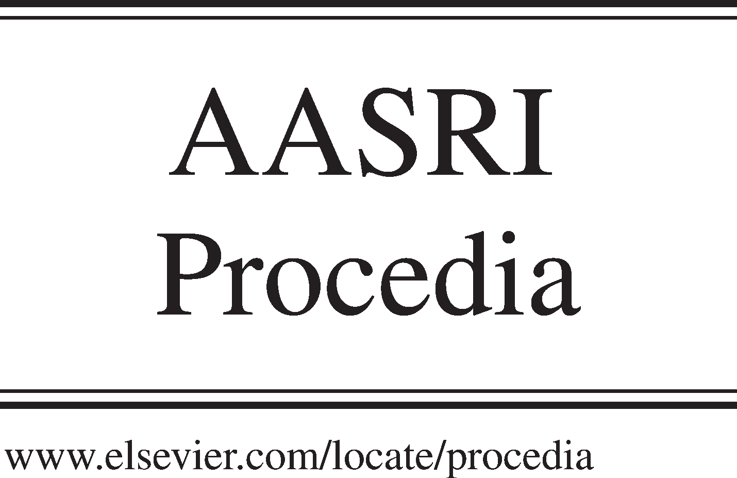Available online at [www.sciencedirect.com](http://www.sciencedirect.com/)

**ScienceDirect**

AASRI Procedia 4 (2013) 9 – 17

2013 AASRI Conference on Intelligent Systems and Control

Circuit Switch Fallback Improvement and the Smarter Way for Implementation

Youness Jouihri, Zouhair Guennoun

*Laboratoire d’Electronique et de Communications – LEC Ecole Mohammadia d’Ingénieurs – EMI Université Mohammed V-Agdal – UM5A, BP 765, avenue Ibn Sina Agdal, Rabat, 10000, Morocco*

**Abstract**

Operators, all over the world, search for the latest technologies and facilities to attract more customers. The LTE is the newest mobile technology, dedicated mainly for high-speed data transfer, and having all the chances to replace the existing legacy networks if it can provide voice services similar or even better from the existing. The delay on providing viable handsets supporting Single Radio Voice Call Continuity (SRVCC) solution forced many operators to use intermediate voice solutions, such as Circuit Switch Fallback (CSFB), not really elegant, in order to announce the support of voice services on their network, and overlook the fact of affecting badly their user’s quality experience. We have proposed a smarter way for CSFB implementation, to clear all the confusions facing operators having still LTE network voiceless, and hesitating between the SRVCC solution, assumed to have viable handset on the coming months, or to the actual CSFB deployment. The first selection might give the precession in the media battle to other competitors, and the second selection might drain the cost resources reserved for voice over LTE project and consume more time depending on the width of the network. We have suggested also interesting recommendations to reduce the call setup time and improve the user quality experience, to overcome the main CSFB solution drawback.

© 2013 The Authors. Published by Elsevier B.V. Open access under [CC BY-NC-ND license.](http://creativecommons.org/licenses/by-nc-nd/3.0/)

© 2013 Published by Elsevier B.V.

Selection and/or peer review under responsibility of American Applied Science Research Institute

Selection and/or peer review under responsibility of American Applied Science Research Institute

*Keywords*: CSFB; Voice over LTE; SRVCC;

# Introduction

The availability of handset supporting SRVCC feature on the near future become a certainty, after the successful testing of the first voice call handover from an LTE network to a WCDMA [1]. This declaration

2212-6716 © 2013 The Authors. Published by Elsevier B.V. Open access under [CC BY-NC-ND license.](http://creativecommons.org/licenses/by-nc-nd/3.0/) Selection and/or peer review under responsibility of American Applied Science Research Institute doi:10.1016/j.aasri.2013.10.003

increases the challenges in front of operators having still a voiceless LTE network, and willing to join the group of operators already publicized the accessibility of voices services on their LTE networks, most of these operators selected Circuit Switch Fallback (CSFB) solution, an unsophisticated solution to provide voice over LTE [2]. The SRVCC solution is the next logical step in the 4G LTE voice roadmap [1], but operators willing to go directly for this option cannot ensure their users about the availability of similar voice services announced by other competitors or operators, as they don’t have any real guaranties about the time of viable handset availability[2]. Also, investing in deploying CSFB solution, should add important charges on the cost reserved for voice over LTE project and might take more time than the one expected to have handset supporting SRVCC, especially by adopting the actual way of CSFB implementation.

The remaining sections are outlined as follows: After an overview on CSFB solution, advantages and disadvantages, actual implementation and Call scenarios having the most noticeable impact on the user quality experience in section 2. Section 3, introduces the smart way of deploying CSFB procedure and the modified call flow to overcome the call setup time delay on the most impacted cases. Section 4 presents our experiment results. Finally, a summary is provided in Section 5.

# CSFB overview, advantages and disadvantages, actual implementation and Call scenarios having the most noticeable impact on the user quality experience.

The CS fallback is one of the interim solution defined by 3GPP to enable voice and other CS-domain services by reusing the CS infrastructure [3], LTE will provide just data services, and for the initiation or the reception of a voice call, fallback to CS domain will be performed [4]. This function is only available in a network where the LTE coverage is overlapped by CS coverage [3], and where the MME and the MSC server can communicate using SGs interface defined to enable the use of CS domain by LTE user’s [5] . The CS Fallback functionality provides a seamless voice services without the implementation of voice over IP (VoIP) in a LTE network [6].

As shown on Fig. 1, when we have a mobile terminating call towards an LTE user, the MSC server will send paging request to MME (message (1)) and the MME will page the UE (message(2)&(3)) [5]. This page initiates CS fallback procedure as the user will request the 2G/3G network for transition (message (4)), once transitioned, normal CS mobile termination call procedure will be performed [5]. For Mobile originating calls, the same process will be followed except for paging part which will not be needed. When the voice call ends, the UE has to return to LTE network [5]. Currently, for operators using MSC server, to add CSFB functionality on their network, they need to upgrade their entire MSC servers to support the SGs interface, this interface will allow the communication between the legacy network and LTE network [3].

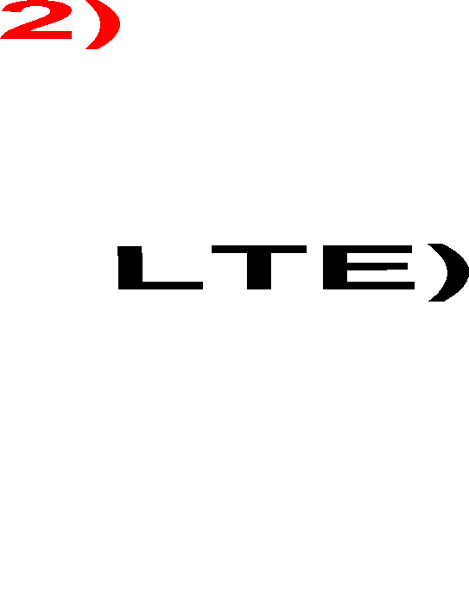

Fig. 1. CS Fallback procedure using SGs interface in a mixed network.

Unfortunately CSFB is suffering from numerous drawbacks and its worst effect is on the addition of an extra time on the call setup while receiving or making a call [7]. The call setup time is a major factor in determining the quality of user experience [7].

The solutions based on SRVCC (One Voice or VOLGA) were more recommended to play the alternative role until having a full LTE coverage and where the VOIP will be the provider of the primary voice services [8], but the delay on SRVCC implementation on the handset level [2] put a big challenge in front of operators willing to add more services to their LTE network already deployed. Adding vital services might attract more customers; also gives additional points for operators willing to advertise the possession of the best LTE network on their advertising campaigns, especially if we knew that these services can generate huge revenue like voice, already proven to be the main revenue generator service on the legacy network [8].

After the successful completion of the first voice call handover from an LTE mobile network to a WCDMA using Single Radio Voice Call Continuity (SRVCC) [1], operators are one step closer to get mobile phone supporting SRVCC, but there is no official confirmation about the exact time of the handset delivery, also the complete test cases should be conducted including all the handover cases (from LTE to 2G network and back, from LTE to UMTS networks and back, from CDMA2000 networks and back) which needs time. Even more, operators using multi technologies have to perform the testing of all the functionalities with the new mobiles, escalate to handset makers if any issue appear during the testing and wait for new releases including the needed corrections, before the commercial launch of voice over LTE services.

Based on the above points, operators willing to add voice functionality to their voiceless LTE networks are hesitating between two options. The first option is to wait for handset supporting SRVCC and to give the precession in the media war to their competitors, as many operators already declared the voice services support on their LTE network using alternative solution like CSFB for UMTS operators or active dual-mode operation for CDMA2000 operators [2]. The second option is to go for other alternatives not really elegant like CSFB [2], which will affect badly the quality of user experience and add more cost charges to the voice over LTE project deployment, even soon; all operators have to go for SRVCC solution as it is the next logical step in the 4G LTE voice roadmap [1]. The actual CSFB implementation needs also time to complete the upgrades on all MSC servers, which will make the selection more difficult, as the handset makers are expecting to have the needed phone in a couple of months.

To make choice easier for operators, we have to simplify the CSFB implementation, so the cost charges and the time consumption will be minimal. Also we have to improve the call setup time delay which is the biggest CSFB drawback. For that, we have to study the actual CSFB implementation and check if the call setup time delay is visible in all the cases or only specific call scenarios have to be improved.

By selecting the correct call Setup Method, redirection-based CSFB approaches, and after performing a detailed measurements in a commercial infrastructure averaged over a variety of good and poor radio conditions, it has been concluded that the CSFB call setup increments may not impact the user experience since the measurements fall within the range of 3G call setup times, even the influence of local signal strength and network conditions can be bigger than CSFB call setup time penalties [5]. The measurements performed took the ideal cases where the UE will target the same 3G cell already stored on the MSC server [5]. To use always the same cell, LTE and 3G, access patterns for any given location must be always identical, which can never be the case, as we have different frequencies having different terrain propagation and structure penetration characteristics, as well as potentially different fixed antenna sites [5].

The LTE cells can overlap two 3G cells or more which can introduce substantial setup delays due to the update of user locations on the MSC server [5]. This Location Area Update procedure might add some seconds delay on the setup time, depending on the load on the network [5]. The impact will be more if the transition from LTE to 3G happens in an MSC Server “border” area, where the MSC server change will be involved [5]. In this situation, a location update procedure involving both MSC server (new and old) and HLR

should occur to update the UE location information. For this last case, if the CS network doesn’t support the Mobile Terminated Roaming Retry (MTRR) procedure, the call will be cleared [6]. The MTRR procedure might add more than four second delay to setup time which will noticeably affect the user quality experience [5]. The current proposition to address the setup delays due to MTRR procedure is the deployment of MSC Pool architecture [5], which might result in exceeding the time and the cost charges reserved for CSFB implementation.

We can conclude that, the actual CSFB deployment requires the addition of SGs interface support in all the MSC servers, also the user experience will be mostly impacted by the calls using the Mobile Terminated Roaming Retry procedure.

So how can we make the CSFB implementation simple? And which modifications we can suggest to improve the call setup time of the calls requiring the MTRR procedure?

# The smart way of deploying CSFB procedure and the modified call flow to overcome the call setup time delay on the most impacted cases.

* 1. *The easy and smart way of deploying CSFB procedure*

For operators having mixed (LTE & 3G/2G) network and using MSC servers, the CSFB deployment requires a software upgrade in all MSC servers to enable the communicate between LTE network (MME) and legacy network (MSC server), by adding the support of SGs interface [3].

The upgrade of the entire network may drain all the resources reserved for voice project on LTE network. This upgrade will just provide a temporary solution for voice services [1], to bypass the prospective short time needed for the availability of SRVCC solution [2], where operators have to invest the majority of their voice project budget. The entire CSFB deployment requires time, the cost will be higher depending on the number of MSC servers on the network, and the implementation will cause a downtime on live services, which might cause revenue lost and give chance to competitive operators to catch roamers moved from MSC servers during the downtime towards their network. The affect will be more visible for operators having big network and huge number of MSC servers.

To make the CSFB implementation easy and simple, we should find a way to compensate the entire implementation and replace the general change with a limited one. The idea of having proxy equipment to enable the needed functionalities seems to be evident, but the smart selection of this equipment might save time and reduce the cost. Normally, all the MSC servers are connected to each other (using BICC or SIP connections), so if we will implement the CSFB procedure on one of them and enhance this implementation to support the traffic coming from all other MSC servers, by increasing the signaling capacity between MME and the MSC server having CSFB solution, we will save the cost of adding new equipment and we will save the time by using the existing connection to provide CSFB services to other MSC servers. The MSC server having this functionality will play the role of proxy for CSFB services and will be called proxy MSS; we can have more than one proxy MSS depending on the traffic load and operators decisions, but as a first step, we can start with one proxy MSS. We have also to select smartly the MSC server planned to be used as a proxy MSS, because the use of proxy MSS will add an additional time to CSFB call setup time, as the call has to be sent to proxy MSS and from there the paging request will be sent to MME. On the case of full CSFB implementation, the paging can be sent directly from MSC server initiating the call to the MME [3]. The selected MSC server should be the one usually serving the biggest number of subscribers and having the largest connections with radio network, so we can reduce the number of subscribers impacted by this additional time due to proxy MSS, also we will minimize the cases where location update will happen in different MSC server during CSFB procedure and reduce the need of MTRR procedure.

The proxy MSS seems to be the best option to enable CSFB solution without impacting significantly the existing 3G/2G network, but as discussed before, the users experience will be badly affected on the MSC Server “border” area, where the MTRR procedure might add more than 4s delay to the call setup time [5]. The use case that we will try to enhance is the call scenario where the MTRR procedure is needed and where the paging request will be forwarded from proxy MSS to MME. By proposing some modifications on the general MTRR call flow, many messages can be removed. So we can overcome the extra time added by the Proxy MSS addition, even more, we can enhance the actual long call setup time, needed to perform MTRR procedure and badly affecting the users’ quality experience [5], without requiring any expensive solutions, such as pooling architecture. These modifications will be based on the addition of extra information on the normal signaling messages, so the entity receiving these messages will get the complete information and will not wait for a new message to perform the next task.

* 1. *The modified call flow of the most impacted use case including the addition of Proxy MSS*

Our optimized call flow will be based on the use case where the UE camps, during CFSB procedure, on a GERAN/UTRAN cell served by different MSS than the one having the user device registration. On the current solution, location update procedure should occur, also the Mobile Terminated Roaming Retry procedure is needed to terminate successfully the call [6].

As shown on Fig. 2, for the normal MTRR scenario, if a Mobile Terminating call arrives to GMSC, the GMSC will perform an HLR inquiry by sending a Send Routing Information (SRI) to the HLR.

The HLR will send a Provide Roaming Number (PRN) message to get the MSRN from MSS, the MSS will provide Mobile Subscriber Roaming Number (MSRN) on the PRN response, and the HLR will forward the MSRN to GMSC on the SRI response. The GMSC will initiate an Initial Address Message (IAM) based on the received MSRN towards MSC server. Once received, the MSC server will send a paging over SGs request to MME and MME will page the UE. Our recommendation here is to add the paging request on the PRN message sent from HLR to Proxy MSS, as shown on Fig. 3, once HLR find that the subscriber is roaming in LTE network, the proxy MSS will send directly the paging over SGs request to MME. The received IAM message from GMSC to trigger the paging procedure will not be required (Fig. 2).

The paging over the SGs interface would initiate a possibly long procedure of CS Fallback, for that we have either to increase the PRN timer on the HLR or make a separate timer for PRN request having paging request, so our call will not be cleared due to PRN timer expiry. After that, for both cases the MME will initiate a paging procedure by sending a SERVICE-REQUEST message to the MSS/VLR or proxy MSS, which will be taken as an intermediate paging response and will be used to stop the paging timer [3]. A new timer will start to supervise the final paging response from the terminating subscriber, as at this point; the subscriber may have the option to decide whether to accept the call or not [3]. If the subscriber accepts the call, on our use case, the UE camps on a GERAN/UTRAN cell served by a different MSS than the one having it is registration. The UE executes fallback to GERAN/UTRAN and sends Location Update Request to the new visit MSS (VMSS) which controls the target GERAN/UTRAN access. The new VMSS initiates an update location procedure to the HLR and the HLR sends MAP Cancel Location to the old MSS in normal MTRR case or to the proxy MSS in our use case (Fig. 2& Fig. 3). In our use case, once the proxy MSS receives the Cancel Location message; it recognizes that the UE executed a fallback to another VMSS. The proxy MSS stops the paging over the SGs interfaces and sends an SRI message to the HLR to obtain routing information (MSRN) from the new VMSS. There will be no need for RCH and release message, as these messages are used to release the connection between GMSC and the MSS initiating the paging procedure, after receiving this request in IAM message from GMSC.

HLR

SRI

SRI ACK (MSRN)

PRN

PRN ACK (MSRN)

IAM (MSRN

Paging over SGs

Paging

Service Request

Extended Service Request

MAP Location Update Roq

Location update

Cancel Location Cancel Location Rsp

Resume Call Handling Resume Call Handling ACK REL

RLC

Sand 2nd SRI

SRI

HLR delays the sending of PRN until LU finishes

Insert Sub data MAP Location update Cfm

PRN

SRI ACK (MSRN)

IAM (MSRN)

PRN Rsp (MSRN)

Location Update Accept TMSI reallocation complete

Paging

Paging response

Setup

Call Confirmed

Alerting

ACM

UE

SAE/LTE

GMS

NEW VMSS/VLR

New VMSC/VLR delay setup until LU procedure finishes

Old MSC stop paging timer and inform GMSC

MSS/VLR

Fig. 2. Information flow for a mobile terminating roaming retry call after successful Retrieval of Routing Information [3].

But in our use case, the proxy MSS start the paging directly after receiving the PRN including this information, which remove the need of the GMSC IAM message to initiate the paging (as described before), so no open connection between GMSC and Proxy MSS, which will not require any RCH and release messages to close it. Next, for both cases, once HLR receives the SRI either from GMSC or proxy MSS, it sends PRN to the new VMSS. The new VMSS answers with an MSRN in the response. The proxy MSS or GMSC initiate an IAM message based on the received MSRN.

On the normal MTRR case, after receiving the IAM message the new MSS will start a paging over A/Iu interface, the UE will reply back with a paging response. From this point, the call establishment procedure is identical to a standard CS Mobile Terminating Call (Fig. 2).

In our use case, we have recommended to use the flag indicating the pending state of any mobile terminating call on the new MSS. So during the location update request initiated by the UE, as a result of CS fallback to GERAN/UTRAN procedure, MSS have to check for any pending terminating CS calls, if the flag is set, maintain the radio connection after the Location Update procedure completion for the pending call. The MSS might start a timer to supervise the arrival of call setup, after receiving the IAM message coming from proxy MSS to new MSS, the MSS stops the timer and establishes the CS Mobile Terminating Call as usual, reusing the signalling connection maintained. So there will be no need for new paging over the A/Iu interface. The paging procedure is a time consuming operation and for many cases the re-paging action is needed to reach the UE which will double the operation time. The call setup time can be reduced considerably by adopting this recommendation.

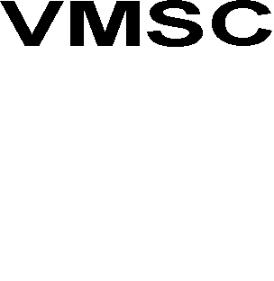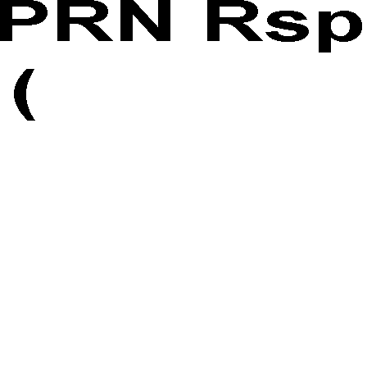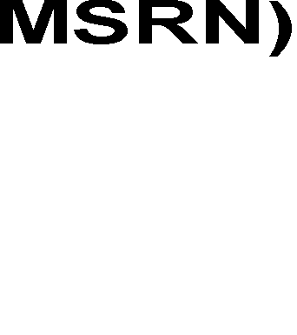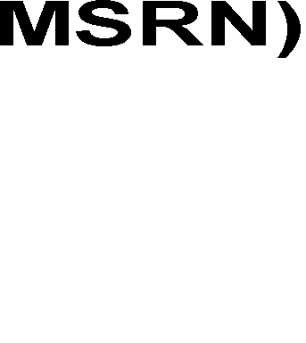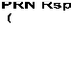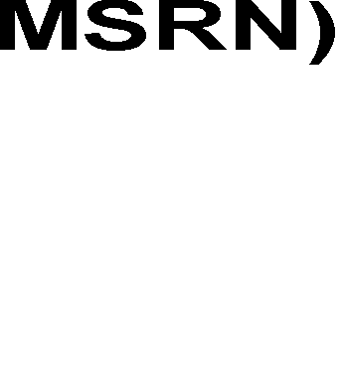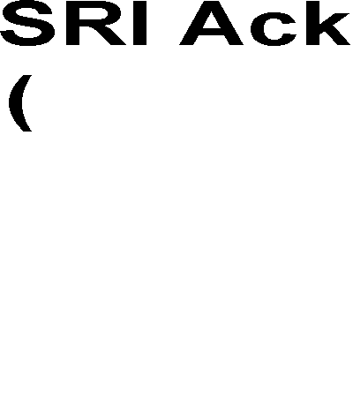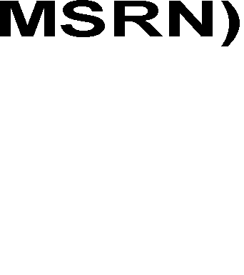

Fig. 3. Successful MT Call flow using Proxy MSS solution

# Experiment Results

The measurements of call setup time have been collected from live 3G network with commercial infrastructure. Our recommendations, to modify the CSFB call flow cannot be implemented directly and easily on a live network. The values of call setup time after change have been measured by simulating the same previous calls, done on live network, reusing the exact duration taken by each message till composing the complete modified call flow respecting our recommendations. On the proposed call flow, the IAM message used to trigger the paging over SGs will be removed along with their corresponding RCH and release messages; also the paging procedure over Iu interface will not be required.

As mentioned before, the paging procedure is time consuming operation. Table 1 show that the re-paging action was needed in most of the calls performed during the testing which added a penalty in the call setup time. From Fig. 4, we can conclude that adopting the modified call flow will give a CSFB call setup time within the range of 3G call setup time which will make this solution more attractive for operators

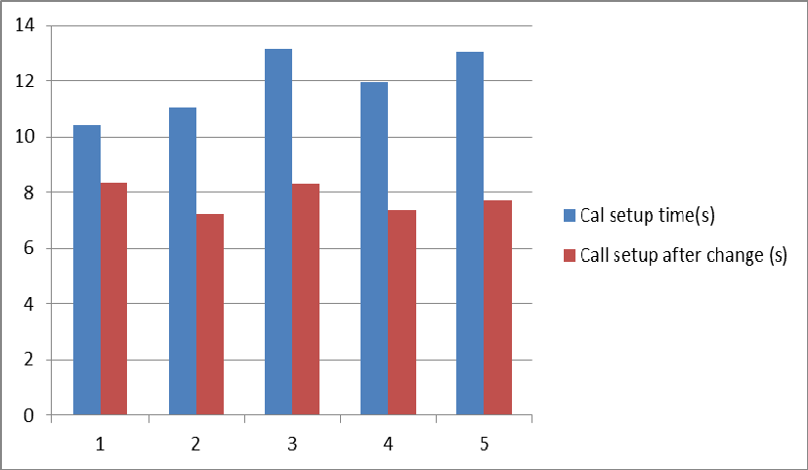

Call setup time(s)

Call setup after change(s)

Fig. 4. Comparing call setup time before and after change.

Table 1. Call setup time before and after change including the number of paging attempt.

Call Call setup times(s)

Paging time (s) Number of Paging

attempt

First ISUP Message time (s)

Call setup after change (s)

|  |  |  |  |  |  |
| --- | --- | --- | --- | --- | --- |
| T1 | 10.41 | 1.37 | 1 | 0.68 | 8.36 |
| T2 | 11.05 | 3.128 | 2 | 0.7 | 7.23 |
| T3 | 13.13 | 3.119 | 2 | 1.7 | 8.31 |
| T4 | 11.96 | 3.127 | 2 | 1.5 | 7.34 |
| T5 | 13.04 | 3.109 | 2 | 2.19 | 7.74 |

# Summary

We presented, for operators ready to add voice services on their LTE networks, a smart and simple method to implement CSFB solution and clear all the confusions for a smooth voice over LTE deployment. This solution will allow operators to announce the availability of voice services by adopting a quick and small

change on the network, which will result in a minimum cost charges. On a time where the majority of LTE operators are forced to wait for viable handset supporting the SRVCC solution to realize their multimedia dreams and provide the high definition (HD) voice services. By adopting our recommendations, operators can overcome the call setup time delay and give confortable quality experience to their customers. Our solution can be used even after the implementation of SRVCC solution, for roamers or handsets not supporting this solution, so how our improved CSFB solution can coexist with SRVCC solution on the future and are there any further improvements?

# References

1. Tina Asmar, Warren Kneeshaw, Qualcomm Chipset Powers First Successful VoIP-over-LTE Call with Single Radio Voice Call Continuity, Qualcomm media, February, 2012.
2. Neal Gompa, First LTE to WCDMA voice call handover completed by Qualcomm and Ericsson, EXTREMETECH, February, 2012.
3. 3GPP TS 23.272, Circuit Switched (CS) fallback in Evolved Packet System (EPS), 2012,Rel 8, stage 2.
4. Chen Qunhui, Evolution and deployment of VoLTE, Huawei Communicate, 2011, 61: 52-55.
5. Qualcomm, Circuit-switched fallback The first phase of voice evolution for mobile LTE devices, Qualcomm media,2012.
6. Nokia Siemens Networks, Feature 1914: CS Fallback in EPS for MSC Server, january, 2012.
7. Kineto Wireless, A critical examination of CSFB as a solution for providing Voice-on-LTE, Disruptive Analysis, December, 2009.
8. Y. Jouihri, Z. Guennoun, Solutions Comparison towards Voice Services Implementation for Operators Starting LTE Deployment. Communications and Network Journal, 2012; 4(2):122-128.